1. Chapter Title
Governed Agentic AI for Banking Fraud Investigation and Response: A Human-in-the-Loop Multi-Agent Workflow
DEMO WEBSITE URL: [ INSERT PUBLIC DEMO WEBSITE URL HERE ]

2. Author Details
Name | Programme | Institute | Faculty Mentor | Email
Pratik Shejwal | MBA – International Business (2025–27) | Symbiosis Centre for Information Technology (SCIT), Symbiosis International (Deemed University), Pune | Anshul Saxena
Badshah Khalik | MBA – International Business (2025–27) | Symbiosis Centre for Information Technology (SCIT), Symbiosis International (Deemed University), Pune | Anshul Saxena | Khalikbadshah918@  gmail.com
Kriss Thakkar | MBA – International Business (2025–27) | Symbiosis Centre for Information Technology (SCIT), Symbiosis International (Deemed University), Pune | Anshul Saxena
Shourya | MBA – International Business (2025–27) | Symbiosis Centre for Information Technology (SCIT), Symbiosis International (Deemed University), Pune | Anshul Saxena
Maheep Singh | MBA – International Business (2025–27) | Symbiosis Centre for Information Technology (SCIT), Symbiosis International (Deemed University), Pune | Anshul Saxena
Sarth Lakhade | MBA – International Business (2025–27) | Symbiosis Centre for Information Technology (SCIT), Symbiosis International (Deemed University), Pune | Anshul Saxena

3. Abstract
Banks process large volumes of digital transactions, while investigators must combine transaction attributes, behavioural indicators, policy thresholds and evidence before deciding how a fraud alert should proceed. This chapter presents a governed multi-agent prototype that redesigns the investigation stage without transferring consequential decision authority to software. A Python orchestrator runs five deterministic agents for transaction analysis, behavioural analysis, risk and policy assessment, recommendation generation and investigation routing. A Streamlit interface presents the results, a local SQLite store preserves investigation records and audit events, and an n8n workflow provides risk-based notification through a webhook. The prototype uses synthetic data and illustrative rules. Functional testing covered normal, incomplete-evidence and high-risk cases, as well as the human-review and closure safeguards. A separate open-model evaluation compared Qwen3:4b, Llama 3.2:3b and Gemma3:4b under identical conditions across six synthetic cases, producing 18 completed evaluations. Llama 3.2:3b achieved the highest risk-level agreement at 83.33% and the lowest average latency at 10.98 seconds. Qwen3:4b and Gemma3:4b each achieved 100% agreement on the human-review requirement, while all three models showed weaker route agreement. All 18 outputs were parseable in the recorded run. The model comparison was an evaluation activity only; the production decision path remains deterministic and human-governed. The contribution is a reusable prototype pattern for governed fraud-investigation assistance.

4. Keywords
Agentic AI; Fraud Investigation; Banking; Human-in-the-Loop; Multi-Agent Orchestration; AI Governance; Open-Weight Models
Submission artifact checklist: Demo website URL (to be inserted by team); AS-IS Process Diagram; TO-BE Process Diagram; Agentic AI Architecture; AI Governance Architecture; and three-model comparison under common evaluation parameters are included below.

5. Introduction

Domain context
Digital banking has changed both the volume and the speed of financial transactions. Customers now pay through unified payment interfaces, cards, mobile applications, internet banking and wallets, and many of these payments settle within seconds. Fraudsters have adapted at the same pace. Account takeover, social engineering, mule accounts, card-not-present fraud and authorised push payment scams all exploit the fact that a legitimate-looking digital transaction can be completed before anyone has had time to question it. Banks therefore run automated monitoring systems that score transactions and raise alerts when behaviour looks unusual. The academic literature on statistical fraud detection has long treated this as a problem of separating a very small number of fraudulent events from a very large number of legitimate ones (Bolton & Hand, 2002). Later work has shown that this imbalance, together with the changing behaviour of both customers and fraudsters, makes detection hard even for strong models (Dal Pozzolo et al., 2015).

Significance of the problem
An alert is only the start of the work. Someone must decide what the alert means and what the bank should do about it. The possible outcomes are to let the transaction proceed, to verify it with the customer, to place a temporary hold, or to escalate it to a specialist team or to regulatory reporting. A wrong decision is costly in either direction. If the bank misses fraud, a customer loses money, the bank carries reputational and regulatory exposure, and the loss is often unrecoverable. If it blocks a genuine transaction, the customer is frustrated, trust erodes, and the bank carries avoidable service costs. Regulators in India expect banks to maintain structured fraud risk management, early warning mechanisms and timely action and reporting (Reserve Bank of India, 2024). Speed, consistency and documentation are therefore regulatory expectations as well as operational goals.

Limitations of the existing process
Detection has become largely automated, but investigation has not. A typical analyst working an alert has to open the transaction record, read the customer's recent history, check device and channel signals, consult the relevant fraud rules and policy thresholds, and then write up a rationale. These pieces of evidence usually sit in different systems with different interfaces. Much of the effort goes into gathering and reconciling information rather than into judgement. As alert volumes grow, queues build up and the most time-sensitive cases wait alongside routine ones. Because analysts apply rules and experience differently, two investigators can reach different conclusions on a similar case, and the written reasoning varies in quality. Most alerts also turn out to be false positives, so a large share of expert time is spent confirming that nothing is wrong. Ambiguous cases, where signals conflict or evidence is incomplete, are the hardest. Standard rules do not cover them well, and they depend heavily on individual experience.

Relevance of Agentic AI
Agentic AI offers a different way to organise this work. In an agentic system, a language model does more than generate text from a single prompt. It is combined with tools, memory and a defined role, so that it can plan steps, call external systems, use the results and pass its output to the next stage (Wang et al., 2024; Yao et al., 2023). Several such agents can be coordinated by an orchestrator that decides which agent acts next and under what conditions. This maps closely onto fraud investigation, which is already a sequence of specialised evidence-gathering and assessment tasks. One agent can analyse the transaction, another can compare it against the customer's normal behaviour, another can check policy and risk thresholds, and another can assemble a recommendation with its reasoning. The orchestrator can also route cases by risk level. The same properties that make agents useful make them risky in a banking setting. Models can hallucinate, can be manipulated through injected text, and can act without adequate oversight. The design therefore has to be governed. Frameworks such as the NIST AI Risk Management Framework (National Institute of Standards and Technology NIST, 2023) and ISO/IEC 42001 (International Organization for Standardization ISO & International Electrotechnical Commission IEC, 2023) give structured ways to identify and control such risks.

Scope of the chapter
This chapter covers fraud alert investigation and response in a retail banking context. It does not cover real-time transaction scoring, model training for the detection engine, or customer-facing fraud recovery. It treats the incoming alert as given and focuses on what happens from the moment an alert reaches an investigator until a decision is recorded. The prototype uses synthetic data only and has no connection to live bank systems. The agents recommend, and human investigators decide. Final authority for holds, customer contact and escalation stays with people.

Chapter objective
The objective is to show how a governed Agentic AI workflow can reduce manual effort and improve the consistency of fraud investigation without removing human decision authority. To do so, the chapter does the following:
- Analyses the current process and identifies its main bottlenecks and risks.
- Reviews existing solutions and the gap the proposed prototype addresses.
- Presents the redesigned process, the agent roles and the technical and governance architecture.
- Describes an integrated working prototype that links a user interface to an orchestration workflow.
- Compares three open-weight models under identical conditions.
- Reports test results across normal, ambiguous and high-risk cases.
- Maps the guardrails to recognised governance frameworks and draws conclusions about where Agentic AI fits and where human judgement remains essential.
The rest of the chapter follows this order.

6. Problem Context and Current Process

Stakeholders
Four groups take part in a typical fraud alert investigation. The first is the monitoring system, which is a rule engine or scoring model that flags a transaction as suspicious. The second is the Level 1 (L1) fraud analyst, who takes the alert from a queue and carries out the first investigation. The third is the customer, who is the only person who can say whether an unusual transaction was really theirs. The fourth is the Level 2 (L2) investigator and compliance team, who handle escalated cases, take decisions on holds and freezes, and prepare any regulatory reporting. The bank's operations and customer service functions sit around these four groups. They depend on how quickly and how accurately the analyst closes each case.

Current workflow
The workflow below describes a typical semi-manual process in a retail bank. Details differ between institutions.
- Alert raised. The monitoring system flags a transaction because it breaks a rule (for example, an unusually large amount or a new beneficiary) or because its risk score crosses a threshold.
- Triage. The alert enters a queue. An L1 analyst picks it up, usually in order of arrival or by a coarse priority label.
- Evidence gathering. The analyst opens the transaction record and then moves between other systems to collect context. These typically include the customer's recent transaction history, account and KYC details, device and channel information such as the login location or whether the device is new, and previous alerts or complaints. Each system has its own screen and its own search method.
- Decision. The analyst compares what they have found with the bank's fraud rules and policy thresholds and uses their own experience to choose an outcome. The usual outcomes are to clear the alert, to verify with the customer, to place a temporary hold, or to escalate.
- Customer verification. If verification is needed, the analyst or a contact-centre colleague calls or messages the customer. The result of that contact then feeds back into the decision.
- Escalation and closure. Complex or high-value cases go to an L2 investigator, who reviews the evidence again and decides whether to hold, block or report. The case is closed with written notes, and reportable cases go through the bank's regulatory filing process.

Systems and data
The evidence needed for a single decision is spread across several sources: transaction and payment data, customer profile and KYC records, device, session and channel logs, fraud rules and policy documents, and case management records and earlier alerts. Few banks have all of these in one view. Policy documents in particular tend to be long PDFs or intranet pages that the analyst must search and read for every unfamiliar case.

Manual activities and decision points
Most of the analyst's time goes into manual work that needs little judgement: opening screens, copying values, comparing a transaction against several months of history, and looking up the right threshold. The real decision points are few but important. The analyst must decide whether the pattern is consistent with the customer's normal behaviour, whether the policy requires action at this risk level, and whether the case is within their authority or must be escalated. These are the points where consistency matters most and where a mistake is most expensive.

Bottlenecks, delays and risks
The numbered markers in Figure 1 correspond to the main bottlenecks:
- Queue waiting time. Alerts are triaged by arrival time or coarse priority, so a high-risk alert can wait behind many routine ones.
- Fragmented evidence. Gathering data from five or more systems takes time and invites omissions. An analyst under pressure may skip a check.
- Inconsistent judgement. Different analysts reach different conclusions on similar cases, and the reasoning is not always recorded in the same depth.
- Customer contact delays. Verification depends on reaching the customer. An unanswered call leaves the case open and the transaction in an uncertain state.
- Manual documentation and reporting. Free-text case notes and manual regulatory reports take time and vary in quality, which weakens audit evidence.
Time matters a great deal because fraudulent funds can be moved on within minutes. Delays therefore increase the chance of loss. On the other side, most alerts are eventually found to be genuine, so a large share of effort goes into clearing false positives. Both pressures push analysts towards either over-caution, which annoys customers, or shortcuts, which risk missed fraud.

Exceptions
Standard rules handle clear-cut cases well and ambiguous ones badly. Examples include a legitimate high-value purchase by a customer travelling abroad, a long-standing customer changing behaviour after a life event, a transaction that fits the customer's history but arrives from a new device, and cases where evidence is missing or contradictory. In practice these cases are resolved by experienced analysts using judgement, often after escalation. This makes them slow and difficult to apply consistently, and it is where decision support and a clear escalation path add the most value. The scenarios described above are illustrative examples of fraud-investigation exceptions and have not been independently validated through industry-expert input. They are included to explain situations in which human judgement, evidence verification and escalation may be required.
AS-IS process diagram
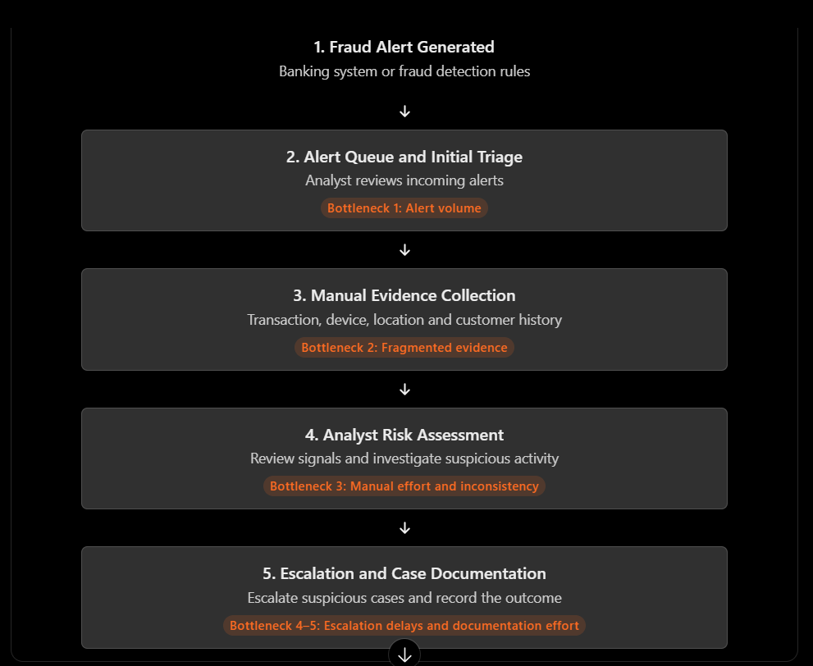

Figure 1. AS-IS Process Diagram — Fraud Alert Investigation.

7. Market and Technology Review

Existing solutions
The fraud technology market is mature at the detection end and less developed at the investigation end. Established enterprise platforms include NICE Actimize, SAS Fraud Management, FICO Falcon, Feedzai and Featurespace (ARIC). They score transactions in real time using machine learning and rules and provide case management for analysts. Behavioural analytics products such as BioCatch add signals about how a user interacts with a device. Their typical outputs are risk scores, rule hits and reason codes, supported by dashboards, alert queues and workflow tools. Core banking vendors and cloud providers also offer fraud detection modules. Robotic process automation (RPA) is widely used for repetitive investigation tasks such as retrieving records and filling forms. The market review identified several commercial solutions relevant to banking fraud detection and investigation. NICE Actimize’s Integrated Fraud Management platform supports fraud detection, investigation and fraud operations. SAS Fraud Decisioning combines fraud analytics, machine learning and real-time decisioning. Feedzai’s RiskOps platform integrates fraud and financial-crime risk management across customer interactions and payment channels. Featurespace’s platform uses adaptive behavioural analytics to identify unusual activity and emerging fraud patterns. These descriptions are based on publicly available vendor documentation and represent a preliminary review of product capabilities. The solutions were not tested hands-on or evaluated using a common benchmark in this project; therefore, no comparative performance or superiority claims are made.
Relevant approaches in the academic literature
Research on fraud detection has focused mostly on classification, meaning how to separate fraudulent from genuine transactions. Surveys describe the central difficulties as extreme class imbalance, changing fraud patterns and the cost of misclassification (Bolton & Hand, 2002; Dal Pozzolo et al., 2015). These works improve the quality of the alert. They say much less about what happens after the alert is raised, which is the focus of this chapter.

Agentic AI approaches and technologies
Large language models (LLMs) are the base of the newer agentic approaches. A language model alone only produces text. An agent adds a role, memory, planning and access to tools, so that it can reason about a task, act through an external system, observe the result and continue (Wang et al., 2024; Yao et al., 2023). Several agents can be organised under an orchestrator, and frameworks such as AutoGen show how conversations and tasks can be shared across multiple specialised agents (Wu et al., 2023). Retrieval-augmented generation (RAG) lets a model answer from a controlled set of documents, such as a bank's own fraud policy, rather than from its general training (Lewis et al., 2020). This is directly relevant to policy checking. Workflow tools such as n8n provide a visual, low-code way to connect triggers, model calls, tools and conditional branches, which suits a prototype that must be demonstrated and explained clearly. The workflow automation platform documentation is listed in the references; the exact n8n version used should be confirmed from the running instance before submission.
The models themselves have also changed. Several capable open-weight families now exist, including Llama (Dubey et al., 2024), Mistral (Jiang et al., 2023), Qwen (Yang et al., 2024) and Gemma (Gemma Team, 2024). These can be run on the bank's own infrastructure or on a local machine. For banking this matters because customer and transaction data does not have to leave a controlled environment. Open weights also allow models to be compared under identical conditions, which is the approach taken later in this chapter.

Limitations of current solutions
Three limitations stand out. First, most commercial tools concentrate on detection and scoring, and the investigation that follows remains largely manual even when the platform provides a case management screen. Second, scores and reason codes explain why an alert fired but do not assemble the evidence into a reasoned recommendation that an analyst can quickly accept or challenge. Third, using language models in a regulated setting brings its own risks. Models can state things that are not supported by the evidence, a problem widely described as hallucination (Ji et al., 2023). They can also be manipulated by instructions hidden in the text they read, known as indirect prompt injection (Greshake et al., 2023). Closed models accessed through external APIs also raise questions about data handling that many banks cannot accept.

The gap addressed by the prototype
The prototype addresses the space between detection and decision. It does not try to replace the monitoring system or the investigator. It takes an alert that has already been raised, gathers and analyses the evidence through specialised agents, checks it against policy, and presents a structured, explained recommendation to a human investigator. It does this using open-weight models that can be compared and controlled, and with guardrails, approval points and an audit trail built in from the start. Within the sources reviewed for this chapter, we did not find a freely reproducible reference design that combines these elements for fraud investigation. This is a prototype design intended to demonstrate a governed workflow; it is not a claim that no comparable reference design exists. A broader market or literature review would be needed to support any novelty claim.

8. Proposed Agentic AI Solution

Objective
The solution aims to shorten and standardise the investigation of a fraud alert while leaving every consequential decision with a human investigator. It does this by turning the evidence gathering and analysis steps, which make up most of the manual workload described in Section 6, into work done by specialised software agents. The investigator then receives a structured, explained recommendation and a suggested route, and decides what to do. The design principle is that agents recommend and humans decide. No agent can hold, block or release a transaction, contact a customer, or file a report on its own.

Workflow overview
An investigator enters the details of an alert in the web interface: transaction identifier, amount, channel, location status, device status and the number of recent failed logins. The orchestrator then passes these details through four analysis agents in sequence. The Transaction Analysis Agent examines the amount and channel. The Behaviour Analysis Agent examines the location, the device and the failed-login pattern. The Risk and Policy Agent combines both findings into a total risk score, a risk level and a human-review flag. The Recommendation Agent turns the assessment into a priority and a list of next steps. A fifth agent, the Investigation Routing Agent, then selects one of four routes: standard review for low-risk cases, investigation for medium-risk cases, evidence verification when information is missing, and priority investigation for high-risk cases. The case is saved with its route, priority and findings, an audit event is recorded, and the investigator reviews it. A case that needs human review cannot be closed until documented review notes and an approval are recorded.
Figure 2 shows the TO-BE process. Each activity is marked A (autonomous), H (human-in-the-loop) or E (escalation), as the assignment requires. The low-risk route is marked A because the rules do not require human review for it, although an investigator may still open the case.
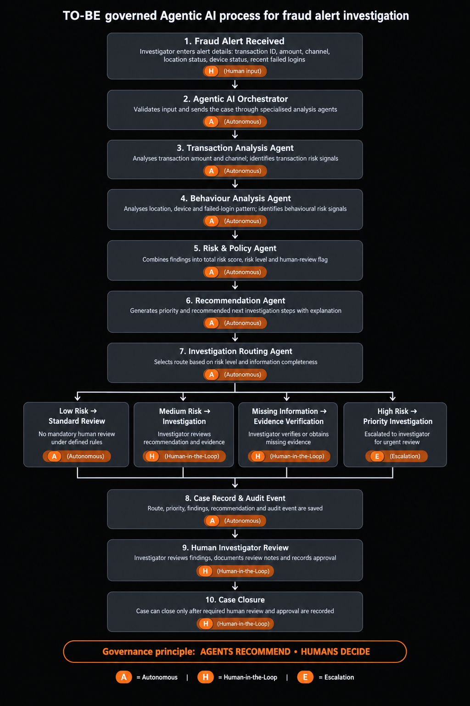
Figure 2. TO-BE Process Diagram — Governed Agentic AI Fraud Alert Investigation (A = Autonomous, H = Human-in-the-Loop, E = Escalation).

The orchestrator
The orchestrator is the control layer. It is a Python function that receives the alert fields, calls each agent in a fixed order, passes each agent's output to the next, and returns one combined result with a workflow status. It makes no judgement about fraud. Its job is sequencing and collecting results, which keeps the reasoning inside the specialist agents where it can be inspected and tested one by one. The interface wraps the call in error handling, so a failure shows a clear message and is written to the terminal log instead of producing a decision. A separate webhook client can notify an n8n workflow when a case is saved. The configured n8n workflow receives a POST event from the application and branches on risk level and route. The HIGH-risk branch prepares a high-risk escalation email; the evidence-verification branch sends an evidence-verification notification; and the remaining branch prepares a standard-review notification. The workflow has been published and email delivery was tested.

Agents, inputs, outputs and data
Each agent has a narrow role, and each returns a structured result containing its name, its risk points, its findings and a status. Section 9 gives the complete design table.
The Transaction Analysis Agent takes the amount and channel. It adds two risk points when the amount is ₹50,000 or more and records a finding when the channel is not one of the recognised channels. The Behaviour Analysis Agent takes the location status, device status and failed-login count. It adds two points for a new location, two for a new device and three for three or more recent failed logins, and it records a finding when the location or device is unknown. The Risk and Policy Agent adds the points from both agents, classifies the case, and sets the human-review flag. The Recommendation Agent converts the risk level into a priority (urgent, normal, routine or review required) and a short list of next steps for the investigator. The Investigation Routing Agent maps the assessment to a route, a route priority and a stated reason.
The agents use synthetic data and transparent rules. They are rule-based by design in the current prototype, which makes every output explainable and repeatable. A language-model layer using open-weight models is planned so that models can be compared (Section 11). No language-model step is confirmed as part of the tested decision path in this prototype. The current investigation agents use deterministic rules; model-based analysis remains an evaluation extension unless separately implemented and evidenced.

Decision logic
The Risk and Policy Agent uses illustrative thresholds. A total of six or more points is HIGH, three to five is MEDIUM, and below three is LOW. The maximum possible score is nine. These values are demonstration settings and not calibrated banking thresholds. Two rules protect against false reassurance. First, if any finding says that the location or device is unknown, human review is required even when the score is LOW, because missing evidence is not proof that a transaction is safe. Second, closure of a case that requires review is blocked until the review is documented and approved. The routing step then follows the assessment, as summarised below.
- High risk: route PRIORITY_INVESTIGATION with urgent priority and mandatory human review. This is the escalation path.
- Medium risk: route STANDARD_INVESTIGATION with mandatory human review. The application maps medium-risk cases to mandatory human review; confirm the exact route and priority against the current routing agent before final submission.
- Unknown location or device: route EVIDENCE_VERIFICATION with high priority and mandatory human review, even if the score is low.
- Low risk with complete evidence: route STANDARD_REVIEW with routine priority and no mandatory human review.

Human-in-the-Loop points
The investigator has three responsibilities in the workflow. The first is review: for every case the investigator can see the findings, the agent outputs, the route and the recommended steps. The second is documentation: the investigator enters review notes and sets a review status of Pending Review, Under Investigation, Escalated or Closed After Review. The third is approval: for a case that requires human review, the investigator records an approval decision (Pending Approval, Approved, Rejected or Not Required), and the system stores the approver's entered name and the time. Closure is available only when notes exist and the decision is Approved.

Escalation mechanisms
Escalation happens through the route and the review status. A high-risk case is routed to priority investigation and marked urgent as soon as it is saved. The investigator can also move any case to the Escalated status. Cases with incomplete evidence go to evidence verification before any decision. Each of these steps creates an audit event. If an agent or the database call fails, the interface displays an error and does not save a partial result.

Technical architecture
Figure 3 shows how the solution is built. The Streamlit interface collects alert details and displays results. The Python orchestrator and routing agent run the analysis agents. Results, review notes, approvals and audit events are stored in a local SQLite database. A webhook client can send the saved case to n8n. Guardrails and human oversight run across all layers, and Section 13 maps them to a governance framework.
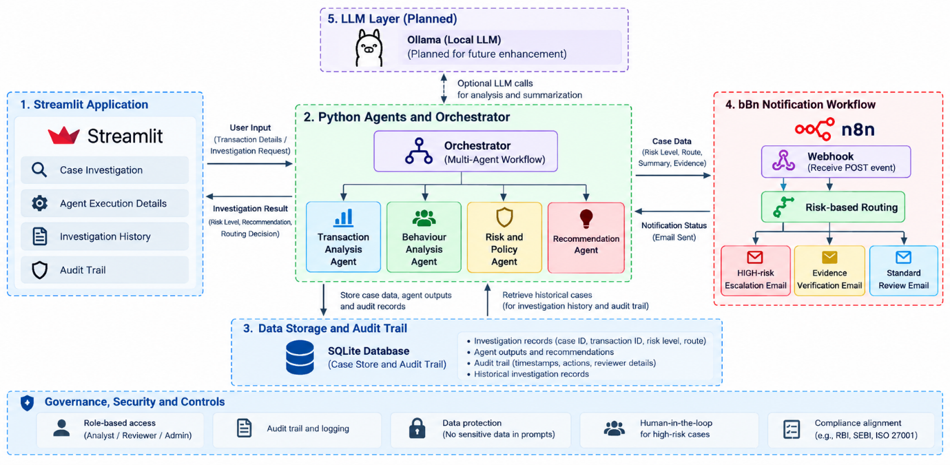
Figure 3. Agentic AI Architecture — Streamlit, Python Multi-Agent Orchestration, SQLite, n8n and Governance Controls.
The layered design has three practical benefits. It separates concerns, so an agent can be replaced, for example by a model-based agent, without changing the interface or the database. It keeps all data local and synthetic. And it places the main safeguards, such as the closure rule and the audit log, outside the analysis agents, so a faulty agent cannot switch them off.

9. Agent Design
Only components that carry out a distinct task are listed as agents. Input validation, the closure safeguard and audit logging are deterministic controls and are described in Sections 10 and 13.
Agent | Purpose | Input | Main Task | Tools / Data | Output | Human Intervention
Orchestrator | Run the full investigation in order | Amount, channel, location, device, failed logins from the form | Call each agent in sequence, pass results forward, return one combined result | Python function; Streamlit interface | Combined result with workflow status | Investigator starts each case and can review every agent output
Transaction Analysis Agent | Identify risk in the transaction itself | Amount and channel | Add points for amounts of ₹50,000 or more; flag unrecognised channels | Rule-based Python module | Risk points, findings, status | None during analysis; output visible in agent details
Behaviour Analysis Agent | Identify risk in device, location and login behaviour | Location status, device status, failed logins | Add points for new location, new device and three or more failed logins; flag unknown values | Rule-based Python module | Risk points, findings, status | Unknown values force human review downstream
Risk and Policy Agent | Combine findings into a risk level and review requirement | Outputs of the two analysis agents | Sum points; classify HIGH (6+), MEDIUM (3–5) or LOW; require review for unknown evidence | Rule-based Python module with illustrative thresholds | Total points, risk level, findings, recommendation, human-review flag | Human review mandatory for HIGH, MEDIUM and incomplete evidence
Recommendation Agent | Prepare an investigator-facing summary | Risk assessment | Set priority and list next steps | Rule-based Python module | Priority, case summary, recommended steps | Advisory only; investigator decides
Investigation Routing Agent | Select the investigation route | Risk assessment and evidence status | Map to PRIORITY_INVESTIGATION, STANDARD_INVESTIGATION, EVIDENCE_VERIFICATION or STANDARD_REVIEW | Rule-based Python module; SQLite for route storage | Route, route priority, reason | Route is a recommendation; investigator approves closure

The implemented prototype uses rule-based agents coordinated by a Python orchestrator. Transaction and behavioural signals are assessed by the agents, the risk and policy agent determines the risk level and review requirement, and the recommendation and routing agents provide investigation guidance and case routing. An LLM-based agent was not confirmed in the tested execution path and is therefore not presented as an implemented component. LLM integration remains a potential future enhancement.

10. Implementation and Functional Prototype

Development environment
The prototype was built in Visual Studio Code with Python 3.12.10 inside a project-specific virtual environment. The main libraries are Streamlit for the interface, pandas for data handling and requests for the webhook client, with SQLite from Python's standard library for storage. Each agent is a separate Python module in an agents folder, and each has its own test script, so components were verified one at a time before being connected. The implemented prototype uses rule-based agents coordinated by a Python orchestrator. Transaction and behavioural signals are assessed by the agents, the risk and policy agent determines the risk level and review requirement, and the recommendation and routing agents provide investigation guidance and case routing. An LLM-based agent was not confirmed in the tested execution path and is therefore not presented as an implemented component. LLM integration remains a potential future enhancement.

Orchestration platform
Orchestration is implemented in two layers. The first is a Python orchestrator that runs the five agents in sequence and returns a combined result. The second is an n8n workflow that is intended to receive a notification when a case is saved and select a branch according to the risk level, the route and the priority. The webhook client is already part of the application. It reads the n8n address from a configuration variable and, until that variable is set, the application reports that the integration is disabled and continues to work normally. Docker Desktop with WSL 2 is the planned way to run n8n locally. The n8n workflow was run locally in Docker and published in the n8n editor. The tested workflow sends notifications through the configured email node.
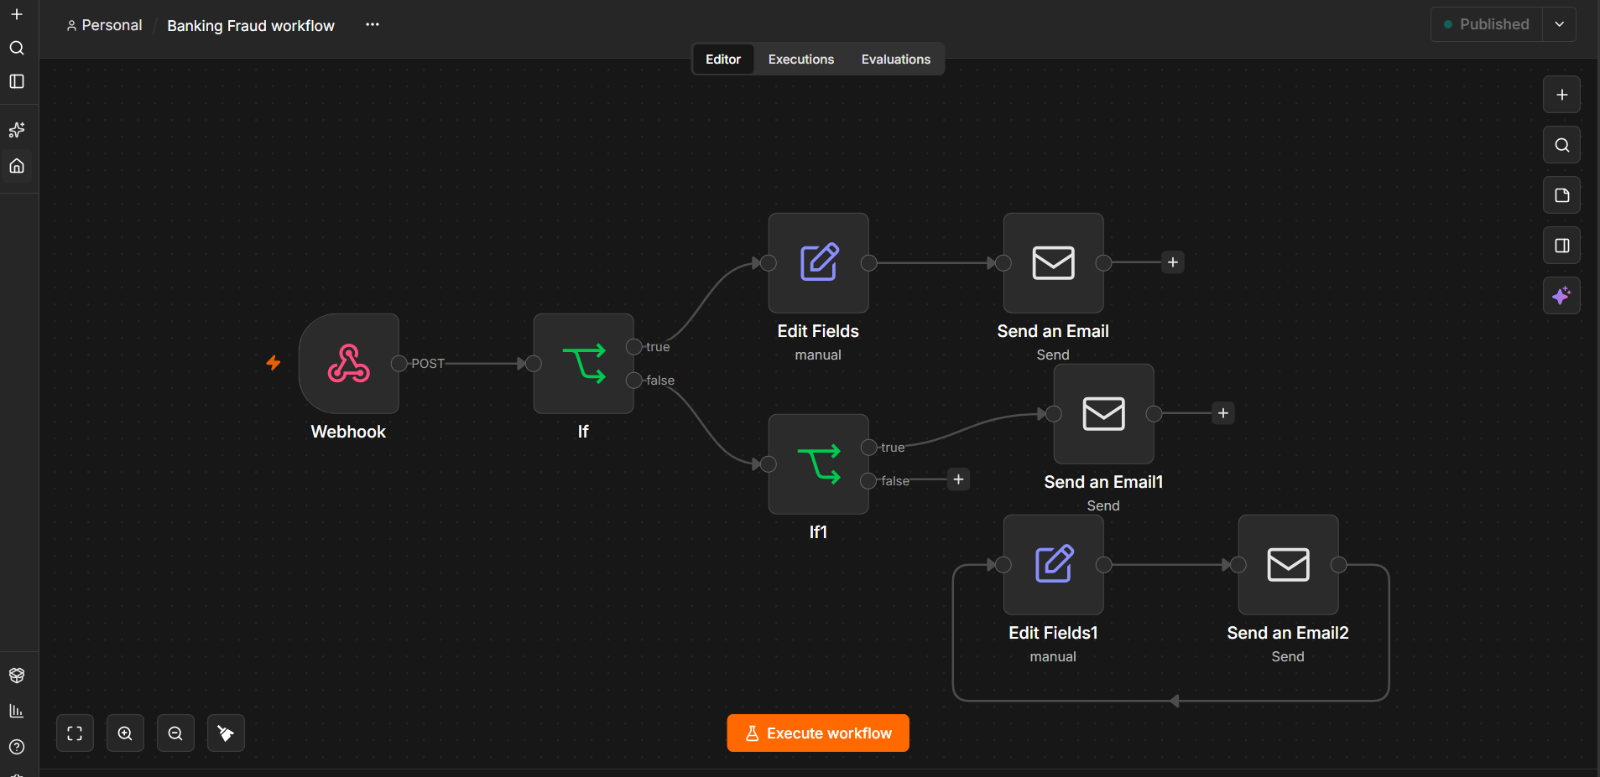

Figure 4. Published n8n Workflow for Risk-Based Fraud Investigation Notifications

UI/UX platform
The Streamlit interface has four parts. The input form collects the transaction identifier, amount, channel, location status, device status and failed-login count. The results area shows the case identifier, the risk score out of nine, the risk level, the selected route, the priority and the human-review requirement, together with the evidence findings, the output of each agent in an expandable panel and the recommended investigation steps. The investigator review and approval section lets the user select any saved case and record review notes, a review status and an approval decision. A dashboard shows total cases, high-risk cases, cases pending human review and open investigations, with charts for the risk distribution, the review status and the saved routing decisions. A case history table and a case audit trail complete the screen. A banner states that the rules are illustrative and that the system is for demonstration only.
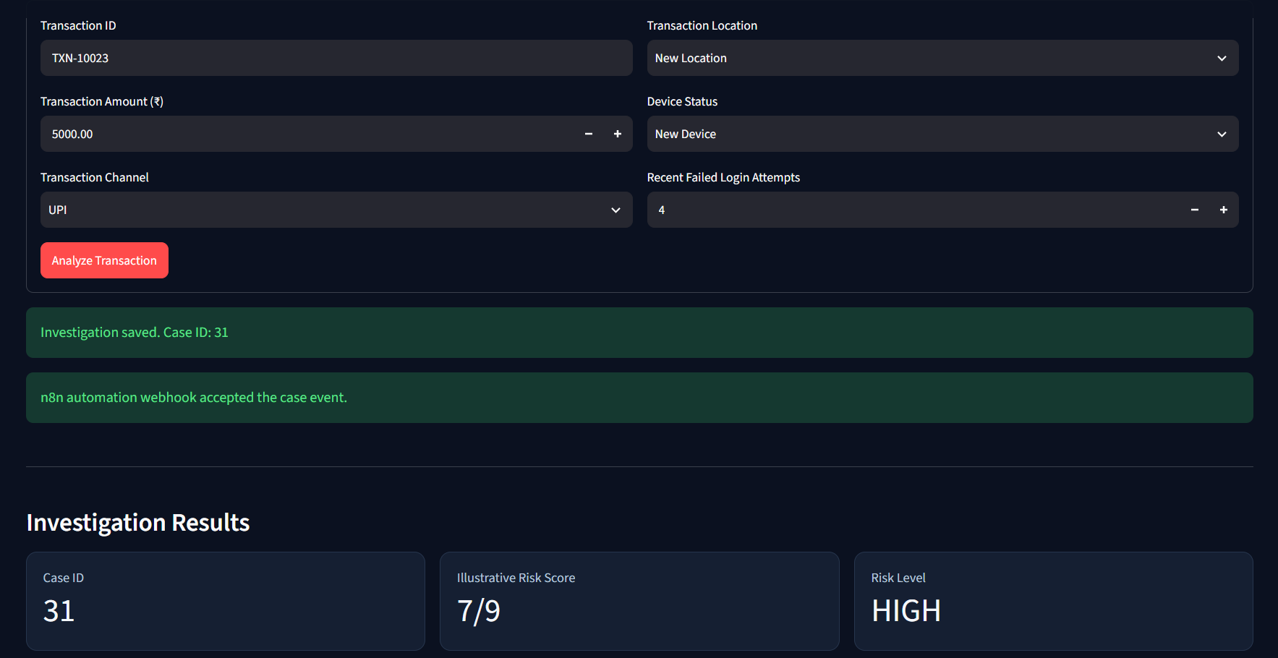
Streamlit Application Input Form for Fraud Investigation.

Data handling and persistence
Only synthetic data is used. A small generated dataset of six synthetic transactions, with demonstration labels assigned by hand, supports development, and all test inputs are invented. Cases are stored in a local SQLite database with one table for investigations and one for audit events. The investigations table holds the inputs, risk score and level, findings, recommendation, human-review flag, review status, route, route priority, routing reason and timestamps. The audit table holds, for each event, the case, the action, the previous and new values, the actor and a UTC timestamp. All queries use parameters instead of string concatenation. Routing fields were added later through a database migration, so cases created earlier show the route as unknown. The prototype keeps this uncertainty visible and does not invent routes for old cases.

Testing approach during development
Each component was built and tested before the next was added. The transaction agent test checks that a ₹75,000 internet-banking transaction adds two points and records the high-amount finding. The behaviour agent test checks that a new location, a new device and four failed logins add seven points and three findings. The risk and policy test checks that the combined score of nine gives a HIGH level with human review required, and the recommendation test checks the urgent priority and three next steps. The orchestrator test checks that all agents run to completion, and a dedicated test confirms that unknown location and device values give a LOW score but still require review. Database tests cover saving, retrieving and updating a case, and an audit test confirms that an event stores the previous value, the new value and the actor. Routing tests confirm the routes for the high-risk and incomplete-evidence cases. This order meant that a fault could be traced to one module instead of the whole system.

Human-in-the-Loop implementation
Human review is part of the workflow itself. The review section records notes, a status and an approval decision, with the approver's entered name and a timestamp. For a case that requires review, the Closed After Review status is refused unless review notes exist and the approval decision is Approved. Each action creates an audit event, including review-note changes, approval decisions, status changes, successful closures and blocked closure attempts. The investigator name is typed in and is not authenticated, so it is a workflow record and not proof of identityThe investigator review interface allows users to record review notes, select a review status and record an approval decision for saved investigation cases. The application also enforces a closure safeguard for cases requiring human review. Attempts to close such cases without satisfying the review requirement are blocked and recorded in the audit trail. These behaviours were verified through application testing and database checks.
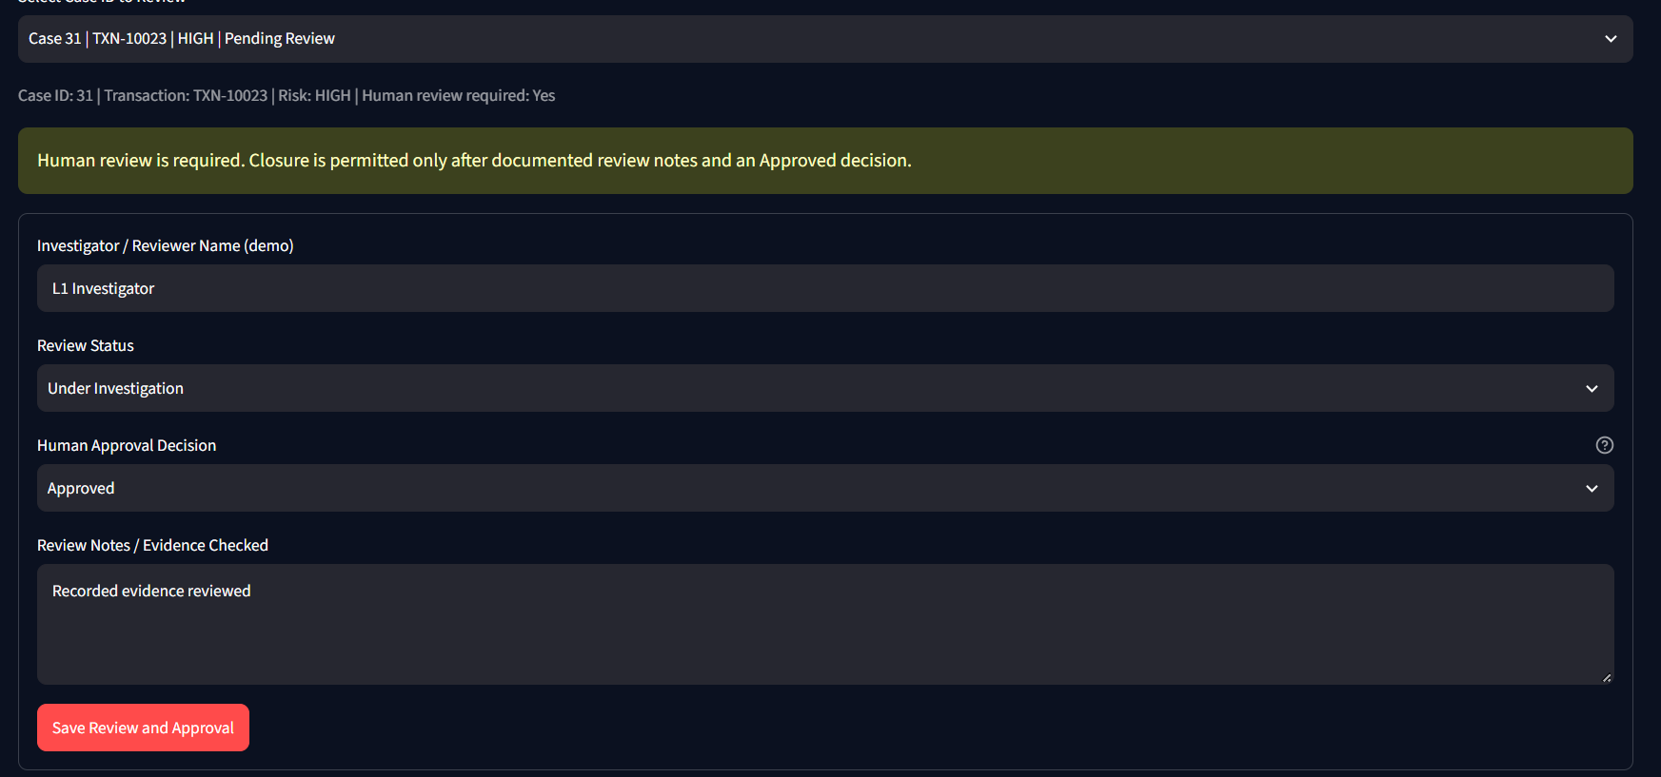

Figure 7. Investigator Review and Approval Controls.

Closure safeguards
The rule that a review-required case cannot be closed is enforced at two levels. The interface checks the saved risk level, the review flag and the evidence status of the selected case and shows a warning. The database function that updates the status performs the same check independently and raises an error that says closure is blocked. This matters because a warning in the interface alone could be bypassed by any other part of the program that calls the database function directly. A direct test of that function against a high-risk case raised the expected error, while a normal status change on the same case succeeded.
Figure 8. Closure Blocked for a Case That Requires Human Review.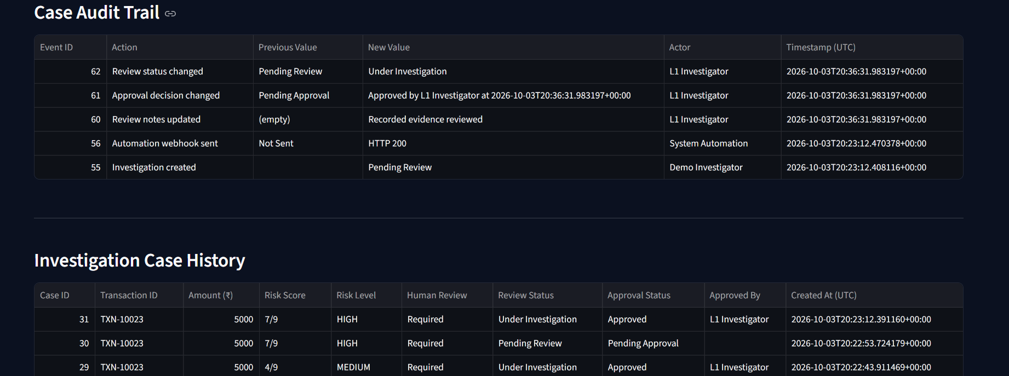

Exception handling
The interface rejects an empty transaction identifier and limits numeric inputs to defined ranges. The investigation call is wrapped in error handling that shows a general message and logs details to the terminal. Unknown location or device values are treated as a recognised exception that routes the case to evidence verification. A webhook failure is designed not to erase a saved case, because the case is stored before any notification is sent. The application saves the investigation record before attempting the webhook notification, so a notification failure should not erase the saved case. A failed-webhook test is not confirmed by the available evidence; record its actual result if tested.
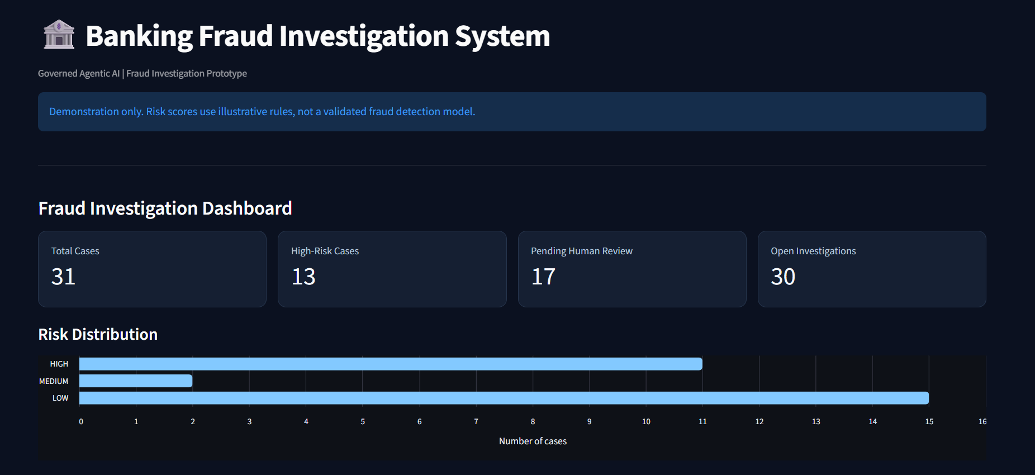

11. Open-Model Comparative Evaluation

Purpose and design

The assignment requires a comparison of at least three open or open-weight models under the same cases, prompts, evidence and output format. The implemented investigation agents remain deterministic rule-based agents and provide the reference output. A separate local evaluation harness was used to compare Qwen3:4b, Llama 3.2:3b and Gemma3:4b against that reference. Each model received the same six synthetic cases, the same evidence fields and the same fixed JSON output requirement. One run was completed for each model on each case, giving 18 completed evaluations. The models were not inserted into the production routing path; the comparison was performed as an evaluation extension so that model variability could be measured without weakening deterministic safeguards.
Evaluation conditions

Evaluation conditions
Evaluation Dimension | Observed Condition / Result | Purpose
Model configuration | Qwen3:4b — 359d7dd4bcda; Llama 3.2:3b — a80c4f17acd5; Gemma3:4b — a2af6cc3eb7f | Reproducibility
Parameter / artifact size | 2.5 GB; 2.0 GB; 3.3 GB respectively | Record model size
Inference environment | Local Ollama service; same development machine; sequential evaluation | Control environment
Prompt / output conditions | Identical prompt; JSON mode; temperature 0; four required fields | Fair comparison
Test set | 6 synthetic cases × 3 models = 18 completed evaluations | Common benchmark
Reference | Deterministic rule-based workflow | Expected answer
Measured metrics | Risk, human review, route, priority, exact match, structured output and latency | Model comparison
Table 11.1. Models and evaluation conditions.
The prompts, six synthetic test cases, input fields and required JSON schema were identical for all three models. The models were served locally through Ollama on the same development machine, sequentially, with temperature fixed at 0 and JSON output mode enabled. The local model identifiers recorded during the experiment were Qwen3:4b — 359d7dd4bcda, Llama 3.2:3b — a80c4f17acd5 and Gemma3:4b — a2af6cc3eb7f. The locally listed model artifact sizes were approximately 2.5 GB, 2.0 GB and 3.3 GB respectively. The evaluation therefore controls for prompt, case evidence, output structure and inference environment.
Models are named with their exact local tags and recorded identifiers because model revisions can change results.
Test set and scoring procedure

The evaluation used six synthetic cases. EVAL-01 was low risk with complete evidence; EVAL-02 was high risk; EVAL-03 had an unknown location and therefore required evidence verification; EVAL-04 was a low-risk high-amount transaction that remained LOW under the illustrative rules; EVAL-05 was medium risk; and EVAL-06 combined an unrecognised channel, unknown location and unknown device. The deterministic rule-based workflow generated the reference output for each case. Each of the three models was run once for every case, producing 18 completed model evaluations.
The expected risk level, human-review requirement, route and priority were taken from the deterministic rule-based workflow. A model was counted as an exact match only when all four fields matched the reference. Field-level agreement was also calculated separately. Structured-output compliance was measured by successful JSON parsing into the required fields. All 18 recorded runs returned parseable structured JSON. The experiment did not request an explanation field, so explanation quality and hallucination rate were not scored in this run. No additional reruns were used to manufacture those metrics.
The fixed evaluation prompt instructed every model to use only the supplied case information and return only four JSON fields: risk_level, human_review_required, route and priority. Ollama JSON mode was enabled and temperature was fixed at 0. The exact evaluation prompt and output schema are reproduced in Appendix A.
Metrics

The metrics used for the completed comparison were selected to match the guidebook-style evaluation dimensions and the governance needs of this prototype:
Classification quality: percentage of cases for which the model risk level matched the deterministic reference.
- Human-review handling: percentage of cases for which the model matched the reference human-review requirement.
- Route agreement: percentage of cases for which the model selected the same investigation route as the reference.
- Priority agreement: percentage of cases for which the model selected the same priority as the reference.
- All-fields exact agreement: percentage of cases for which risk level, human-review requirement, route and priority all matched the reference.
- Structured-output compliance: percentage of runs that returned parseable JSON in the required structure.
- Latency: average response time measured for the six cases for each model.
- Task completion: percentage of evaluation cases completed without an error path.
- Results

Table 11.2. Comparative results across the three open-weight models.
Metric | Qwen3:4b | Llama 3.2:3b | Gemma3:4b
Completion | 6/6 (100%) | 6/6 (100%) | 6/6 (100%)
Risk-level match | 50.00% | 83.33% | 66.67%
Human-review match | 100.00% | 83.33% | 100.00%
Route match | 50.00% | 16.67% | 50.00%
Priority match | 66.67% | 16.67% | 33.33%
All-fields exact match | 50.00% | 16.67% | 33.33%
Structured-output rate | 100.00% | 100.00% | 100.00%
Average latency | 59.40 s | 10.98 s | 13.49 s
Table 11.2. Comparative results across the three model
Figure 10. Model Comparison Evaluation Evidence — insert the final evaluator-output screenshot here.
MODEL COMPARISON EVIDENCE
Evaluator output / evaluation_summary.json / terminal results
[ INSERT SCREENSHOT HERE ]

Interpretation

The completed comparison shows measurable differences between the three local models. Llama 3.2:3b had the highest risk-level agreement at 83.33% and the lowest average latency at 10.98 seconds. Qwen3:4b achieved 50.00% risk-level agreement and 59.40 seconds average latency, while Gemma3:4b achieved 66.67% risk-level agreement and 13.49 seconds average latency. Qwen3:4b and Gemma3:4b each matched the human-review requirement in all six cases. Route agreement was weak for all three models, and none achieved 100% exact agreement across the four evaluated decision fields.
The results support a governed assistive architecture rather than autonomous model-based routing. The model layer can be evaluated for decision-support quality, but deterministic rules, evidence-completeness checks, human approval and closure controls remain outside the model. The evaluation also shows why route and priority should not be delegated to an LLM without an independent control layer.
The experiment is intentionally limited: six synthetic cases and one run per model per case. Explanation quality and hallucination rate were not measured because the fixed JSON prompt did not request explanations. The reported results therefore describe this specific local configuration and test set; they are not evidence of production banking performance.
The three-model open-weight evaluation has been completed. Therefore, classification accuracy, escalation accuracy, hallucination rate, JSON-validity rate, explanation quality and average latency cannot yet be reported. Future evaluation should test the models using identical synthetic cases, prompts and evaluation criteria. Conclusions should be limited to the scenarios and configurations actually tested.

12. Test Cases and Results

Test design
Testing combined scripted checks and manual runs of the interface. Each agent has its own test script, and further scripts cover the orchestrator, the unknown-evidence rule, the routing logic, the database and the audit log. Manual runs through the interface covered a normal case, an ambiguous case with missing evidence and a high-risk case, followed by checks that closure of review-required cases is blocked at both the interface and database levels. The expected result for each case was written down before the run. Case identifiers in the screenshots match the saved cases in the case history table, so each result can be traced to a stored record.
Test Case | Input | Expected Behaviour | Actual Behaviour | Human Intervention | Result
TC1: Normal | ₹5,000, UPI, usual location, recognised device, 0 failed logins | LOW, 0/9, route STANDARD_REVIEW, routine priority, no mandatory review | LOW, 0/9, STANDARD_REVIEW, ROUTINE, review not required | Optional review only | Pass
TC2: Ambiguous | ₹5,000, UPI, unknown location, recognised device, 0 failed logins | Score LOW but route EVIDENCE_VERIFICATION with human review required | 0/9, EVIDENCE_VERIFICATION, high priority, human review required | Investigator verifies location before any decision | Pass
TC3: High-risk | ₹75,000, Internet Banking, new location, new device, 4 failed logins | HIGH, 9/9, PRIORITY_INVESTIGATION, urgent, human review required | HIGH, 9/9, PRIORITY_INVESTIGATION, URGENT, review required | Investigator reviews, documents and approves before closure | Pass
TC4: Closure safeguard (interface) | Try to set Closed After Review on a high-risk case and on an unknown-evidence case | Closure refused with a warning; status unchanged | Warning shown; cases stayed Under Investigation and Pending Review | Investigator must complete review first | Pass
TC5: Closure safeguard (database) | Call the status update function directly to close a high-risk case, then set Under Investigation | Closure raises an error; normal update succeeds | Error “Closure blocked” raised; normal update returned True | None | Pass
Table 12.1. Test cases and results.

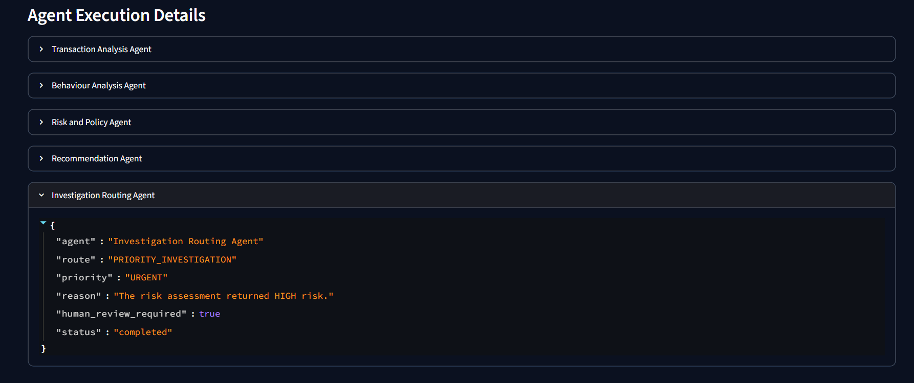
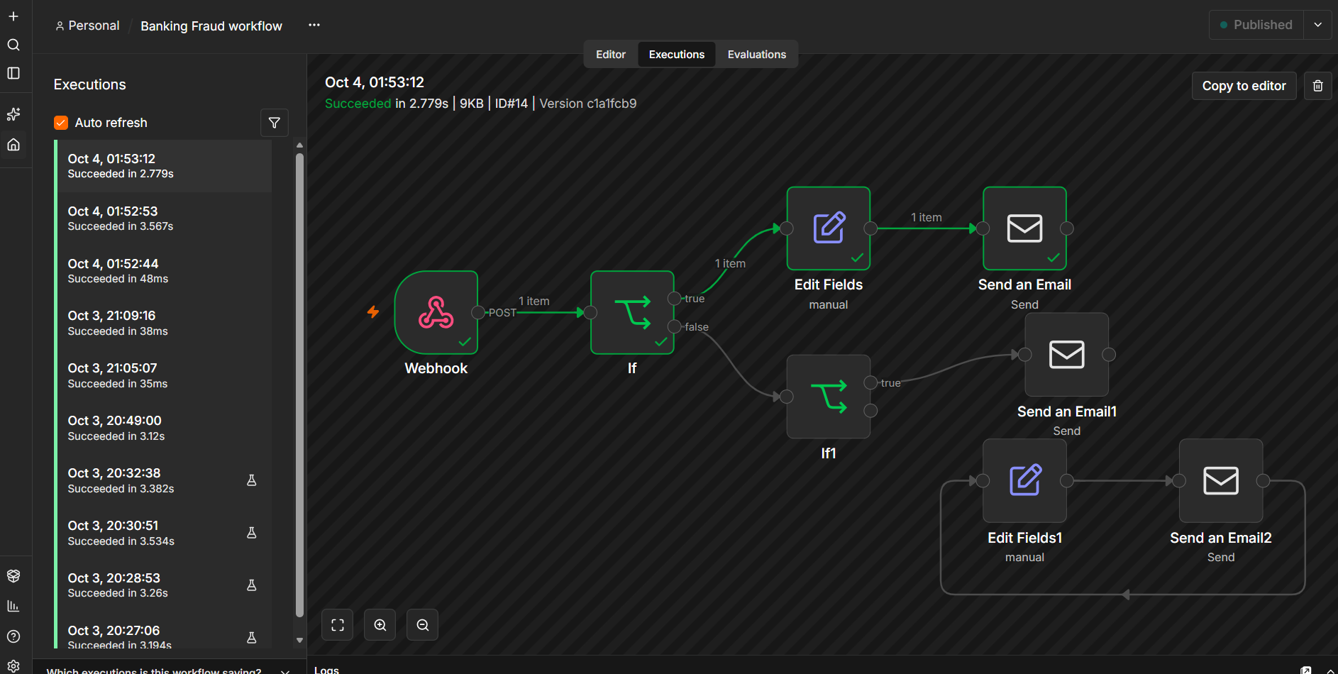

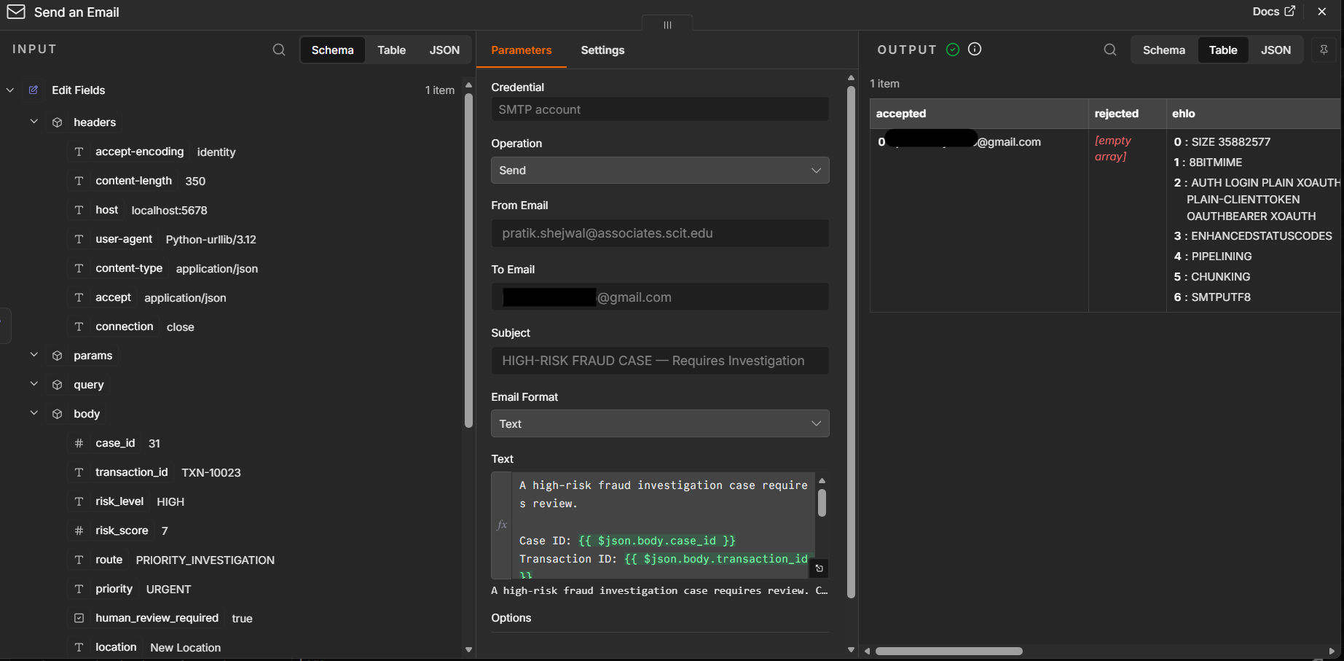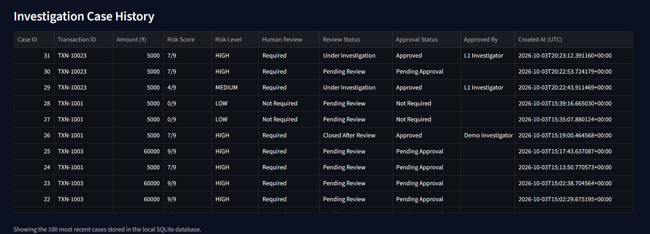
Figures 11–15. Test-case screenshots.

Results
Normal case. The low-risk transaction scored 0 out of 9, was classified LOW, and was routed to standard review with routine priority and no mandatory human review. This is the baseline behaviour: a transaction with no indicators does not consume investigator time.
Ambiguous case. With the location unknown, the numerical score was still 0 out of 9, yet the case was routed to evidence verification with high priority and human review required. This is the most important behaviour in the test set, because it shows that a low score is not treated as clearance when evidence is incomplete.
High-risk case. The transaction with a large amount, a new location, a new device and four failed logins reached the maximum score of 9, was classified HIGH, routed to priority investigation with urgent priority, and required human review. Four separate indicators contributed, and each was listed in the evidence section.
Closure safeguards. The interface refused to close the high-risk and incomplete-evidence cases, and the direct database test raised the expected error. Normal status changes remained possible. The application prevents cases requiring human review from being closed without the required review. Blocked closure attempts are recorded in the audit trail, supporting traceability of review-control enforcement.

Failures and observations
Testing exposed several faults that were fixed during development. First, the review controls were not visible at first because the review section depended on the most recent case, so a selector for any saved case was added. Second, the closure rule initially lived only in the interface, so it was moved into the database update function as well. Third, the first version of the check used variables from the latest submitted case and not from the selected case, which could have applied the wrong rule, so the check now reads the saved record of the selected case. Fourth, blocked closure attempts were at first not logged, so an audit event was added for them. Fifth, cases saved before routing was stored showed an unknown route and were left as unknown. Finally, the application failed to start until the webhook client file was copied into the project folder. Each fault was found by a test or a visual check, which supports testing every component before integration. The tests use illustrative rules and a small set of synthetic inputs, so they show that the logic behaves as designed and do not show that it detects real fraud.

Coverage gaps
The manual cases did not include a medium-risk transaction, an unrecognised channel, a failed webhook or a repeated transaction identifier. These are listed for the next round of testing. A medium-risk case, for example a high amount combined with a new device, which the rules score at four points, should be added before submission so that all three risk levels are demonstratedThe current testing focused on normal, incomplete-evidence and high-risk scenarios. Additional testing is required for medium-risk transactions, unrecognised transaction channels, repeated transaction identifiers and webhook failures. These scenarios should be tested and documented with supporting screenshots before being reported as completed.

13. Guardrails, Governance and Compliance

Why governance is part of the design
A system that reads financial information and advises on actions needs controls that do not depend on any single component working well. The prototype therefore places its main controls outside the analysis agents. The guiding rule is the one stated in Section 8: agents recommend and humans decide. Several of the risks usually discussed for language models, such as hallucination and prompt injection, apply fully only when a model layer is added, so the section distinguishes between controls that are built and controls that are planned.

Risks and guardrails
Privacy and confidential data. The prototype uses synthetic data only. The form collects no names, account numbers or contact details, and the database holds only the fields needed for the demonstration. A production system would add masking, retention limits and encrypted storage.
Hallucination. The current agents are deterministic and cannot invent facts, since each finding comes from a stated rule. If a language-model layer is added, hallucination becomes a real risk (Ji et al., 2023). The planned controls are to pass only structured evidence, require a fixed JSON schema, measure the hallucination rate in the model comparison and keep the investigator as the final check.
Bias. The inputs are amount, channel, location status, device status and failed logins. No personal or protected attributes are used. Even so, location and device indicators can disadvantage customers who travel or change devices often, which is why the ambiguous route sends such cases to verification and not to a block. Real bias testing needs real data and is listed as future work.
Prompt injection. The current form uses fixed choices and numeric fields, with one free-text field for the transaction identifier. Injected instructions would matter if free text were passed to a model, a risk described for applications that connect models to external data (Greshake et al., 2023). The planned control is to screen free text before it reaches any model and to escalate flagged cases.
Unsafe autonomous action. This risk is handled by design. No agent can block a transaction, move money or contact a customer. The system only records recommendations, and the interface states that it does not determine fraud.
Access control and approval limits. Approval is recorded by a name typed into the form, which is not authentication. A production system would use the bank's identity and access management and separate roles for analysts, senior investigators and administrators. The approval limit that is built is the closure rule: a case that needs review cannot be closed without notes and an approved decision.
Audit trail and monitoring. Every case creation, status change, approval and blocked closure attempt is recorded with an actor and a UTC time. The audit table is not tamper-proof. The dashboard gives a basic form of monitoring through counts of cases, high-risk cases, pending reviews, urgent routes and escalated cases.
Escalation and Human-in-the-Loop controls. High-risk cases are routed as priority investigations, unknown evidence goes to verification, and the investigator can set an Escalated status. Human review is mandatory for high, medium and incomplete-evidence cases.

What is built and what is planned
Of the ten risks in Table 13.1, six are addressed by controls that are built and tested: unsafe autonomous action, approval limits, incomplete evidence, escalation, the audit trail and privacy through synthetic data. Two are partly addressed: bias, through the design of the inputs, and access control, through a typed investigator name that is not authentication. Two depend on a model layer that does not yet exist, hallucination and prompt injection, and are described as planned so that the chapter does not claim protection that has not been built. This distinction matters for an examiner and for a bank, because a control that has only been designed has not been shown to work. Test cases TC2 to TC5 exercise the unknown-evidence rule, the high-risk route and the two closure safeguards, and the audit trail was checked visually for creation and status-change events.

Governance diagram
Figure 15 shows how the controls are organised. The guardrails are grouped by where they act: data, logic, action and human oversight. Each group is linked to a NIST AI Risk Management Framework function, and two foundation layers for access control and audit logging are mapped to ISO/IEC 27001.
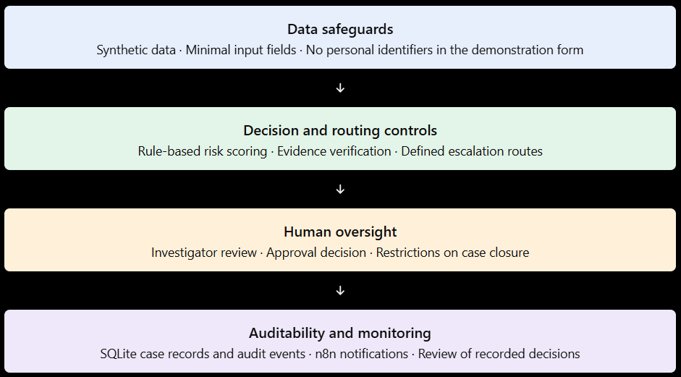
Figure 15. AI Governance Architecture — Guardrails mapped to NIST AI RMF and ISO/IEC 27001.

Choice of framework
The NIST AI Risk Management Framework (NIST, 2023) is the main framework because it covers AI risk across a system's whole life through four functions: Govern, Map, Measure and Manage. Risks are identified in context (Map), tested through unit tests and the test cases (Measure), controlled through guardrails and routing (Manage), and owned through approval and review rules (Govern). ISO/IEC 27001 (ISO & IEC, 2022) supplements it for access control, logging and monitoring, and protection of personal information. ISO/IEC 42001 (ISO & IEC, 2023) is the natural next step for a bank that wants a certifiable AI management system. The Reserve Bank of India expects structured fraud risk management and timely action (Reserve Bank of India, 2024), which the audit trail and escalation controls support. The governance mapping is intended to show how the prototype's safeguards align with recognised AI risk management and information security principles. The mapping is conceptual and should not be interpreted as evidence of formal compliance or certification. The applicable ISO/IEC 27001:2022 Annex A control references should be verified against an authorised copy of the standard before final submission.

Risk to guardrail mapping
Risk | Guardrail | Governance Requirement | Implementation in Prototype
Privacy and exposure of confidential data | Synthetic data only; minimal fields; no personal identifiers in the form | NIST AI RMF: Map, Manage; ISO/IEC 27001 A.5.34 (privacy and protection of PII) | Built: synthetic dataset and test inputs; form has no personal fields
Hallucination | Deterministic production rules; model evaluation uses fixed JSON schema and evidence-only input; hallucination scoring is a future extension because the completed prompt requested no explanation. | NIST AI RMF: Measure, Manage | Rules built; model comparison completed; hallucination rate not scored in this run.
Bias in findings | No protected attributes as inputs; ambiguous cases sent to verification, not blocked | NIST AI RMF: Map, Measure | Built: input design and evidence-verification route; real bias testing is future work
Prompt injection | Fixed-choice inputs and numeric fields; screening of free text before any future model call. | NIST AI RMF: Measure, Manage; ISO/IEC 27001 A.8.16 | Fixed inputs built; model-layer prompt-injection testing remains future work.
Unsafe autonomous action | Advisory-only agents; no financial actions; interface states results are not a fraud verdict | NIST AI RMF: Govern, Manage | Built: no agent has any action capability
Weak access control | Authentication and role separation | NIST AI RMF: Govern; ISO/IEC 27001 A.5.15, A.8.3 | Partial: investigator name is typed, not authenticated; planned for production
Decisions beyond authority (approval limits) | Closure refused without notes and an approved decision for review-required cases | NIST AI RMF: Govern | Built: checked in the interface and in the database function
Incomplete evidence treated as safe | Unknown location or device forces human review and evidence verification | NIST AI RMF: Map, Manage | Built and tested (TC2)
No audit trail | Audit event for creation, status change, approval and blocked closure, with actor and UTC time | NIST AI RMF: Govern, Measure; ISO/IEC 27001 A.8.15 (logging) | Built: audit table; not tamper-proof
Missed or mishandled risk (escalation failure) | High-risk cases routed as urgent priority investigations; Escalated status available | NIST AI RMF: Manage; ISO/IEC 27001 A.5.26 | Built and tested (TC3); n8n HIGH-risk escalation notification branch executed successfully and email delivery was verified.

Table 13.1. Mapping of risks to guardrails, governance requirements and the prototype implementation.
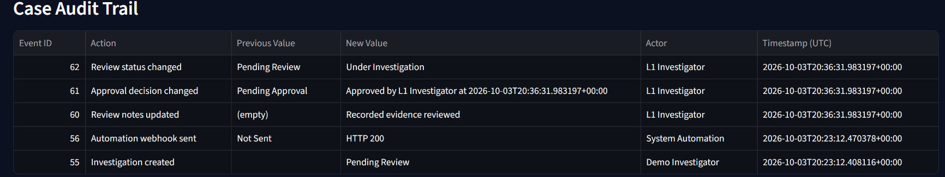

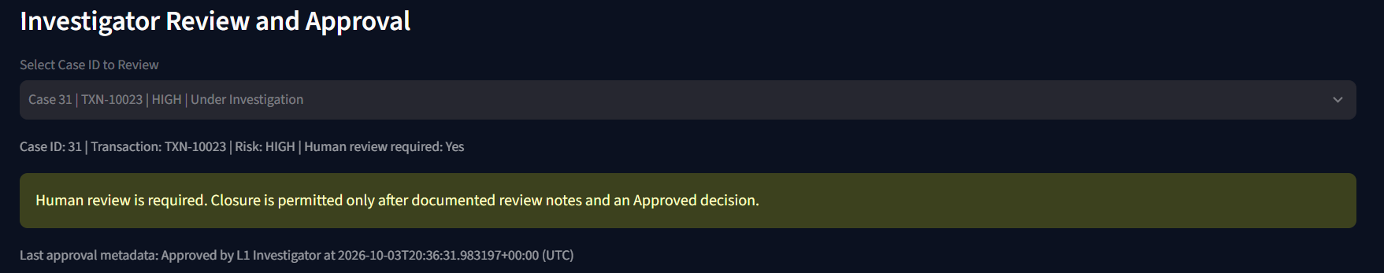
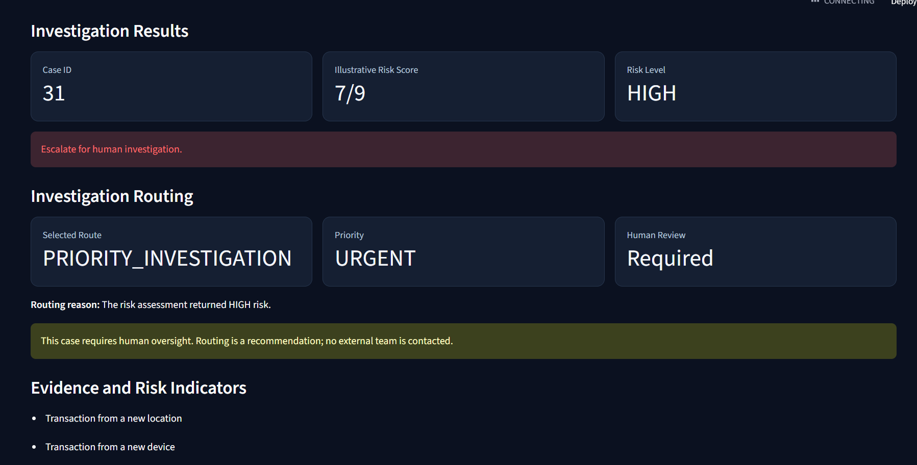
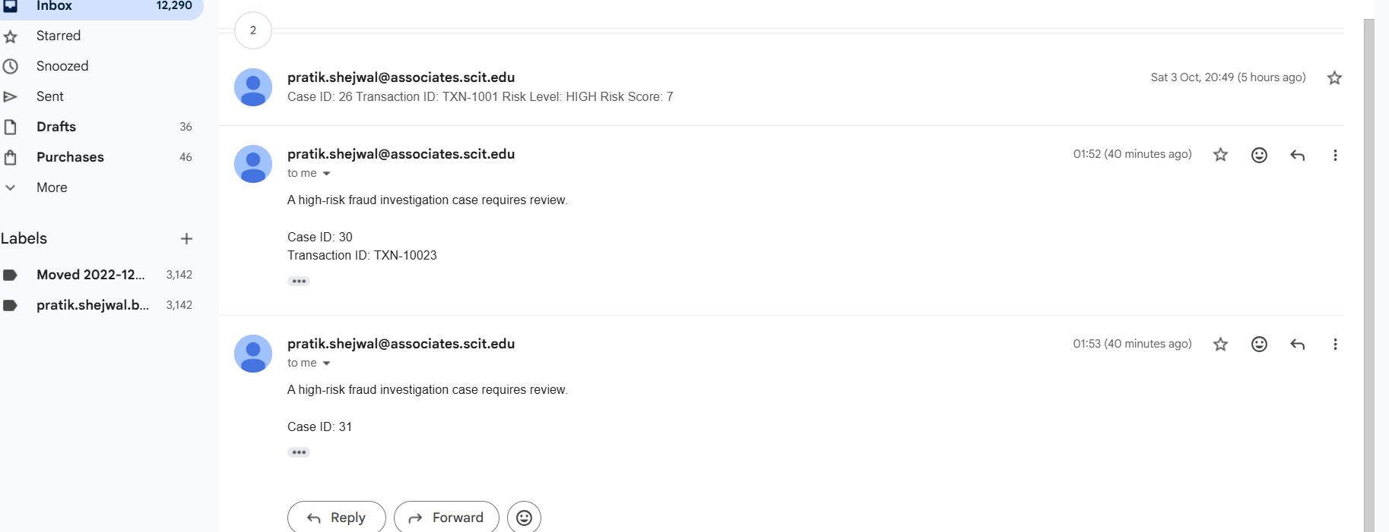
Figure 16. Case audit trail.

14. Discussion

What the implementation shows
The prototype shows that the evidence-gathering and analysis part of fraud investigation can be divided into narrow roles, automated and tested without taking decisions away from people. An alert entered in the interface passes through four analysis agents and a routing agent, is saved with its route, and reaches a human review stage with notes, approval and a record of every action. The three test branches behaved as designed: the normal case went to standard review, the case with unknown evidence went to verification despite a low score, and the high-risk case went to priority investigation. The main bottlenecks in Section 6, namely fragmented evidence, inconsistent judgement and manual documentation, are the ones the design addresses. The investigator receives a structured, explained case and spends effort on judgement. The rest of the effort is spent on checking, noting and approving.

Where Agentic AI fits well
The fit is best where work is structured, repetitive and evidence-heavy. Comparing a transaction with simple behaviour indicators and assigning a priority are tasks with clear inputs and checkable outputs. A role-based design suits them because each agent has a small job that can be tested alone, as the individual test scripts show. Consistency is a further gain. The same inputs always produce the same route, which reduces the variation between analysts described in Section 6. The current agents are rule-based, so the prototype shows the workflow pattern more than the value of language models. That value lies in tasks the rules cannot express, such as reading free-text notes or writing a more natural explanation, and is the purpose of the planned model comparison. A language-model contribution cannot be assessed until the model layer is implemented and evaluated; no model-specific benefit is claimed in this draft.

Where human judgement remains necessary
Human judgement remains necessary in three places. The first is the decision itself: a recommendation is a proposal, and the consequences of a wrong decision fall on a customer. The second is the ambiguous case. The test with an unknown location showed that the system cannot decide without the missing fact, and only an investigator can verify it, for example by contacting the customer. The third is oversight of the system: someone must set the thresholds, review failures and answer to regulators. The prototype reflects this through the closure rule and the approval record.

Implications of model differences
The completed model comparison shows that model choice affects both agreement and latency. Llama 3.2:3b produced the strongest risk-level agreement in this six-case benchmark and the lowest average latency, while Qwen3:4b and Gemma3:4b were stronger on the human-review requirement. Route agreement remained weak across all three models. This supports keeping routing, approval and closure safeguards deterministic and outside the model layer.

Operational benefits
If the pattern holds at scale, the benefits are of four kinds. Investigators would spend less time collecting and reconciling data. Cases would be ordered by risk and route, so urgent cases are not stuck behind routine ones. Documentation would be more uniform, since every case receives the same structured record. And audit would be easier, because each case carries its findings, route, notes, approval and event history. The prototype provides a structured investigation workflow that may help reduce manual effort by organising case details, risk indicators, routing decisions and review records in one interface. However, the time saved compared with a conventional manual investigation has not yet been measured. A future expanded evaluation should record the time required for comparable cases using both approaches before estimating any efficiency improvement.

Practical lessons from building
Building the system in small tested steps worked well. Each agent was verified alone before the orchestrator joined them, so faults were easy to locate. The faults found later were not in the agents. They were in how the interface and the database enforced the rules, which suggests that testing should concentrate on the points where decisions are saved and where people act. Another lesson concerns scope. It is tempting to add features such as dashboards before the controls are tested, but the closure rule and the audit trail turned out to be what makes the prototype defensible.

Governance implications
The controls that mattered most were simple structural ones: advisory-only agents, the unknown-evidence rule, the closure safeguard in the interface and the database, and the audit trail. They work whatever the agents do. The development fixes in Section 12 also show a practical lesson: a safeguard in the interface alone is not enough, and it has to be enforced where the data is written. The honest limits matter as well. Typed names are not authentication, and the audit table is not tamper-proof, so the prototype cannot be presented as production-ready. The prototype's governance approach emphasises human oversight, transparent routing decisions and auditability. The implementation demonstrates how advisory-only agents, evidence-verification rules and case-closure safeguards can support a controlled investigation workflow. However, these design choices have not been independently validated by an industry expert, so the findings should be treated as prototype observations rather than expert-endorsed conclusions.

15. Limitations
This work has limits that readers should keep in mind when judging its findings.
Prototype status. The solution is a proof of concept. It shows that the interface, agents, routing, database and review workflow operate together. It has not been security-tested, load-tested or hardened for production use.
Rules and synthetic data. The thresholds and point values are illustrative and were not calibrated or validated against real fraud data. The dataset is a small set of six synthetic transactions with hand-assigned labels, and all test inputs are invented. The results show that the logic behaves as designed, not that it detects real fraud.
Model limitations. The production agents are rule-based and remain the authoritative decision path. The completed open-model comparison used only six synthetic cases and one run per model per case. It therefore demonstrates comparative behaviour for this benchmark rather than general model performance. Explanation quality and hallucination were not measured in this run.
Integration limitations. The webhook client exists but the n8n workflow depends on a configured address and a working local installation. The prototype connects to no real core banking system, case management tool or identity provider. The investigator name is typed in and is not authenticated, and the audit table is not tamper-proof.
Evaluation limitations. The test set is small and was defined by the team. Each submission creates a new case even if a transaction identifier is reused, so duplicate handling is missing. Cases saved before routing was stored have no route.
Deployment limitations. Operating a system like this in a bank involves regulatory approval, model risk management, staff training, change control, incident response and long-term monitoring. The prototype does not show that these processes are in place.
Reproducibility. The project did not start with a verified dependency list, and the starter requirements file was not checked against every module, so reproducing the environment on another machine needs care. Work was also handed to another team member at the n8n stage, which adds a risk of configuration differences.

16. Future Development
Several realistic steps would move the prototype toward a pilot.
Complete the workflow automation. The n8n workflow is already running locally in Docker and published, with tested high-risk, evidence-verification and standard-review notification paths. Future work should add stronger failure handling and duplicate-event protection.
Expand the model evaluation. The initial three-model comparison is complete for six synthetic cases. Future work should expand the benchmark, repeat runs, add explanation and hallucination scoring, and test additional open-weight models under the same controlled conditions.
Stronger identity and audit. Replace the typed name with real authentication and role separation, and move the audit log to an append-only or tamper-evident store.
Production data and integration. Replace the synthetic data and SQLite with access-controlled APIs and a production database, tested first in a sandbox, with duplicate-case handling and a complete requirements file.
Better rules and larger datasets. Calibrate thresholds on a larger, realistic or anonymised dataset that includes rare fraud types and borderline cases, and test outcomes across customer groups.
Additional guardrails. Add screening of free text, masking of identifiers, rate limits and detailed role-based permissions once a model layer or real data is present.
Pilot testing. Run a limited shadow-mode pilot in which investigators use the system on a small share of real alerts without being influenced by it, and measure agreement, time per case and trust.
Documentation and reproducibility. Verify a complete requirements file, add a README and an example configuration file, and keep secrets and private webhook addresses out of the code and the repository.
Wider testing. Extend the test suite with medium-risk cases, unrecognised channels, repeated identifiers and webhook failures, and automate the interface checks so they can be repeated before each demonstration.
Customer verification step. Add a step that records the result of customer contact, so that evidence verification can be closed with documented evidence.

17. Conclusion
Fraud investigation in banks is slow and uneven largely because the work after an alert is raised remains manual. Analysts gather evidence from several systems, apply policy and experience, and record their reasoning by hand. This chapter analysed that process and identified five main bottlenecks: queue waiting, fragmented evidence, inconsistent judgement, delays in customer contact and manual documentation. It then proposed a governed Agentic AI redesign in which an orchestrator routes each alert through four analysis agents for transaction analysis, behaviour analysis, risk and policy assessment, and recommendation, and a routing agent selects one of four investigation routes. A human investigator reviews every case that needs it, and closure is allowed only after documented review and approval.
The redesign was built as a working prototype with a Streamlit interface, a Python orchestrator, a SQLite case store, a case audit trail and a dashboard. It was tested on a normal case, an ambiguous case with missing evidence and a high-risk case, and on the safeguards that stop review-required cases from being closed. The normal case went to standard review, the ambiguous case to evidence verification despite a low score, and the high-risk case to priority investigation. Development also showed that a safeguard in the interface alone was not enough, so the closure rule was enforced in the database function as well. The completed three-model comparison will be reported only after the models have been run under the same conditions and the measured results have been recorded in Section 11.
Governance was treated as part of the design. The guardrails address privacy, bias, unsafe autonomous action, approval limits, incomplete evidence, audit and escalation, and the risks of hallucination and prompt injection are planned for the stage in which a language-model layer is added. They were mapped to the NIST AI Risk Management Framework and to ISO/IEC 27001 controls. The simplest controls proved the most important: agents that can only recommend, a rule that missing evidence requires human review, a closure rule enforced where data is written, and a record of every action.
The practical contribution is a reusable design pattern for governed, agent-assisted fraud investigation. It splits the work into narrow, separately tested roles, places the main safeguards outside the agents, keeps a person accountable for every consequential decision, records an audit trail and provides a separate local benchmark for comparing open-weight models. The comparison demonstrated that model outputs can vary materially in risk classification, route and priority, which reinforces the need for deterministic controls around consequential banking actions.
The work has clear limits. It used illustrative rules, a small set of synthetic data and a prototype environment, so it demonstrates feasibility and a governed design and does not prove performance in production. The next steps are completing the n8n workflow, adding and comparing open-weight models, stronger authentication and audit, larger datasets and a pilot in shadow mode. Within those limits, the chapter suggests that Agentic AI can reduce routine investigative effort and improve the consistency and traceability of fraud decisions when it is designed so that people stay in control.

18. References
Bolton, R. J., & Hand, D. J. (2002). Statistical fraud detection: A review. Statistical Science, 17(3), 235–255.
Dal Pozzolo, A., Caelen, O., Johnson, R. A., & Bontempi, G. (2015). Calibrating probability with undersampling for unbalanced classification. 2015 IEEE Symposium Series on Computational Intelligence, 159–166.
Dubey, A., et al. (2024). The Llama 3 herd of models. arXiv. https://arxiv.org/abs/2407.21783
Gemma Team. (2024). Gemma: Open models based on Gemini research and technology. arXiv. https://arxiv.org/abs/2403.08295
Greshake, K., Abdelnabi, S., Mishra, S., Endres, C., Holz, T., & Fritz, M. (2023). Not what you've signed up for: Compromising real-world LLM-integrated applications with indirect prompt injection. Proceedings of the 16th ACM Workshop on Artificial Intelligence and Security, 79–90.
International Organization for Standardization & International Electrotechnical Commission. (2022). ISO/IEC 27001:2022 Information security, cybersecurity and privacy protection: Information security management systems: Requirements.
International Organization for Standardization & International Electrotechnical Commission. (2023). ISO/IEC 42001:2023 Information technology: Artificial intelligence: Management system.
Ji, Z., Lee, N., Frieske, R., Yu, T., Su, D., Xu, Y., Ishii, E., Bang, Y. J., Madotto, A., & Fung, P. (2023). Survey of hallucination in natural language generation. ACM Computing Surveys, 55(12), Article 248.
Jiang, A. Q., et al. (2023). Mistral 7B. arXiv. https://arxiv.org/abs/2310.06825
Lewis, P., Perez, E., Piktus, A., Petroni, F., Karpukhin, V., Goyal, N., Küttler, H., Lewis, M., Yih, W., Rocktäschel, T., Riedel, S., & Kiela, D. (2020). Retrieval-augmented generation for knowledge-intensive NLP tasks. Advances in Neural Information Processing Systems, 33, 9459–9474.
National Institute of Standards and Technology. (2023). Artificial Intelligence Risk Management Framework (AI RMF 1.0) (NIST AI 100-1). U.S. Department of Commerce.
Reserve Bank of India. (2024). Master Directions on Fraud Risk Management in Commercial Banks (including Regional Rural Banks) and All India Financial Institutions.
Wang, L., Ma, C., Feng, X., Zhang, Z., Yang, H., Zhang, J., Chen, Z., Tang, J., Chen, X., Lin, Y., Zhao, W. X., Wei, Z., & Wen, J. (2024). A survey on large language model based autonomous agents. Frontiers of Computer Science, 18(6), Article 186345.
Wu, Q., et al. (2023). AutoGen: Enabling next-gen LLM applications via multi-agent conversation. arXiv. https://arxiv.org/abs/2308.08155
Yang, A., et al. (2024). Qwen2 technical report. arXiv. https://arxiv.org/abs/2407.10671
Yao, S., Zhao, J., Yu, D., Du, N., Shafran, I., Narasimhan, K., & Cao, Y. (2023). ReAct: Synergizing reasoning and acting in language models. International Conference on Learning Representations (ICLR 2023).

n8n. (n.d.). Documentation. https://docs.n8n.io/

19. Appendices

Appendix A: Full prompts
Appendix A. Evaluation prompt and output schema. The exact prompt used for all three models was: “You are evaluating a banking fraud investigation case. You are NOT making a final banking decision. You are producing a structured assessment for comparison with a deterministic rule-based reference system. Use only the information provided in the case. Return ONLY valid JSON with exactly these fields: { \"risk_level\": \"LOW|MEDIUM|HIGH\", \"human_review_required\": true, \"route\": \"PRIORITY_INVESTIGATION|STANDARD_INVESTIGATION|EVIDENCE_VERIFICATION|STANDARD_REVIEW|MANUAL_REVIEW\", \"priority\": \"URGENT|NORMAL|HIGH|ROUTINE\" }. Do not add markdown. Do not add explanations. Do not add extra fields.” The same case fields were supplied to every model: amount, channel, location, device and failed logins. Ollama JSON mode was enabled and temperature was 0.

Appendix B: Extended model outputs
Appendix B. Extended model outputs. The raw outputs for all 18 evaluations are retained in evaluation/evaluation_results.json and the generated model-level metrics are retained in evaluation/evaluation_summary.json. The recorded experiment used Qwen3:4b, Llama 3.2:3b and Gemma3:4b across six synthetic cases. All 18 runs completed with parseable structured JSON. These outputs are evaluation evidence only and are not part of the production decision path.

Appendix C: Additional screenshots
Appendix C. Additional screenshots. The main report contains the required AS-IS and TO-BE process diagrams, Agentic AI Architecture, AI Governance Architecture, n8n workflow, Streamlit input/results, investigator review, closure safeguard, dashboard and audit evidence. The spaces below are intentionally retained for any final screenshots required by the faculty or guidebook, especially the public demo website and final model-evaluation evidence.
[ INSERT SCREENSHOT HERE ]
[ INSERT SCREENSHOT HERE ]

Appendix D: Detailed configuration

The prototype is implemented using Python and Streamlit, with SQLite for storing investigation records and audit events. The application uses separate modules for transaction analysis, behaviour analysis, risk-policy evaluation, recommendation generation, routing decisions, and orchestration. The rule-based agents evaluate synthetic transaction inputs and generate structured investigation findings, risk scores, recommended actions, and routing outcomes.

The investigator review interface supports case review and status updates. Closure safeguards prevent cases requiring human review from being closed without the required review status. Relevant review actions and blocked closure attempts are recorded in the audit trail.

The n8n workflow receives selected investigation fields through an HTTP webhook and uses conditional routing to distinguish high-risk cases, evidence-verification cases, and standard-review cases. Email notification nodes communicate the corresponding escalation or review requirements. The workflow is used for notification and coordination; it does not independently block banking transactions.

Configuration details include the Streamlit application, Python dependencies, SQLite database, webhook URL, conditional routing rules, and email notification settings. Sensitive values, including webhook secrets, email credentials, and application passwords, must be stored outside the source code and excluded from shared project files. Exact software versions and final node-level settings should be recorded from the installed environment and actual workflow configuration. No separate LLM or retrieval-augmented generation configuration is claimed for the implemented rule-based prototype.

Appendix E: Supplementary tables and additional test cases

The prototype was evaluated using synthetic transaction cases designed to check risk scoring, evidence handling, routing decisions, human-review requirements, and closure safeguards.

The documented cases include a high-risk transaction with multiple risk indicators, a low-risk transaction with complete evidence, and a low-risk transaction with an unknown location. The high-risk case received a risk score of 9 out of 9 and was routed to priority investigation with urgent priority and mandatory human review. The low-risk case with complete evidence followed the standard-review route without a mandatory review flag. The case with an unknown location was routed to evidence verification and required human review despite its low risk score.

Additional checks cover saved investigation records, routing information, review-status updates, and audit-trail events. These tests demonstrate the behaviour of the prototype with the selected synthetic inputs; they do not establish real-world fraud-detection accuracy or performance on production banking data.

Supplementary test cases, model-comparison results, and quantitative evaluation metrics should be included only after the corresponding tests have been executed and the results recorded. Tests not yet performed, including medium-risk scenarios, repeated transaction identifiers, unrecognised channels, and webhook failure handling, should be identified as future testing rather than completed results.

Appendix F: Project links
Project title: Governed Agentic AI for Banking Fraud Investigation and Response
Application: Streamlit-based fraud investigation prototype.
Workflow automation: n8n webhook integration for risk-based email notifications and review coordination.
Source code repository: To be added if the project is published in a repository.
Demonstration video: To be added if a shareable demonstration has been recorded.
Public project website: Not available for this prototype unless a website has been deployed.
The application and workflow should be demonstrated using synthetic transaction data. Before sharing the project, verify that the repository, screenshots, exported workflow, and demonstration video do not expose personal information, customer data, database records, email credentials, application passwords, webhook secrets, or other confidential configuration values. Localhost URLs are for local development and should not be presented as publicly accessible project links.

