


People’s Democratic Republic of Algeria
Ministry of Higher Education and Scientific Research
Larbi Tebessi University – Tebessa
Faculty of Science and Technology
Department of Mechanical Engineering

MINI-PROJECT :
Python Programming

Submitted by: GATI MOHAMMED TEDJ EDDINE
Under the supervision of:
Dr. GASMI Mohamed

Academic Year : 2025/2026

1. Introduction
Within the framework of our studies in maintenance engineering and industrial safety, preventive and precautionary maintenance plays a key role in ensuring the safe and continuous operation of industrial machines. Preventive maintenance aims to avoid unexpected failures, reduce industrial risks, protect equipment and personnel, and extend the operational lifetime of machines.
This mini-project aims to develop a simple Python-based program to monitor preventive maintenance of industrial machines based on their operating hours. The program calculates maintenance due times, identifies machines requiring maintenance, generates an Excel report, and produces a graphical summary.

2. Tools and Libraries Used
The mini-project was developed using the Python programming language. The following libraries were used:
-pandas: for data reading, processing, and calculations.
-matplotlib: for chart generation and visualization.
-openpyxl: for exporting results to Excel files.
The program was executed using Google Colab, which allows code execution without local installation.

3. Principle of Operation of the Program
The program reads a CSV file containing machine data. Successful data loading is verified by displaying the information in the console before performing any calculations.
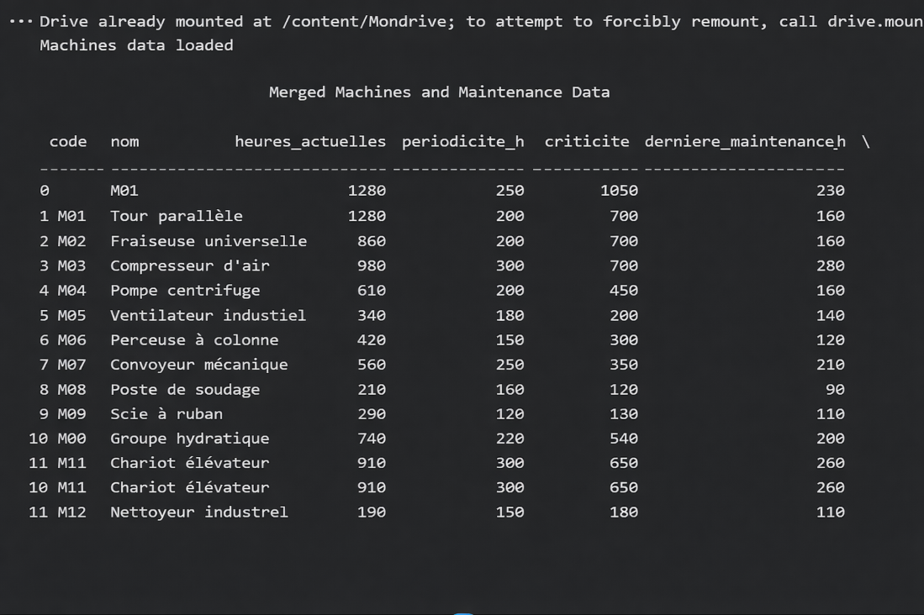
Figure 1: Console output confirming successful loading of machine data.

4. Performed Calculations
The program calculates the maintenance due time and the maintenance delay for each machine. Machines with a delay greater than or equal to zero are considered to require maintenance.
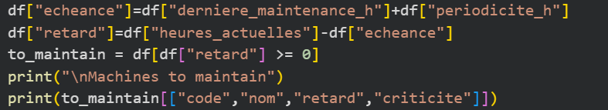
Figure 2: Python code snippet showing the calculation of maintenance due time, delay, and the filtering condition (retard ≥ 0).

5. Results
After executing the program, all machines showed negative maintenance delay values. This indicates that none of the machines exceeded their maintenance due time. Therefore, no machine requires preventive maintenance at the time of analysis.
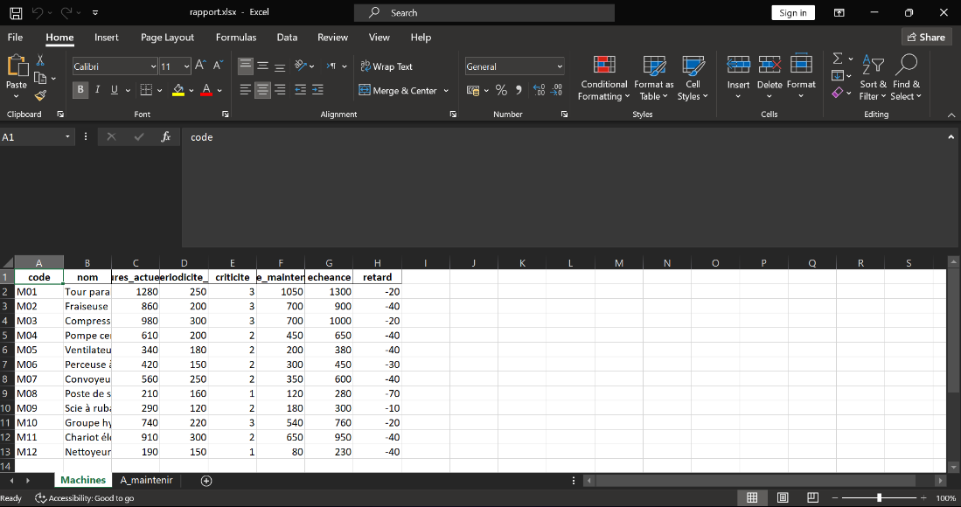
Figure 3: Excel sheet 'Machines' containing all machines with calculated values.
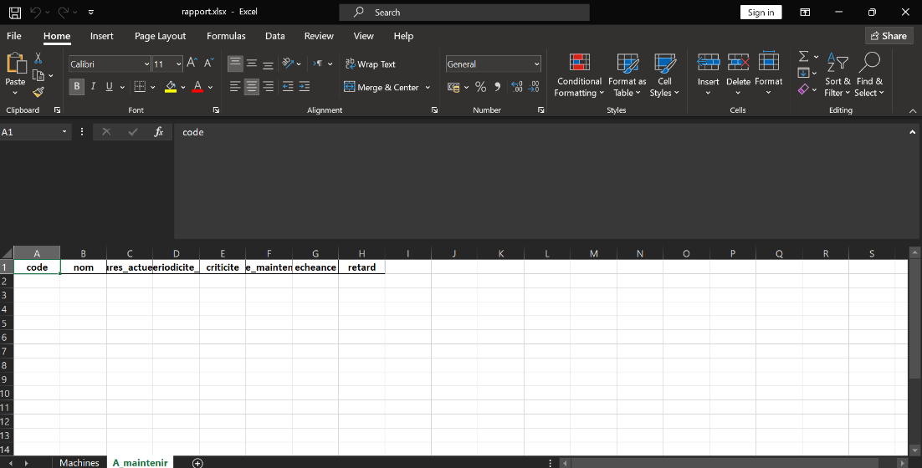
Figure 4: Excel sheet 'A_maintenir' showing no machines requiring maintenance.

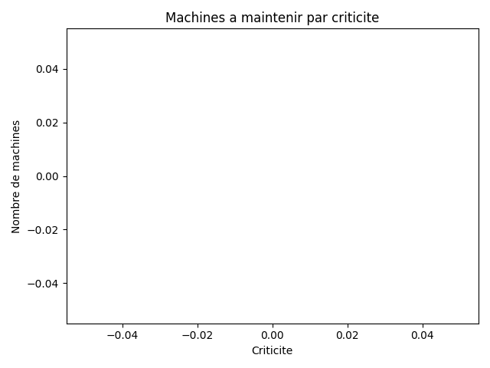
Figure 5: Bar chart representing the number of machines to maintain by criticality level.

6. Output File Generation
The program successfully generates the Excel report and graphical output, as confirmed by console messages.
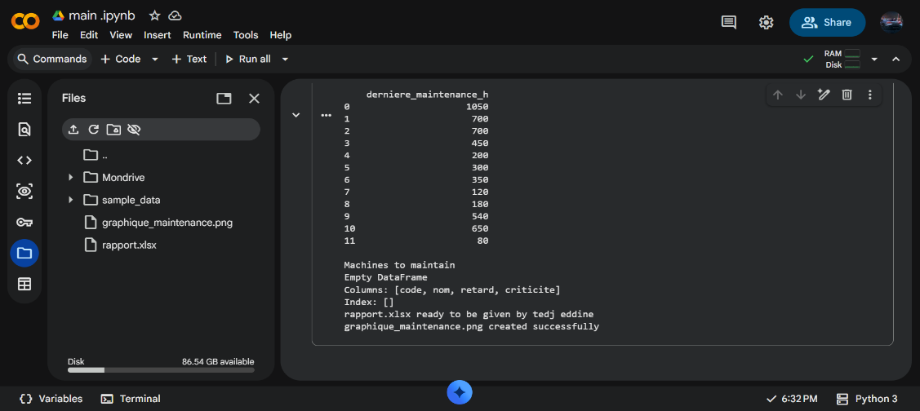
Figure 6: Console output confirming the successful generation of the Excel report and chart.

7. Conclusion and Future Perspectives
This mini-project demonstrates the effectiveness of using Python to automate preventive maintenance monitoring. The results confirm that the maintenance schedule is respected and that machine conditions are satisfactory.
As a future extension, the same approach can be applied in a mechanical engineering laboratory for chemical inventory management. By tracking quantities, expiration dates, and hazard levels, the program could help improve laboratory safety, inventory control, and compliance with health and environmental regulations.

