Task 1

What does the 3-letter acronym SMB stand for?

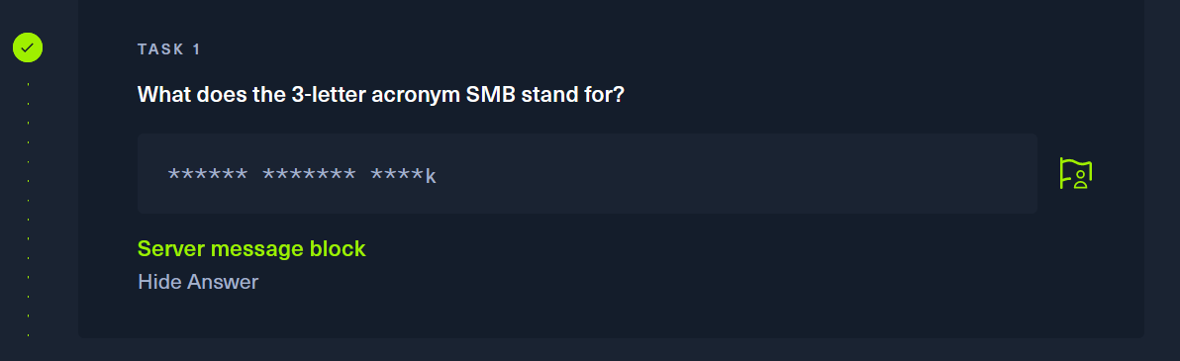

Task 2

What port does SMB use to operate at?

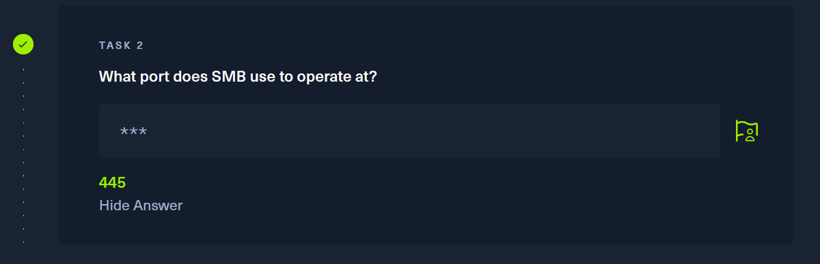

Scanning the target using nmap

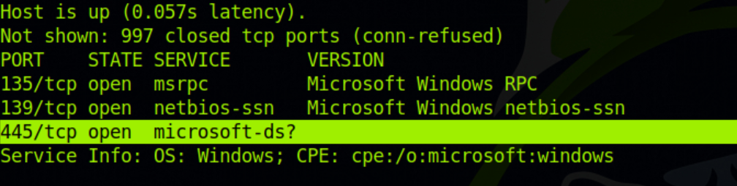

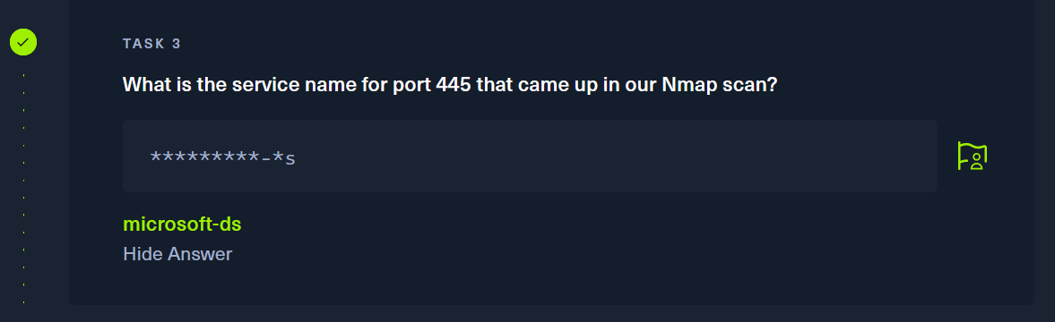

Task 4

What is the 'flag' or 'switch' we can use with the SMB tool to 'list' the contents of the share?

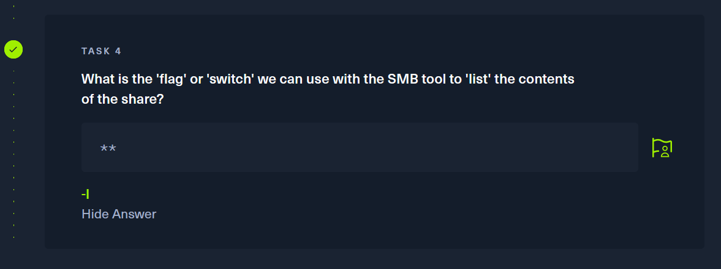

Task 5

How many shares are there on Dancing?

Using the command smbclient -L 10.129.2.82 we are able to see that there are a total of 4 shares.

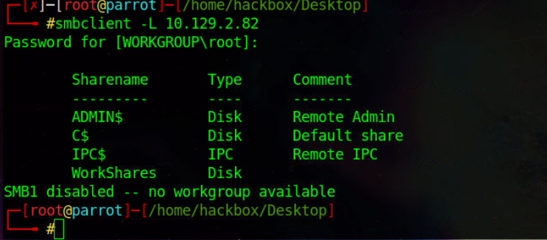

Task 6

What is the name of the share we are able to access in the end with a blank password?

This is because if it ends in a “$” that means only an administrator can sign in.

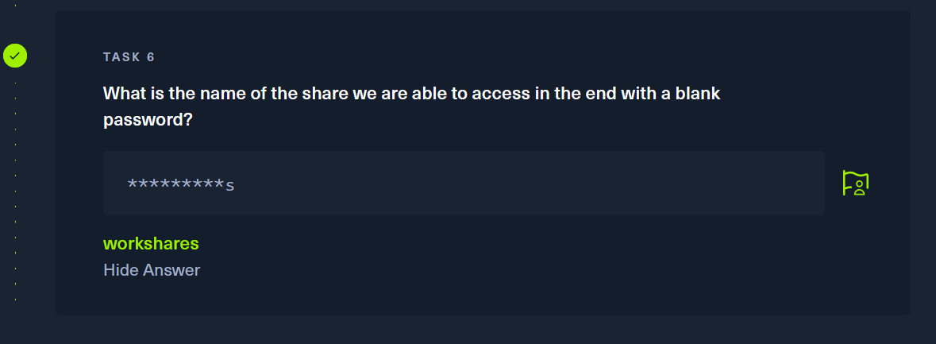

Task 7

What is the command we can use within the SMB shell to download the files we find?

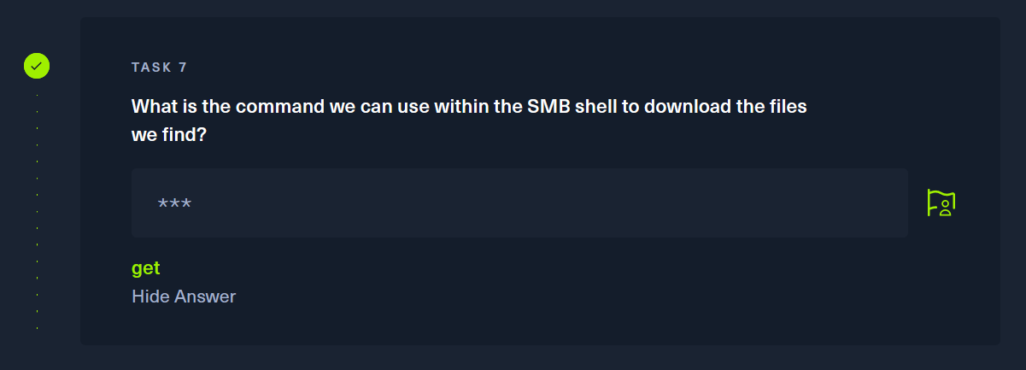

Submit Flag

Submit root flag

Using the command “smbclient \\\\10.129.2.82\\WorkShares” to connect to the WorkShares

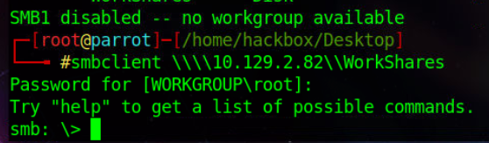

Browsing the contents of the the smb with ls command

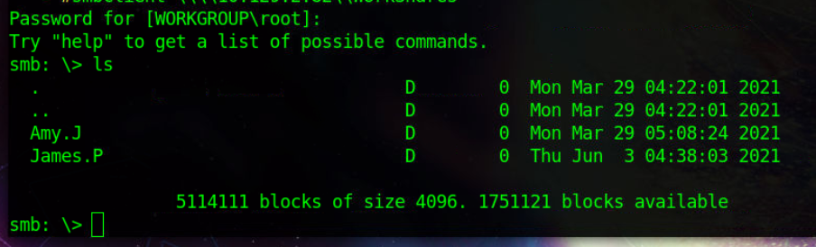

Searching Amy.j and setting our download location to desktop

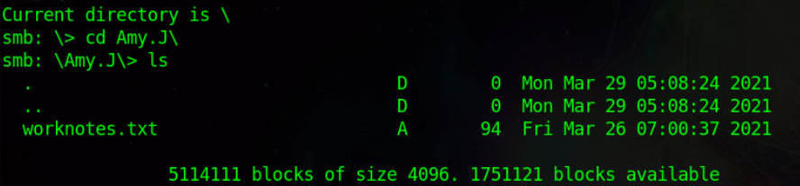

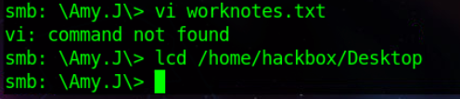

Using the command “get worknotes.txt Amy-Notes” to copy the file to the desktop

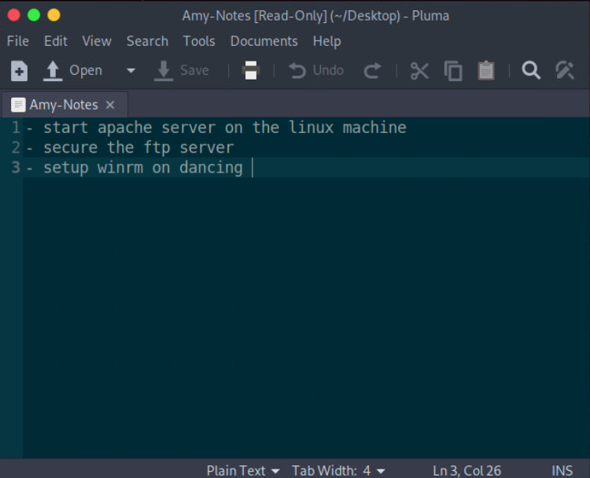

These are not the files we are looking for backing out of Amy.J directory and going back to root

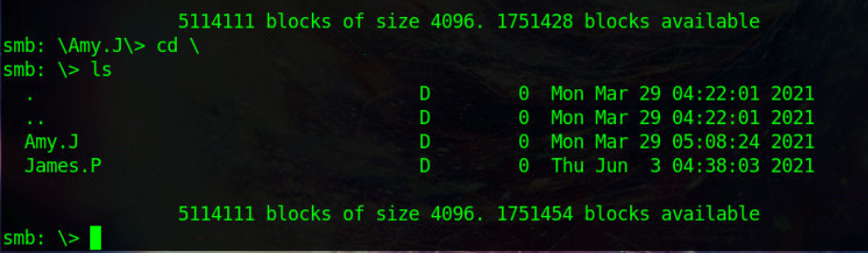

After going into the James directory however it has the flag.txt file we are looking for

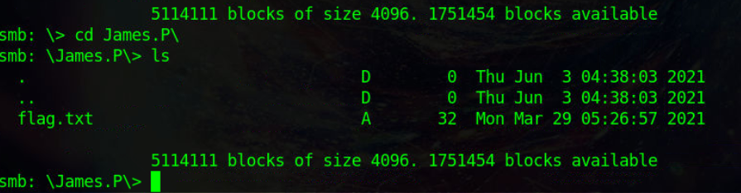

Setting download location to desktop and copying/opening the flag.txt file

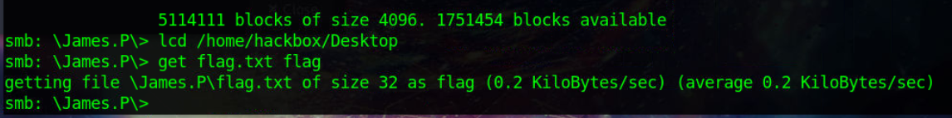

We have our flag