Task 1

What does the 3-letter acronym FTP stand for?

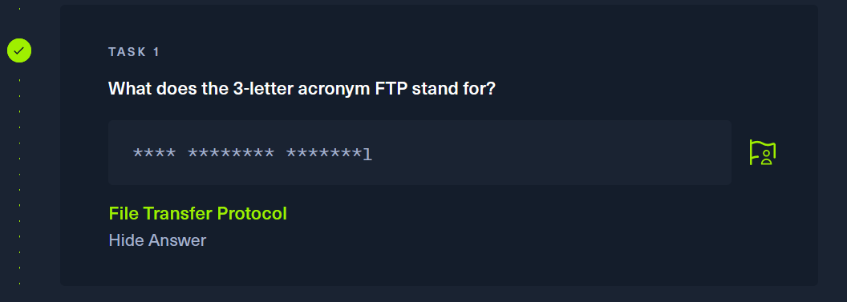

Task 2

Which port does the FTP service listen on usually?

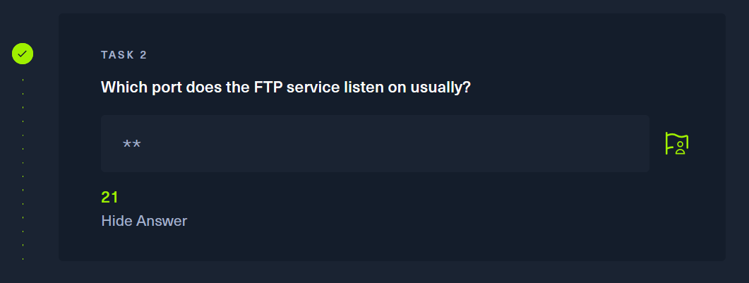

Task 3

What acronym is used for the secure version of FTP?

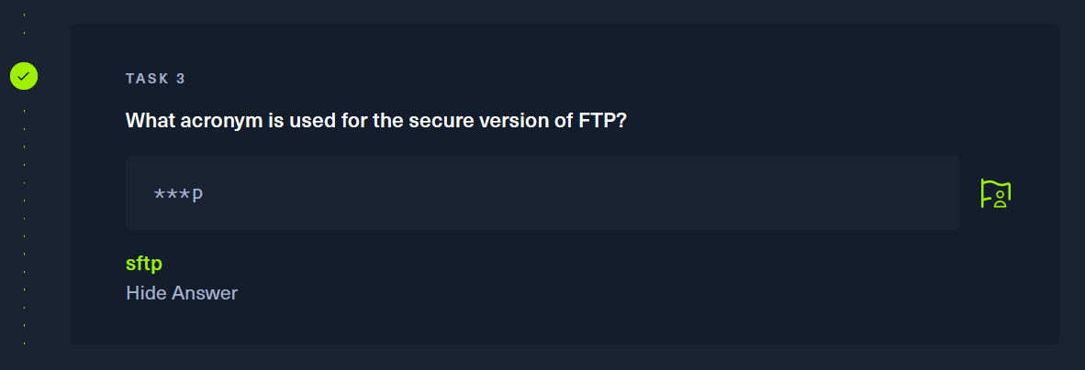

Task 4

What is the command we can use to send an ICMP echo request to test our connection to the target?

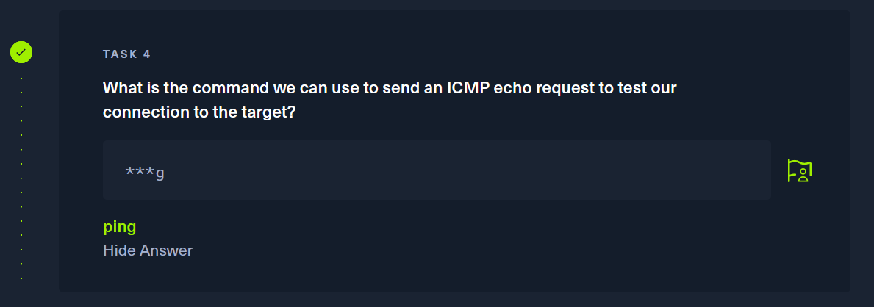

Task 5

From your scans, what version is FTP running on the target?

Running the command “nmap -v -A 10.129.57.243

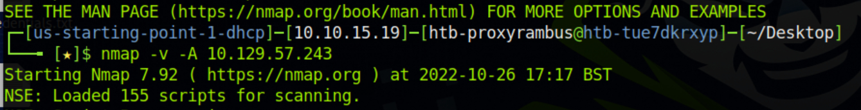

This gives us the FTP version number

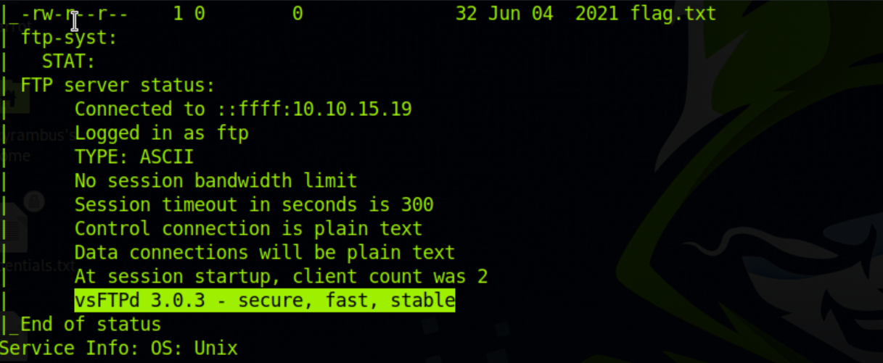

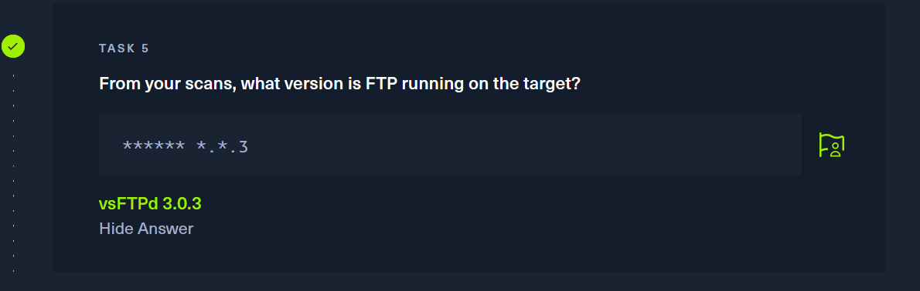

Task 6

From your scans, what OS type is running on the target?

That same command also give us the targets OS

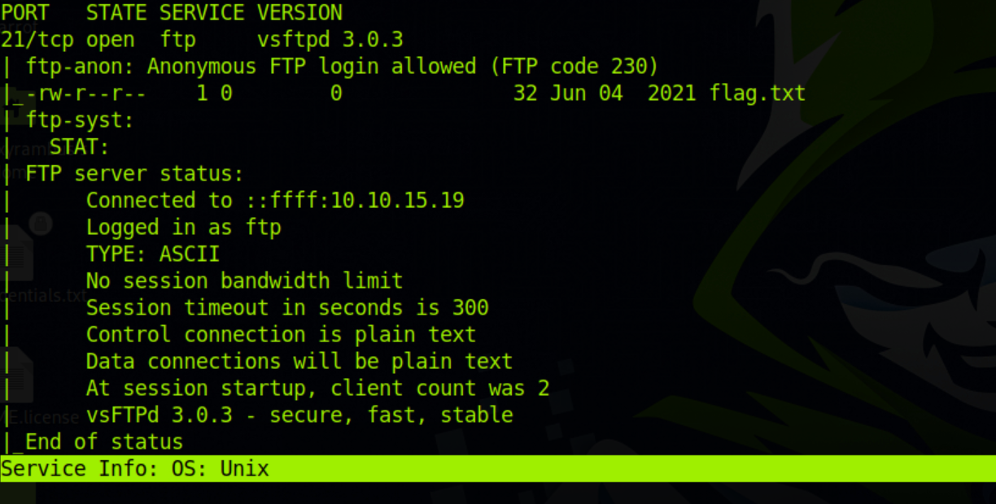

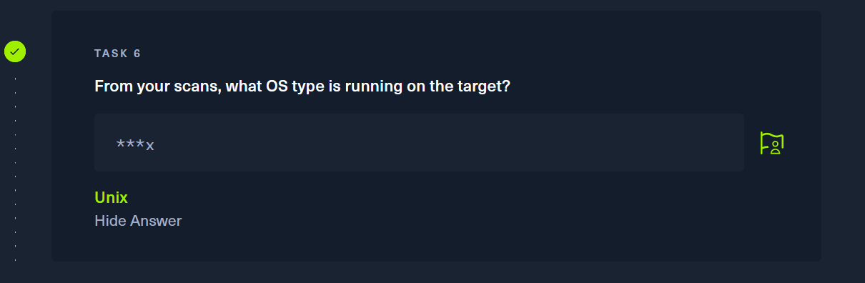

Task 7

What is the command we need to run in order to display the 'ftp' client help menu?

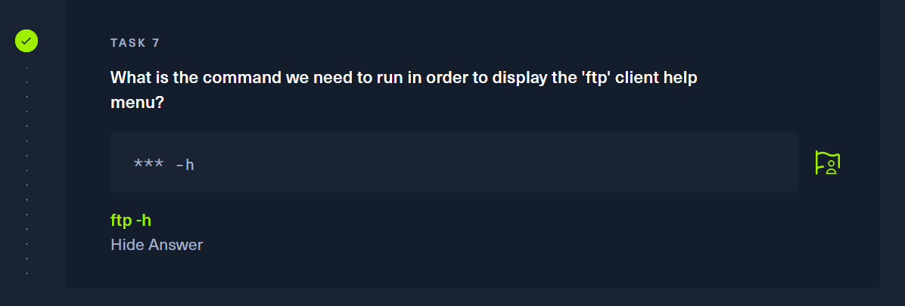

Task 8

What is username that is used over FTP when you want to log in without having an account?

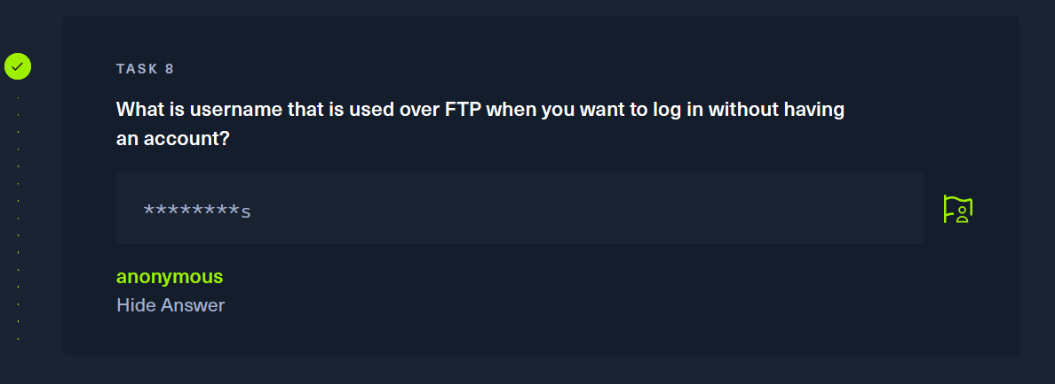

Task 9

What is the response code we get for the FTP message 'Login successful'?

Attempting to FTP into the target with the the provided username anonymous

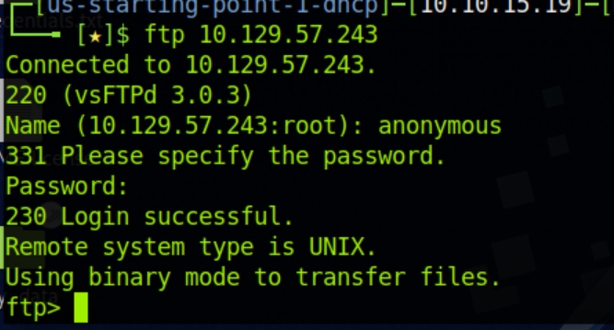

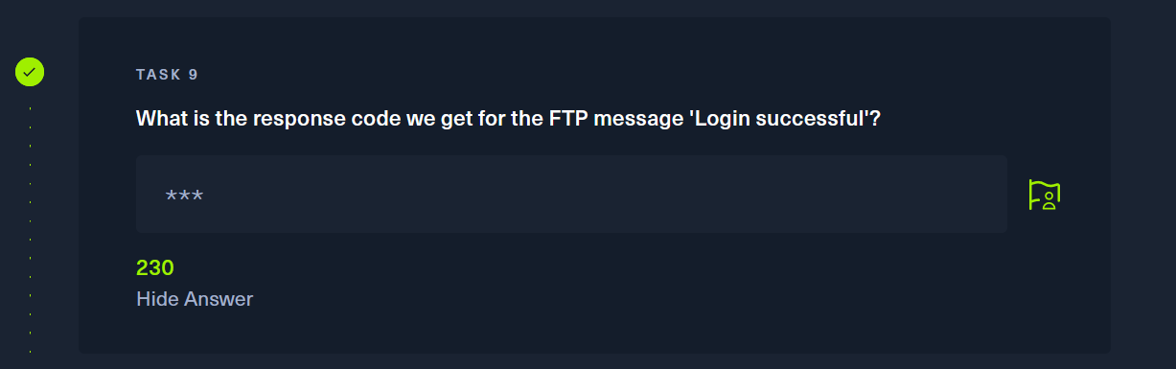

Task 10

There are a couple of commands we can use to list the files and directories available on the FTP server. One is dir. What is the other that is a common way to list files on a Linux system.

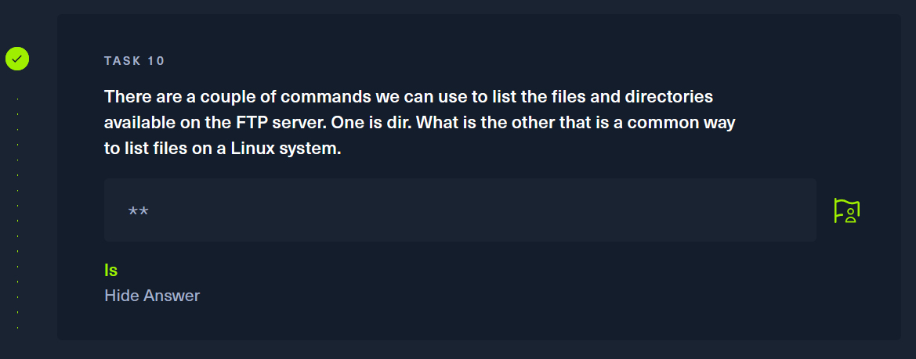

Task 11

What is the command used to download the file we found on the FTP server?

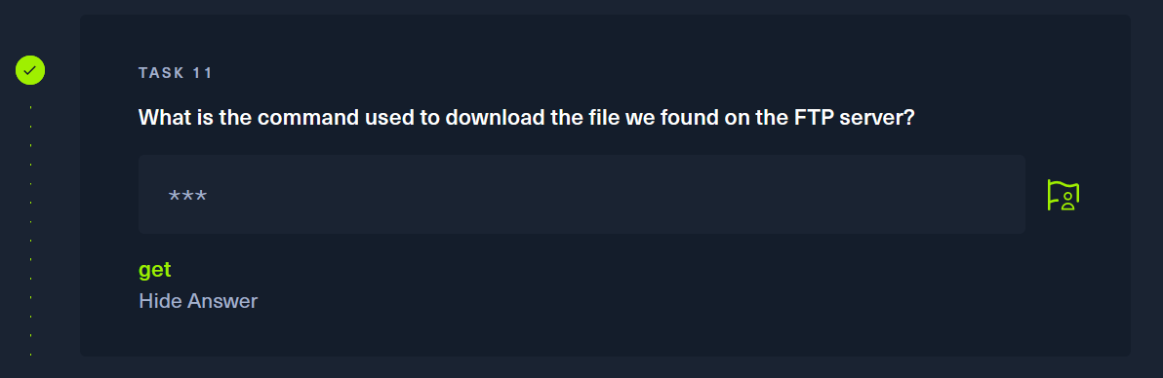

Submit Flag

Submit root flag

Searching the FTP server for the flag.txt file

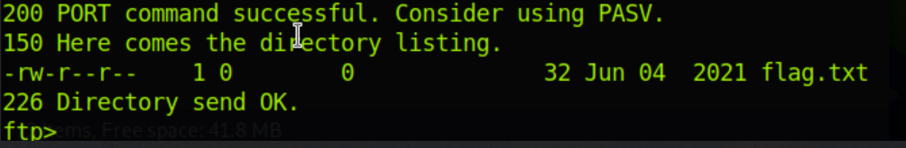

Setting the download location to be desktop with command “lcd /home/htb-proxyrambus/Desktop”

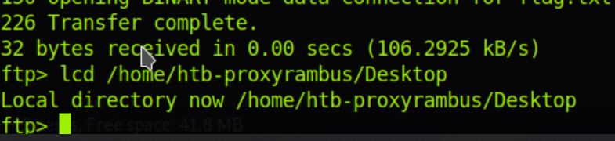

Using the get command and naming the file flag

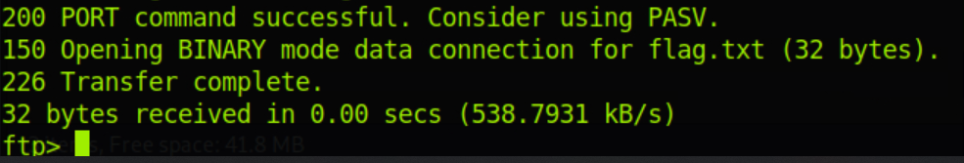

Opening flag file from the Desktop

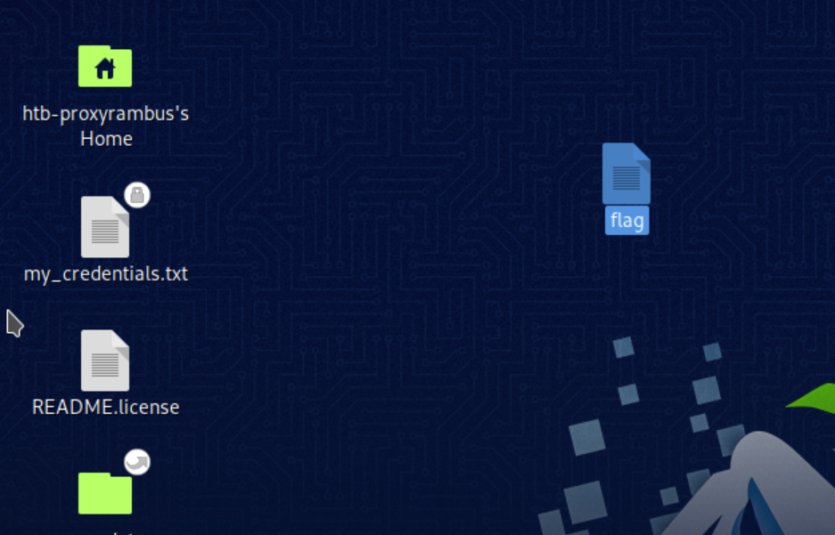

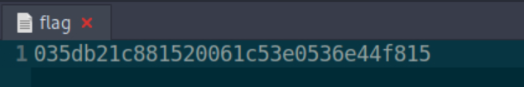

Submitting the flag root file

