
Anthiyal-Onakkoor Road, Ernakulam, Kerala 686667


INTENT-DRIVEN CODE COMPLETION

FOR VISUAL STUDIO CODE USING LOCAL LLMs
MINI PROJECT REPORT

PRANAV H
VEDASURYAN K
SANATH S

In partial fulfilment for the award of the degree of
BACHELOR OF TECHNOLOGY IN
COMPUTER SCIENCE AND ENGINEERING (AI & ML)

Anthiyal-Onakkoor Road, Ernakulam, Kerala 686667


DEPARTMENT OF COMPUTER SCIENCE AND ENGINEERING
BONAFIDE CERTIFICATE

This is to certify that the project report entitled “ INTENT-DRIVEN CODE COMPLETION” is a bonafide record of the project work presented by PRANAV H (241160099) VEDASURYAN K (241160063) SANATH S (241160062) during the academic year 2026–2027. This work is submitted towards the partial fulfillment of the requirements for the award of the degree of Bachelor of Technology in Computer Science and Engineering of Chinmaya Vishwa Vidyapeeth Deemed to be University, Ernakulam.

Ms. Deepa P.L. Assistant Professor
Project Coordinator

Dr. Anand H.S Associate Dean -- STEM
Head of the School

DECLARATION
We, Pranav H., Vedasuryan K., Sanath S., hereby declare that this project report entitled “Intent-Driven Code Completion” is the bonafide work of us carried out under the supervision of Ms. Deepa P.L.. We declare that to the best of our knowledge, the work reported herein does not form part of any project report or dissertation on the basis of which a degree or award was conferred on an earlier occasion on any other candidate. The content of this report is not presented by any other student to this or any other university for the award of a degree.
Name of the Student: PRANAV H.
Register No: 241160099

Signature:
Name of the Student: VEDASURYAN K.
Register No: 241160063

Signature:
Name of the Student: SANATH .S
Register No: 241160062

Signature:
Name of the Guide: MS. DEEPA P.L.

Signature:

Countersigned with Name: DR. ANAND H.S HOS,INSTITUTE OF SCIENCE AND TECHNOLOGY, CHINMAYA VISHWA VIDYAPEETH
Date : Place: Piravom
ACKNOWLEDGEMENT
The success and final outcome of this project required a lot of guidance and assistance from many people, and we are extremely privileged to have got this all through the completion of our project. All that we have done is only due to such supervision and assistance and we would not forget to thank them.
We respect and thank Dr. Anand H.S, Associate Dean — STEM, Head - Department of Artificial Intelligence and Emerging Technologies, for providing us with all the necessary facilities and support required for the completion of this project.
We are extremely grateful to our Project Coordinator, Ms. Deepa P.L., Senior Assistant Professor Faculty of Science, Technology, Engineering and Management (STEM) – Faculty of STEM, for his/her constant encouragement and valuable suggestions that helped us refine our work.
We owe a deep sense of gratitude to our Project Guide, Ms. Deepa P.L., Senior Assistant Professor Faculty of Science, Technology, Engineering and Management (STEM) – Faculty of STEM, whose help, stimulating suggestions, and constant encouragement helped us in all stages of this project work.
We also thank all the faculty members of the Department of Computer Science and Engineering for their support and technical guidance.
Finally, we express our heartfelt thanks to our parents and friends for their continuous support and prayers, which provided us with the strength and motivation to complete this work successfully.

Date :
Place: Piravom
Pranav H.
Vedasuryan K.
Sanath .S

ABSTRACT

Writing code with the help of a language model today usually means leaving the editor: describing the problem in a chat window, copying context in, copying an answer out, and then debugging whatever was pasted. This project presents Intent-Driven Code Completion, a Visual Studio Code extension that builds the fastest, most frictionless pipeline between natural-language intent and functional code, allowing developers to inject, refactor and debug code directly inside the editor using a locally hosted model.

The system is built from three cooperating parts. The host is written in TypeScript on the VS Code Extension API and provides a silent Status Bar spinner, the native side-by-side Diff Viewer, a Lightbulb refactoring action, and the shortcuts Ctrl+Alt+E (extract selected procedural code into typed object-oriented classes) and Ctrl+Alt+D (read a stack trace from the clipboard and output the exact line fix). A Python validation engine performs structural AST splicing and syntax validation with py_compile. Generation is served by a self-hosted Ollama endpoint running qwen2.5-coder:1.5b for low-latency local inference.

Two mechanisms make a small model dependable. A self-healing loop compiles every generated candidate invisibly and, on a syntax error, feeds the traceback back to the model for up to three attempts before the code ever reaches the screen. Workspace RAG scans the project’s .py files and injects existing class and function signatures into the prompt so that the model uses the real architecture instead of hallucinating imports. The result is a private, offline, editor-native assistant in which unverified code is never displayed and every change is merged under the developer’s control.

TABLE OF CONTENTS
Chapter | Title | Page No.
1. | Introduction | 1-4
 | 1.1 Project Overview | 1
 | 1.2 Background and Motivation | 2
 | 1.3 Problem Statement | 2
 | 1.4 System Objectives | 2
 | 1.5 Technical Scope | 3
 | 1.6 VS Code Extension API | 3
 | 1.7 Ollama and qwen2.5-coder:1.5b | 4
 | 1.8 Python Validation Engine | 4
 | 1.9 Organization of the Report | 4
2. | Literature Survey | 5-7
 | 2.1 M. Chen et al. (2021) | 5
 | 2.2 B. Hui et al. (2024) | 5
 | 2.3 P. Lewis et al. (2020) | 5
 | 2.4 F. Zhang et al. (2023) | 6
 | 2.5 X. Chen et al. (2023) | 6
 | 2.6 A. Madaan et al. (2023) | 6
 | 2.7 S. Peng et al. (2023) | 6
 | 2.8 Summary and Research Gap | 6
3. | System Architecture | 8-11
 | 3.1 Command and Intent Capture | 8
 | 3.2 Workspace RAG Indexer | 8
 | 3.3 Prompt Builder | 9
 | 3.4 LLM Engine (Ollama and qwen2.5-coder:1.5b) | 9
 | 3.5 Validation Engine and the Self-Healing Loop | 9
 | 3.6 Native Diff Viewer | 10
 | 3.7 Targeted Refactoring Module | 10
 | 3.8 Terminal Interception Module | 10
 | 3.9 Status Bar Feedback | 11
4. | System Implementation | 12-16
 | 4.1 Development Environment | 12
 | 4.2 Extension Manifest, Commands and Key Bindings | 12
 | 4.3 Host-to-Validator Protocol | 12
 | 4.4 Workspace RAG Implementation | 13
 | 4.5 Prompt Design | 13
 | 4.6 Ollama Client | 14
 | 4.7 Self-Healing Loop Implementation | 14
 | 4.8 Diff Viewer and Temporary File Lifecycle | 14
 | 4.9 Refactoring and Lightbulb Integration | 15
 | 4.10 Terminal Interception Implementation | 15
 | 4.11 Status Bar and Error Handling | 15
 | 4.12 Privacy and Safety Considerations | 16
5. | Results and Discussion | 17-19
 | 5.1 Testing Approach | 17
 | 5.2 Functional Verification | 17
 | 5.3 Behaviour of the Self-Healing Loop | 18
 | 5.4 Effect of Workspace RAG | 18
 | 5.5 Latency and Resource Use | 18
 | 5.6 Advantages of the System | 19
 | 5.7 Limitations of the System | 19
6. | Conclusion and Future Scope | 20-20
 | 6.1 Conclusion | 20
 | 6.2 Future Scope | 20
7. | References | 21-21
8. | Appendix | 22-23
 | Appendix A: Python Validation Engine (validator.py) | 22
 | Appendix B: Manifest Contributions (package.json) | 23
 | Appendix C: Core Host Logic (TypeScript) | 23

1. INTRODUCTION
1.1 Project Overview
Intent-Driven Code Completion is a Visual Studio Code extension that builds the fastest, most frictionless pipeline possible between a developer’s natural-language intent and functional, verified code. Instead of asking the developer to leave the editor, open a chat panel, paste context and copy an answer back, it lets the developer inject, refactor and debug code directly in the editor buffer, using a language model that runs entirely on the developer’s own machine.
The extension is implemented as a two-part system. The host is written in TypeScript on top of the VS Code Extension API and is responsible for everything the user sees and touches: keyboard shortcuts, the Lightbulb (Code Action) menu, the Status Bar, the side-by-side Diff Viewer and the clipboard. The correctness layer is a set of Python background scripts that perform structural AST splicing and syntax validation with the standard-library module py_compile. The language model is a self-hosted Ollama endpoint serving qwen2.5-coder:1.5b, a small code-specialised model chosen because it responds quickly enough on commodity hardware to feel instantaneous.
What distinguishes it from a plain code generator is that it does not trust the model. Every candidate is compiled invisibly before it is shown. If the generated Python contains a syntax error, the traceback is fed back to the model automatically, for up to three attempts, so that the code reaching the developer’s screen has already passed a compile check. Combined with Workspace RAG (retrieval of the project’s own class and function signatures), a zero-friction user interface, targeted refactoring and terminal stack-trace interception, the result is a coding assistant that behaves like a native editor feature rather than a separate product.
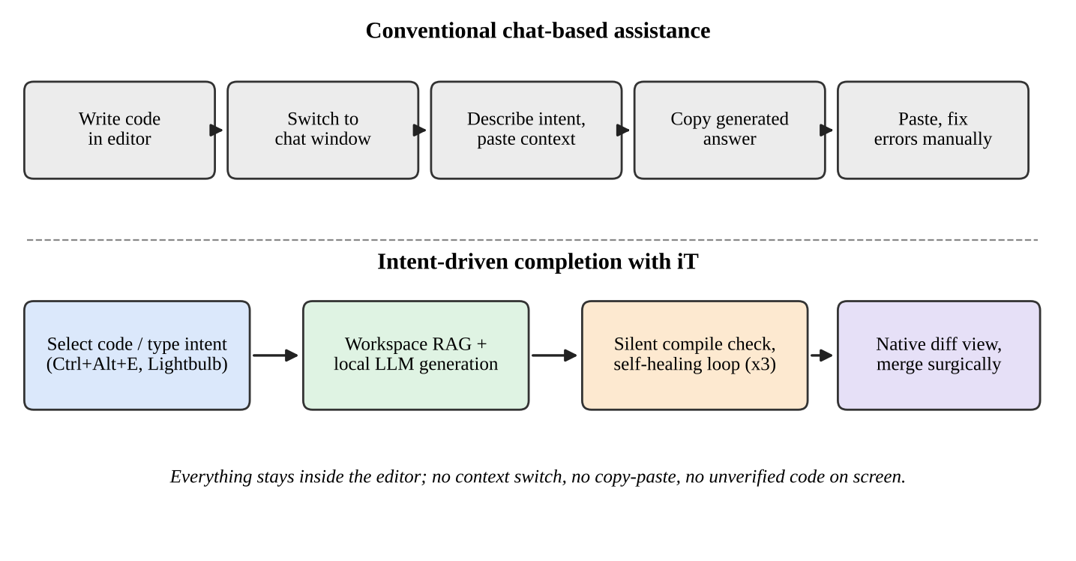
Fig 1.1 Conventional chat workflow versus the in-editor workflow
1.2 Background and Motivation
Large language models have changed how software is written. Tools such as GitHub Copilot popularised inline completion, and controlled studies have reported measurable gains in task completion speed for developers who use them [10]. However, the dominant interaction models still carry hidden costs. Chat-based assistants force a context switch: the developer must describe the problem in prose, paste the relevant code, wait for a long answer, and then transfer the result back into the editor by hand. Each step interrupts the state of flow that productive programming depends on.
A second cost is trust. Language models regularly produce output that looks plausible but does not even parse: unbalanced brackets, missing colons, inconsistent indentation, or calls to functions that do not exist in the project. When such output is pasted into a file, the developer becomes the compiler, and the time saved by generation is spent on debugging the generated code. A third cost is privacy and availability. Cloud-hosted assistants transmit source code to a third party, which is unacceptable for many proprietary or academic code bases, and they stop working without a network connection.
Recent progress in small, code-specialised models makes a different design point attractive. Models in the one-to-three billion parameter range can now be served locally with modest memory, produce their first tokens within a fraction of a second, and still handle routine tasks such as writing a function from a comment, extracting a class from procedural code, or explaining a stack trace [2]. The motivation for it is to pair such a model with a rigorous verification and integration layer, so that speed does not have to be traded against correctness.
1.3 Problem Statement
Existing AI coding assistants either live outside the editor (chat windows and browser tabs) or insert unverified text directly into the buffer. Both approaches break the developer’s flow and shift the burden of validation onto the user. There is a need for an editor-native tool that accepts intent in the place where the code already lives, grounds the model in the actual project, verifies the output before it is displayed, and lets the developer merge the result with the precision of an ordinary diff, all without sending a single line of code off the machine.
1.4 System Objectives
The primary objectives of IDCC are:
- Frictionless Intent Injection To let the developer express intent and receive code without leaving the editor, using native surfaces (keyboard shortcuts, the Lightbulb menu and the Status Bar) instead of custom panels or chat windows.
- Verified Generation To compile every generated Python candidate invisibly and to repair syntax errors automatically through a bounded self-healing loop of up to three attempts, so that unverified code never reaches the screen.
- Project-Grounded Output To scan the workspace’s .py files and inject existing class and function signatures into the prompt, so that the model reuses the real architecture of the project instead of hallucinating imports or helpers.
- Surgical Integration To present every change in VS Code’s native side-by-side Diff Viewer, allowing selective merging, and to clean up all temporary diff artefacts automatically when the tab is closed.
- Local, Low-Latency Inference To run a compact model (qwen2.5-coder:1.5b) on a self-hosted Ollama endpoint, keeping latency low and guaranteeing that source code never leaves the developer’s machine.
- Targeted Refactoring and Debugging To provide one-keystroke refactoring (Ctrl+Alt+E) that extracts selected procedural code into typed object-oriented classes, and one-keystroke stack-trace diagnosis (Ctrl+Alt+D) that outputs the exact line fix.
1.5 Technical Scope
IDCC integrates several mature technologies, each chosen for a specific responsibility:
- Host layer: TypeScript running inside the VS Code Extension Host, using the Extension API for commands, code actions, status bar items, text document content providers and the built-in diff command.
- Validation layer: Python 3 background scripts that use the ast module for structural parsing and splicing and py_compile for syntax verification.
- Inference layer: an Ollama server exposing a local HTTP API, serving the qwen2.5-coder:1.5b model.
- Context layer: a lightweight, regular-expression and AST-based indexer that builds a signature digest of the workspace.
The current release targets Python projects. The architecture, however, separates language-specific validation from the host, so that additional languages can be supported by supplying a new validator without changing the user interface.
1.6 VS Code Extension API
Visual Studio Code is the most widely used source-code editor, and its extension model is deliberately rich. An extension runs in a separate Node.js process (the Extension Host), which isolates it from the editor’s user interface and prevents a misbehaving extension from freezing typing. Through the API, an extension can register commands and keybindings, contribute Code Actions to the Lightbulb menu, create Status Bar items, supply virtual documents through a TextDocumentContentProvider, open the native diff editor with the vscode.diff command, and read the system clipboard [7]. IDCC relies exclusively on these first-party surfaces. That decision is central to its “zero-friction” goal: every interaction looks and behaves like a feature of VS Code itself, honours the user’s theme and key bindings, and requires no additional learning.
1.7 Ollama and qwen2.5-coder:1.5b
Ollama is an open-source runtime that packages quantised language models and serves them over a simple HTTP interface on localhost [8]. IDCC sends a prompt to the generated endpoint and receives the completion, optionally as a stream. The chosen model, qwen2.5-coder:1.5b, belongs to the Qwen2.5-Coder family, which was trained on a large corpus of source code and reports strong results for its size across code generation, completion and repair benchmarks [2]. At roughly 1.5 billion parameters it fits comfortably in the memory of an ordinary laptop, loads quickly and generates tokens fast enough for interactive use. The trade-off is lower raw capability than larger models, which is precisely why IDCC surrounds the model with retrieval and verification rather than relying on it unaided.
1.8 Python Validation Engine
The validation engine is a small Python program that the extension invokes as a child process and communicates with through JSON over standard input and output. It exposes two operations. The first extracts class and function signatures from a source file using the ast module, which feeds Workspace RAG. The second splices a generated fragment into a file at a given line range and then compiles the merged result with py_compile in a throw-away temporary file. If compilation fails, the engine returns the formatted traceback, which becomes the repair signal for the model. Because the engine is only Python’s own compiler, its verdict on syntax is authoritative; it cannot disagree with the interpreter that will eventually run the code.
1.9 Organization of the Report
Chapter 2 surveys the research on code language models, retrieval augmentation and iterative self-repair that informs the design. Chapter 3 describes the system architecture module by module. Chapter 4 documents the implementation, including the message protocol, the self-healing loop and the diff-viewer lifecycle. Chapter 5 presents the verification approach, discusses behaviour, advantages and limitations, and Chapter 6 concludes with directions for future work. References and an appendix with representative source listings follow.

2. LITERATURE SURVEY
Intent-driven code completion sits at the intersection of four research threads: language models trained on source code, retrieval of repository context, execution- or compiler-feedback for self-repair, and the human factors of AI-assisted programming. This chapter summarises the work that most directly shaped the design of IDCC and identifies the gap that the project addresses.
2.1 M. Chen et al. (2021)
The Codex paper, “Evaluating Large Language Models Trained on Code”, introduced the HumanEval benchmark and showed that a GPT model fine-tuned on public code could synthesise Python functions from docstrings with useful accuracy, and that sampling multiple candidates and selecting among them substantially raised the pass rate [1]. The paper established two ideas that IDCC inherits: that natural-language intent is a viable specification for code, and that candidate generation followed by an automated check is more reliable than trusting a single sample. Its limitation, from the standpoint of this project, is that the model operates on the prompt alone and has no knowledge of the surrounding repository.
2.2 B. Hui et al. (2024)
The Qwen2.5-Coder technical report describes a family of code-specialised models from 0.5 to 32 billion parameters, trained on a large, carefully filtered code corpus with an emphasis on code completion, fill-in-the-middle behaviour and instruction following [2]. The report shows that the smaller members of the family achieve competitive results on standard code benchmarks relative to their size. This makes a 1.5B-parameter variant a realistic engine for local, latency-sensitive tooling. IDCC adopts qwen2.5-coder:1.5b on that basis, accepting its smaller capacity in exchange for speed and compensating through context retrieval and compiler feedback.
2.3 P. Lewis et al. (2020)
Retrieval-Augmented Generation (RAG) combines a parametric language model with a non-parametric memory from which relevant passages are retrieved at inference time and supplied as additional context [3]. RAG was originally evaluated on knowledge-intensive question answering, but the principle generalises: a model that cannot memorise facts can be handed them just in time. In IDCC the “knowledge” is the project’s own symbol table. Rather than embedding vectors and a vector database, which would add latency and dependencies, IDCC retrieves by construction: it parses the workspace and injects exact class and function signatures, which are compact, precise and always current.
2.4 F. Zhang et al. (2023)
RepoCoder studies repository-level code completion and proposes an iterative retrieve-and-generate procedure in which the model’s own draft is used to retrieve further relevant snippets from the repository [6]. The authors show that completions improve markedly when the model can see code from elsewhere in the repository, particularly for functions that call project-specific APIs. This finding supports the central design choice of Workspace RAG in IDCC: a small model that sees the real signatures of the project is far less likely to invent imports or call non-existent helpers than one that sees only the current file.
2.5 X. Chen et al. (2023)
“Teaching Large Language Models to Self-Debug” shows that a model can improve its own code when it is shown execution feedback or error messages, even without additional training [4]. The method feeds the failure information back into the prompt and asks for a corrected program, iterating until the program passes or a budget is exhausted. IDCC applies the same principle to the narrowest and cheapest signal available: a Python syntax error from py_compile. The signal is deterministic, has no side effects (nothing is executed), and is available in milliseconds, which makes it ideal for an invisible loop that must not delay the user perceptibly.
2.6 A. Madaan et al. (2023)
Self-Refine proposes an iterative loop in which a model generates an output, produces feedback on it, and refines the output using that feedback, with improvements reported across a range of tasks including code optimisation [5]. Whereas Self-Refine uses the model itself to critique, IDCC substitutes an external, authoritative critic, the Python compiler, for the syntactic part of the task. This avoids a known weakness of purely self-generated feedback in small models, which can fail to notice their own errors.
2.7 S. Peng et al. (2023)
In a controlled experiment, developers with access to GitHub Copilot completed a programming task significantly faster than a control group [10]. The study is relevant to IDCC less for the headline speed-up than for what it implies about interface design: the benefit is greatest when assistance is embedded in the existing workflow. This reinforces the decision to avoid chat windows and bespoke panels and to use native editor surfaces.
2.8 Summary and Research Gap
Table 2.1 summarises how each strand of prior work maps onto a component of IDCC and what remains unaddressed by it alone.
Table 2.1 Mapping of prior work to IDCC components
Work | Contribution | Used in IDCC as | Gap left
Chen et al. (2021) | Natural-language-to-code with generate-and-check | Intent as specification; automated candidate check | No repository context
Hui et al. (2024) | Small, strong code models | qwen2.5-coder:1.5b local engine | Lower capacity than large models
Lewis et al. (2020) | Retrieval-augmented generation | Workspace RAG signature injection | Not code-specific
Zhang et al. (2023) | Repository-level completion | Justification for project grounding | No editor integration
Chen et al. (2023) | Self-debugging with feedback | Self-healing loop (max 3) | Needs execution or error signal
Madaan et al. (2023) | Iterative self-refinement | Bounded refine loop | Self-critique can be unreliable
Peng et al. (2023) | Productivity with AI assistants | Native, in-editor UX | Cloud-hosted tooling

Taken together, the literature supplies the ingredients (capable small models, retrieval, compiler feedback and in-workflow assistance) but no single tool that combines them into a local, editor-native, verify-before-display pipeline. IDCC is designed to fill that gap.

3. SYSTEM ARCHITECTURE
IDCC is organised as a set of small modules with a strict separation of concerns. The TypeScript host owns every interaction with the user and the editor; the Python engine owns every judgement about code correctness; and the Ollama endpoint owns text generation. The modules communicate only through narrow, explicit interfaces (function calls inside the host, JSON over a child-process pipe to the validator, and HTTP to the model server), which keeps each component independently testable and replaceable. Figure 3.1 shows the overall architecture.
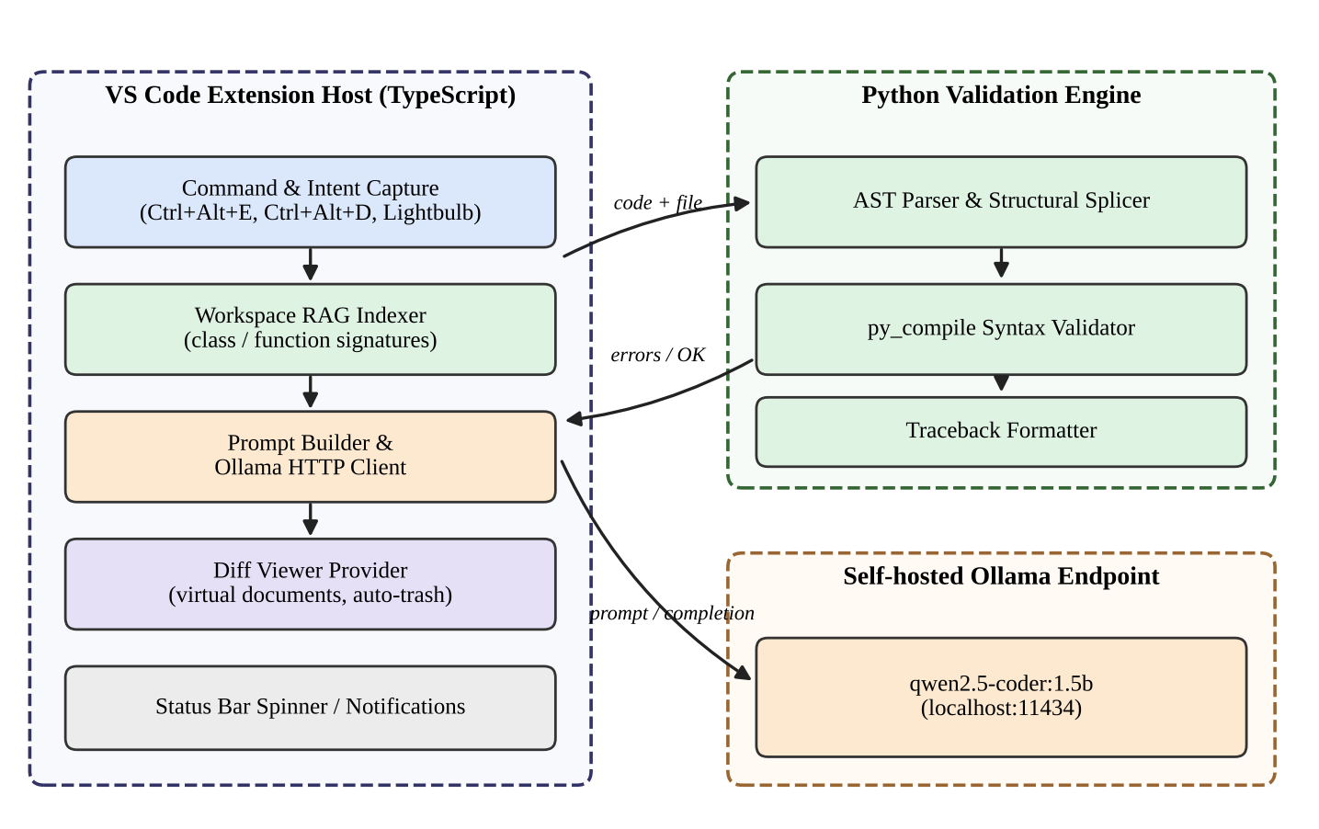
Fig 3.1 IDCC System Architecture
3.1 Command and Intent Capture
Intent enters the system through three native entry points. The first is a command invoked from the Command Palette or a key binding, which opens an input box in which the user types an instruction such as “read a CSV file and return the rows as dictionaries”. The second is the Lightbulb menu: when the user selects code, the extension contributes Code Actions, such as “iT: Extract to typed classes”, that appear next to VS Code’s own quick fixes. The third is the dedicated shortcut pair: Ctrl+Alt+E for targeted refactoring of the current selection and Ctrl+Alt+D for terminal stack-trace interception. Each entry point produces the same internal object, an intent request, containing the instruction text, the active file, the selected range (if any) and the intent type (generate, refactor or debug).
3.2 Workspace RAG Indexer
Before a prompt is built, the Workspace RAG indexer scans the .py files in the open workspace and extracts the signatures of their classes and functions. The scan is performed by the Python engine using the ast module, so that decorators, nested definitions, default arguments and annotations are parsed correctly instead of being approximated by pattern matching. The resulting digest, one line per symbol, is cached and refreshed when files are saved, so that the cost of indexing is paid in the background rather than at request time. When the digest would exceed the prompt budget of a 1.5B-parameter model, symbols from the active file and from files it imports are ranked first and the remainder is truncated.
3.3 Prompt Builder
The prompt builder assembles a deterministic template from five parts: a short system instruction that constrains the model to return only code; the signature digest; the contents of the active file (or the relevant window of it); the user’s selection or cursor position; and the instruction itself. Output constraints are explicit: no prose, no Markdown fences, preserve indentation, and use only imports and symbols that appear in the digest or the standard library. A deterministic template matters for a small model, which is sensitive to prompt form, and it makes the system’s behaviour reproducible when diagnosing failures.
3.4 LLM Engine (Ollama and qwen2.5-coder:1.5b)
The LLM engine is an Ollama server running on the developer’s machine, typically at localhost:11434. The host communicates with it through a small HTTP client that sets a low sampling temperature, a bounded output length and a request timeout. Because the model is local, no source code or intent leaves the machine, there is no per-token cost, and the tool continues to work offline. The 1.5B-parameter model is loaded once and remains resident, so subsequent requests avoid the cost of loading weights.
3.5 Validation Engine and the Self-Healing Loop
The validation engine is the architectural centrepiece. After the model returns a candidate, the host sends it, together with the original file and the target line range, to the Python engine. The engine splices the fragment into the file structurally, compiles the merged result in a temporary file with py_compile, and returns either success or a formatted traceback. On failure, the host appends the traceback and the failing candidate to the prompt and asks the model for a corrected version. This repeats for at most three attempts. The user never sees an intermediate failure; they see either a verified candidate or, after the third failure, a concise message that generation did not succeed. Figure 3.2 illustrates the loop.
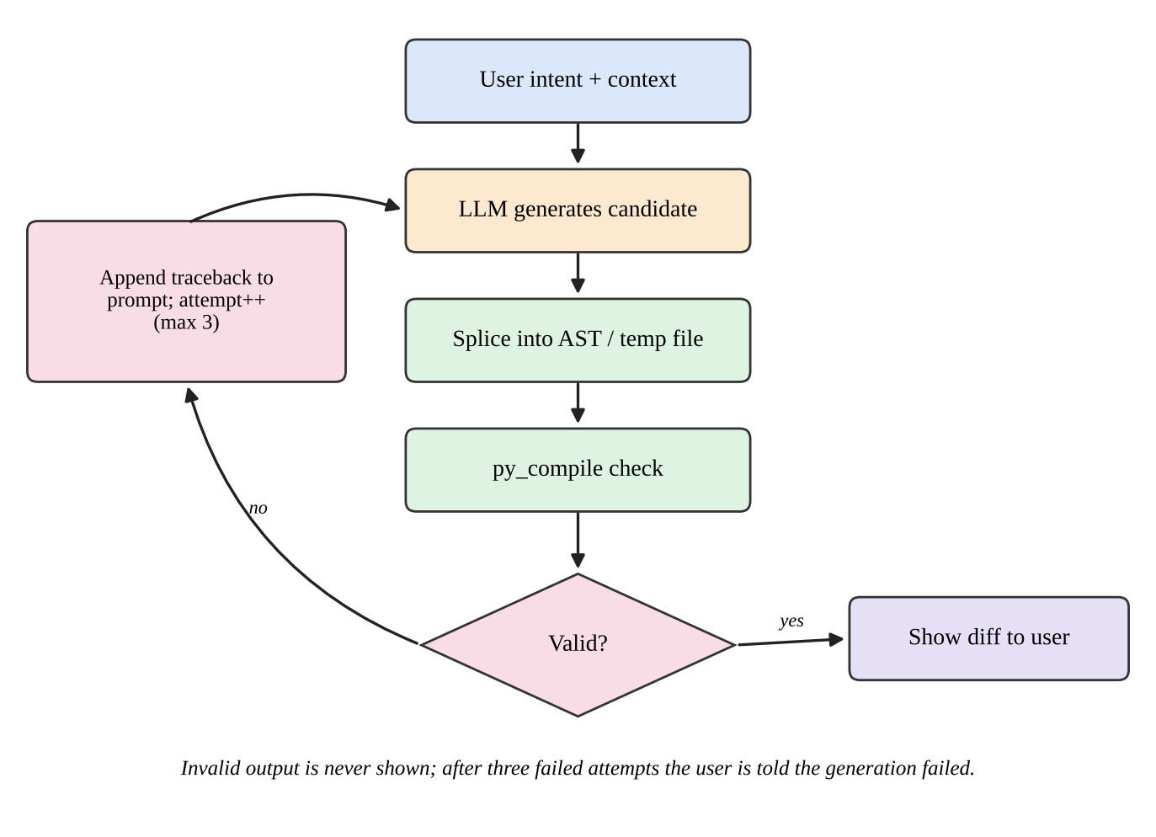
Fig 3.2 The self-healing generation loop
Three design details deserve emphasis. First, the check is purely syntactic and nothing is executed, so validation is safe for arbitrary generated code. Second, the retry bound keeps worst-case latency predictable. Third, the traceback is passed verbatim, including the offending source line and caret, because that is the format the model has seen most often in training data and therefore the one it repairs most reliably.
3.6 Native Diff Viewer
Verified code is presented through VS Code’s own side-by-side Diff Viewer rather than being written into the buffer. The extension registers a virtual document scheme whose provider returns the proposed file contents from memory, then calls vscode.diff with the original document on the left and the proposed document on the right. The developer can inspect each hunk and use the editor’s native merge controls to accept the change, partially or fully. A listener on tab closure disposes of the virtual document and removes any temporary file, so that no residue accumulates in the workspace or the system temp folder.
3.7 Targeted Refactoring Module
The refactoring module is bound to Ctrl+Alt+E and to a Lightbulb action. When the developer highlights a block of messy procedural code, the module prompts the model to extract it into one or more typed, object-oriented classes: data held in module-level variables becomes attributes, repeated parameter lists become constructor arguments, and free functions that share state become methods with type annotations. The result passes through the same RAG, validation and diff pipeline as any generation, so a refactoring is also compile-checked and merged surgically.
3.8 Terminal Interception Module
Debugging begins in the terminal, where a stack trace appears. The terminal interception module, bound to Ctrl+Alt+D, reads the stack trace directly from the clipboard, so the developer only has to select and copy it. It parses the frames, identifies the frame that refers to the active file, and builds a prompt containing the error type and message, the failing line and its surrounding lines, and the relevant signatures. The model is asked to output the exact line fix, which is validated and shown in the diff viewer. Using the clipboard avoids the need for privileged access to terminal buffers and works identically across shells and operating systems.
3.9 Status Bar Feedback
Long-running operations normally show a modal progress notification, which is intrusive and steals attention. IDCC instead displays a single spinner item in the Status Bar for the duration of a request and removes it when the diff opens or an error is reported. Errors are shown as unobtrusive notifications with a short, actionable message. The principle is that the tool should be visible only when it has something to say.

4. SYSTEM IMPLEMENTATION
4.1 Development Environment
The extension is developed in TypeScript with the standard VS Code extension toolchain: Node.js and npm for dependency management, the yo code generator for the initial scaffold, the TypeScript compiler for transpilation, and the Extension Development Host (launched with F5) for interactive debugging. The validation engine requires only a Python 3 interpreter and the standard library, so no packages need to be installed for it. The model is installed with a single command (ollama pull qwen2.5-coder:1.5b) and served by the Ollama background service. Table 4.1 lists the environment.
Table 4.1 Development and runtime environment
Component | Technology | Purpose
Host language | TypeScript (Node.js runtime of the Extension Host) | Commands, UI, diff, clipboard
Editor API | VS Code Extension API | Code actions, status bar, diff, content providers
Validation language | Python 3 (standard library only) | AST parsing, splicing, py_compile
Model server | Ollama (localhost:11434) | Local HTTP inference
Model | qwen2.5-coder:1.5b | Low-latency code generation
Build tools | npm, tsc, vsce | Compile and package the extension

4.2 Extension Manifest, Commands and Key Bindings
The extension is described by its package.json manifest. The manifest declares the commands, binds Ctrl+Alt+E to the refactoring command and Ctrl+Alt+D to the stack-trace command, restricts both to Python editors using a when clause, and registers activation on Python files so that the extension costs nothing for other languages. Contributions are intentionally few: the more the tool relies on built-in surfaces, the less there is to learn. The relevant fragment of the manifest is reproduced in Appendix B.
At activation, the extension’s activate function registers each command, registers the Code Action provider for the Python language, creates the Status Bar item, registers the virtual document provider and starts the validator child process. Every registration returns a Disposable that is pushed onto the extension context’s subscription list, so that VS Code releases the resources automatically when the extension is deactivated.
4.3 Host-to-Validator Protocol
The TypeScript host and the Python engine communicate by exchanging single JSON documents over standard input and output. A request carries an op field selecting the operation. For signatures, it contains the source text of one file and the reply is a list of signature strings. For validate, it contains the original source, the one-based inclusive line range to replace and the candidate code; the reply contains a boolean ok, the traceback text if compilation failed, and the merged source if it succeeded. JSON was chosen because both runtimes parse it natively, because it is easy to log and replay when debugging, and because it leaves the door open to running the validator as a long-lived service in the future. The complete engine is listed in Appendix A.
The splicing step deserves a note. Replacing lines by index is simple, but it is only safe if the replacement respects the indentation of its surroundings. The engine therefore preserves the replacement’s own indentation as returned by the model, which the prompt instructs it to match to the selection’s first line, and relies on the compiler to reject mismatches, which then enter the self-healing loop like any other syntax error. Because errors are located by py_compile in the merged file, the reported line numbers are meaningful to the model, and the engine rewrites the temporary file path in messages to the neutral token <generated>, so that the model does not waste attention on an irrelevant path.
4.4 Workspace RAG Implementation
The indexer enumerates .py files with vscode.workspace.findFiles, applying the user’s exclude patterns so that virtual environments, build output and node_modules are skipped. For each file it requests signatures from the engine, which uses ast.parse and walks the top-level nodes: for a ClassDef it records the name and bases and the methods with their arguments, and for a FunctionDef it records the name, arguments and return annotation. Files that fail to parse (for example because the user is mid-edit) are skipped without error. Signatures are keyed by file path and modification time, so that a save event re-indexes only the file that changed. Figure 4.1 shows how the digest is combined with the editor state to form the final prompt.
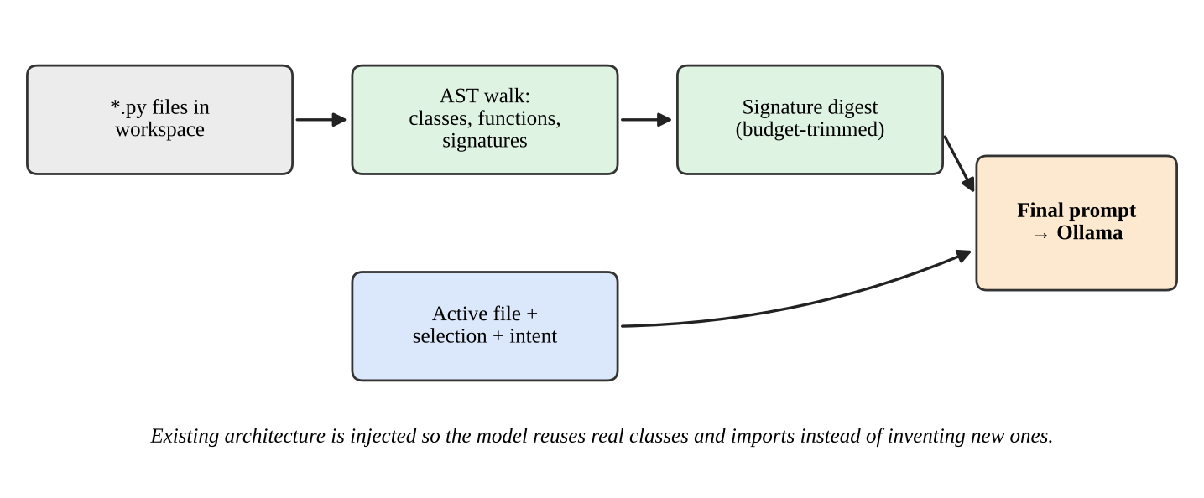
Fig 4.1 Workspace RAG prompt assembly
4.5 Prompt Design
Prompt design for a 1.5B-parameter model must be economical and explicit. The prompt begins with a role line and a rigid output contract: “Return only valid Python code. Do not include explanations or Markdown fences. Preserve indentation.” It then lists the project signatures under a heading such as “Existing project API (use these, do not invent others)”, followed by the active file, the selection delimited by clear markers, and the instruction. Retry prompts keep the same structure and add a final block containing the previous candidate and the compiler’s traceback with the instruction “Fix the syntax error and return the full corrected code”. Responses are post-processed to strip any residual code fences that the model emits despite the instruction.
4.6 Ollama Client
The client is a thin wrapper around the fetch API available in the Extension Host. It posts a JSON body containing the model name, the prompt, stream: false and an options object that sets a low temperature for determinism and a cap on predicted tokens. A timeout implemented with an AbortController prevents a stalled server from freezing the Status Bar spinner indefinitely. Connection failures are mapped to a single helpful message that tells the user to start Ollama and to pull the model if it is missing. Because the endpoint address and model name are exposed as settings, users can point iT at a remote GPU server within their own network, or switch to a larger local model, without changing any code.
4.7 Self-Healing Loop Implementation
The loop is implemented as a bounded for loop of three iterations in an asynchronous function. Each iteration requests a completion, cleans it, asks the engine to validate it, and returns the merged source on success. On failure it appends the traceback to a repair block that is added to the next prompt. After the last iteration it throws a typed error that the command handler converts into a notification. A cancellation token is checked between steps so that pressing Escape or closing the document aborts work immediately. A compact version of the loop is shown in Appendix C.
The bound of three was chosen empirically as a balance. A single retry fixes the most common failure, a missing colon or bracket. A second retry covers errors introduced by the first repair. Beyond the third, a small model that is still failing is usually stuck on a deeper misunderstanding that more attempts will not cure, so the loop stops and reports failure promptly rather than burning the user’s time.
4.8 Diff Viewer and Temporary File Lifecycle
The virtual document provider holds a map from URI to proposed content. The command opens the diff, then subscribes to vscode.window.tabGroups.onDidChangeTabs. When the tab for the diff is closed, the handler deletes the entry from the map, disposes of the subscription and removes any temporary file created on disk. This lifecycle handling ensures that the developer’s working tree stays clean: no stray “.iT.tmp” files, no leftover virtual documents, and no memory growth over long sessions.
4.9 Refactoring and Lightbulb Integration
The Code Action provider implements provideCodeActions. If the range is non-empty, it returns a CodeAction of kind refactor.extract titled “iT: Extract to typed classes”, which invokes the refactoring command with the current selection. Using the standard kind means the action also appears in the Refactor context menu and under the keyboard-accessible “Refactor…” command, with no extra work. The refactor prompt asks for dataclass-style typed classes, with type hints on every attribute and method, and for the original behaviour to be preserved. Figure 4.2 summarises the refactoring and debugging flows.
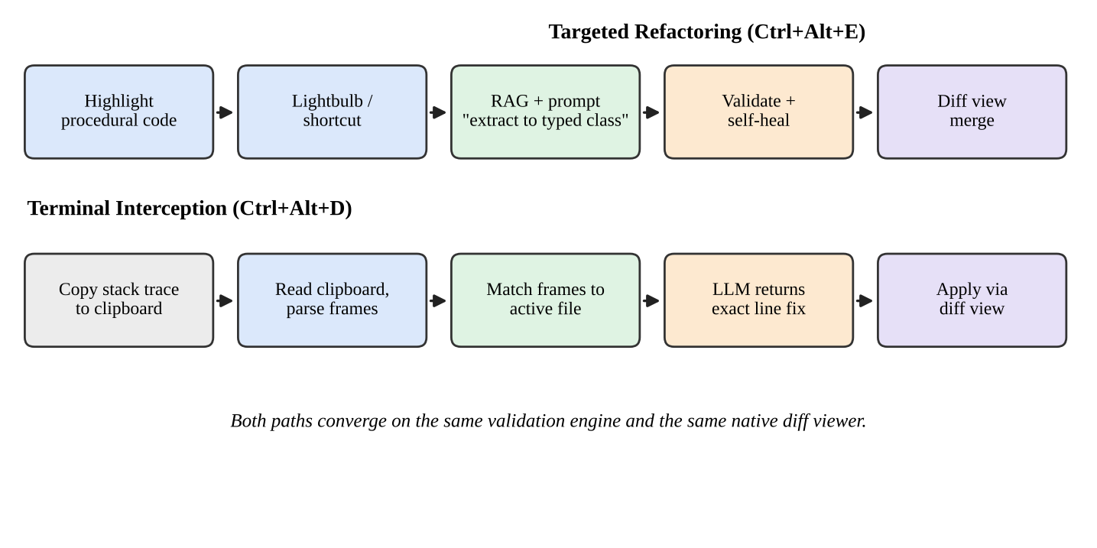
Fig 4.2 Refactoring (Ctrl+Alt+E) and terminal interception (Ctrl+Alt+D) flows
4.10 Terminal Interception Implementation
The debug command reads the clipboard with vscode.env.clipboard.readText. A short parser recognises the standard Python traceback format: lines of the form File “path”, line N, in name followed by the source line, and a final line with the exception type and message. The parser selects the innermost frame whose path matches the active editor’s file; if none matches, it falls back to the innermost frame overall and tells the user. The prompt then contains the exception, the failing line number, a window of context lines around it, and the signature digest. The model is instructed to reply with the corrected line or lines only, and the engine splices the reply over the failing range, validates it and opens the diff. The effect is that a stack trace in the terminal turns into a reviewable one-line change in the editor within a single keystroke.
4.11 Status Bar and Error Handling
A single Status Bar item with the built-in “sync~spin” codicon provides the spinner. It is shown when a request starts and hidden in a finally block, so that no failure path leaves it spinning. Errors are classified into four groups: server unreachable, model missing, validation exhausted (three failed attempts) and cancelled by the user. Each has a one-sentence message with a suggested action. No error ever modifies the user’s files, since all writes happen only through the diff viewer after explicit user action.
4.12 Privacy and Safety Considerations
Three properties are enforced by construction. All inference runs on a local endpoint, so source code is never transmitted to a third party. The validator compiles but never executes generated code, so a malicious or faulty candidate cannot run during validation. And the user remains the final gatekeeper: nothing is merged into a file without being displayed in the diff viewer first.

5. RESULTS AND DISCUSSION
5.1 Testing Approach
Because IDCC is an interactive tool built from loosely coupled components, it was verified at three levels. At the unit level, the Python engine’s functions (signature extraction, line splicing and syntax checking) were exercised with small fixtures: well-formed fragments, fragments with a missing colon or unbalanced bracket, selections at the first and last lines of a file, and files that do not parse. At the integration level, the host and validator were run together against a stub model server that returns scripted completions, including deliberately broken ones, so that the self-healing loop could be tested deterministically without depending on the stochastic output of a real model. At the system level, the extension was run in the Extension Development Host with the real Ollama server and qwen2.5-coder:1.5b on representative Python files.
The validator behaviour in particular was confirmed directly: splicing a syntactically valid replacement into a three-line file returned success and the merged text, while splicing the fragment “def f(:” returned a failure with the traceback “SyntaxError: invalid syntax” pointing at the offending line, with the temporary path replaced by the token <generated>. Signature extraction on a file with a class and an annotated function returned the expected three signature lines.
5.2 Functional Verification
Table 5.1 lists the feature scenarios against which the system is checked, together with the behaviour that constitutes success. These criteria were derived directly from the objectives in Section 1.4.
Table 5.1 Functional scenarios and acceptance criteria
Feature | Scenario | Acceptance criterion
Intent injection | Type an instruction at an empty line | Verified code opens in diff view; buffer untouched until merge
Self-healing loop | Stub model returns broken code, then valid code | Invalid code never shown; valid code shown after retry
Retry bound | Stub model always returns invalid code | Exactly three attempts, then a failure notice
Workspace RAG | Project defines a helper class; request needs it | Prompt contains its signature; output reuses it
Diff viewer | Close the diff tab | Virtual document and temp files are removed
Targeted refactoring | Select procedural block, press Ctrl+Alt+E | Typed class returned and validated, shown in diff
Lightbulb | Select code and open Quick Fix menu | “iT: Extract to typed classes” is listed
Terminal interception | Copy a traceback, press Ctrl+Alt+D | Exact-line fix proposed for the matching frame
Status Bar | Start a request | Spinner appears and always disappears afterwards
Offline use | Disconnect the network | All features continue to work

5.3 Behaviour of the Self-Healing Loop
The loop changes what the user experiences more than any other component. Without it, an invalid candidate from a small model is simply displayed, and the developer must notice and repair it. With it, the first candidate that is shown has already compiled. The typical failure classes that the loop is designed to absorb are those that dominate the output of compact models: missing colons after def, if or for statements; unbalanced parentheses or brackets in long expressions; truncated output when the token cap is reached; and mixed or incorrect indentation after splicing. Each of these produces a clear, one-line SyntaxError or IndentationError from the compiler that points at the problem, which is exactly the kind of signal that makes a repair request effective.
The loop also has a clear boundary. It guarantees syntactic validity, not semantic correctness. A candidate may compile and still compute the wrong thing. That is why the diff viewer remains mandatory and why the interface presents the result as a proposal. The guarantee that IDCC does provide, that nothing which fails to compile ever reaches the screen, removes an entire category of tedious errors without claiming more than it can deliver.
5.4 Effect of Workspace RAG
The practical value of Workspace RAG is easiest to see in a concrete case. Suppose a project defines a class InvoiceRepository with a method load(path: str) -> list[Invoice]. A request such as “write a function that totals the invoices in a file” sent without context typically yields a function that opens the file itself and invents a parsing scheme, or imports a non-existent module. With the digest in the prompt, the model sees the real class and method and calls them. The generated code is shorter, consistent with the rest of the project and, importantly, free of invented imports, which are one of the most common sources of failure when generated code is first run. The cost is a modest increase in prompt length, bounded by the digest budget described in Section 3.2.
5.5 Latency and Resource Use
Interactive tools are judged by responsiveness. The design contributes to low latency in four ways: a small model with fast token generation, a model that stays resident between requests, background indexing that removes scanning from the request path, and a validator whose compile step takes milliseconds because it only parses and compiles a single file. Only generation grows with retries, hence the cap of three attempts. Table 5.2 defines the measurements recommended for characterising a deployment on a particular machine; the values depend on hardware and should be recorded on the target system.
Table 5.2 Performance measurements to be recorded on the target machine
Metric | How measured | Recorded value
Time to first token | Request sent to first streamed token | to be recorded
End-to-end latency, single attempt | Intent submitted to diff opened | to be recorded
Validation time | py_compile on merged file | to be recorded
Retry rate | Requests needing at least one repair / total | to be recorded
Failure rate after 3 attempts | Requests ending in failure notice / total | to be recorded
Peak memory of Ollama process | Process monitor during use | to be recorded

5.6 Advantages of the System
- Zero context switching: all interaction happens through native editor surfaces, preserving the developer’s flow.
- Verified output: generated Python has passed a compile check before it is displayed, and syntax errors are repaired automatically.
- Project-aware: Workspace RAG grounds generation in the project’s real classes and functions, reducing hallucinated imports.
- Private and offline: inference runs on a local endpoint, so code never leaves the machine and no network is required.
- Surgical merging: the native diff viewer lets the developer accept exactly the hunks they want and leaves no temporary residue.
- Extensible: language-specific validation is isolated, so additional languages can be added without redesigning the host.
5.7 Limitations of the System
- Syntactic, not semantic, guarantee: a candidate that compiles may still be logically wrong; review in the diff viewer remains essential.
- Python only, small model: the validator targets Python, and a 1.5B-parameter model is weaker than large cloud models on complex multi-file reasoning.

6. CONCLUSION AND FUTURE SCOPE
6.1 Conclusion
This project set out to build the shortest possible path between a developer’s intent and working code, and to do so without the costs that usually accompany AI assistance: context switching, unverified output and loss of privacy. IDCC achieves this by combining a native VS Code extension written in TypeScript, a Python validation engine based on AST splicing and py_compile, and a self-hosted qwen2.5-coder:1.5b model served by Ollama.
The key engineering idea is that a small, fast model becomes dependable when it is surrounded by the right infrastructure. Workspace RAG gives it knowledge of the real project. The self-healing loop converts compiler errors into repairs, up to three attempts, before the user sees anything. The native diff viewer returns control to the developer with surgical precision, and the Lightbulb, Ctrl+Alt+E and Ctrl+Alt+D entry points make refactoring and debugging a keystroke away. Together these features make the assistant feel like part of the editor rather than an add-on to it.
The project also demonstrates a broader design principle: use the language model for what it is good at, producing plausible code quickly, and use deterministic tools, here the Python compiler and the AST, for what they are good at, deciding whether code is well-formed. Dividing the work in this way yields a system that is faster, cheaper and more trustworthy than either component alone.
6.2 Future Scope
Several directions would extend the system from a research prototype toward a production tool:
- Semantic validation: extend the loop beyond syntax by running the project’s unit tests, a type checker such as mypy, or a linter on the merged result, and feeding failures back to the model.
- Multi-language support: add validators for JavaScript and TypeScript (using the TypeScript compiler API), and for Java, Go and C++, reusing the same host.
- Streaming and inline ghost text: stream tokens into an inline preview for very short completions while retaining the diff viewer for larger changes.
- Model flexibility: allow per-task model selection, using the small model for completions and a larger local model for hard refactorings, and support fine-tuning on the user’s own repository.
- Evaluation harness: add an offline benchmark suite so that prompt and model changes can be compared on a fixed task set.

7. REFERENCES
[1] M. Chen et al., “Evaluating Large Language Models Trained on Code,” arXiv preprint arXiv:2107.03374, 2021. Available: https://arxiv.org/abs/2107.03374
[2] B. Hui et al., “Qwen2.5-Coder Technical Report,” arXiv preprint arXiv:2409.12186, 2024. Available: https://arxiv.org/abs/2409.12186
[3] P. Lewis et al., “Retrieval-Augmented Generation for Knowledge-Intensive NLP Tasks,” in Advances in Neural Information Processing Systems (NeurIPS), 2020. Available: https://arxiv.org/abs/2005.11401
[4] X. Chen, M. Lin, N. Schärli and D. Zhou, “Teaching Large Language Models to Self-Debug,” arXiv preprint arXiv:2304.05128, 2023. Available: https://arxiv.org/abs/2304.05128
[5] A. Madaan et al., “Self-Refine: Iterative Refinement with Self-Feedback,” in Advances in Neural Information Processing Systems (NeurIPS), 2023. Available: https://arxiv.org/abs/2303.17651
[6] F. Zhang et al., “RepoCoder: Repository-Level Code Completion Through Iterative Retrieval and Generation,” in Proc. EMNLP, 2023. Available: https://arxiv.org/abs/2303.12570
[7] Microsoft, “Visual Studio Code Extension API.” Available: https://code.visualstudio.com/api
[8] Ollama, “Ollama API documentation.” Available: https://github.com/ollama/ollama/blob/main/docs/api.md
[9] Python Software Foundation, “py_compile — Compile Python source files” and “ast — Abstract Syntax Trees,” Python 3 Documentation. Available: https://docs.python.org/3/library/py_compile.html
[10] S. Peng, E. Kalliamvakou, P. Cihon and M. Demirer, “The Impact of AI on Developer Productivity: Evidence from GitHub Copilot,” arXiv preprint arXiv:2302.06590, 2023. Available: https://arxiv.org/abs/2302.06590

8. APPENDIX
The appendix contains representative source listings of the principal components of IDCC. Appendix A is the complete Python validation engine; Appendices B and C show the manifest contributions and the core TypeScript logic of the host (Ollama client and self-healing loop).
Appendix A: Python Validation Engine (validator.py)
"""iT validation engine: AST signature extraction, structural splicing, py_compile check."""
import ast, json, os, py_compile, sys, tempfile

def extract_signatures(source: str) -> list[str]:
"""Return 'class X(Base)' and 'def f(a, b) -> T' lines for every top-level symbol."""
out = []
try:
tree = ast.parse(source)
except SyntaxError:
return out
for node in tree.body:
if isinstance(node, ast.ClassDef):
bases = ", ".join(ast.unparse(b) for b in node.bases)
out.append(f"class {node.name}({bases})")
for sub in node.body:
if isinstance(sub, (ast.FunctionDef, ast.AsyncFunctionDef)):
out.append(f" def {sub.name}({ast.unparse(sub.args)})")
elif isinstance(node, (ast.FunctionDef, ast.AsyncFunctionDef)):
ret = f" -> {ast.unparse(node.returns)}" if node.returns else ""
out.append(f"def {node.name}({ast.unparse(node.args)}){ret}")
return out

def splice(source: str, start: int, end: int, replacement: str) -> str:
"""Replace 1-based inclusive lines [start, end] of source with replacement."""
lines = source.splitlines(keepends=True)
if not (1 <= start <= end <= len(lines)):
raise ValueError("selection outside file")
if replacement and not replacement.endswith("\n"):
replacement += "\n"
return "".join(lines[: start - 1]) + replacement + "".join(lines[end:])

def check_syntax(source: str):
"""Return (ok, traceback_text). Compiles a temp file exactly as the interpreter would."""
with tempfile.NamedTemporaryFile("w", suffix=".py", delete=False) as fh:
fh.write(source)
path = fh.name
try:
py_compile.compile(path, doraise=True, cfile=path + "c")
return True, ""
except py_compile.PyCompileError as exc:
return False, exc.msg.replace(path, "<generated>")
finally:
for p in (path, path + "c"):
if os.path.exists(p):
os.unlink(p)

def main() -> None:
req = json.load(sys.stdin)
if req["op"] == "signatures":
print(json.dumps({"signatures": extract_signatures(req["source"])}))
elif req["op"] == "validate":
merged = splice(req["source"], req["start"], req["end"], req["code"]) if "start" in req else req["code"]
ok, tb = check_syntax(merged)
print(json.dumps({"ok": ok, "traceback": tb, "merged": merged if ok else ""}))

if __name__ == "__main__":
main()

Appendix B: Manifest Contributions (package.json)
{
"name": "it-intent-completion",
"engines": { "vscode": "^1.85.0" },
"activationEvents": [ "onLanguage:python" ],
"contributes": {
"commands": [
{ "command": "it.generate", "title": "iT: Generate from Intent" },
{ "command": "it.refactor", "title": "iT: Extract to Typed Classes" },
{ "command": "it.debugClipboard", "title": "iT: Fix from Stack Trace (Clipboard)" }
],
"keybindings": [
{ "command": "it.refactor", "key": "ctrl+alt+e", "when": "editorLangId == python && editorHasSelection" },
{ "command": "it.debugClipboard", "key": "ctrl+alt+d", "when": "editorLangId == python" }
]
}
}

Appendix C: Core Host Logic (TypeScript)
C.1 Ollama client
import * as vscode from "vscode";

async function ask(prompt: string, signal: AbortSignal): Promise<string> {
const cfg = vscode.workspace.getConfiguration("it");
const res = await fetch(`${cfg.get("endpoint")}/api/generate`, {
method: "POST",
headers: { "Content-Type": "application/json" },
body: JSON.stringify({
model: cfg.get("model"),
prompt,
stream: false,
options: { temperature: 0.1, num_predict: 768 },
}),
signal,
});
if (!res.ok) { throw new Error(`Ollama returned ${res.status}`); }
const data = (await res.json()) as { response: string };
return data.response.trim();
}

C.2 Self-healing loop
async function generateVerified(
buildPrompt: (repair?: string) => string,
file: string, start: number, end: number,
token: vscode.CancellationToken
): Promise<string> {
const max = vscode.workspace.getConfiguration("it").get<number>("maxAttempts", 3);
const abort = new AbortController();
let repair: string | undefined;

for (let attempt = 1; attempt <= max; attempt++) {
const code = await ask(buildPrompt(repair), abort.signal);
const verdict = await runValidator({ op: "validate", source: file, start, end, code });
if (verdict.ok) { return verdict.merged; }
repair = `Previous attempt:\n${code}\n\nCompiler error:\n${verdict.traceback}\n` +
`Fix the syntax error and return the full corrected code.`;
}
throw new GenerationFailed(`No valid code after ${max} attempts`);
}

