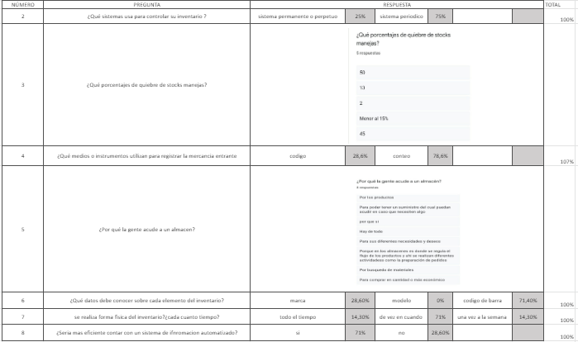

https://drive.google.com/file/d/1S9_SfjcgOJ7YCi8nNHSUTOePhX/1OA8OWview?usp=sharing