**INVESTIGACIÓN**

1. **NULL**

* ¿Qué significa?

Significa “un valor desconocido que falta” y se trata de forma algo diferente a otros valores. [1]

* ¿Resultado de operarlo con diferentes tipos de operadores: aritméticos, lógicos y de comparación?

1. **JUNTA**

* ¿Cuáles son las diferencias entre junta interna y externa?
* ¿Qué opciones se tienen para la junta interna?
* ¿Qué opciones se tienen para la junta externa?

**PRÁCTICA**

**6 JOIN**

1. **SELECT** matchid**,** player

**FROM** goal

**WHERE** teamid **=** 'GER'

2. **SELECT** id**,** stadium**,** team1**,** team2

**FROM** game

**WHERE** id **=** '1012'

3. **SELECT** player**,** teamid**,** stadium**,** mdate

**FROM** game **JOIN** goal **ON** **(**id **=** matchid**)**

**WHERE** teamid **=** 'GER'

4. **SELECT** team1**,** team2**,** player

**FROM** game **JOIN** goal **ON** **(**id **=** matchid**)**

**WHERE** player **LIKE** 'Mario%'

5. **SELECT** player**,** teamid**,** coach**,** gtime

**FROM** goal **JOIN** eteam **ON** **(**id **=** teamid**)**

**WHERE** gtime**<=**10

6. **SELECT** mdate**,** teamname

**FROM** game **JOIN** eteam **ON** **(**team1 **=** eteam**.**id**)**

**WHERE** coach **=** 'Fernando Santos'

7. **SELECT** player

**FROM** goal **JOIN** game **ON** **(**id **=** matchid**)**

**WHERE** stadium **=** 'National Stadium, Warsaw'

8. **SELECT** **DISTINCT(**player**)**

**FROM** game **JOIN** goal **ON** **(**matchid **=** id**)**

**WHERE** teamid **!=** 'GER' **AND** **(**team1 **=** 'GER' **OR** team2 **=** 'GER'**)**

9. **SELECT** teamname**,** **COUNT(**player**)** **AS** goals

**FROM** eteam **JOIN** goal **ON** **(**id**=**teamid**)**

**GROUP** **BY** teamname

10. **SELECT** stadium**,** **COUNT(**player**)** **AS** goals

**FROM** game **JOIN** goal **ON** **(**id **=** matchid**)**

**GROUP** **BY** stadium

11. **SELECT** matchid**,** mdate**,** **COUNT(**teamid**)**

**FROM** game **JOIN** goal **ON** **(**matchid **=** id**)**

**WHERE** **(**team1 **=** 'POL' **OR** team2 **=** 'POL'**)**

**GROUP** **BY** matchid**,** mdate

12. **SELECT** matchid**,** mdate**,** **COUNT(**teamid**)**

**FROM** game **JOIN** goal **ON** **(**id **=** matchid**)**

**WHERE** teamid **=** 'GER'

**GROUP** **BY** matchid**,** mdate

13. **SELECT** mdate**,** team1**,** **SUM(CASE** **WHEN** teamid**=**team1

**THEN** 1 **ELSE** 0 **END)** **AS** score1**,** team2**,**

**SUM(CASE** **WHEN** teamid**=**team2 **THEN** 1 **ELSE** 0 **END)** **AS** score2

**FROM** game **LEFT JOIN** goal **ON** **(**matchid **=** id**)**

**GROUP** **BY** mdate**,** team1**,** team2

**ORDER** **BY** mdate**,** matchid**,** team1**,** team2

**7 More JOIN operations**

1. **SELECT** id**,** title

**FROM** movie

**WHERE** yr**=**1962

2. **SELECT** yr

**FROM** movie

**WHERE** title **=** 'Citizen Kane'

3. **SELECT** id**,** title**,** yr

**FROM** movie

**WHERE** title **LIKE** '%Star Trek%'

**ORDER** **BY** yr

4. **SELECT** id

**FROM** actor

**WHERE** name **=** 'Glenn Close'

5. **SELECT** id

**FROM** movie

**WHERE** title **=** 'Casablanca'

6. **SELECT** name

**FROM** actor **JOIN** casting **ON** (id **=** actorid)

**WHERE** movieid**=**11768

7. **SELECT** name

**FROM** **(**actor **JOIN** casting **ON** actor**.**id **=** actorid**)**

**JOIN** movie **ON** movieid**=**movie**.**id

**WHERE** title **=** 'Alien'

8. **SELECT** title

**FROM** **(**actor **JOIN** casting **ON** actor**.**id**=**actorid**)**

**JOIN** movie **ON** movieid**=**movie**.**id

**WHERE** name **=** 'Harrison Ford'

9. **SELECT** title

**FROM** **(**actor **JOIN** casting **ON** actor**.**id**=**actorid**)**

**JOIN** movie **ON** movieid**=**movie**.**id

**WHERE** name **=** 'Harrison Ford' **AND** **ord** **<>** 1

10. **SELECT** title**,** name

**FROM** **(**actor **JOIN** casting **ON** actor**.**id**=**actorid**)**

**JOIN** movie **ON** movieid**=**movie**.**id

**WHERE** yr**=**1962 **AND** **ord** **=** 1

11. **SELECT** yr**,** **COUNT(**title**)**

**FROM** movie **JOIN** casting **ON** **(**movie**.**id **=** movieid**)**

**JOIN** actor **ON** **(**actorid **=** actor**.**id**)**

**WHERE** name **=** 'John Travolta'

**GROUP** **BY** yr

**HAVING** **COUNT(**title**)** **>** 2

12. **SELECT** title**,** name

**FROM** **(**movie **JOIN** casting **ON** **(**movie**.**id **=** movieid **AND** **ord** **=** 1**))**

**JOIN** actor **ON** **(**actor**.**id **=** actorid**)**

**WHERE** movieid **IN** **(SELECT** movieid **FROM** casting

**WHERE** actorid **IN** **(SELECT** id

**FROM** actor

**WHERE** name**=**'Julie Andrews'**))**

13. **SELECT** name

**FROM** **(**actor **JOIN** casting **ON** **(**actor**.**id **=** actorid**))**

**JOIN** movie **ON** **(**movie**.**id **=** movieid **AND** **ord** **=** 1**)**

**GROUP** **BY** name

**HAVING** **COUNT(**title**)** **>=** 30

**ORDER** **BY** name

14. **SELECT** title**,** **COUNT(**actorid**)**

**FROM** movie **JOIN** casting **ON** **(**id **=** movieid**)**

**WHERE** yr **=** '1978'

**GROUP** **BY** title

**ORDER** **BY** **COUNT(**actorid**)** **DESC,** title

15. **SELECT** name

**FROM** actor **JOIN** casting **ON** **(**id **=** actorid**)**

**WHERE** name **<>** 'Art Garfunkel' **AND** movieid **IN** **(SELECT** movieid

**FROM** casting **JOIN** actor **ON** **(**id **=** actorid **AND**

name **=** 'Art Garfunkel'**))**

**8 Using NULL**

1. **SELECT** name

**FROM** teacher

**WHERE** dept **IS** **NULL**

2. **SELECT** teacher**.**name**,** dept**.**name

**FROM** teacher **INNER** **JOIN** dept **ON** **(**teacher**.**dept **=** dept**.**id**)**

3. **SELECT** teacher**.**name**,** dept**.**name

**FROM** teacher **LEFT** **JOIN** dept **ON** **(**dept**.**id **=** dept**)**

4. **SELECT** teacher**.**name**,** dept**.**name

**FROM** teacher **RIGHT** **JOIN** dept **ON** **(**dept **=** dept**.**id**)**

5. **SELECT** name**,** **COALESCE(**mobile**,** '07986 444 2266'**)**

**FROM** teacher

6. **SELECT** teacher**.**name**,** **COALESCE(**dept**.**name**,** 'None'**)**

**FROM** teacher **LEFT** **JOIN** dept **ON** **(**dept **=** dept**.**id**)**

7. **SELECT** **COUNT(**name**),** **COUNT(**mobile**)**

**FROM** teacher

8. **SELECT** dept**.**name**,** **COUNT(**teacher**.**name**)**

**FROM** teacher **RIGHT** **JOIN** dept **ON** **(**dept **=** dept**.**id**)**

**GROUP** **BY** dept**.**name

9. **SELECT** name**,**

**(CASE** **WHEN** dept **=** '1' **OR** dept **=** '2'

**THEN** 'Sci' **ELSE** 'Art' **END)** **AS** Tipe

**FROM** teacher

10. **SELECT** name**,**

**(CASE** **WHEN** dept **=** '1' **OR** dept **=** '2' **THEN** 'Sci'

**WHEN** dept **=** '3' **THEN** 'Art' **ELSE** 'None' **END)** **AS** Tipe

**FROM** teacher

**8+ Numeric Examples**

1. **SELECT** A_STRONGLY_AGREE

**FROM** nss

**WHERE** institution **=** 'Edinburgh Napier University'

**AND** question **=** 'Q01' **AND** subject **=** '(8) Computer Science'

2. **SELECT** institution**,** subject

**FROM** nss

**WHERE** question **=** 'Q15' **AND** score **>=** 100

3. **SELECT** institution**,** score

**FROM** nss

**WHERE** subject **=** '(8) Computer Science'

**AND** question **=** 'Q15' **AND** score **<** 50

4. **SELECT** subject**,** **SUM(**response**)**

**FROM** nss

**WHERE** question **=** 'Q22' **AND** **(**subject **=** '(8) Computer Science'

**OR** subject **=**'(H) Creative Arts and Design' **)**

**GROUP** **BY** subject

5. **SELECT** subject**,** **SUM(**A_STRONGLY_AGREE**\***response**)/**100

**FROM** nss

**WHERE** question **=** 'Q22' **AND** **(**subject **=** '(8) Computer Science'

**OR** subject **=** '(H) Creative Arts and Design'**)**

**GROUP** **BY** subject

6. **SELECT** subject**,** **ROUND((SUM(**response**\***A_STRONGLY_AGREE**))/(SUM(**response**)))**

**FROM** nss

**WHERE** question **=** 'Q22' **AND** **(**subject **=** '(8) Computer Science'

**OR** subject **=** '(H) Creative Arts and Design'**)**

**GROUP** **BY** subject

7. **SELECT** institution**,** **ROUND(SUM(**score**\***response**)/(SUM(**response**)))**

**FROM** nss

**WHERE** question **=** 'Q22' **AND** **(**institution **LIKE** '%Manchester%'**)**

**GROUP** **BY** institution

8. **SELECT** institution**,** **SUM(**sample**),** com

**FROM** **(**nss **NATURAL** **JOIN** **(SELECT** institution**,** **SUM(**sample**)** **AS** com

**FROM** nss y **WHERE** question**=**'Q01'**AND**

institution **LIKE** '%Manchester%' **AND**

subject **=** '(8) Computer Science'

**GROUP** **BY** institution**)** x**)**

**WHERE** institution **LIKE** '%Manchester%' **AND** question **=** 'Q01'

**GROUP** **BY** institution**,**com

**9 Self join**

**10 Tutorial Quizzes**

1. **SELECT Quiz**

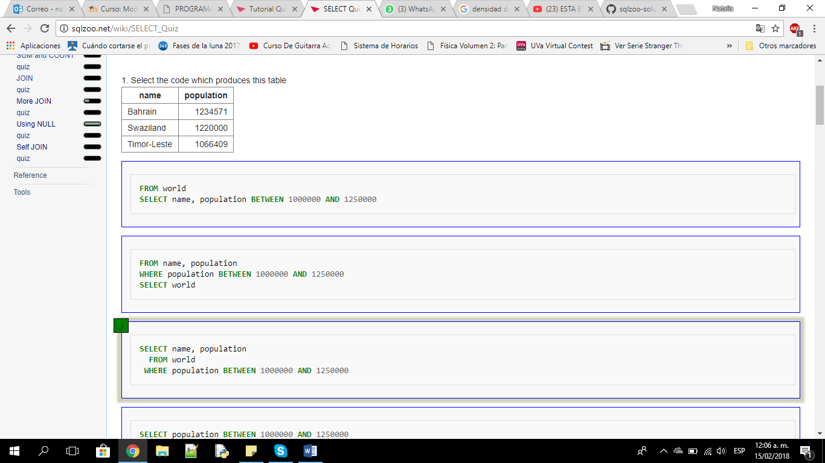

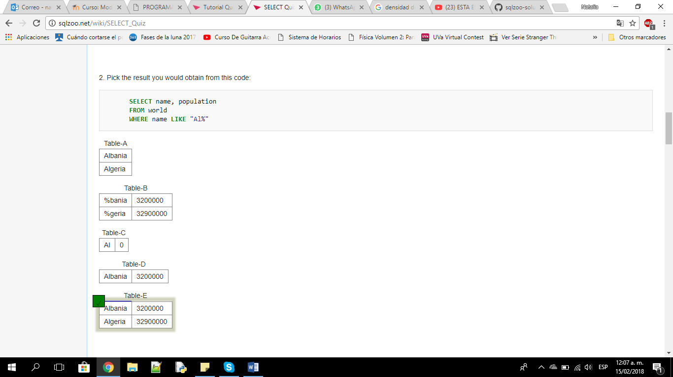

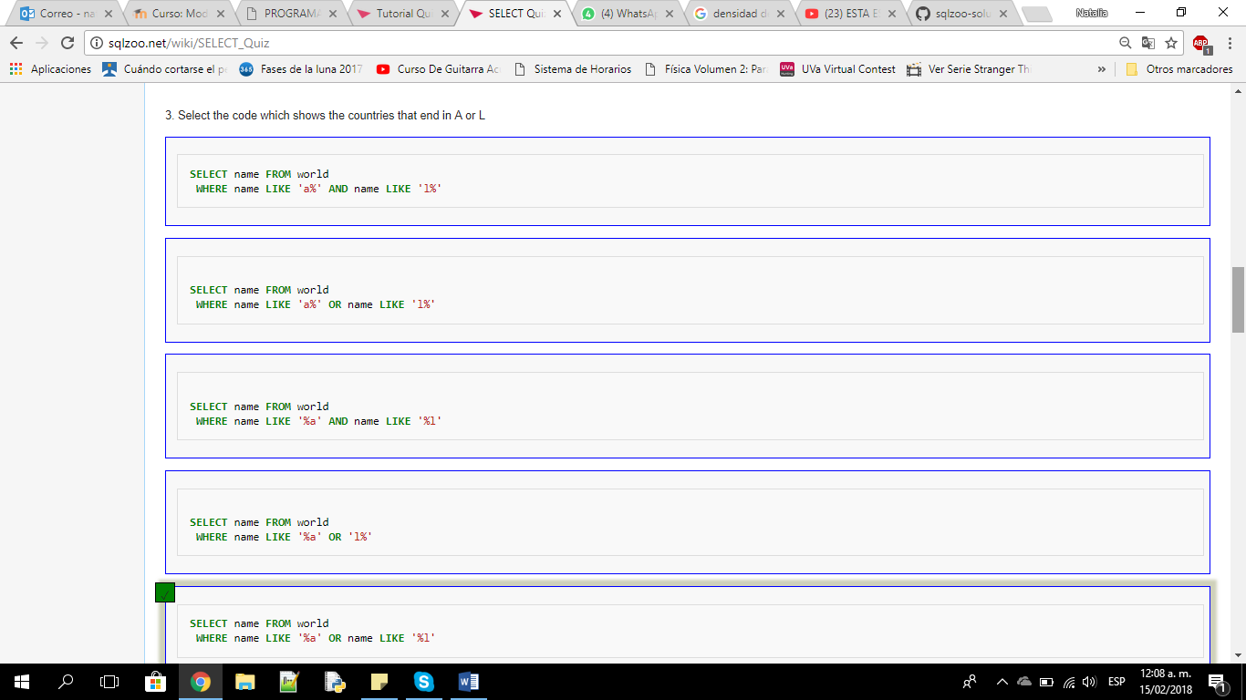

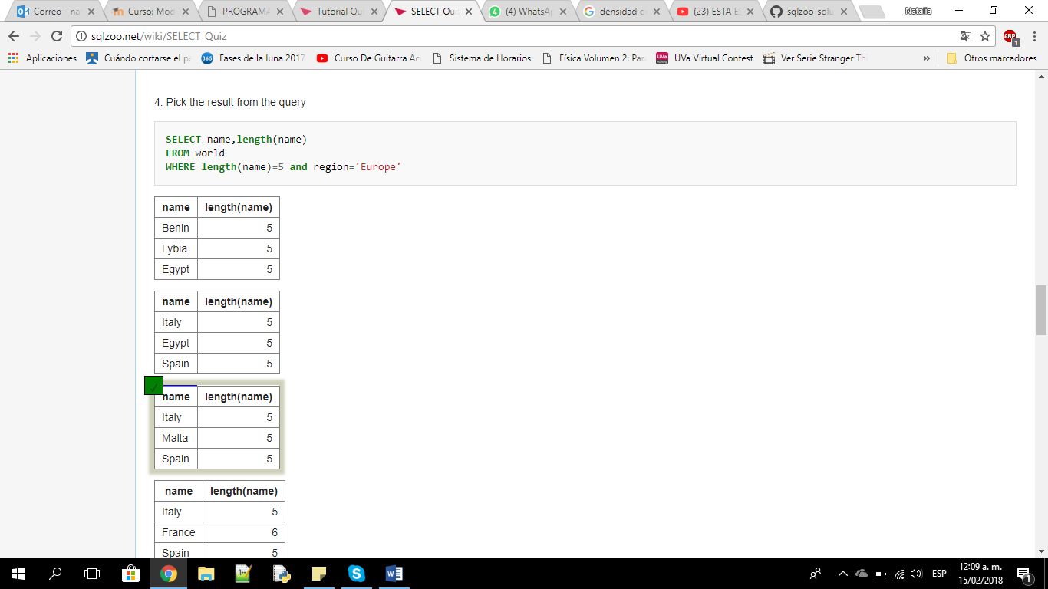

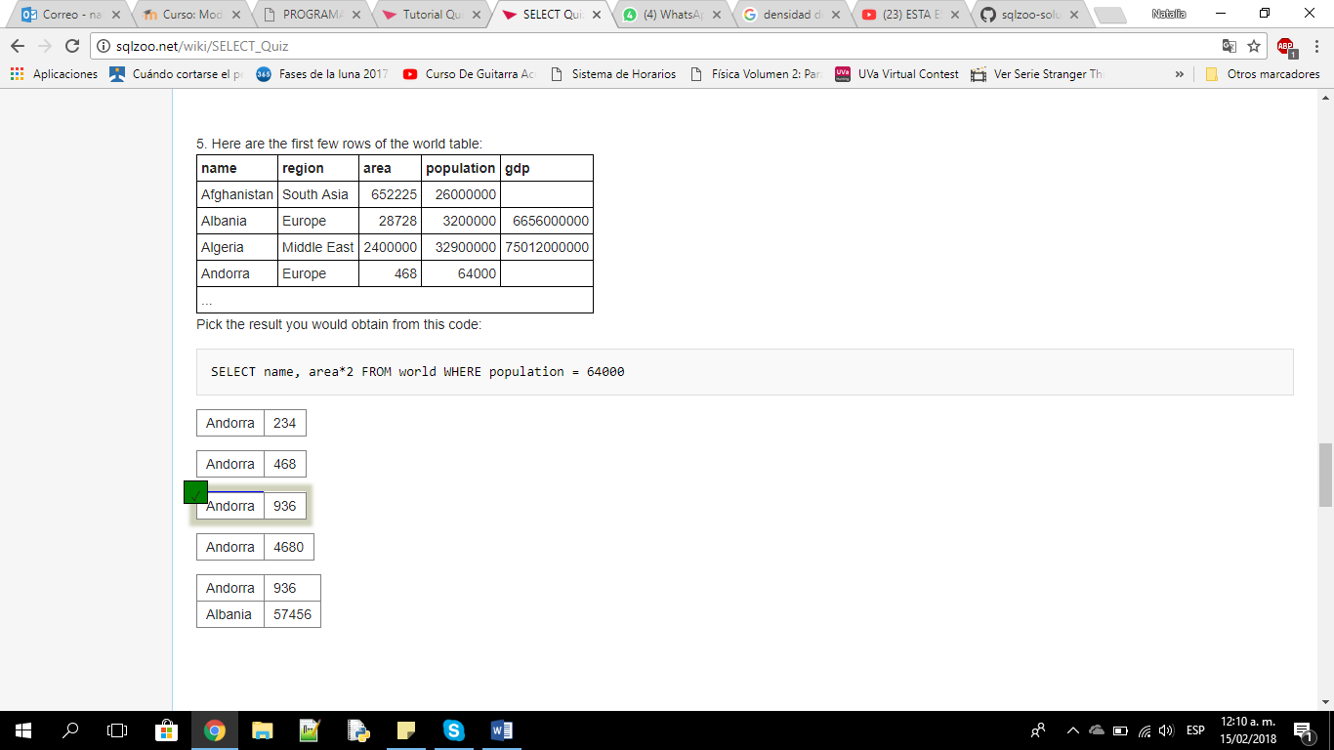

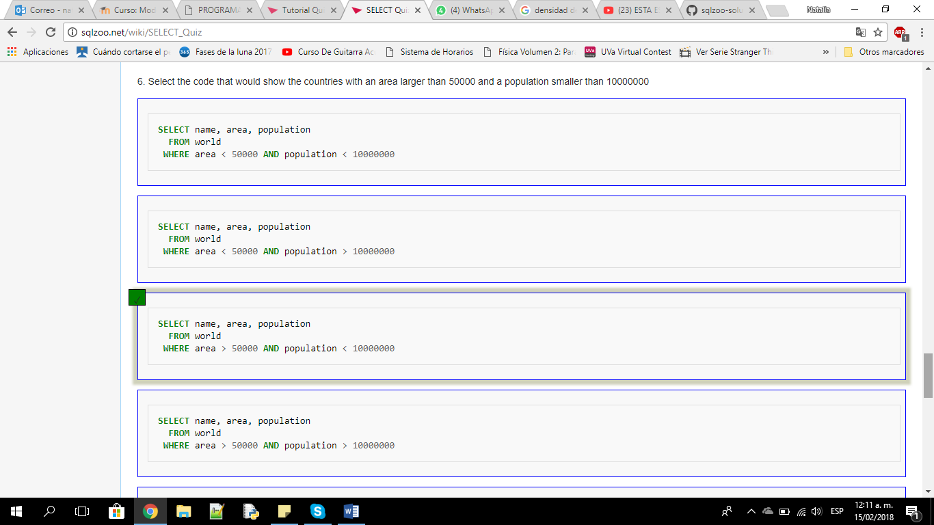

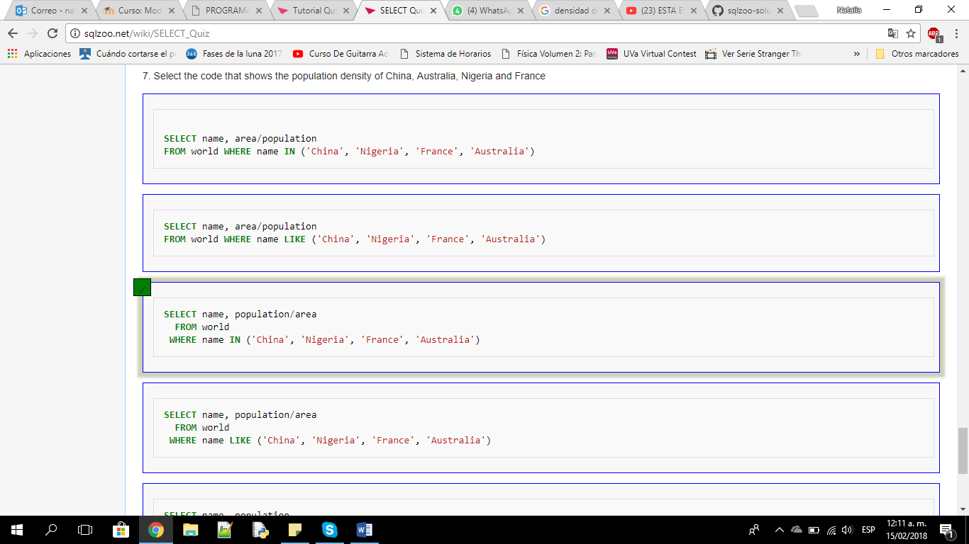

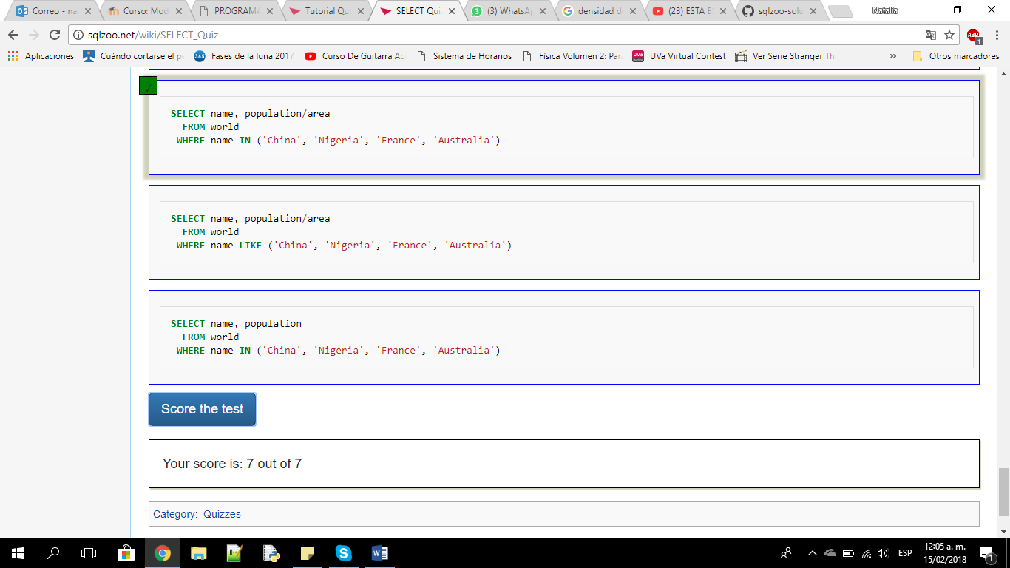

1. **BBC QUIZ**

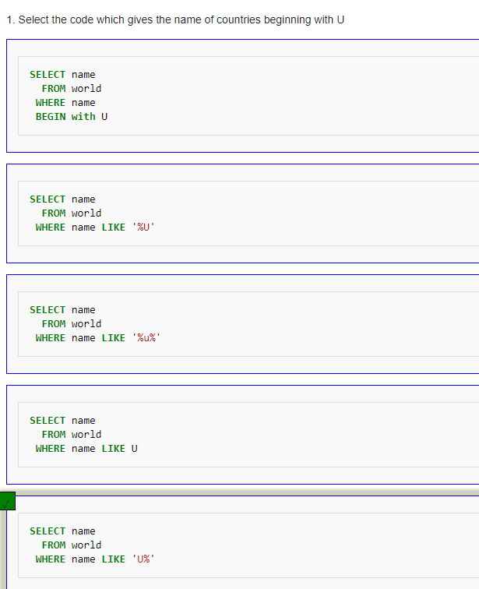

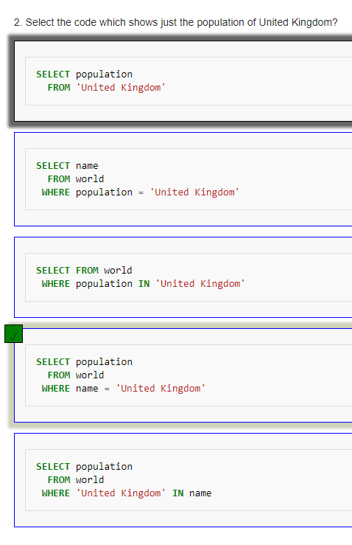

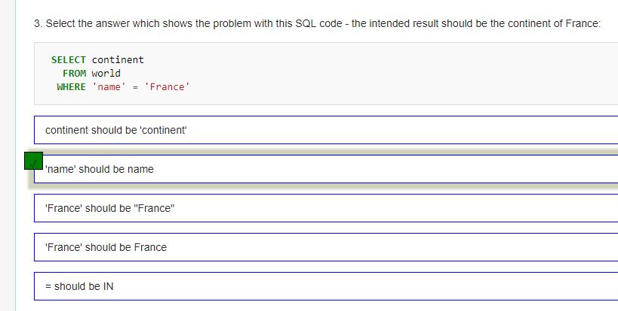

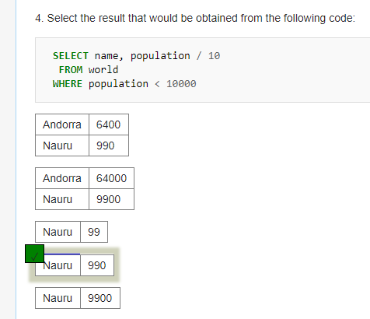

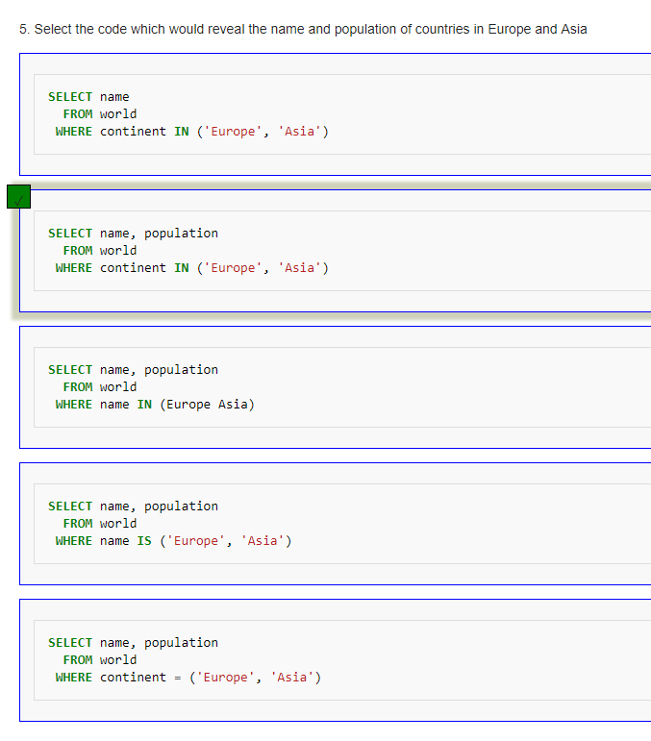

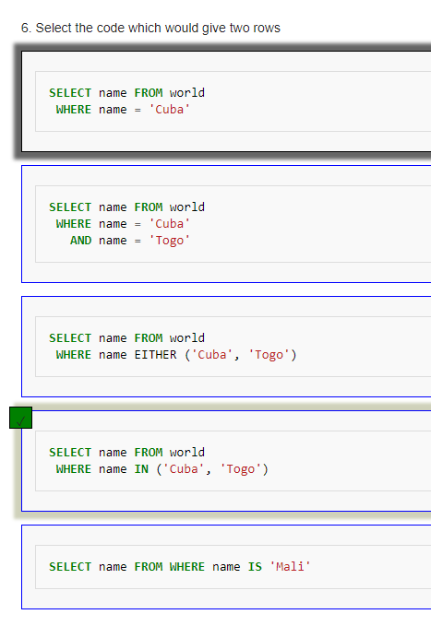

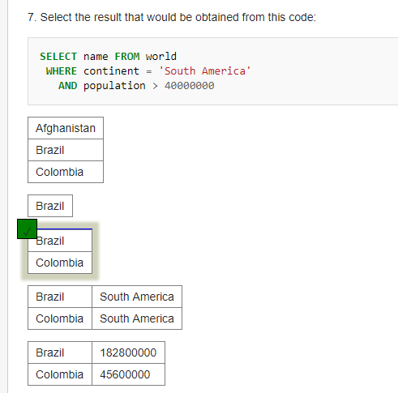

1. **Nobel Quiz**

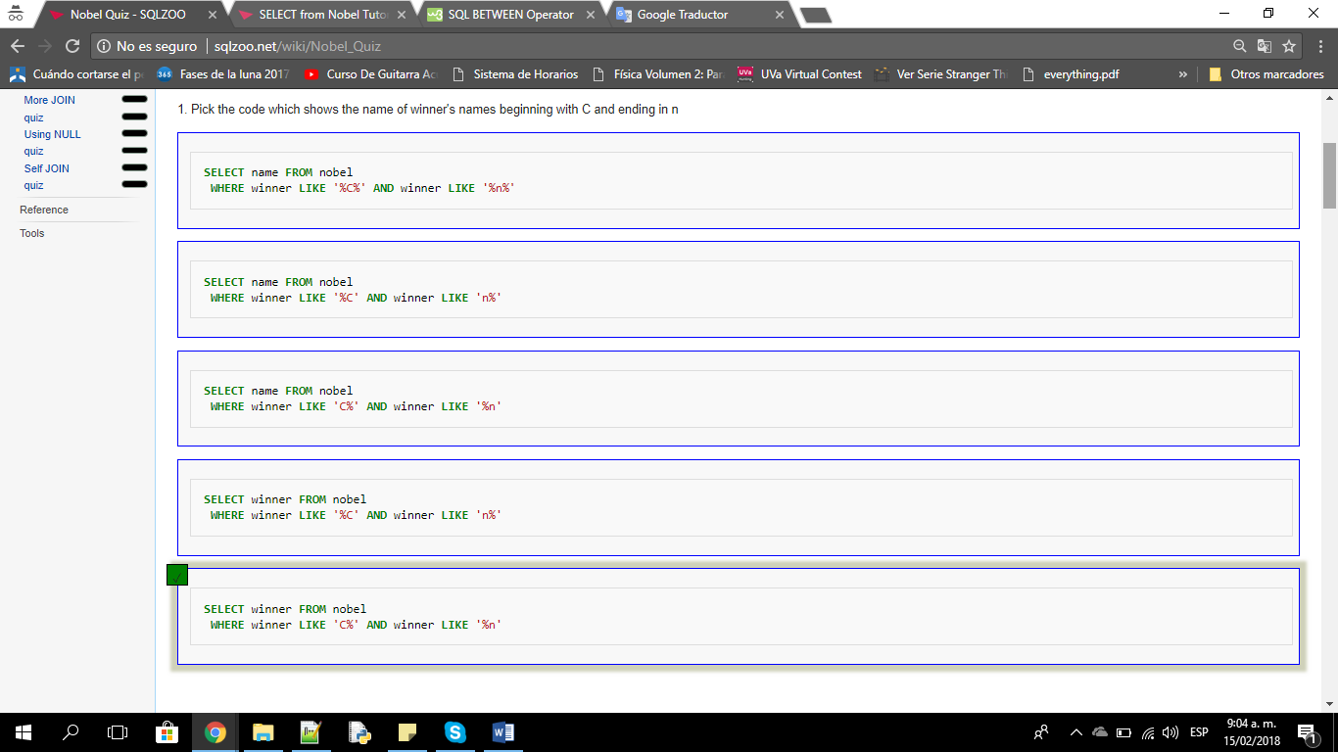

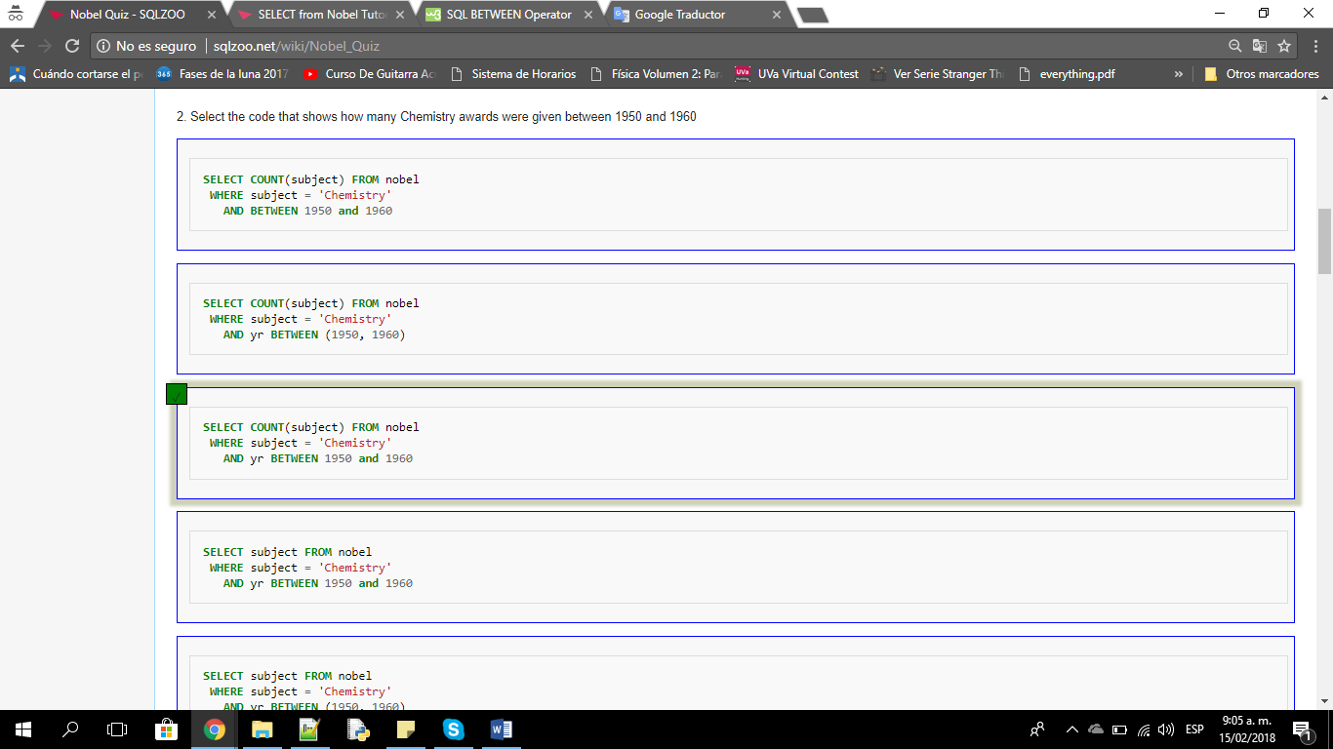

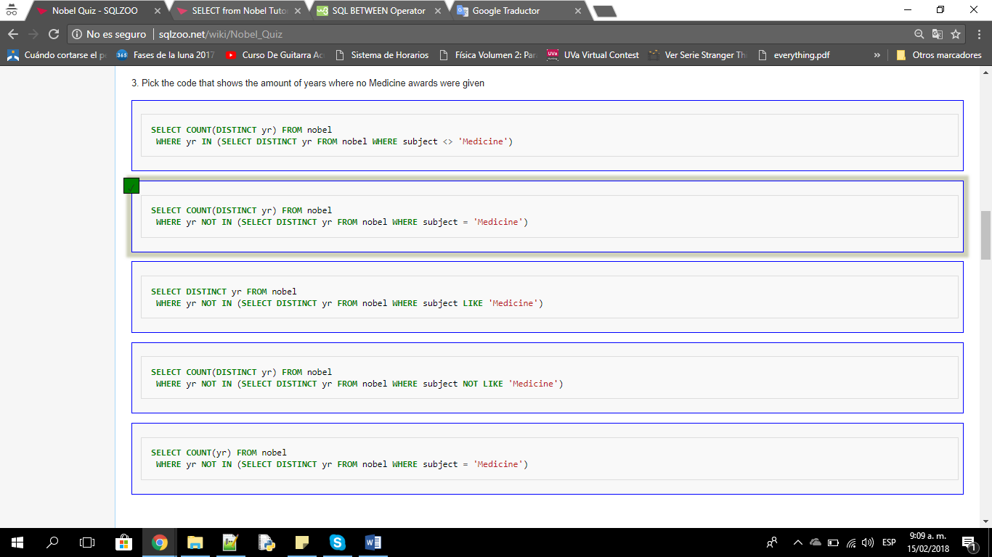

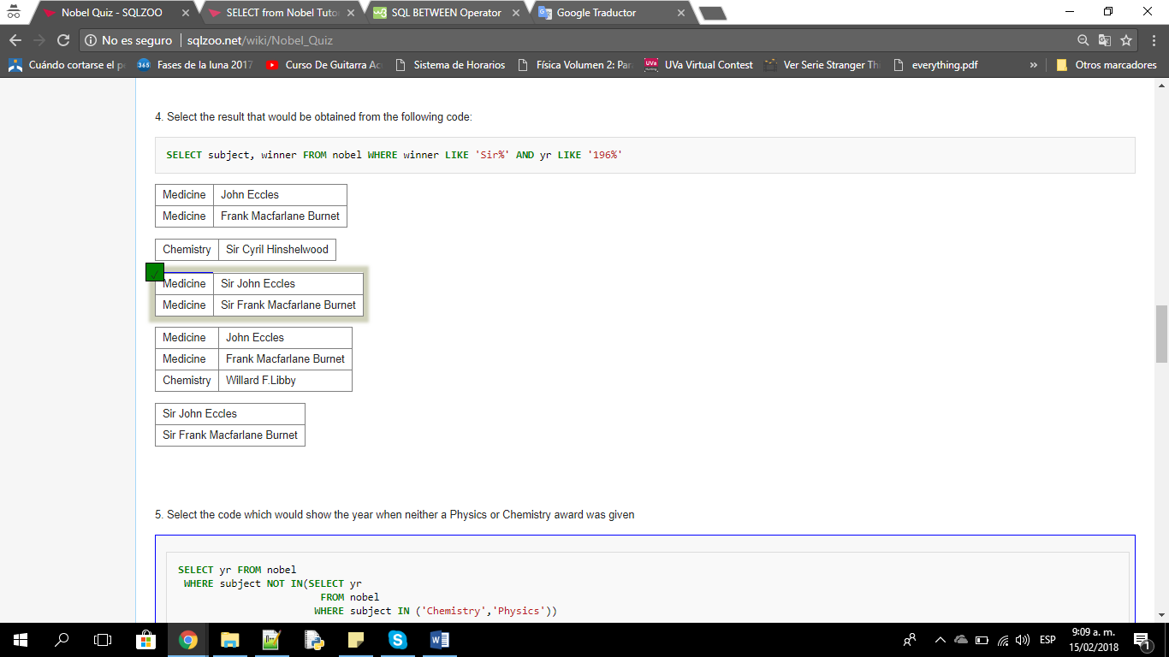

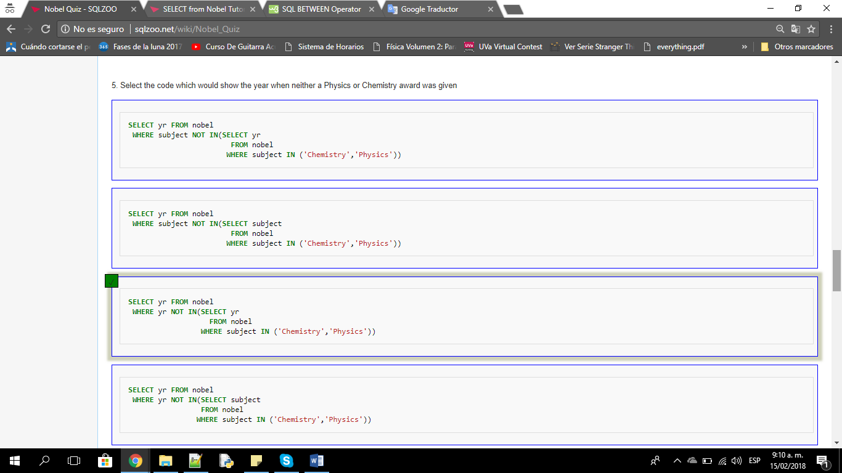

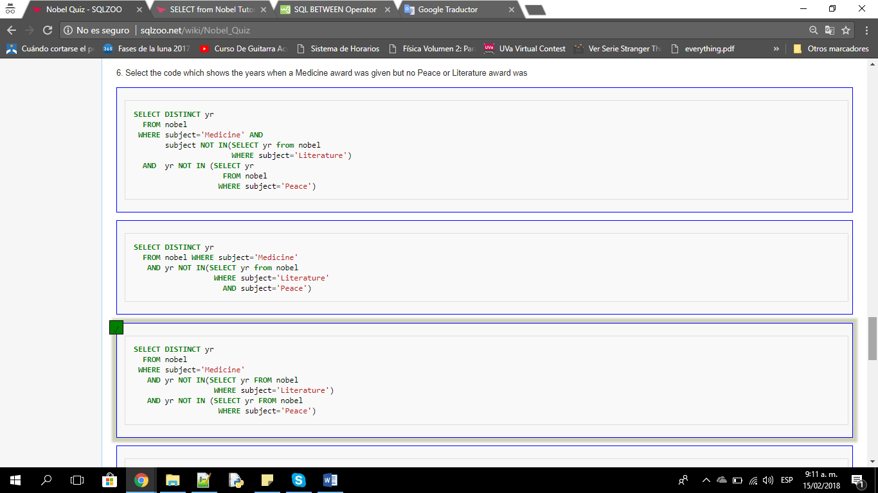

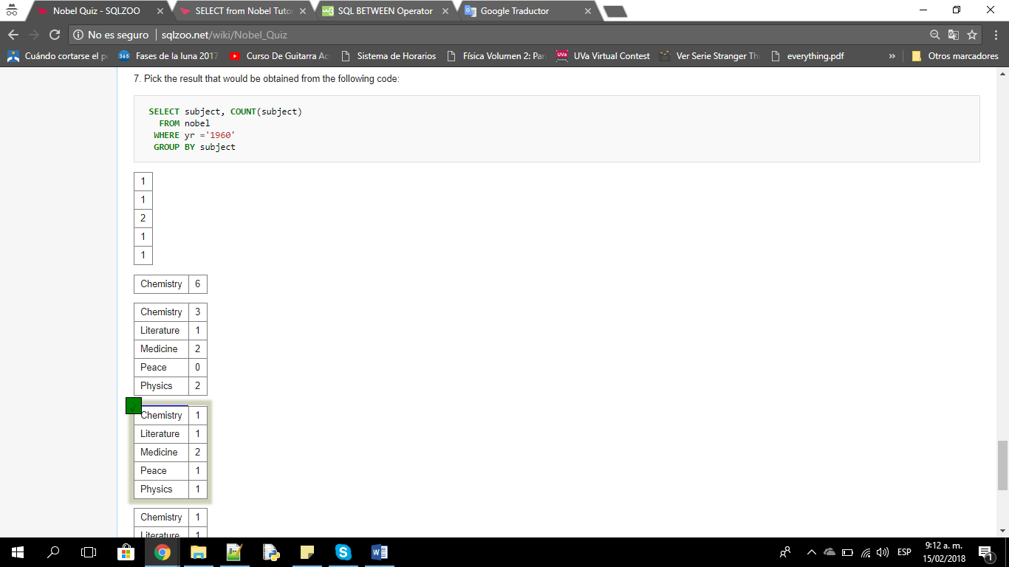

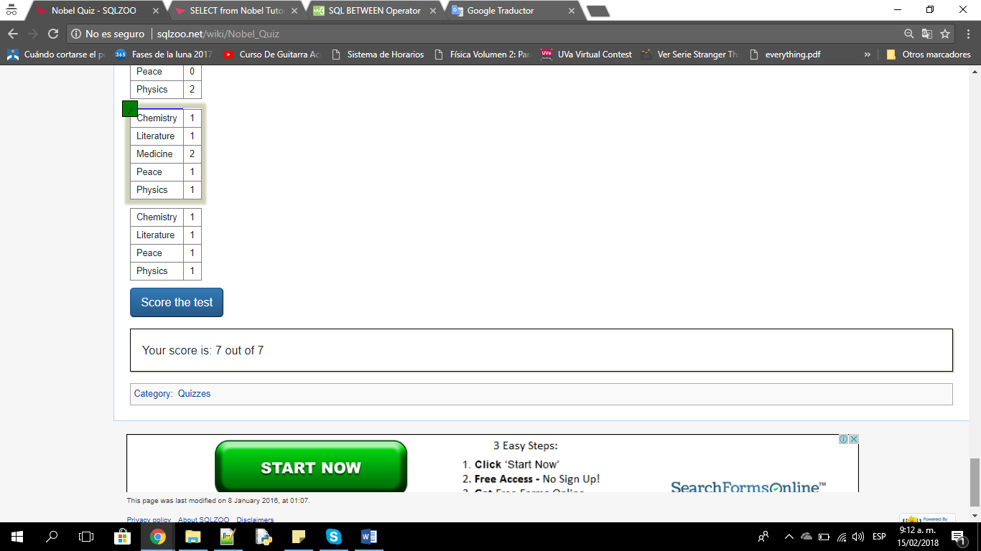

1. **Nested SELECT Quiz**

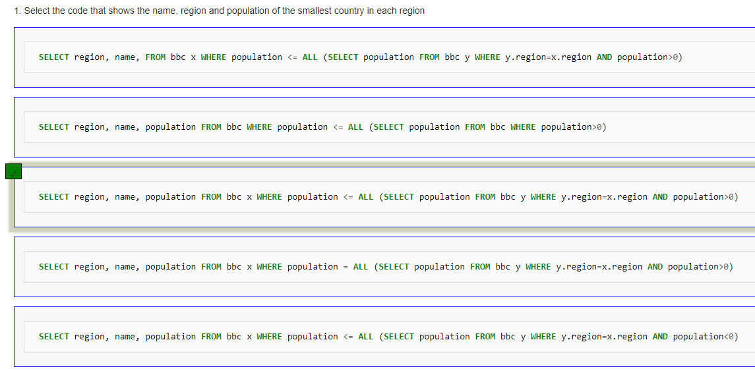

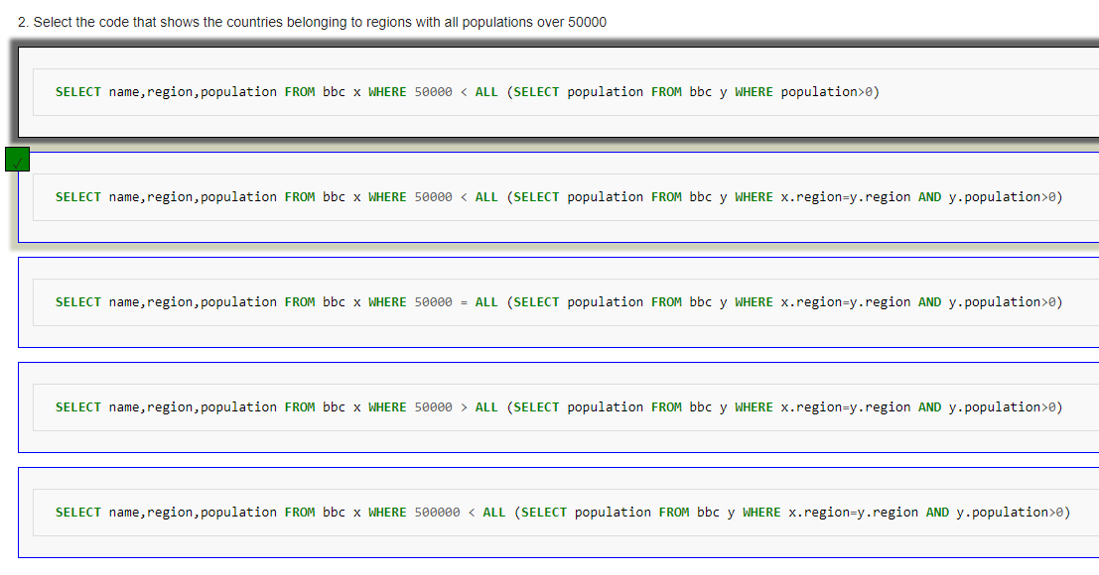

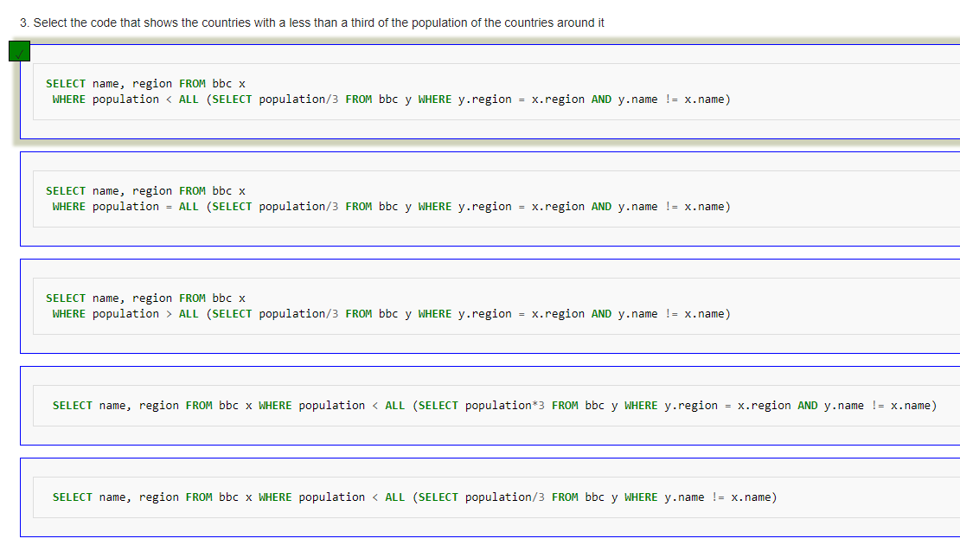

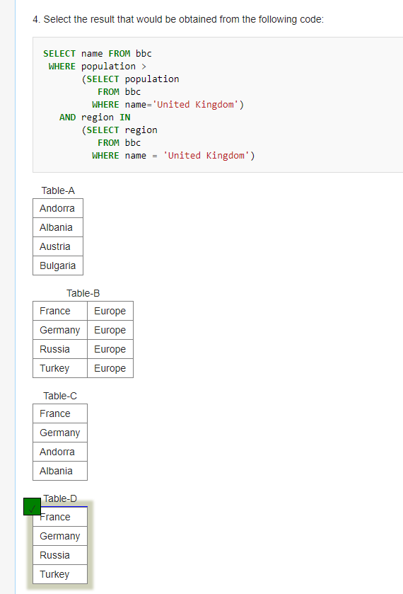

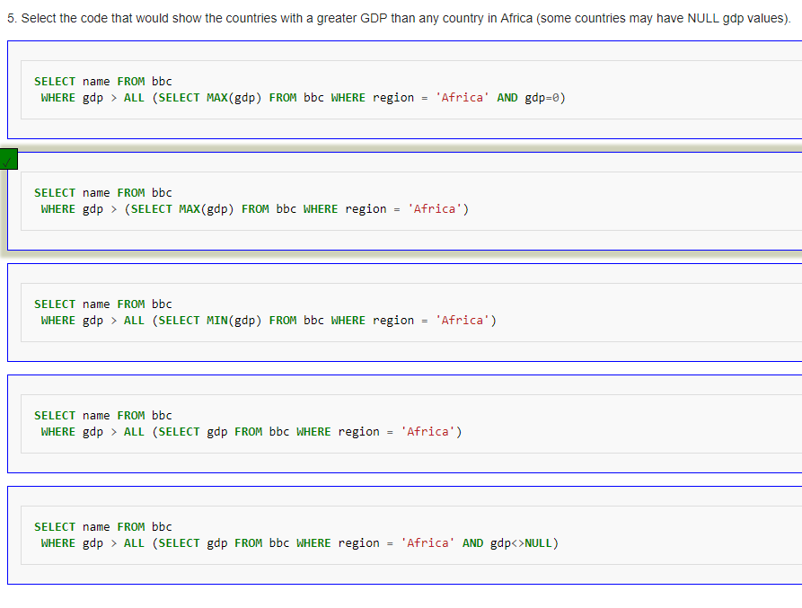

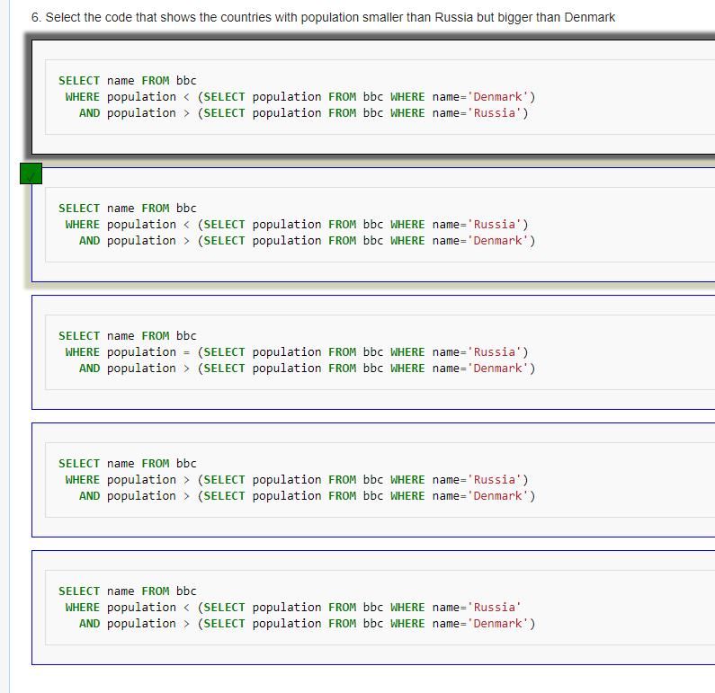

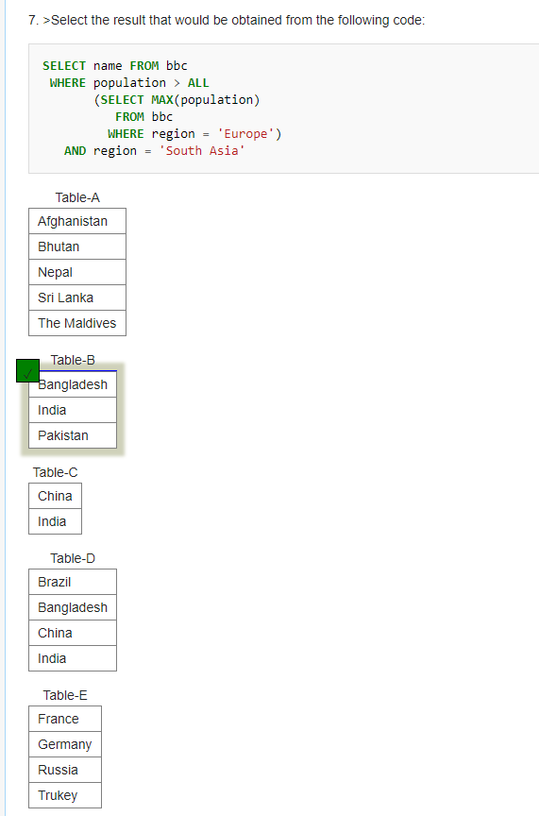

1. **SUM and COUNT Quiz**
2. **JOIN Quiz**

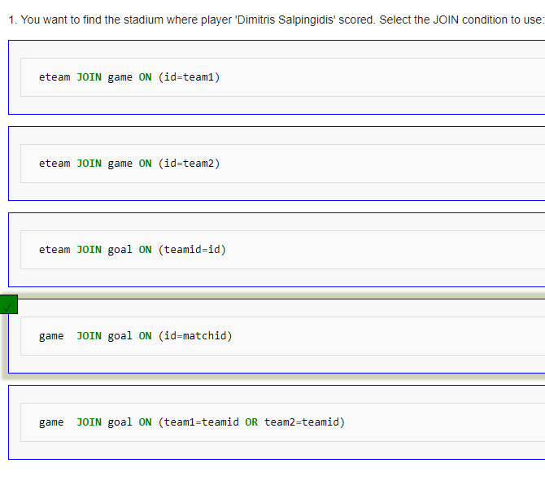

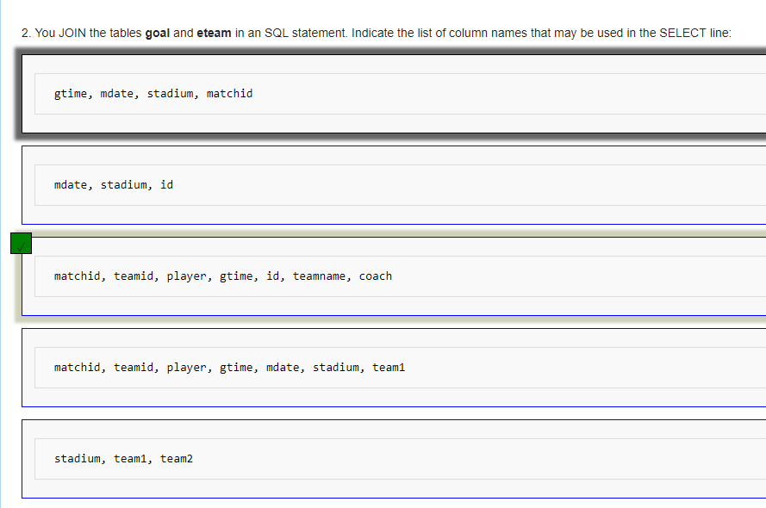

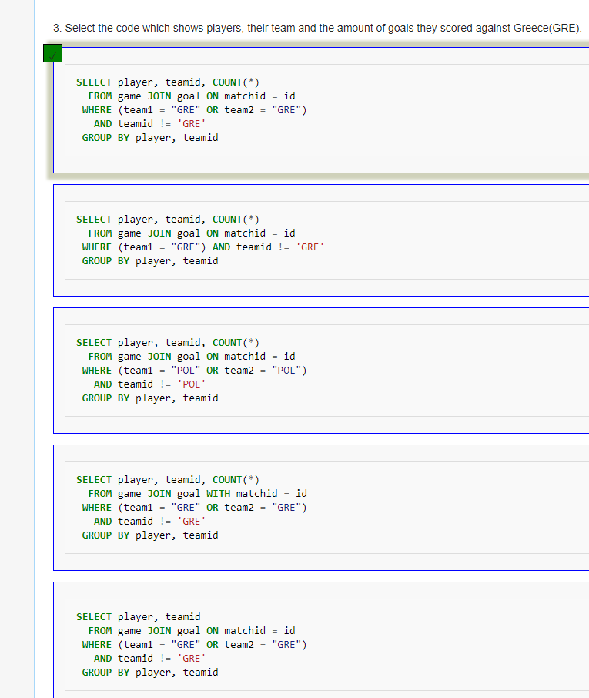

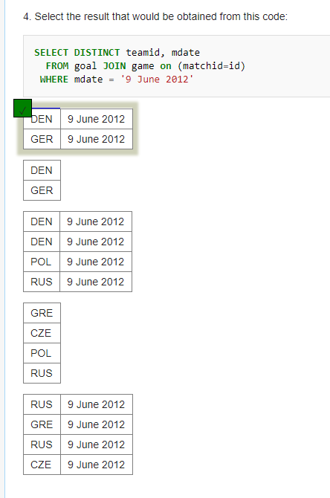

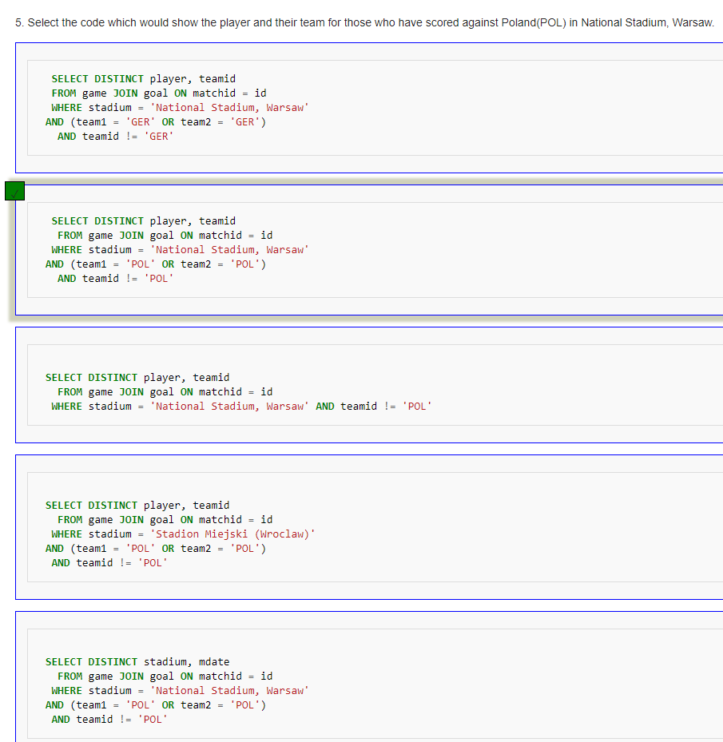

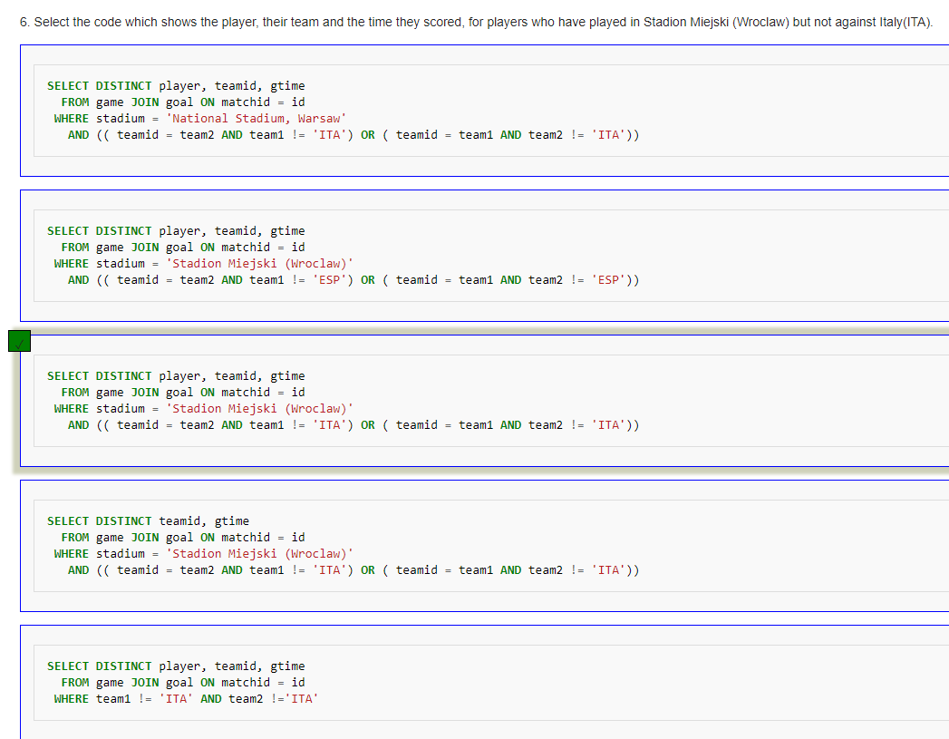

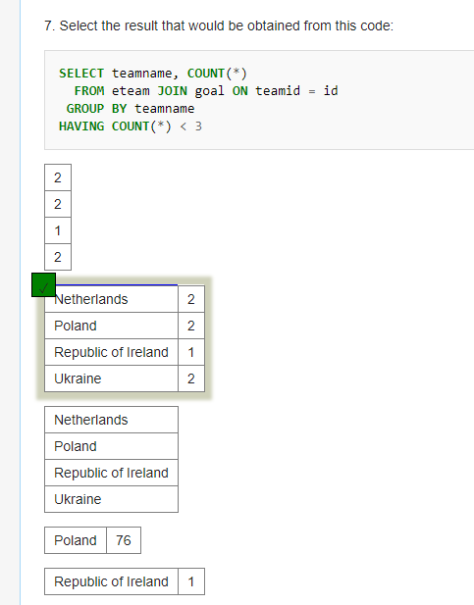

1. **JOIN Quiz 2**
2. **Using Null Quiz**

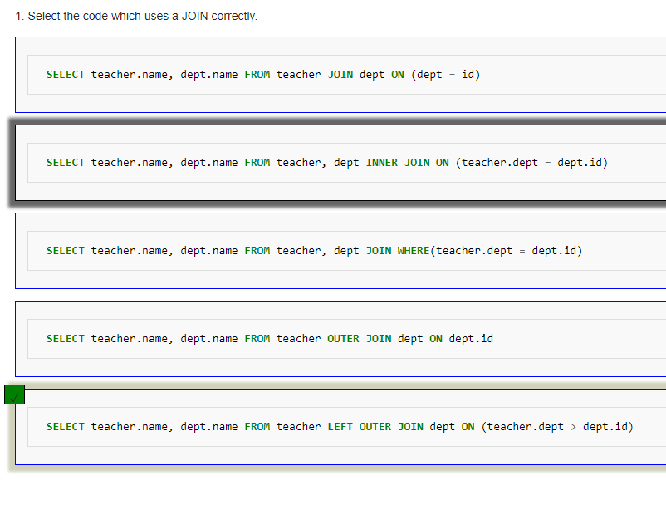

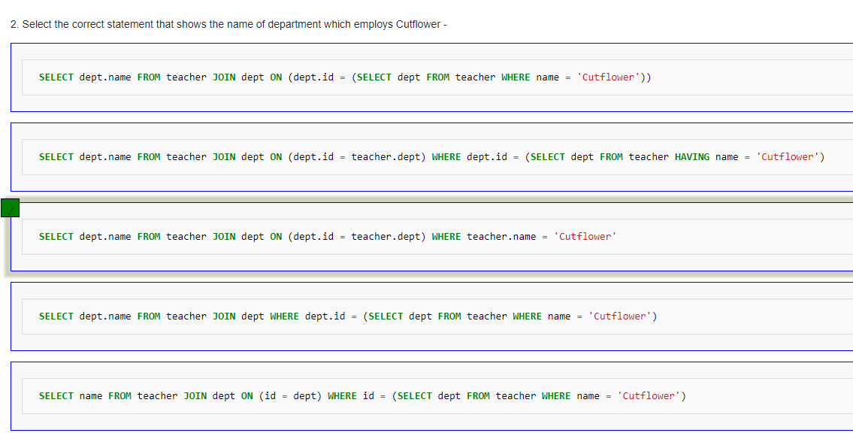

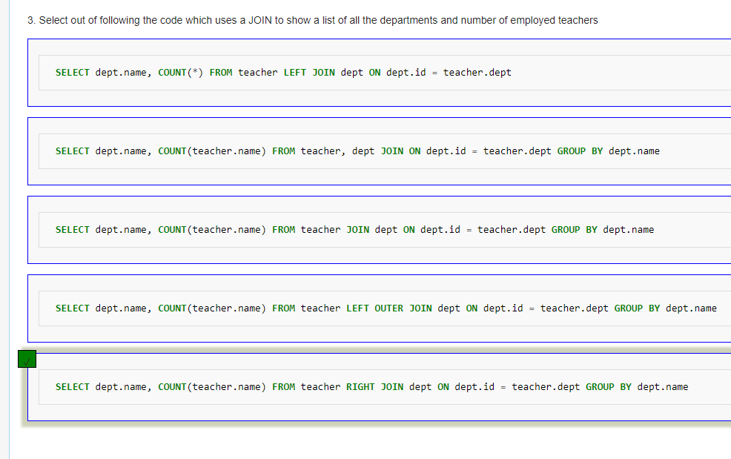

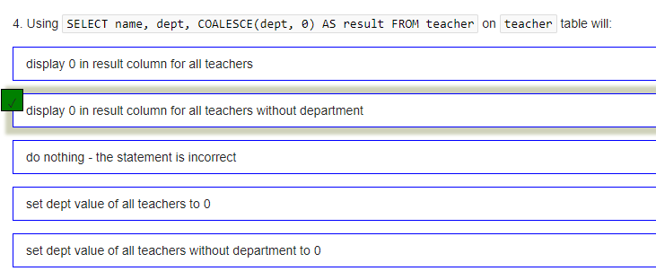

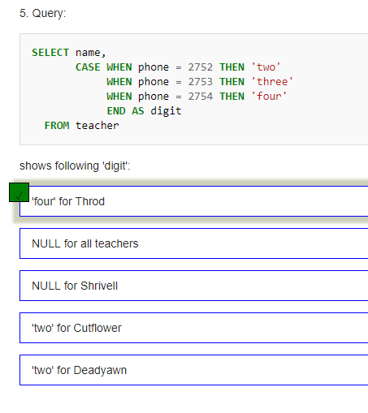

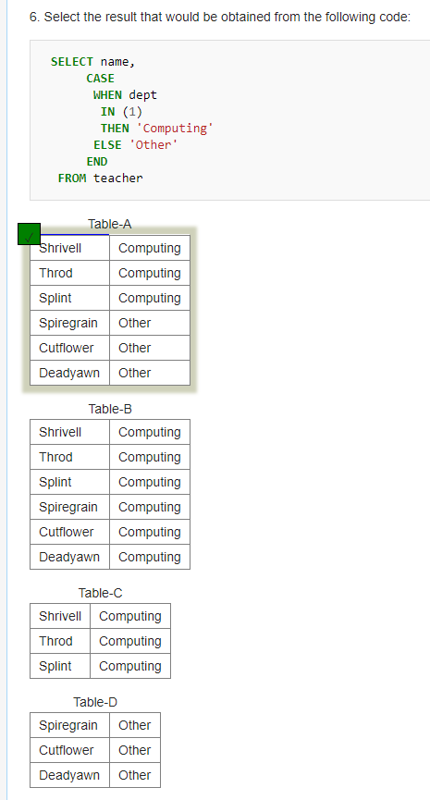

1. **Self join Quiz**

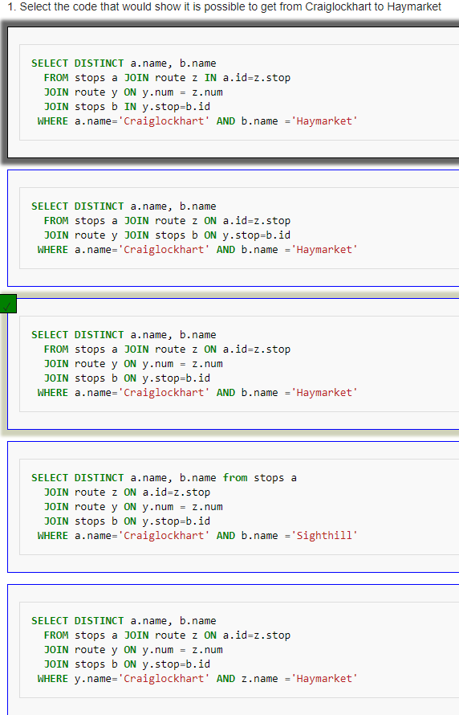

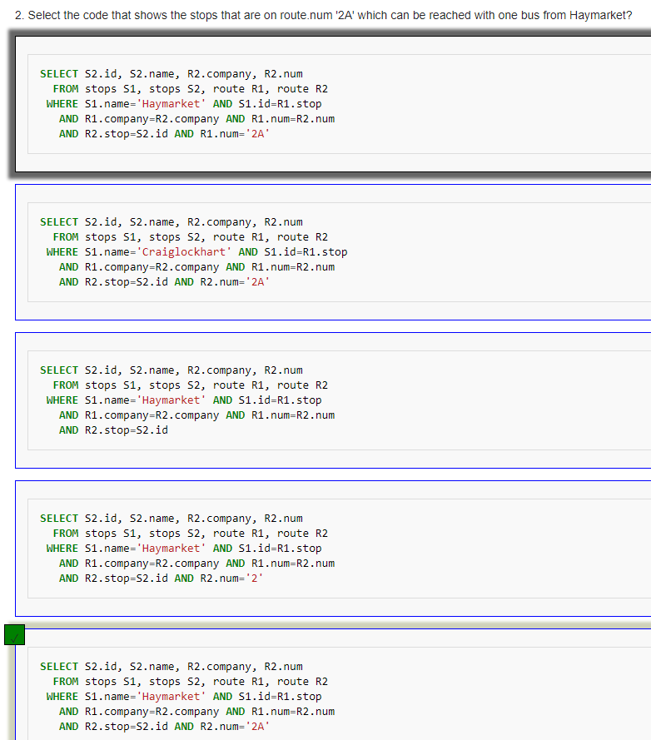

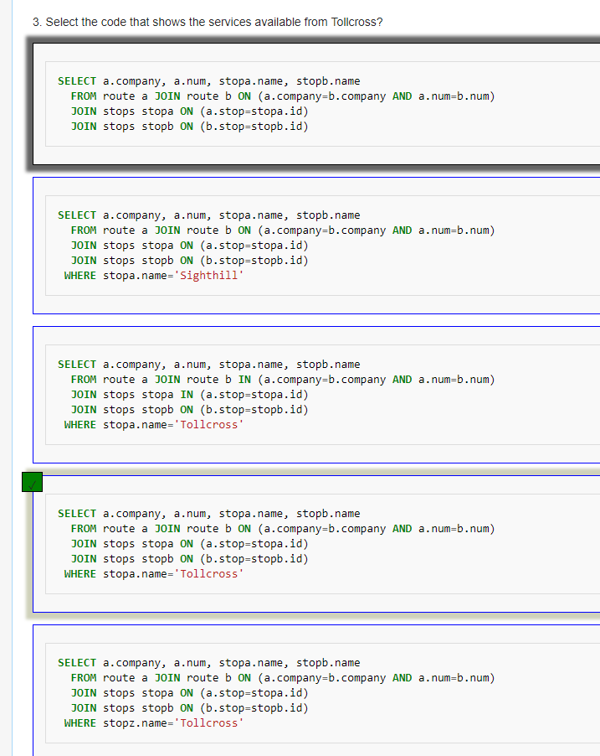

**UNION:**

* Mostrar la union de CustomerAddress y Customer
* **SELECT** CustomerID
* **FROM** CustomerAddress
* **UNION**
* **SELECT** CustomerID
* **FROM** Customer

**UNION ALL:**

* Mostrar la union all de CustomerAddress y Customer
* **SELECT** CustomerID
* **FROM** CustomerAddress
* **UNION** **ALL**
* **SELECT** CustomerID
* **FROM** Customer

**INTERSECT:**

* Realizar la intersección de SalesOrderDetail y SalesOrderHeader
* **SELECT** **\***
* **FROM** SalesOrderDetail
* **INTERSECT**
* **SELECT** **\***
* **FROM** SalesOrderHeader

**EXTRACT:**

* Extraer todas las ciudades Bothell
* **SELECT** City
* **FROM** Address
* **WHERE** City **=** 'Bothell'

**JUNTA INTERNA:**

1. Mostrar las ciudades de la unión de Address y CustomerAddress

**SELECT** City

**FROM** Address **INNER** **JOIN** CustomerAddress **ON** Address**.**AddressID**=**CustomerAddress**.**AddressID

1. Mostrar el primer nombre de la unión de CustomerAddress y Customer:

**SELECT** FirstName

**FROM** Customer **INNER** **JOIN** CustomerAddress **ON** Customer**.**CustomerID**=**CustomerAddress**.**CustomerID

**JUNTA EXTERNA**

1. Mostrar el primer nombre de la unión externa de CustomerAddress y Customer:

**SELECT** FirstName

**FROM** Customer **LEFT** **OUTER** **JOIN** CustomerAddress **ON** Customer**.**CustomerID**=**CustomerAddress**.**CustomerID

1. Mostrar las ciudades de la unión externa de Address y CustomerAddress

**SELECT** City

**FROM** Address **LEFT OUTER** **JOIN** CustomerAddress **ON** Address**.**AddressID**=**CustomerAddress**.**AddressID

**REFERENCIAS**

[1] <https://dev.mysql.com/doc/refman/5.7/en/working-with-null.html>