CURRICULUM VITAE
IMRAN BAIG 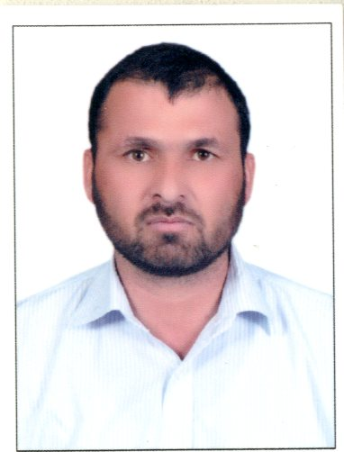
(SENIOR LAND SURVEYOR)
TOTAL EXPERIENCE: 10 + YEARS
Contact No: KSA +966-054-2170393 @ Pak: 0092-346-9589928
E. mail imranbaig2000@yahoo.com

CAREER OBJECTIVE:
My career objective is to acquire a suitable position in a market leader environment where an employer and employee relation based on mutual respect & recognition of professionalism.
Job Responsibilities:
• To perform survey works under the direction and guidance of the site PM or Engineer.
• To check Contractor’s establishment of the primary horizontal and vertical control points including reference points and reference ties for re-establishing the points in the field.
•Coordinate with the Sub Contractor’s Surveyors on work priorities and schedule.
• Check completed work for conformance to the line and grade required by the project plans in coordination with the inspector assigned in the work.
• Perform regular checks of the Contractor setting out to verify proper execution and accuracy.
• To maintain equipment in proper condition and perform frequent calibration checks.
• To ensure that the works are being constructed to the latest construction and sharp drawings
• Record all measurements and calculations etc neatly and accurately in field books as the work progress
• Traversing + Calculation
• Topographic Survey
• All type of Layout for Roads, Building & Tower
• Prepare Layout of underground utilities
• To prepare survey Inspections for consultant
• Transfer grid lines horizontally and vertically
• To arrange all necessary markings for structural and finishing works
• Responsible in planning organizing and directing works of one or more survey parties.

EXPERIENCE:

Employer Name : Saudi Oger Contracting Company Ltd (Riyadh KSA)
Projects : Royal Family Luxury Hotel, Ministry of Interior (KAP2)
: National Guard Housing Project (SANG)
Designation : Sr, Land Surveyor
: Jan 2010 to till date
Employer Name : Robust Contracting Company L.L.C. (U.A.E)
Project : Green Community West (DIP)
: (Villas, Swimming Pools & Roads Project)
Designation : Land Surveyor
: Dec’2006 to Feb 2009

Employer Name : Capital Survey & Road Mapping L.L.C (U.A.E)
Project : Metro Project Dubai “Union Square” Underground Station
Designation : Land Surveyor
Nov 2005 to Dec 2006.

Employer Name : Emirates Roads Contracting Company L.L.C (U.A.E)
Project : Maintenance Improvement & Upgrading of Roads &
: Culverts of Ras-Al-Khaimah Roads
Designation : Asst. Surveyor
Jan 2003 to Sep 2005
Instrument Used

Nikon Total Station; (352,552)
Topcon Total Station; (N7500, GPT7502)
Leica Total Station; (TCR407, 303, 1203, 1203+)
GPS of Topcon FC200
GPS of Leica GPS1200
All Kind of Auto levels

Special Skills:
- Fully conversant with the job of Senior Land Surveyor
- Excellent communication and interpersonal skill and verbal
- Strong negotiator, demonstrate ability to work with people
- From lower management to the Consultant

Academic Qualification:

- Intermediate Certificate from Board of Intermediate & Secondary Education Abbott bad
- Secondary School Certificate from Board of Intermediate & Secondary Education Abbott bad
Professional Qualification & Computer Skills:

- One Year Diploma in Survey from Punjab Board (Pakistan)
- One Year Diploma in Auto Cad (2D & 3D)
- Liscad, MS Excel,& Civil 3D

Personal Details

Father’s Name : Safran Baig

Date of Birth : 14 March 1981

Nationality : Pakistani

Religion : Islam

Passport no : AB3927262

Languages : Urdu, Arabic & English

Marital Status : Married

Drive. License : KSA

