Raúl Ibáñez Solas
Curriculum Vitae

Date of birth: 20/10/1986

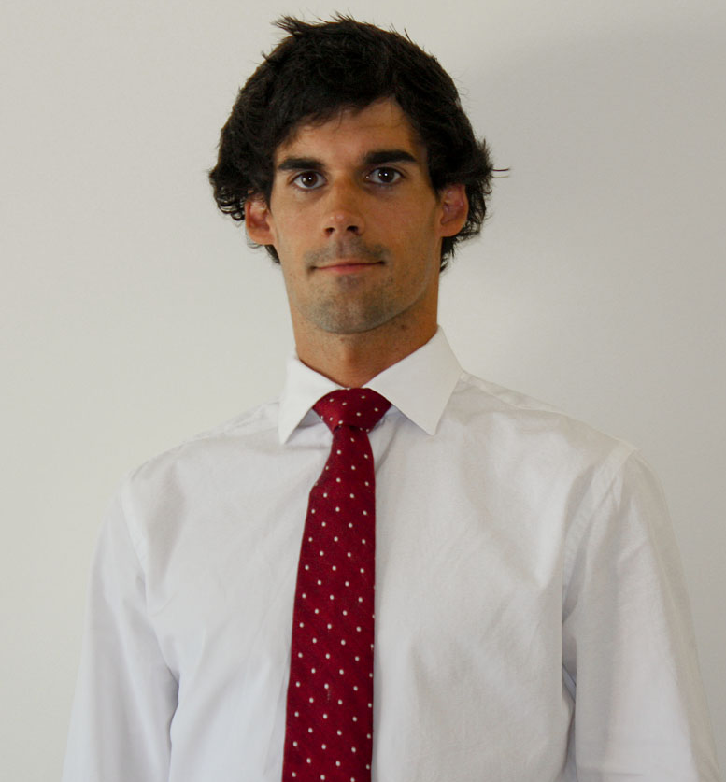
Adress: C/ Zaldukanpo, 10, Sopelana,
48600, Vizcaya, Spain.

Contact: Home: +34 94 676 05 15,
Cell phone: +34 609 976 615
E-mail: r.ibanez001@gmail.com

Profile

Enthusiastic, professional and ambitious GNSS engineer with 2 years of experience in aerospace sector, mostly in the GNSS area involved in Galileo project and it’s applications to the air navigation.

Summary of qualifications

- Working experience………………………………………………..............2012 / 2013

GMV Aerospace and Defence department
From 09/01/2012 until 08/07/2013 I have been working at GMV as GNSS system engineer involved in the GNSS Galileo project in collaboration with ESA (European Space Agency), where the most relevant tasks were:
- Data analysis of the results obtained from satellites.
- Statistical analysis (Student’s t-test, analysis of variance, time series, Mean square weighted deviation, etc.) of the results obtained from satellites performances.
- Improving and developing the algorithms in charge of the satellites orbit determination and time synchronization (Kalman filter, RX algorithm, etc.)
- Team management for distributing tasks among the team members, scheduling, documents review.
- Algorithms improvements implementation. Programming experience.
- Attending to meetings with the main clients and internal meetings for discussing the future tasks and results presentation.
- GNSS applications. SESAR, PBN, ATM airspace.

- Internships and projects ……………………………………………………...2011

Internship at Tecnalia
I accomplished 6 months of internships in Tecnalia involved in the ESA (European Space Agency) BETs project, where the most relevant tasks were:
- Making the study of the state of the art and bibliography for the new Tether design and in order to have better comprehension about materials and environment.
- Materials study for fulfilling the client requirements.
- Attending to the meetings for external advice and meeting with the rest of the consortium.
- Lab testing and presenting of the documentation.

Final project for the master
“New designs for electrodynamic tethers”. It was accomplished in Tecnalia Research & Innovation, directed by Francisco Estensoro.
This project was made for the BETs project (http://www.thebetsproject.com/)

- Master’s degree in Science and Space Technology in the Escuela Técnica Superior de Ingenieros de Bilbao…………………….……………………...2011

Scientific part: Plasma physics
Astrodynamics
Non-destructive testing
Materials I
Materials II
Optics
Space interferometry

Technological part: Project Management
Navigation systems
Radio
Energy sources for aircrafts
Sensors and detectors
Data processing
Mechanical structures
Propulsion systems (for aircrafts and space crafts:
Turbines, nozzles, internal architecture, thermodynamics)

Radar project entitled “Radar study: antennas, radar types and future technologies” in collaboration with the Department of Electronics and Telecommunications, directed by Dr. David de la Vega.

- Physics degree in the Universidad del País Vasco…………………………...2010

The final project entitled “Research of the atmospheric waves in Saturn using images from Cassini spacecraft” was made in collaboration with the department of applied physics of the Engineering School of Bilbao, directed by Dr. Ricardo Hueso Alonso.

Professional skills

Accurate, determined, organized, strong adaptability, people-oriented, teamwork aptitude, effective communicator.

Engineering knowledge

- GNSS. Galileo, GPS, SBAS. Applications in air navigation
- Design, development and verification of algorithms
- Aerospace and Space technology
- Ranging and positioning techniques, signal processing techniques
- Digital navigation receivers

Languages

- English C1 level, Certificate in Advanced English.
- French B2 level
- Spanish Mother tongue
- Basque C1 Level

Other skills

Software
- Advanced level in the most common office software and operating systems (Windows, UNIX, Microsoft Office)
- Advanced level in Bash & Shell, Matlab
- Intermediate level in Fortran, C/C++, Eclipse
- Basic level in SQL, XML

Others
- Driving license (International)
- Nine years of violin and orchestra

