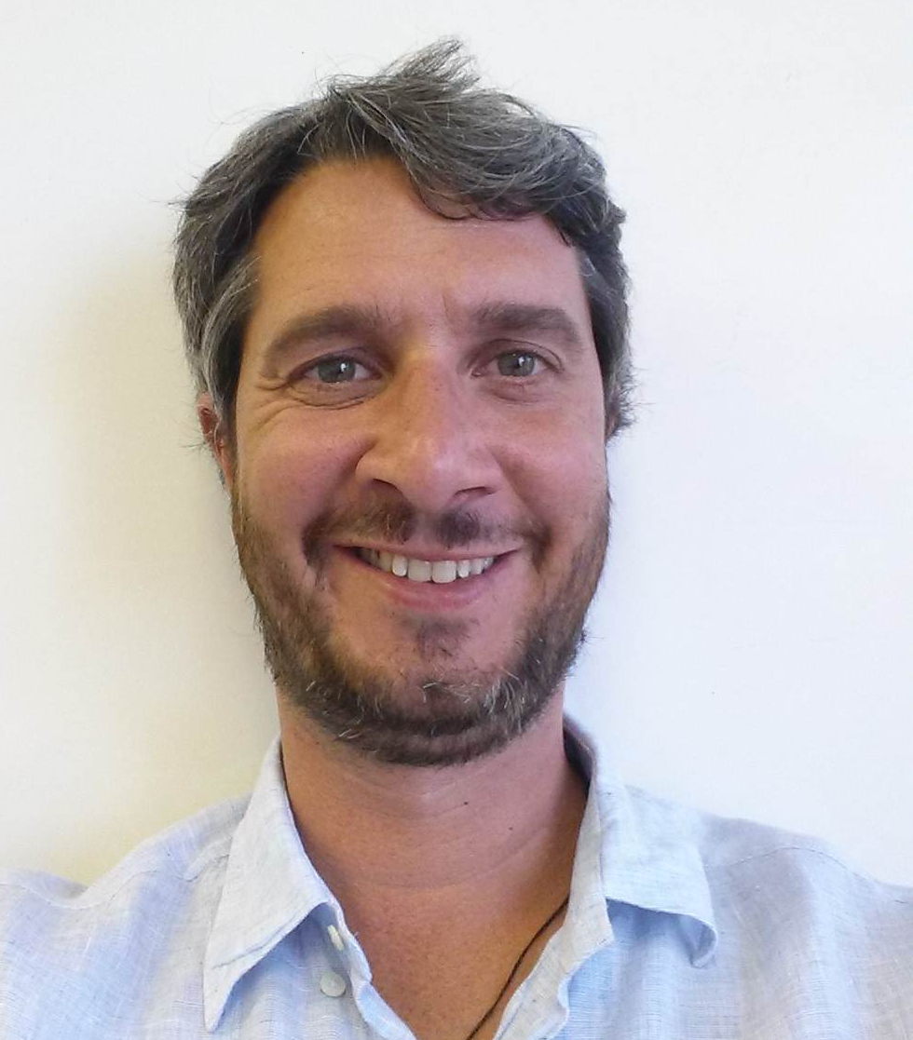
CURRICULUM VITAE
NAME: Robert Colombo Llimona
DATE OF BIRTH: Barcelona, 12 November 1975, SPAIN
CURRENT ADDRESS: SQS 312 Bl B Brasilia DF, Brasil
MOBILE: +55 61 91245974
E. MAIL: robertcolombo@gmail.com
SKYPE: robert_vram
ABSTRACT:
Experience in Coordination and management of international projects in the field of Road Safety, Transportation, Public Health and Geographic Information Systems with experience in developing countries in Africa and Latin America. Funds, activities and staff management, activity implementation and evaluation, diplomacy and negotiation with partners (national and international)

RELEVANT PROFESSINAL EXPERIENCE:
August/12-present Program coordinator/manager. International Program Officer on Road Safety. World Health Organization (WHO/PAHO) Brasiliam Brasil. Coordination and project management, budget drafting, monitoring and evaluation of activities, coordination of teams, planning and implementation of activities. Negotiation at national and local government level as well as donor relations and international organization liaising. Advocay activities, social marketing activities, technical assessment on RS .
Reference:
Dr. Joaquin Molina (WHO Representative in Brasil).
SEN, Lote 19 CEP Brasilia-DF 70.800-400
Tel: (+55) 61 98512056
e.mail: molinajo@paho.org

May/10-August/12 GIS Technical officer/project manager on DRR Population Vulnerability and Risk Analysis & Mapping (VRAM) and Disaster Risk Reduction for populations. Geographic Information systems specialist. World Health Organization (WHO) Tunis, Tunisia. Technical support and project management on the implementation of the VRAM analysis in countries (Oman, Sudan, Mexico, Kazakhstan, Kenya, Nigeria). Development of GIS based protocols, databases and methods for conducting geographically based risk assessments.

Reference:
Dr. Altaf Musani (Director of WHO WMC Tunis)
Rue Developement s/n Tunis 1003, Tunis
Tel: (+216) 71155601
e.mail: musania@emro.who.int

Feb/08-May/10 Project manager/Surveillance, monitoring, analysis and mapping and DRR analysis and GIS. Research and documentation of population livelihoods, urban settlements, human habitats (NCD), living patterns and organization of settlements, infrastructures and transport/traffic networks. (multiple locations on the field (35)

Dr. Steeve Ebener
Po Box 795,PC 114, Muscat - Sultanate of Oman
Tel:(+968)96939465
e.mail:steeve.ebener@gaia-geosystems.org
Oct/07-Jan/08 GIS analysts, UNV-United Nations (UN). United Nations Mission in Congo (MONUC). Engineering Department. Democratic Republic of Congo. GIS Analyst. Map production, field survey development, troop training and workshop facilitator. Project Development on road navigation tool.

Reference:
Mr. Diego Gonzalez (MONUC Program Officer)
Rue des Aviateurs s/n Kinshasa), DR Congo
Tel : (+243) 998 319 630
e.mail: iberdiego@gmail.com

Oct/05-Oct/07 Project manager on transport and urban analysi., traffic simulators and transport systems Technical officer Centre of Transport innovation (CENIT) UPC, Barcelona Spain
Implementation of GIS structure on-site. Transportation planning on diverse cities in Spain. Evaluation of city interventions.Map production and interdepartmental link on GIS applications. Monitoring and analysis of urban sprawl and urban evolution.

Jun/04-Oct/05 Project manager traffic, Transport, urban space management and GIS. Researcher-PhD (as a Fellow of the MCYT FPI) at the Centre for Land Policy and Valuations, CPSV, UPC.
Research on urban sprawl models for the city of Barcelona, transportation networks and land valuations. GIS modelling with the use of Remote Sensing. Map production and database development. Presented dissertation and approved, FPI grant from the Ministry of Science and Technology.

Mar/03-Jun/04 Project Associate on Traffic, transportation, urban indicators and geographic information systems, Local Urban Ecology Agency of Barcelona (BCN Ecology).
Project researcher on Traffic modelling, in charge of calculating the urban compactness and mobility indicators for the city of Barcelona, monitoring urban spaces and evolutions. GIS specialist and focal point .

May/01-Oct/02 Junior Traffic engineer/project manager. Modelling Specialist Models and simulations of traffic data collection and editor-group studies. Doymo/SET. Manager Assistant for the departments of Andorra and Palma de Mallorca. Development of mobility management projects, comprehensive plans for mobility, temporary solutions to traffic.

Mar/00-May/01 Researcher on Transports and traffic, mobility and transport for the Processing and Research for the Atlas of the Pyrenees (published 2001). Institute of Territorial Studies. Universitat Pompeu Fabra. Barcelona
LANGUAGES:
- SPANISH/CATALAN Mother tongues
- FRENCH 10 years of compulsory schooling.
- ENGLISH 10 years of compulsory education.
- PORTUGUESE: Technical knowledge (current working language oral/written)
- RUSSIAN 5 years at the Official Language School (EOI Drassanes, Barcelona)
- ARABIC Basic knowledge

ACADEMIC TRAINING:
2013-currently MsC in Public Health. Facultade Estacio-Lavoro (ongoing)
2002-2006 All but Dissertation PhD candidate. Diploma of Advanced Studies (DEA) Studies PhD, Polytechnic University of Catalonia, (UPC) (PhD thesis proposal presented)
2001-2002 MsC in Geographic Information Systems (GIS). UPC, Spain
2000-2001 MsC in Management and Planning of Urban Mobility. UPC (Spain)
1994-2000 BSc in Geography from the University of Barcelona.

ACADEMIC PUBLICATIONS/ PROJECTS:

WHO/PAHO BRA:
- Bebida no transito mata social marketing campaign (2013)
http://goo.gl/LUDUFn
- Velocidade no transito mata social marketing campaign(2014)
http://goo.gl/LiR4al
http://goo.gl/aCXGMQ
http://goo.gl/T8qRvA

WHO:
- The WHO e-atlas of disaster risk , Volume 1, version 2.0: Exposure to natural hazards. (http://www.who-eatlas.org/)
- E-Atlas para los riesgos de desastres, aplicación a México: Metodologías y procesos de implementación (book) Códice Roseta, S.A. de C.V, 2013
- Mapping Libyan Health Facilities - A collaboration between crisis mappers and the World Health Organization; Chan J, Colombo R, ISCRAM 2012 proceedings http://www.iscramlive.org/ISCRAM2012/proceedings/298.pdf)
CENIT
- “Analysis of existing monitoring Catalan roads." Soriguera, F., R. Colombo, L. Thorson and F. Robusté VII Congress of Transport Engineering (CIT), Ciudad Real, 14-16 June 2006. ISBN: 84-689-8341-1
- “Plan director of mobility of the RMB. Rail System Analysis (CENIT-ATM 2006) http://www.atm.cat/pdfs_cat/pdm/Analisi% 20sistema% 20ferroviari.pdf

Center for Land Policy and Valuations (CPSV)
- J. Roca, MC Burns, P. García, B. In Haddad, R. Colombo and JM Carreras (march 2005) Reconciling Precision and Scale in Monitoring Urban Land Cover Changes with Satellite Imagery, 3rd International Symposium of Remote Sensing and Date Fusion Over Urban Areas (URBAN 2005) http://www.isprs.org/proceedings/XXXVI/8-W27/roca.pdf
- Madrid Barcelona: two convergent processes of urbanization? Project co-financed by the Ministry of Science and Technology.
- A Basic Sleuth urban growth process modeling tutorial and example for the Atlanta Metro Doctoral Thesis Project http://www-cpsv.upc.es/documents/PresentacioSleuth.pdf SLEUTH model: basic concepts, a brief tutorial
Institut d 'Estudis Territorials (IET)
- Transport Atlas of the Pyrenees, Institute of Territorial Studies (2002) Dir. Rafael Gimenez and Capdevila 2001-2002 http://www.midi-pyrenees.equipement.gouv.fr/atlas/atlaspdf/preface_p01-06.pdf

ADDITIONAL TRAINING:

2011 Public Health Pre Deployment Course (WHO Emergency coordination training)
- 2006 Planning local mobility Course (Cole Architects)
- 2005 International 2005 Seminar on Computers in urban planning (CUPUM)
- 2004 Course of Law Catalonia mobility (AGPC)
- 2003 Technical Conference Ecobarrios (Pro-Noubarris)
- 1999 Technician Diploma of multimedia and the Internet. design
- 1999 Course of International Trade. La Caixa-Port de Barcelona

COMPUTER SKILLS:

GIS Tools: ArcGIS, ArcView, Arc Info, Geomedia, Bridges, Transport simulators: TSS AIMSUN, TransCAD, ATMax, DPTOP transport applications, ArcGIS Network Analyst, TranPlan, Geomedia
- Remote Sensing Tools: Erdas Imagine, ER Mapper (basic)
- Other: Software for editing and graphic design, multimedia tools, HTML (Photoshop, Illustrator ...)
- HTML, Web managing, ICT4D theorical knowledge

INTERNATIONAL EXPERIENCES (Expat)

Multiple offices ( short term) in Africa-Asia, southamerica, Oceania, pacific islands) (2008-2010)

Tunisia (2010-2012)

Brasil(2012-2014)

ADDITIONAL INFORMATION:

Outgoing personality with good communication skills

Proactive and hard worker

Availability to change residence

Driving License (car and motorbike)

Recreational Skipper License boat (PER)

Interest: traveling, snowboarding, hiking, fishing, team ball sports, diving, photography, diving,
Brasilia, August 2014

