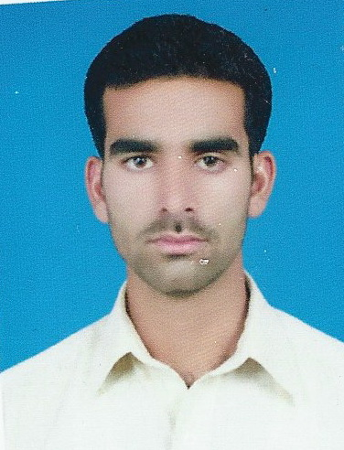

**KhawarNaseem Worked as: Surveyor**

**E-mail:** [**khawar.naseem1@gmail.com**](mailto:khawar.naseem1@gmail.com) **Contact #: 0599533932**

**Iqama Transferable**

**Career Objective:-**

**I intend a career in a well reputed organization. I strongly believe that institutional path reveals in gathering in-depth knowledge of sector dynamics for enriched later vision that steers individual’s growth and career progression.**

**EDUCATION**

**F.A Allama Iqbal Open University Islamabad (Pakistan).**

**AUTO CAD CERTIFACTE (F.V.O) Future Vision Organization in Board of PESHAWAR in (Pakistan).**

**Course Certificate (Civil Surveyor) LAHORE board (Pakistan) 1 year (561 / 700).**

**Additional Skill:-**

* **Having Valid Driving Licenses from KSA.**

**Experience:-**



1. **COMPANY MOHAMMAD AL-OJAOMI GROUP (KSA).**

**DESIGNATION Surveyor**

**DURATION Nov 2013 to Till Date.**



1. **COMPANY Al Muhaidib Contracting Co (Saudi Arabia).**

**PROJECT Thuwal City Development Phase 2.**

**DESIGNATION Surveyor**

**DURATION May 2013 to Oct 2013.**

1. **COMPANY Defense Housing Authority Islamabad (Pakistan).**

**PROJECT Defense Mall, Defense Avenue, Phase-I**

**DESIGNATION Surveyor**

**DURATION Sep 2011 to Dec 2012.**



1. **COMPANY Bahria Town Rawalpindi / Islamabad (Pakistan).**

**PROJECT Safari Valley Ph-VIII**

**DESIGNATION Surveyor**

**DURATION Aug 2008 to July 2011.**

**DUTIES & RESPONSIBILITIES:-**

* **Prepare the daily inspection log.**
* **Checking the actual progress and comparing it with the plan.**
* **Inspection of work as per standers.**
* **Cutting, filling and grading work for street pond and lots in common soil and with**

**Borrowed material filled and compacted in layers.**

* **Work in Plan Elevation L-Section & X-Section.**
* **Set out of Culverts in all crossings of pipelines.**
* **Transferring the survey data from instrument using a PC.**
* **Receiving the Topography data from the site & survey crews and forward to CAD section**

**For further Processing.**

* **Layout for sewerage and water line, according the given invert level.**

**(Total Work Experience in Earth Work for 5 Years)**

**PERSONAL DATA:-**

**Date of Birth 23 March 1990**

**Iqama no 2348521820**

**Temporary Address Al Madina Road, Al Riyadh, (Saudi Arabia).**

**Marital Status Un-married**

**COMPUTER SKILLS:-**

* **Data transferring from Excel to Auto CAD.**
* **Microsoft Office.**
* **Civil AutoCAD.**

**Languages:-**

* **English, Arabic. Urdu,**

**Hobbies:-**

* **Exercise, Playing Football, Book Reading.**