#### 

**CURRICULUM VITAE**

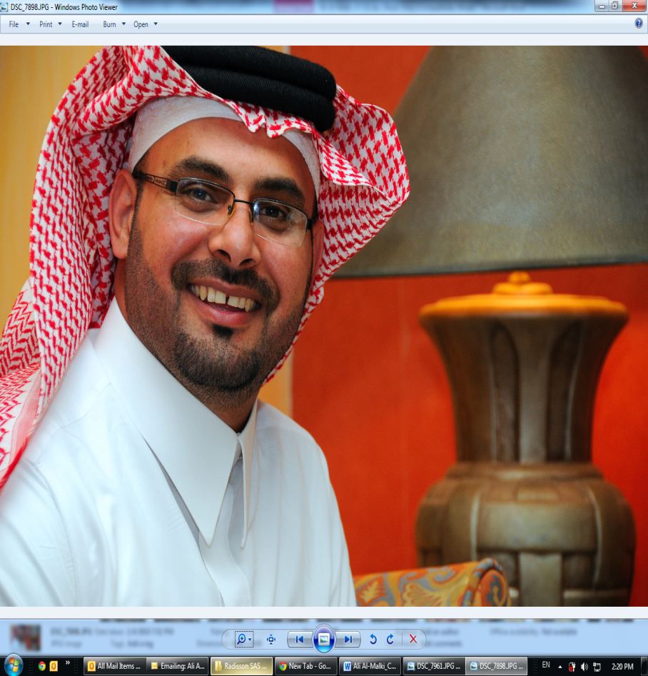

**Postal Address**

**Ali Yahya Al-Malki**

Electrical Supervisor, MAINTENANCE

National Industrial Gases Company

A SABIC Affiliate

P.O Box 30898

Yanbu 41912, Saudi Arabia

T +966 (14) 321-9214

F +966 (14) 321-0982

M +966 505906984

E [MALKIAY@GAS.SABIC.com](mailto:MALKIAY@GAS.SABIC.com)

* **Education** 
  + Higher School certificate exam passed in 1991 April.
  + Aramco Training school for two &half years.

.

* **Training & Certificates :**

**I have been joined SDAUDI ARMACO from 1991- till 1998 and been attended below courses:**

* + PH1 and PH2 Aramco electrical training program (Ras Tanurah) along with Level 7 of English language Reading and writing.
  + PH 3 on job electrical training program in SAFANYAH.
  + PH4 training electrical program in (Ras Tanurah).
  + An advanced power services course in Dhahran 2-July 1997.
  + An advanced power relay course in Dhahran 24-Decmber 1997.

**Joined in GAS-1998 and taken below triaging.**

* + Introduction to quality management course in 1998.
  + ISO-9002 in 1998.
  + PSM course in 1998.
  + CENTUM CS FUNDAMETAL 1998.
  + Introduction to quality management course in 1998.
  + Air separation process 1998.
  + MASTERDRIVE 6SE70 training course in 2001.
  + Seven habits of highly effective people in 2002.
  + Incident investigation root cause analysis training in 2002.
  + Introduction to quality management course in 1998.
  + Introduction to quality management course in 1998.
  + Using numerical protection devices SIPROTEC V4 in 2003 Germany.
  + PM 02 Master Data Technical Objects 2 in 2004.
  + PM 04 Notification Processing in 2004
  + PM 06 Completion Confirmation in 2004.
  + MM 02 martial requirements planning in 2004.
  + QM 05 reporting in 2004.
  + fire fighter level 1 in 2004(SFTC)
  + Basic cathodic protection course in 2005 SABIC technology center.
  + DDC defensive driving course in 2005 Meric Saudi Arabia.
  + Hazard Analysis and Risk Assessment in RWTUV in 2005.
  + Integrated management system (IMS) in RWTUV in 2005.
  + Modern power system protective relaying course in 2005.
  + Risk Assessor in electrical section GAS /YANBU in 2006..
  + GIMS pre-assessment internal auditor in 2006.
  + Risk Assessor in electrical section GAS /YANBU in 2006..
  + An advanced Exterior/ Interior Structural Industrial Fire Brigade course in 2006.
  + fire fighter level 2 in 2006(SFTC)
  + RCA member’s workshop as part of STRP4 in 2007.
  + Technical information course GIS in Germany 2007.
  + Training of electrical regeneration gas heater in 2008.
  + UPS& BATTREY CHARGER in 2008 provided by Chloride.
  + HV Transformers and Tap Changer, MV Switchgears , Protection Relays in 2008.
  + Electrical Overall System and Interlocks ,Battery and Battery Charger/ NGRs in 2008.
  + Fire alarm system, HVAC in 2008
  + Fire fighter refresher in 2008
  + Advanced supervisory skills in 2008
  + Supervisory skill in 2005
  + The American society of Safety Engineers in 2010 Bahrain
  + Fire fighter Rescue level-1 in 2010
  + Problem solving and decision making in 2010
  + Incident investigation and root cause ACTrain-2010
  + Effective presentation skills program -2010
  + Process safety Management ( PSM) and PSM auditing-2010
  + Electrical supervisor certificate 2009-2010
  + Electrical supervisor certificate of PH-II Plant turn around-2010
  + Alarm manger user training Matrikon -2011
  + Advance communication skills and dealing with others-2011
  + SABIC;S Careers in management- Alpha transition program( Gate-I)”is becoming a 1st –Level supervisor Right for you?”-2011
  + Train the trainer-2011
  + Cathodic protection and Remote monitoring and control system-2012
  + ETAP basic training five days-2012
  + Job safety analysis- JSA-2012
  + Fundamental of C & I lighting-2012
  + Central safety on handing chemical-2012
  + GAS EDDMS SPF Viewer Course-2013
  + Dual UPS APODYS-2 and Dual Charger APODYS-2-2013
  + SABIC;S Careers in management Beta Transition program Preparing: 1st –Level supervisors for promotion to Management.-2013
  + Integrated Management system Auditing (ISO9001:2008, ISO14001:2004 & OHSAS 18001:2007).-2013
  + Risk Assessment-2013
  + Mega-drive LCI in-house operation training at Yanbu by ABB Switzerland.
  + Electrical Regeneration Gas Heater Training by Klopper Therm Germany
  + UPS and Battery Charger chloride training by chloride France
  + Medium Voltage Vacuum Circuit Breaker, DIGSI and SIPROTEC Relays Siemens Germany.
  + HV Transformer and Tap Changer, MV Switchgears Protection Relay by ISCOSA Saudi Arabia.
  + Fire Alarm System and HVAC system by ISCOSA Saudi Arabia.
  + Electrical over all system and interlocks battery charger and battery/NGR ISCOSA Saudi Arabia.
* **Job Skills :**
* Have reliable Management ability/ capability to lead the teams to achieve the target with in appropriate time in safely manner .
* Has an Administration skill and has High personal skill as team player.
* Innovative, self-motivated with strong leadership to manage normal/abnormal cases.

* Strong analytical and problem solving abilities.
* Handling the critical situations in calm and capable manner with

An Excellent team work.

* Proficiency and working knowledge of Electrical Projects

Erection & Commissioning and Maintenance

* Maintenance (preventive & breakdown), and Liaoning.
* An excellent planning performance.
* Initiative of actions.
* Running company business towards its goals.
* Has a highly personality skill with team and all customers.
* **Objective :**
* Management position in growth oriented organization offering Challenging environment for advancement & professional Development challenging position where excellent supervisory leadership, Communication and problem solving and achieve the target of company targets and objectives in safely manner.
* **EXPERIENCE**

About 22 years of Rich an experience in the field of Electrical System, leadership and management skill with respect to successful handling of Electrical Projects and Maintenance of Air Separation unit, as detailed in the subsequent section of CV. In brief project jobs includes, design review and support, material procurement, Inspection of material, Execution of work, Commissioning and Testing, as build drawing and close out project. And also had exposure to Pre-commissioning activity, checklist for proper implementation of Electrical activities of the projects.

In addition Maintenance Planning and Troubleshooting dept. and considerable experience in the plant Preventive Maintenance and Breakdown Maintenance of Electrical Equipment. It includes daily routine checks, PM checks, Electrical circuit analysis and trouble shooting of electrical system during the plant outages. To analyze the obsolete electrical equipment with respect to plant reliability point of view and suggest suitable replacement and implementation during the plant turn around or shutdown. Also participated in shutdown work activity of electrical jobs, planning, review to implementation, deal with electrical safety procedure as per PSM (Process Safety Management) for the safe electrical lock out system during electrical equipment maintenance and subsequent receiving/issuance of work permits.

Also write down the preventive Maintenance, shutdown Maintenance procedure checklist for daily, Monthly, Bi-Monthly, and Quarterly, Half yearly and yearly procedure. Preparing a complete shutdown, Testing and calibration procedure of Electrical equipment.

Further had good knowledge with respect to latest applicable Electrical standards such as NEC, NEMA, IEEE, SES (SABIC Engineering Standard) and IEC.

* **National industrial gases co.(gas-SAbic, yanbu)**

**(ISO 9001:2000, ISO 14001:2004, OHSAS 18001:1999 & SABIC PSM)**

**ASU plant**

Period: 1998 to continue

Position: Electrical Supervisor Maintenance and covering maintenance manger position from time to time successfully (elect/Mech/Instrument)

**Duties & Responsibility,**

I am working as Electrical Supervisor Maintenance Dept. in GAS SABIC company and having three air separation plants, phase-I, Phase-II and Phase-III.

Working as supervisor, has been assigned many times as Maintenance Manager and succeeded with assignment in professional way/high skilled of leadership.

For a Maintenance dept. which has three sections Mech./Instr./Elect.

I have been attended a lot of Electrical technical courses internally and externally. I have been attended a lot of safety and health courses. Also certified as internal auditors and selected as member of SABIC Auditing team in year 2013.

I have completed Level -1, 2, 3 firefighting training, HAZMAT and Recue level -1

I have been attended a lot of process training courses belongs to air separation unit/plant.

I am dealing as Element and sub element administrator for Many SHEM’S elements (Working at height, cathodic protection system, illumination system etc).

I am certified as RCA team leader and assigned as leader for many RCA, BAC compressor tripped due to oil pump.

**Daily Activities:**

Supervisor of electrical section as monitoring daily, routine job, maintenance activities and trouble shooting during any abnormalities/breakdown.

I am providing technical supports for the following equipments, 115 KV GIS switchgear, 34.5 GIS switchgear, 34.5KV,13.8KV & 4.16 KV Vacuum switchgear and 480 volts LV Switchgear, 115KV/34.5KV, 140MVA, power transformer, 34.5KV/13.8KV,75KVA, 40KVA and 32KVA oil transformer, the other medium & low voltage transformer for 13.8/4.16KV, 480 volts different rating 23. Total number of oil transformer is 31 numbers, soft-starter panel for starting the synchronous motor 35MW, 25MW, 19.8MW, 11.2MW, 9.2MW, 6.5MW and 4.2MW as well as the motor control panel for all synchronous motor. DC charger system for all substations is 4 numbers; UPS system for all 3 plants (7 numbers), fire alarm system and Cathodic protection system for all three plant. Moreover, taking care as PM /CM of **ISS**.

Turnaround & shut down job planning and materials procurement, Spare materials availability in ware house. Updating spare materials description, creating new material, material description amendment and searching the material in RAMIS/MDRM required for the maintenance. Responsible for modification projects and expansion projection of Electrical along with reliability crew , Pre-start Safety Review (PSSR), Handling of MOC, Coordinating with other departments. Shutdown job planning and scheduling, Preparing scope of work, Execution of shutdown successfully, like substation all switchgears (34.5, 13.8, 4.6 KV) preventive maintenance, Transformers preventive maintenance and Control panel like, Soft starter for 35MW,25MW,19.8MW,11.2MW,9.2MW,6.5MW and 4.2MW Compressor Synchronous Motor, variable frequency drive and exciter panels for synchronous motors. Preventive maintenance of synchronous motors 19.8 MW, 9.2 MW and 5.6 MW synchronous motors and induction motors preventive maintenance carried out, Coordination with contractors and vendors. Working in SAP environment, creating the notification & work order, closing the work order, Creating technical Id, Preventive Maintenance Planning & order in SAP, Creating the Purchase Request (PR), Bill of Material.

Worked as leader in turnaround for electrical jobs for PH-I and II plant. preparing shutdown job, planning job schedule, arrange the material for shutdown job, technical evaluation of vendors offer, carried out shutdown job execution.

Presently I am handling project like Industrial Security System, Heater MCC feeder modification, Plant Siren system up-gradation, Replace Transformer with higher capacity for Regeneration Gas Heater and Replacing the old Excitation ( ALSTOM) Control Panel for Synchronous Motor (9.2MW & 6.5MW) with new ABB Excitation .

New project work data entry in SAP/R3 like Technical Id of Equipments, PM task list for the equipment and scope of work for PM.

# Personal Details:

# Date of Birth: 07/02/1391 H

**Marital Status**: Married.

**Dependence:** Wife+ 5 Children’s.

* **Salary Expected**: Negotiable.

**(Ali Yahya Al-Malki)**