**NOTE:-**

Major Project Port Number and Path:-

URL:-[**http://localhost:8011/project1/collegelogin.php**](http://localhost:8011/project1/collegelogin.php)

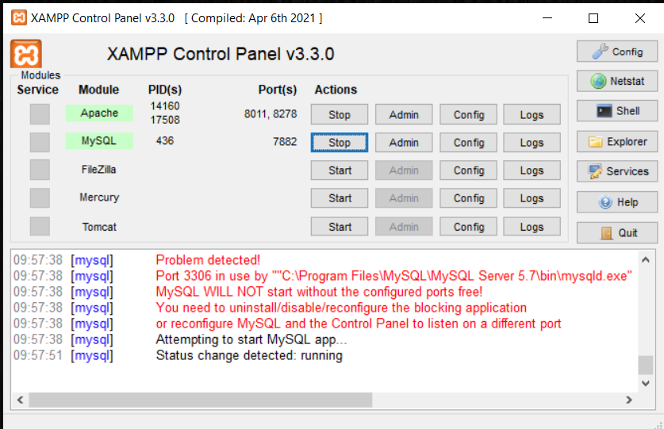

$server = "localhost:7882";

$database = “crud”;

$username = “root”;

$password = “ ”;