BUAN 6359.003 - Advanced Statistics for Data Science - Final Test

Prriyamvradha Parthasarathi - pxp220005

library(readxl)  
library(tidyr)  
library(moments)  
library(dplyr)

##   
## Attaching package: 'dplyr'

## The following objects are masked from 'package:stats':  
##   
## filter, lag

## The following objects are masked from 'package:base':  
##   
## intersect, setdiff, setequal, union

**######################################################################################################################**

**Problem 1: Does Confidence Interval work?**  
**We’ll generate a population, get a sample from it, create a Confidence Interval using this sample, and then check if our Confidence interval has the Population parameter. Use a 4-digit number (nnnn) of your choice to set the seed using this command: set.seed=nnnn Generate a Normal distribution problem with N = 2,500, Mean =180, and Std dev = 30. Round it off to 1 decimal place Find the mean of this population.Now, from this population, after setting the same seed again, draw a random sample of size n = 30.**

rm(list=ls()) ;  
  
# Set Seed  
set.seed(1234)  
  
# Generating a Normal distribution   
ND <- round(rnorm(2500,180,30),1);  
  
# Mean of the Population.   
Population_Mean <- mean(ND)  
  
# Setting same seed again,   
set.seed(1234)  
  
# Random sample of size n = 30.  
Sample <- sample(ND,30)  
  
# Mean of the Sample  
Sample_Mean <- mean(Sample)  
  
# Standard Deviation of the Sample  
Sample_Sd <- sd(Sample)  
  
# Standard Error of the Sample  
Standard_Error <- Sample_Sd/sqrt(30)  
  
# t-score for a Confidence level of 84.65%.  
n=30  
t <- qt(0.07675,n-1,lower.tail = FALSE)  
  
# Lower and Upper limits of the Confidence interval  
Lower_Tail <- Sample_Mean - t*Standard_Error  
Upper_Tail <- Sample_Mean + t*Standard_Error  
  
# If statement to see if the population mean falls within the Confidence interval  
if(Population_Mean >= Lower_Tail & Population_Mean <= Upper_Tail)   
 {cat("Population Mean is within the Confidence Interval")} else  
 {cat("Population Mean is not within the Confidence Interval")}

## Population Mean is within the Confidence Interval

**Problem 1 Answers**

**a.** Find the mean and the std error of this sample: **Sample Mean:** **175.5133333** and **Standard Error:** **5.9241755**

**b.** Get the proper t-score for a Confidence level of 84.65%: **t-score:** **1.4656614**

**c.** Find the lower and upper limits of the Confidence interval: **Lower limit:** **166.8304977** **Upper Limit:** **184.196169**

**d.** Use If statement to see if the population mean falls within the Confidence interval. Get the appropriate output from the R code: **Population Mean is within the Confidence Interval**

**######################################################################################################################**

**Problem 2: (Set-1)**  
**Three anti-bacteria creams were used on three age groups.The number of hours before the medicines started to show a noticeable effect are recorded in the table.Assume Alpha = 0.05**

rm(list=ls()) ;  
  
# Read Set-1 from the Excel  
prob_2<-data.frame(read_excel("F22-6359-Test-3.xlsx", sheet="Set-1"))  
  
# Create individual vectors. rep command rep("Young",30) will repeat Young 30 times.   
v1<-data.frame(Hours = prob_2[, 2], Medicine = prob_2[, 1], Age=rep("Young",30))  
v2<-data.frame(Hours = prob_2[, 3], Medicine = prob_2[, 1], Age=rep("Middle_Age",30))  
v3<-data.frame(Hours = prob_2[, 4], Medicine = prob_2[, 1], Age=rep("Senior",30))  
  
# Rename columns   
names(v1)[1] <- 'Hours'   
names(v2)[1] <- names(v1)[1]   
names(v3)[1] <- names(v1)[1]   
  
# Combine everything and create a new dataset   
data1=rbind(v1, v2, v3)   
attach(data1)  
  
# a. Run this as an ANOVA 2-factor R program.  
a1 <- aov(Hours~Medicine+Age+Medicine:Age)  
summary(a1)

## Df Sum Sq Mean Sq F value Pr(>F)   
## Medicine 2 8414 4207 5.950 0.00388 **  
## Age 2 661 331 0.468 0.62814   
## Medicine:Age 4 10022 2506 3.543 0.01026 *   
## Residuals 81 57280 707   
## ---  
## Signif. codes: 0 '***' 0.001 '**' 0.01 '*' 0.05 '.' 0.1 ' ' 1

P_Age <- summary(a1)[[1]][[2,"Pr(>F)"]]  
P_Medicine <- summary(a1)[[1]][[1,"Pr(>F)"]]  
F_Medicine <- summary(a1)[[1]][[1,"F value"]]  
  
# c. Also draw the interaction graph to show the interaction between the two factors.   
interaction.plot (Medicine, Age, Hours, lwd = 2, col=1:3, main="Age vs Medicine")

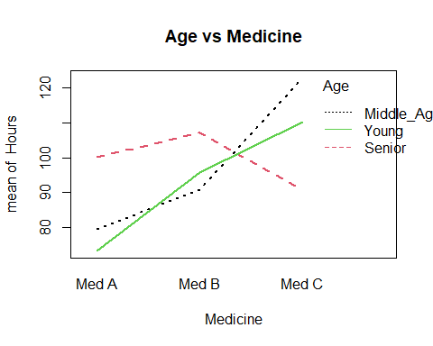

interaction.plot (Age, Medicine, Hours, lwd = 2, col=1:3, main="Medicine vs Age")

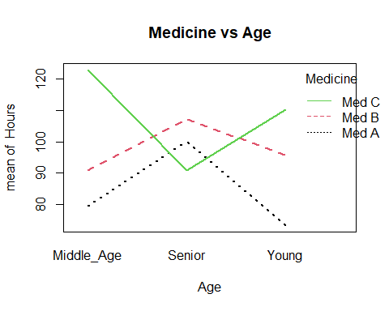

**Problem 2 Answers**

**QUESTION 1:** For Set 1, the P-value for Age is: **P-value for Age:** **0.6281449**

**QUESTION 2:** For Set 1, what is the P-value for Medicine?: **P-value for Medicine:** **0.0038831**

**QUESTION 3:** For Set 1, is there an interaction between Medicine and Age: **There is interaction**

**QUESTION 4:** For Set 1, what is the F-stat for medicine ?: **F-stat:** **5.9495318**

**QUESTION 5:** Does Age have any effect on the number of hours before the medicines start work?: **No**

**QUESTION 6:** For Set 1, can you say that the medicines behave differently in regards to the time it takes to show an effect?: **Yes because we reject the Null hypothesis**

**######################################################################################################################**

**Problem 3: (Set-2) Two sample t-test** **Automobile Insurance companies consider many factors including the miles driven by a driver and the gender.**  
**The dataset consists of the reported miles (in thousands) driven by young drivers (25 years or less)** **in the previous year. One insurance company wants to know if there are any difference between the two genders.**

rm(list=ls()) ;  
  
# Read Set-2 from the Excel  
prob_3 <-read_excel("F22-6359-Test-3.xlsx", sheet="Set-2")  
  
# a. Do a variance test to see if the two variances are equal.  
var.test(Distance~Gender, data = prob_3)

##   
## F test to compare two variances  
##   
## data: Distance by Gender  
## F = 1.0246, num df = 99, denom df = 99, p-value = 0.904  
## alternative hypothesis: true ratio of variances is not equal to 1  
## 95 percent confidence interval:  
## 0.6893942 1.5227966  
## sample estimates:  
## ratio of variances   
## 1.024601

var_test_pval <- var.test(Distance~Gender, data = prob_3)$p.value  
  
# b. Do the appropriate t-test at α = 5%.   
t.test(Distance~Gender, var.equal= TRUE, data = prob_3)

##   
## Two Sample t-test  
##   
## data: Distance by Gender  
## t = -1.4193, df = 198, p-value = 0.1574  
## alternative hypothesis: true difference in means between group Female and group Male is not equal to 0  
## 95 percent confidence interval:  
## -1.3810709 0.2250709  
## sample estimates:  
## mean in group Female mean in group Male   
## 9.677 10.255

t_test_pval <- t.test(Distance~Gender, var.equal= TRUE, data = prob_3)$p.value  
t_test_tstat <- t.test(Distance~Gender, var.equal= TRUE, data = prob_3)$statistic

**Problem 3 Answers**

**QUESTION 7:** For Set 2, what is the p-value from the Variance test?: **P-value for Variance test:** **0.9040073**

**QUESTION 8:** For Set 2, after calculating Variance what are you observations?: **Variances are equal**

**QUESTION 9:** What is the Null Hypothesis for Set-2?: **μmale = μfemale**

**QUESTION 10:** For Set 2, what is the p-value for the t-test?: **P-value for t-test:** **0.1573739**

**QUESTION 11:** For Set 2, what is the t-statistics?: **t-statistics:** **-1.4193343**

**QUESTION 12:** For Set 2, what decision is made after calculating T-test?: **There is no difference between the male and the female drivers**

**######################################################################################################################**

**Problem 4 (Set-3)** **A bank has collected a sample and is trying to see how various factors impact it’s loan approvals.** **Divide Credit Scores by 10 and incomes by 1000 (in R) and perform Logistics Regression.**

rm(list=ls()) ;  
  
# Read Set-3 from the Excel  
prob_4<-read_excel("F22-6359-Test-3.xlsx", sheet = "Set-3")  
  
# Rename the variables  
names(prob_4)[1] <- 'Loan.Approved'  
names(prob_4)[2] <- 'Credit.scores'  
names(prob_4)[3] <- 'Income'  
names(prob_4)[4] <- 'Neighborhood.income'  
  
# Divide Credit Scores by 10 and incomes by 1000   
prob_4$Credit.scores<- prob_4$Credit.scores/10  
prob_4$Income<- prob_4$Income/1000  
prob_4$Neighborhood.income<- prob_4$Neighborhood.income/1000  
  
attach(prob_4)  
  
# Logistic Regression  
Loan <-glm(Loan.Approved ~ Credit.scores + Income + Neighborhood.income, family="binomial")  
summary(Loan)

##   
## Call:  
## glm(formula = Loan.Approved ~ Credit.scores + Income + Neighborhood.income,   
## family = "binomial")  
##   
## Deviance Residuals:   
## Min 1Q Median 3Q Max   
## -1.5276 -0.9104 -0.6602 1.1599 2.1914   
##   
## Coefficients:  
## Estimate Std. Error z value Pr(>|z|)   
## (Intercept) -9.23814 1.54545 -5.978 2.26e-09 ***  
## Credit.scores 0.03141 0.01088 2.888 0.00387 **   
## Income 0.04892 0.02028 2.412 0.01589 *   
## Neighborhood.income 0.09551 0.02615 3.653 0.00026 ***  
## ---  
## Signif. codes: 0 '***' 0.001 '**' 0.01 '*' 0.05 '.' 0.1 ' ' 1  
##   
## (Dispersion parameter for binomial family taken to be 1)  
##   
## Null deviance: 510.13 on 399 degrees of freedom  
## Residual deviance: 468.78 on 396 degrees of freedom  
## AIC: 476.78  
##   
## Number of Fisher Scoring iterations: 4

# Maximum likelihood estimates of the parameters  
RegOut<-c(coef(Loan))  
  
# Neighborhood with income of 40192  
odd40192<-exp(RegOut[1]+RegOut[2]+RegOut[3]+RegOut[4]*40.192)  
# Neighborhood income of 46569   
Odd46569<-exp(RegOut[1]+RegOut[2]+RegOut[3]+RegOut[4]*46.569)  
# odds of loan approval for Neighborhood with income of 40192 vs Neighborhood income of 46569   
odds_ratio <- odd40192/Odd46569  
  
# Loan approval for a person whose credit score is 728, income is 61653 and lives in a neighborhood whose income is 35436  
odds<-exp(RegOut[1]+RegOut[2]*72.8+RegOut[3]*61.653+RegOut[4]*35.436)  
#Probability  
probabbility <- odds/(odds+1)  
  
# Loan approval for a person whose credit score is 716, income is 56759 and whose income is 40746  
odds1<-exp(RegOut[1]+RegOut[2]*71.6+RegOut[3]*56.759+RegOut[4]*40.746)

**Problem 4 Answers**

**QUESTION 13:** For Set 3, what are the odds of loan approval for a person who lives in a neighborhood with income of 40192 vs someone with the neighborhood income of 46569 assuming everything else being equal?: **Odds ratio:** **0.5438447**

**QUESTION 14:** For Set 3, what is the probability of loan approval for a person whose credit score is 728, income is 61653 and lives in a neighborhood whose income is 35436?: **Probability:** **0.3656949**

**QUESTION 15:** For Set 3, what are the Odds of loan approval for a person whose credit score is 716, income is 56759 and lives in a neighborhood whose income is 40746: **Odds:** **0.7256806**

**QUESTION 16:** For the Logistics Problem in Set 3, what is the coefficient of Income as calculated by R? : **Coefficient of Income:** **0.0489162**

**QUESTION 17:** For the Logistics Problem in Set 3, what is the coefficient of Credit Scores as calculated by R?: **Coefficient of Credit Scores:** **0.0314141**

**QUESTION 18:** For the Logistics Problem in Set 3, what is the Intercept calculated by R? : **Intercept:** **-9.2381363**

**######################################################################################################################**

**Problem 5 (Set-4)** **You’ve picked up a bunch of rocks from a rocky beach and want to estimate the weight of all the** **rocks at the beach with a Confidence level of 93.47%.**

rm(list=ls()) ;  
  
# Read Set-4 from the Excel  
prob_5 <-read_excel("F22-6359-Test-3.xlsx", sheet="Set-4")  
attach(prob_5)  
  
# a. Plot the qqline and box plot of the data. Also get the skewness. What is your conclusion about the distribution being normal?  
qqnorm(Weight)   
qqline(Weight)

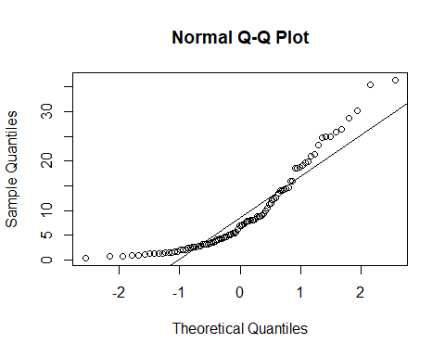

boxplot(Weight)

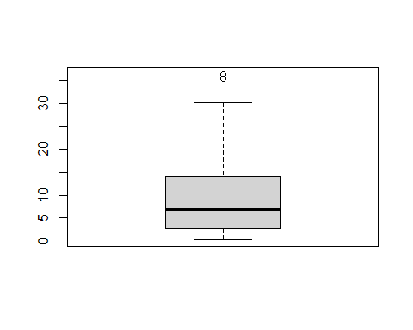

# skewness Before log Transformation?  
skewness(Weight)

## [1] 1.233937

# b. Do a log transformation (base e) and perform the steps in a. What's your conclusion? Use Log transformed data for the following questions.  
log_data <- log(prob_5$Weight,base = exp(1))  
qqnorm(log_data)   
qqline(log_data)

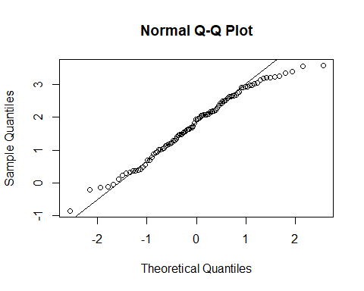

boxplot(log_data)

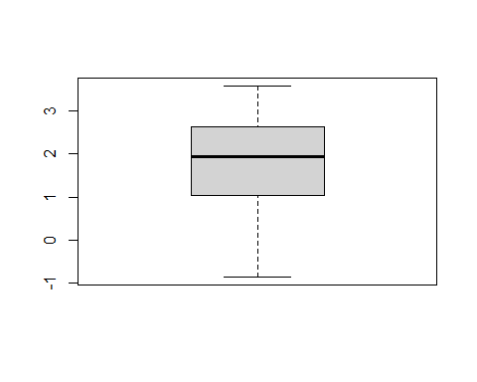

skewness(log_data)

## [1] -0.2867998

# c. What is the mean, Std dev, and the sample size?  
mean_prob5 <- mean(log_data); mean_prob5

## [1] 1.79195

sd_prob5 <- sd(log_data); sd_prob5

## [1] 1.026756

sample_size_prob5 <- length(log_data); sample_size_prob5

## [1] 96

# d. Find std error using the std error formula we've discussed.  
std_error_prob5 <- (sd_prob5/sqrt(sample_size_prob5)); std_error_prob5

## [1] 0.1047928

# e. Find the t-score for the 93.47% confidence interval.   
t_score_prob5 <- qt(0.03265,sample_size_prob5-1,lower.tail = FALSE); t_score_prob5

## [1] 1.864775

# f. Use this t-score, sample mean, std error to get the upper and lower limit of the Confidence Interval. Use the formula we've discussed.   
Lower_Tail_prob5 <- mean_prob5 - t_score_prob5*std_error_prob5; Lower_Tail_prob5

## [1] 1.596535

Upper_Tail_prob5 <- mean_prob5 + t_score_prob5*std_error_prob5; Upper_Tail_prob5

## [1] 1.987366

# g. Do reverse transformation to get the Confidence Interval in Ounces.   
Upper_Tail_rev <- exp(Upper_Tail_prob5); Upper_Tail_rev

## [1] 7.296286

Lower_Tail_rev <- exp(Lower_Tail_prob5); Lower_Tail_rev

## [1] 4.935902

**QUESTION 19:** For Set 4, what is the mean of the log-transformed data? : **Mean:** **1.7919505**

**QUESTION 20:** For Set 4, what is the skewness Before log Transformation? : **Skewness:** **1.2339372**

**QUESTION 21:** For Set 4, calculate Skewness after log transformation? : **Skewness:** **-0.2867998**

**QUESTION 22:** For Set 4, calculate the standard Deviation after log transformation :**Standard Deviation:** **1.0267557**

**QUESTION 23:** For Set 4, what is the standard error? : **Standard Error:** **0.1047928**

**QUESTION 24:** For Set 4, what is the lower limit of Confidence Interval for a Confidence level of LCL? : **Lower Limit of CI:** **1.5965354**

**QUESTION 25:** For Set 4, calculate Upper Limit after reverse Transformation? : **Upper Limit:** **7.2962865**

**QUESTION 26:** For Set 4, what is the Lower Limit after reverse Transformation? : **Lower Limit:** **4.935902**

**######################################################################################################################**

**Problem 6 (Set-5)** **A random sample of 1100 U.S. adults were questioned regarding their political affiliation and opinion on a tax reform bill** **Perform a test to see if the political affiliation and their opinion on a tax reform bill are independent**

prob_6 <- data.frame(read_excel("F22-6359-Test-3.xlsx", sheet="Set-5"))

## New names:  
## • `` -> `...1`

# Get ChiSq Stats, P-values, etc. as required by the Online test.   
chisq_prob_6 <- prob_6[1:3,2:4]  
chisq.test(chisq_prob_6)

##   
## Pearson's Chi-squared test  
##   
## data: chisq_prob_6  
## X-squared = 8.9437, df = 4, p-value = 0.06252

df <- chisq.test(chisq_prob_6)$parameter  
Chi_Sq_Critical <- qchisq(p =0.05, df = 4, lower.tail =FALSE)  
p_val <- chisq.test(chisq_prob_6)$p.value

**QUESTION 27:** For Set-5, what are the degrees of Freedom? : **Degrees of Freedom:** **4**

**QUESTION 28:** For Set-5, what is the ChiSq Critical? Assume Alpha = 5% : **ChiSq Critical:** **9.487729**

**QUESTION 29:** For Set-5, what is the P-Value? : **P-value:** **0.0625224**

**QUESTION 30:** For Set-5, what is the correct outcome? Assume Alpha = 5% : **The opinion on the Tax form doesn’t depend on the political affliation**