24-04-2025

* Create two vnet and two VM separately inside each vnet which further has a subnet
* SSH to VM1 and if we try to ping VM2 through public IP or private IP of VM 2 ping is not working .
* For public IP issue go to VM2 network interface and for inbound rules add ICMPv4 protocol with a priority number less than SSH.
* Now if we ping from VM1 to VM2 using VM2 public IP it will work .
* Still using private IP of VM2 it will not work as both are in separate VNET and for that we require Vnet Peering.

Step 1) Login in azure using CLI

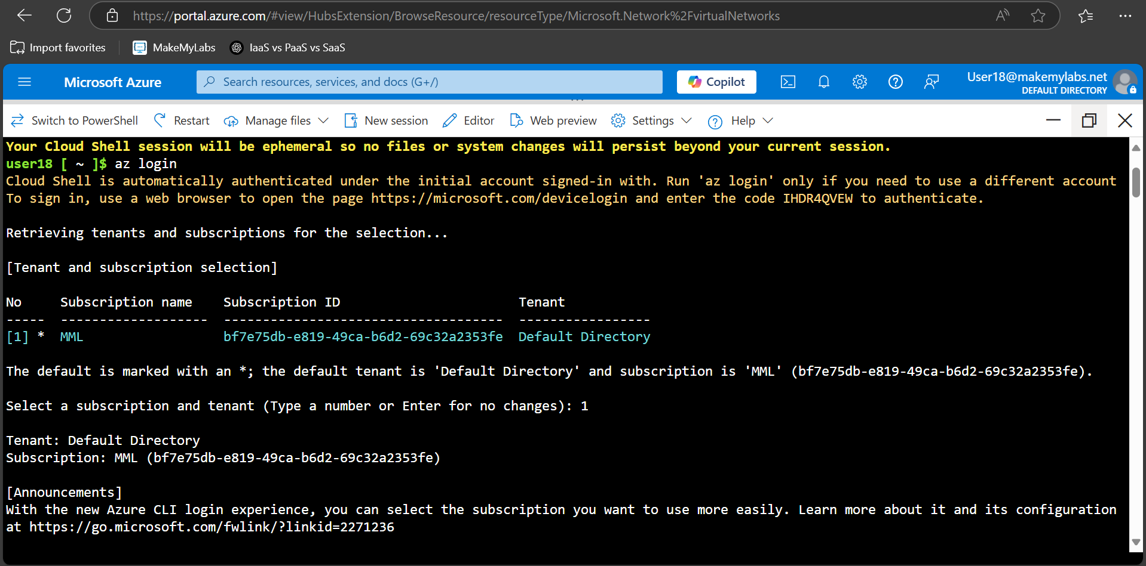

Step 2) Create two vnet with the following command, address-prefixes is the IP range and both VNET should have different range

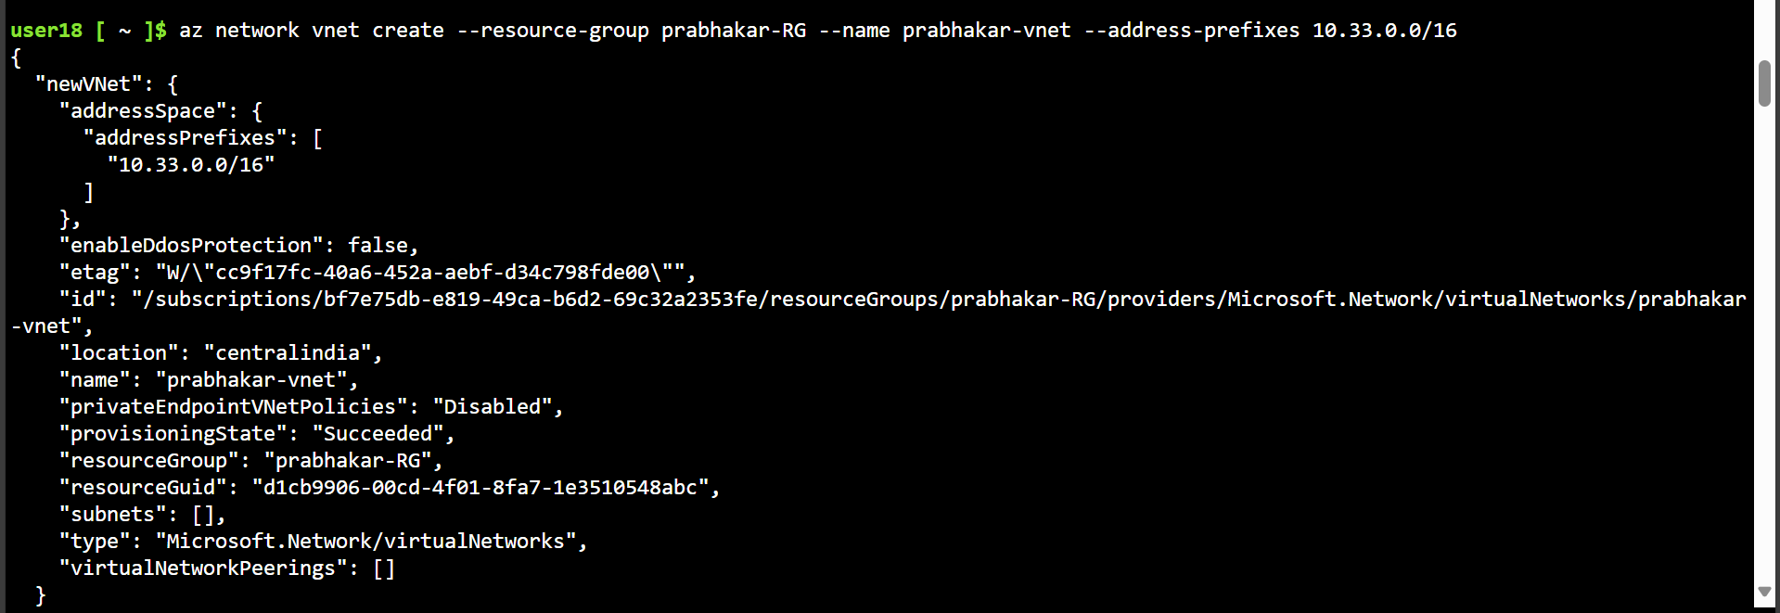

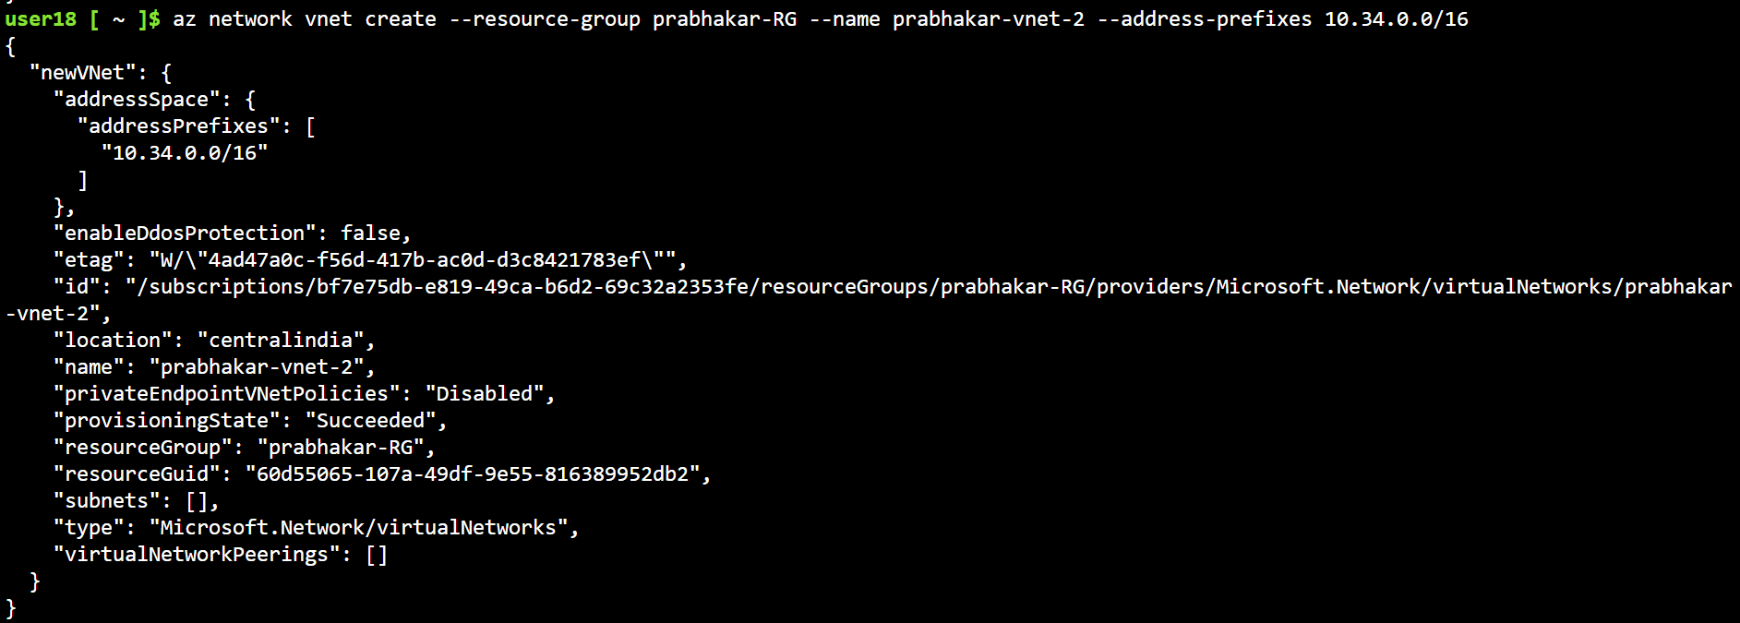

Step 3) Create subnet separately for each vnet

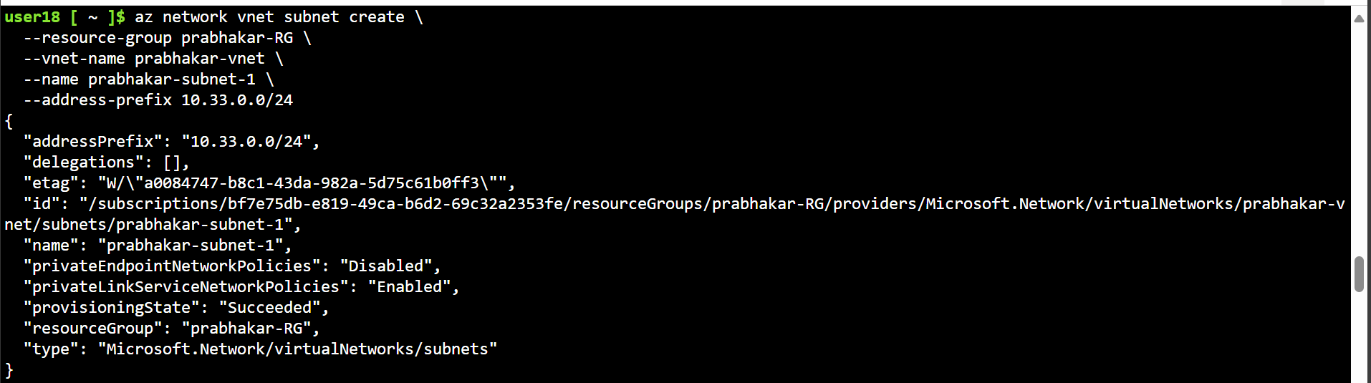

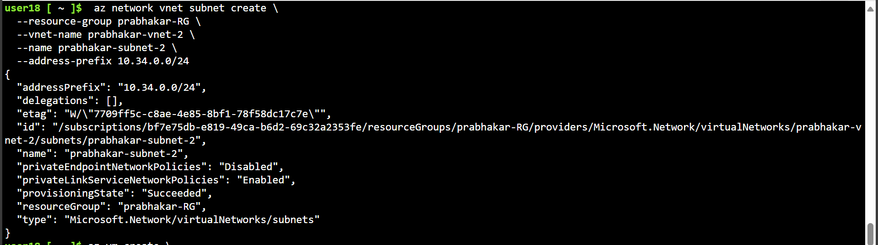

Step 4) Create two VM in the separate Vnet ad Subnet group

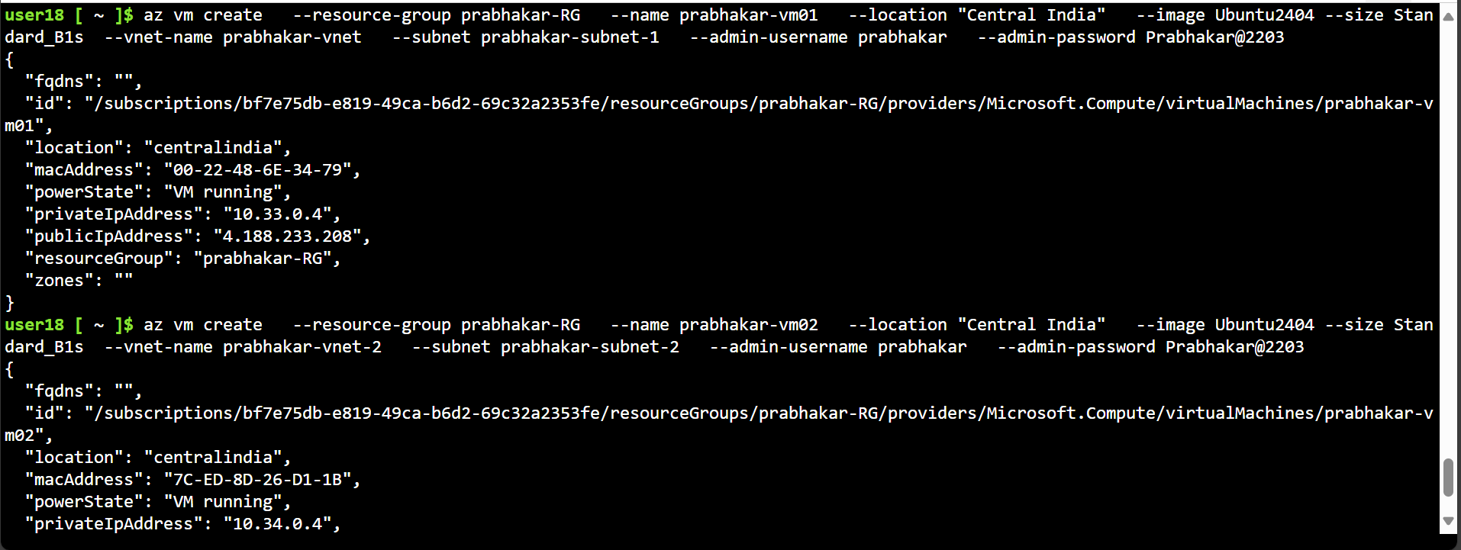

Step 5) Copy .pem file in VM1 and SSH into VM1 after this add ICMPv4 protocol in inbound rules in VM2 and now we can ping to VM2 form VM1 using VM2 public IP

