**VNET AND SUBNET**

1) First create a Vnet with three subnets , two subnets with public IP and one with private IP.

2) Create three virtual machine frontend(public IP) , backend(private IP ) , private(public IP)

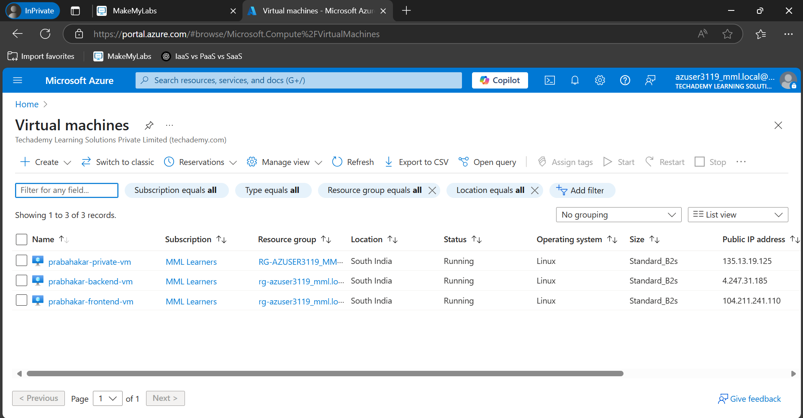

3) Through SSH we can connect to frontend and private VM , despite private VM has subnet attached which has private IP.

4) To resolve this first stop all the VMs

5) Go to the VM and network interface and disassociate the VM with the default NSG created.

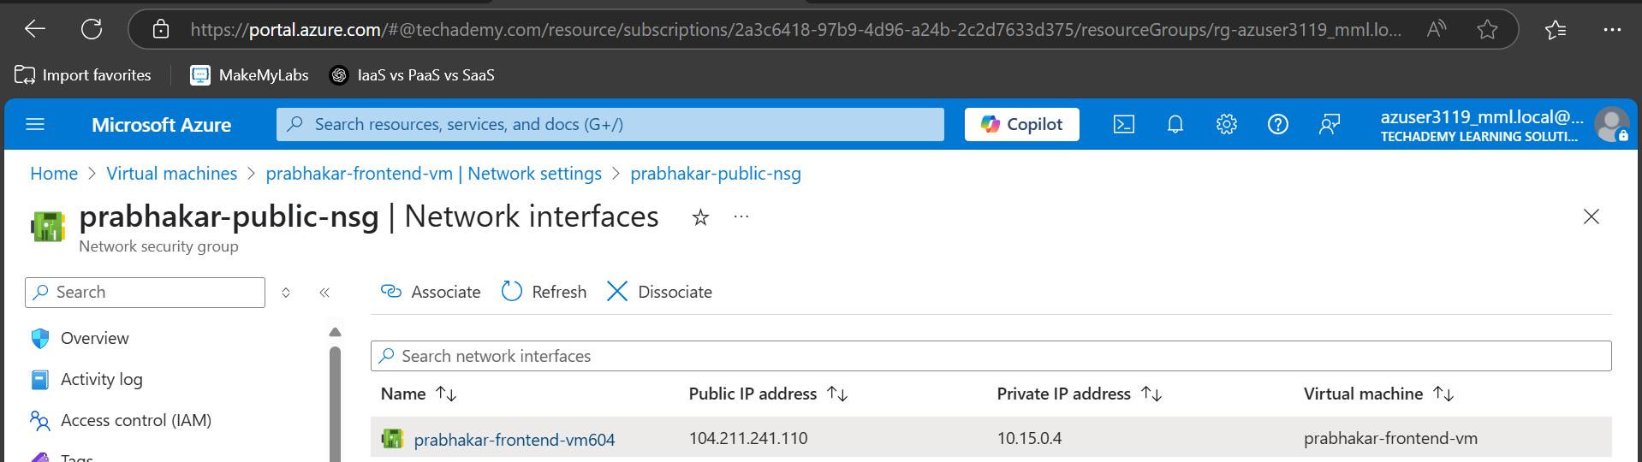

6) Go to the NSG and create two NSG public (frontend, backend) and private (private-vm)

7) Go to the public NSG and associate frontend and backend

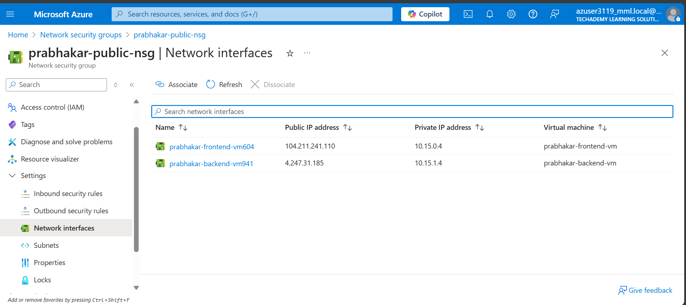

8) Go to private NSG and associate private

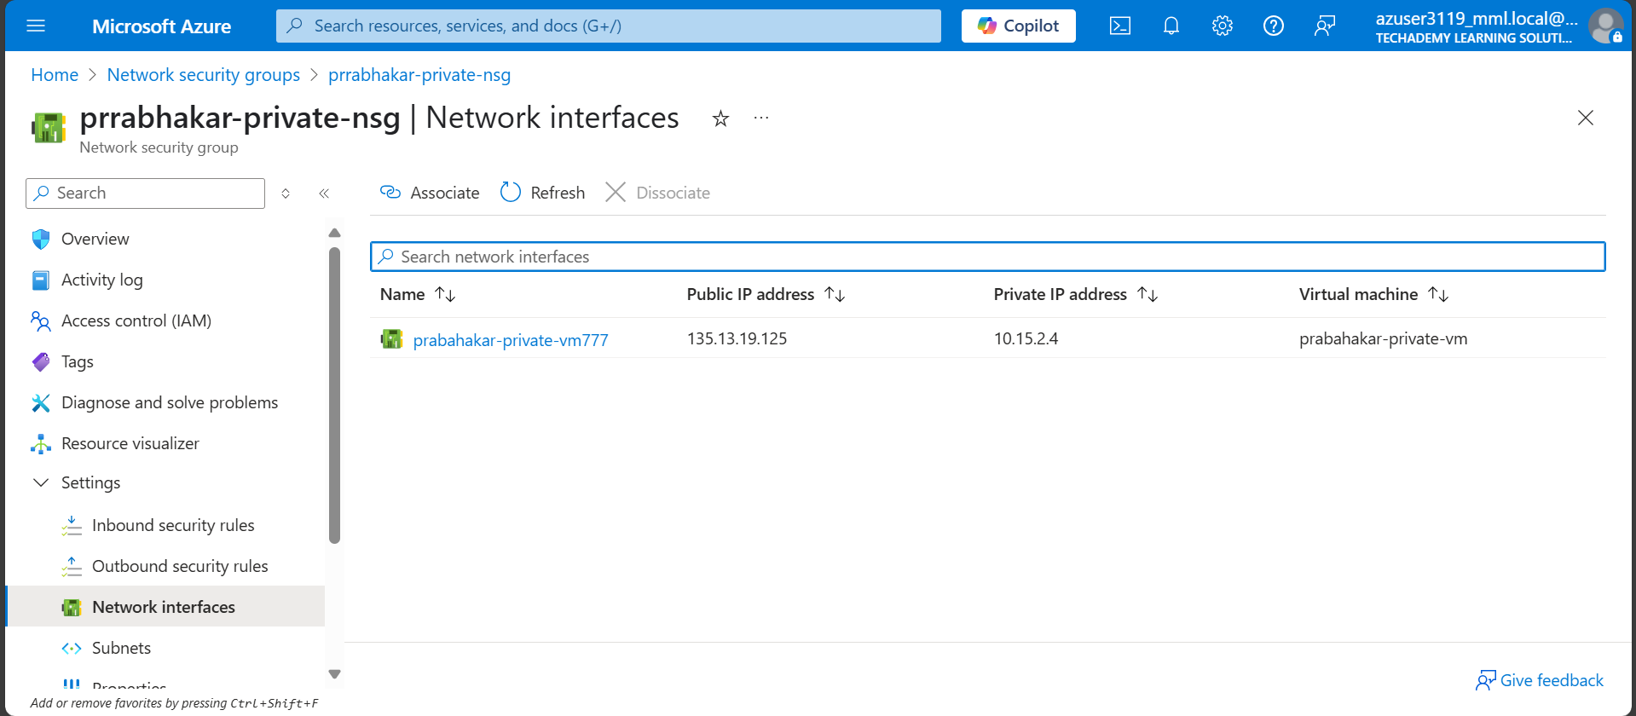

9) Set up inbound rule in private nsg to block all incoming traffic additionally add SSH with lower priority number for ssh access from other machines.

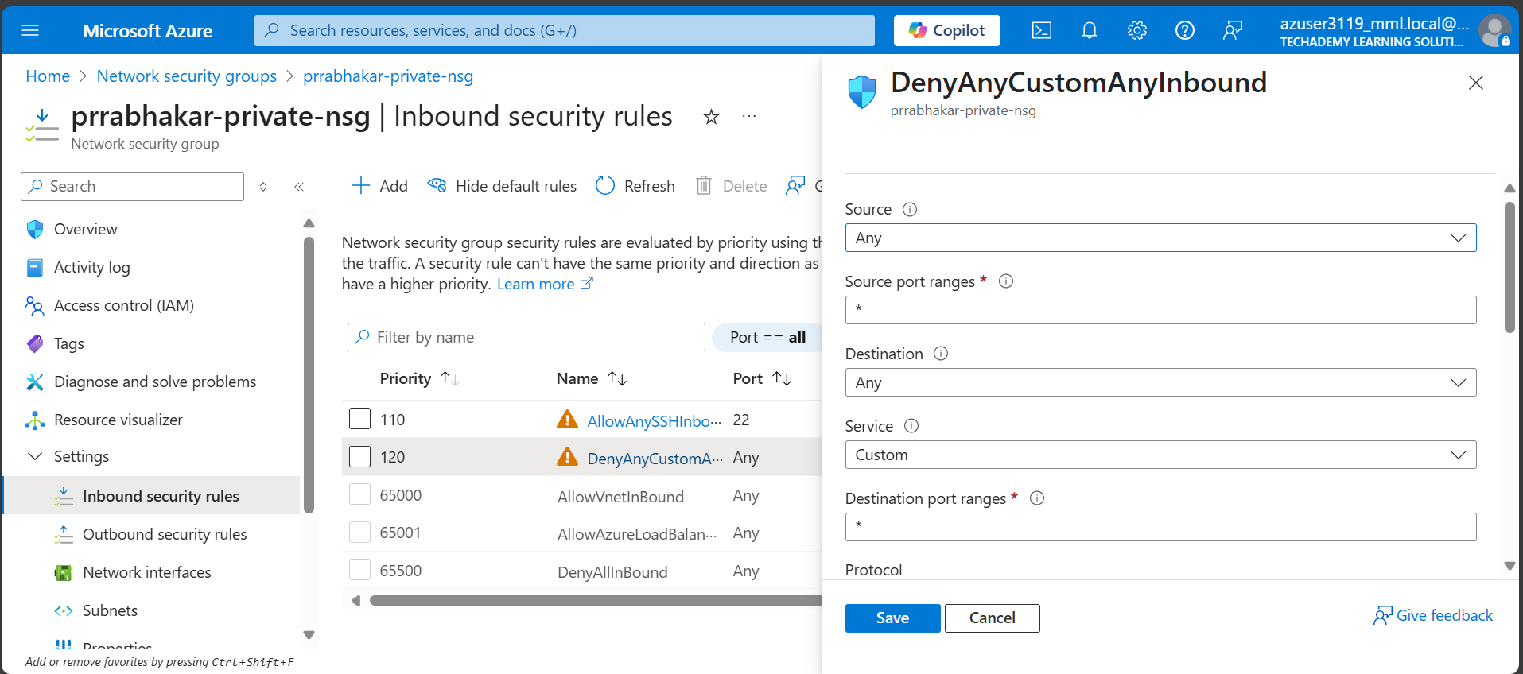

10) Now we can’t SSH into the private VM .

11) To access the private VM from either frontend VM or backend VM add SHH with lower priority number .

12 ) To copy .pem file to the frontend or backend using the scp.

