Part 1: The Cascode Amplifier.

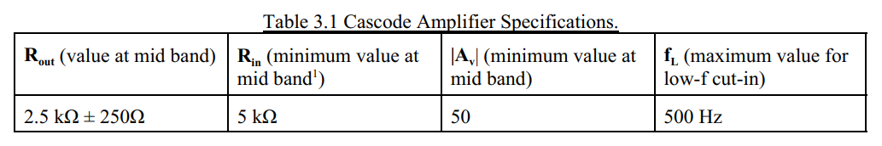

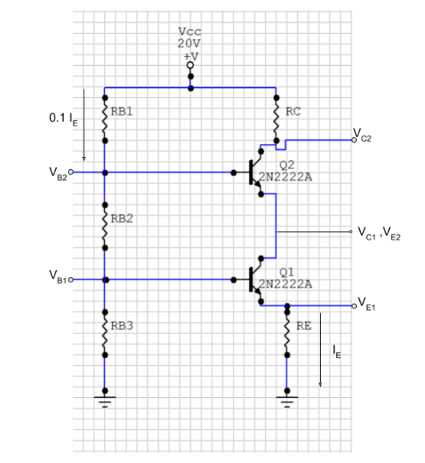
Calculations:
Circuit 1: 1/4 rule for biasing Cascode Amplifier
Using ¼ Rule
$I_{1}=0.1I_{E}$
$V_{E1}=\frac{V_{CC}}{4}=5 V$
$V_{C1}=V_{E2}=\frac{V_{CC}}{2}=10 V$
$V_{C2}=\frac{3}{4}V_{CC}=15 V$
$V_{B1}=V_{E1}+0.7=5.7 V$
$V_{B2}=V_{E2}+0.7=10.7 V$
$β=167$ (From Mini Project 2)
To design the Cascode to meet the above specifications, max values of R_{out} = 2.750 kΩ.
Since R_{c} = R_{out} and the nearest standard resistor is 2.7kΩ, therefore

$I_{C2}=\frac{20-15}{2700}=1.852 mA$
$I_{B2}=\frac{I_{C2}}{β}=11.089 µA$
$I_{B1}=\frac{I_{C1}}{β}=11.553 µA$
$I_{E1}=1.874 mA$

$I_{E2}=I_{C1}=I_{C2}+I_{B2}=1.863 mA$
Hence,
$I_{1}=0.1 I_{E1}=0.187 mA$
$I_{2}=I_{1}-I_{B2}=0.176 mA$
$I_{3}=0.165 mA$

Therefore, the values of remaining resistors are:

$R_{E}=\frac{5V}{1.874 mA}=2.668 kΩ$
$R_{B1}=\frac{20 V-10.7 V}{0.187 mA}=49.733 kΩ$
$R_{B2}=\frac{10.7 V-5.7 V}{0.176 mA}=28.409 kΩ$
$R_{B3}=\frac{5.7 V}{0.165 mA}=34.545 kΩ$

For Capacitor values, C_{E} will see the least resistance because of emitter de-magnification effect, thus to determine the values of C_{E} and to meet the specifications required,
$$f_{Lp3}=\frac{1}{C_{E}.(R_{E}||\frac{r_{π1}+R_{B23}||(R_{s}+R_{in})}{β+1})}=500Hz$$
C_{E} will determine the dominant pole value with location at 500 Hz and to ensure it, we set
C_{E} = C_{C1} = C_{C2}
$r_{π1}=\frac{βV_{T}}{I_{C1}}=2.241 kΩ$
Hence,
$$C_{E}=\frac{1}{2π*500*28.827 Ω}=11.042 µF$$

After changing values to Standard Resistors and Capacitors,
Circuit 2:Biased Cascode Amplifier with standard values
- DC Operating Points
Using CircuitMaker,
 | $$V_{C}$$ | $$V_{B}$$ | $$V_{E}$$ | $$I_{C}$$ | $$I_{B}$$ | $$I_{E}$$
$$Q_{1}$$ | 9.949 V | 5.869 V | 5.250 V | 1.949 mA | 11.08 µA | 1.960 mA
$$Q_{2}$$ | 14.81 V | 10.57 V | 9.949 V | 1.939 mA | 11.01 µA | 1.950 mA

- Comparison of ω_{L3dB} and ω_{H3dB}

- Calculated Frequencies

$ω_{{LpC}_{E}}=\frac{1}{22µF × {(R}_{E}||\frac{r_{π1}+R_{B23}||{(R}_{s}+R_{in})}{β+1})}=1.577 krad/s$
$ω_{{LpC}_{C1}}=\frac{1}{22µF × (R_{S}+R_{BB}||(r_{π1}+\left(1+β\right)R_{E})}=2.023 rad/s$
$ω_{{LpC}_{C2}}=\frac{1}{22µF × (R_{L}+R_{C})}=0.575 rad/s$
$ω_{{zC}_{E}}=\frac{1}{22µF × (R_{E})}=11.2233 rad/s$

$$ω_{L3dB}=\sqrt{ω_{{LpC}_{E}}^{2}+ω_{{LpC}_{C1}}^{2}+ω_{{LpC}_{C2}}^{2}-2ω_{{zC}_{E}}^{2}}=1.577\frac{krad}{s}=250.95 Hz$$
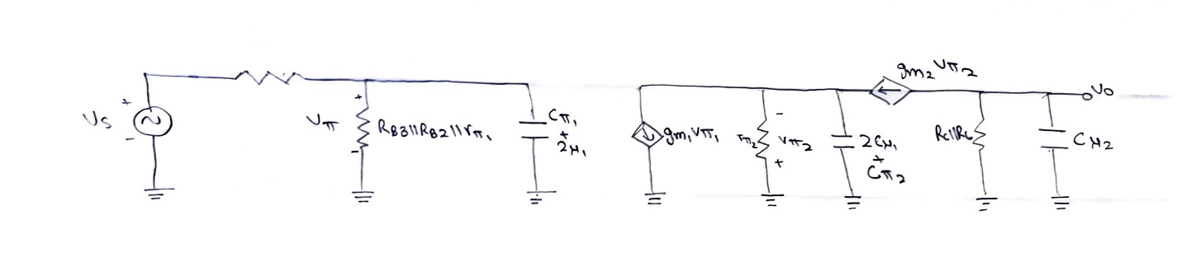
Circuit 3:Cascode high frequency small signal model

$$ω_{HP1}=\frac{1}{({(R}_{S}+R_{in})\left|\left|R_{B3}\right|\right|R_{B2}||r_{π1})(C_{π1}+2C_{μ1})}=1.21MHz$$
$$ω_{HP2}=\frac{1}{(\frac{r_{π2}}{1+β})(C_{π2}+2C_{μ1})}=117.08 MHz$$
$$ω_{HP3}=\frac{1}{(R_{C}||R_{L})(C_{μ2})}=7.63 MHz$$

$$ω_{H3dB}=\frac{1}{\sqrt{τ_{HP1}^{2}+τ_{HP2}^{2}+τ_{HP2}^{2} }}=1.3 MHz$$

 | $$ω_{L3dB}$$ | $$ω_{H3dB}$$
Calculated | 250 Hz | 1.3 MHz
Estimated | 249 Hz | 1.355 MHz

- Amplitude Response

Using Bode plot, at 10kHz, Amplitude Response plot is estimated.

- Input Impedance

Calculated:
$$R_{in}=R_{in}+R_{B2}\left|\left|R_{B3}\right|\right|r_{π}= 5.181 kΩ$$

Measured (Using CircuitMaker):
$$R_{in}=\frac{V_{Test}}{I_{Test}}=5.600 kΩ$$

Part 2: Cascaded Amplifiers — The Common-Base followed by the Common-Collector.

Design Specifications:
We need to build a common-collector (followed by a common-base) amplifier with an input impedance and output impedances of $50±5 Ω$. The 2N3904 NPN transistors are to be used in this project. Note that, from previous investigations, 2N3904 has β=164
- Cascaded Biasing
$R_{i}=R_{E1}||\frac{r_{π1}}{β+1}$
$R_{i}≈\frac{V_{T}}{I_{c1}}$
$I_{E1}=I_{C1}=\frac{0.025}{50}=0.5 mA$
Using 1/3 Rule

$V_{E1}=\frac{1}{3}V_{CC}=4V$
$V_{B1}=4.7V$
$V_{C1}=V_{B2}=\frac{2}{3}V_{CC}=8V$
$V_{E2}=7.3V$
$I_{1}=0.1I_{E}=50 μA$

Therefore, the values of Resistors are,

$R_{E1}=\frac{4}{0.5 mA}=8 kΩ$
$R_{B1}=\frac{12-4.7}{50 μA}=146 kΩ$
$R_{B2}=\frac{4.7}{47 μA}=100 kΩ$
$$R_{C1}=\frac{4}{I_{C1}+I_{B2}}$$
$$R_{E2}=\frac{7.3}{I_{E2}}$$

Moreover, to get the specified $R_{o}=50±5Ω$ and the equivalent circuit,
$$R_{o}=\frac{R_{C1+r_{π2}}}{1+β}||R_{E2}=50$$
$$R_{o}=\left(\frac{R_{C1}}{1+β}+\frac{{R_{E2}V}_{T}}{V_{E2}}\right)||R_{E2}$$
Solving for $R_{C1},R_{E2} and I_{E2}$ yields,
$$R_{E2}=1.59 kΩ ;I_{E2}=4.6 mA$$
$$R_{C1}=7.62 kΩ$$
Capacitance Values:
We design the model such that $C_{C1}$and $C_{C2}$ contribute equally for dominant poles and to do so, we set $C_{C1}=C_{C2}=C$.
$$f_{L3dB}=\sqrt{2{\left(\frac{1}{C×\left(\frac{R_{C1}+r_{π2}}{1+β}||R_{E2}\right)}\right)}^{2}}$$
$$C=4.496 μF$$
Changing the resistor and capacitors to standard values,
Circuit 4: Cascaded Amplifier
$C_{B}=0.082 μF$ was the lowest possible value to observe 1000Hz low frequency cut-in.
- Midband Gain

Using CircuitMaker, the observed $R_{i}$ and $R_{o}$ by setting the source at -1m/1mV at 100kHz,
$$R_{i}=\frac{1mV}{20μA}=50 Ω$$
$$R_{o}=\frac{1mV}{19.46 μA}=50 Ω$$

Both the input and output impedances are within the required ranges.

The midband voltage gain without load and source impedance attached,

$$\left|A_{M}\right|=62.73 V/V$$
Plot 3: Phase Bode plot for Cascaded Amplifier.

Plot 4:Bode Plot for Cascaded Amplifier

As observed from the bode plots,
$$ω_{L3dB}=1000 Hz$$

$$ω_{H3dB}=3.602 MHz$$

Part 3: The Differential Amplifier.
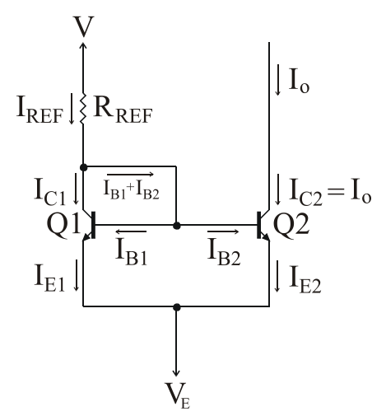
Using the methods taught in class,
Circuit 5: The Current Mirror

$I_{REF}=I_{o}\left(1+\frac{2}{β}\right) ≈I_{o}$
$I_{REF}=\frac{V-(V_{EE}+B_{BE})}{R_{REF}}$
$R_{REF}=\frac{0-(-12+0.7)}{I_{REF}}=\frac{11.3V}{2mA}=5.650 kΩ$

- Differential, small signal input

After “wiring up” the circuit and using standard resistor for $R_{REF}=5.6 kΩ$

Circuit 6: Differential Amplifier
Plot 5: Amplitude Bode Plot for Differential Amplifier Plot 6: Phase Bode Plot for Differential Amplifier

$$f_{H3dB}=1.173 MHz$$
Using Transient Analysis and analyzing $V_{PP}$
Plot 7:Transient Analysis of Differential Amplifer
$$\left|A_{M}\right|=306.55 V/V$$

- Calculated Values

$$r_{π}=8.2 k$$
$$g_{m}=0.020 s$$
$$C_{π}=74.1 pF$$
$$C_{μ}=8.27 pF$$

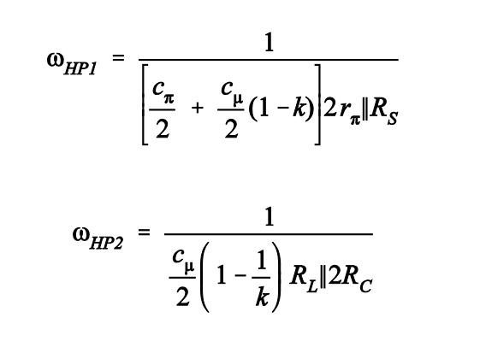

$$f_{H3dB}=1.1MHz$$

- Maximum input signal at Midband Frequency

Plot 8: Amplitude Response at Midband Frequency for Differential Amplifier
We picked 100kHz as “mid band” frequency and then after applying small differential signal to amplifier from -1mV/1mV to -300mV/300mV, it started becoming linear around $-25mV/25mV$

Part 4: AM Modular

- Modular Output

Circuit 7:AM modulator
We observed the following plot when 50mV_{P}, 1kHz sine wave is applied to input of Modulator.
Plot 9: Transient Analysis for output of AM modulator.

- Undistorted output signal

Varying the input signal from $10mV_{P}$ to $100mV_{P}$ , the output signal started to get distorted shortly after $-40mV/40mV$ amplitude.
Even at $-45mV/45mV$ clipping of signal was noticed.
- Square Wave Signal
On increasing the input Amplitude of square wave from $10mV_{P}$ to $100mV_{P}$, the output signal started to get less distorted.

