|  |
| --- |
| FIT VUT |
| ISS Projekt |
| Protokol s riešením |

|  |
| --- |
| Peter Rúček, xrucek00  3.1.2021 |

# **Úloha**

|  |  |
| --- | --- |
| maskon_sentence.wav | 2.76s 44211 samples |
| maskoff_sentecne.wav | 2.65s 42353 samples |

# **Úloha**

|  |  |
| --- | --- |
| maskoff_tone.wav | 2.02s 32322 samples UPDATEEEE |
| maskon_tone.wav | 2.32s 35666 samples UPDATEEEE |

# **Úloha**

framesize = window_size * fs

window_size = 20 ms

fs = 16 000 Hz

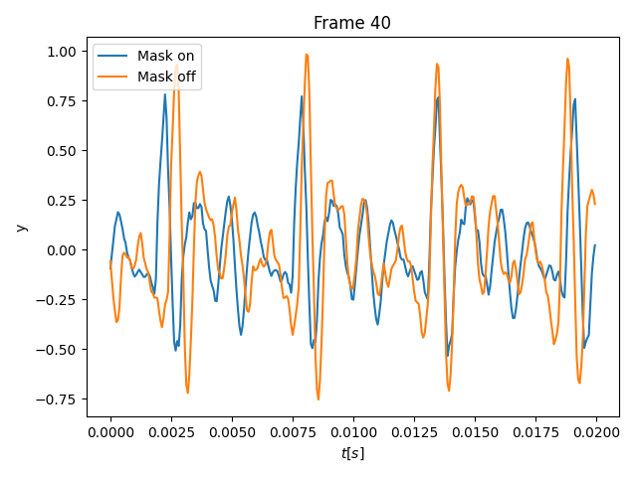

# **Úloha**

a)

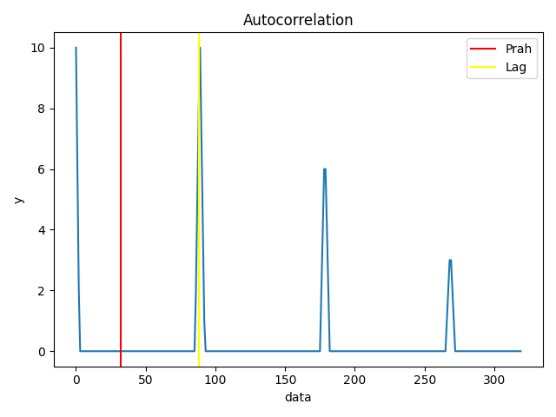

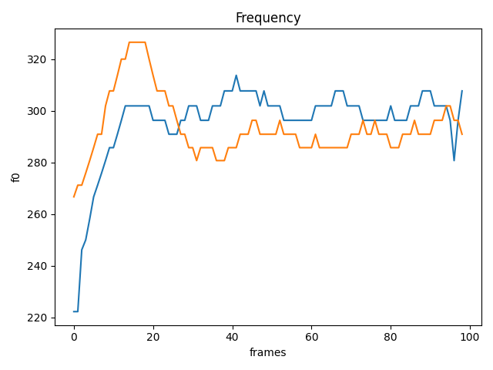

b)

Mask On Median = 290.90909090909093

Mask Off Median = 301.8867924528302

Mask On Variance = 145.61056584681748

Mask Off Variance = 235.43183771923574

c)

# **Úloha**

a)

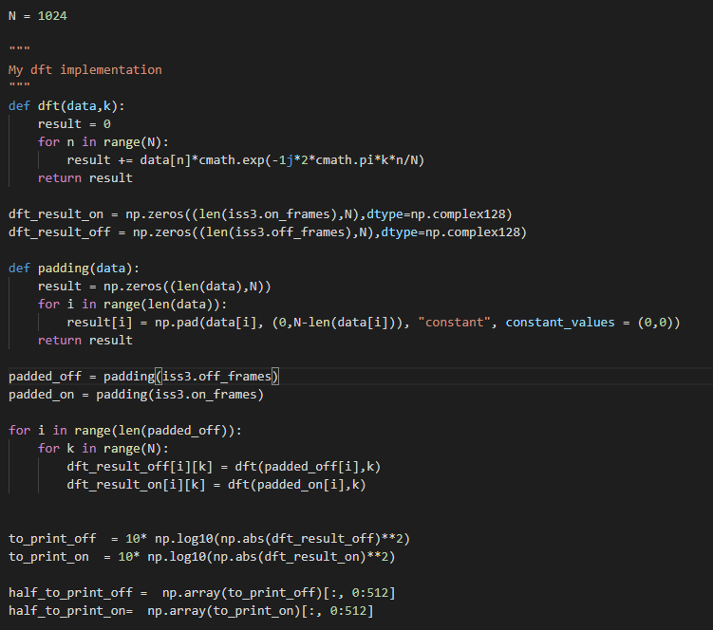

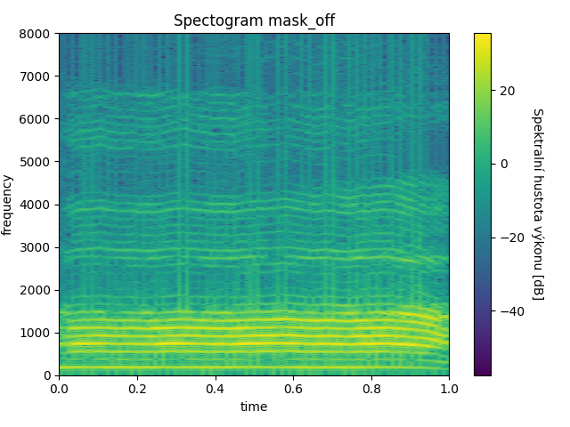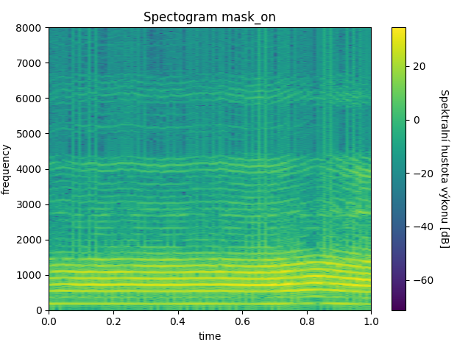b)

# **Úloha**

a)

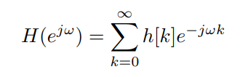

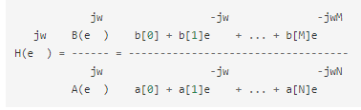b)