Q1: This question has no complete options
A. Option A
B. Option B
Q2: This one is valid and has an image
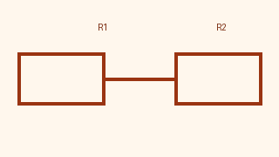
A. Alpha
B. Beta
C. Gamma
D. Delta
Hint: Read the figure carefully.

