Q1: Find the current in the circuit shown below
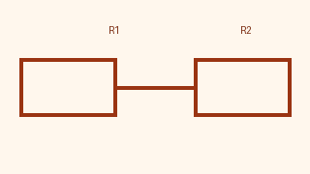
A. 2A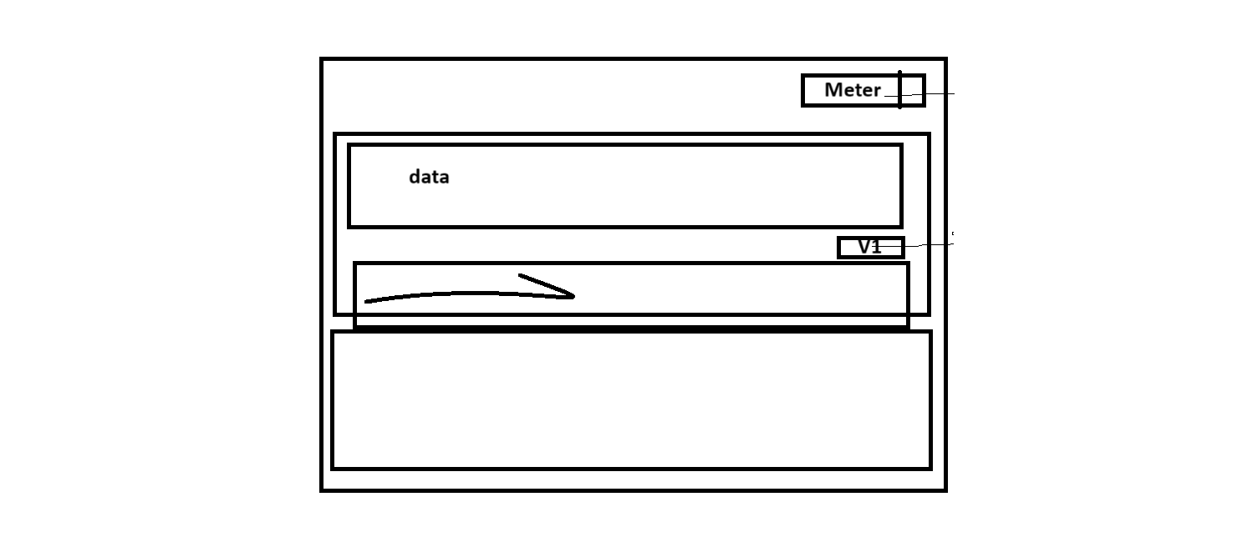
B. 3A
C. 4A
D. 5A
Solution: Use V = IR and substitute the given values.
Hint: Start from Ohm's law.
Q2: Identify the equivalent resistance
A. 1 Ohm
B. 2 Ohm
C. 3 Ohm
D. 4 Ohm
Solution: Series resistances add up.



