Contents

1. Documentation 1

2. TEM installation 1

2.1 Adding “Document Management Client” and “Active Workspace Document Management” 1

2.2 Define when to add the Teamcenter attributes in template files 3

2.3 Adding “Logical Object” Client and Server 3

3. Configuration 3

3.1 Define Logical Object 3

3.2 Add Logical Object to MS WordX Dataset 6

3.3 Define MS Word Document Properties 7

3.4 Insert Document Properties 7

4. Events that trigger an update of the Document Properties 8

# Documentation

Active Workspace 4.3 Help > Deployment and Configuration > Configuration and Extensibility > Administration > Use logical objects to consolidate properties

Teamcenter 12.3 Help > Document Management > Deploying Document Management > Synchronizing attributes from Teamcenter to Microsoft Office files by using logical objects

# TEM installation

In addition to a ‘standard’ Teamcenter and Active Workspace configuration, install the following features:

Base Install

* Business Modeler IDE

Active Workspace > Client

* Document Management Client
* Logical Object

Active Workspace > Server

* Active Workspace Document Management

Active Workspace > Server (> Active Architect, *depends on TEM version*)

* Logical Object

## Adding “Document Management Client” and “Active Workspace Document Management”

The following will be installed;

- feature Document Management for Active Workspace Client (tc/docmgmt_aws2stage)

- feature Active Workspace Document Management/Runtime Server (tc/dma1docmgmtaw_rtserver)

- feature Active Workspace Document Management/Data Model (tc/dma1docmgmtaw_template)

Which makes the BMIDE template “dma1docmgmtaw” available.

TEM Add/Update Templates for working with the BMIDE Client

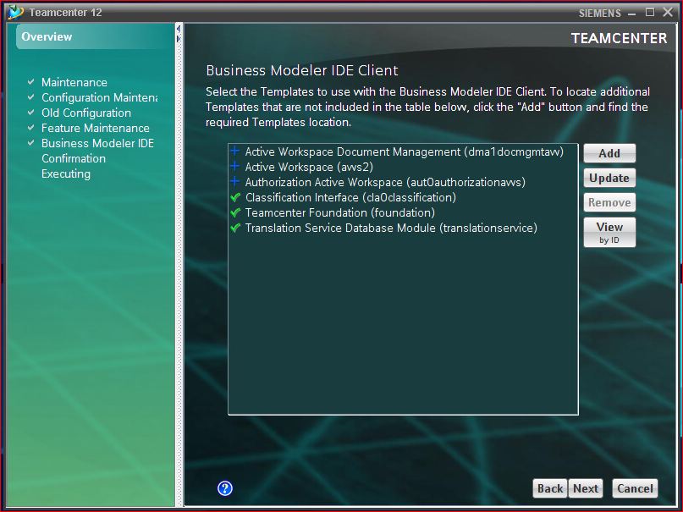

Note: *aws2* and *aut0authorizationaws* are required and need to be installed along with *dma1docmgmtaw*

1) 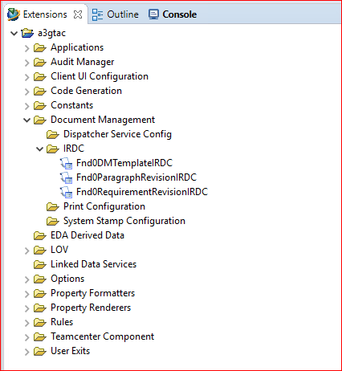 2) 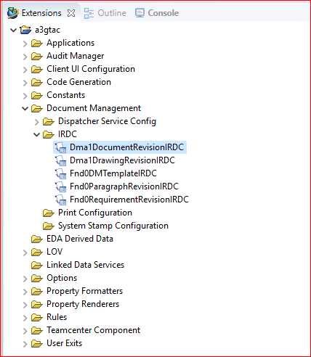

1. Note that in an OOTB BMIDE Template Project there is no *DocumentRevisionIRDC* available.
2. After adding the *dma1docmgmtaw* template there are two additional IRDC’s available.

For further explanation the *Dma1DocumentRevisionIRDC* will be used.

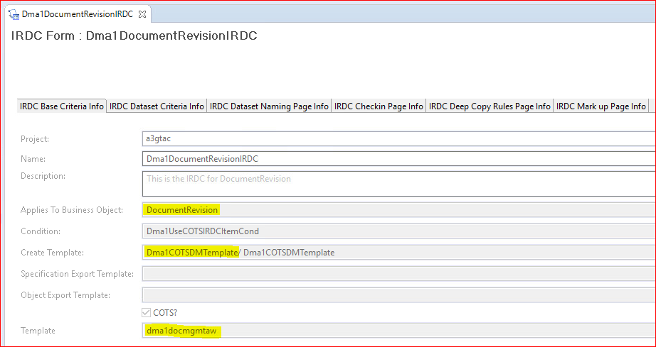 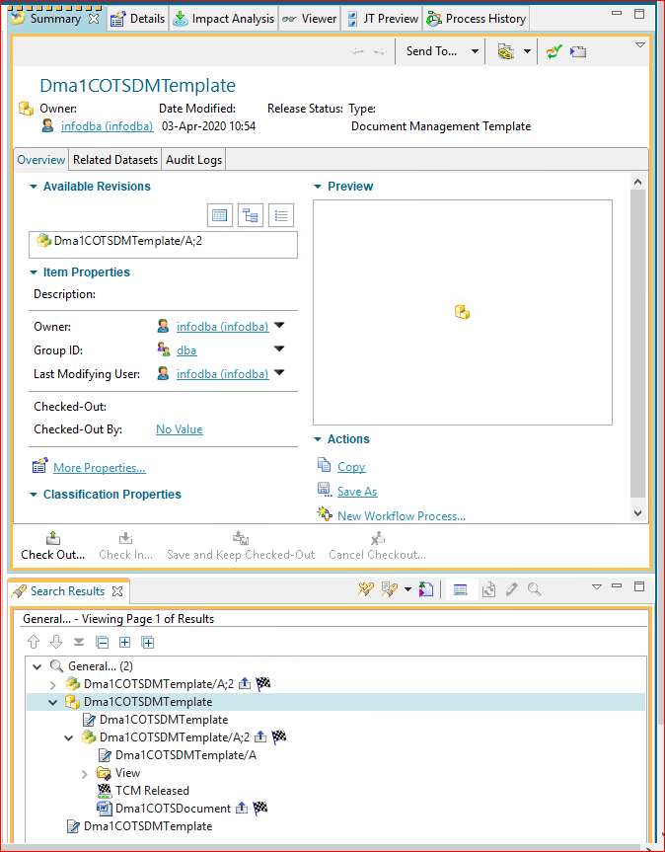

*Template:* tells us that this IRDC is part of the *dma1docmgmtaw* BMIDE template.  
*Create Template:* tells us that a new IRDC template *Dma1COTSDMTemplate* is created in Teamcenter.

*Applies To Business Object:* tells us that the IRDC applies to *DocumentRevision.*

As a result, after deployment of the Active Workspace Document Management template, every instance of a Document created in Teamcenter will automatically get an MS Word document attached to its Document Revision. This differs from a Teamcenter environment where no Active Workspace Document Management has been installed. In such an environment the DMTemplate and IRDC need to be created and applied manually.

The Document, DocumentRevision and MS WordX Dataset play a role in the further explanation of Attribute Exchange based on Logical Objects.

## Define when to add the Teamcenter attributes in template files

This step needs to be performed manually in the BMIDE, unless the optional *Sample Document Management (sdm0sampledocmgt)* has been installed, which will override the values automatically with TC_Attaches and IMAN_specification.

*Fnd0RelToDatasetforLOAttrExch*: Fill in the relation type (in this example *TC_Attaches*).  
*Fnd0TriggerLOAttrExchange*: Fill in *Configured* or *Enabled* (if *Enabled* you don’t need to fill in a relation type).

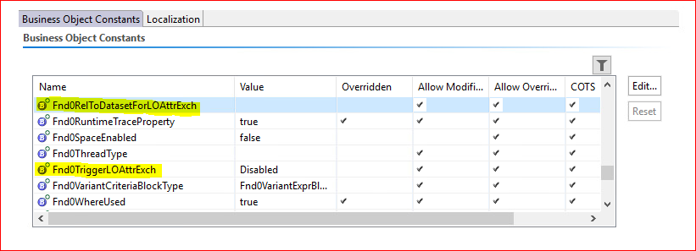

## Adding “Logical Object” Client and Server

Although the Logical Object feature under “Active Architect” may appear to be for the Active Admin workspace (which is an *exclusive* workspace designed for Active Workspace administrators) only and thus optional, it is not.

(The Active Admin workspace requires some additional deployment and configuration, but that is outside the scope of this document and therefore not covered.)

It adds the following;  
- feature Logical Object/Data Model (tc/lo1logicalobject_template);  
- feature Logical Object/Runtime Server (tc/logicalobject_rtserver)

After deployment the non-dba users will get the “Logical Objects” tile on their Active Workspace Homepage and there will be one Parent Logical Object available.

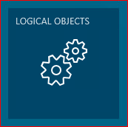

The deployment also adds some logic to the data model, but since the Logical Objects are administered in Active Workspace there is no need to consider the BMIDE at this point.

# Configuration

## Define Logical Object

As an Administrative user click on the Logical Objects tile to open the Logical Object Configuration page.  
Click New > Define Logical Object.  
Fill in the required values for *Internal Name*, *Name* and *Description*.  
*Root Object*: Choose Dataset since that is the parent business object of MS WordX -or- select subclass itself when you define attributes at subclass level. OOTB all attributes are at dataset level, in that case it would make sense to select the Dataset class.  
*Parent Logical Object*: Choose the OOTB available Logical Object (or any Child if already existing).  
Click [Add].

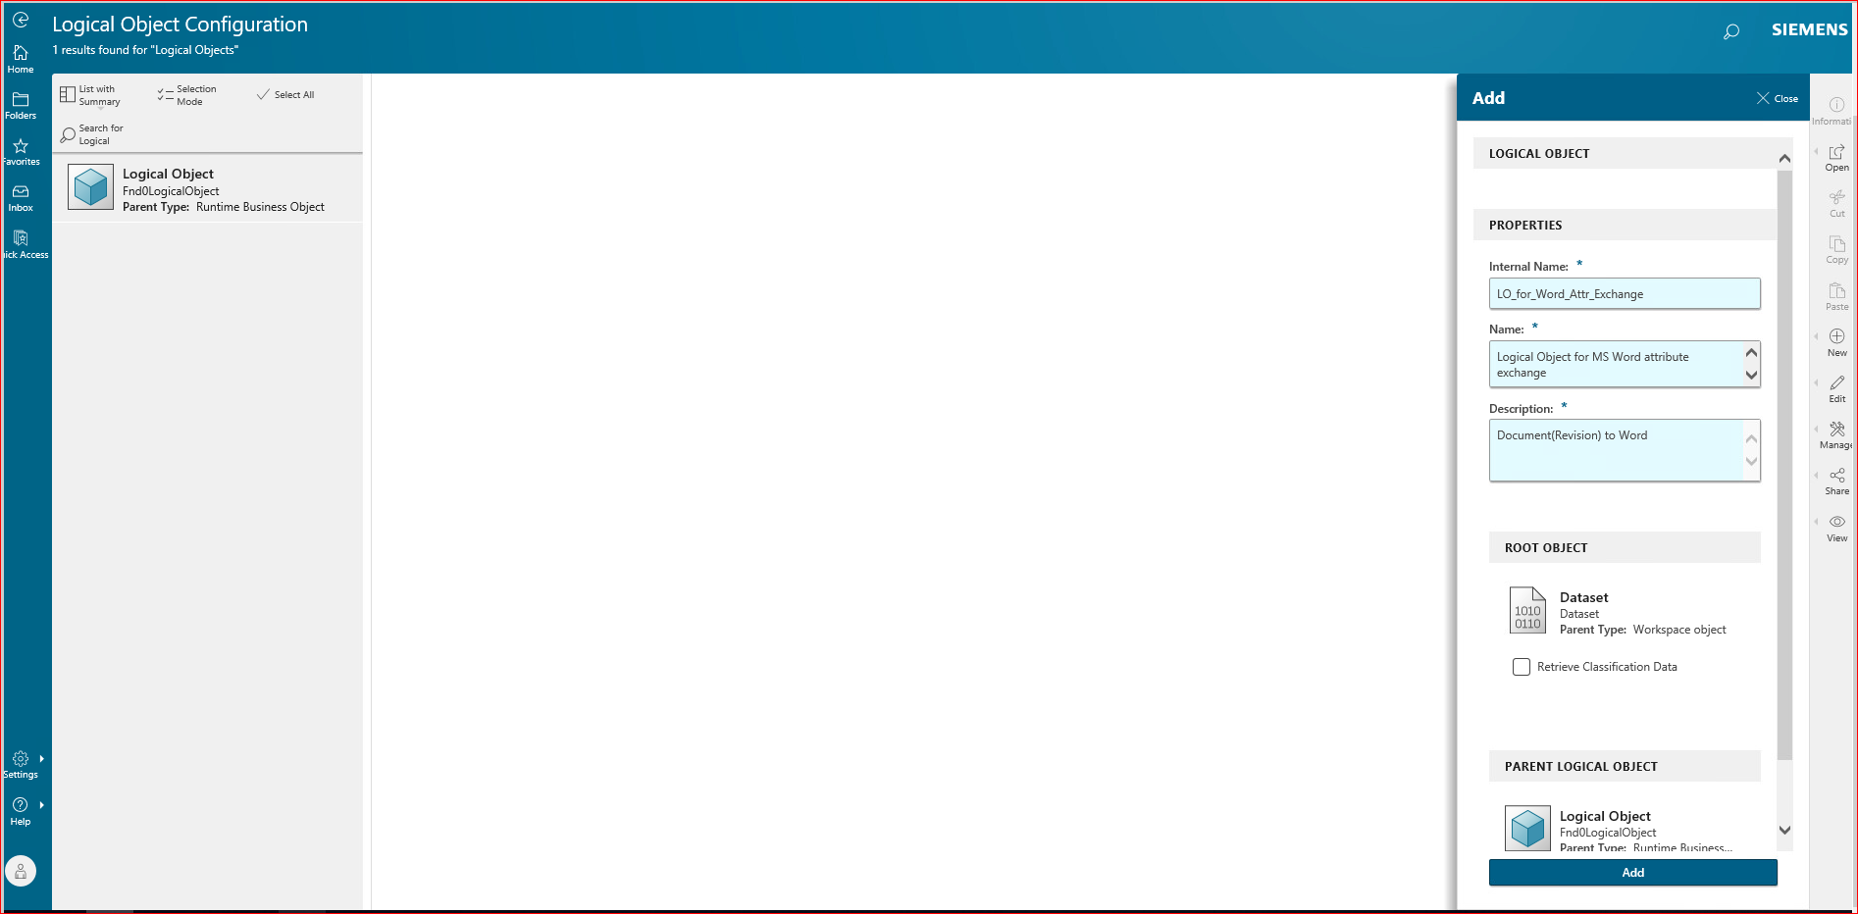

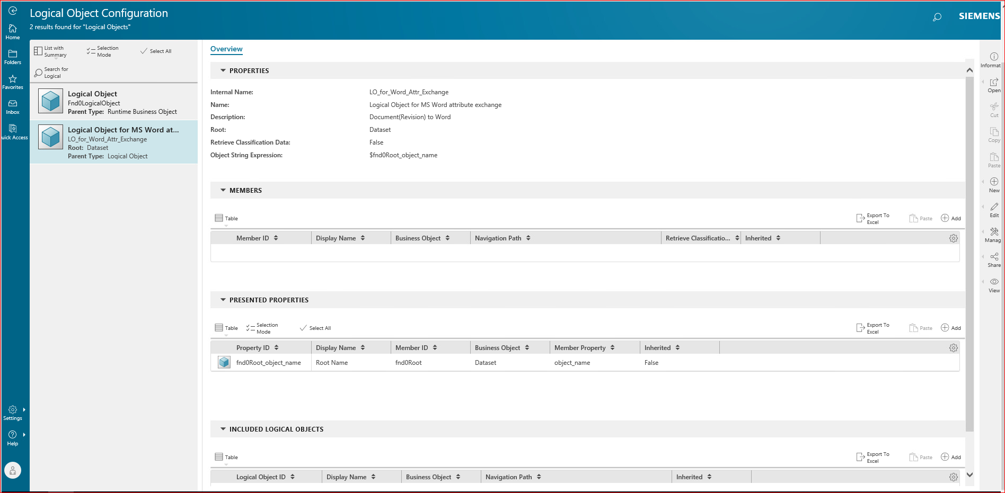

Click (+) Add in the MEMBERS pane.

Fill in the required values for *Member ID* and *Display Name*.  
**Tip**: Keep the member ID short, since it will be part of the property identification name that needs to be used in the Office documents.  
*Segment 1*: Choose Backward.  
**Explanation**: In Teamcenter, there is a forward relation from the ItemRevision to the Dataset. In our example, the Dataset is the starting point. There we need to follow the TC_Attaches relation “backwards” from Dataset to ItemRevision.  
*Business Object*: Choose DocumentRevision.  
*Relation or Reference*: Choose TC_Attaches (which is the relation between the DocumentRevision and MS WordX Dataset).  
Click [Add].

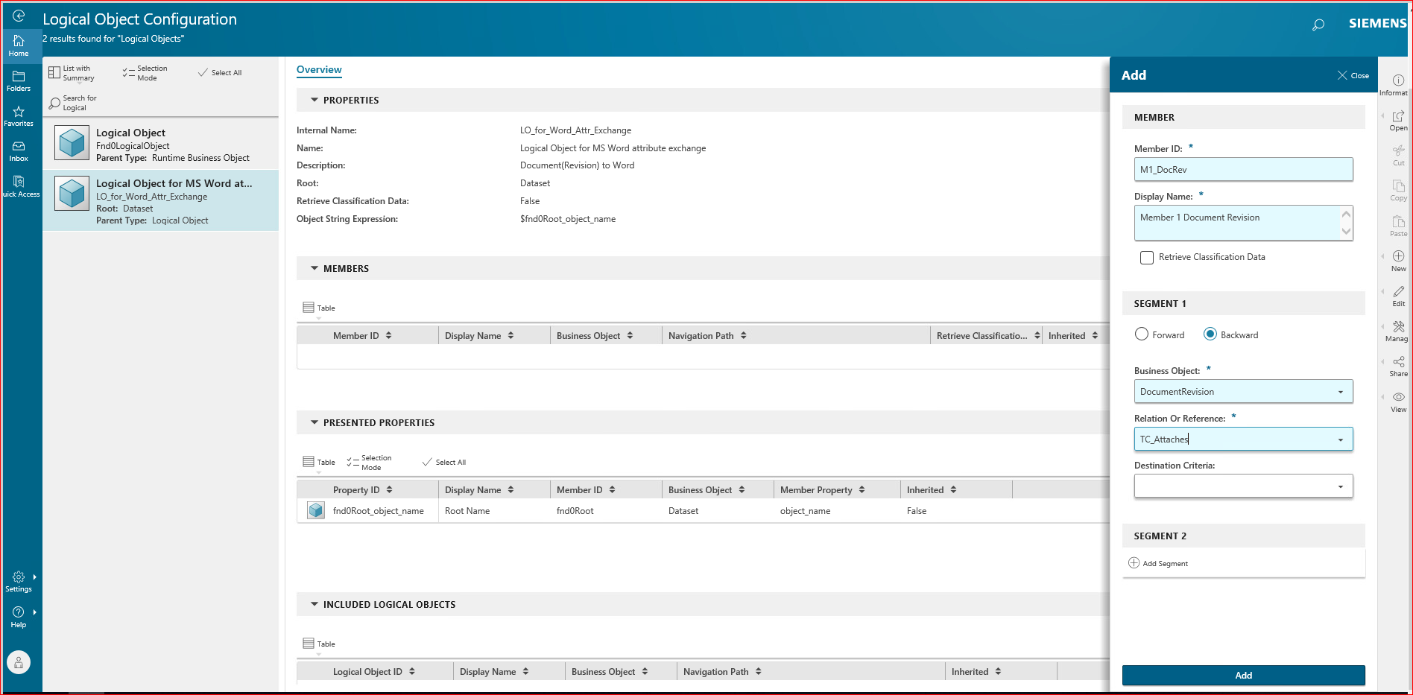

Click (+) Add in the MEMBERS pane.

Fill in the required values for *Member ID* and *Display Name*.  
*Segment 1*: Choose Backward.  
*Business Object*: Choose DocumentRevision.  
*Relation or Reference*: Choose TC_Attaches (which is the relation between the DocumentRevision and MS WordX Dataset).  
*Segment 2*: Choose Forward.  
**Explanation**: In this case, the relation is specified on the ItemRevision (items_tag). Since in Segment 1, we already moved from Dataset tot the ItemRevision, now the starting point is the ItemRevision. Therefore, we now need to follow the relation in the “Forward” direction.  
*Relation or Reference*: Choose items_tag (which is the Reference between the DocumentRevision and Document).  
*Business Object*: Choose Document.  
Click [Add].

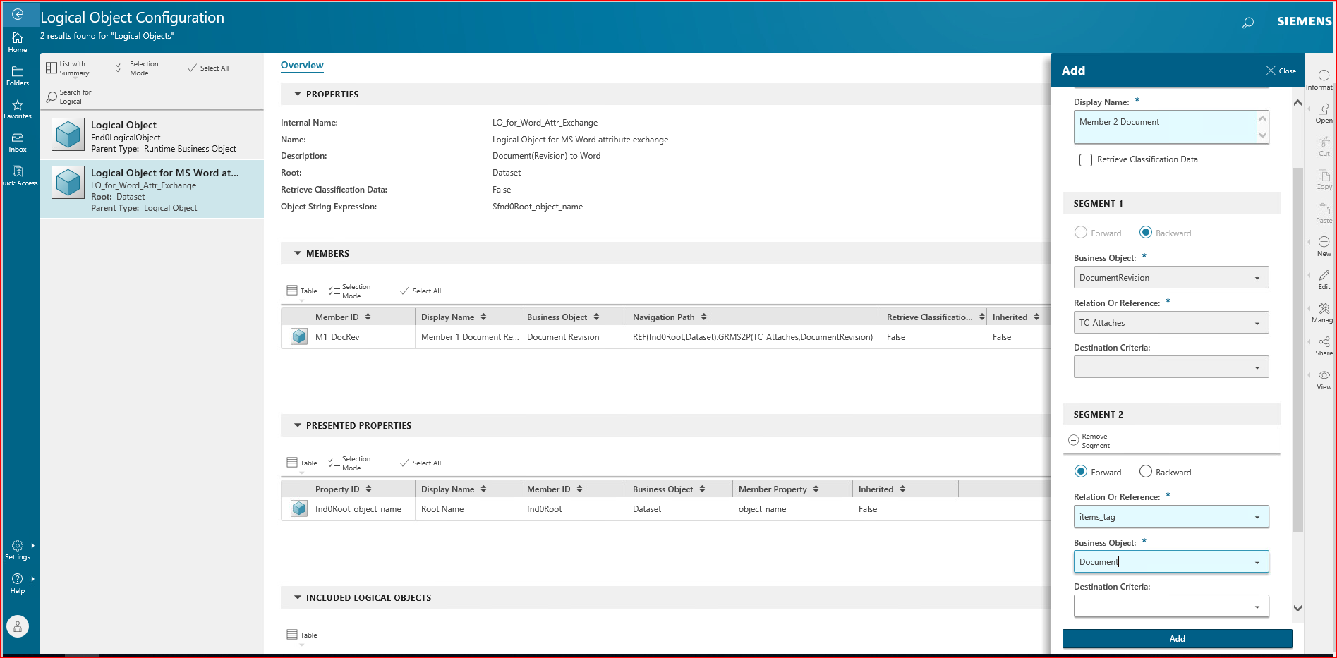

Result;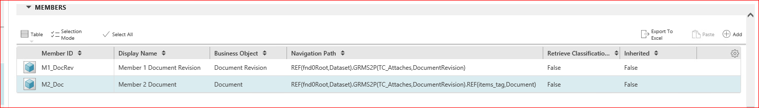

Click (+) Add in the PRESENTED PROPERTIES pane.

*Root Or Member* ID: Select the source where the properties are defined. This can be the root object, or any of the defined members. In this example; *M1_DocRev*.  
*Member Properties*: Choose one or more properties from the dropdown list, for example *object_desc* and *object_name*.  
Click [Add].

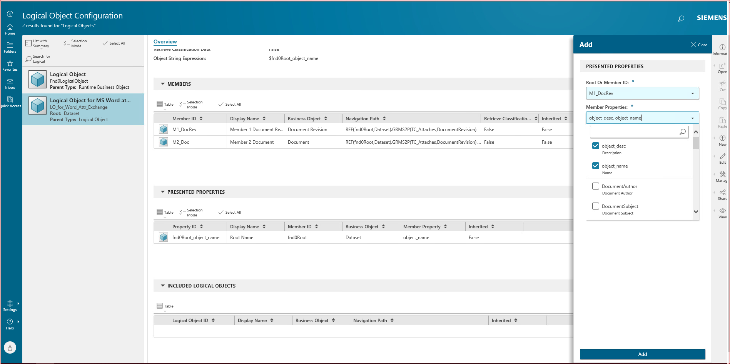

Repeat the above steps for the *M2_Doc* and choose for example *item_id*.

Result;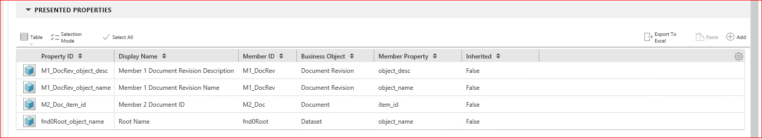

Note that the Property ID’s created here, are the Property ID’s to be used in the MS Word Document Properties (step 3.3)

Sign out of Active Workspace.

## Add Logical Object to MS WordX Dataset

As an Administrative user login to the Teamcenter Rich Client.

Search for *Dma1COTSDMTemplate*. This is the template that is specified in the IRDC rule.  
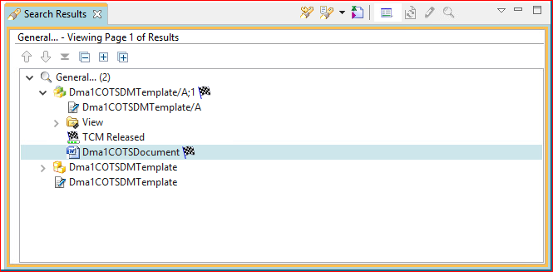

Select the *MS WordX* Dataset, choose Edit Properties and allow to Check Out.  
Scroll to the bottom and click Show Empty Properties…  
Scroll down to *Logical Object Type Relation*.  
Click the *Expand to Modify* (pencil) icon.  
Choose *Logical Object for MS Word attribute exchange* from the dropdown list.Click the *Add objects* (plus) icon.  
  
 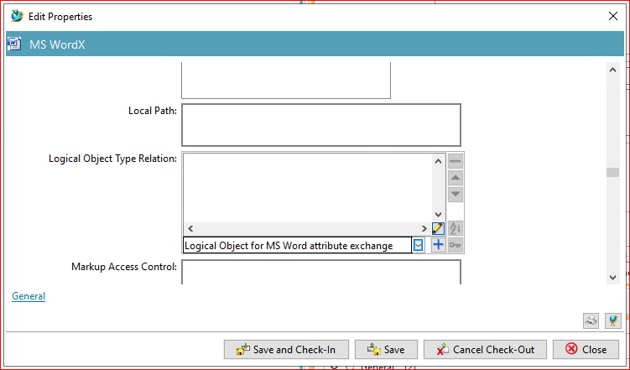 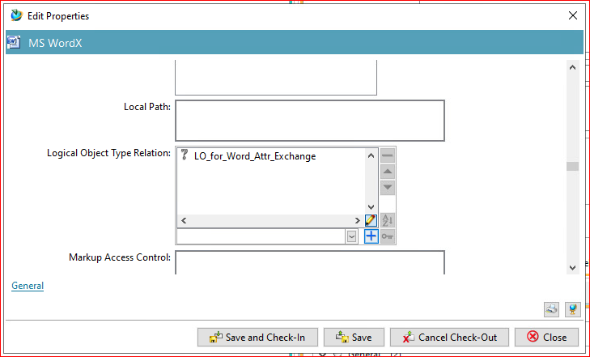

Click [Save and Check-In].

## Define MS Word Document Properties

Still logged in as an Administrative user.  
Launch the MS WordX Dataset.  
Choose File > Properties > Advanced Properties.  
  
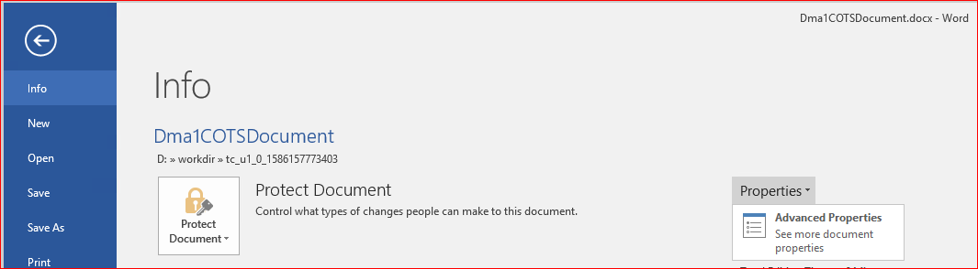

Open the *Custom* tab and fill in values for;  
*Name*: Type exactly the first *Property ID* as defined in step 3.1 Define Logical Object.  
*Type*: Text.  
*Value*: An initial value (for example *initial*).  
Click [Add].  
Repeat the above steps for the other *Property ID’s*.  
Click [OK].

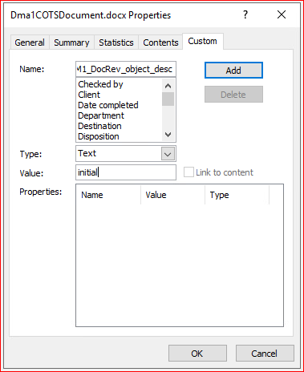 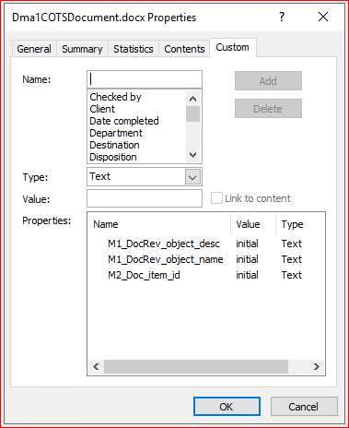

## Insert Document Properties

Back on the *Home* page of the MS Word document, the user can now start formatting the actual document template with some fixed text, tables, images, etc. For example the lines *Document ID, Document Name* and *Document Description*.

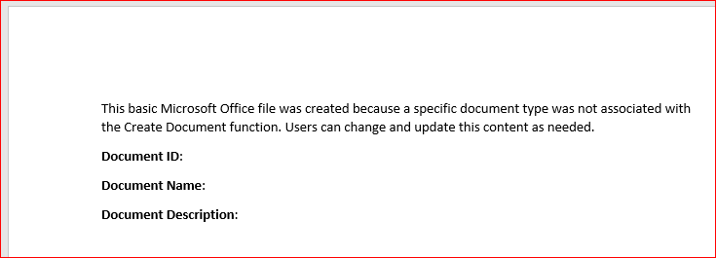

The user can also insert the values of the previously defined document properties.

Place the cursor behind the text and choose Insert > Quick Parts > Field…  
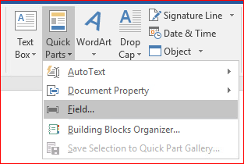 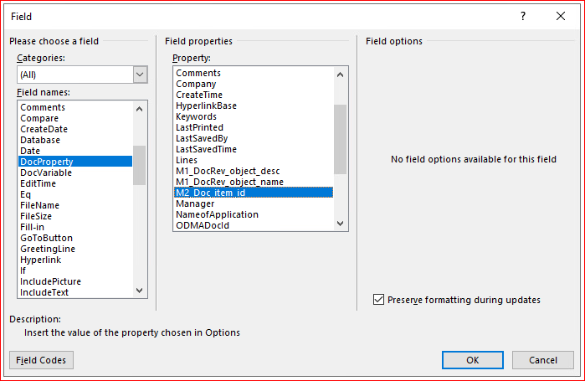

In the *Field* dialog choose the following values;  
*Field Names*: DocProperty.  
*Property*: the previously created custom document properties (for example M2_Doc_item_id).  
Repeat these steps for the other (custom) document properties.  
Click [OK].

Result;  
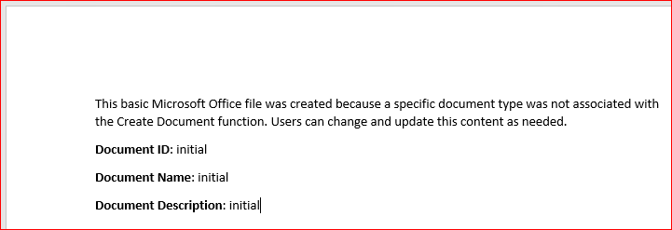

Note that a non-Administrative user might as well create an instance of a Document(Revision) and apply the same sort of mapping to the attached MS Word dataset. However, typically the attribute mapping will be applied to custom Document Management templates as specified in the IRDC rule, so that every instance created will have the same document format and mapped properties.

# Events that trigger an update of the Document Properties

The Teamcenter attributes along with logos, distribution statements, and workflow signoff tables are included in a file when a user creates, checks in, revises, saves as, prints, or renders a document revision.

To get the latest information in an Office file, a user can also send the file through an attribute exchange workflow process. For this, you must set up a workflow task for the users by using the [DOCMGTAPP-update-docprop-logicalobject](https://docs.plm.automation.siemens.com/tdoc/tc/12.3/help#uid:xid1671709:index_xid1655986:xid1743939:xid1559242:xid1632219::docmgtapp_update_docprop_logicalobject) action handler.

Finally, [you may verify if you have set up the attribute exchange correctly](https://docs.plm.automation.siemens.com/tdoc/tc/12.3/help#uid:xid1671709:index_xid1655986:xid1743939:xid1559242:xid1561609).

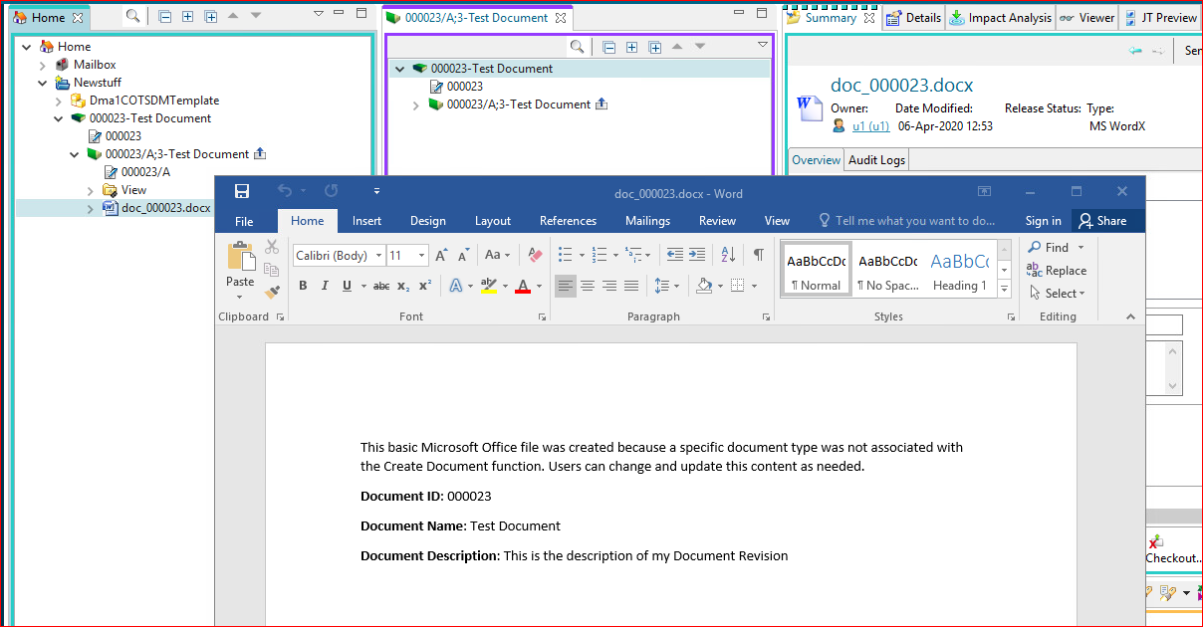

Eric de Graaff – GTAC EMEA, April 2020