ASSIGNMENT-14

**Uc-1-**As a User need to enter a valid First Name

---First name starts with Cap and has minimum 3 characters

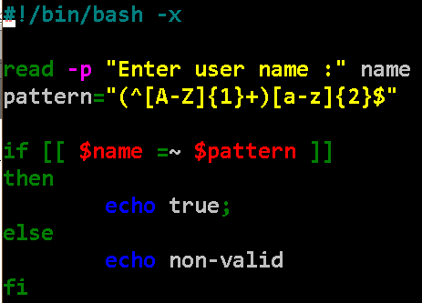

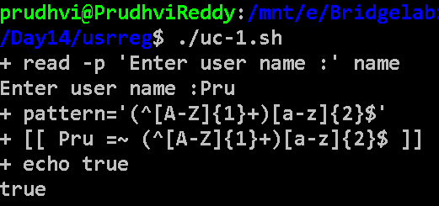

**uc-2-**As a User need to enter a valid Last Name

Last name starts with Cap and has minimum 3 characters

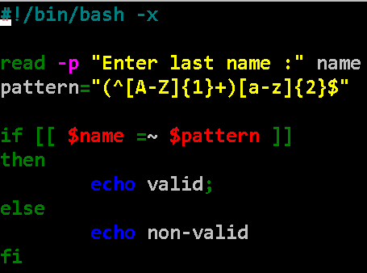

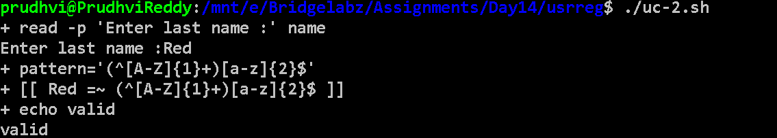

**Uc-3-**As a User need to enter a valid email

Ex:-abc.xyz@bl.co.in

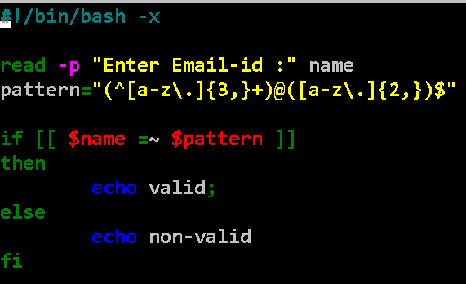

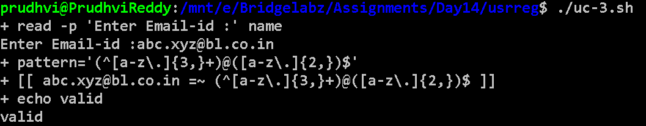

As a User need to follow pre-defined Mobile Format

Ex; - 91 9919819801

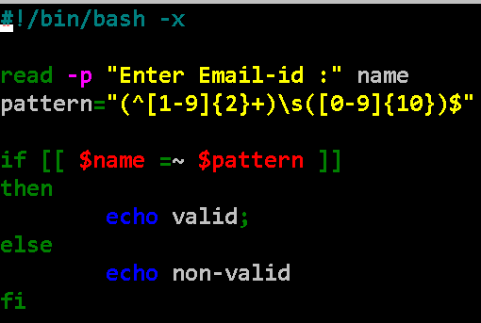

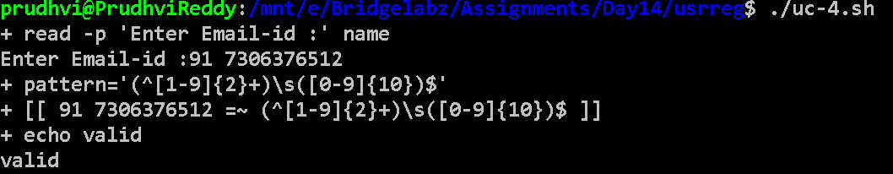

As a User need to follow pre-defined Password rules.

**Rule1 –** minimum 8 Characters

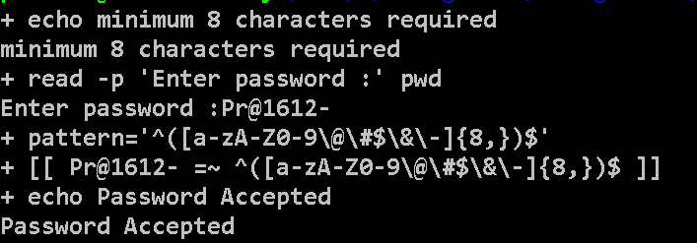

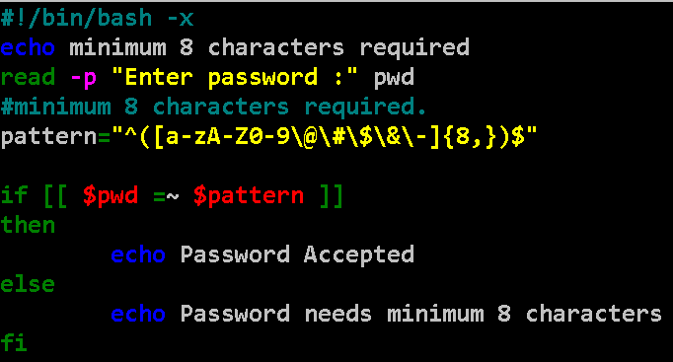

**Rule2 –** Should have at least 1 Upper Case

**Rule3 –** Should have at least 1 numeric number in the password

**Rule4 –** Has exactly 1 Special Character

