**ASSIGNMENT-05**

**Selection Practice Problems with if & else**

Write a program that reads 5 Random 3 Digit values and then outputs the minimum and the maximum value

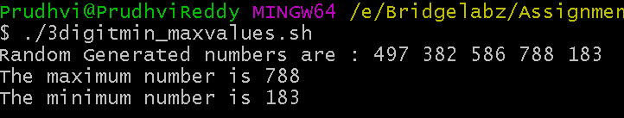

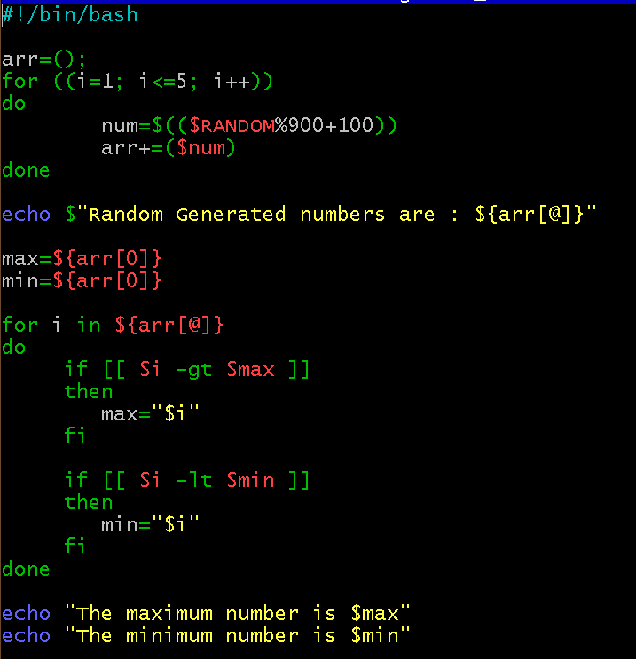

Write a program that takes day and month from the command line and prints true if day of month is between March 20 and June 20, false otherwise.

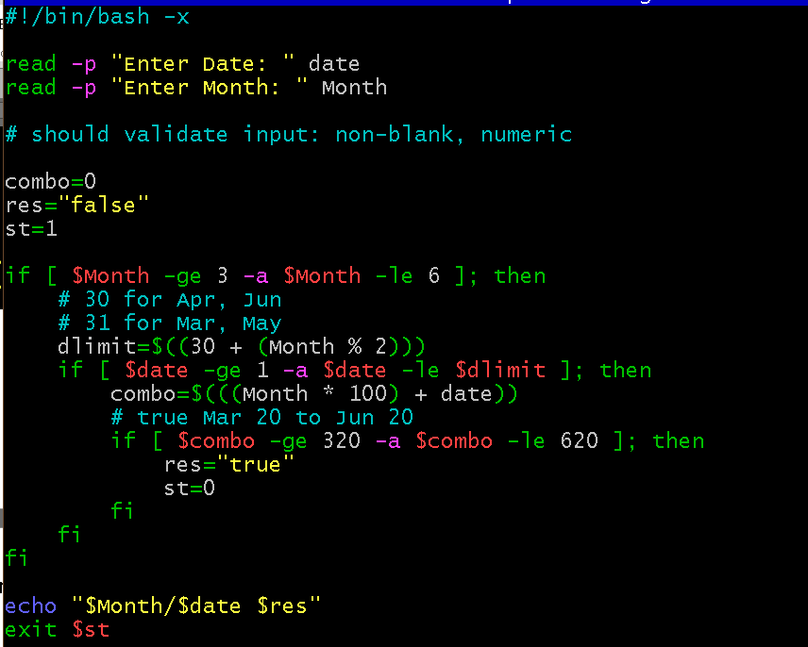

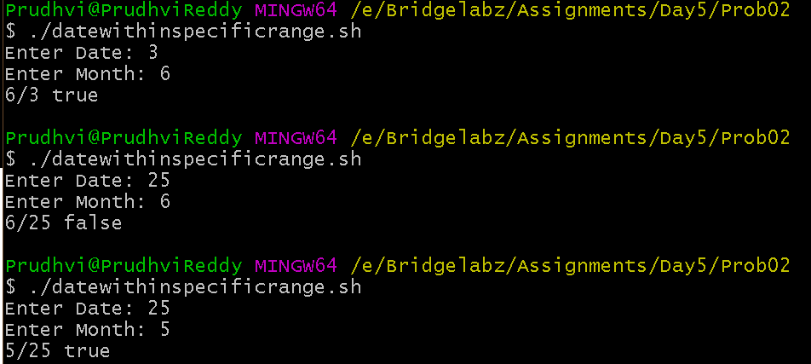

Write a program that takes a year as input and outputs the Year is a Leap Year or not a Leap Year. A Leap Year checks for 4 Digit Number, Divisible by 4 and not 100 unless divisible by 40.

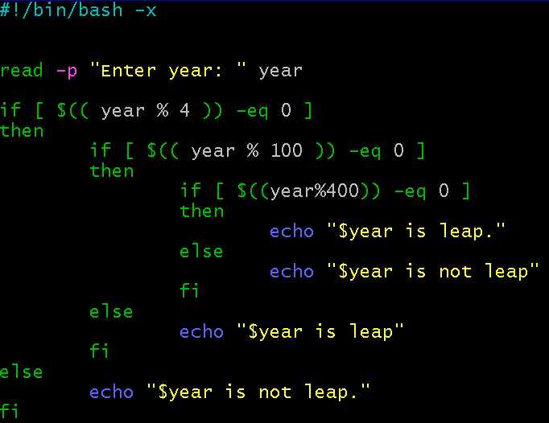

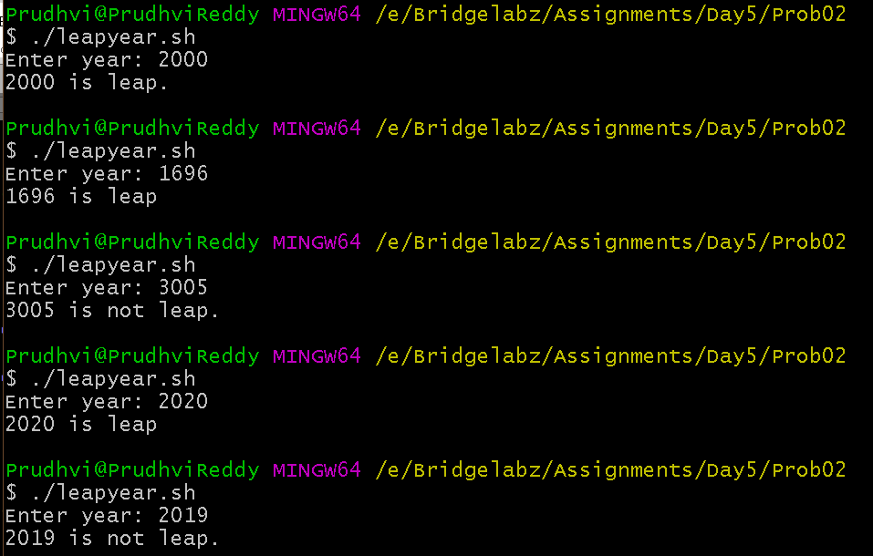

Write a program to simulate a coin flip and print out "Heads" or "Tails" accordingly.

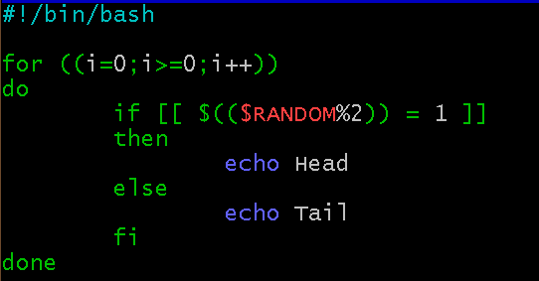

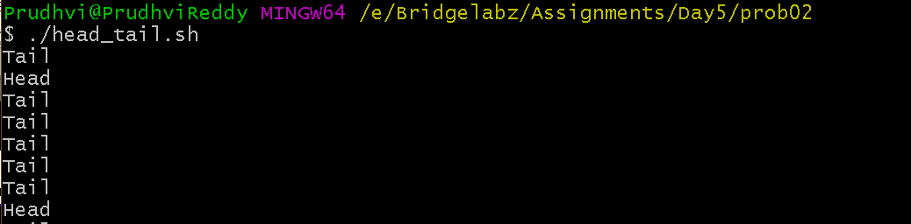

**Selection Practice Problems with if, elif and else**

Read a single digit number and write the number in word

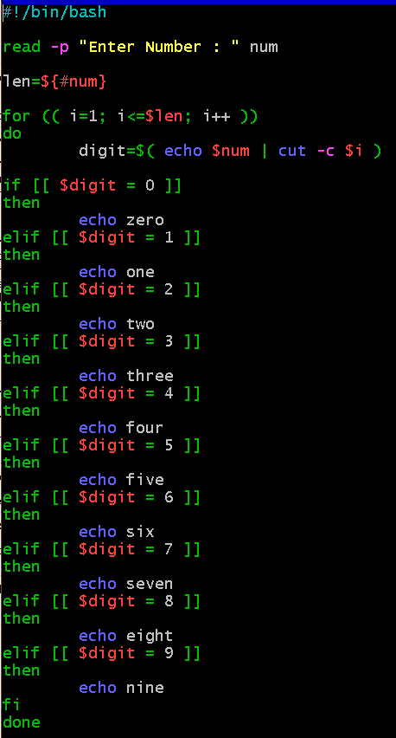

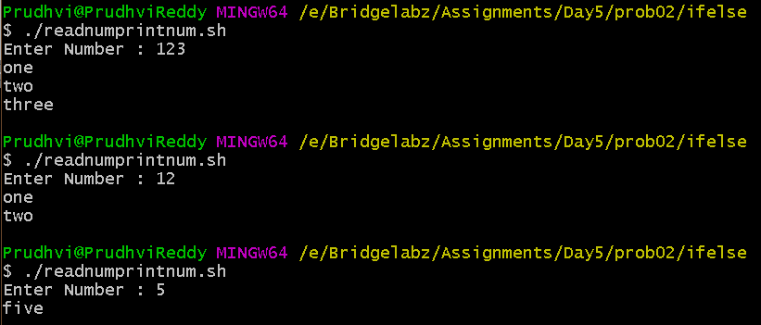

Read a Number and Display the week day (Sunday, Monday,…)

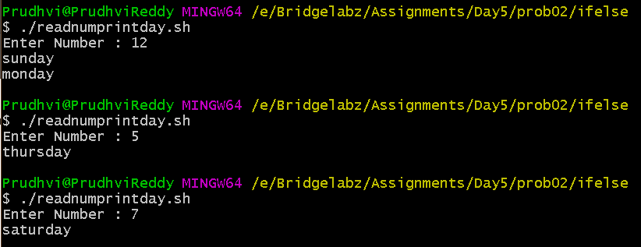

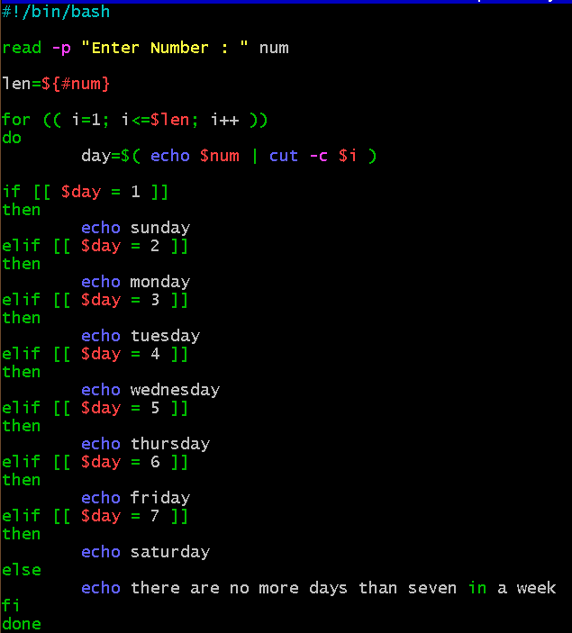

Read a Number 1, 10, 100, 1000, etc and display unit, ten, hundred,…

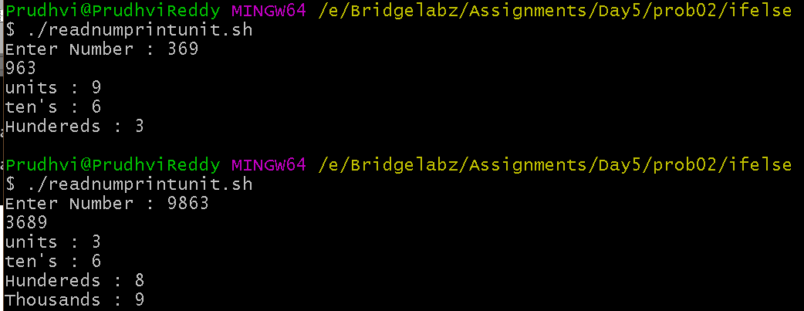

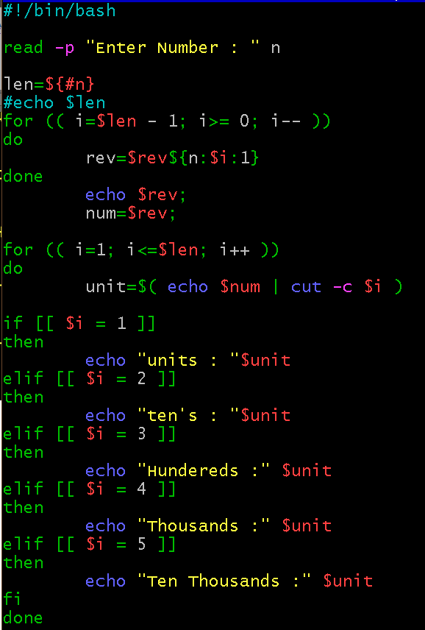

Enter 3 Numbers do following arithmetic operation and find the one that

is maximum and minimum

1. a + b * c 2. a % b + c 3. c + a / b 4. a * b + c

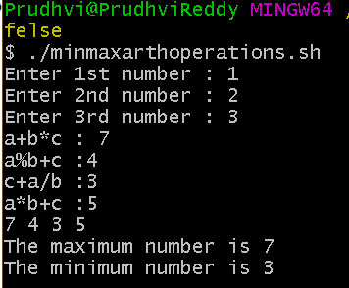

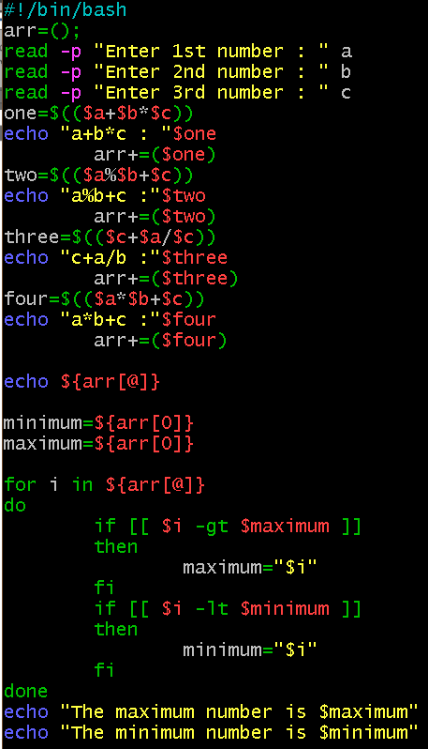

**Selection Practice Problems with case statement**

Read a single digit number and write the number in word using Case

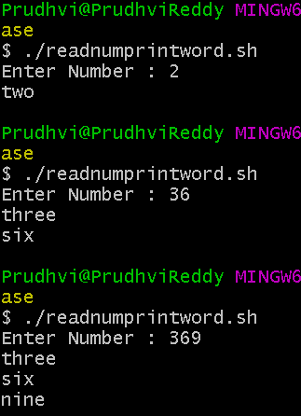

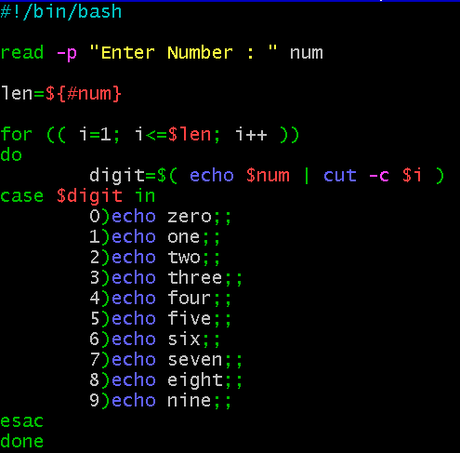

Read a Number and Display the week day (Sunday, Monday,…)

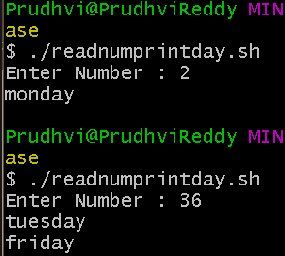

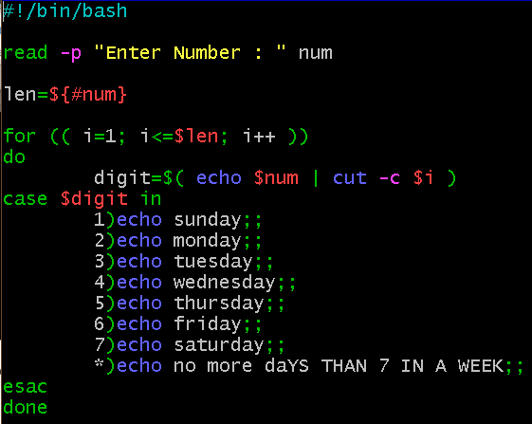

Read a Number 1, 10, 100, 1000, etc and display unit, ten, hundred,…

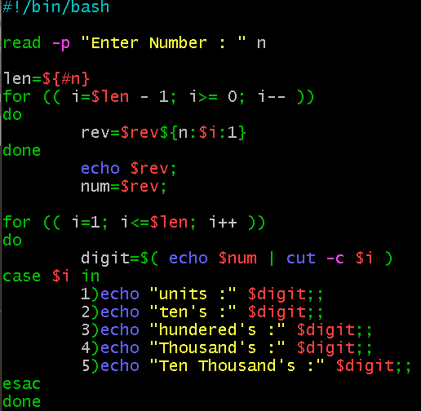

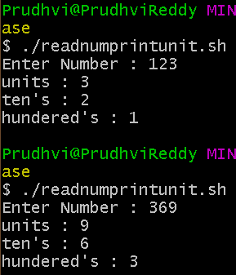

Write a program that takes User Inputs and does Unit Conversion of different Length units

1. Feet to Inch 2. Feet to Meter 3. Inch to Feet 4. Meter to Feet



