Assignment-05

Use Random Function ***((RANDOM))*** to get Single Digit

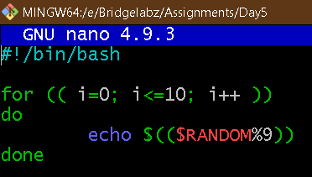

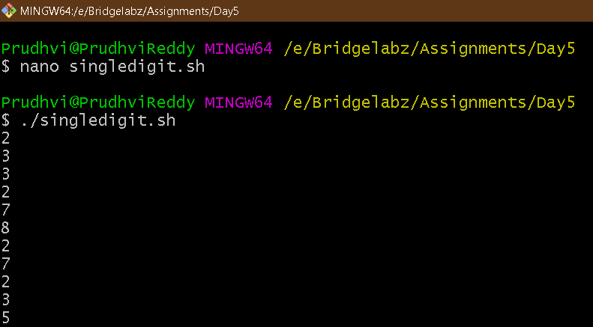

Use Random to get Dice Number between 1 to 6

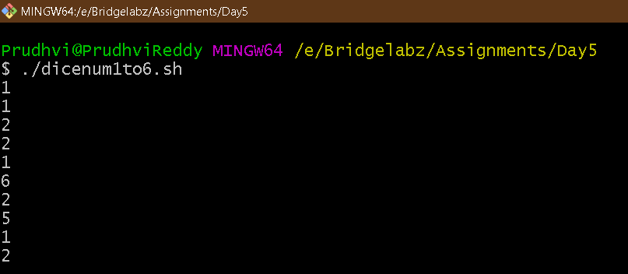

Script

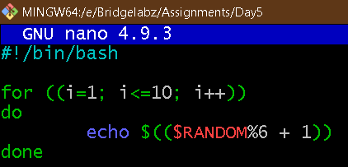

Add two Random Dice Number and Print the Result

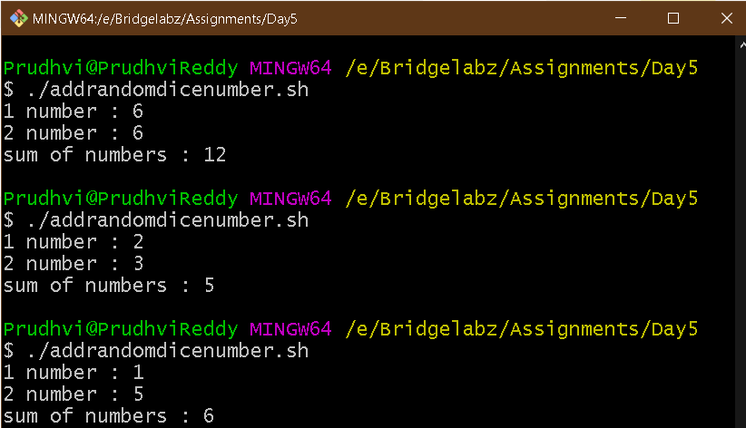

Script

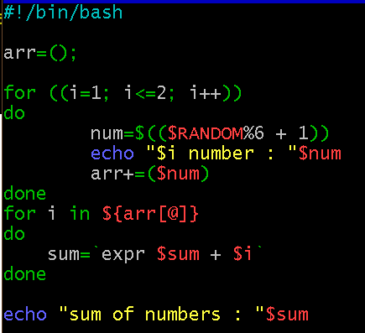

Write a program that reads 5 Random 2 Digit values, then find their sum and the average

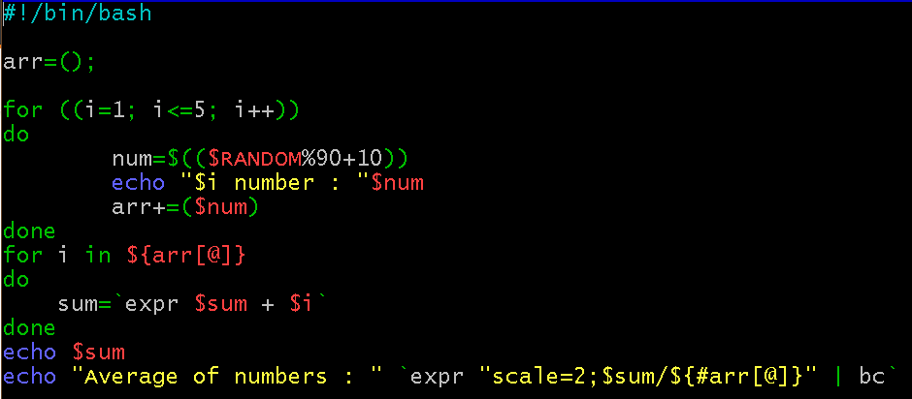

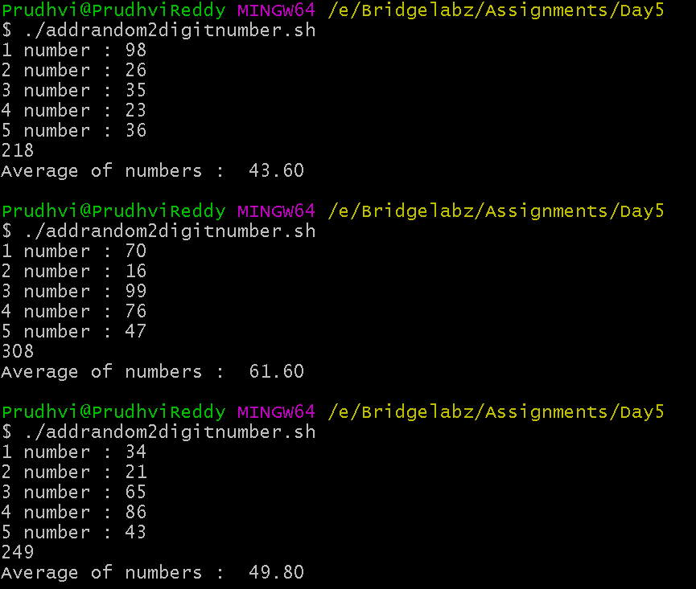

Unit Conversion

a. 1ft = 12 in then 42 in = ? ft

b. Rectangular Plot of 60 feet x 40 feet in meters

c. Calculate area of 25 such plots in acres

