**Repetition Practice Problems with for loop**

Write a program that computes a factorial of a number taken as input.

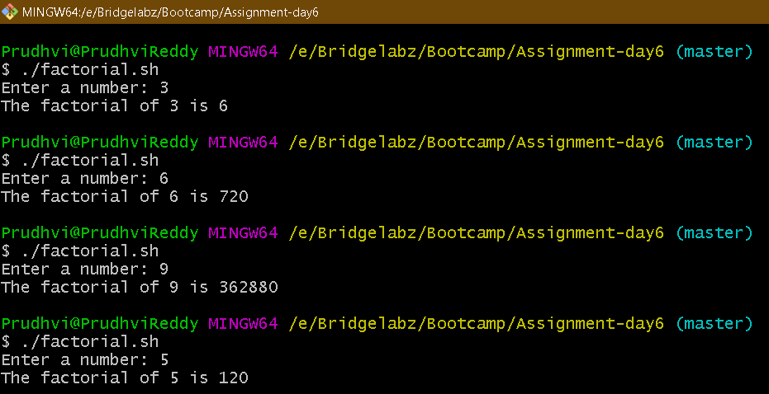

Script

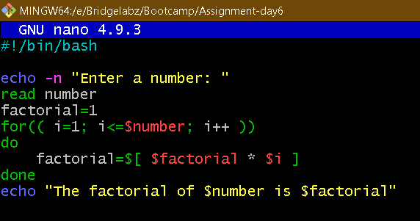

Write a program that takes a input and determines if the number is a prime

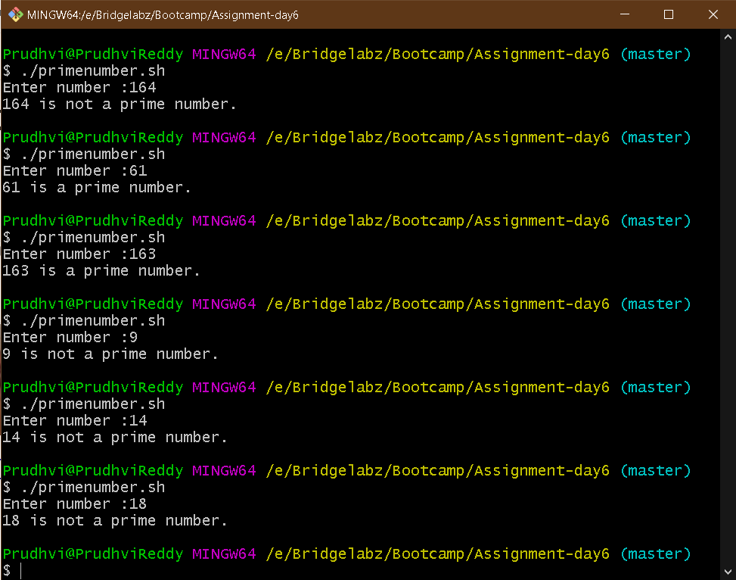

Script

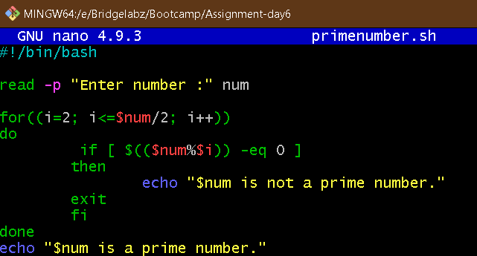

Write a program that takes a command-line argument n and prints the nth harmonic

number. Harmonic Number is of the form 

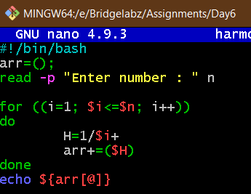

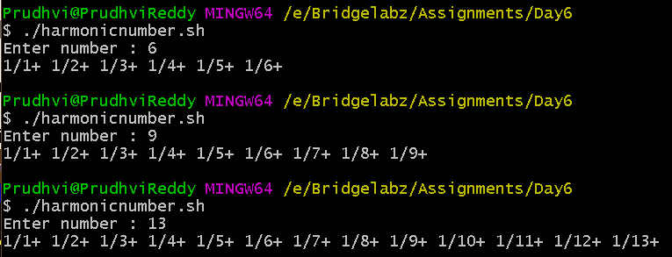

Write a program that takes a command-line argument n and prints a table of the

powers of 2 that are less than or equal to 2^n.

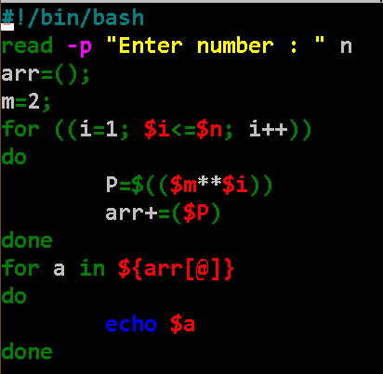

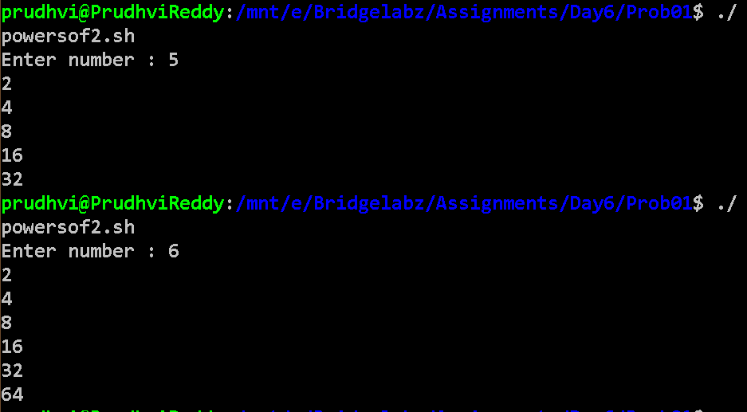

Extend the program to take a range of number as input and output the Prime Numbers in that range

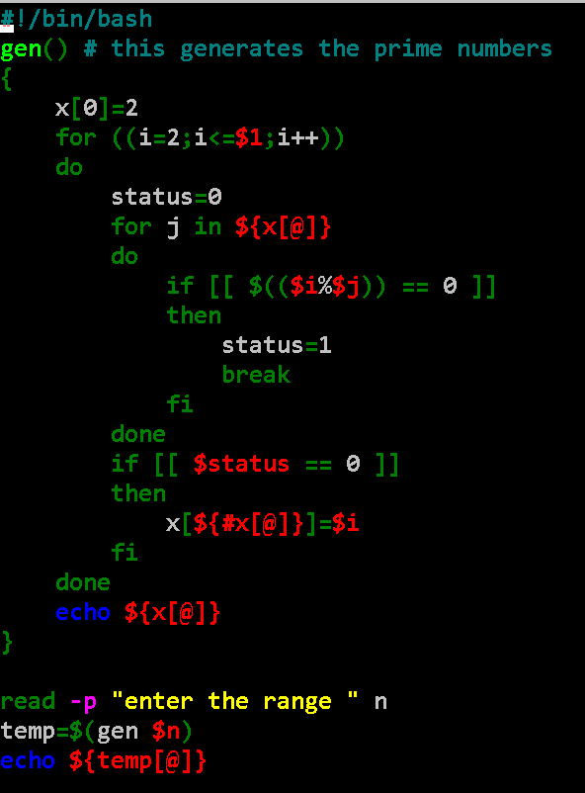

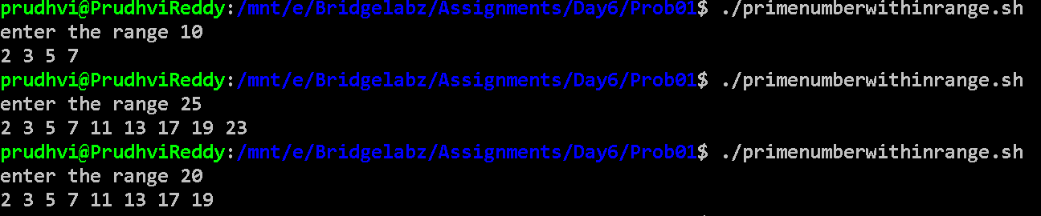

Write a program to compute Factors of a number N using prime factorization method

