Write a function to check if the two numbers are Palindromes

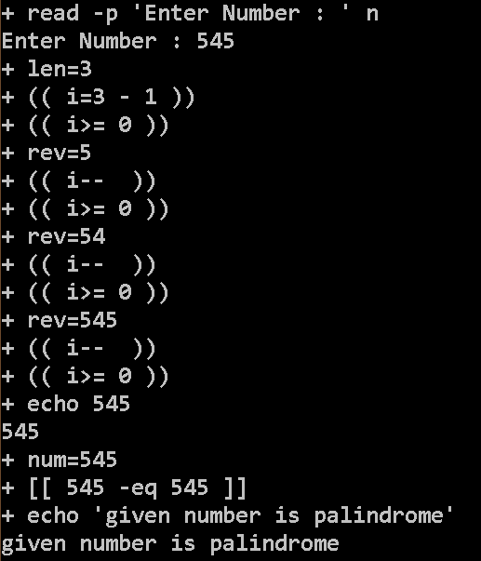

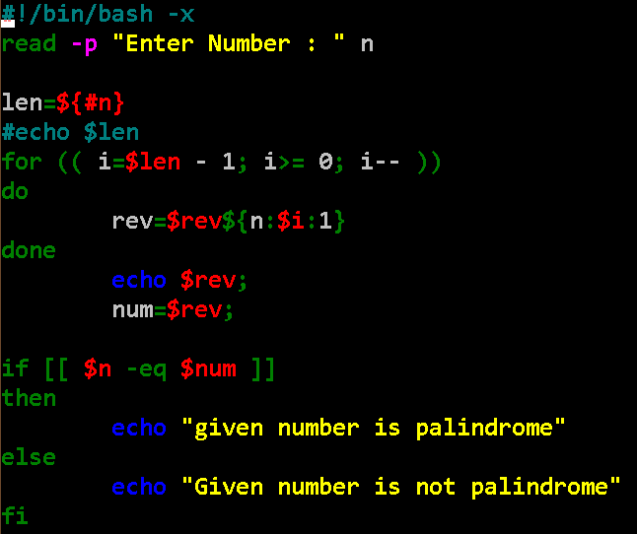

Take a number from user and check if the number is a Prime then show that its palindrome is also prime

a. Write function check if number is Prime

b. Write function to get the Palindrome.

c. Check if the Palindrome number is also prime

