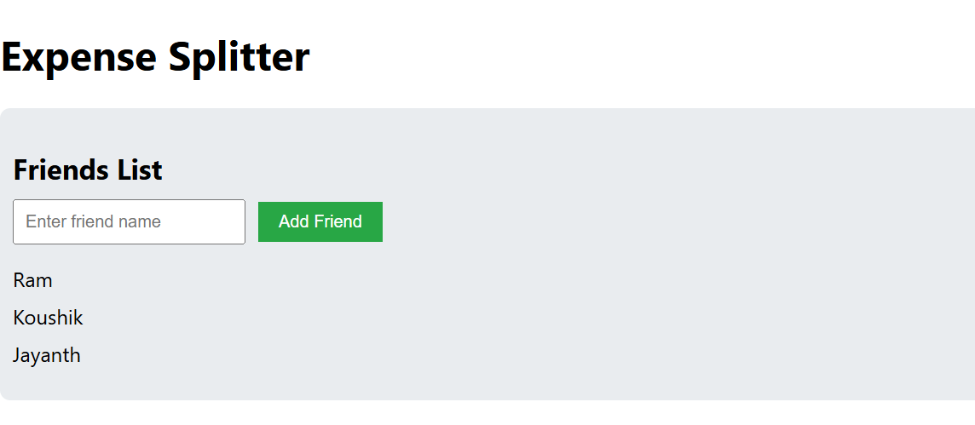

By clicking here you can Add friends

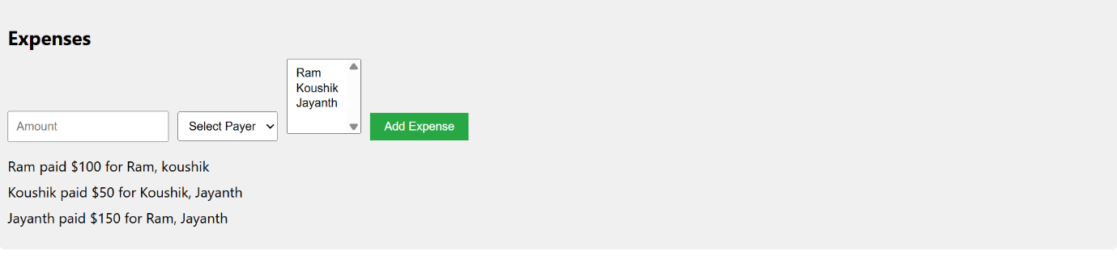

By clicking here you can add expenses and



