**Chapter 1**

**INTRODUCTION**

* 1. **GENERAL**

Induction motors are the most commonly used prime movers for many equipments in industrial applications, because of their reliability and simplicity of construction. Induction motors have important roles industrially and commercially. Some applications of the induction motor are in electric train engine, cooling fans and chimneys at power plants. The operators of induction motor drives are always under pressure to reduce its maintenance costs and to prevent the unscheduled downtimes which leads to the production loss and financial income. Many operators now use online condition-based maintenance schemes such as by analyzing the stator current of the induction motor which is called as Motor Current Signature Analysis (MCSA)[1]. Current signature analysis is the process of measurement of electric current around any one phase either by clamp on meters or through CT's. This current signal is now transformed into its frequency spectra and is analyzed for detection of fault in the motor. However, it is still the operator who has makes the final decision on whether to remove a motor from service or let it run based on information from condition monitoring systems.

**1.2 OBJECTIVE**

In this project, we have proposed a method to detect two faults,

1. Bearing Fault (Mechanical fault) by analyzing the stator current using VMD algorithm.

2. Stator winding fault (Electrical fault) by analyzing the magnitude of stator current.

**1.3 ORGANIZATION OF THE REPORT**

The relevant literature on the work is described in Chapter 2. The faults considered are explained in Chapter 3. The prime signal processing method used for fault analysis namely Variational Mode Decomposition (VMD) is described in detail in Chapter 4.Hardware set up is explained in Chapter 5.The simulation results and conclusions are given in Chapter 6.

**1.4 FLOW OF THE PROJECT**

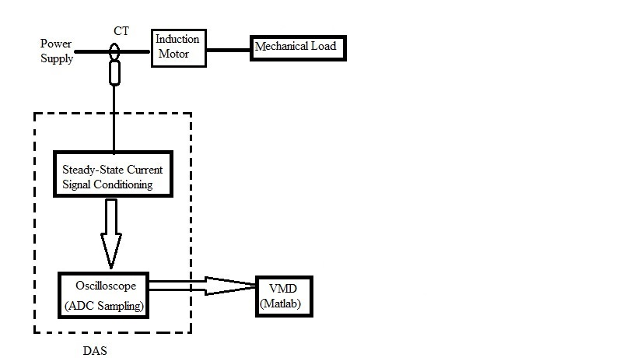

*Fig. 1.3 Methodology block diagram*

The stator current signal from the healthy motor and faulted motor are taken through current transformer (CT) and is given to the oscilloscope which is connected to computer. The faulty signals are compared with the healthy motor signals. In the computer, the fault is detected in the MATLAB software using Variational Mode Decomposition (VMD).

**Chapter 2**

**LITERATURE SURVEY**

**2.1 EXISTING ALGORITHMS**

**2.1.1 Fast Fourier Transform**

Several techniques have been developed for the diagnosis and monitoring of motors, the classic method used for detection of motor faults is based on the Fast Fourier Transform (FFT) [2].The main disadvantage of this method is that the FFT diagnosis considers the signal linear and stationary, but it is common that numerous real time signals have a strong tendency to behave in a nonlinearly and non-stationary way.

**2.1.2 Wavelet Transform**

The main advantage of Wavelet transform to that of FFT is that it is applicable to non-stationary signals and it can be used with suitable filtering technique to detect vibration signals [3], but in detection of higher frequency components, wavelet transform has a better time localization but a lower frequency resolution and vice versa for lower frequency components. The biggest challenge is the selection of the types of wavelet basis for faithful extraction of machinery faults.

**2.1.3 Hilbert Transform**

In paper [5], V. K Rai and A. R. Mohanty  have indicated the effectiveness of using frequency domain approach in HHT and its efficiency as one of the best-suited techniques for bearing fault diagnosis (BFD).HHT transform can be applied to non-linear and non-stationary signal [4-5], but it suffers from sampling rate and has less immune to noise [6].

**2.1.4 Empirical Mode Decomposition**

Empirical Mode Decomposition (EMD) fails to decompose close multi tone signals and it can be better performed using VMD [7]. It has certain limitation with the selection of modes and the bandwidth selection during shifting operation and it has some short fall in handling the non-stationary signal.

**2.2 PROPOSED AlGORITHM**

**2.2.1 Variational Mode Decomposition**

The principle of VMD is to look for an ensemble of modes with their respective center frequencies, such that the modes collectively reproduce the input signal and each mode is smooth after demodulation into baseband. The advantage of VMD is that there is no residual noise in the modes. Moreover, The VMD is an adaptive signal decomposition technique, which can non-recursively decompose a multi component signal into number quasi-orthogonal intrinsic mode functions [10]. This new tool is based on a solid mathematical foundation and can obtain a well –defined time frequency representation, which is more robust than the Empirical Mode Decomposition (EMD).

**2.3 Advantages of VMD**

* VMD is a non recursive algorithm and is robust to noise when compared with the other signal processing techniques.
* The signals used in VMD can have hard band limits of wavelet approaches.
* VMD algorithm determines the relevant bands adaptively, estimates the corresponding modes concurrently and thus properly balancing the modes between them.
* In VMD, the signal is represented as an analytical signal which helps in analysis of time-varying amplitude and instantaneous frequency.
* The unilateral frequency of analytical signal consisting of non-negative frequencies helps in single-sideband modulation.

**2.4 RELAVENT PAPERS**

The contribution of paper[8] is a fusion of the Empirical Mode Decomposition (EMD) and Multiple Signal Classification (MUSIC) methodologies for detection of multiple combined faults which provides an accurate and effective strategy for the motor condition diagnosis.

This paper [9] performs the signal analysis on vibration data of ball bearing using Variational mode decomposition (VMD). Firstly, the intrinsic mode functions are extracted using VMD followed by Fast Fourier Transform, and finally the status of bearing is analyzed to be faulty or impeccable. This paper, stress on VMD rather than on EMD, due to its qualities in the detection of close tone vibration signatures and takes less computation time. Variational mode decomposition is referred from the Konstantin Dragomiretskiy and Dominique Zosso’s paper [10].

**Chapter 3**

**TREATED FAULTS**

**3.1 BEARING FAULT**

A bearing is a machine component that constrains relative motion to only the desired motion, and reduces friction between moving parts. Bearings are connected to the rotor in an induction-machine. When there is a fault in the bearing, it produces certain vibration which affects the air gap eccentricity between stator and rotor and induces a fault frequency into stator current. The different types of bearing faults are: Outer-raceway defect, Inner-raceway defect, Ball defect.

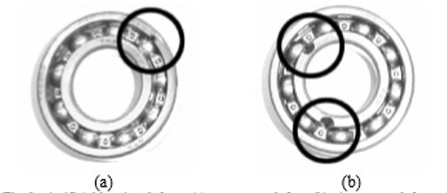

*Fig.3.1 .1 Outer raceway defect Fig.3.1.2 Inner raceway defect*

The main causes of the bearing fault are:

* Lubrication failure.
* Corrosion.
* Improper mountings.

The effects of the bearing fault are:

* Non-uniform magnetic field in the air gap.
* Overload and over-heating of the machine.
* High repair cost.

The corresponding frequencies for the different types of faults are given as:

BPFI=(N/2)*S(1+(Bd/Pd)*cos(𝜙))

BPFO=(N/2)*S(1-(Bd/Pd)*cos(𝜙))

BSF=(Pd/2Bd)*S(1-((Bd/Pd)^2)*cos(𝜙)^2)

where,

BPFI is the Ball Pass Frequency of Inner race.

BPFO is the Ball Pass Frequency of Outer race.

BSF is the Ball Spin Frequency.

Bd is the Ball diameter.

N is the number of balls.

Pd is the Pitch diameter.

𝜙 is the contact angle.

S is the relative speed between inner and outer race of the bearing.

These frequencies are emerged as side bands around electrical supply frequency in frequency spectrum of stator current which is given by

fo = | fs ±m*f |

where fs is supply frequency

fo is side band frequency

m is 0,1,2,3,4,5……..m

**3.2 STATOR WINDING FAULT.**

Stator insulation system in squirrel cage three-phase induction motors is considered as one of the most critical components of this type of motors and also one of the main sources for their failures [11]. When stator of an induction motor is subjected to severe stresses such as mechanical, electrical, thermal and environmental then stator faults are created in the machine.

Different types of stator winding faults are:

1. short circuit between two turns of same phase—called turn-to-turn fault.
2. short circuit between two coils of same phase—called coil to coil fault
3. short circuit between of two phases—called phase to phase fault.
4. short circuit between turns of all three phases.
5. short circuit between winding conductors and the stator core—called coil to ground fault and
6. open-circuit fault when winding gets break.

Different types of stator winding faults are shown in*Fig.3.2.*

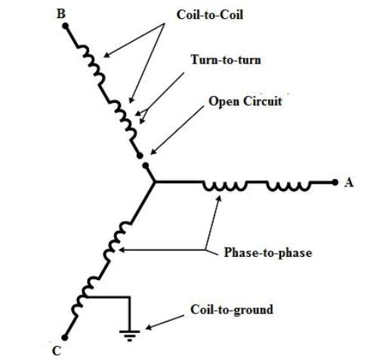

*Fig. 3.2 Different types of stator winding faults.*

**Chapter 4**

**VARIATIONAL MODE DECOMPOSITION**

**4.1 INTRODUCTION TO VMD**

In this chapter, we propose a new, fully intrinsic and adaptive, variational method, the minimization of which leads to a decomposition of a signal into its principal modes.VMD is a signal processing method which decomposes the signal into various modes or intrinsic mode functions using calculus of variation. Each mode of the signal is assumed to have compact frequency support around a central frequency. VMD tries to find out these central frequencies and intrinsic mode functions centered on those frequencies concurrently using an optimization methodology called ADMM.

The original formulation of the optimization problem in VMD is continuous in time domain.

The formulation is worded is as follows.

**Minimize the sum of the bandwidths of k modes subject to the condition that sum of the k modes is equal to the original signal. So, the unknowns are k central frequencies and k functions centered at those particular frequencies.**

Conditions to be satisfied for VMD algorithm are:

* No bandwidth of a particular central frequency should overlap.
* The summation of n modes of the decomposed signal must be approximately equal to the original input signal.

**4.2 ALGORITHM**

The Intrinsic Mode Functions (IMF) are amplitude-modulated-frequency-modulated (AM-FM) signals written as:

uk(t)=Ak(t)(cos𝜙k(t))

where Ak(t) is amplitude of signal in time domain and 𝜙𝑘′(𝑡) is instantaneous frequency.

𝐴k(𝑡) and the time derivative of phase change 𝜙𝑘′(𝑡) are assumed to be positive and slowly varying component compared to phase 𝜙𝑘(𝑡).

Now,

* Compute Hilbert transform of . Let  be Hilbert Transform.
* Form an analytic function as.

The frequency spectrum of this function is one sided (exist only for positive frequency) and assumed to be centered on ,where is the frequency of that particular mode.

* Multiply this analytical signal with , so that the signal is frequency translated to be centered at origin.

Let the shifted signal be,



* Find the bandwidth of the signal.

The magnitude of time derivative of this analytic function when integrated over time gives the bandwidth.



where,



The integral can also be expressed as a norm.



The Sum of bandwidths of K modes is given by 

The resulting variational formulation is as follows.



where, is the original signal.

The augmented Lagrangian Multiplier method converts this into a unconstrained optimization problem as follows:



In ADMM (Alternating Direction of Multipliers)philosophy, we solve for one variable at a time assuming all others are known. Thus, the unknown variables are found.

**Update for u terms:**

The formula for updating  at the n+1 the iteration is as follows:



Where n is number of iteration.

By absorbing the last inner product which is basically  into the term .

we obtain ,



Therefore,



This problem can be solved in spectral domain by noting the fact that norm in time domain is same as norm in frequency domain.

We use the following results in Fourier transform





For negative , and

For positive , 



Therefore,



Replacing 

 (1)

In the above expression (1), the first term vanishes for negative frequencies =

Second term is symmetric around origin, therefore



Also  being a complex number

 = ,

where  represent magnitude of the complex number.

Therefore,



Here unknown is a function, so we should apply Euler Lagrangian condition to obtain the solution.







 , 

**Update for **









Here,  is given by the solution of 





**Update for  (Lamda)**



**Final algorithm for VMD:**

























From the algorithm depicted above, there are two key parameters that can affect the VMD results. They are

1. The number of modes 𝐾and

2. Bandwidth control parameter 𝛼

The former is determined based on the number of frequency components included in the signal being inspected, while the latter is determined based on the central frequency of interest. They are correlated to each other. In theory,

1. A large number of modes would lead to redundant VMD information, while a small number of modes would result in the phenomenon of mode mixing in the VMD results;
2. The smaller the value of bandwidth control parameter, the wider the bandwidth of the filter tends to be. When the bandwidth of the filter is wide, more background noise and interference items will be included in the VMD result. But if the filter bandwidth is too narrow, the VMD results are likely to be distorted sometimes. From these reasons, both parameters 𝐾 and 𝛼 should be optimised to assure the accuracy of the VMD

**Chapter 5**

**HARDWARE IMPLEMENTATION**

**5.1 HARDWARE SET UP**

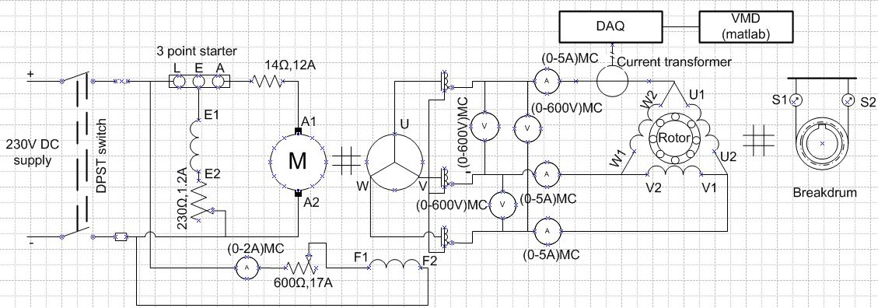

*Fig.5.1 Circuit diagram for 3 phase Induction Motor.*

Circuit diagram consists of mainly three circuits:

1. Alternator circuit.
2. Induction motor circuit.
3. Interfacing circuit between induction motor and analyzing in MATLAB.
4. Alternator circuit: Three phase voltage from the grid is unbalanced with ±10V difference between phases. This unbalance leads to wrong results. So, alternator is used to produce balanced voltages with ±2V difference between phases. Alternator circuit consists of DC shunt motor coupled to a 3phase generator with a varying armature, shunt field and separate dc excitation field resistance to control speed and 3 phase voltage.
5. Induction motor circuit: The Three input terminals of three phase induction motor fed from three phase transformer connected to output of three terminals of alternator. Shaft of induction motor attached to brake drum which is used to load the motor.
6. Interfacing circuit: Stator current signal of any one phase is connected to oscilloscope through current transducer. Data are stored in the form of excel sheet. Results are analyzed in MATLAB.

**5.2 DESIGN OF CURRENT TRANSDUCER:**

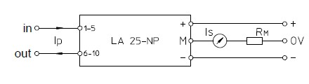

*Fig.5.2 circuit diagram of current transducer LA 25-NP*

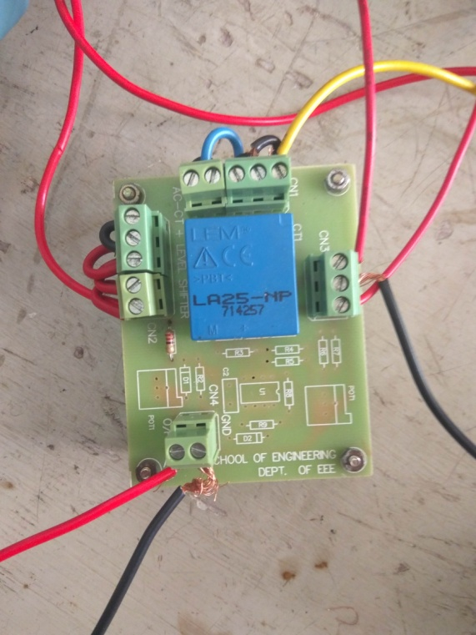

*Fig.5.3 CT LA 25-NP*

Maximum primary current (Ip) = 25A

Ratio of secondary to primary current k = 1∕1000

Maximum secondary current (Is) = k * Ip = 25mA

Voltage across Rm (Vm) = 5V

Resistance value of Rm = Vm/Is = 5V/ 25mA=220Ω

Procedure for conducting test:

1. Turn on DC motor by keeping armature, shunt field and external field excitation rheostats at maximum, minimum and maximum position.
2. Maintain speed at1500rpm [to maintain 50Hz] and 3 phase voltage of alternator at 415V by controlling armature, shunt field and external field excitation rheostats.
3. Now increase the voltage from zero to rated voltage 415V using three phase transformer for induction motor till it reaches steady state condition.
4. For different loading of induction motor [using brake drum] stator current is taken through current transducer and fault diagnosis is done.

Practical experimental setup is shown below:

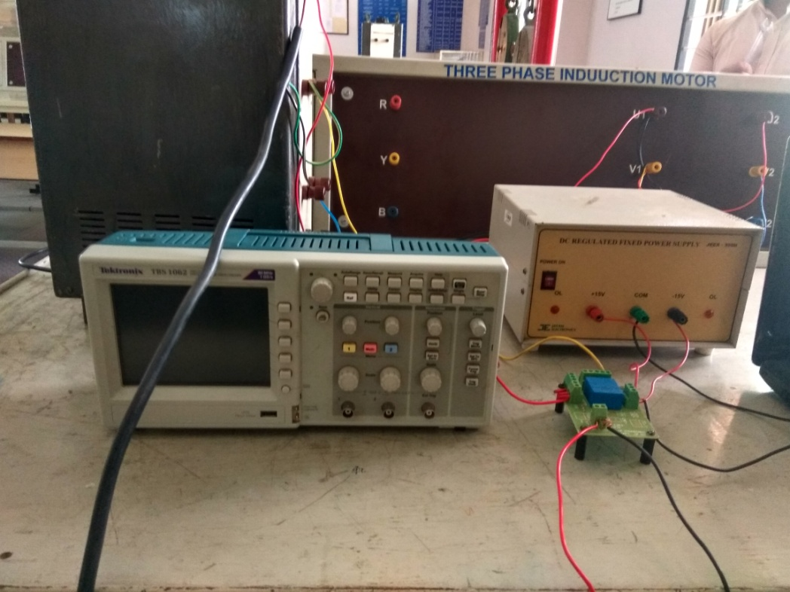

*Fig.5.4 Practical experimental setup*

**Chapter 6**

**RESULTS**

**6.1 Bearing Fault:**

Bearing Fault is created by damaging the shell of ball bearings, stator current of R-phase is collected from the induction motor using oscilloscope at 25000 samples/second in excel sheet. 2500 samples are taken from the oscilloscope. Data is analyzed in MATLAB using Variational Mode Decomposition (VMD).By tuning process, k and alpha value is taken as 3 and 2000, thus the modes of stator current at loaded condition is plotted in time domain and frequency domain.

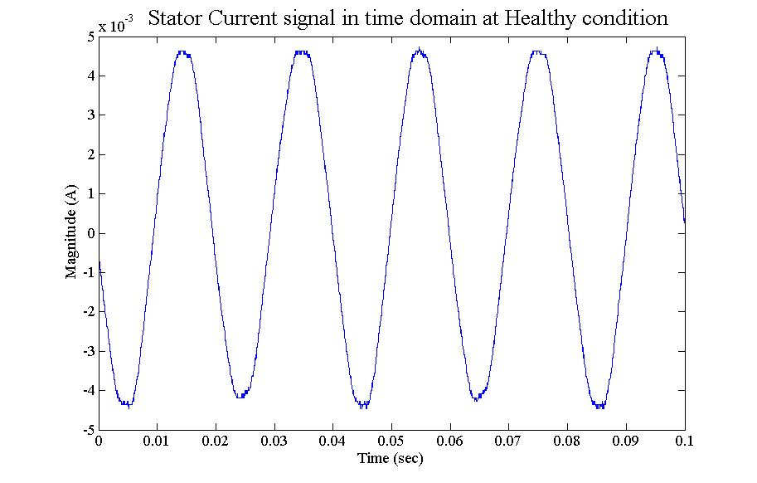

*Fig.6.1.1 Stator current signal [time domain]at healthy condition*

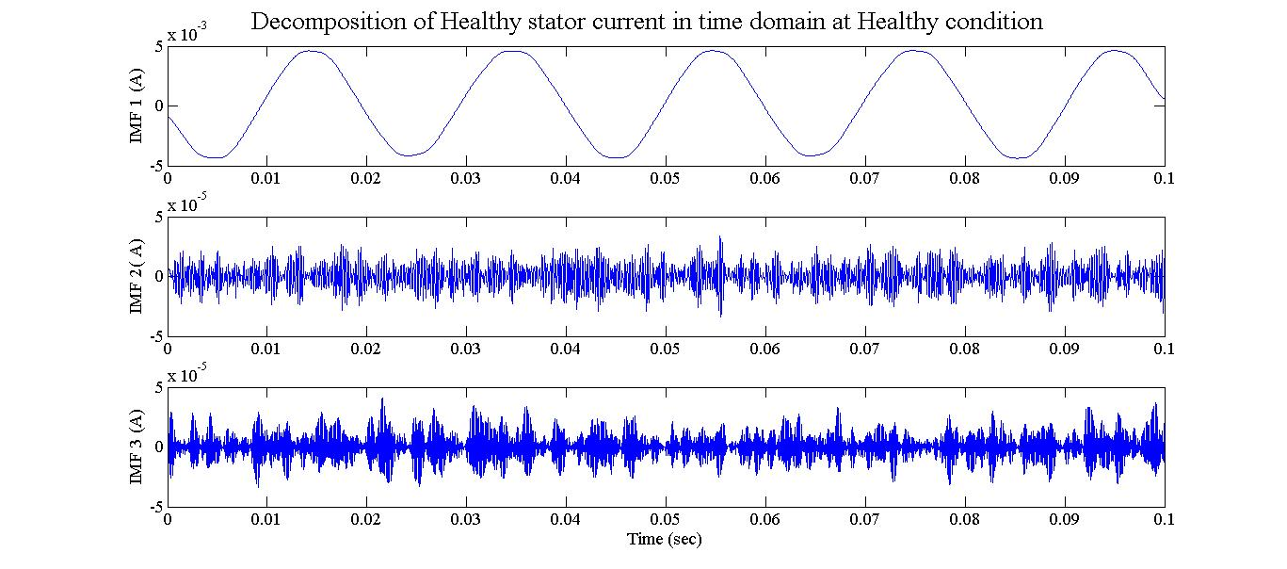

*Fig 6.1.2 Healthy stator input signal decomposed into three modes [time domain] using VMD.*

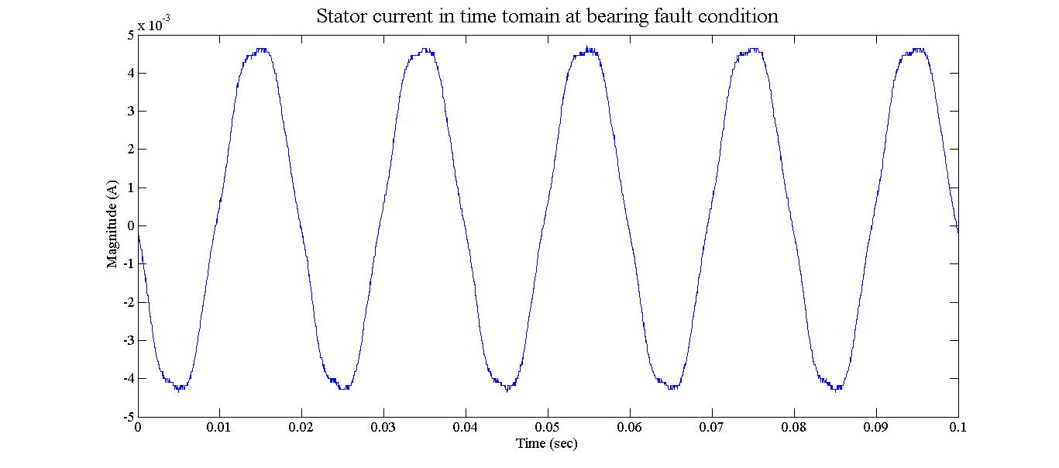

*Fig.6.1.3 Stator current signal [time domain] at bearing faulted condition*

*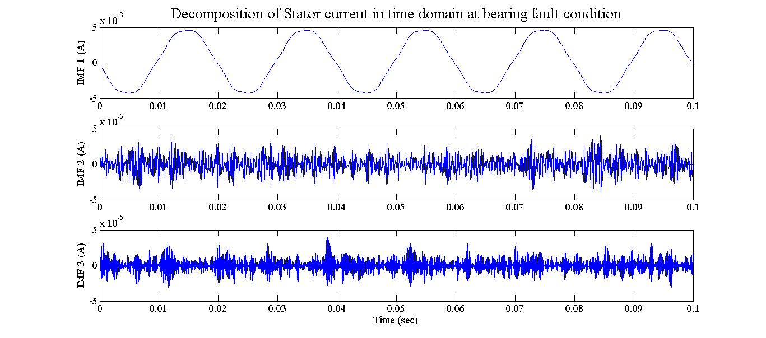 Fig 6.1.4 Bearing fault current is decomposed into three modes [time domain] using VMD*

Decomposed modes of both healthy signal and bearing faulty signal are then transformed into frequency domain using FFT algorithm in MATLAB. Then both spectral modes are compared for the frequency components which are emerged as side bands of line frequency [50Hz] which can be found using the formulae given in chapter 3. Given below in *Fig.6.1.5*, are the spectral modes of Healthy and Bearing Fault Signal.

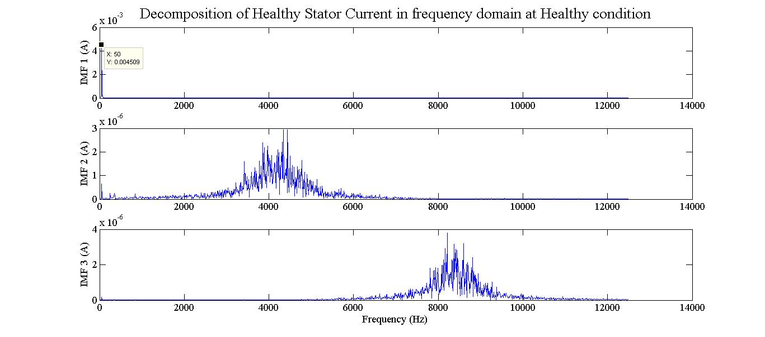

*Fig 6.1.5 Spectral Decomposition of stator current signal in Healthy condition.*

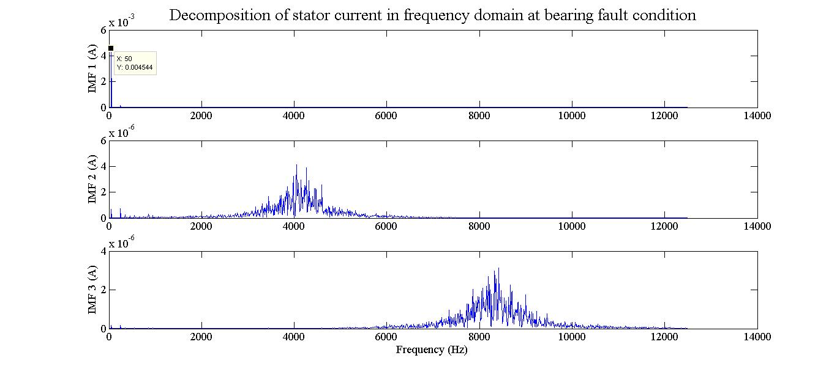

*Fig.6.1.6 Spectral Decomposition of stator current signal in Bearing fault condition.*

By comparing the both Spectra of modes in *Fig.6.1.7*, there is no much difference in the side bands around the line frequency 50Hz. This shows that VMD fails to detect the fault using current signature analysis which is created by damaging the balls of the bearing. So, Vibration analysis or sound analysis is required to detect the fault since there is a huge difference in vibration and sound when sensed physically.

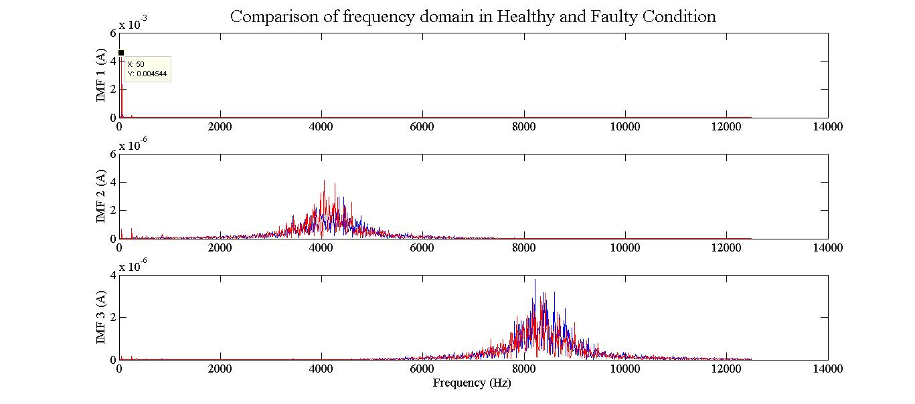

*Fig.6.1.7 Comparison of frequency spectrum between healthy and bearing fault condition.*

**6.2 Stator fault:**

Stator fault is created by removing or shorting of set of coil in R-phase of the Stator Winding. Test is conducted on stator faulted motor by applying 415V line voltage across windings which is star connected. Results are tabulated as below:

Table 6.2.2 Stator fault readings

|  |  |  |  |  |  |  |  |  |  |
| --- | --- | --- | --- | --- | --- | --- | --- | --- | --- |
| **IIr**  **(A)** | **IIy**  **(A)** | **IIb**  **(A)** | **VVrn**  **(V)** | **VVyn**  **(V)** | **VVbn**  **(V)** | **VVry**  **(V)** | **VVyb**  **(V)** | **VVrb**  **(V)** | **N**  **RPM** |
| 11.49 | 00.62 | 0 .9 | 2213 | 2251 | 2251 | 4411 | 4415 | 4409 | 11495 |
| 22.5 | 11 9 | 11.41 | 2215 | 2253 | 2251 | 410 | 418 | 417 | 11460 |
| 33.5 | 22.8 | 22.2 | 2214 | 2253 | 2252 | 414 | 420 | 410 | 11424 |
| 4.7 | 3.9 | 3 | 215 | 255 | 254 | 414 | 423 | 406 | 11350 |

From Table 6.2.2, it can be inferred that current in R-phase is greater than other two phases due to decrease in winding resistance. Also Voltage across R-phase and neutral is less compared to other phases and neutral which shows that there is decrease in impedence of the winding. This shows that there is short circuit in the R-phase winding.

**6.3 CONCLUSIONS**

Several conclusions were inferred after doing the work. The work was carried out to analyse whether the electrical signature analysis could be used to identify the bearing fault and the stator fault alternatively to the mechanical signature analysis like vibration. However, it is observed that the bearing fault employed in the project namely the ball bearing fault is insufficient to make a significant variation in the electrical signature analysis and hence application of VMD results only in a magnitude change and the expected frequency change from the theoretical calculation is not observed in the work . Perhaps more severe bearing fault like raceway fault should have been considered. So an attempt was done to record the sound signal and analyse the fault. As the work was incomplete it is not included in the project. Also coil to coil stator fault produces a marked difference in both voltage and current signals. They could have been analyzed using FFT or other signal processing techniques.

**REFERENCES**

[1] [1] William T.Thompson and Ronald J.Gilmore,“Motor current signature analysis to detect faults in induction motor drives – fundamentals, data interpretation, and industrial case histories.” [Online]

Available at: https://pdfs.semanticscholar.org/7af1/964ffb69b942ed4efdd2674f2e332d79a77d.pdf

[2] M.E.H. Benbouzid, and G.B. Kliman,“What stator current processing-based technique to use for induction motor rotor faults diagnosis?”, IEEE Transactions on Energy Conversion, vol. 18, no. 2, pp. 238-244, 2003.

[3] N. Nikolaev, Z. Nikolov, A. Gotchev, and K. Egiazarian, “Wavelet domain Wiener ﬁltering for ECG denoising using improved signal estimate,” presented at the IEEEInt. Conf. on Acoustic Speech Signal Process, vol. 6, pp. 3578–3581, 2000.

[4] V. K Rai and A. R. Mohanty, "Bearing fault diagnosis using FFT of intrinsic mode functions in Hilbert Huang Transform", Article in Mechanical Systems and Signal Processing, vol. 21, pp. 2607-2615, 2006.

[5] Hui Li, Y. Zhang and H. Zheng,”Hilbert-Huang Transform and marginal spectrum for detection and diagnosis of localized defects in roller bearing,” *Journal of Mechanical Science and Technology*, vol. 23, no. 2, pp. 291-301, 2009.

[6] G. Rilling and P. Flandrin,"On The Influence of sampling on the empirical mode decomposition,"presented at IEEE Int.Conf. on Acoustic Speech and Signal Processing, pp.444-447, 14-19 May 2006.

[7] K. Dragomiretskiy and D. Zosso, “Variational Mode Decomposition,” IEEE Transaction on Signal Processing, vol. 62, no. 3, pp. 531-544, 2014.

[8] D. Camarena-Martinez,R. Osornio-Rios,R. J. Romero-Troncoso and A. Garcia-Perez “Fused Empirical Mode Decomposition and MUSIC Algorithms for Detecting Multiple Combined Faults in Induction Motors," *Journal of Applied Research and Technology*, vol.13, 2015.

[9]Mohanty, K.K.Gupta and K.S.Raju “Bearing Fault Analysis Using Variational Mode Decomposition,” presented at IEEE Int. Conf. on Industrial and Information systems*,*pp.1-6,Dec.2014.

[10] [1] VMD MATLAB code .[Online].

Available: <https://in.mathworks.com/matlabcentral/fileexchange/44765-variational-mode-decomposition>

[11] O. V. Thorsen and M. Dalva, “A survey of faults on induction motors in

offshore oil industry, petrochemical industry, gas terminals, and oil refineries,”

IEEE Trans. on Industrial Applications, vol. 31, no.5, pp.1186–1196, 1995.

[12] M’hamed Drif, Antonio J. Marques Cardoso, “Stator Fault Diagnostics in Squirrel Cage Three-Phase Induction Motor Drives Using the Instantaneous Active and Reactive Power Signature Analyses,” IEEE Transactions on Industrial Informatics*,* vol.10, no. 2, May 2014.

[13] Subhasis Nandi*,* Hamid A. Toliyat and Xiaodong Li, “Condition Monitoring and Fault Diagnosis of Electrical Motors”, IEE Transactions On Energy Conversion, vol. 20, no. 4, December 2005.

[14] Y. Gritli, et al., “Advanced diagnosis of broken bar fault in induction machines by using Discrete Wavelet Transform under time-varying condition”, Proc. of the IEEE International Conference on Electric Machines & Drives, pp. 424-429, 2011.

**APPENDIX**

**Motor ratings:**

Power 2.2 kW/3.0 HP

Voltage 415V

Current 4.7 A

RPM 1450

Frequency 50 Hz

Number of poles 4

Number of slots 36

Stator connection Delta

Rotor type Squirrel-cage

**VMD CODE IN MATLAB**

**VMD TEST CODE**

clc;

clear all;

close all;

f=xlsread('faultedbearingapril.xlsx'); % Bearing data taken from oscilloscope

f=f/220; % divide with current transformer resistance

fs=25000; % sampling frequency

samples=2500;

t = 0:(1/fs):(((1/fs)*samples)-(1/fs)); % time domain vector

freq = (0:((samples-1)/2))*fs/samples; % frequency domain vector

% some parameters for VMD

alpha = 2000; % moderate bandwidth constraint

tau = 0; % noise-tolerance (no strict fidelity enforcement)

K = 3; % 3 modes

DC = 1; % no DC part imposed

init = 1; % initialize omegas uniformly

tol = 1e-7;

% -----------------Run actual VMD code

[u, u_hat, omega] = VMD(f, alpha, tau, K, DC, init, tol);

%---------------------------------------------------------------------------------------------------------------

% -----------------Plotting

% ------------------stator current input signal

figure('Name', 'stator current signal' );

plot(t,f);

% -------------------plotting modes in time domain

figure('Name','Decomposition in time domain');

for k = 1:K

subplot(K,1,k);

plot(t,u(k,:));

end

% -------------------plotting modes in frequency domain

figure('Name','Decomposition in frequency domain');

for k = 1:K

subplot(K,1,k);

plot(freq,abs(u_hat(length(f)/2+1:end,k)*2)/length(f));

end

%------------------- plotting modes individually

for k = 1:K

figure('Name','Mode in frequency domain');

plot(freq,abs(u_hat(length(f)/2+1:end,k)*2)/length(f));

end

%--------------------evolution of omegas

omega = omega/0.00004;

%-----------------------------------------------------------------------------------------------------------------

**VMD MAIN CODE**

function [u, u_hat, omega] = VMD(signal, alpha, tau, K, DC, init, tol)

% Variational Mode Decomposition

% Authors: Konstantin Dragomiretskiy and Dominique Zosso

% zosso@math.ucla.edu --- http://www.math.ucla.edu/~zosso

% Initial release 2013-12-12 (c) 2013

%

% Input and Parameters:

% ---------------------

% signal - the time domain signal (1D) to be decomposed

% alpha - the balancing parameter of the data-fidelity constraint

% tau - time-step of the dual ascent ( pick 0 for noise-slack )

% K - the number of modes to be recovered

% DC - true if the first mode is put and kept at DC (0-freq)

% init - 0 = all omegas start at 0

% 1 = all omegas start uniformly distributed

% 2 = all omegas initialized randomly

% tol - tolerance of convergence criterion; typically around 1e-6

%

% Output:

% -------

% u - the collection of decomposed modes

% u_hat - spectra of the modes

% omega - estimated mode center-frequencies

%

% When using this code, please do cite our paper:

% -----------------------------------------------

% K. Dragomiretskiy, D. Zosso, Variational Mode Decomposition, IEEE Trans.

% on Signal Processing (in press)

% please check here for update reference:

% http://dx.doi.org/10.1109/TSP.2013.2288675

%---------- Preparations

% Period and sampling frequency of input signal

save_T = length(signal);

fs = 1/save_T;

% extend the signal by mirroring

T = save_T;

f_mirror(1:T/2) = signal(T/2:-1:1);

f_mirror(T/2+1:3*T/2) = signal;

f_mirror(3*T/2+1:2*T) = signal(T:-1:T/2+1);

f = f_mirror;

% Time Domain 0 to T (of mirrored signal)

T = length(f);

t = (1:T)/T;

% Spectral Domain discretization

freqs = t-0.5-1/T;

% Maximum number of iterations (if not converged yet, then it won't anyway)

N = 500;

% For future generalizations: individual alpha for each mode

Alpha = alpha*ones(1,K);

% Construct and center f_hat

f_hat = fftshift((fft(f)));

f_hat_plus = f_hat;

f_hat_plus(1:T/2) = 0;

% matrix keeping track of every iterant // could be discarded for mem

u_hat_plus = zeros(N, length(freqs), K);

% Initialization of omega_k

omega_plus = zeros(N, K);

switchinit

case 1

fori = 1:K

omega_plus(1,i) = (0.5/K)*(i-1);

end

case 2

omega_plus(1,:) = sort(exp(log(fs) + (log(0.5)-log(fs))*rand(1,K)));

otherwise

omega_plus(1,:) = 0;

end

% if DC mode imposed, set its omega to 0

if DC

omega_plus(1,1) = 0;

end

% start with empty dual variables

lambda_hat = zeros(N, length(freqs));

% other inits

uDiff = tol+eps; % update step

n = 1; % loop counter

sum_uk = 0; % accumulator

% ----------- Main loop for iterative updates

while ( uDiff>tol&& n < N ) % not converged and below iterations limit

% update first mode accumulator

k = 1;

sum_uk = u_hat_plus(n,:,K) + sum_uk - u_hat_plus(n,:,1);

% update spectrum of first mode through Wiener filter of residuals

u_hat_plus(n+1,:,k) = (f_hat_plus - sum_uk - lambda_hat(n,:)/2)./(1+Alpha(1,k)*(freqs - omega_plus(n,k)).^2);

% update first omega if not held at 0

if ~DC

omega_plus(n+1,k) = (freqs(T/2+1:T)*(abs(u_hat_plus(n+1, T/2+1:T, k)).^2)')/sum(abs(u_hat_plus(n+1,T/2+1:T,k)).^2);

end

% update of any other mode

for k=2:K

% accumulator

sum_uk = u_hat_plus(n+1,:,k-1) + sum_uk - u_hat_plus(n,:,k);

% mode spectrum

u_hat_plus(n+1,:,k) = (f_hat_plus - sum_uk - lambda_hat(n,:)/2)./(1+Alpha(1,k)*(freqs - omega_plus(n,k)).^2);

% center frequencies

omega_plus(n+1,k) = (freqs(T/2+1:T)*(abs(u_hat_plus(n+1, T/2+1:T, k)).^2)')/sum(abs(u_hat_plus(n+1,T/2+1:T,k)).^2);

end

% Dual ascent

lambda_hat(n+1,:) = lambda_hat(n,:) + tau*(sum(u_hat_plus(n+1,:,:),3) - f_hat_plus);

% loop counter

n = n+1;

% converged yet?

uDiff = eps;

fori=1:K

uDiff = uDiff + 1/T*(u_hat_plus(n,:,i)-u_hat_plus(n-1,:,i))*conj((u_hat_plus(n,:,i)-u_hat_plus(n-1,:,i)))';

end

uDiff = abs(uDiff);

end

%------ Postprocessing and cleanup

% discard empty space if converged early

N = min(N,n);

omega = omega_plus(1:N,:);

% Signal reconstruction

u_hat = zeros(T, K);

u_hat((T/2+1):T,:) = squeeze(u_hat_plus(N,(T/2+1):T,:));

u_hat((T/2+1):-1:2,:) = squeeze(conj(u_hat_plus(N,(T/2+1):T,:)));

u_hat(1,:) = conj(u_hat(end,:));

u = zeros(K,length(t));

for k = 1:K

u(k,:)=real(ifft(ifftshift(u_hat(:,k))));

end

% remove mirror part

u = u(:,T/4+1:3*T/4);

% recompute spectrum

Clear u_hat;

for k = 1:K

u_hat(:,k)=fftshift(fft(u(k,:)))';

end

end