**NAV EEN PR INCE THOMAS**

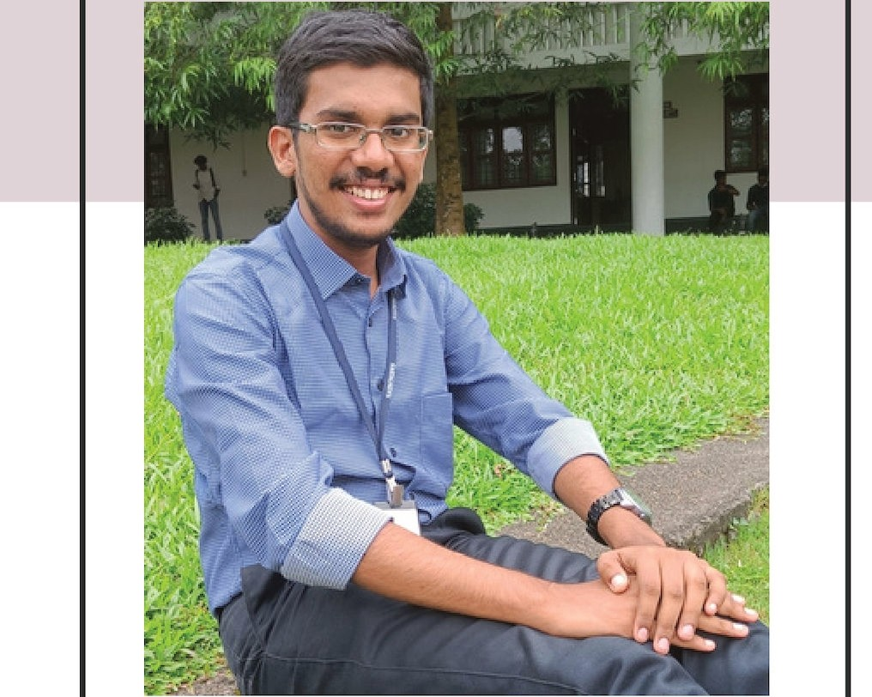

**A n d r o i d De v e l o p e r**

**c:::ii Profile**

**0**

Professionally skilled in Web and Android Development and also have experience in android application designing. Experienced in working with cross working platforms and have essent ial knowledge about programming concepts. Have a hard working mindset to get well reputed in the society .

04-04-2002



Karingattil House, Bethel Road, Chengannur P.O, Alappuzha, Kerala

•·.. +91 9188327753

**i:'i** naveenprincethomas

[040402@gmail.com](mailto:040402@gmail.com)

# Skills

**2020**

**2025**

**201 8**

# Academics

### Integrated MCA

Saintgits College of Engineering

APJ Abdul Kalam Technological University

Percentage: 70%

### Senior Secondary Education

Christ Central School, Thiruvalla

#### Web Designing

* Linux Shell Scripting

**2020** Central Board of Secondary Education

Passed w ith 78%

#### C/C++ Programming

* Logical Reasoning

**201 7**

### Secondary School Education

Believers Church Resedential School, Thiruvalla

#### PHP & MySQL

# Hobbies

#### Singing

* Cricket
* Listening Music
* Watching movies
* Discovering

**Language**

* + English
  + Malayalam

**201 8** Central Board of Secondary Education Passed w ith 70%

mb **Projects**

|  |  |  |
| --- | --- | --- |
| **20 2 3** | **- 20 2 4** | **DIRT SWEEPER - Vaccum** |
|  | | **Cleaner Robot** |
| A small vaccum cleaner model |
| developed using Arduino UNO and loT sensors. |

|  |  |  |
| --- | --- | --- |
| **20 2 2 -** | **2 02 3** | **Object Detection Car**  An object detection model developed |
|  |  | using Raspberry Pi and loT camera module and sensors . |
| **20 21 -** | **2 02 2** | **Tecknohow Solution** - |
|  | | **Business Portfolio Website** |
| A website designed using HTML5, CSS3, |
| Bootstrap, JavaScript and PHP. |

# ft Certifications & Accomplishments

**l.!1. 1 Family**

**Father :** Prince John

**Occupation :** Business

**Mother :** Biji Prince

**Occupation** :House Wife

**Brother :**Nithin Prince John

**Occupation :** DevOps Engineer

**M References**

**Mrs. Ansu Mariam Cheriyan**

Assistant Professor

**Phone:** +91 9567546996

**Email** : [ansu.mc@saintgits.org](mailto:ansu.mc@saintgits.org)

**Dr. Bindu M.S**

Professor

**Phone:** +91 9447063153

**Email** : [bindu.ms@saintgits.org](mailto:bindu.ms@saintgits.org)

## e Databases and SQL for Data Science & Python

* IBM Certification
* On June 2024

**e Cyber Security Fundamentals**

* University of London Certification
* On May 2024

**e Python for Everybody**

* University of Michigan Certification
* On May 2024

**e National Level Project Exhibition** -

**SRISHTI 2024**

* Saintgits College of Engineering
* On February 2024

*:.'*..*!*.*:.* **Workshops & Bootcamps**

## e FOSS TechVenture Workshop Series

* ICFOSS
* On June 2024

**e Workshop on Open Source Intelligence**

* Facein Technologies Pvt Ltd.
* On March 2024

**e Python Django Framework Workshop**

* Saintgits College of Engineering
* On August 2023

**e Bootcamp on Git & GitHub**

* Saintgits TinkerHub Chapter
* On October 2022

**e Bootcamp on Web Developement**

* Saintgits TinkerHub Chapter
* On June 2022