Student Mental Health & Depression Insights (India)

  
  
  
  
  
  
  
  
  
  
  
  
  
  
  
  
  
**Submitted by**: Gadeshula Prudvi  
**Department**: School of Computer Science and Engineering   
**Institution**: Lovely Professional University   
**Date**: April 12, 2025

# 1. Introduction

Mental health among students in India has become a growing concern, especially with increasing academic and societal pressures. The onset of issues such as depression, sleep deprivation, financial stress, and even suicidal ideation highlights the urgent need to understand and address these challenges. This report uses a Power BI dashboard to visualize and analyze student mental health data, providing valuable insights to foster awareness and potential intervention strategies.

# 2. Objective

The primary goal of this project is to:  
- Analyze depression trends among students across India.  
- Investigate the role of academic pressure, sleep duration, CGPA, financial stress, and other demographic factors.  
- Identify at-risk groups based on profession, age, gender, and educational background.  
- Facilitate informed decision-making for mental health policy recommendations within educational institutions.

# 3. Methodology

Tools Used:  
- Power BI for data modeling, visualization, and dashboard creation.  
- DAX (Data Analysis Expressions) for calculated columns and custom metrics.

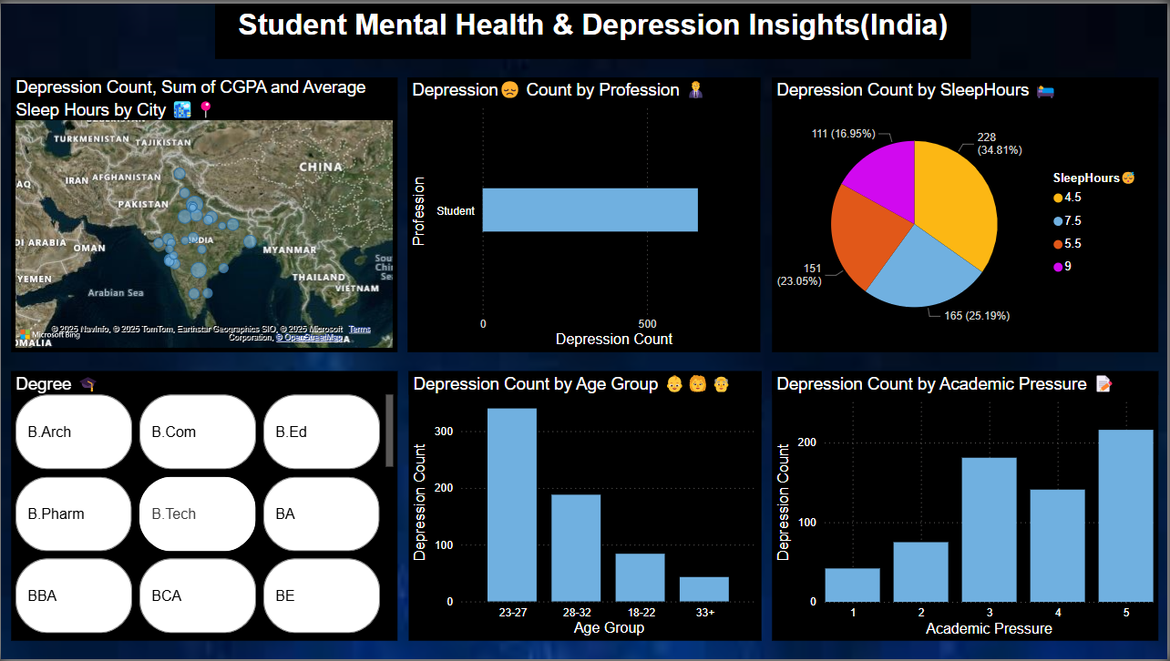Data Sources:  
- Student survey data including variables such as depression status, sleep hours, CGPA, academic pressure, suicidal thoughts, financial stress, gender, city, and degree.

# 4. Key Metrics and DAX Formulas

|  |  |  |
| --- | --- | --- |
| **Metric** | **DAX Formula** | **Purpose** |
| Average Sleep Hours | AVERAGE('Table'[SleepHours]) | Measures average rest per student. |
| Suicidal Thoughts % | DIVIDE(CALCULATE(COUNTROWS('Table'), 'Table'[Have you ever had suicidal thoughts ?] = "Yes"), COUNTROWS('Table')) * 100 | Indicates mental health severity. |
| Depression Count by Age Group  Depression Rate vs Financial Stress | SWITCH(TRUE(), 'Table'[Age] <= 22, "18-22", 'Table'[Age] <= 27, "23-27", 'Table'[Age] <= 32, "28-32", "33+")  DIVIDE(CALCULATE(COUNTROWS('Table'), 'Table'[Depression] = 1), COUNTROWS('Table')) | Categorizes students into age-based groups.  Shows how financial stress levels impact depression rates. |

# 5. Depression by Profession Visual: Clustered Bar Chart Insight: Highlights professions with higher depression rates.

# 6. Depression by Academic Pressure

Visual: Clustered Bar Chart Insight: Highlights professions with higher depression rates.

# 7. Depression by Sleep Duration

Visual: Column ChartInsight: Reveals how sleep deprivation correlates with depression frequency.

# 8. CGPA vs Academic Pressure

Visual: Scatter ChartInsight: Displays the relationship between academic pressure and performance, with depression as a color legend.

# 9. Gender vs Degree

Visual: Matrix TableInsight: Provides a tabular view of how gender and degree programs influence depression and CGPA.

# 10. Depression by City

Visual: Filled MapInsight: Geographic distribution of depression, with tooltips showing CGPA and Sleep Hours.

# 11. Tools & Technologies

Power BI, DAX, Data Cleaning & Modeling, Visual Design

# 12. Published URL

[View](https://app.powerbi.com/view?r=eyJrIjoiZDc3YjM4YTgtNmI5MS00OTE3LTk3MGQtNjgzNDdjNmNhODFjIiwidCI6ImUxNGU3M2ViLTUyNTEtNDM4OC04ZDY3LThmOWYyZTJkNWE0NiIsImMiOjEwfQ%3D%3D&pageName=187c1842287b84e22891)

