**Loan Prediction using Deep Learning and Machine Learning Models**

ABSTRACT

Loan prediction is a really crucial matter in the financial industry, as it allows organizations to calculate the risk related to sending money to a hopeful borrower. The present study is intended to evaluate the capability of particular machine learning models for successful credit score prediction. In this particular work, the dependencies on the specific type of loan dataset are equally considered as the convolutional neural networks (CNN), LSTM networks, RNN, FFNN and random forest classifier algorithms will be tested. The study involves the setting of accuracy as the main evaluation factor. An accurate prediction model based on loans can be performed with the use of CNN, LSTM, and RNN based on the results, as they have the highest scores of accuracy, hence they have a significant role in the task of loan prediction. Random Forest and FFNN also do well of their own accord; However, the important conclusion of this article is that it provides us with a profound understanding of the performance of different machine learning models for loan prediction so we can choose the right models for loan approvals and, in the end, develop credit risk assessment techniques.

Keywords: Loan Prediction, Machine Learning, Convolutional Neural Networks, Long Short-Term Memory Networks, Recurrent Neural Networks, Feedforward Neural Networks, Random Forest, Accuracy

1. INTRODUCTION

Stability features like the ability to foresee loan outcomes have become focal points for lending bodies from all over the global financial system in the adventure and uncertainty of changing times (Benediktsdottir et al., 2011). In this regard, the key task is that financial institutions must not only deal with risk management in a cautionary way but also make their operations sustainable, thus avoiding losses caused by the client's failure to repay the loan. In the real world, this began ages ago when traditional credit scoring was employed by commercial enterprises. It involves a rule-based system and outlining certain boundaries within a certain standard. Nonetheless, the present faults of the approach include the failure to precisely reflect borrowers' financial profiles to the required level, and therefore, there is a demand for a paradigm shift towards much more intricate and data-dressed approaches. Data analytics with neural networks has played a key role in predictive modelling today. It became commonly popular in the loan prediction area. The neural network paradigm is the most convenient algorithmic mental framework that can not only analyze large data volumes but can also sense sophisticated patterns and make correct predictions, which influences the lending decision- making process. By means of the natural nonlinearity and adaptability of neural network architectures, technicians in the financial sphere can achieve more thoroughness in their of important factors that have an enormous impact on loan repayment performance, which in turn leads to better decision-making from the lenders (de la Torre, I. and Torralba, L., 2017).

**Motivation:**

The valuation of credit risk and rendering of informed lending decisions by lending institutions highly pivot on loan prediction methodologies (Wang, K.., 2023). With the growing complexity in financial markets and the complexity in the nature of underlying financial data too, traditional approaches like logistic regression and decision trees may not be able to produce accurate predictions of loans. Consequently, these methodologies need to be investigated so as to bring forth approaches that have an enhanced level of accuracy, wider implement ability, and greater responsiveness to changes in the economy (Reed et. al., 2009). More intricate models, like convolutional neural networks (CNN), recurrent neural networks (RNN), long short-term memory (LSTM) networks and random forests classifiers, are believed to yield positive achievements in resolving the stated problems and maximizing loan prediction precision.

**Problem Statement:**

Current loan-scoring systems, relying on methods such as logistic regression and decision trees, are prone to the issue of being accurately assigned to the loan outcomes with the highly complicated and continually changing financial datasets. Although the financial markets grow fast and acquire new complex products, they require increasingly sophisticated and tailored analytics that should adapt to the ever-changing economic environment while providing sufficient data for sounder lending decisions. Furthermore, the goals of the project are to find and apply the most suitable ML tools, particularly CNN, RNN, LSTM, Random Forest, and MLP classifiers, that increase the precision, capacity, and robustness of financing prediction systems. Obtaining and Formatting the Data Source and Description: In order to do that, we will start with data that is available on [insert the data source] with historical loan applications.

**Research Question:**

The research question are as follows:

1. What are the distinctive strengths and potential limitations associated with different neural network architectures (CNNs, LSTMs, RNNs, and FFNNs) within the context of loan prediction?
2. To what extent do the selection of dataset, preprocessing techniques, and choice of evaluation metrics influence the predictive performance of neural network models for loan prediction tasks?

**State of art**:

In the modern era of loan prediction, diverse approaches, including classical logistic regression and decision trees, as well as multiple techniques like ensemble methods and sophisticated neural networks, were used. Importantly, the emergence of neural networks as the choice of current research is due to the ability of the networks to identify complex patterns in massive data sets and therefore improve predictive accuracy compared to the traditional approach. Numerous exploratory studies have concentrated on the different aspects of neural network-driven loan prediction, revealing model architectures, feature-engineering methodologies, data pre-processing techniques, and performance evaluation metrics. First and foremost, the study conducted by Čeponis, D., (2021) focused on the comparative analysis between CNNs and LSTMs for detecting loan default, revealing the capacity of LSTMs to uncover the temporal dependencies that are characteristic of sequential data. Also, Swathika et al. (2023) initiated a brand-new approach for feature selection based on autoencoders that improves the robustness and interpretability of the neural network models applied to predict credit risk. Fundamentally, the modern landscape of loan prediction research is that of a dynamic mixture of a host of innovative methods, because it is always being used to overcome the difficulties of Clarity, scalability, and generalization in the real-world financial environment.

1. LITERATURE REVIEW

The mistake-making possibility of living entities is one of those factors that can be called a potential defect of the current human-based system, as stated by Pusapati (2022). However, the computer system becomes more accurate and labor-saving than humans, for sure. It is quite obvious that this will improve the efficiency of this system considerably. Machine learning technologies have the speed to fix mistakes in system data up to ten times faster than an individual. Integrating machine learning techniques is a kind of enhancement that can eliminate the need for third-party refunds and, at the same time, enable automatic early detection of issues (Puri et al., 2023). There is not an exact setting, but the following framework must be closely customer-oriented and reliable on data, and it should be strong enough to test the data. The lenders base their decisions not on the historical study of business processes but rather on probability criteria generated using machine learning. The algorithms provide sufficient capability to improve the sources of proficient search processes many times as much as the existing systems. ML overcomes the issues of usability in the criterion intervention by way of an expanded observational perspective in the data analysis process (Ren et al., 2020). The research paper singularly assesses the verification points of relative figures that balance Actively incorporate heatmaps into data visualization. Digital lending and loan predictive modeling operationally region the neuro-centric network of dropouts that functionally connects the neural networks. Moreover, the evaluation of the classification modeling involves boosting the accuracy of recalling the F1-Score value as well as decreasing the loss of the model. Even as observed in the work of Sachan et al. (2020), “artificial intelligence” has received a warm welcome in various contexts where it replaces human beings in decision-making and optimization processes, and this calls for an urgent increase in speed and optimization methods, particularly in “machine learning." Though opaque ML models do have high prediction accuracy, their use in an automation process for taking loan decisions is not fair. This fact is not ascertained by the opacity of these ML models (Atieh, 2021). The work is contributing to the existing explicable artificial intelligence decision-support system (EAIS) to perform an automatic USA loan underwriting process based on BB rules.

BRB's structure and decision-making process have the benefit of being easily narrated to and understood by non-technical individuals.

In the publication "Machine learning and credit rating prediction in the age of the Fourth Industrial Revolution," Li et al. (2020) did another study that conceptualizes numerous machine learning strategies in the credit rating determination process. Numerous macroeconomic factors are taken into account in the study; these factors are frequently thought to be the most crucial when rating investments. From 2010 to 2018, a variety of macro and bank-specific characteristics were included in the data utilized to conduct this analysis. Three years' worth of "out-of-sample predictions" were also given. Arbitrary Forests was the most precise machine learning technique used for the predictions out of all of them. This was determined by looking at both the accuracy scores and the generated F1 score. Additionally, it was discovered that the prediction scores held steady and strong across all class ratings. The best credit quality and default modes were incorporated in this. Additionally, the study demonstrated that Artificial Neural Networks maintained their ranking as the second most accurate total forecast. But the study also showed that, with very little but insignificant variations, Classification and Regression Trees performed worse than Random Forests for results based on speculative and default credit categories. Therefore, in order to provide more accurate and well-informed risk evaluations, the authors of this work recommend using both CART and Random Forests.

A bagging strategy based on the idea of self-adaptive learning was presented in a fairly recent study by He et al., 2022, published in the journal "Self-adaptive bagging approach to credit rating." Another name for the bagging process is an ensemble learning technique called bootstrapping aggregation method. This method is frequently used in processes where a dataset of noisy variances exists.

There has been a noticeable decrease in variations within the datasets thanks to this technique (IBM Cloud Education, 2021). During the bagging process, a random data sample is chosen with a replacement to train the algorithm. This allows for the selection of individual data points several times (Tüysüzoğlu et al., 2020). The research paper's suggested approach, which is based on a limited sample size of data with high heterogeneity of the distributed attributes, was found to have particular benefits in handling and sorting credit ratings. It is discovered that the classic learning methods and bagging strategy are more effective in terms of the model's structure due to the self-organizing and self-adapting learning mechanism.

The study by Xia et al. in 2022 suggests that credit scoring can be improved with an emphasis on three factors as per the study. These characteristics should be guided by the developers of solutions for credit scoring. These three components include modelling the approach, the data source and evalaution. The article elaborates on "Heterogeneous Deep Forest Model" which is a hybrid method of different deep learning structures and decision trees-based models.

A "Credit Sanction Forecasting Framework" was used in a study on "credit sanction forecasting" by Kirubanantham et al. (2021) to accurately analyze the customer credit data. According to the researchers, the Random Forest classifier's method can be utilized to accurately predict a customer's potential for payback. Because of this, the random forest model's various strategies form the foundation of the projected method's efficiency. Machine learning methods and a Python software package are used in the experiment. The prediction model is based on a combinatory method using the Random Forest classifier, deep learning models, logistic regression developed with Tensor Flow, and min-max standardization. The findings indicated safe clients for loan approval. With the help of "machine learning and deep learning algorithms," the credit sanction forecasting model supplied the researchers with vital information while retaining a high level of accuracy (Bhatore et al., 2020).

1. METHODOLOGY

In this methodology I will use the following steps are as follows:

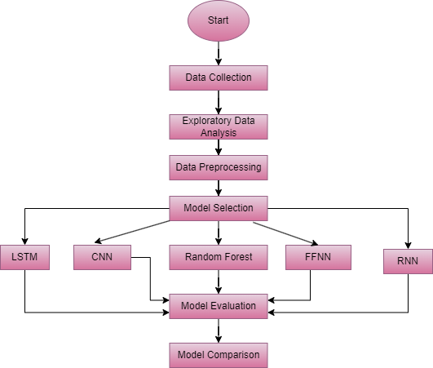

Fig 1: Project Methodology

1. **Data Collection:** The dataset used for the research was picked from Kaggle, which is widely known as one of the largest hubs for data sharing and the link is https://www.kaggle.com/datasets/zaurbegiev/my-dataset. The columns are Term, Loan status, Credit Score, and Annual income etc.
2. **Data Preprocessing:** Data preparation is an important step in the research process, which implies doing quality control and data suitability analysis in order to set the data ready for analysis. This was carried out by implementing functions like those for missing value management, deletion of duplicates, and standardization of variable names. Those were thematical variables that were properly encoded using distinct techniques, such as label encoder, to transform them into a numerical sequence conducive to analysis.
   * **Model Selection:** Among the many machine learning models that were put forward, there were LSTM, FFNN, CNN, RNN, and Random Forest.  These general components include interpretability, predictive accuracy, and computational efficiency**.**
   * Convolutional Neural Networks (CNN): CNNs are a kind of deep learning network primarily used for processing a wide range of visual information. In the specific application of loan prediction, CNNs can be used to deal with structured image data from loan documents or forms. The CNN network generally comprises a number of convolution and max-pooling layers that let the network learn the hierarchy of features from the input image's. After this, these characteristics go to fully interconnected layers for the purpose of classification. Convolutional neural networks (CNNs), which are great at discovering spatial aspects and patterns in image data, prove to be a perfect tool for the implementation of document classification and recognition tasks.
   * Long Short-Term Memory (LSTM) Networks: The LSTM networks are a type of RNN that are capable of tackling the problem of long-term dependency encountered with sequential data. For loan prediction, LSTM networks can be used on time-series data that represents historical loan application reports. In contrast to RNNs, LSTMs incorporate memory cells that can retain information throughout lengthy periods, making them competent at handling temporal dependencies in sequential data. This is what makes LSTM networks outstanding at jobs that require the memory of past events, for instance, predicting the risk of loan defaults given a person’s financial behavior in the past.
   * Recurrent Neural Networks (RNN): RNNs are a type of neural network characterized by the ability to process sequential data using an internal state, also called memory. In this case, RNN can be used on a sequence of loan application features at a given time, for instance, credit score changes and employment history graphing. The architecture of RNN is typically made of recurrent layers, which allow the network to use the sequential input data and learn the dependencies between the time steps.
   * Feedforward Neural Networks (FFNN): Nevertheless, the main architecture of neural networks known as feedforward neural networks, which are also called multilayer perceptrons (MLP), is composed of numerous nodal units that are interconnected in a layered pattern. The CCNNs can be utilized to collect data that will be plotted in the form of tables, with the columns displaying the details that are related to avenue features as well as financial factors. These data can also be used to predict loans. The neuron is made up of an input layer, a hidden layer (s), and an output layer. The conclusion holds that all these hidden layers are tied together one to another, with the present layer being fully connected to the preceding one, and the nonlinearity inserted in the hidden layers is due to the nonlinear activation function usage. The highlights of the FFNNs are that this type of structure comes with the ability to classify complex patterns, making them ideal for different prediction tasks. It is, for instance, the forecast of loan approval.
   * Random Forest: Random Forest operates through the process of creating multiple decision trees, where the tree with the highest voting polling during training is the one we use. In addition, a common approach is to take the mean prediction from all the trees (classification) or a single tree (regression). An algorithm for loan forecasting is a fact that allows studying the relationship between parameters an applicant has and the probability of obtaining a loan. It involves generating several decision trees, both randomly and with a structured process. Finally, it can determine its result through the average of trees, which improves its stability and gives it a low chance of overfitting. The credibility given to the random forest is mainly related to its simplicity, versatility, capability to scale, and ability to work even with complex datasets, hence its wide application in finance and other fields as well as for classification tasks.
3. **Model Training:** After the model’s selection was done, and the selected models were trained using the data that had been pre-processed. The set dataset was split for training and validation to allow for model fitting and prediction evaluation. Training implied iterative adjustment of model parameters under minimization of the chosen loss. Training was applicable to examining the model's performance.
4. **Model Evaluation:** The model's implementation showed success in terms of precision, recall, and confusion matrix. Accuracy in general evaluated the model's performance in terms of overall accuracy, whereas the classification report disclosed information about how precise each class was according to measures like precision, recall, and F1-score. For instance, the columns of the confusion matrix reveal that the model has high accuracy in any loan status.Top of FormTop of Form
5. DATA VISUALIZATION

Here I have use the following data visualization for this dataset are as follows:

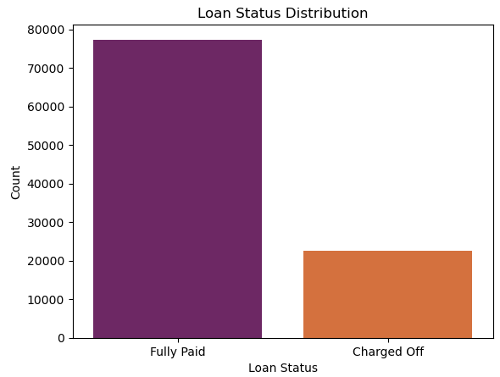

Fig 1: Countplot for Loan Status

Here countplot is plot for loan status. From the above diagram , here we see that fully paid loan status has maximum count as compare to charged off.

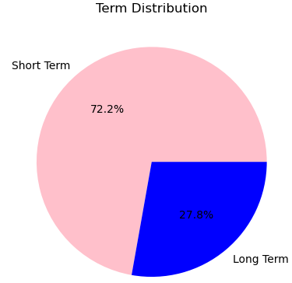

Fig 2: Pie Chart for Term

From the above figure, here pie chart is plot for Term. Here short term is 72.2% and Long Term is 27.8%.

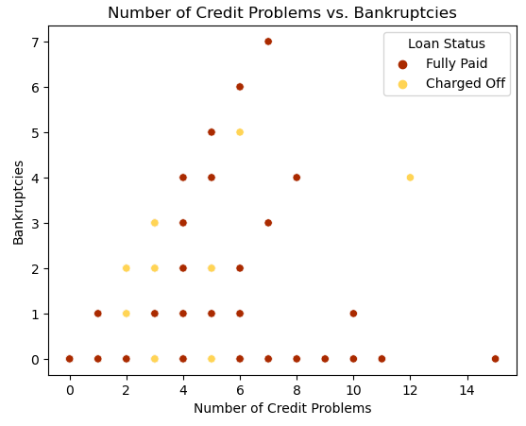

Fig 3: Scatterplot for number of credit problems and Bankruptcies

Here scatterplot is plot for number of credit problems and Bankruptcies where number of credit problems is on axis and Bankruptcies is on y axis. The different colour indicate different loan status.

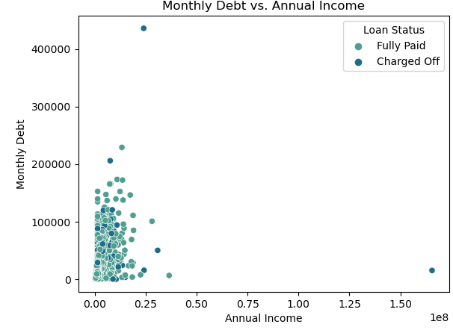

Fig 4: Scatterplot for Monthly Debt and Annual Income

In the above figure, here scatterplot is plot for Annual Income and Monthly Debt, where Annual Income is on x axis and Monthly Debt is on y axis. Here different colour indicate the different Loan Status.

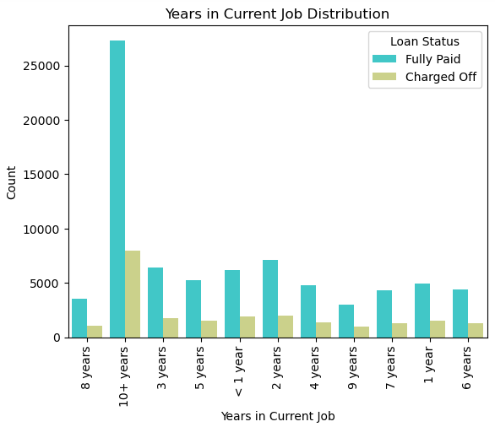

Fig 5: Count plot for years in current job using Loan Status.

In the above figure, here Count plot is plot for years in current job using the loan status, here fully paid loan status has maximum count as compare to Charged off.

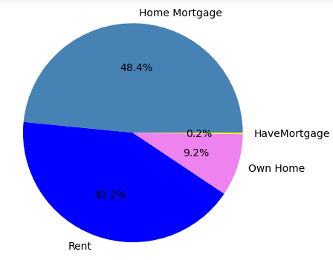

Fig 6: Home Ownership Distribution

In the above figure here pie chart is plot for Home ownership, here Home mortgage has maximum count as compare to other home ownership.

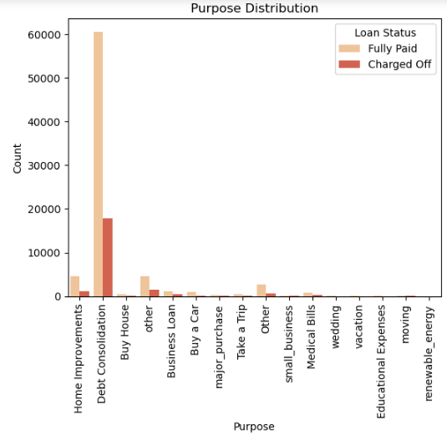

Fig 7: Count plot for Purpose with Loan Status

In the above figure, here count plot is plot for purpose with loan status , here different colour indicate the different loan status.

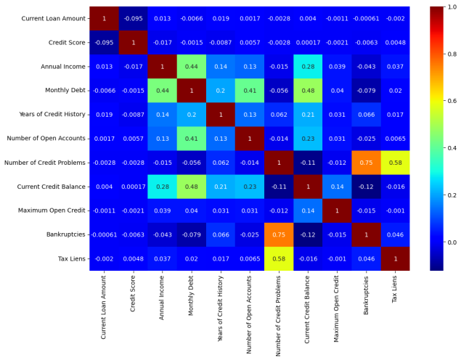

Fig 8: Heat map for Dataset

In the above figure, here heatmap is plot for correlation dataset, here red region indicate highly correlation as compare to blue region.

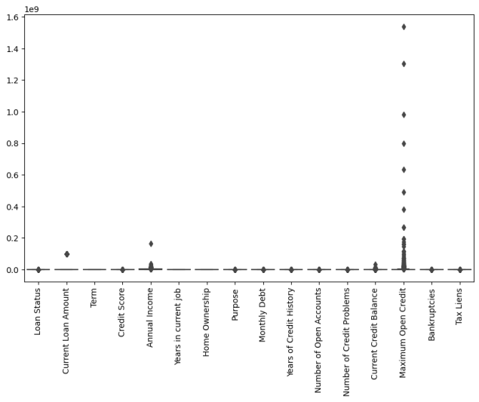

Fig 9: Boxplot for dataset before removing outlier

In the above figure, here boxplot plot is plot for checking the outlier in dataset.

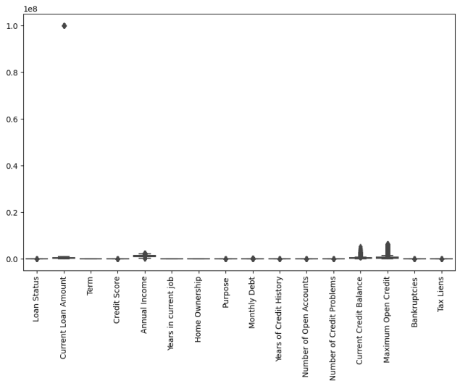

Fig 10: Boxplot after removing outlier

In the above figure , here boxplot is plot after removing the outliers, here we see te reduction in outliers.

1. RESULT

In model evaluation here I calculate the accuracy, precion and recall. The term are as follows:

**Accuracy:** Accuracy is a metric of how frequently the model predicts that the event will occur correctly. It is defined as total correct predictions as compared to the total number of predictions. The simplest criterion for accuracy cannot be the only requirement for judging the performance of the model.

**Classification Report:** A report of class classification illustrates overall compiled metrics for each class of data for a classification task. The error rate represents the percentage of the target class which is not predicted correctly, while other metrics considered include precision, recall, F1, and support. The precision refers to the number of true positive predictions within all the predicted positive, while the recall refers to the number of these true positive predictions out of the number of true positives. The F1-score is calculated as the harmonic mean of precision and recall; hence, it is a measure of trade off between both metrics.

**Confusion Matrix:** A confusion matrix is a table that portrays a data using the performance graph of a classification model. Through such notion, the depicted result is the number of true positive, true negative, false positive, and false negative predictions of the model. Performance measures such accuracy, precision, recall and F1-score in addition to confusion matrix can be calculated.

After building the models we get the following resilts are as follows:

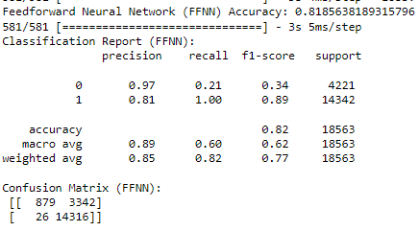

Fig 11: Result of FFNN

In the above figure, here for FFNN I get the accuracy 0.8185, the figure above show the classification report and confusion matrix for FFNN. The classification report for class 0 I get precision, recall, f1 score 0.97, 0.21 and 0.34 and for class 1 I get precision, recall and f1 score is 0.81, 1.00 and 0.89. In confusion matrix here true negative is 879, false positive is 3342, false negative is 26 and true positive is 14316.

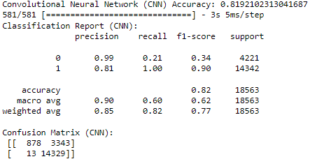

Fig 12: Result of CNN

In the above figure, here for CNN I get the accuracy 0.8192, the figure above show the classification report and confusion matrix for CNN. The classification report for class 0 I get precision, recall, f1 score 0.99, 0.21 and 0.34 and for class 1 I get precision, recall and f1 score is 0.81, 1.00 and 0.90. In confusion matrix here true negative is 878, false positive is 3343, false negative is 13 and true positive is 14329.

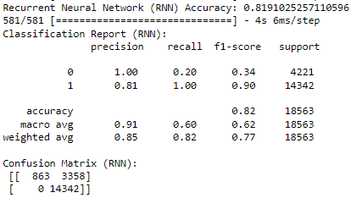

Fig 13: Result of RNN

In the above figure, here for RNN I get the accuracy 0.8191, the figure above show the classification report and confusion matrix for RNN. The classification report for class 0 I get precision, recall, f1 score 1.00, 0.20 and 0.34 and for class 1 I get precision, recall and f1 score is 0.81, 1.00 and 0.90. In confusion matrix here true negative is 863, false positive is 3358, false negative is 0 and true positive is 14342.

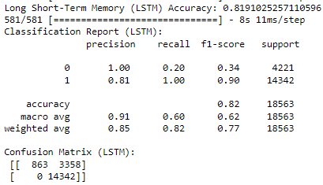

Fig 14: Result of LSTM

In the above figure, here for LSTM I get the accuracy 0.8191, the figure above show the classification report and confusion matrix for LSTM. The classification report for class 0 I get precision, recall, f1 score 1.00, 0.20 and 0.34 and for class 1 I get precision, recall and f1 score is 0.81, 1.00 and 0.90. In confusion matrix here true negative is 863, false positive is 3358, false negative is 0 and true positive is 14342.

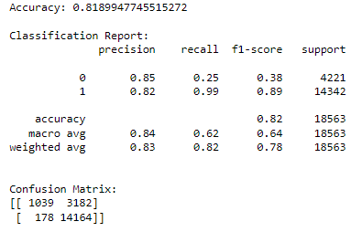

Fig 15: Result of Random forest

In the above figure, here for random forest I get the accuracy 0.8191, the figure above show the classification report and confusion matrix for random forest. The classification report for class 0 I get precision, recall, f1 score 1.00, 0.20 and 0.34 and for class 1 I get precision, recall and f1 score is 0.81, 1.00 and 0.90. In confusion matrix here true negative is 863, false positive is 3358, false negative is 0 and true positive is 14342.

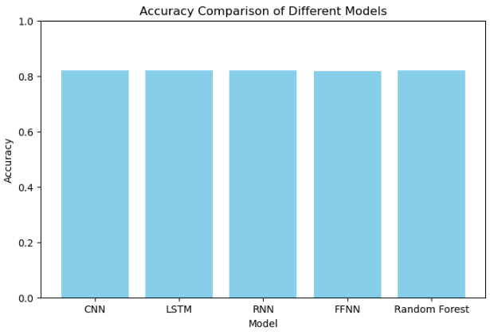

Fig 16: Accuracy Comparison

After comparing all the models here for all models I get nearby same accuracy.

1. CONCLUSION

As more financial industry decision-makers search for ways to improve their operations and preserve a balance between the security and dependability of their financial lending system, machine learning techniques can be highly helpful in accomplishing this goal. Convolutional neural networks, long short-term memory, recurrent neural networks, and random forest ensemble models have the highest accuracy after employing goal variables such as loan status. The cases proved the models had a high level of accuracy of forecasting the loan's performance, which implies their usefulness in credit risk assessment among financial institutions. Nevertheless, there remains the issues related to the model's interpretability and the ability to use it for a competent set of datasets with a complex and mixed structure.

**Limitations:**

Although machine learning models proved useful in solving problems in our evaluated study, their drawbacks must be taken into account. The model’s interpretability still poses a considerable challenge for the widespread adoption of machine learning techniques in corporate finance. Additionally, models performance might be subject to the composition of the dataset and the addressed specific domain of the problem. Besides that, complex computational nature and high resource consumption of some models could be the bottleneck for application of them in real-world conditions. Elimination of the challenges will play a key role in refining the credit scoring methodology and creation of trustworthy credit risk assessment models.

**Future Research:** Forward-looking, there are several perspectives that need to be explored in further research. First among all, accent should be made on increasing the interpretability of the machine learning models, which can be achieved through incorporating the explainable artificial intelligence (AI) techniques. Also, the development of new strategies and skills by feature engineering methods and model generalization approaches would be very useful in the complex environment of the real-world Financial data. However, the use of the latest technologies as federated learning and block chain can give the chance to develop transparency, trust and scalability models for the lending prediction systems.Top of Form

REFERENCES

[1] Atieh, A.T., 2021. The next generation cloud technologies: a review on distributed cloud, fog and edge computing and their opportunities and challenges. ResearchBerg Review of Science and Technology, 1(1), pp.1-15.

[2] Bhatore, S., Mohan, L. and Reddy, Y.R., 2020. Machine learning techniques for credit risk evaluation: a systematic literature review. Journal of Banking and Financial Technology, 4(1), pp.111-138.

[3] Benediktsdottir, S., Danielsson, J. and Zoega, G., 2011. Lessons from a collapse of a financial system. Economic Policy, 26(66), pp.183-235.

[4] Čeponis, D., 2021. Research of machine and deep learning methods application for host-level intrusion detection and classification.

[5] de la Torre, I. and Torralba, L., 2017. Technological Disruption Is Already Here.

[6] He, N. et al. (2022) “Self-adaptive bagging approach to credit rating,” Technological Forecasting and Social Change, 175, p. 121371. Available

[7] IBM Cloud Education (2021) What is bagging?, IBM. Available at: https://www.ibm.com/cloud/learn/bagging (Accessed: October 20, 2022).

[8] Kirubanantham, P., Saranya, A. and Kumar, D.S., 2021, December. Credit Sanction Forecasting. In 2021 4th International Conference on Computing and Communications Technologies (ICCCT) (pp. 155-159). IEEE.

[9] Li, J.P., Mirza, N., Rahat, B. and Xiong, D., 2020. Machine learning and credit ratings prediction in the age of fourth industrial revolution. Technological Forecasting and Social Change, 161, p.120309.

[10] Puri, V., Mondal, S., Das, S. and Vrana, V.G., 2023, January. Blockchain propels tourism industry—an attempt to explore topics and information in smart tourism management through text mining and machine learning. In Informatics (Vol. 10, No. 1, p. 9). MDPI.

[11] Pusapati, P., 2022. Loan Under writing prediction using Deep learning techniques (Doctoral dissertation, Dublin, National College of Ireland).

[12] Reed, M.S., Graves, A., Dandy, N., Posthumus, H., Hubacek, K., Morris, J., Prell, C., Quinn, C.H. and Stringer, L.C., 2009. Who's in and why? A typology of stakeholder analysis methods for natural resource management. Journal of environmental management, 90(5), pp.1933-1949.

[13] Ren, S., Choi, T.M., Lee, K.M. and Lin, L., 2020. Intelligent service capacity allocation for cross-border-E-commerce related third-party-forwarding logistics operations: A deep learning approach. Transportation Research Part E: Logistics and Transportation Review, 134, p.101834.

[14] Sachan, S., Yang, J.B., Xu, D.L., Benavides, D.E. and Li, Y., 2020. An explainable AI decision-support-system to automate loan underwriting. Expert Systems with Applications, 144, p.113100.

[15] Swathika, R., Radha, N., Sasirekha, S.P. and Dhanabal, S., 2023. Flood susceptibility in urban environment using multi-layered neural network model from satellite imagery sources.

[16] Tizghadam, A., Khazaei, H., Moghaddam, M.H. and Hassan, Y., 2019. Machine learning in transportation. Journal of Advanced Transportation, 2019.

at: https://doi.org/10.1016/j.techfore.2021.121371.

[17] Tüysüzoğlu, G.Ö.K.S.U. and Birant, D., 2020. Enhanced bagging (eBagging): A novel approach for ensemble learning. International Arab Journal of Information Technology, 17(4).

[18] Wang, K., 2023. Study on loan risk control by Markov chain and variational method (Doctoral dissertation, Victoria University).

[19] Xia, Y. et al. (2022) “Deep Learning Meets Decision Trees: An application of a heterogeneous deep forest approach in credit scoring for online consumer lending,” Journal of Forecasting [Preprint]. Available at: https://doi.org/10.1002/for.2891.