Changing PITR value

1. Connect to Azure portal and search with server name

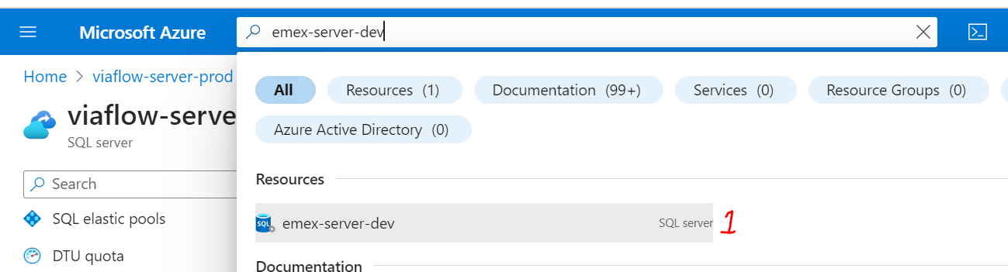

1. Select the server and go to Data Management and select Backup option

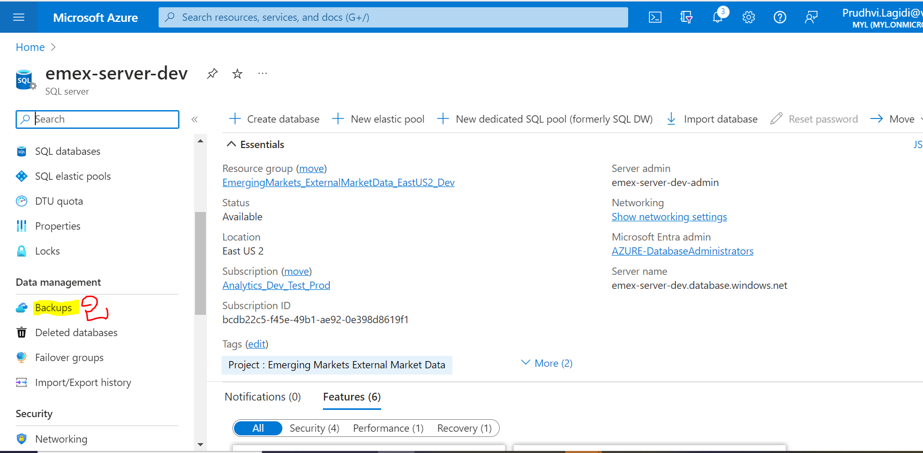

1. Go to Retention Policies Section and select the database name

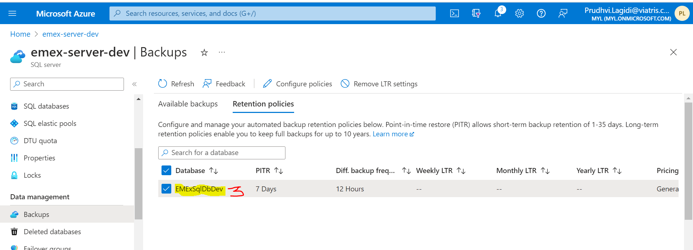

1. Go to configuration policies and change value to required days and select apply

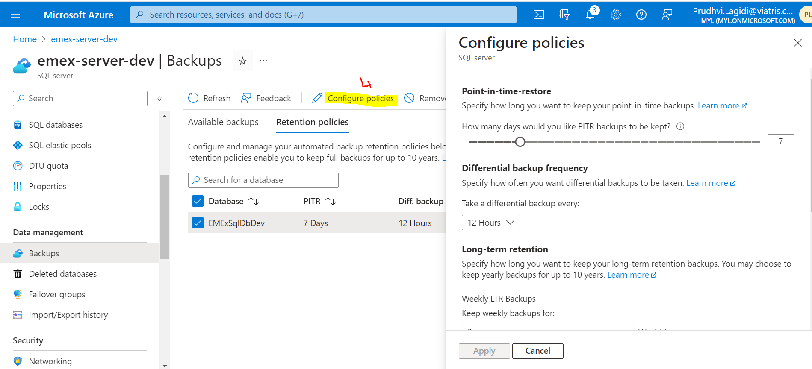

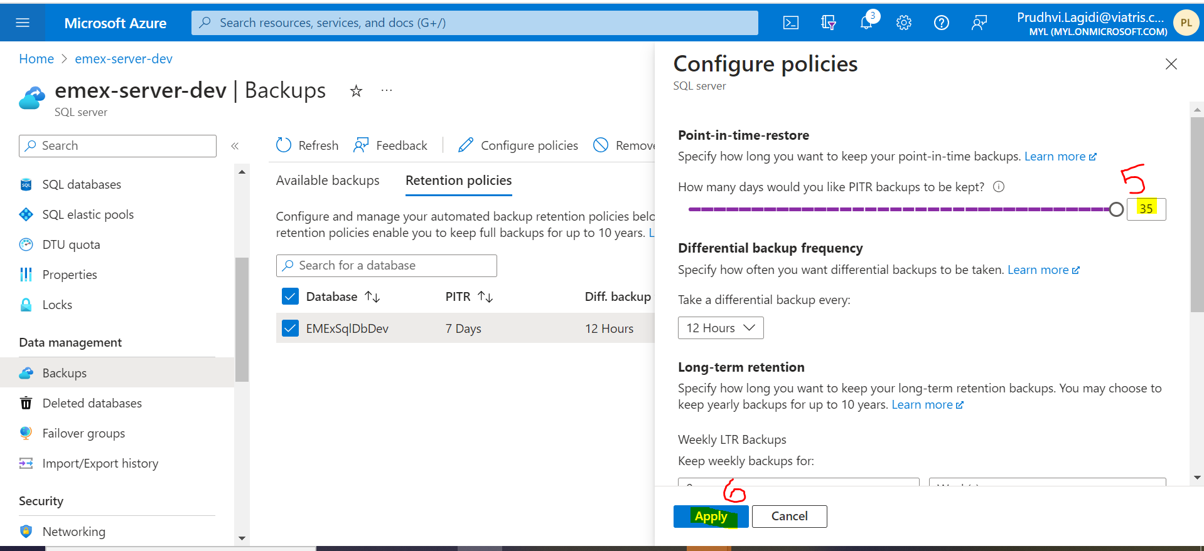

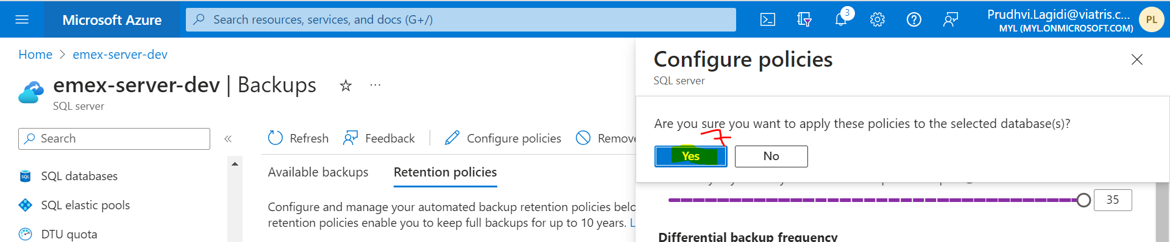

1. **Once deployment completed you will get deployment success screen**

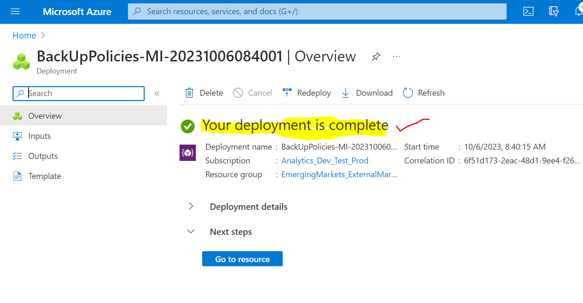

**6. Cross verify either value is changed or not**