1. Logins need to create in sourse and destination server with (GRANT CONTROL, ALTER, SELECT, INSERT, UPDATE, DELETE, EXECUTE).
2. Now validate the tables are available in destination server or not, if not then only move forward or else reach to the requestor.
3. Search for data factories in azure portal.

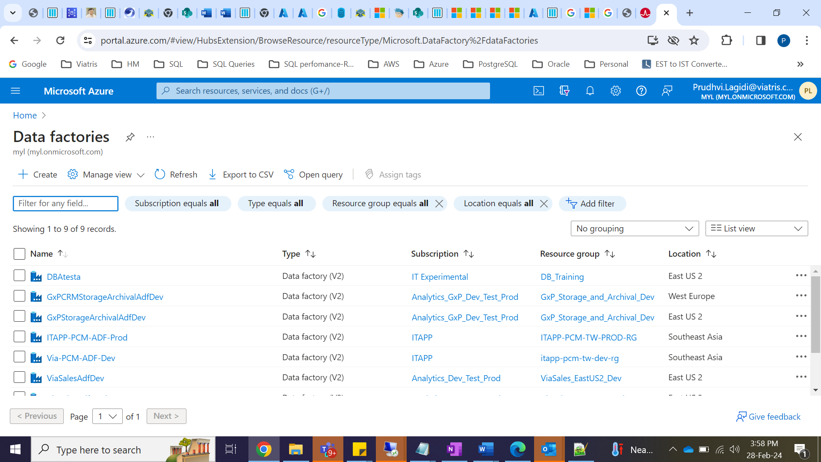

1. Find our datafactor (DBAtesta) and click on It will get Azure factory studio.

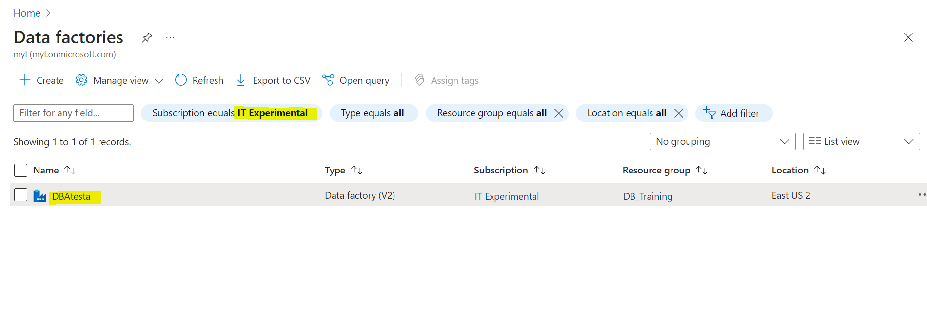

1. Click on launch studio.

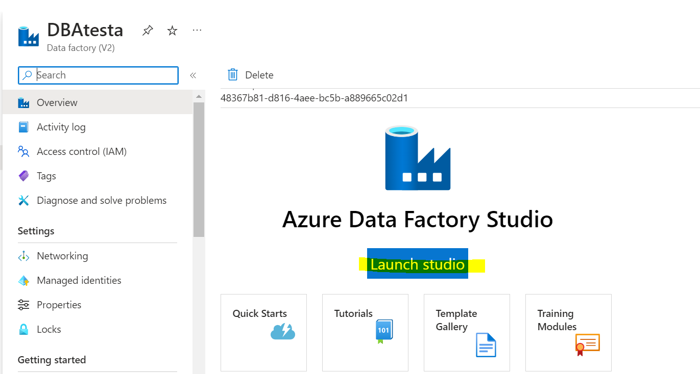

1. .Will get factory studio page then click on Manage will get Ingest option click on It.

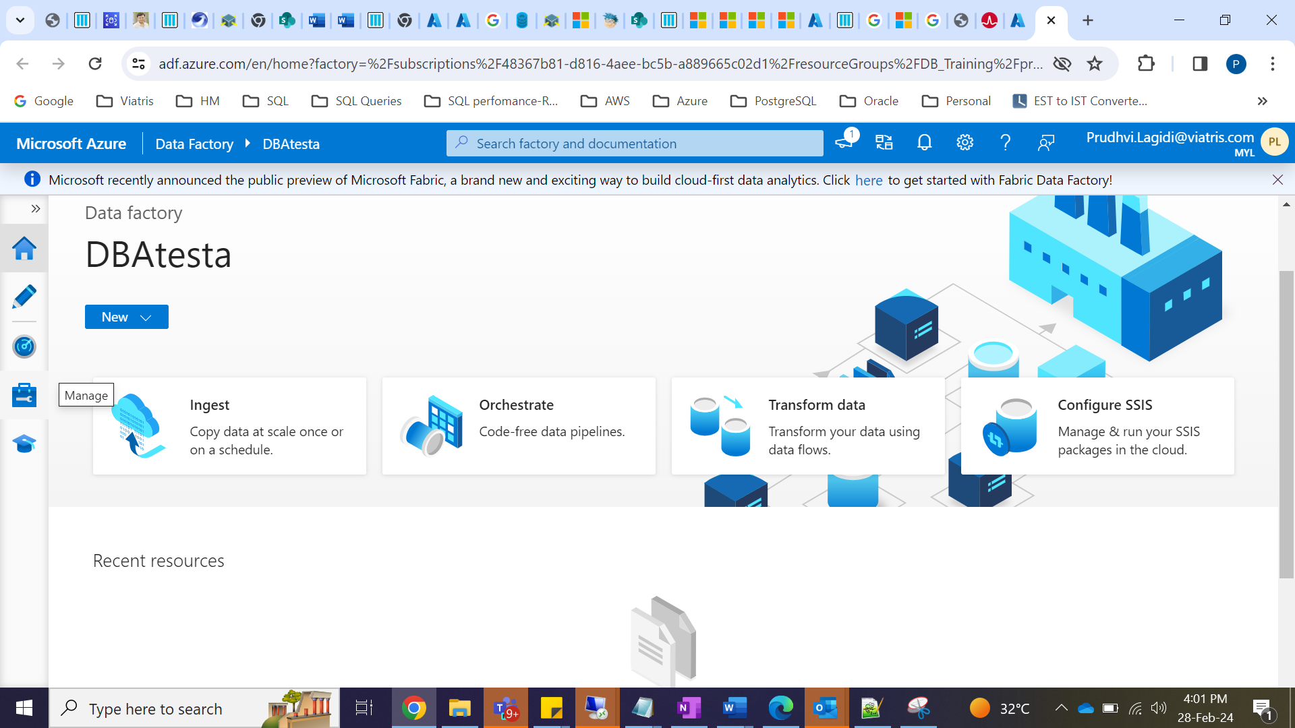

1. Select linked servers and create linked server

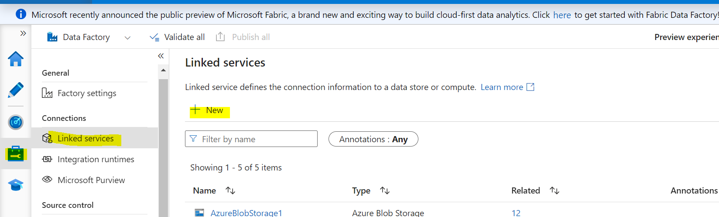

1. Search for azure synapse

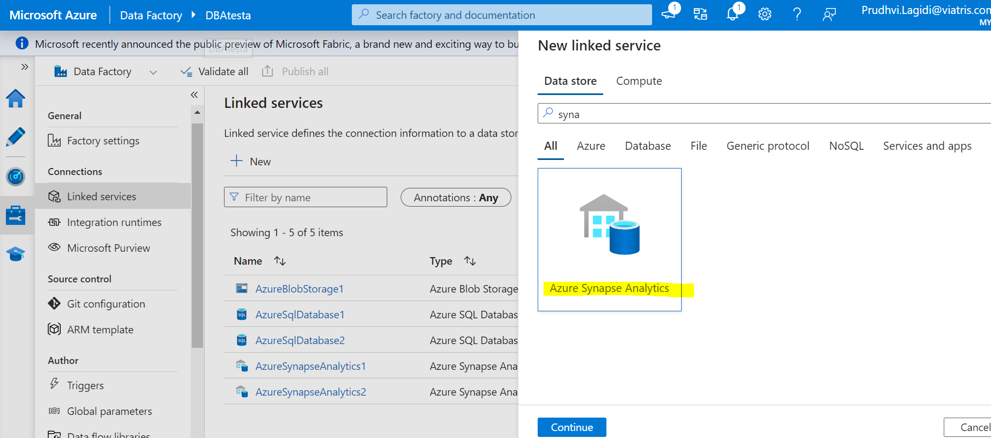

1. Create linked servers for both the servers(Source and Destination)

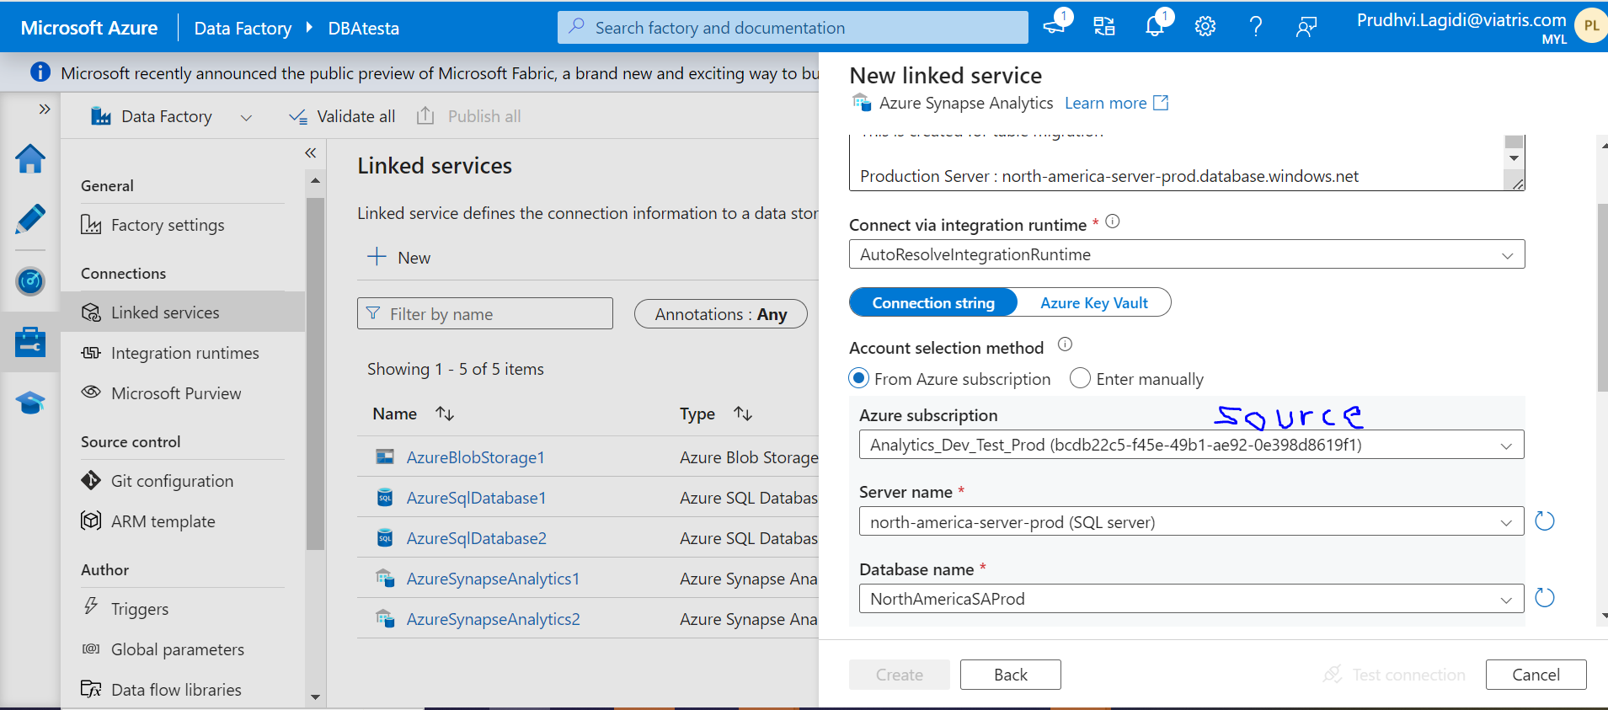

1. Once linked servers created come to our data factory(DBAtesta) and select Home and Ingest option

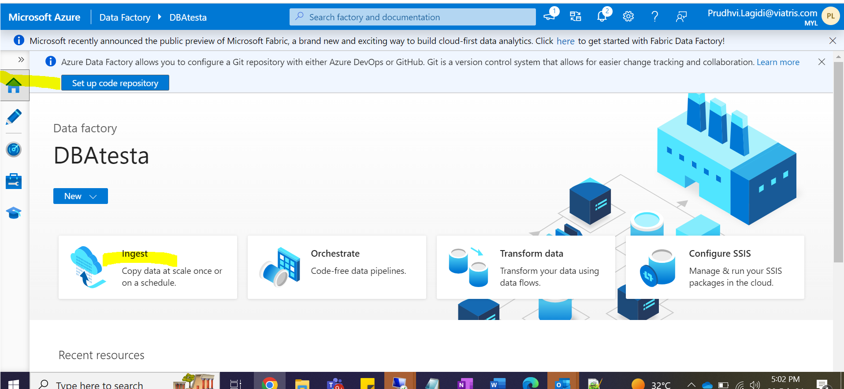

1. Click on Built-in copy task

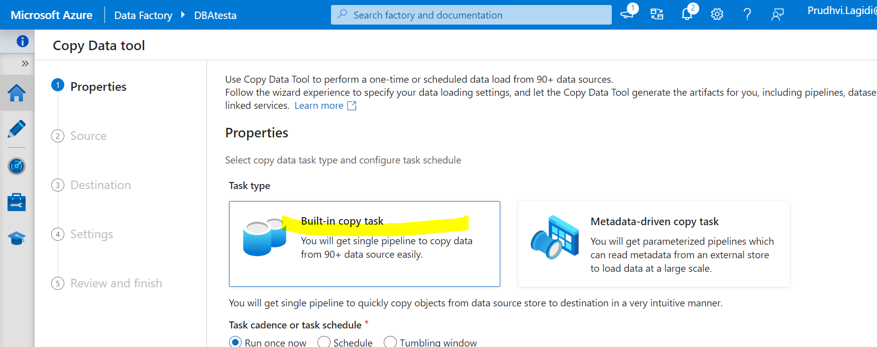

1. Now select the before created linked server sourse details then it will the all the tables details

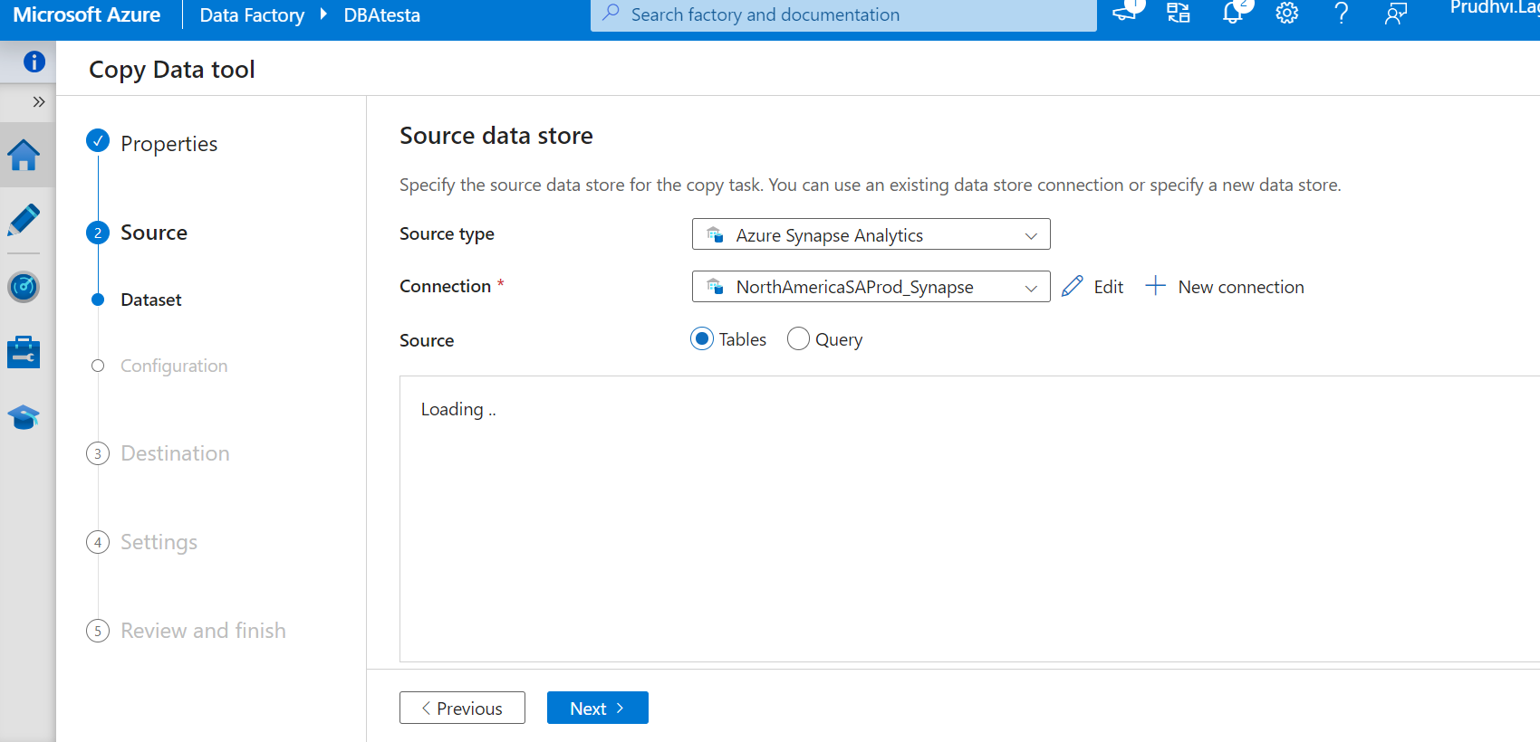

1. Select required tables which we need to move from source to destination.

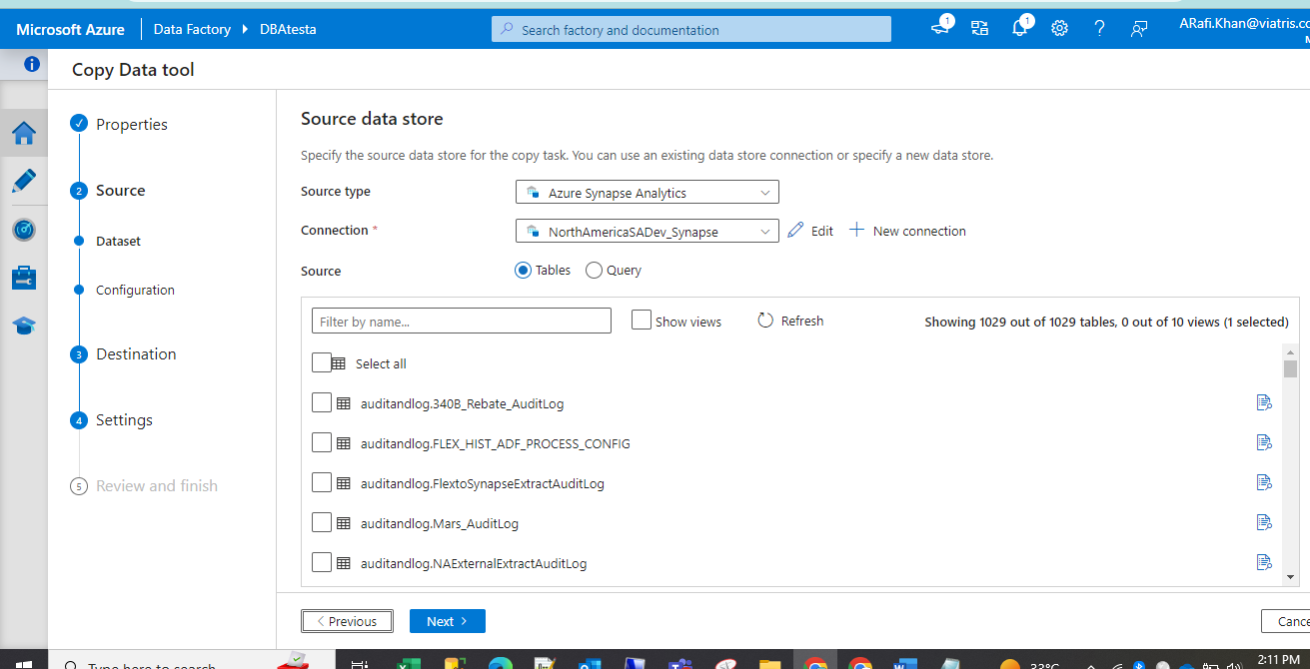

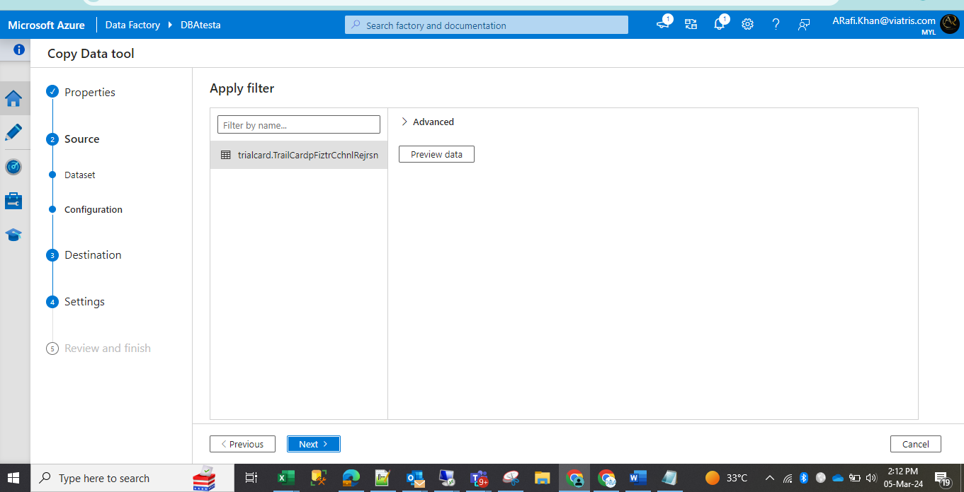

1. Now select the destination linked server details(Be careful while selecting source and destination)

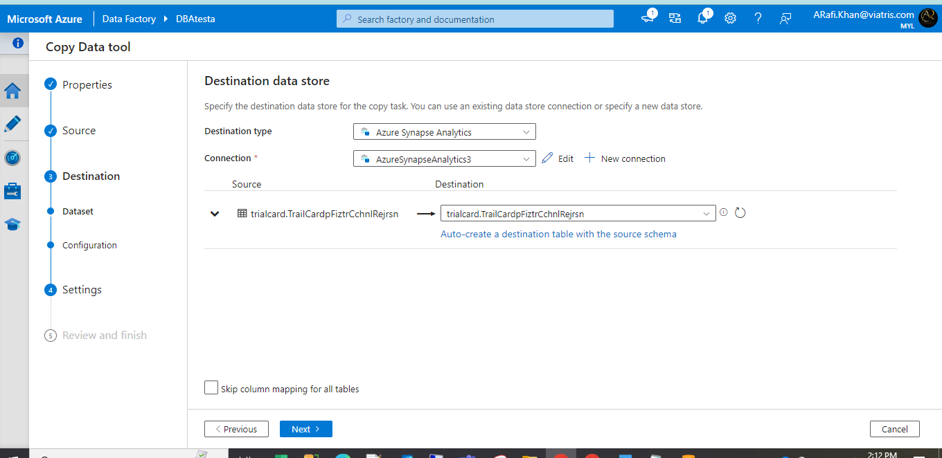

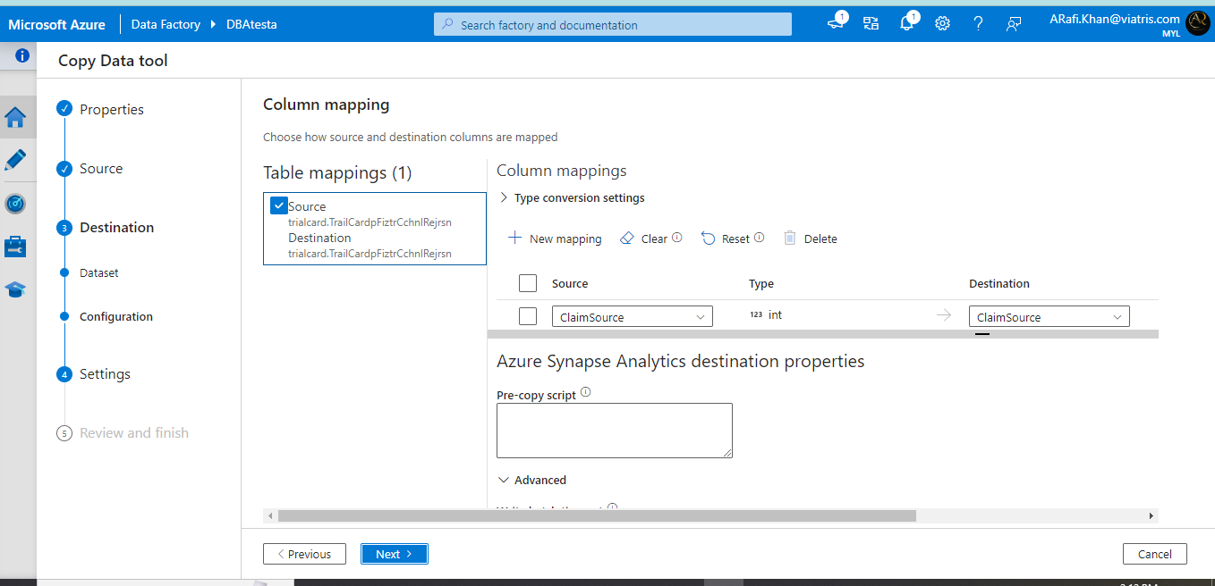

1. For synapse DB we need to select the one storage account so select our storage account(AzureBlobStorage1)
2. In copy method need to select Bulk insert option

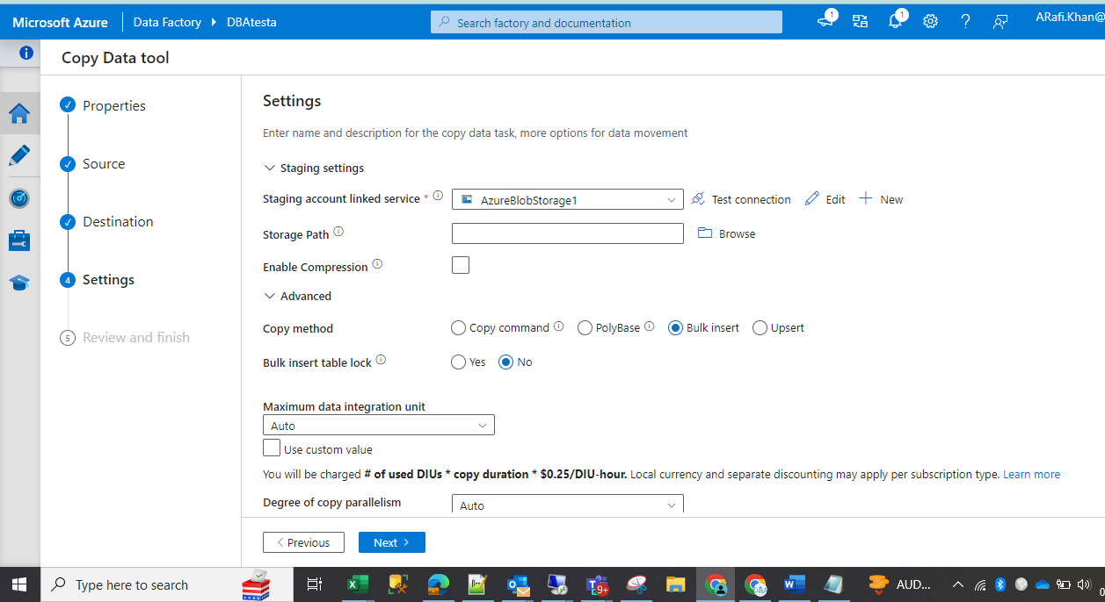

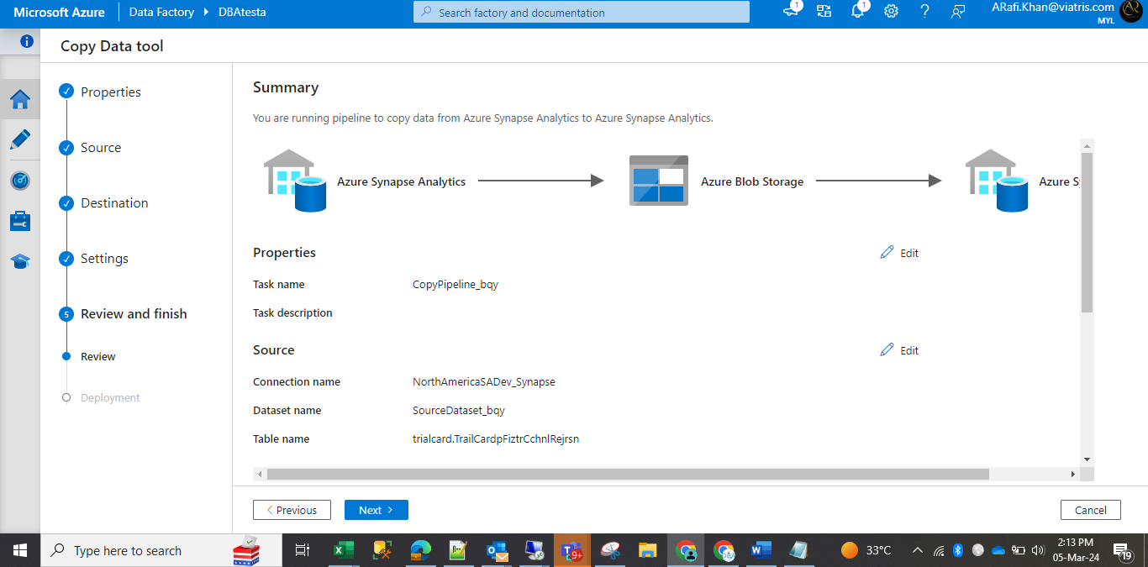

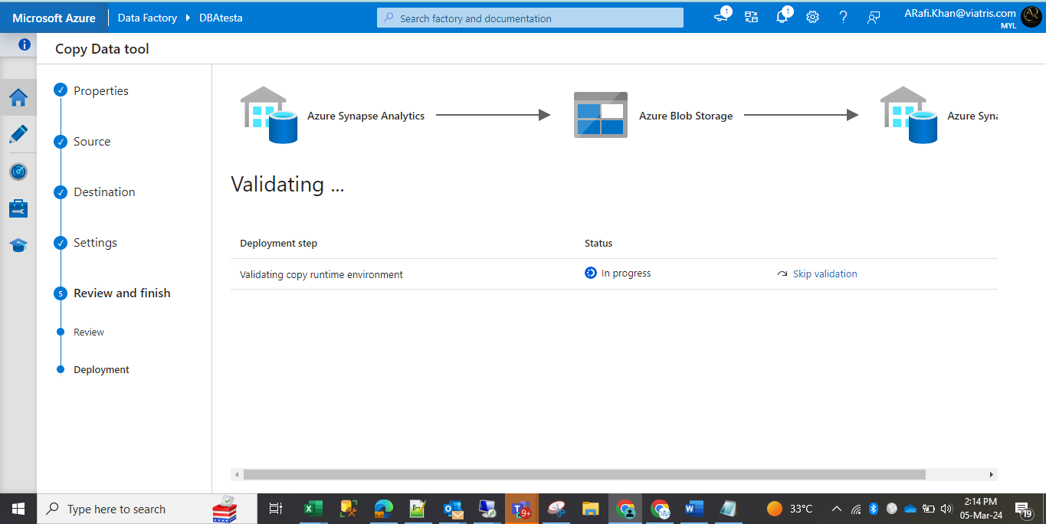

1. Once we click on finish go to the Monitor page to check the status  
   