CODIGO INTEGRACION CON CHATWOOT

Codigo de desarrollo CHATWOOT
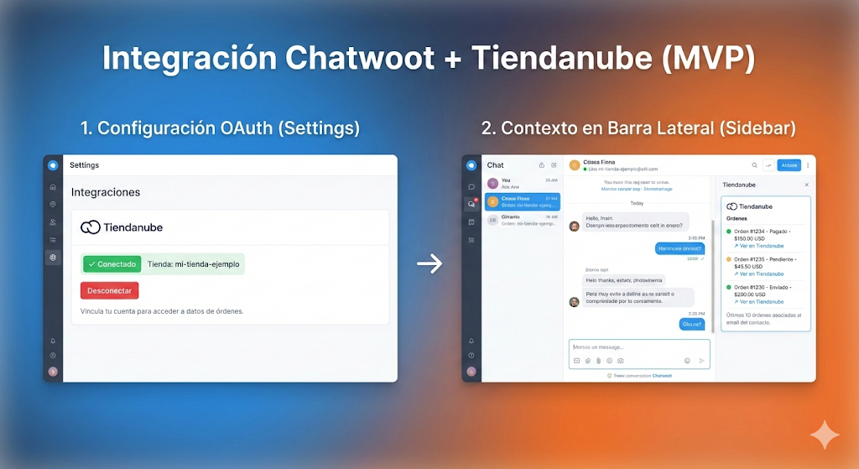

OBJETIVO
Este documento explica los fragmento de código , que se geneneraron y refinaron por IA ; para disminuir los tiempos de desarrollo, es códigos es agregado a un proyecto Ruby para ajustarlo y compilarlo

código completo (Rails) para integrar Tiendanube nativo en Chatwoot, con:
- ✅ Endpoint interno para el Dashboard: GET /api/v1/integrations/tiendanube/products
- ✅ Webhooks nativos:
  - POST /webhooks/tiendanube/:store_id/orders
  - POST /webhooks/tiendanube/:store_id/customers
- ✅ Cliente Tiendanube con header correcto: Authentication: bearer ...
- ✅ Samples para probar con curl

1) Routes (pegar en config/routes.rb)
# === Tiendanube Integration ===

namespace :api do
namespace :v1 do
namespace :integrations do
namespace :tiendanube do
resources :products, only: [:index]
end
end
end
end

namespace :webhooks do
namespace :tiendanube do
post ':store_id/orders', to: 'orders#create'
post ':store_id/customers', to: 'customers#create'
end
end

2) Cliente Tiendanube (crear app/services/tiendanube/client.rb)
# frozen_string_literal: true

require 'faraday'
require 'json'

module Tiendanube
class Client
BASE_URL = 'https://api.tiendanube.com/v1'.freeze

def initialize(
store_id: ENV.fetch('TIENDANUBE_STORE_ID'),
access_token: ENV.fetch('TIENDANUBE_ACCESS_TOKEN'),
user_agent: ENV.fetch('TIENDANUBE_USER_AGENT', 'app-chatwoot')
)
@store_id = store_id.to_s
@access_token = access_token.to_s
@user_agent = user_agent.to_s
end

def list_products(page: nil, per_page: nil, query: nil)
params = {}
params[:page] = page if page
params[:per_page] = per_page if per_page
params[:q] = query if query

get("/#{@store_id}/products", params: params)
end

def get_order(order_id)
get("/#{@store_id}/orders/#{order_id}")
end

def get_customer(customer_id)
get("/#{@store_id}/customers/#{customer_id}")
end

private

def get(path, params: {})
resp = connection.get(path, params)
raise "Tiendanube API error #{resp.status}: #{resp.body}" unless resp.status.between?(200, 299)
resp
end

def connection
@connection ||= Faraday.new(url: BASE_URL) do |f|
f.request :url_encoded
f.adapter Faraday.default_adapter
end.tap do |c|
# Tiendanube usa 'Authentication' (no 'Authorization')
c.headers['Authentication'] = "bearer #{@access_token}"
c.headers['User-Agent'] = @user_agent
c.headers['Accept'] = 'application/json'
c.options.timeout = 15
c.options.open_timeout = 5
end
end
end
end

3) Endpoint interno para Dashboard (crear)

app/controllers/api/v1/integrations/tiendanube/products_controller.rb
# frozen_string_literal: true

class Api::V1::Integrations::Tiendanube::ProductsController < Api::V1::BaseController
# Hereda auth del dashboard (Current.user). El token nunca va al frontend.

def index
client = ::Tiendanube::Client.new
resp = client.list_products(
page: params[:page],
per_page: params[:per_page],
query: params[:q]
)
render json: JSON.parse(resp.body)
rescue KeyError => e
render json: { error: 'missing_env', detail: e.message }, status: :unprocessable_entity
rescue => e
Rails.logger.error("[TiendanubeProducts] #{e.class}: #{e.message}")
render json: { error: 'tiendanube_error', detail: e.message }, status: :bad_gateway
end
end

4) Webhooks nativos (crear controllers)

4.1 Orders webhook

app/controllers/webhooks/tiendanube/orders_controller.rb
# frozen_string_literal: true

class Webhooks::Tiendanube::OrdersController < ActionController::API
def create
store_id = params[:store_id].to_s
payload = parse_json(request.raw_post)

event = payload['event'] || payload['type'] || 'order/event'
data = payload['data'] || {}
order = data['order'] || data

Rails.logger.info("[Tiendanube][Orders] event=#{event} store_id=#{store_id}")

account = resolve_account(store_id)
inbox = resolve_inbox(account)

contact = upsert_contact_from_order(account, order)
conversation = find_or_create_conversation(account, inbox, contact)

content = format_order_note(event, order)

Messages::MessageBuilder.new(
user: nil,
conversation: conversation,
params: {
content: content,
message_type: :outgoing, # nota interna
private: true
}
).perform

head :ok
rescue ActiveRecord::RecordNotFound
head :not_found
rescue => e
Rails.logger.error("[Tiendanube][Orders] #{e.class}: #{e.message}")
head :unprocessable_entity
end

private

def parse_json(raw)
JSON.parse(raw.presence || '{}')
rescue JSON::ParserError
{}
end

def resolve_account(store_id)
# MVP: cuenta por nombre. Mejor: mapear store_id en Channel::Tiendanube.
Account.find_by!(name: "Tienda #{store_id}")
end

def resolve_inbox(account)
account.inboxes.find_by(name: 'Tiendanube') || account.inboxes.first!
end

def upsert_contact_from_order(account, order)
customer = order['customer'] || {}
email = customer['email'].presence || "tiendanube_#{customer['id']}@no-email.local"
name = customer['name'].presence || [customer['first_name'], customer['last_name']].compact.join(' ')
phone = customer['phone'] || customer['phone_number']

Contact.find_or_initialize_by(account_id: account.id, email: email).tap do |c|
c.name = name if name.present?
c.phone_number = phone if phone.present?
c.custom_attributes ||= {}
c.custom_attributes.merge!(
'tiendanube_store_id' => store_id_safe(order, customer),
'tiendanube_customer_id' => customer['id'],
'orders_count' => customer['orders_count'],
'total_spent' => customer['total_spent']
).compact
c.save!
end
end

def store_id_safe(order, customer)
order['store_id'] || customer['store_id'] || params[:store_id]
end

def find_or_create_conversation(account, inbox, contact)
Conversation.find_or_create_by!(
account_id: account.id,
inbox_id: inbox.id,
contact_id: contact.id
)
end

def format_order_note(event, order)
items = (order['line_items'] || []).map do |i|
"- #{i['name'] || i['title']} x#{i['quantity']} (sku: #{i['sku'] || '-'})"
end.join("\\n")

<<~TXT.strip
🛒 Tiendanube - Evento: #{event}
Pedido: #{order['number'] || order['id'] || '-'}
Estado: #{order['financial_status'] || order['status'] || '-'}
Total: #{order['total'] || order['total_price'] || '-'}
Items:
#{items.presence || '- (sin items)'}
TXT
end
end

4.2 Customers webhook

app/controllers/webhooks/tiendanube/customers_controller.rb
# frozen_string_literal: true

class Webhooks::Tiendanube::CustomersController < ActionController::API
def create
store_id = params[:store_id].to_s
payload = parse_json(request.raw_post)

event = payload['event'] || payload['type'] || 'customer/event'
data = payload['data'] || {}
customer = data['customer'] || data

Rails.logger.info("[Tiendanube][Customers] event=#{event} store_id=#{store_id}")

account = Account.find_by!(name: "Tienda #{store_id}")

email = customer['email'].presence || "tiendanube_#{customer['id']}@no-email.local"
name = customer['name'].presence || [customer['first_name'], customer['last_name']].compact.join(' ')
phone = customer['phone'] || customer['phone_number']

contact = Contact.find_or_initialize_by(account_id: account.id, email: email)
contact.name = name if name.present?
contact.phone_number = phone if phone.present?
contact.custom_attributes ||= {}
contact.custom_attributes.merge!(
'tiendanube_store_id' => store_id,
'tiendanube_customer_id' => customer['id'],
'orders_count' => customer['orders_count'],
'total_spent' => customer['total_spent'],
'accepts_marketing' => customer['accepts_marketing']
).compact
contact.save!

head :ok
rescue ActiveRecord::RecordNotFound
head :not_found
rescue => e
Rails.logger.error("[Tiendanube][Customers] #{e.class}: #{e.message}")
head :unprocessable_entity
end

private

def parse_json(raw)
JSON.parse(raw.presence || '{}')
rescue JSON::ParserError
{}
end
end

5) Variables .env (producción/DEV)
Agregar en .env del Chatwoot:
TIENDANUBE_STORE_ID=7208693
TIENDANUBE_ACCESS_TOKEN=REEMPLAZAR
TIENDANUBE_USER_AGENT=app-chatwoot (tu-email@dominio.com)
Reiniciar servicios:
sudo systemctl restart chatwoot.target

6) Pruebas rápidas

6.1 Productos (Dashboard autenticado)
Abrí en el browser (logueado en Chatwoot):
/api/v1/integrations/tiendanube/products

6.2 Webhook Orders (local)
curl -X POST http://localhost:3000/webhooks/tiendanube/7208693/orders \
-H "Content-Type: application/json" \
-d '{
"event":"order/created",
"data":{
"order":{
"number":"1001",
"total":"12000",
"financial_status":"paid",
"line_items":[{"name":"Producto A","quantity":2,"sku":"SKU-A"}],
"customer":{"email":"test@mail.com","name":"Juan","phone":"1133334444","id":99,"orders_count":3,"total_spent":"50000"}
}
}
}'
Ver logs:
journalctl -u chatwoot-web.1.service -f

Importante (seguridad)
El token bearer que compartiste quedó expuesto. Si es real, rotalo y reemplazalo en .env.

Si querés, te agrego ahora mismo (también en código) estas 3 mejoras “pro” sin romper nada:
- Idempotencia por event_id (evitar duplicados por reintentos)
- Validación de firma del webhook (si tu app Tiendanube lo soporta)
- Crear automáticamente el Inbox “Tiendanube” si no existe

