GAME DESIGN & DEVELOPMENT
FSHING
Environmental Science on an Expanding Lake
Measure the water. Predict a species. Plan the crossing. Protect the ecosystem.
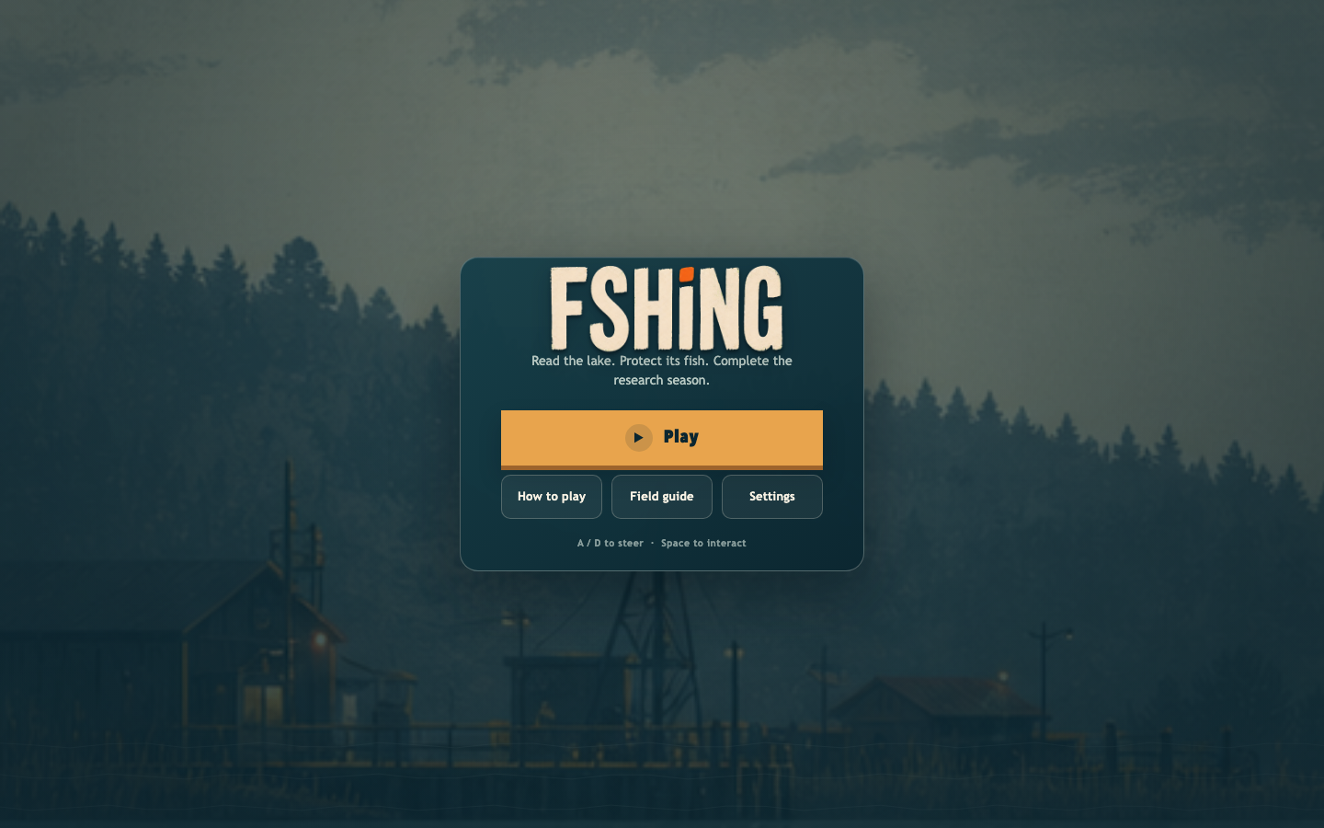
Assessment 3 — Game Design Submission
Student: Saxon Rigg-Smith
Original browser game • TypeScript • Canvas 2D • HTML/CSS
Portfolio version 1.0 • 31 July 2026

Portfolio contents
- Executive summary
- Purpose and intended audience
- Research, inspiration, and originality
- Gameplay design
- Algorithms and computational thinking
- Interface and accessibility design
- Assets and design plans
- Testing and iteration
- Reflection and evaluation
- Rubric evidence map
- Final submission checklist
Evidence note: Automated results are recorded from the repository. Human playtest cells remain marked Pending until real participants complete the protocol.

1. Executive summary
FSHING is an original side-on environmental-science fishing and delivery game. The player operates a research boat across a lake that spans several camera widths. At each site, the player reads depth, temperature, dissolved oxygen, turbidity, and habitat evidence, predicts which fish is adapted to those conditions, and then tests the prediction by fishing underwater. A delivery requires a second STEM decision: compare distance, travel time, predicted freshness, and hazard risk before choosing a survey or express route.
The game teaches through cause and effect. Catching a fish lowers its population. Releasing an unneeded fish reverses that catch's modelled population cost. Very low stocks become protected, and healthy ecosystems provide a delivery bonus. The field guide records discoveries, adaptations, food-web roles, population labels, survey accuracy, and depth access. After eight deliveries, a season report asks the player to evaluate their evidence, route decisions, and conservation impact.
The completed vertical slice contains:
- one continuous lake across approximately three landscape camera widths;
- two harbors, three ecosystem regions, six fishing sites, and three visible hazards;
- nine original fish with different silhouettes, habitat profiles, values, and depth tiers;
- four upgrade paths with six tiers each and seven visible boat classes;
- water surveys, route mathematics, freshness, contracts, hazards, populations, protection, release, recovery, and a mastery report;
- keyboard, pointer, and touch controls;
- mute, volume, high-contrast, reduced-motion, remappable controls, and pause on focus loss;
- deterministic gameplay tests, browser interaction tests, and versioned validated saves.

2. Purpose and intended audience

Game purpose
The game’s learning purpose is to let players practise scientific reasoning inside a short, understandable game loop. Players do not receive a fact sheet and then answer a disconnected quiz. They observe evidence, make a prediction, act on it, and compare the result with their model.

STEM learning outcomes
By the end of a research season, a player should be able to:
- interpret common water-quality measurements as connected environmental evidence;
- explain how fish body shapes and sensory features can suit a habitat;
- calculate or compare journey time using time = distance ÷ speed;
- explain a speed–freshness–risk trade-off;
- predict how harvesting, release, protection, and recovery affect populations;
- revise a prediction after receiving evidence-based feedback.

Learning-to-gameplay alignment
STEM outcome | Gameplay action | Immediate feedback | Measurable evidence
Interpret water-quality evidence | Read depth, temperature, oxygen, turbidity, and habitat at a buoy | Written field note links the readings | Survey completed; selected prediction stored
Connect adaptation to habitat | Choose one contract species from three silhouettes and descriptions | Supported/rethink result explains the fish feature | Correct predictions and field-guide discovery
Apply distance–speed–time | Compare catch-to-harbor route distance and two calculated times | Both estimates show the same equation and units | Route-plan count; chosen route stored
Evaluate a risk trade-off | Choose safer/slower or faster/higher-damage travel | Route card and hazard hit report show multipliers | Predicted versus actual freshness result
Predict population change | Catch, release, revisit, and observe a 0–100 stock index | Written percentage and Healthy/Watch/Vulnerable/Protected label | Lake-health average and conservation score
Revise a model | Read an explanation after any prediction, then fish in that habitat | Incorrect answers remain playable and reveal the supported species | Accuracy across the eight-delivery season

Target audience
The primary audience is Year 7–10 students. The secondary audience is casual browser-game players who enjoy collection, upgrading, vehicle movement, and short objectives. A first contract is designed to be understandable without specialist vocabulary: every measurement has a plain-language clue, numerical units remain visible, and feedback explains the relevant adaptation.

User needs
User need | Design response
Know what to do next | One dominant action, contextual prompts, destination arrow, numbered contract steps
Understand why an answer is right | Immediate written explanation connecting measurements, habitat, and adaptation
Learn without a punishing quiz | Incorrect predictions still reveal evidence and allow play to continue
Recognise fish without colour | Distinct silhouettes, shape descriptions, names, and depth tiers
See the consequence of fishing | Written population label and percentage at markers, harbor, and field guide
Recover from mistakes | Rescue keeps the save, release restores stocks, and contracts remain repeatable
Use different devices or needs | Keyboard, pointer, touch, remapping, high contrast, reduced motion, mute

3. Research, inspiration, and originality
I analysed fishing games at the level of general design patterns. The official Cat Goes Fishing store description demonstrates a clear progression from simple equipment to different fish, quests, boats, deeper water, and a catalogue. FSHING transforms those abstract patterns into a scientific evidence loop: survey water, predict a species, plan a route, manage populations, and evaluate results. Official Steam listing
The project does not copy another game’s protagonist, title treatment, humour, fish names, silhouettes, art, animations, interface, map, dialogue, prices, balance curve, source code, or data. Every FSHING species, ecosystem, visual prompt, rule, and line of implementation was produced for this project. The original-art record is maintained in Docs/Asset-Manifest.md.
The Australian Copyright Council distinguishes an abstract idea from its protected expression and also identifies computer programs as protected works. I used a stricter practical boundary: analyse genre patterns, then independently design all expression and implementation. Ideas: Legal Protection · Games & Copyright

4. Gameplay design

Core loop
ACCEPT → PLAN → TRAVEL → MEASURE → PREDICT → EXPLAIN → FISH → CONSERVE → DELIVER → EVALUATE → UPGRADE

First-player journey
- Press Play and arrive at Brindle Harbor.
- Accept The Morning Order, which requests a Reedfin for Gloam Ferry.
- Travel to the water-connected Sunward Shoal marker.
- Read: 4 m, 21°C, 8.4 mg/L dissolved oxygen, low turbidity, sunlit reeds.
- Predict the Reedfin from three species descriptions.
- Read why broad fins help it manoeuvre in reeds, then lower the hook.
- Catch the Reedfin. Its population changes from 100 to 93 and freshness begins at 100%.
- Compare two routes from the catch site to Gloam Ferry. The screen displays distance, estimated minutes, predicted freshness, and hazard multiplier.
- Select a route and cross the lake, using visible yellow hazard signs and braking when needed.
- Dock, deliver, and compare the catch-to-harbor prediction with actual freshness.
- Spend the reward on a larger boat, engine, lamp, or line depth.
- Open the field guide to review the confirmed species and lake-health data.

World and scientific progression
Site | Region | Readings | Habitat residents | Required line
Sunward Shoal | Brindle Coast | 4 m, 21°C, 8.4 mg/L, clear reeds | Reedfin, Sun Perch, Silver Dart | T0
Silver Bay | Brindle Coast | 7 m, 18°C, 8.0 mg/L, gravel shelf | Silver Dart, Sun Perch, Needle Pike | T0
Needle Run | Mosswater Reach | 13 m, 15°C, 7.2 mg/L, current channel | Needle Pike, Silver Dart, Mossback | T1
Mosswater Pool | Mosswater Reach | 20 m, 12°C, 6.4 mg/L, vegetation/debris | Mossback, Lantern Eel, Needle Pike | T2
Outer Gloam | Violet Gloam | 31 m, 8°C, 5.5 mg/L, rocky drop-off | Gloam Gill, Violet Ray, Lantern Eel | T3 + permit
Blackwater Trench | Violet Gloam | 46 m, 5°C, 4.6 mg/L, lightless trench | Abyss Crown, Violet Ray, Gloam Gill | T5 + permit

Each fishing view contains two individuals from each of its three documented residents. A later contract can request any resident of its assigned site; the survey then evaluates that contract target instead of silently reverting to the site's primary species.

Progression and upgrades
Upgrade | Six-tier effect | Player decision
Boat and cargo | One more space per tier; Skiff → Lakebreaker | Carry more, but spend money that could improve speed or depth
Engine | 11% speed increase per tier | Better freshness and estimates, but express travel still raises hazard damage
Lamp | Larger readable area at night | Safer information versus immediate earning upgrades
Line depth | Reaches the next visible underwater band | Opens rarer fish and new scientific conditions
Outer Gloam permit | Access to the two outer sites | Invest in exploration after equipment is ready

Feedback and reward
- Survey feedback names whether evidence supported the prediction and explains the relationship.
- Underwater depth boundaries remain visible with an upgrade instruction.
- Fishing markers physically meet the water and show site, species, and population text.
- Hazards use a shape, ! symbol, written name, and colour.
- Delivery results compare prediction and actual outcome instead of showing only currency.
- A healthy-ecosystem bonus rewards sustainability without blocking ordinary progress.
- The season report displays four measurable outcomes and includes reflection questions.

5. Algorithms and computational thinking

Decomposition
The program separates responsibilities:
main.ts startup and dependency wiring
Game.ts high-level lifecycle and HTML overlay coordination
simulation.ts deterministic gameplay state and rules
stem.ts water evidence, species profiles, surveys, route estimates
balance.ts central units, prices, fish, sites, regions, hazards
renderer.ts Canvas drawing only; never changes simulation state
input.ts browser input → game intent
saveGame.ts versioning, validation, clamping, migration
platformService.ts only CrazyGames SDK boundary
feedbackService.ts audio/haptic feedback

Survey algorithm
FUNCTION recordSurvey(site, prediction, contractTarget)
expected <- contractTarget IF contractTarget is a documented site resident
ELSE site.primarySpecies
surveysCompleted <- surveysCompleted + 1
IF prediction = expected
correctPredictions <- correctPredictions + 1
ENDIF
discoveredSpecies <- UNIQUE(discoveredSpecies + expected)
RETURN explanation(site.measurements, expected.adaptation)
END FUNCTION

Population algorithm
FUNCTION catch(species)
IF cargo is full THEN reject
IF population[species] <= 15 THEN protect and reject
cargo.add(species, freshness = 100)
depletion <- 7 + species.depthTier * 2
population[species] <- MAX(0, population[species] - depletion)
END FUNCTION
FUNCTION release(cargoItem)
restored <- 7 + cargoItem.depthTier * 2
population[cargoItem.species] <- MIN(100, population + restored)
conservationScore <- conservationScore + restored
END FUNCTION
This model is intentionally simplified into a 0–100 index. It is not presented as a real population count. The abstraction makes the direction and relative impact of a decision understandable to the target audience.

Route algorithm
distanceKm <- ABS(destinationHarborX - catchSiteX) * 18
engineFactor <- 1 + engineTier * 0.11
safeSpeed <- 0.05 * 0.92 * engineFactor * 18
fastSpeed <- 0.05 * 1.12 * engineFactor * 18
safeMinutes <- distanceKm / safeSpeed
fastMinutes <- distanceKm / fastSpeed
predictedFreshness <- MAX(0, 100 - minutes * 0.667)
safeHazardDamage <- baseDamage * 0.70
fastHazardDamage <- baseDamage * 1.45
The estimate begins when the requested fish is caught, exactly when freshness begins to fall. One scaled in-game second is treated as one model minute, so predicted time and measured delivery time share the same distance, maximum-speed, and freshness rules. Slower steering, braking, or detours can therefore explain a lower actual result.

Determinism
Gameplay uses a fixed 1/120-second simulation step. Random target positions and speeds come from a seeded random source. The same initial state, seed, input sequence, and time step therefore produce the same result. Determinism makes bugs reproducible and tests reliable.

Save validation
Save version 5 treats stored data as untrusted. Money, upgrade tiers, populations, learning counters, volume, and other numerical values are checked and clamped. Species identifiers are filtered against the real species list, duplicate discoveries are removed, old saves receive safe defaults, and malformed JSON falls back to a valid new save.

6. Interface and accessibility design

Visual hierarchy
The menu was revised from a stylised arrangement into a conventional centred panel. Play is the largest action. How to play, Field guide, and Settings are clearly secondary. The harbor uses a consistent dispatch-sheet structure:
- current task and reward;
- numbered catch/freshness/destination steps;
- cargo;
- upgrades and services;
- return to lake.
Science overlays use the same hierarchy: heading, measurements, evidence clue, decision, feedback, next action.

Colour system
- deep teal: background and primary structure;
- lighter teal and sea-glass: regions and neutral information;
- warm ivory: readable text;
- muted amber: actionable or caution information;
- restrained green/yellow/coral: supported, watch, and vulnerable states.
Colour is redundant. Population states include words and percentages. Hazards include a symbol and name. Fish use names and silhouette descriptions. Buttons have focus outlines, and depth locks include text.

Input and inclusion
- Keyboard navigation and gameplay controls
- Remappable action bindings with collision-safe swapping
- Pointer and touch controls with large targets
- Pause on focus loss or hidden tab
- High-contrast mode
- Reduced-motion mode
- Mute and volume
- No essential audio-only or colour-only information
- Local fallback when the external SDK is unavailable

7. Assets and design plans
The art direction uses original restrained gouache/screen-print scenery, deep teal interfaces, and high-readability side silhouettes. Runtime assets are explicitly imported so authoring files do not accidentally enter the production build.
The nine-fish 3 × 3 atlas was generated specifically for FSHING. Its row-major layout matches typed fish data, so each fish maps to one deterministic cell. The original two-by-two atlas remains only for its fishing-hook cell. Exact prompts, sizes, roles, source/reference images, runtime paths, and originality notes are in Docs/Asset-Manifest.md.

Procedural audio and equivalent feedback
No external audio file is copied or bundled. FeedbackService creates short Web Audio tones/noise and optional device vibration at runtime.
Cue | Procedural implementation and purpose | Non-audio equivalent | Status
Engine/boost | Filtered triangle oscillator changes pitch and gain with speed | Boat movement, wake, boost control state | Implemented
UI/cast | Short sine sweep; filtered noise plus descending tone | Focus/pressed state; hook visibly enters the water | Implemented
Catch/delivery/upgrade | Rising triangle/sine patterns distinguish success types | Named toast, flash, result panel, changed values | Implemented
Collision/deny | Low sawtooth/noise impact or descending square tone | Hazard symbol/name, damage toast, denial text | Implemented
Dock | Two restrained descending triangle tones | Harbor overlay and dock state | Implemented
Accessibility controls | Master gain follows saved mute and volume; vibration is optional | Every cue has text, motion, shape, or state feedback | Implemented

Important design decisions:
- six fishing signs are anchored to the waterline with a stem and water ellipse;
- each region has a different surface, shallow, middle, and deep palette;
- fish silhouettes differ in height, length, tail, fins, crest, lure, ray wings, or armour;
- deeper fish remain visible but dimmed below the labelled line limit;
- cargo-tier upgrades visibly enlarge the boat and rename its class.

Implemented visual evidence
Main menu   | Route mathematics  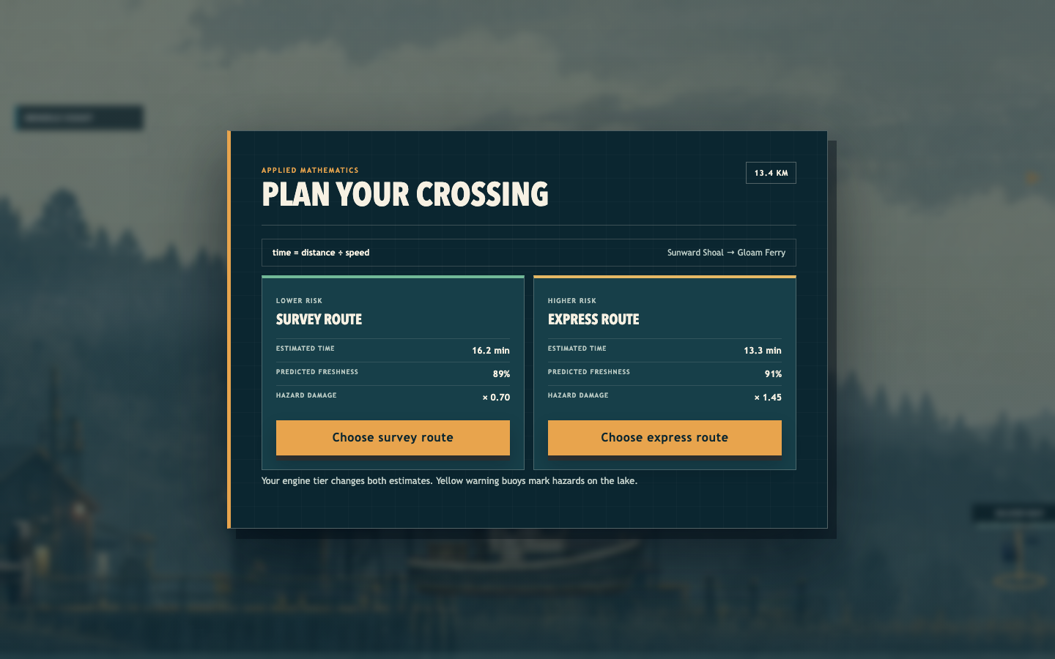

Water-evidence prediction  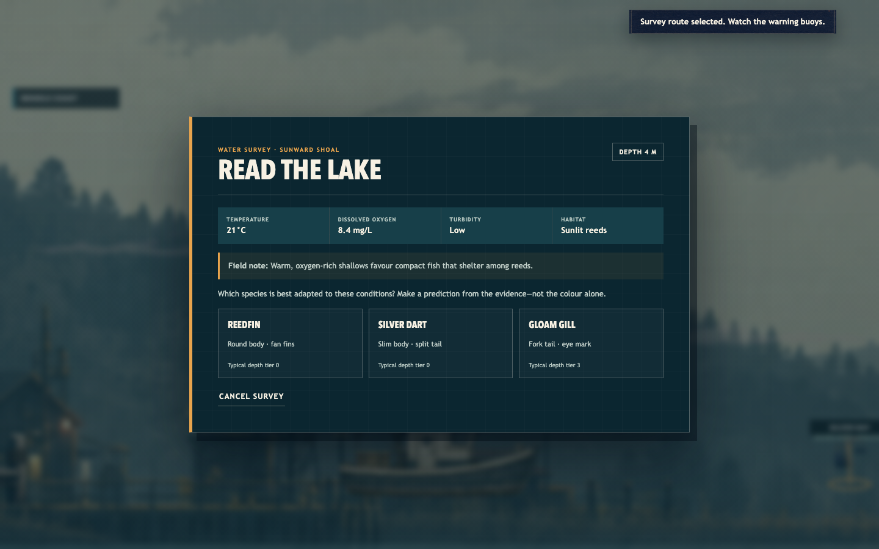 | Habitat-specific, upgrade-gated fish  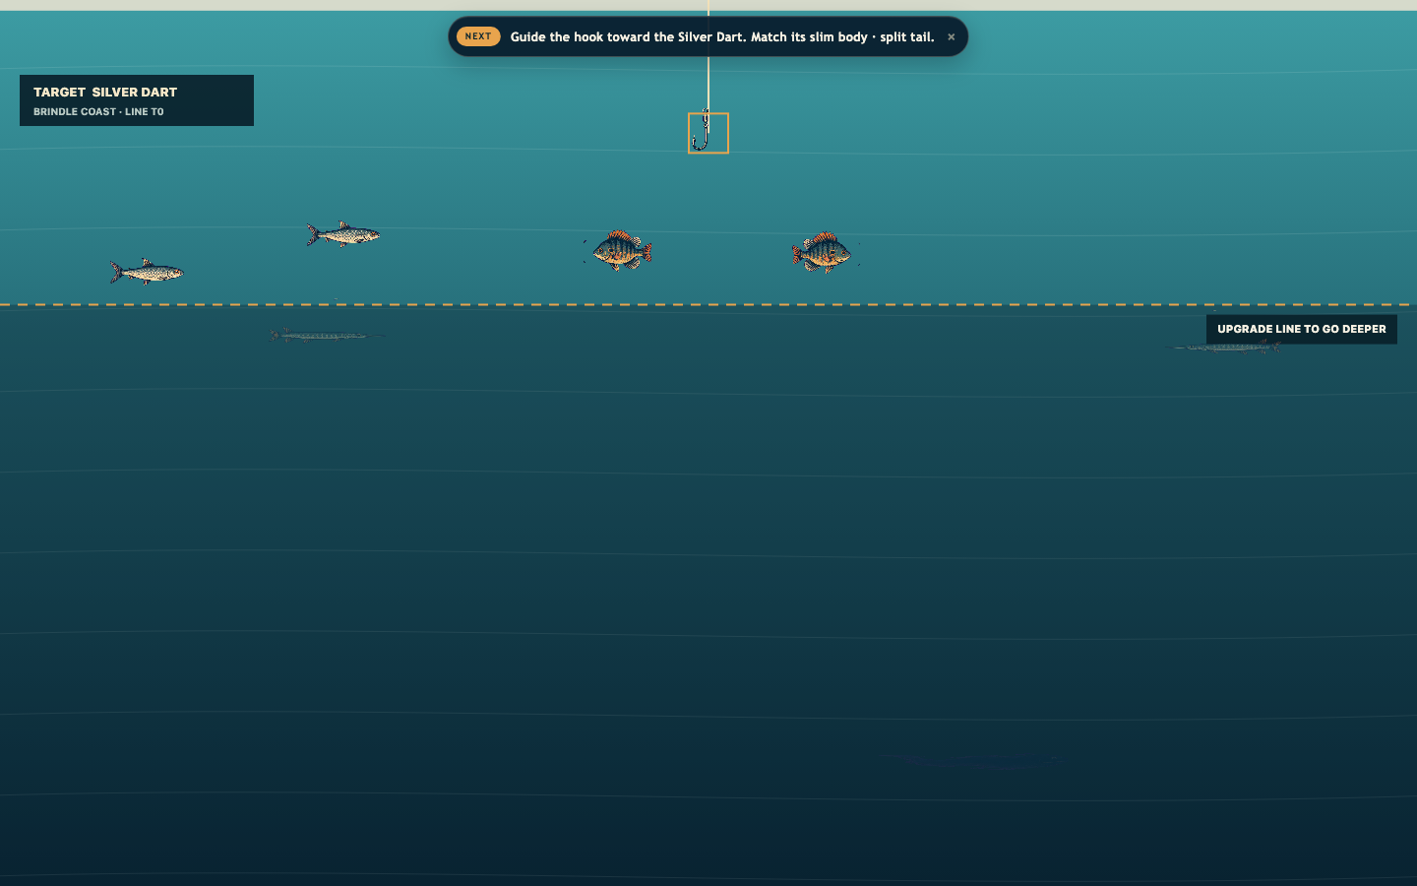

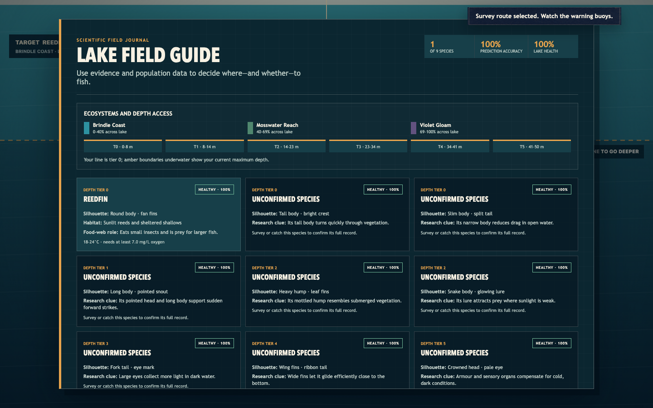
Scientific field guide with ecosystem map, depth access, discovery, accuracy and written population labels

8. Testing and iteration

Stakeholder feedback and resulting iterations
The development brief was refined through direct stakeholder requests:
Feedback | Problem identified | Implemented response
“Make it a much larger map” | The voyage felt too small | Camera view reduced to 0.30 world width, making the harbor span about three views
“Menu screen … a lot more normal” | Initial menu hierarchy was unusual | Centred bounded panel, dominant Play button, familiar secondary actions
“Fix the colour scheme” | Colours lacked cohesion | Unified deep teal, sea-glass, ivory, amber, and restrained warning colours
“Fishing spots more obvious” | Markers were hard to read and appeared airborne | Large labelled markers with vertical stems and ellipses touching the water
“Lots of different types of fish” | Repeated fish did not support discovery | Nine named, illustrated, silhouette-distinct species and profiles
“Water deeper … only with upgrades” | Depth progression was unclear | Six visible depth tiers and labelled upgrade boundary
“Larger boats … upgrade way more” | Progression ended too quickly | Six tiers in four upgrade paths and seven named boat classes
“Different worlds … colour schemes” | Areas lacked identity | Three connected ecosystems with separate above/below-water palettes
Assignment needed a clear STEM purpose | Fishing loop alone did not demonstrate learning | Surveys, route mathematics, populations, field guide, explanations, season evaluation

Automated test strategy
Unit/model tests cover:
- map scale, movement, facing, braking, speed, bounds, and deterministic state;
- fishing targets, catch radius, cargo capacity, depth gates, and permits;
- contracts, freshness, payments, upgrades, rescue, and progression;
- survey correctness, explanations, discoveries, and accuracy;
- contract-specific survey targets and habitat-specific fish spawning;
- population depletion, release, protection, and conservation score;
- protected-stock contract filtering, harbor recovery, and invalid-save fallbacks;
- route estimates, engine effect, and safe/fast hazard damage;
- season completion;
- save corruption, migration, clamping, learning records, and round-trip persistence.
Browser tests cover:
- the complete survey → fish → deliver → result → upgrade → reload flow;
- route choice and displayed equation;
- settings, remapping, pause, high contrast, reduced motion, and SDK fallback;
- six-step help navigation;
- touch controls at mobile landscape size;
- horizontal keyboard movement and facing;
- field-guide regions, depth access, and written population labels.

Automated verification record
Final local verification on 31 July 2026:
Check | Result | Evidence
Strict TypeScript | Pass | tsc --noEmit completed with zero errors
Unit/model suite | Pass | 23 of 23 Vitest tests passed
Production build | Pass | Vite transformed 25 modules and produced dist/
Browser suite | Pass | 6 of 6 Playwright Chromium tests passed
SDK-unavailable fallback | Pass | Browser suite blocks the CrazyGames SDK and completes local play

Human playtest protocol
Automated tests can prove correct states, but not whether a student understands or enjoys them. The following script is ready for at least three testers who have not seen the project. Results must be recorded honestly after testing; blank cells are not invented evidence.
An em dash means that a real participant result is still pending.
Measure | Method | Success target | T1 | T2 | T3
First contract completion | Observe without verbal help | 3/3 complete | — | — | —
Time to first survey prediction | Stopwatch | Under 3 minutes | — | — | —
Habitat explanation | Ask “Why did that fish fit?” | 2/3 cite a measurement + adaptation | — | — | —
Route reasoning | Ask why they chose safe/fast | 2/3 mention time and risk/freshness | — | — | —
Population comprehension | Ask effect of repeated catches | 3/3 predict a decline | — | — | —
Control errors | Count wrong/unclear actions | No repeated blocker | — | — | —
Readability/accessibility | Toggle contrast/reduced motion | All information remains available | — | — | —
Enjoyment | 1–5 rating plus reason | Mean at least 3.5 | — | — | —

For each test, record the observation, not only the score. Convert each repeated issue into: severity, reproduction steps, change, and retest result.

9. Reflection and evaluation

What is effective
The strongest decision was integrating learning into the same decisions that already make a fishing-delivery game interesting. The survey controls where the player fishes; route mathematics controls travel; and population data controls catch/release decisions. This is more effective than pausing the game for unrelated multiple-choice questions.
The deterministic architecture also improved quality. Rules can be tested without Canvas, audio, the DOM, or wall-clock time. Central balance values made the larger lake, six tiers, freshness, hazard risk, and population change easier to revise without searching through interface code.
The interface now gives a clear progression of information and uses written non-colour feedback. The new atlas gives each species a recognisable identity. Visible but inaccessible deep fish create curiosity while the labelled boundary explains how to reach them.

Challenges and solutions
Challenge: expansion could make the game confusing. Solution: use the same evidence-card structure at every survey, preserve one main action on each overlay, and place detailed information in the optional field guide.
Challenge: a fast route was always the obvious choice. Solution: make speed improve freshness but multiply hazard damage by 1.45, while the survey route reduces damage to 0.70.
Challenge: the first diverse-fish prototype put every species at every site. Solution: define three scientifically plausible residents per site, spawn two of each, and make later surveys follow the contract resident. This preserves a busy lake without contradicting the habitat evidence.
Challenge: an early route forecast measured a different journey from the delivered catch. Solution: open planning after the catch and calculate catch-site-to-destination time with the same maximum-speed and freshness model used by the simulation.
Challenge: “sustainability” could become decorative text. Solution: attach a numerical population cost to catching, a protection threshold, recovery to release/delivery/harbor return, protected-contract filtering, a field-guide display, and a currency bonus. If all unlocked stocks are protected, no impossible catch contract is created; repeated harbor visits visibly restore a viable stock.
Challenge: existing save files lacked new learning data. Solution: bump to version 5, validate every field, and supply safe 100-population and zero-mastery defaults.
Challenge: nine fish based on three atlas cells would not be genuinely distinct. Solution: produce a new original 3 × 3 atlas and map each typed species to one cell.

Limitations
The ecological model is simplified. A 0–100 index does not model age structure, reproduction, carrying capacity, predator–prey feedback, seasonal variation, or sampling uncertainty. The route display uses scaled in-game values rather than a real lake. These simplifications are acceptable for the audience only if the interface calls them population and route estimates, not real-world measurements.
Fish currently share a general swimming algorithm; silhouette, depth, and speed vary more than behaviour. The lamp primarily changes visibility rather than scientific sampling. Three hazards are fixed, so expert players can memorise them. Most importantly, the human playtest table is pending and must be completed before making claims about learning effectiveness.

Realistic future improvements
- Run the documented student playtest and revise the two most frequent issues.
- Add deterministic environmental events such as a cold front or algal bloom that change readings and require a revised hypothesis.
- Give fish behaviour rules linked to adaptation, such as schooling in clear water or holding position in a current.
- Add an optional worked route calculation where players enter the time before comparing it.
- Model food-web effects carefully, with visual explanations and new tests.
- Improve soundscapes per ecosystem while retaining mute and visual warnings.
- Add a downloadable season summary for teacher discussion, without collecting personal data.

10. Rubric evidence map
Rubric criterion | Evidence in this submission
Game purpose and STEM learning | Sections 1–2; playable surveys, route maths, populations, season evaluation
Target audience | Section 2; scaffolded language, short loop, accessibility
Gameplay mechanics | Sections 4–5 and Docs/Game-Brief.md
Design plans and assets | Sections 6–7; Docs/Asset-Manifest.md; typed balance tables
Algorithms/pseudocode | Section 5; survey, catch/release, route, determinism, save validation
Computational thinking | Decomposed module architecture, abstraction, deterministic tests
User-centred design | User-needs table, hierarchy, iterative feedback table, accessibility
Testing and iteration | Section 8; automated suites plus honest human protocol
Functional and engaging game | Complete onboarding-to-upgrade loop, expanded progression, visible feedback
Reflection and evaluation | Section 9; strengths, challenges, limitations, realistic next steps

11. Final submission checklist
☐ Replace the human-playtest “Pending” cells with real observations and retest notes.
☑ Strict TypeScript and all 23 unit/model tests pass.
☑ Create and verify the production build.
☑ Pass all 6 Playwright Chromium tests.
☑ Verify desktop and mobile-landscape interaction paths.
☑ Confirm CrazyGames SDK failure still falls back locally.
☑ Confirm a refresh retains field-guide and upgrade progress.
☑ Capture final screenshots of title, survey, underwater depth, route plan, and field guide.
☐ Export this report to the teacher’s required format.
☑ Create and integrity-check the clean game submission ZIP.
☐ Submit the report and ZIP or hosted link before the deadline.

