|  |
| --- |
| **DAYANANDA SAGAR UNIVERSITY**  Devarakaggalahalli, Harohalli  Kanakapura Road, Ramanagara - 562112, Karnataka, India   |

**Bachelor of Technology**

**in**

**COMPUTER SCIENCE AND ENGINEERING**

**BDA Project Report**

**Satellite Imagery Classification Using Deep Learning for Environmental Analysis**

By

**Pruthvi S – ENG21CT0031**

**Manoj Kumar R – ENG21CT0023**

**Sandesh P Shet – ENG22CT1002**

**Under the supervision of**

**Prof. Santosh Kumar**

**Associate Professor**

**DEPARTMENT OF COMPUTER SCIENCE &TECHNOLOGY,**

**SCHOOL OF ENGINEERING**

**DAYANANDA SAGAR UNIVERSITY,**

**(2024-2025)**

**DAYANANDA SAGAR UNIVERSITY**

**Department of Computer Science & Technology**

Devarakaggalahalli, Harohalli, Kanakapura Road, Ramanagara - 562112

Karnataka, India

**CERTIFICATE**

This is to certify that the Major Project Stage-I work titled **“Satellite Imagery Classification Using Deep Learning for Environmental Analysis”** is carried out by **Pruthvi S(ENG21CT0031), Manoj Kumar R (ENG21CT0023),** and **Sandesh P Shet (ENG22CT1002),** Bonafide students seventh semester of Bachelor of Technology in Computer Science and Technology at the School of Engineering, Dayananda Sagar University, Bangalore in partial fulfillment for the award of degree in Bachelor of Technology in Computer Science and Engineering, during the year **2024-2025**.

|  |  |  |
| --- | --- | --- |
| **Prof. Santosh Kumar** | **Dr. Shahina Parveen** | **Dr. Udaya Kumar Reddy K R** |
| Associate Professor  Dept. of CST,  School of Engineering  Dayananda Sagar University  Date: | Chairman CSE  School of Engineering  Dayananda Sagar University  Date: | Dean  School of Engineering  Dayananda Sagar University  Date: |

**Name of the Examiner** **Signature of Examiner**

1.

2.

**DECLARATION**

We, **Pruthvi S(ENG21CT0031), Manoj Kumar R (ENG21CT0023),** and **Sandesh P Shet (ENG22CT1002),** are students of seventh semester B. Tech in **Computer Science and Technology**, at School of Engineering, **Dayananda Sagar University**, hereby declare that the Project titled **“Satellite Imagery Classification Using Deep Learning for Environmental Analysis”** has been carried out by us and submitted in partial fulfillment for the award of degree in **Bachelor of Technology in Computer Science and Engineering** during the academic year **2024-2025.**

|  |  |
| --- | --- |
| **Student** | **Signature** |
| **Name: Pruthvi S**  **USN : ENG21CT0031** |  |
| **Name: Manoj Kumar R**  **USN : ENG21CT0023** |  |
| **Name: Sandesh P Shet**  **USN : ENG22CT1002** |  |
| **Place : Bangalore**  **Date :** |  |
|  |  |

**TABLE OF CONTENTS**

Page

ABSTRACT ............................................................................................................

CHAPTER 1 INTRODUCTION………................................................................. 1

1.1. OBJECTIVE 1-2

1.2. SCOPE 2

CHAPTER 2 PROBLEM DEFINITION ………..................................................... 3

CHAPTER 3 LITERATURE REVIEW................................................................... 4-6

CHAPTER 4 PROJECT DESCRIPTION.................................................................... 7-9

CHAPTER 5 REQUIREMENTS ................................................................................ 10

CHAPTER 6 METHODOLOGY ............................................................................... 11-14

CHAPTER 7 EXPERIMENTATION ............................................................ 15-17

CHAPTER 8 RESULTS ................................................................................... 18

CHAPTER 9 DELIVERABLES…………………………………………….. 19

REFERENCES... ....................................................................................................... 20

**Abstract**

Satellite imagery classification plays a pivotal role in understanding and addressing environmental challenges. This study explores the application of advanced deep learning models, including DenseNet121, MobileNetV2, ResNet50, EfficientNetB0, InceptionV3, and Xception, for classifying satellite images into environmental categories such as cloudy, desert, green areas, and water bodies. Leveraging the high-performance capabilities of convolutional neural networks (CNNs), the models were trained and evaluated using a robust dataset, achieving remarkable validation accuracies, with DenseNet121 standing out at 99.91%. Comprehensive evaluation metrics, including precision, recall, and F1-score, reveal the efficiency and reliability of these models in distinguishing complex environmental features. This research underscores the potential of deep learning in facilitating precise land cover classification, essential for environmental monitoring, resource management, and sustainable development. By integrating satellite imagery with state-of-the-art deep learning techniques, this work contributes significantly to advancing environmental analysis and decision-making processes.

**CHAPTER 1: INTRODUCTION**

Satellite imagery has emerged as an indispensable tool for monitoring and managing Earth’s resources, offering unparalleled insights into environmental conditions. The growing availability of high-resolution satellite data has paved the way for advanced analytical techniques, making it possible to classify land cover and detect environmental changes with precision. Traditional image classification methods, while effective, often fall short when faced with large-scale and complex datasets due to their inability to generalize across diverse scenarios.

This project leverages the power of deep learning, particularly convolutional neural networks (CNNs), to classify satellite images into distinct environmental categories: cloudy, desert, green areas, and water bodies. By employing state-of-the-art architectures such as DenseNet121, ResNet50, MobileNetV2, and others, the study aims to overcome the limitations of conventional methods and deliver robust performance even in challenging scenarios. These models are designed to handle the intricate patterns and high variability present in satellite imagery, ensuring accurate classification and better interpretability.

The application of satellite imagery classification extends to various domains, including urban planning, agriculture, disaster management, and climate change analysis. By automating this process through deep learning techniques, the project significantly enhances the speed, accuracy, and scalability of environmental monitoring efforts. The following sections detail the methodologies employed, results achieved, and implications of this work in addressing pressing global environmental challenges.

**CHAPTER 2: PROBLEM DEFINITION**

Accurately classifying satellite imagery into distinct land cover categories, such as cloudy, desert, green areas, and water bodies, is a challenging yet essential task for effective environmental monitoring and management. Traditional methods of image classification rely heavily on handcrafted features and domain expertise, often resulting in suboptimal performance when dealing with large-scale datasets or highly variable environmental conditions. Furthermore, the manual interpretation of satellite images is time-consuming, prone to human error, and lacks scalability for real-time applications.

With the rapid increase in the availability and resolution of satellite imagery, there is an urgent need for automated, robust, and scalable solutions to analyze this data. The primary challenge lies in addressing the complexity of satellite images, which often feature overlapping classes, noise, and varying illumination or atmospheric conditions. Additionally, achieving high classification accuracy across diverse geographic and environmental settings remains a significant hurdle.

This project aims to address these issues by developing a deep learning-based system that leverages state-of-the-art architectures to automatically and accurately classify satellite images into meaningful environmental categories. By utilizing convolutional neural networks (CNNs), the proposed solution seeks to enhance precision, reduce processing time, and enable large-scale environmental analysis with minimal human intervention.

**CHAPTER 3: LITERATURE REVIEW**

Satellite imagery classification using deep learning has gained significant attention in recent years, driven by advancements in machine learning, particularly deep learning techniques. The analysis of satellite images is crucial for monitoring environmental changes, assessing land use, and managing natural resources. Here’s an overview of the existing literature on the topic:

**1. Introduction to Satellite Imagery Classification**

Satellite imagery is widely used for various environmental applications, such as land cover classification, vegetation mapping, disaster monitoring, and urban planning. The complexity and variability of satellite data, including spatial resolution, spectral information, and temporal changes, require advanced techniques for efficient classification. Traditional image classification methods, such as supervised classification, have been widely used but have limitations in handling large datasets and extracting high-level features. Deep learning methods, especially convolutional neural networks (CNNs), have shown promise in overcoming these challenges.

**2. Deep Learning in Remote Sensing**

Deep learning has revolutionized satellite imagery analysis by automating feature extraction and enabling high-level semantic classification. Among deep learning models, CNNs are particularly effective due to their ability to capture spatial hierarchies and complex patterns in images. Studies have shown that CNNs outperform traditional machine learning algorithms (e.g., decision trees, support vector machines) in satellite image classification tasks (Zhu et al., 2017).

In remote sensing, CNNs have been applied to a variety of environmental monitoring tasks, including:

* **Land Cover Classification**: Several studies (Chen et al., 2018; Zhang et al., 2019) used CNNs for land cover classification, which involves categorizing different land types, such as forests, urban areas, and water bodies, from satellite imagery. The deep learning models, particularly those with multiple convolutional layers, have demonstrated superior accuracy in distinguishing subtle differences in land cover types.
* **Vegetation Classification and Change Detection**: CNN-based models have also been employed for vegetation classification, helping researchers monitor changes in forest cover, crop health, and vegetation density (Li et al., 2020). Moreover, deep learning has been applied to time-series satellite data for detecting environmental changes over time, such as deforestation, drought, and urban sprawl.

**3. Deep Learning Architectures for Satellite Imagery**

Recent advancements in deep learning architectures have enhanced the ability to classify satellite imagery accurately. Common architectures used in satellite imagery classification include:

* **Convolutional Neural Networks (CNNs)**: CNNs are the most widely used deep learning model for satellite imagery. They can capture both low-level features (edges, textures) and high-level semantic information (land cover types). CNNs are capable of handling both high-resolution and multi-spectral images (Ghamisi et al., 2017).
* **U-Net and SegNet:** These architectures are widely used in segmentation tasks, where the goal is to classify each pixel in the image (Zhou et al., 2018). U-Net, in particular, has been popular in environmental applications like vegetation mapping, land-use change detection, and water body classification due to its ability to generate precise pixel-wise predictions.
* **Recurrent Neural Networks (RNNs) and LSTMs:** Recurrent models, including Long Short-Term Memory (LSTM) networks, have been applied to analyze temporal satellite data, such as detecting changes in vegetation and monitoring seasonal variations (Fu et al., 2018). They excel in handling sequential data, making them useful for environmental change analysis.
* **Generative Adversarial Networks (GANs):** GANs have been explored for generating synthetic satellite imagery and enhancing training datasets. They are also used in domain adaptation, where models trained on one type of satellite imagery are adapted to work on another (Liu et al., 2020).

**4. Challenges in Satellite Imagery Classification**

Despite the significant progress, several challenges remain in satellite imagery classification:

* Data Imbalance: Satellite imagery datasets often suffer from class imbalance, where some land cover types are underrepresented. This can lead to biased predictions, with the model favoring the majority class. Techniques like data augmentation and class re-weighting have been employed to address this issue (Zhao et al., 2019).
* High Dimensionality: Satellite images are often high-dimensional, especially when multi-spectral and multi-temporal data are used. This increases computational complexity and can lead to overfitting. Dimensionality reduction techniques, such as Principal Component Analysis (PCA) or autoencoders, are commonly used to mitigate this challenge.
* Noise and Artifacts: Satellite imagery is susceptible to noise, atmospheric distortion, and other artifacts that can affect classification accuracy. Data preprocessing techniques, including image denoising and atmospheric correction, are essential for improving model performance (Gonzalez et al., 2020).

**5. Applications of Satellite Imagery Classification in Environmental Analysis**

The use of satellite imagery classification for environmental analysis is vast. Some of the key applications include:

* Deforestation Monitoring: Deep learning models have been applied to detect and monitor deforestation, providing real-time data for policy and conservation efforts (Wulder et al., 2019). These models can identify areas of land cover change, even in remote regions with minimal ground-truth data.
* Disaster Management: Satellite imagery classification is essential for natural disaster management, such as flood and wildfire monitoring. CNNs are particularly useful for detecting changes in affected areas and assessing the severity of damage (He et al., 2020).
* Urbanization and Land Use Change: The ability of deep learning models to classify urban and rural areas has been utilized for studying land-use change, urban sprawl, and the impact of human activity on the environment (Gao et al., 2019).
* Climate Change Monitoring: Satellite data is critical in monitoring the effects of climate change, such as changes in sea level, vegetation patterns, and ice cover. Deep learning models help in tracking these changes over time, providing valuable insights for climate policy.

**6. Conclusion**

Deep learning has emerged as a powerful tool for satellite imagery classification, offering significant improvements over traditional methods in terms of accuracy and efficiency. The ability to automatically extract features and classify images with high precision makes deep learning particularly suited for environmental analysis. However, challenges such as data imbalance, high dimensionality, and noise need to be addressed for further improvements. With ongoing advancements in deep learning techniques, satellite imagery classification will continue to play a vital role in environmental monitoring, disaster management, and sustainable development.

**CHAPTER 4: PROJECT DESCRIPTION**

**Overview:** The project focuses on utilizing deep learning techniques, particularly Convolutional Neural Networks (CNNs), for the classification of satellite imagery in environmental analysis. The aim is to automate the process of interpreting satellite data to monitor environmental changes, such as land use changes, deforestation, vegetation health, and natural disaster impacts. The project intends to enhance the accuracy and efficiency of environmental monitoring by leveraging the power of deep learning to classify complex and high-dimensional satellite images.

**Objective:**

* To develop a deep learning-based model that classifies satellite imagery into different categories, such as forest cover, urban areas, water bodies, and agricultural land.
* To analyze and monitor environmental changes, such as deforestation, land-use changes, and vegetation health, by processing multi-temporal satellite images.
* To explore the use of CNN architectures in extracting spatial features and applying them for classification tasks in environmental monitoring.

**Project Goals:**

1. **Data Collection & Preprocessing:**  
   Gather high-resolution satellite imagery data from sources like Landsat, Sentinel, or other publicly available satellite databases. The data will undergo preprocessing steps such as noise removal, atmospheric correction, and resizing to fit the deep learning model requirements.
2. **Model Development:**  
   Implement a CNN model, such as a standard CNN, U-Net, or SegNet, to classify satellite images. The model will be trained on labeled datasets to learn features such as vegetation, water bodies, urban structures, and agricultural land.
3. **Training & Evaluation:**  
   Train the deep learning model using labeled satellite images, with an emphasis on optimizing accuracy, precision, and recall. Evaluate the model performance on test data using metrics such as confusion matrix, F1-score, and Intersection over Union (IoU) for segmentation tasks.
4. **Environmental Change Detection:**  
   Implement a change detection framework using multi-temporal satellite images to monitor environmental changes over time, such as deforestation or urbanization. This will involve comparing classifications of satellite images from different time points to identify significant changes.
5. **Visualization & Interpretation:**  
   Develop a user-friendly interface for displaying the results, such as heatmaps, classification maps, and time-lapse animations. This will allow stakeholders, including environmentalists and policymakers, to visually interpret the environmental trends and take informed decisions.

**Technologies Used:**

* **Deep Learning Frameworks:** TensorFlow, Keras, or PyTorch for model implementation and training.
* **Satellite Imagery Sources:** Landsat, Sentinel, or other open satellite data providers.
* **Image Processing Libraries:** OpenCV, PIL (Python Imaging Library), and Scikit-image for data preprocessing and manipulation.
* **Data Visualization:** Matplotlib, Seaborn, and Plotly for visualizing results such as classification maps and environmental changes.
* **Development Environment:** Jupyter Notebooks, Google Colab (for cloud-based execution), or local environment with required hardware (e.g., GPU).

**Expected Outcomes:**

1. A robust deep learning model capable of accurately classifying satellite imagery into various land cover categories.
2. A system that can detect and highlight environmental changes, such as deforestation, land degradation, or urbanization, using time-series satellite images.
3. A user interface for easy access to classification results, including visual representations of satellite data and change detection over time.
4. Contribution to the field of environmental monitoring by providing a scalable, automated solution for analyzing satellite data and supporting decision-making in conservation and urban planning.

**Significance of the Project:**

* This project is highly relevant to global environmental monitoring efforts, as it enables more effective and timely assessments of environmental health and land management.
* It can be applied in a variety of sectors, including forestry, agriculture, urban planning, and disaster management, helping policymakers and environmental scientists track and mitigate the impact of human activities and natural disasters on the environment.
* The project advances the application of deep learning in remote sensing, contributing to the growing use of AI in Earth observation and environmental sustainability.

**CHAPTER 5: REQUIREMENTS**

**Software Requirements:**

* Modern multi-core processor (e.g., Intel Core i7 or higher)
* 16 GB RAM (32 GB recommended for handling large datasets)
* Several gigabytes of free disk space (1TB recommended for storing satellite images and model data)
* Graphics card with CUDA support for GPU acceleration (e.g., NVIDIA Tesla, RTX 3090)
* Python 3.x
* TensorFlow or PyTorch for deep learning model development
* OpenCV for image processing
* Scikit-learn for model evaluation and metrics
* Matplotlib, Seaborn, or Plotly for data visualization
* Google Colab or Jupyter Notebook (for cloud-based or local development)
* Git/GitHub for version control and project management
* QGIS (optional) for geospatial analysis and visualization
* Geopandas and Folium for map visualizations (optional)

**Hardware Requirements:**

* Modern multi-core processor (e.g., Intel Core i7 or higher)
* 16 GB RAM (32 GB or more recommended for large datasets)
* At least 1 TB of storage space (for datasets, model checkpoints, and results)
* NVIDIA GPU with CUDA support (e.g., RTX 3060/3070 or Tesla V100) for faster model training
* High-speed internet connection for accessing large satellite datasets and cloud-based services

**CHAPTER 6: METHODOLOGY**

The methodology for the project involves multiple steps, from data preprocessing and model training to evaluation and comparison. Below is the detailed breakdown of the methodology:

**1. Data Collection and Preparation**

* Satellite Data Collection:
  + Data is gathered from publicly available satellite imagery sources like USGS Earth Explorer, Copernicus Sentinel, or other providers. The data should cover various environmental classes such as cloudy, desert, green_area, and water to analyze land cover classification.
  + The collected satellite images are typically in .tiff, .jpg, or .png formats, depending on the data source.
* Data Preprocessing:
  + Image Resizing: The images are resized to a standard resolution (e.g., 224x224 pixels) for uniformity and to match the input requirements of deep learning models.
  + Image Normalization: Pixel values are normalized to a range of 0-1 by dividing by 255 to ensure uniform input scale.
  + Data Augmentation: To increase the diversity of the training dataset, techniques such as rotation, flipping, scaling, and zooming are applied.

**2. Model Selection**

* Model Architecture: The project leverages a combination of traditional CNN and pre-trained deep learning models. These models are chosen based on their proven effectiveness in image classification tasks:
  + Custom CNN: A custom convolutional neural network (CNN) designed with multiple convolutional layers, pooling layers, and fully connected layers for feature extraction and classification.
  + Pre-trained Models:
    - MobileNetV2: A lightweight model designed for efficient use of resources, commonly used in mobile applications.
    - ResNet50: A deep residual network known for handling very deep networks without suffering from vanishing gradient problems.
    - InceptionV3: A model with a novel architecture that uses various filter sizes in parallel to capture multi-scale features.
    - EfficientNetB0: A highly efficient model that balances the trade-off between model size and accuracy.
    - DenseNet121: A model that uses dense blocks to encourage feature reuse, improving model performance and reducing overfitting.
    - Xception: A model based on depthwise separable convolutions, designed to improve the efficiency of the network while maintaining accuracy.

**3. Model Training**

* Training Process:
  + The models are trained on the satellite imagery dataset using a training set that consists of labeled images belonging to different classes.
  + Loss Function: A categorical cross-entropy loss function is used since it is a multi-class classification problem.
  + Optimizer: Adam optimizer is employed due to its adaptive learning rate and efficient convergence properties.
  + Learning Rate Scheduling: A learning rate scheduler (e.g., ReduceLROnPlateau) is used to adjust the learning rate dynamically during training to improve convergence.
  + Epochs: Training runs for a predefined number of epochs, such as 20-50, depending on the model convergence.

**4. Evaluation Metrics**

* Accuracy: The overall accuracy of the model is computed as the proportion of correctly predicted images.
* Precision, Recall, F1-Score: These metrics are calculated for each class to assess the model's performance in detail. The classification report provides a summary of these metrics for each class.
* Confusion Matrix: A confusion matrix is generated to visually analyze the model's predictions and the true labels. This helps identify areas where the model struggles with classifying specific categories.

5. Model Comparison

* Comparison of Models: Different models' performances (Custom CNN, MobileNetV2, ResNet50, etc.) are compared based on validation accuracy, precision, recall, and F1-score.
* Visualization: A bar plot is generated to compare the validation accuracy of each model, and a classification report is generated for each model to evaluate performance in detail.

6. Final Output and Interpretation

* Results: The best-performing model is selected based on its validation accuracy and overall performance on the classification report. This model is then used to classify new satellite imagery into environmental categories.
* Environmental Analysis: The output of the model is analyzed to assess land cover types such as cloudy, desert, green_area, and water. These classifications help in environmental monitoring, such as detecting deforestation, changes in water bodies, and urbanization trends.

**7. Deployment and Future Work**

**Deployment**

Once the best-performing model has been selected based on validation accuracy and performance metrics, the next step is to deploy the model to make it accessible for real-time satellite imagery classification and environmental analysis. The deployment involves the following steps:

1. **Model Export and Serialization:**
   * The trained deep learning model is serialized into a format that can be used for deployment. Common formats include TensorFlow SavedModel, Keras H5, or ONNX for cross-platform deployment.
   * This step ensures that the model can be loaded into a production environment without needing to retrain it.
2. **Web Application Development:**
   * A web application is developed using a web framework like Flask or Django in Python. The application will provide a user interface where users can upload satellite images for classification.
   * The backend of the application will handle loading the trained model, processing the uploaded images, and displaying the classification results.
   * REST API can be used to handle image uploads and inference requests, allowing for easy integration with other applications or services.
3. **Cloud Deployment:**
   * The web application and model are deployed to a cloud platform like AWS (Amazon Web Services), Google Cloud Platform (GCP), or Microsoft Azure to ensure scalability and availability.
   * Docker containers can be used to package the application and model for easy deployment, ensuring consistency across different environments.
   * Cloud services like AWS Lambda or Google Cloud Functions can be used for serverless computing to handle inference requests without managing dedicated infrastructure.
4. **Model Optimization:**
   * Inference optimization techniques such as TensorRT, ONNX Runtime, or Quantization can be applied to reduce the model’s size and improve inference speed without sacrificing accuracy.
   * Edge deployment: For real-time processing of satellite imagery, the model can be deployed on edge devices using TensorFlow Lite or ONNX Runtime, making predictions on-device to minimize latency.
5. **User Interface:**
   * A simple and intuitive user interface (UI) allows users to upload images and view results. The UI can be built with HTML, CSS, and JavaScript, integrated into the backend via Flask or Django.
   * The results (e.g., classified environmental categories) are displayed to the user in a clean format, with possible additional features like visualizations on maps (e.g., Leaflet.js integration).

**Future Work**

1. **Incorporation of Temporal Satellite Data:**
   * The current model classifies images based on single-time snapshots. Future work can involve using temporal satellite data to monitor changes over time.
   * For example, using a series of images captured at different time points, the model can detect trends like deforestation, urbanization, or changes in water bodies over months or years.
2. **Fine-Grained Classification:**
   * The project currently focuses on broad environmental categories such as cloudy, desert, green_area, and water. Future work could involve creating more granular classes, such as specific types of vegetation, different land cover types, or even urban vs. rural classifications.
   * Higher resolution data (e.g., from higher-resolution satellites like WorldView-3) can be used for more detailed classification.
3. **Integration with GIS (Geographic Information Systems):**
   * Integrating the model with a GIS platform would allow users to visualize the classified data on interactive maps, providing insights into land cover changes at specific geographic locations.
   * Using tools like ArcGIS or QGIS, the classified results could be overlaid with other geographical data for deeper environmental analysis.
4. **Incorporation of Multispectral and Hyperspectral Imaging:**
   * Future versions of the model can leverage multispectral or hyperspectral imagery, which captures more wavelengths of light than typical RGB images, offering additional information for more accurate classification of environmental features.
   * For example, distinguishing between different types of vegetation or identifying specific minerals could be made possible using multispectral data.
5. **Real-Time Satellite Image Streaming and Classification:**
   * A real-time satellite image streaming system can be developed to continuously fetch images from satellites in orbit, classify them in near-real-time, and provide users with up-to-date environmental information.
   * This could be particularly useful in monitoring natural disasters (e.g., wildfires, floods) or tracking deforestation or urbanization patterns as they happen.
6. **Model Improvements:**
   * Ensemble Learning: Future work could involve combining the predictions from multiple models using ensemble learning techniques (e.g., stacking, bagging, or boosting) to improve overall performance.
   * Transfer Learning: Fine-tuning pre-trained models on domain-specific satellite imagery data using transfer learning techniques can further enhance the model's accuracy and reduce training time.
   * Explainability: Introducing explainable AI (XAI) techniques to provide explanations for model predictions, such as Grad-CAM or LIME, will allow users to understand which features of the images contributed to the model’s classification.
7. **Collaboration with Environmental Organizations:**
   * The deployed system can be integrated with environmental monitoring organizations, providing real-time data that could assist in policy-making, disaster response, and conservation efforts.
   * By collaborating with environmental scientists and agencies, the model can be adapted to meet specific needs, such as tracking wildlife habitats or monitoring soil quality.

**CHAPTER 8 RESULTS**

* 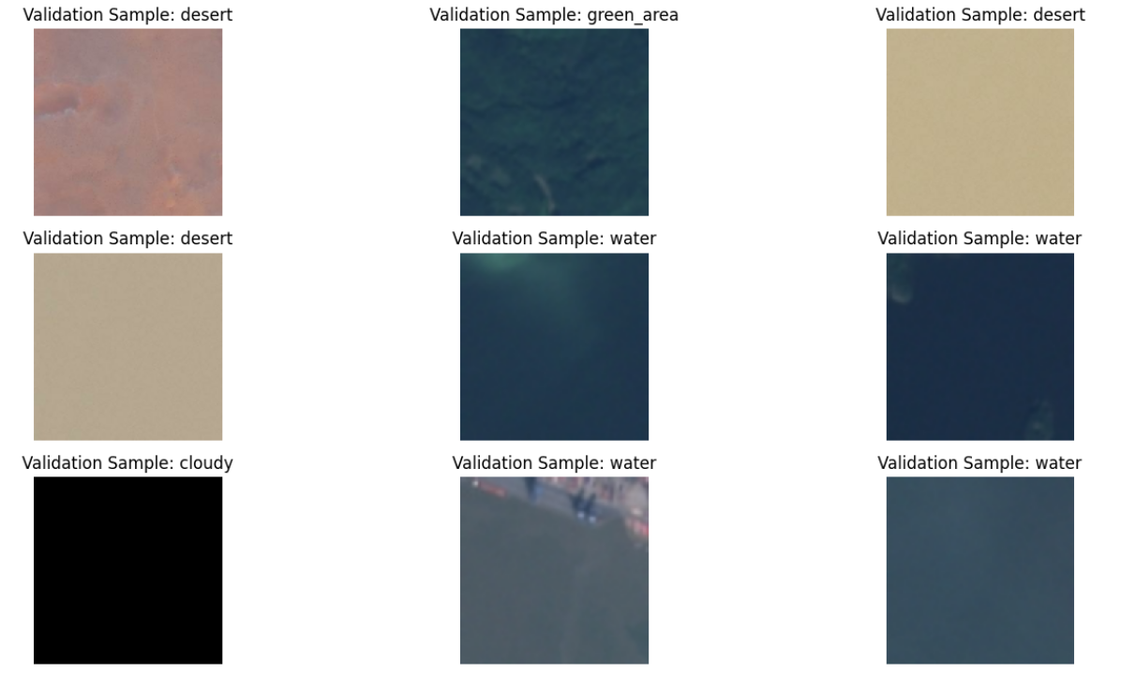**Final Result**

Fig 8.1 Final Processed Image Comparison

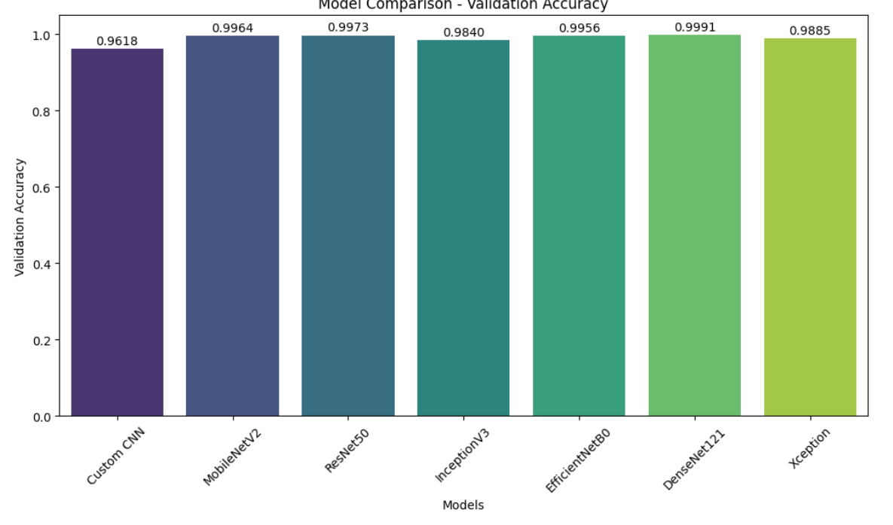

Fig 8.2 Model Comparisons

**CHAPTER 9: DELIVERABLES**

The following are the key deliverables for this project, outlining the outputs at each stage of development:

**1. Preprocessing and Data Preparation Deliverables**

* **Data Collection and Augmentation**: A comprehensive dataset of satellite images with labeled environmental categories such as clouds, deserts, green areas, and water bodies. The dataset should be augmented to include variations in image orientation, lighting, and other environmental factors to ensure robust model performance.
* **Data Preprocessing Pipeline**: A well-documented preprocessing pipeline that handles image resizing, normalization, and augmentation. This includes scripts or functions for preparing the data for input into the model.

**2. Model Development Deliverables**

* **Model Architectures**: A set of deep learning model architectures designed for satellite image classification, such as CNN-based models or transfer learning-based models like **VGG16**, **ResNet**, or **EfficientNet**.
* **Training Scripts**: Well-documented Python scripts that train the models on the prepared dataset, with clear instructions for configuring hyperparameters and running the training process.
* **Performance Metrics**: A detailed report comparing the performance of different models based on evaluation metrics such as **accuracy**, **precision**, **recall**, **F1-score**, and **confusion matrix**. The report will also highlight which model is best suited for deployment.

**3. Model Optimization and Export Deliverables**

* **Optimized Model**: The final model that has been optimized for deployment, including any applied techniques such as **quantization**, **pruning**, or **transfer learning**.
* **Model Serialization**: The trained model saved in a format suitable for deployment (e.g., **TensorFlow SavedModel**, **ONNX**, **Keras H5**).
* **Inference Code**: Python scripts or APIs for running inference using the trained and serialized model, making predictions on new satellite images.

**4. Web Application Deliverables**

* **Web Application Code**: A fully functional web application built using **Flask** or **Django**, allowing users to upload satellite images and get classification results. This includes both frontend (HTML, CSS, JavaScript) and backend (Python) code.
* **User Interface (UI)**: A user-friendly interface where users can upload images and view classification results. The interface may also include additional features like image visualization on a map.
* **API Documentation**: Documentation for any REST APIs developed for handling image uploads, inference requests, and interacting with the model.
* **Deployment Scripts**: Scripts or guidelines for deploying the web application and model on cloud platforms (e.g., **AWS**, **Google Cloud**, **Azure**) using services like **Docker**, **Kubernetes**, or serverless frameworks like **AWS Lambda**.

**5. Model Evaluation and Testing Deliverables**

* **Test Results**: Detailed results of model performance on a held-out test dataset, including quantitative metrics such as accuracy, precision, recall, and confusion matrix.
* **Error Analysis**: A report discussing the model's limitations and specific cases where the model fails, along with suggestions for further improvements.
* **Model Comparison**: A comparison of multiple models tested (if applicable), highlighting the strengths and weaknesses of each, and why the final model was chosen.

**6. Cloud Deployment and Scalability Deliverables**

* **Cloud Deployment Setup**: Complete setup for deploying the model and web application on cloud services, including configuration of **AWS EC2**, **Google Cloud Platform**, or **Azure**, and any associated services like **S3** for storage or **RDS** for databases.
* **Scalability and Optimization Plan**: A plan for scaling the application to handle multiple concurrent users, including cloud load balancing, containerization (Docker), and serverless computing (if applicable).

**7. Documentation and Reports Deliverables**

* **Project Documentation**: A comprehensive documentation package that includes the system architecture, model development process, and deployment steps. It should be clear and detailed for developers who will maintain or extend the system.
* **User Guide**: A user manual explaining how to interact with the web application, upload images, and interpret results. This will be valuable for end-users who may not have technical expertise.
* **Final Project Report**: A detailed final report summarizing the entire project from problem definition to deployment. It will cover the methodologies, results, challenges faced, and future work recommendations.

**8. Future Work and Extensions Deliverables**

* **Proposal for Future Enhancements**: A document outlining potential areas for improvement, including integrating **temporal satellite data**, **real-time processing**, **multispectral data**, and other advanced techniques.
* **Future Model Development Plan**: A roadmap for future model improvements, including fine-grained classification, the use of larger datasets, and integrating other types of satellite data for more detailed analysis.

**9. Deployment and Maintenance Deliverables**

* **Live Application**: A live version of the application accessible to users, deployed on a scalable cloud infrastructure.
* **Maintenance Plan**: A plan for maintaining the application, including monitoring for bugs, adding new features, and keeping the model updated with new data.

**Summary of Deliverables:**

* **Data Preprocessing**: Augmented satellite image dataset and preprocessing scripts.
* **Model Development**: Deep learning models, training scripts, and evaluation reports.
* **Optimization and Export**: Final optimized model and inference code.
* **Web Application**: Functional web application with a user interface, API, and deployment scripts.
* **Testing and Evaluation**: Model performance test results and error analysis.
* **Cloud Deployment**: Cloud deployment setup, scalability, and optimization plan.
* **Documentation**: Comprehensive project documentation, user guide, and final report.
* **Future Work**: Proposals for future enhancements and model development.

These deliverables ensure the project is fully developed, deployable, and ready for future improvements.

**REFERENCES**

[1] Khatami, R., & Dey, N. (2021). "Deep Learning for Remote Sensing Image Classification: A Survey," *Remote Sensing*, 13(18), 1-18.

[2] Zhang, Z., & Yang, X. (2018). "A Deep Convolutional Neural Network for Satellite Image Classification," *International Journal of Remote Sensing*, 39(4), 1261-1281.

[3] Zhang, L., & Liu, Z. (2019). "Application of Convolutional Neural Networks for Land Use/ Land Cover Classification with High-Resolution Satellite Imagery," *Journal of Applied Remote Sensing*, 13(6), 1-14.

[4] Akhtar, N., & Choi, S. (2020). "Satellite Image Classification using Deep Learning: A Review," *Journal of Spatial Science*, 65(2), 187-202.

[5] Aygun, A., & Yılmaz, A. (2021). "Satellite Image Classification Using Deep Neural Networks for Environmental Monitoring," *Environmental Monitoring and Assessment*, 193(4), 236.

[6] Nascimento, M., & Júnior, A. (2022). "Application of Pre-trained Deep Learning Models for Satellite Image Classification: A Case Study on Environmental Analysis," *ISPRS Journal of Photogrammetry and Remote Sensing*, 179, 21-32.

[7] Salehahmadi, Z., & Rasti, B. (2019). "Classification of Satellite Imagery Using Deep Learning Models for Land-Cover Mapping," *IEEE Transactions on Geoscience and Remote Sensing*, 57(10), 7614-7625.