**Database: ServerEquipmentStatistic**

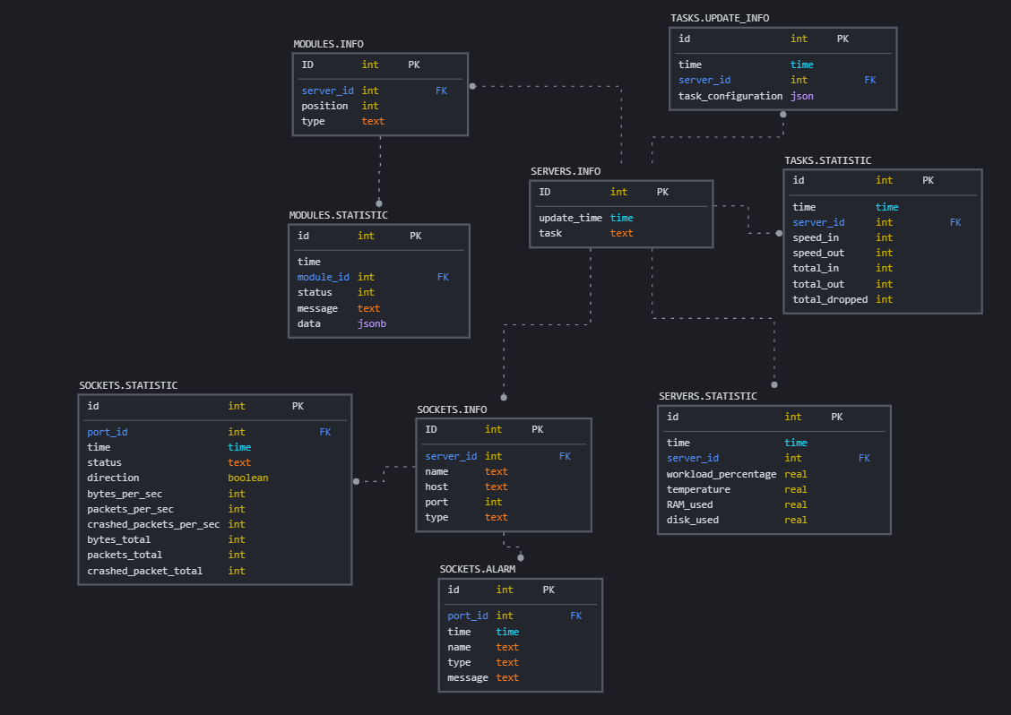

**Table** SERVERS.INFO

Information about servers

Cardinality: One-to-many

Columns (3)

|  |  |  |  |  |
| --- | --- | --- | --- | --- |
| № | Name | Type | Description | Logical constrains |
| 1 | ID (PK) | int | Server ID | NOT NULL |
| 2 | update_time | time | Time of task updating |
| 3 | task | text | Task description |

**Table**: SERVERS.STATISTIC

Statistic of servers

Cardinality: Many-to-one

Columns (7)

|  |  |  |  |  |
| --- | --- | --- | --- | --- |
| № | Name | Type | Description | Logical constrains |
| 1 | id (PK) | int | Record id | surrogate |
| 2 | time | time | Time of record | NOT NULL |
| 3 | server_id (FK) | int | Server ID |  |
| 4 | workload_percentage | real | Workload | >= 0 |
| 5 | temperature | real | Server temperature |  |
| 6 | RAM_used | real | Used RAM (bytes) | >= 0 |
| 7 | disk_used | real | Used disk memory (bytes) | >= 0 |

**Table**: TASKS.UPDATE_INFO

Statistic of tasks updating

Cardinality: Many-to-one

Columns (4)

|  |  |  |  |  |
| --- | --- | --- | --- | --- |
| № | Name | Type | Description | Logical constrains |
| 1 | id (PK) | int | Record id | surrogate |
| 2 | time | time | Time of record |  |
| 3 | server_id (FK) | int | Server ID |  |
| 4 | task_configuration | json | Task configuration | NOT NULL |

**Table**: TASKS.STATISTIC

Statistic of tasks

Cardinality: Many-to-one

Columns (8)

|  |  |  |  |  |
| --- | --- | --- | --- | --- |
| № | Name | Type | Description | Logical constrains |
| 1 | ID (PK) | int | Socket ID | surrogate |
| 2 | time | time | Time of record |  |
| 3 | server_id (FK) | int | Server ID |  |
| 4 | speed_in | int | Speed of data receiving (bytes/sec) | >= 0 |
| 5 | speed_out | int | Speed of data sending (bytes/sec) | >= 0 |
| 6 | total_in | int | All bytes has been received | >= 0 |
| 7 | total_out | int | All bytes has been sending | >= 0 |
| 8 | total_dropped | int | All bytes has been dropped | >= 0 |

**Table**: MODULES.INFO

Information about tasks modules

Cardinality: One-to-many

Columns (4)

|  |  |  |  |  |
| --- | --- | --- | --- | --- |
| № | Name | Type | Description |  |
| 1 | ID | int | Module ID |  |
| 2 | server_id | int | Server ID |  |
| 3 | position | int | Module position in task |  |
| 4 | type | text | Type of module |  |

Indexes: server_id, type, server_id-type – User needs data about servers modules. There are many modules for each server, and amount of reading operation is expected to be less than writing.

**Table**: MODULES.STATISTIC

Modules statistic

Cardinality: Many-to-one

|  |  |  |  |
| --- | --- | --- | --- |
| № | Name | Type | Description |
| 1 | id | int | Record id |
| 2 | time | time | Time of record |
| 3 | server_id | int | Server ID |
| 4 | status | int | Module status |
| 5 | message | text | Message from module |
| 6 | data | jsonb | Module statistic |

**Table**: SOCKETS.INFO

Information about sockets

Cardinality: One-to-many

Columns (5)

|  |  |  |  |
| --- | --- | --- | --- |
| № | Name | Type | Description |
| 1 | ID | int | Socket ID |
| 2 | server_id | int | Server ID |
| 3 | name | text | Name of socket |
| 4 | host | text | Host of socket |
| 5 | port | int | Port of socket |
| 6 | type | text | Type of socket |

Indexes:

* server_id – User needs data about sockets, which is used by each server. Amount of reading operation is expected to be less than writing.
* Type – It will be helpful, if it needs get ports by type.

**Table**: SOCKET.STATISTIC

Sockets statistic

Cardinality: Many-to-one

Columns (11)

|  |  |  |  |
| --- | --- | --- | --- |
| № | Name | Type | Description |
| 1 | ID | int | Socket ID |
| 2 | port_id | int | Pot ID |
| 3 | time | time | Time of record |
| 4 | status | text | Port status |
| 5 | direction | Boolean | 0 – in / 1 – out |
| 6 | bytes_per_second | int | Bytes amount per second |
| 7 | packate_per_sec | int | Packets amount per second |
| 8 | crashed_packet_per_sec | int | Crashed packets amount per second |
| 9 | bytes_total | int | Bytes amount during the work |
| 10 | packets_total | int | Packets amount during the work |
| 11 | crashed_packed_total | int | Crashed packets amount during the work |

**Table**: SOCKETS.ALARM

Cardinality: Many-to-one

Statistic of socket alarms

|  |  |  |  |
| --- | --- | --- | --- |
| № | Name | Type | Description |
| 1 | ID | int | Socket ID |
| 2 | port_id | int | Pot ID |
| 3 | time | time | Time of record |
| 4 | name | text | Alarm name |
| 5 | type | text | Alarm type |
| 6 | message | text | Alarm text |

Indexes: port_id – This table stories data about alarms from all sockets. It need to get information about separate sockets. Amount of reading operation is expected to be less than writing.