Assignment No:2
Name: Prutha Ranjit Sawale
Class: CS(AI)- B
Roll no.: 18
PRN: 12310272

Title: Setting up small wireless computer network and hands-on networking command
Problem Statement: Set up a small wired network of 2 to 4 computers using access point and ask students to access it on their wireless gadgets. Hands on for network commands - ping, pathping, ipconfig/ifconfig, arp, netstat, nbtstat, nslookup, route, traceroute/tracert, nmap.
Course Objective: To learn transmission mediums, networking devices and topologies used in the Internet.
Course Outcome: Select topology, essential components of physical layer and networking devices to design computer networks.
Tools Required: Access point, Personal Computer/Laptop with wireless connectivity.
Theory:
1. Access Point (AP)
An Access Point (AP) is a networking hardware device that allows wireless devices to connect to a wired network using Wi-Fi or related standards. It acts as a bridge between wireless clients (like laptops, smartphones, tablets) and the wired LAN (Local Area Network).

1.1 Key Functions of Access Point:
- Wireless Connectivity: Enables wireless communication within a local area by transmitting and receiving wireless signals.
- Data Bridging: Connects wireless clients to a wired Ethernet network.
- Network Extension: Extends the range of a wired network to accommodate mobile devices.
- Authentication and Security: Supports security protocols like WPA2/WPA3 to protect the wireless network from unauthorized access.
- Traffic Management: Manages wireless traffic by distributing bandwidth among multiple clients.

1.2 Working of an Access Point:
- The AP connects to a router or switch via an Ethernet cable.
- It broadcasts a wireless signal (SSID – Service Set Identifier).
- Wireless devices detect this signal and connect using proper credentials.
- The AP forwards the wireless traffic to the router/switch, which then routes it to the Internet or local resources.

1.3 Advantages:
- Provides mobility to users within the network coverage area.
- Reduces cabling costs.
- Easily scalable for more devices and larger areas.

1.4 Common Standards:
- IEEE 802.11 a/b/g/n/ac/ax (Wi-Fi standards)

2. Wireless Gadgets – Theory (for CN Subject)
Wireless gadgets are electronic devices that connect to a network or other devices without using physical cables, typically through Wi-Fi, Bluetooth, or cellular networks. These devices rely on wireless communication standards to exchange data, enabling mobility and ease of use.

2.1 Common Wireless Gadgets in Networking:
Gadget | Description
Smartphone | Mobile device with Wi-Fi and cellular connectivity for internet access and communication.
Laptop | Portable computer that connects wirelessly to a network via Wi-Fi.
Tablet | Touchscreen device, similar to a smartphone, used for internet access, reading, and multimedia.
Smart TV | Television that connects to the internet via Wi-Fi to stream online content.
Wi-Fi Printer | Printer that connects to devices over a wireless network, allowing remote printing.
Smartwatch | Wearable device that connects via Bluetooth or Wi-Fi for syncing with phones and receiving notifications.
IoT Devices | Gadgets like smart bulbs, thermostats, or security cameras that operate wirelessly over a home or office network.
Wireless Headphones | Use Bluetooth to connect to computers or phones for audio communication.

2.2 Wireless Technologies Used:
- Wi-Fi (IEEE 802.11) – For connecting to wireless LANs.
- Bluetooth – For short-range device-to-device communication.
- Cellular (3G/4G/5G) – For wide-area network access using SIM-enabled devices.
- Zigbee/Z-Wave – For smart home and IoT connectivity.

2.3 Advantages of Wireless Gadgets:
- Mobility – Use anywhere within signal range.
- Ease of Use – No cables required.
- Flexibility – Easily connect and disconnect.
- Portability – Lightweight and travel-friendly.

3. Networking Commands:
3.1 tracert: The traceroute command (or tracert on Windows) is used to track the path that a packet takes from your computer to a destination (like google.com). It helps in understanding network hops and identifying latency or failure points in a network.
Linux/macOS
traceroute google.com
Windows
tracert google.com
Tracing route to google.com [2404:6800:4009:812::200e]
over a maximum of 30 hops:
1 2 ms 2 ms 2 ms 2401:4900:52fb:51a0::16
…….

What It Shows
Each line in the output tells:
- The hop number (router in the path)
- The IP address (and domain if resolved)
- Response times for three packets (in milliseconds)
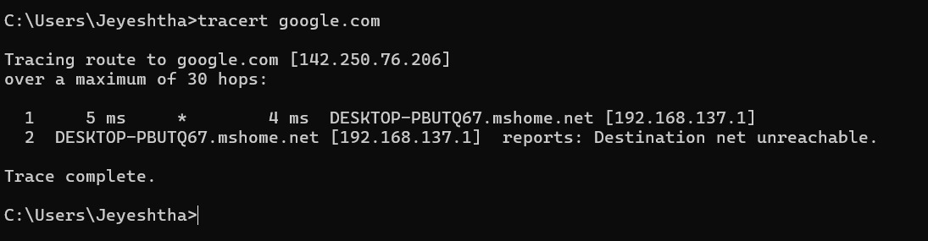

3.2 pathping: The pathping command is a Windows network diagnostic tool that combines the features of ping and tracert. It provides detailed information about the route and packet loss between your computer and a destination (like a website or IP address).
pathping www.google.com
Tracing route to google.com [2404:6800:4009:830::200e]
over a maximum of 30 hops:
0 LAPTOP-1HQO4D8I [2409:4042:4e15:34a8:b9ca:4b52:7ba6:1d63]
1 jiofi.local.html [2409:4042:4e15:34a8:cc3:4945:643d:9c0d]
2 * * *
Computing statistics for 25 seconds...
Source to Here This Node/Link
Hop RTT Lost/Sent = Pct Lost/Sent = Pct Address
0 LAPTOP-1HQO4D8I [2409:4042:4e15:34a8:b9ca:4b52:7ba6:1d63]
1/ 100 = 1% |
1 6ms 1/ 100 = 1% 0/ 100 = 0% jiofi.local.html [2409:4042:4e15:34a8:cc3:4945:643d:9c0d]

Trace complete.
What pathping Does
- Traces the route your packets take to the destination (like tracert).
- Pings each hop (router) multiple times to measure:
  - Latency (delay)
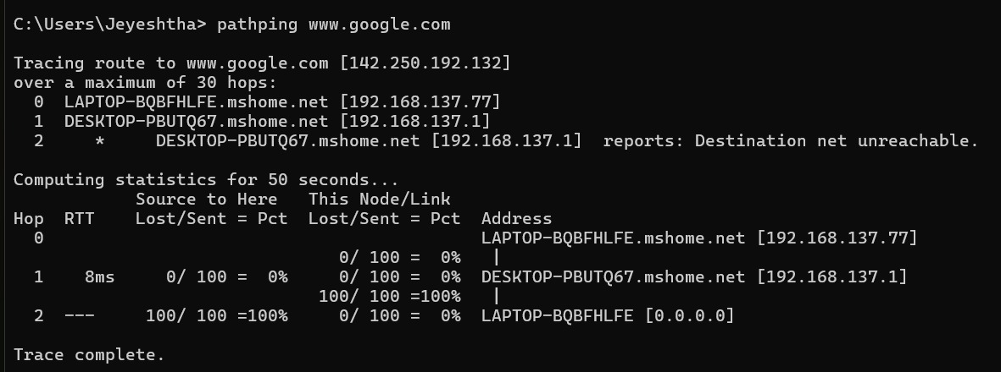
  - Packet loss at each hop

3.3 ipconfig: The ipconfig command is used in Windows to view and manage your network configuration details. "ipconfig helps users find out their current IP configuration.
ipconfig
Ethernet adapter Ethernet:

Connection-specific DNS Suffix . :
Link-local IPv6 Address . . . . . : fe80::5e7f:98ff:fe20:7c3a%5
IPv4 Address. . . . . . . . . . . : 192.168.1.5
Subnet Mask . . . . . . . . . . . : 255.255.255.0
Default Gateway . . . . . . . . . : 192.168.1.1

- ipconfig /all → Shows detailed info, including DNS, MAC address, DHCP server.
- ipconfig /release → Releases current IP address.
- ipconfig /renew → Requests a new IP from the DHCP server.

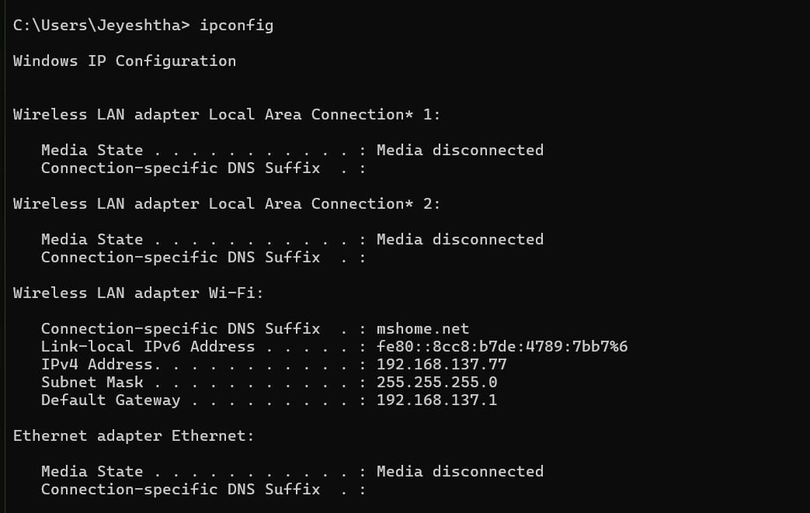

3.4 arp: The arp command in Windows is used to view and manage the Address Resolution Protocol (ARP) cache, which maps IP addresses to MAC (hardware) addresses on your local network.
arp -a
Interface: 192.168.225.138 --- 0xe
Internet Address Physical Address Type
169.254.169.254 fa-69-9c-67-91-2d dynamic
192.168.225.1 fa-69-9c-67-91-2d dynamic
192.168.225.255 ff-ff-ff-ff-ff-ff static
224.0.0.2 01-00-5e-00-00-02 static
224.0.0.22 01-00-5e-00-00-16 static
224.0.0.251 01-00-5e-00-00-fb static
224.0.0.252 01-00-5e-00-00-fc static
239.255.255.250 01-00-5e-7f-ff-fa static
255.255.255.255 ff-ff-ff-ff-ff-ff static

Useful Commands:
Command | Description
arp -a | View ARP table
arp -d <ip> | Delete an ARP entry (e.g., arp -d 192.168.1.1)
arp -s <ip> <mac> | Manually add a static ARP entry
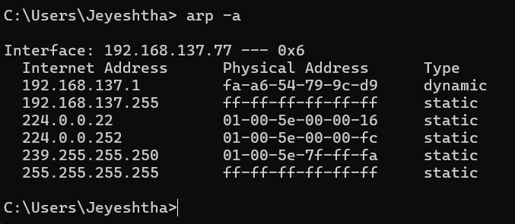

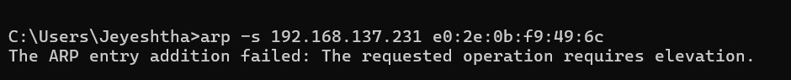

3.5 netstat: The netstat (Network Statistics) command is used to display network connections, routing tables, interface statistics, and port usage on your computer.
Netstat -a
Active Connections

Proto Local Address Foreign Address State

TCP 127.0.0.1:2030 LAPTOP-1HQO4D8I:0 LISTENING
TCP 127.0.0.1:5500 LAPTOP-1HQO4D8I:0 LISTENING
TCP 127.0.0.1:27017 LAPTOP-1HQO4D8I:0 LISTENING
TCP 127.0.0.1:49682 LAPTOP-1HQO4D8I:49683 ESTABLISHED
TCP 192.168.225.138:61634 23.100.109.78:https ESTABLISHED
TCP 192.168.225.138:63985 www:https CLOSE_WAIT
TCP 192.168.225.138:64202 download:http CLOSE_WAIT
TCP [2409:4042:4e15:34a8:b9ca:4b52:7ba6:1d63]:49921 whatsapp-chatd-edge6-shv-02-pnq1:5222 ESTABLISHED

Useful Options (Windows):
Command | Description
netstat -a | Show all active connections and listening ports
netstat -n | Show addresses and ports in numeric format (IP instead of hostname)
netstat -o | Show connections with Process ID (PID)
netstat -b | Show which executable (program) is using each connection
netstat -an | Combine -a and -n for detailed info
netstat -r | Show the routing table (like route print)
netstat -e | Show Ethernet statistics

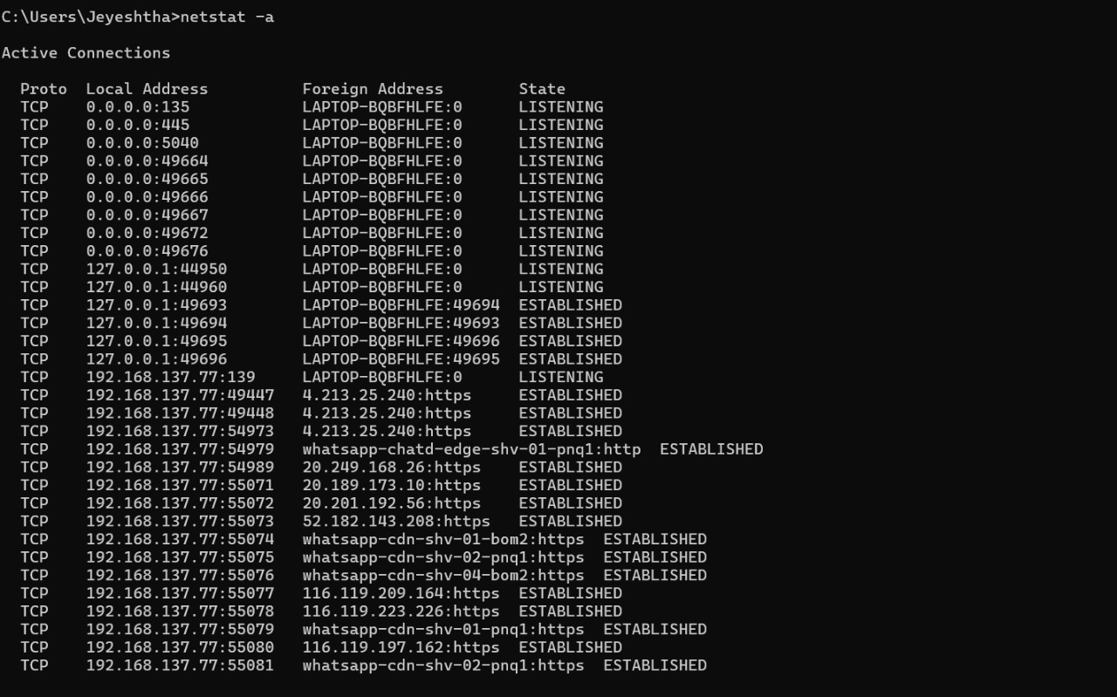

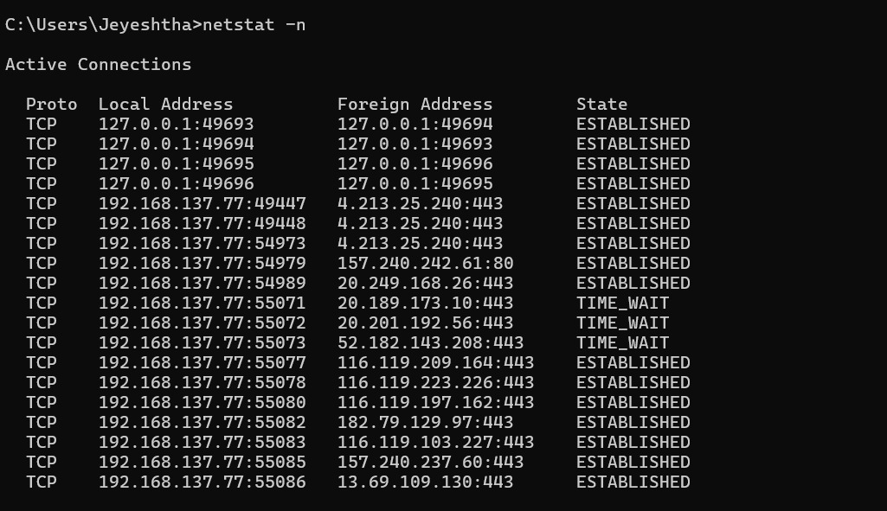

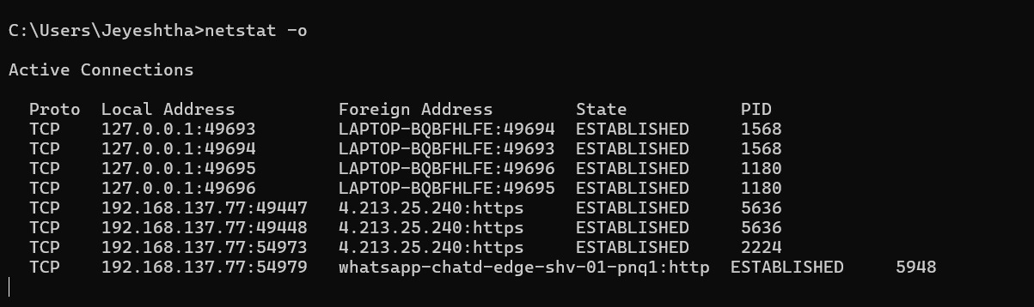

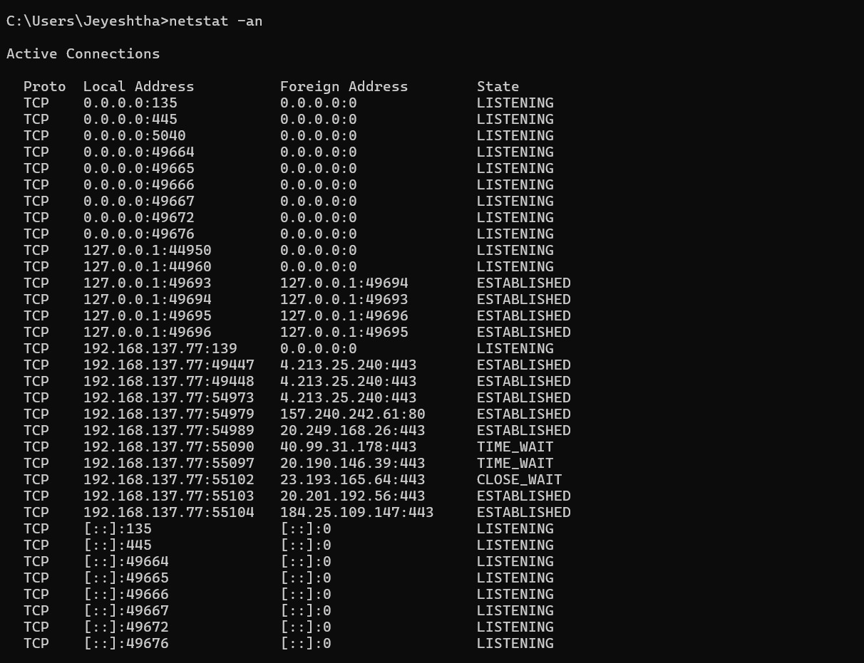

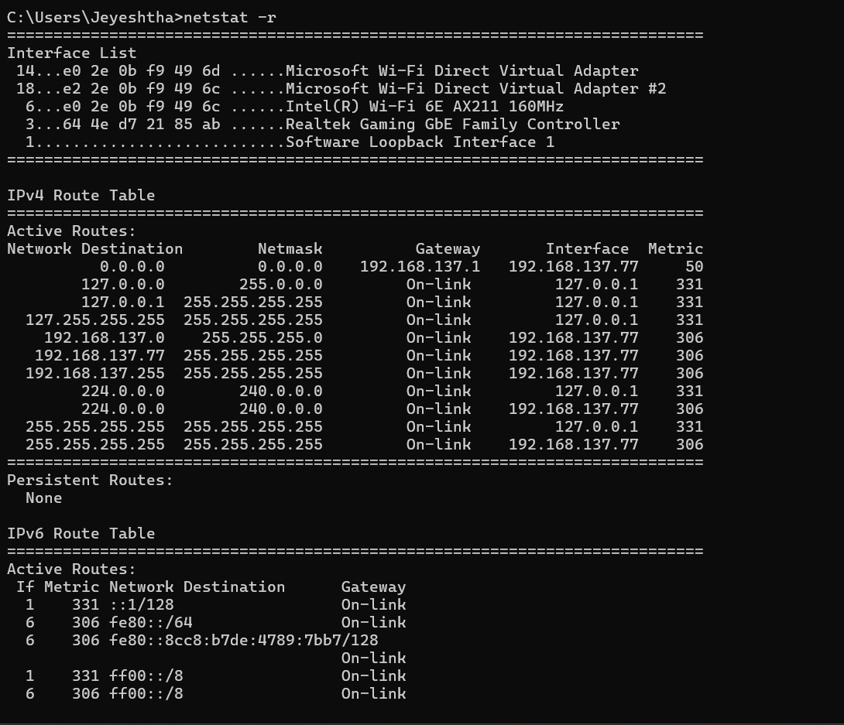

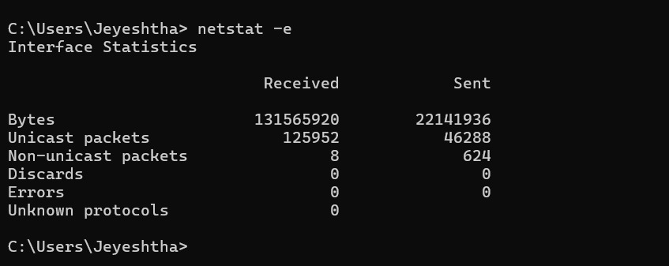
3.6 nbtstat: The nbtstat command is used to troubleshoot NetBIOS name resolution issues in Windows systems. It displays NetBIOS over TCP/IP (NetBT) protocol statistics, name tables, and name caches.
nbtstat -n
Bluetooth Network Connection:
Node IpAddress: [0.0.0.0] Scope Id: []

No names in cache

Wi-Fi:
Node IpAddress: [192.168.203.185] Scope Id: []

NetBIOS Local Name Table

Name Type Status
---------------------------------------------
LAPTOP-1HQO4D8I<20> UNIQUE Registered
LAPTOP-1HQO4D8I<00> UNIQUE Registered
WORKGROUP <00> GROUP Registered

Local Area Connection* 1:
Node IpAddress: [0.0.0.0] Scope Id: []

No names in cache

Local Area Connection* 2:
Node IpAddress: [0.0.0.0] Scope Id: []

No names in cache

Useful Options:
Command | Description
nbtstat -n | Shows local NetBIOS names and their status
nbtstat -c | Displays the NetBIOS name cache (recently resolved names)
nbtstat -R | Clears the NetBIOS name cache
nbtstat -r | Lists names resolved by broadcast and WINS
nbtstat -S | Shows NetBIOS sessions with IP addresses
nbtstat -a <hostname> | Displays NetBIOS table of a remote computer by hostname
nbtstat -A <IP> | Displays NetBIOS table of a remote computer by IP address

3.7 nslookup: The nslookup command is used to query DNS (Domain Name System) servers and obtain domain name or IP address mapping information.
nslookup google.com
Server: UnKnown
Address: 192.168.203.48

Non-authoritative answer:
Name: google.com
Addresses: 2404:6800:4009:812::200e
142.250.67.174

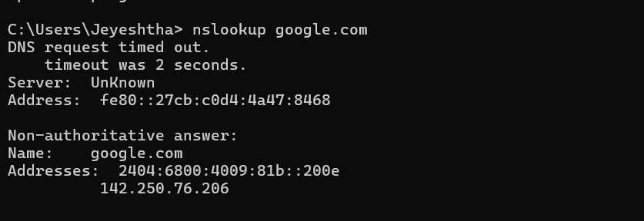
3.8 route: The route command is used to view, add, delete, or modify entries in the IP routing table on your system. It shows how packets are forwarded when sent across networks.
route print
===================================================================
Interface List
16...a0 e7 0b 36 79 79 ......Microsoft Wi-Fi Direct Virtual Adapter #3
18...a2 e7 0b 36 79 78 ......Microsoft Wi-Fi Direct Virtual Adapter #4
14...a0 e7 0b 36 79 78 ......Intel(R) Wireless-AC 9560
5...a0 e7 0b 36 79 7c ......Bluetooth Device (Personal Area Network)
1...........................Software Loopback Interface 1
===================================================================
IPv4 Route Table
===================================================================
Active Routes:
Network Destination Netmask Gateway Interface Metric
0.0.0.0 0.0.0.0 192.168.203.48 192.168.203.185 50
127.0.0.0 255.0.0.0 On-link 127.0.0.1 331
127.0.0.1 255.255.255.255 On-link 127.0.0.1 331
…….

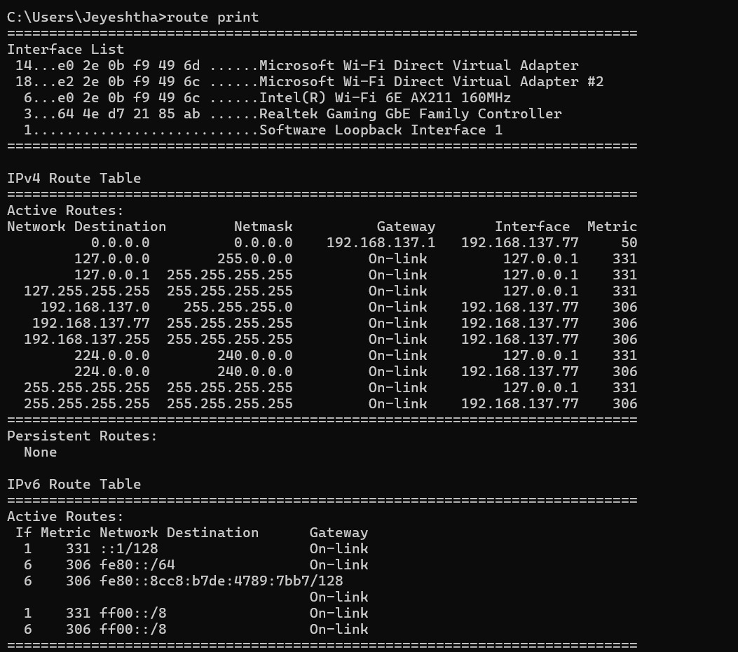
3.9 nmap: nmap is a powerful open-source tool used for network discovery, security auditing, and port scanning. It’s widely used by system administrators and cybersecurity professionals.

- Scan a single IP:
nmap 192.168.0.1
- Scan a range of IPs:
nmap 192.168.0.1-10
- Scan a subnet:
nmap 192.168.0.0/24
- Scan for open ports and services:
nmap -sV 192.168.0.1
- Detect operating system:
nmap -O 192.168.0.1
- Aggressive scan (OS, services, traceroute, scripts):
nmap -A 192.168.0.1
- Scan top 100 ports:
nmap --top-ports 100 192.168.0.1

Conclusion: Hence, a small network we have successfully established using an access point, and relevant networking commands were executed effectively..

