CLASS ACTIVITY 20.07.26

1.
Python code :-
import pandas as pd
import matplotlib.pyplot as plt
import seaborn as sns
data = {
"Department": [
"Cardiology", "Neurology", "Pediatrics",
"Orthopedics", "Emergency"
],
"Admissions": [320, 250, 410, 290, 520]
}
df = pd.DataFrame(data)
print(df)
plt.figure(figsize=(7,5))
sns.barplot(x="Department", y="Admissions", data=df)
plt.title("Hospital Admissions by Department")
plt.xticks(rotation=20)
plt.show()
plt.figure(figsize=(5,5))
sns.boxplot(y=df["Admissions"])
plt.title("Admission Variability")
plt.show()
plt.figure(figsize=(6,4))
sns.histplot(df["Admissions"], bins=5, kde=True)
plt.title("Distribution of Admissions")
plt.show()
try:
import squarify

plt.figure(figsize=(7,5))
squarify.plot(
sizes=df["Admissions"],
label=df["Department"],
alpha=0.8
)
plt.title("Department Workload Treemap")
plt.axis("off")
plt.show()
except ImportError:
print("Install squarify using:")
print("pip install squarify")

Output:-
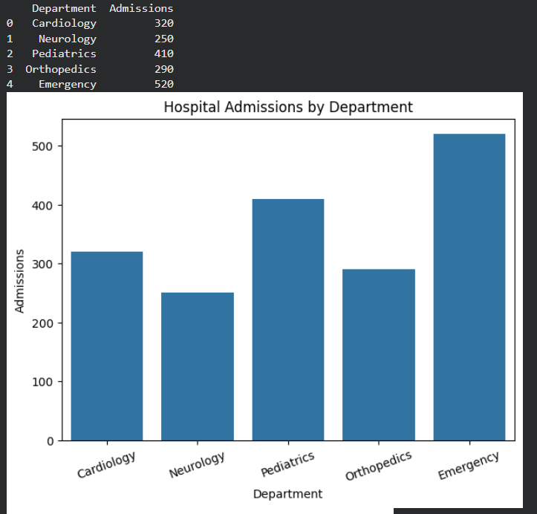
R-code:-
library(ggplot2)
library(dplyr)
hospital <- data.frame(
Department = c("Cardiology", "Neurology", "Pediatrics", "Orthopedics", "Emergency"),
Admissions = c(320, 250, 410, 290, 520)
)
print(hospital)
ggplot(hospital, aes(x = Department, y = Admissions, fill = Department)) +
geom_bar(stat = "identity") +
ggtitle("Hospital Admissions by Department") +
theme_minimal()
ggplot(hospital, aes(y = Admissions)) +
geom_boxplot(fill = "skyblue") +
ggtitle("Admission Variability") +
theme_minimal()
ggplot(hospital, aes(x = Admissions)) +
geom_histogram(binwidth = 50, fill = "steelblue", color = "black") +
ggtitle("Distribution of Admissions") +
theme_minimal()

Output:-
Department Admissions
1 Cardiology 320
2 Neurology 250
3 Pediatrics 410
4 Orthopedics 290
5 Emergency 520
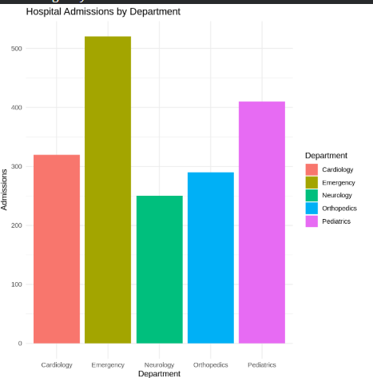
2.
Python code :-
import pandas as pd
import matplotlib.pyplot as plt
import seaborn as sns
data = {
"Customer": ["C1", "C2", "C3", "C4", "C5", "C6", "C7", "C8"],
"PurchaseAmount": [1200, 2500, 1800, 4200, 3100, 1500, 5000, 2700],
"OrderFrequency": [5, 8, 6, 12, 10, 4, 15, 7],
"Category": ["Electronics", "Fashion", "Electronics", "Home",
"Fashion", "Home", "Electronics", "Fashion"]
}

df = pd.DataFrame(data)
print(df)
plt.figure(figsize=(6,4))
sns.histplot(df["PurchaseAmount"], bins=5, kde=True, color="skyblue")
plt.title("Purchase Amount Distribution")
plt.xlabel("Purchase Amount")
plt.show()
plt.figure(figsize=(6,4))
sns.violinplot(y=df["PurchaseAmount"], color="lightgreen")
plt.title("Purchase Amount Violin Plot")
plt.show()
plt.figure(figsize=(6,4))
sns.boxplot(y=df["PurchaseAmount"], color="orange")
plt.title("Purchase Amount Box Plot")
plt.show()
plt.figure(figsize=(6,4))
sns.kdeplot(df["PurchaseAmount"], fill=True, color="red")
plt.title("Purchase Amount Density Plot")
plt.show()
plt.figure(figsize=(7,4))
sns.barplot(x="Category", y="PurchaseAmount", data=df, estimator=sum)
plt.title("Total Purchase Amount by Category")
plt.xlabel("Category")
plt.ylabel("Total Purchase Amount")
plt.show()

Output:-
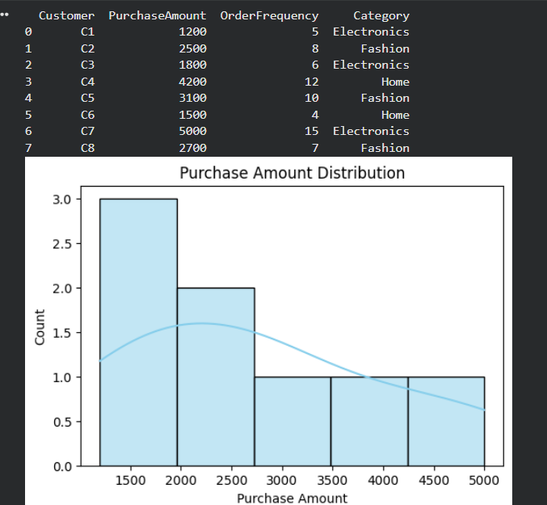

R-code :-
library(ggplot2)
library(dplyr)
customer <- data.frame(
Customer = c("C1","C2","C3","C4","C5","C6","C7","C8"),
PurchaseAmount = c(1200,2500,1800,4200,3100,1500,5000,2700),
OrderFrequency = c(5,8,6,12,10,4,15,7),
Category = c("Electronics","Fashion","Electronics","Home",
"Fashion","Home","Electronics","Fashion")
)
print(customer)
ggplot(customer, aes(x = PurchaseAmount)) +
geom_histogram(binwidth = 500, fill = "skyblue", color = "black") +
ggtitle("Purchase Amount Distribution") +
theme_minimal()
ggplot(customer, aes(x = "", y = PurchaseAmount)) +
geom_violin(fill = "lightgreen") +
ggtitle("Purchase Amount Violin Plot") +
xlab("") +
theme_minimal()
ggplot(customer, aes(x = "", y = PurchaseAmount)) +
geom_boxplot(fill = "orange") +
ggtitle("Purchase Amount Box Plot") +
xlab("") +
theme_minimal()
ggplot(customer, aes(x = PurchaseAmount)) +
geom_density(fill = "pink", alpha = 0.5) +
ggtitle("Purchase Amount Density Plot") +
theme_minimal()
ggplot(customer, aes(x = Category, y = PurchaseAmount, fill = Category)) +
stat_summary(fun = sum, geom = "bar") +
ggtitle("Total Purchase Amount by Category") +
theme_minimal()

Output:-
Customer PurchaseAmount OrderFrequency Category
1 C1 1200 5 Electronics
2 C2 2500 8 Fashion
3 C3 1800 6 Electronics
4 C4 4200 12 Home
5 C5 3100 10 Fashion
6 C6 1500 4 Home
7 C7 5000 15 Electronics
8 C8 2700 7 Fashion

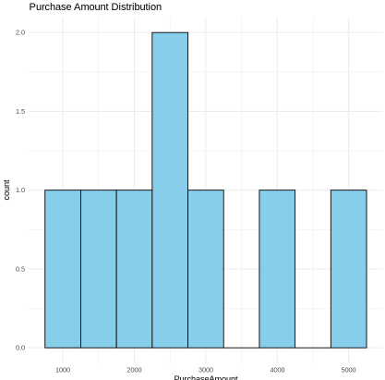
3.
Python code :-
import pandas as pd
import matplotlib.pyplot as plt
import seaborn as sns

data = {
"Department": ["CSE", "CSE", "AI&DS", "AI&DS", "ECE", "ECE", "MECH", "MECH"],
"Student": ["S1", "S2", "S3", "S4", "S5", "S6", "S7", "S8"],
"Marks": [92, 85, 78, 95, 88, 72, 80, 90]
}

df = pd.DataFrame(data)
print(df)
plt.figure(figsize=(7,5))
sns.barplot(x="Department", y="Marks", data=df, estimator="mean")
plt.title("Average Marks by Department")
plt.xlabel("Department")
plt.ylabel("Average Marks")
plt.show()
plt.figure(figsize=(7,5))
sns.boxplot(x="Department", y="Marks", data=df)
plt.title("Marks Distribution by Department")
plt.show()
plt.figure(figsize=(6,4))
sns.histplot(df["Marks"], bins=5, kde=True, color="skyblue")
plt.title("Distribution of Student Marks")
plt.xlabel("Marks")
plt.show()
plt.figure(figsize=(7,5))
sns.scatterplot(x="Department", y="Marks", hue="Department", s=100, data=df)
plt.title("Student Marks by Department")
plt.show()
pivot = df.pivot_table(values="Marks", index="Department", aggfunc="mean")
plt.figure(figsize=(5,4))
sns.heatmap(pivot, annot=True, cmap="YlGnBu")
plt.title("Average Marks Heatmap")
plt.show()

Output:-
Department Student Marks
0 CSE S1 92
1 CSE S2 85
2 AI&DS S3 78
3 AI&DS S4 95
4 ECE S5 88
5 ECE S6 72
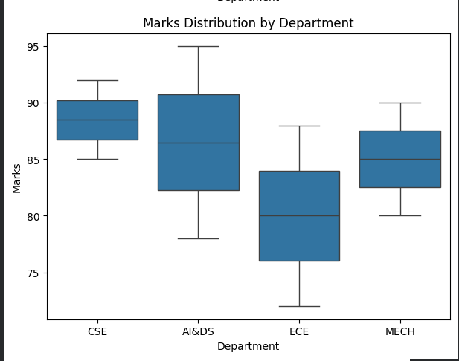
R code :-

library(ggplot2)
library(dplyr)
students <- data.frame(
Department = c("CSE","CSE","AI&DS","AI&DS","ECE","ECE","MECH","MECH"),
Student = c("S1","S2","S3","S4","S5","S6","S7","S8"),
Marks = c(92,85,78,95,88,72,80,90)
)
print(students)
ggplot(students, aes(x = Department, y = Marks, fill = Department)) +
stat_summary(fun = mean, geom = "bar") +
ggtitle("Average Marks by Department") +
theme_minimal()
ggplot(students, aes(x = Department, y = Marks, fill = Department)) +
geom_boxplot() +
ggtitle("Marks Distribution by Department") +
theme_minimal()
ggplot(students, aes(x = Marks)) +
geom_histogram(binwidth = 5, fill = "skyblue", color = "black") +
ggtitle("Distribution of Student Marks") +
theme_minimal()
ggplot(students, aes(x = Department, y = Marks, color = Department)) +
geom_point(size = 4) +
ggtitle("Student Marks by Department") +
theme_minimal()
avg_marks <- students %>%
group_by(Department) %>%
summarise(Average_Marks = mean(Marks))

ggplot(avg_marks, aes(x = "Average", y = Department, fill = Average_Marks)) +
geom_tile() +
geom_text(aes(label = round(Average_Marks, 1)), color = "white", size = 5) +
ggtitle("Average Marks Heatmap") +
theme_minimal()
Output:-
Department Student Marks
1 CSE S1 92
2 CSE S2 85
3 AI&DS S3 78
4 AI&DS S4 95
5 ECE S5 88
6 ECE S6 72
7 MECH S7 80
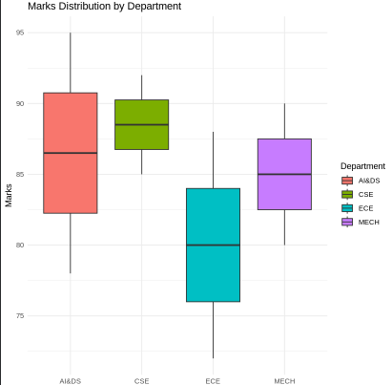

4.
Python code :-
import pandas as pd
import matplotlib.pyplot as plt
import seaborn as sns
data = {
"City": ["Chennai", "Coimbatore", "Madurai", "Salem",
"Trichy", "Chennai", "Coimbatore", "Madurai"],
"Rainfall": [120, 95, 80, 110, 90, 140, 100, 85],
"Temperature": [34, 30, 36, 33, 35, 32, 29, 37],
"Humidity": [78, 70, 65, 72, 68, 82, 74, 63]
}
df = pd.DataFrame(data)
print(df)
plt.figure(figsize=(6,4))
sns.histplot(df["Rainfall"], bins=5, kde=True, color="skyblue")
plt.title("Rainfall Distribution")
plt.xlabel("Rainfall (mm)")
plt.show()
plt.figure(figsize=(6,4))
sns.kdeplot(df["Rainfall"], fill=True, color="green")
plt.title("Rainfall Density Plot")
plt.xlabel("Rainfall (mm)")
plt.show()
plt.figure(figsize=(6,4))
sns.boxplot(y=df["Rainfall"], color="orange")
plt.title("Rainfall Box Plot")
plt.ylabel("Rainfall (mm)")
plt.show()
plt.figure(figsize=(7,5))
sns.barplot(x="City", y="Rainfall", data=df, estimator="mean")
plt.title("Average Rainfall by City")
plt.xlabel("City")
plt.ylabel("Average Rainfall (mm)")
plt.show()

Output:-
City Rainfall Temperature Humidity
0 Chennai 120 34 78
1 Coimbatore 95 30 70
2 Madurai 80 36 65
3 Salem 110 33 72
4 Trichy 90 35 68
5 Chennai 140 32 82
6 Coimbatore 100 29 74
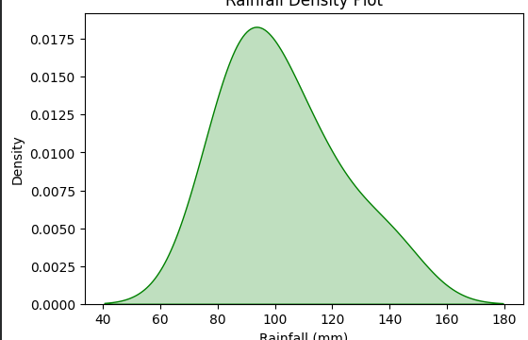

R-code :-
# Load Libraries
library(ggplot2)
library(dplyr)

# Create Dataset
climate <- data.frame(
City = c("Chennai", "Coimbatore", "Madurai", "Salem",
"Trichy", "Chennai", "Coimbatore", "Madurai"),
Rainfall = c(120, 95, 80, 110, 90, 140, 100, 85),
Temperature = c(34, 30, 36, 33, 35, 32, 29, 37),
Humidity = c(78, 70, 65, 72, 68, 82, 74, 63)
)

# Display Dataset
print(climate)

# -------------------------
# 1. Histogram
# -------------------------
ggplot(climate, aes(x = Rainfall)) +
geom_histogram(binwidth = 10, fill = "skyblue", color = "black") +
ggtitle("Rainfall Distribution") +
theme_minimal()

# -------------------------
# 2. Density Plot
# -------------------------
ggplot(climate, aes(x = Rainfall)) +
geom_density(fill = "lightgreen", alpha = 0.5) +
ggtitle("Rainfall Density Plot") +
theme_minimal()

# -------------------------
# 3. Box Plot
# -------------------------
ggplot(climate, aes(y = Rainfall)) +
geom_boxplot(fill = "orange") +
ggtitle("Rainfall Box Plot") +
theme_minimal()

# -------------------------
# 4. Bar Chart
# -------------------------
ggplot(climate, aes(x = City, y = Rainfall, fill = City)) +
stat_summary(fun = mean, geom = "bar") +
ggtitle("Average Rainfall by City") +
theme_minimal()

Output:-
City Rainfall Temperature Humidity
1 Chennai 120 34 78
2 Coimbatore 95 30 70
3 Madurai 80 36 65
4 Salem 110 33 72
5 Trichy 90 35 68
6 Chennai 140 32 82
7 Coimbatore 100 29 74
8 Madurai 85 37 63
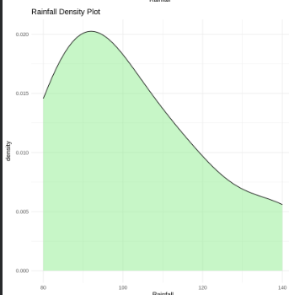

5.
Python code :-
import pandas as pd
import matplotlib.pyplot as plt
import seaborn as sns

# Create Dataset
data = {
"Customer": ["C1", "C2", "C3", "C4", "C5", "C6", "C7", "C8"],
"LoanAmount": [50000, 120000, 80000, 150000, 95000, 60000, 180000, 110000],
"Income": [30000, 55000, 40000, 70000, 50000, 35000, 80000, 60000],
"CreditScore": [720, 680, 750, 650, 710, 730, 620, 690],
"Repayment": ["Good", "Average", "Good", "Poor", "Good", "Good", "Poor", "Average"]
}

df = pd.DataFrame(data)

print(df)

# -------------------------
# 1. Histogram
# -------------------------
plt.figure(figsize=(6,4))
sns.histplot(df["LoanAmount"], bins=5, kde=True, color="skyblue")
plt.title("Loan Amount Distribution")
plt.xlabel("Loan Amount")
plt.show()

# -------------------------
# 2. Box Plot
# -------------------------
plt.figure(figsize=(6,4))
sns.boxplot(y=df["LoanAmount"], color="orange")
plt.title("Loan Amount Box Plot")
plt.ylabel("Loan Amount")
plt.show()

# -------------------------
# 3. Scatter Plot
# -------------------------
plt.figure(figsize=(7,5))
sns.scatterplot(x="Income", y="LoanAmount", hue="Repayment", s=100, data=df)
plt.title("Income vs Loan Amount")
plt.show()

# -------------------------
# 4. Bar Chart
# -------------------------
plt.figure(figsize=(6,4))
sns.barplot(x="Repayment", y="LoanAmount", data=df, estimator="mean")
plt.title("Average Loan Amount by Repayment Status")
plt.show()

# -------------------------
# 5. Credit Score Distribution
# -------------------------
plt.figure(figsize=(6,4))
sns.histplot(df["CreditScore"], bins=5, color="green", kde=True)
plt.title("Credit Score Distribution")
plt.xlabel("Credit Score")
plt.show()

Output :-
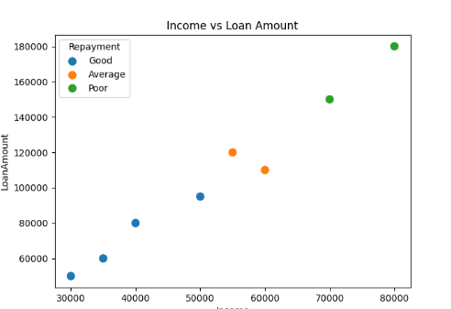
R-code:-
# Load Libraries
library(ggplot2)
library(dplyr)

# Create Dataset
loan <- data.frame(
Customer = c("C1","C2","C3","C4","C5","C6","C7","C8"),
LoanAmount = c(50000,120000,80000,150000,95000,60000,180000,110000),
Income = c(30000,55000,40000,70000,50000,35000,80000,60000),
CreditScore = c(720,680,750,650,710,730,620,690),
Repayment = c("Good","Average","Good","Poor","Good","Good","Poor","Average")
)

# Display Dataset
print(loan)

# -------------------------
# 1. Histogram
# -------------------------
ggplot(loan, aes(x = LoanAmount)) +
geom_histogram(binwidth = 25000, fill = "skyblue", color = "black") +
ggtitle("Loan Amount Distribution") +
theme_minimal()

# -------------------------
# 2. Box Plot
# -------------------------
ggplot(loan, aes(y = LoanAmount)) +
geom_boxplot(fill = "orange") +
ggtitle("Loan Amount Box Plot") +
theme_minimal()

# -------------------------
# 3. Scatter Plot
# -------------------------
ggplot(loan, aes(x = Income, y = LoanAmount, color = Repayment)) +
geom_point(size = 4) +
ggtitle("Income vs Loan Amount") +
theme_minimal()

# -------------------------
# 4. Bar Chart
# -------------------------
ggplot(loan, aes(x = Repayment, y = LoanAmount, fill = Repayment)) +
stat_summary(fun = mean, geom = "bar") +
ggtitle("Average Loan Amount by Repayment Status") +
theme_minimal()

# -------------------------
# 5. Credit Score Distribution
# -------------------------
ggplot(loan, aes(x = CreditScore)) +
geom_histogram(binwidth = 20, fill = "lightgreen", color = "black") +
ggtitle("Credit Score Distribution") +
theme_minimal()
Output:-
