A
Project Report
On

SPI QUEST

Developed at

eSparkBiz Technologies

Developed by
KRUNAL DUDHATRA - Department of IT, DD University

Guided By

Internal Guide:  Prof. Deven Gol  Department of Information Technology  Faculty of Technology  DD University | External Guide:  Mr. Chintan Gor  Chief Technology Officer (CTO)  eSparkBiz Technologies  Ahmedabad



Department of Information Technology
Faculty of Technology, Dharmsinh Desai University
Collage Road, Nadiad-387001
March-2026
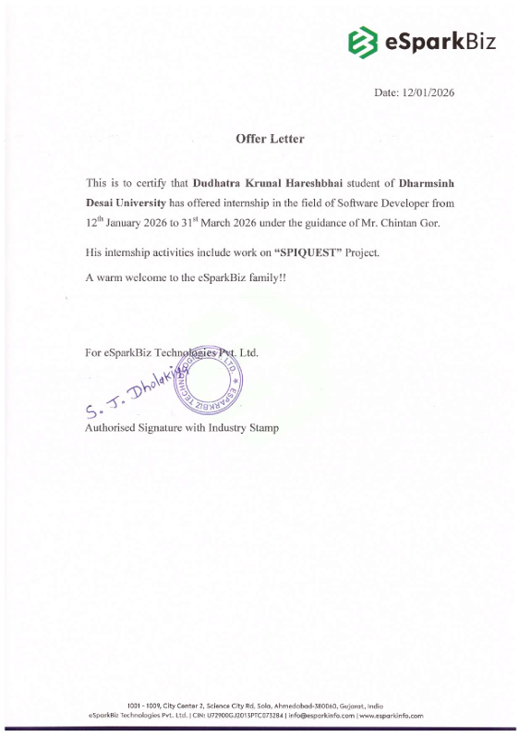

CANDIDATE'S DECLARATION

I declare that final semester report entitled "SPI QUEST" is my own work conducted under the supervision of the external guide Mr. Chintan Gor from eSparkBiz Technologies.
I further declare that to the best of my knowledge the report for B.Tech. final semester does not contain part of the work which has been submitted for the award of B.Tech. Degree either in this or any other university without proper citation.

Candidate's Signature:

Candidate's Name: Krunal Dudhatra
Branch: IT026
Student ID: 22ITUOS117

DHARMSINH DESAI UNIVERSITY
NADIAD-387001, GUJARAT



CERTIFICATE

This is to certify that the project entitled "SPI QUEST" is a bonafide report of the work carried out by Mr. Krunal Dudhatra, Student ID No: 22ITUOS117 of Department of Information Technology, semester VIII, under the guidance and supervision for the award of the degree of Bachelor of Technology at Dharmsinh Desai University, Nadiad. (Gujarat). He was involved in Project training during the academic year 2025-2026.

Prof. Deven Gol
(Project Guide)
Department of Information Technology,
Faculty of Technology,
Dharmsinh Desai University, Nadiad
Date:

Prof. (Dr.) V. K. Dabhi
Head, Department of Information Technology,
Faculty of Technology,
Dharmsinh Desai University, Nadiad
Date:

ACKNOWLEDGEMENT

The success and final outcome of this project required a lot of guidance from many people, and I am extremely fortunate to have received such support throughout the completion of my project work. Whatever I have accomplished is only due to this guidance and assistance, and I will always be grateful for it.
I feel very fortunate to have had the opportunity to pursuing on my Bachelor of Technology (Information Technology) at DDU, and be able to complete the project "SPI QUEST" as part of my final semester internship training.
I sincerely thankful Prof. (Dr.) V. K. Dabhi (Head, Department of Information Technology) and Prof. Deven Gol (Assistant Prof, Department of IT) for their constructive thoughts and vision, which contributed to the successful completion of this project.
I am also highly grateful to Mr. Chintan Gor (CTO) for his kind support, encouragement, and motivation throughout this challenging task.
My heartfelt appreciation also goes to my colleagues who provided valuable insights and assistance during the development of this project. Lastly, I express my deep gratitude to my family members and friends, who have been a constant source of inspiration and support throughout this journey.

With sincere regards,
Krunal Dudhatra

TABLE OF CONTENT

ABSTRACT……………………………………………………………………………… i
COMPANY PROFILE…………………………………………………………………. ii
LIST OF FIGURES……………………………………………………………………. iii
LIST OF TABLES……………………………………………………………………... iv
CHAPTER 0: TRAINING TAKEN AT INDUSTRY………………………………… 1
CHAPTER 1: INTRODUCTION……………………………………………………… 3
1.1 Project Details………………………………………………………………………. 3
1.2 Purpose……………………………………………………………………………… 3
1.3 Scope………………………………………………………………………………... 3
1.4 Objective……………………………………………………………………………. 4
1.5 Technology…………………………………………………………………………. 4
CHAPTER 2: PROJECT MANAGEMENT………………………………………….. 5
2.1. Feasibility Study…………………………………………………………………… 5
2.1.1 Technical feasibility……………………………………………………………. 5
2.1.2 Time schedule feasibility……………………………………………………….. 5
2.1.3 Operational feasibility………………………………………………………….. 5
2.1.4 Implementation feasibility……………………………………………………… 5
2.2. Project Planning……………………………………………………………………. 6
2.2.1. Project Development Approach and Justification……………………………… 6
2.2.2. Group Dependencies…………………………………………………………… 7
2.2.3. Project Scheduling……………………………………………………………... 7
CHAPTER 3: SYSTEM REQUERMENTS STUDY…………………………………. 9
3.1 Study of Current System……………………………………………………………. 9
3.2 Problems and Weaknesses of Current System……………………………………… 9
3.3 User Characteristics………………………………………………………………… 9
3.4 Hardware and Software Requirements……………………………………………. 10
3.5 Constraints………………………………………………………………………… 11
3.3.1 Hardware Limitations…………………………………………………………. 11
3.3.2 Reliability Requirements……………………………………………………… 11
3.6 Assumptions and Dependencies…………………………………………………... 11
CHAPTER 4: SYSTEM ANALYSIS…………………………………………………. 12
4.1 Requirements of New System…………………………………………………….. 12
4.1.1 Functional requirements………………………………………………………. 12
4.1.2 Non-Functional requirements…………………………………………………. 13
4.2 Use-case diagram………………………………………………………………….. 14
4.3 Class diagram……………………………………………………………………… 15
4.4 Flow Chart………………………………………………………………………… 16
CHAPTER 5: SYSTEM DESIGN……………………………………………………. 17
5.1 System Architacture………………………………………………………………. 17
5.2 Dataflow diagram…………………………………………………………………. 18
CHAPTER 6: IMPLEMENTATION PLANNING…………………………………. 21
6.1 Implementation Environment……………………………………………………... 21
6.2 Program/Modules Specification………………………………………………….. 21
6.3 Coding Standards…………………………………………………………………. 23
CHAPTER 7: TESTING………………………………………………………………. 24
7.1 Testing Plan………………………………………………………………………. 24
7.2 Testing Strategy…………………………………………………………………… 24
7.3 Test Cases - SPI Calculator…………………………………...…………………… 24
7.4 Test Cases - CPI Calculator ……………………………………………………….26
7.5 Test Cases - Admin Panel………………………………………………………….26
CHAPTER 8: USER MANUAL……………………………………………………… 28
CHAPTER 9: LIMITATION AND FURTURE ENHANCEMENT………………. 36
9.1 Limitation……………………………………………………………………….....36
9.2 Future Enhancement………………………………………………………………36
CHAPTER 10: CONCLUSION AND DISCUSS……………………………………..37
10.1 Conclusion………………………………………………………………...……..37
10.2 Discussion………………………………………………………………………..37
10.2.1 Problem Encountered……………………………………………………….37
10.2.2 Possible Solutions…………………………………………………………..37
10.2.3 Summery Of Project Work…………………………………………………38
CHAPTER 11: REFERENCES………………………………………………………. 39
CHAPTER 12: EXPERIENCE……………………………………………………….. 40

ABSTRACT

SPI-Quest is a full-stack web application developed to automate the calculation of Semester Performance Index (SPI) and Cumulative Performance Index (CPI) for students of Dharmsinh Desai University (DDU). The system eliminates the need for manual grade computation by providing an intelligent, accurate, and user-friendly platform.

The application allows students to select their branch and semester, enter subject-wise marks across components such as sessional, term-work, attendance, and external examinations, and instantly receive their computed SPI based on the university’s grading scheme. The CPI calculator further enables students to track their cumulative academic performance across multiple semesters.

From the administrative side, an authenticated admin panel allows management of branches, semesters, and subject data including subject codes, credits, and maximum marks for each component. The system enforces DDU’s official grade boundaries and FF (fail) rules, ensuring results that mirror the university’s actual marking scheme.

Built using the MERN stack (MongoDB, Express.js, React.js, Node.js) and developed during an internship at eSparkBiz Technologies Private Limited, SPI-Quest delivers a scalable, modular, and maintainable solution for academic performance tracking.

COMPANY PROFILE

Name: eSparkBiz Technologies

At eSparkBiz, our vision is to be a globally recognized software consulting and development company that provides innovative and high-quality solutions to empower businesses to scale and succeed in the digital era. We aim to lead the way in delivering transformative digital products that simplify complex business processes and enhance overall performance.
Our mission is to offer cost-effective, purpose-driven software solutions tailored to meet the unique needs of each client. We leverage cutting-edge technologies such as the MERN stack, Cloud Computing, and DevOps to create intelligent systems that optimize workflows and drive growth. By embracing a culture of continuous improvement and technical excellence, we ensure that our solutions not only solve today's challenges but also prepare businesses for future success.

Address:
422, Silver Radiance-2,
Opp. Empire Business Hub,
Science City Road, Sola, Ahmedabad,
Gujarat 380060, India
LIST OF FIGURES

Fig No. | Name |  | Page No.
Fig 4.1 | Use case diagram | 14
Fig 4.2 | Class diagram | 15
Fig 4.4 | Flow Chart | 16
Fig 5.1 | System Architacture | 17
Fig 5.2 | Dataflow diagram | 18

LIST OF TABLES

Table No. |  | Name |  |  |  | Page No.
 | Table 7.3 |  | SPI test case | 24
 | Table 7.4  Table 7.5 |  | CPI test case  Admin test case | 26  26

CHAPTER 0: TRAINING TAKEN AT INDUSTRY
The training program in the industry is structured to provide participants with a comprehensive foundation in software development and industry-standard practices. Participants delve into a range of topics, including logic building, programming fundamentals, object-oriented programming, and data structures, gaining practical experience in these areas. The curriculum also covers a diverse array of tools and technologies.
Through hands-on projects and interactive sessions, participants develop proficiency across various platforms and learn to apply their knowledge to real-world scenarios. Additionally, the program emphasizes the importance of collaboration, communication, and problem-solving skills, which are essential for navigating the challenges of software development projects. By fostering a learning environment that encourages continuous improvement and adaptation to emerging technologies, the training program aims to equip participants with the skills and mindset necessary for success in the dynamic field of software development.
During the training period at the industry, the focus was on developing comprehensive skills and knowledge in various areas of software development and system architecture. The scope included:
- Logic Building: Emphasizing problem-solving techniques and algorithmic thinking to address complex challenges efficiently.
- Object-Oriented Programming (OOP): Understanding the principles of OOP such as encapsulation, inheritance, and polymorphism, and applying them to design and develop modular and scalable software systems.
- C#: Acquiring knowledge of the C# programming language, known for its object-oriented features, strong typing, and versatility, and exploring its applications in desktop development and web applications.
- JavaScript: Gaining proficiency in JavaScript programming language, including its core features, asynchronous programming, and popular frameworks/libraries like Node.js and React.js for building dynamic web applications.
- MongoDB: Acquiring knowledge of MongoDB, a NoSQL database known for its flexibility, scalability, and document-oriented structure, and exploring its applications in modern web development and data-driven applications.
- React: Acquiring knowledge of React, a JavaScript library known for its component-based architecture, virtual DOM, and efficient UI rendering, and exploring its applications in building interactive and responsive web applications.
- Node.js: Acquiring knowledge of Node.js, a JavaScript runtime known for its non-blocking, event-driven architecture, and exploring its applications in building scalable server-side applications and APIs.
Overall, the training aimed to equip participants with a comprehensive understanding of software development concepts, tools, and technologies enabling them to contribute effectively to the development of robust and scalable software solutions.

CHAPTER 1: INTRODUCTION
1.1 Project Details
1.1 Project Details SPI-Quest is a full-stack web application built using the MERN stack (MongoDB, Express.js, React.js, Node.js) that automates SPI and CPI calculation for students at Dharmsinh Desai University. The project was developed during an internship at eSparkBiz Technologies Pvt. Ltd. under the mentorship of Mr. Chintan Gor.
The system supports multiple branches and semesters, with subject-level mark entry across sessional, term-work, attendance, and external components. The grading logic strictly follows DDU's official grading system, including FF rules for below-threshold performance in individual components.

1.2 Purpose
The primary goal of SPI-Quest is to provide students with an accurate, automated, and easy-to-use platform to calculate their SPI and CPI based on DDU's grading system. The system eliminates manual computation errors and saves time by automating grade and point calculations. It also provides administrative tools for managing branch, semester, and subject data.

1.3 Scope
The project adopts a modular approach with two core user roles — Student (calculator user) and Admin. The scope includes:
- SPI calculation for any branch, semester, and subject combination
- CPI calculation using per-semester SPI and credit data
- Admin panel for CRUD operations on branches, subjects, and semester assignments
- Real-time grade computation with DDU-compliant FF rule enforcement
- Expandable architecture to support additional universities in the future

1.4 Objective
The key objectives of SPI-Quest are:
- Provide students with an automated SPI/CPI calculator that mirrors DDU's official results
- Implement DDU's grading scheme including grade boundaries (AA, AB, BB, BC, CC, CD, FF) and fail conditions
- Enable admin users to manage branch and subject data through a secure admin panel
- Deliver a responsive, intuitive user interface accessible from any browser
- Ensure data integrity through a MongoDB-backed persistent database

1.5 Technology
A cutting-edge and reliable technological stack will be utilized by the hotel management system to guarantee optimum performance and scalability. Powered by Node.js, the server-side application will be built using the Express.js framework for backend development. The project's data will be effectively managed and stored in MongoDB, a NoSQL database. React, a powerful and dynamic library, will be used in the frontend development process to provide a user experience that is both responsive and easy to use.

CHAPTER 2: PROJECT MANAGEMENT
2.1 FEASIBILITY STUDY
2.1.1 Technical feasibility
From a technical standpoint, the MERN stack (MongoDB, Express.js, React.js, Node.js) is a well-proven, open-source technology stack that supports building scalable and maintainable web applications. All chosen technologies are freely available and well-documented. The development environment uses VS Code as the IDE, and MongoDB Atlas as the cloud database provider. All team members had fundamental understanding of the selected stack, making this project technically feasible.

2.1.2 Time schedule feasibility
The development was structured in a phased approach over approximately 15 weeks. Each phase was assigned a specific timeframe to allow for iterative development, testing, and refinement. Agile methodology was followed to accommodate changing requirements and ensure timely delivery.

2.1.3 Operational feasibility
The system is designed to be highly accessible, requiring only a web browser and internet connection to operate. There are no special hardware requirements beyond a standard computer or mobile device. The admin panel is secured with credential-based authentication, ensuring safe and authorized operations.

2.1.4 Implementation feasibility
The MERN stack ensures reliable and scalable implementation. The use of existing frameworks, libraries, and a NoSQL database simplifies development. The adoption of a modular MVC-inspired architecture improves code organization and maintainability, ensuring an efficient and structured system.

2.2 PROJECT PLANNING
2.2.1 Project Development Approach and Justification
We will follow the Agile development model for the development of the SPIQuest learning and performance analysis system. Agile methodology divides the development process into smaller iterations, allowing the team to continuously improve the system based on feedback and testing results.
This approach ensures flexibility, faster development cycles, and the ability to quickly adapt to changes in requirements. The project requirements and scope are defined at the beginning, while development progresses in iterative phases with clear objectives and deliverables.
The phases of the Agile model used in this project are as follows:
1. Requirement Gathering
In this phase, the system requirements are collected and analyzed. The goal is to understand the needs of students and administrators for tracking academic performance and SPI progression. Functional and non-functional requirements are identified and documented.
2. System Design
During this phase, the system architecture and database structure are designed. The design includes the user interface, data flow, and backend structure required to support student performance analysis and report generation.
3. Construction / Iteration
This phase involves the actual development of the system in multiple iterations. Each iteration focuses on implementing specific modules such as user management, performance tracking, and report generation.
4. Testing / Quality Assurance
In this phase, the developed modules are tested to ensure they function correctly and securely. Different testing methods such as unit testing and integration testing are performed to identify and fix errors.
5. Deployment
After successful testing, the system is deployed on the server so that users can access the SPIQuest platform.

2.2.2 Group Dependencies
Development Team:
- Responsible for implementing the system based on the finalized Software Requirements Specification (SRS).
- Collaborates with database designers to ensure efficient data storage and retrieval.
- Integrates necessary technologies such as Node.js, Express.js, MongoDB, and React for building the system.
Testing Team:
- Ensures that the developed modules work properly and meet the required performance standards.
- Coordinates with the development team to identify bugs.
- Focuses on improving system stability.

2.2.3 Project Scheduling
Initiation Phase (Week 1 – Week 2)
- Define project objectives and scope
- Identify system requirements
- Conduct feasibility analysis
- Form the project development team

Planning Phase (Week 3 – Week 4)
- Prepare the Software Requirements Specification (SRS)
- Design the database schema for students, courses, and performance records
- Plan system architecture and application flow

Development Phase (Week 5 – Week 10)
- Set up the development environment
- Implement MVC architecture
- Develop student registration and login module
- Implement student performance tracking system
- Develop lesson progress tracking
- Implement exam and assessment modules
- Generate SPI and performance reports

Testing Phase (Week 11 – Week 12)
- Conduct Unit Testing for individual modules
- Perform Integration Testing for system components
- Verify database operations and report generation
- Identify and fix system bugs

Deployment Phase (Week 13)
- Deploy the SPIQuest system on the server
- Perform final system testing
- Ensure the system runs smoothly in the production environment

Maintenance and Support (Future Scope)
- Provide ongoing system support
- Fix bugs and improve system performance
- Implement new features based on user feedback

CHAPTER 3: System Requirements Study
3.1 STUDY OF CURRENT SYSTEM
Prior to SPI-Quest, students at DDU had to manually calculate their SPI by gathering individual subject marks, looking up grade points from the grading chart, and performing weighted averages by hand. This process was error-prone, time-consuming, and lacked transparency. There was no centralized system for students to track their academic performance semester-by-semester.

3.2 PROBLEMS AND WEAKNESSES OF CURRENT SYSTEM
- Manual SPI calculation leads to frequent arithmetic errors
- Students lack awareness of the detailed DDU grading scheme and FF rules
- No automated way to track CPI across multiple semesters
- Administrative overhead for managing subject data per branch/semester
- Inconsistent understanding of mark components (sessional, term-work, external)

3.3 USER CHARACTERISTICS
There are 2 types of users in the system required:
Student:
- Select branch and semester
- Enter subject-wise marks (sessional, term-work, attendance, external)
- View computed grades, points, and SPI
- Use CPI calculator by inputting SPI per semester
- Edit and delete subject entries

Admin:
- Secure admin login with credential verification
- Create, update, and delete branch records
- Add, update, and delete subjects with codes, credits, and max marks
- Assign subjects to specific semesters within branches

3.4 HARDWARE AND SOFTWARE REQUIREMENTS
The SPIQuest system does not require any specialized hardware. It can run on a standard computer system with an internet connection and a modern web browser that supports web technologies such as Node.js, JavaScript, and React.

Hardware: -
- System: Intel Core i3 or above
- Hard Disk: Minimum 120 GB storage
- RAM: Minimum 4 GB
Software: -
- Operating System: Windows 7 or above / Linux
- Frontend Technologies: HTML, CSS, JavaScript, React
- Backend Technologies: Node.js, Express.js
- Database: MongoDB
- Browser: Google Chrome, Microsoft Edge, or any modern browser

3.5 CONSTRAINTS
3.5.1 Hardware Limitation
The SPIQuest system is a web-based application, therefore the device must have a web browser and internet connectivity to access the platform.

3.5.2 Reliability Requirement
The system requires reliable operation to ensure accurate tracking of student performance and SPI calculation. User data must be stored securely and accessed only by authorized users. Proper authentication and secure database operations are implemented to maintain data integrity and reliability.

3.6 ASSUMPTIONS AND DEPENDENCIES
- Users have access to a stable internet connection.
- The device used by the user has a modern web browser installed and functioning properly.
- The MongoDB database server is running correctly and providing accurate data retrieval and storage.
- The server hosting the application remains available and accessible during system usage.
- Users follow the defined system workflow for proper data entry and interaction.

CHAPTER 4: SYSTEM ANALYSIS
4.1 REQUIREMENTS OF NEW SYSTEM
4.1.1 Functional requirements
Student:
- Registration
Input: Guests enter their username, password, and personal details.
Output: Conformation of registration and redirection to the log in page.
Description: Guests need to register with basic details before making reservations.

- Login
Input: Username and password.
Output: Successful login confirmation or error message.
Description: Users enter their credentials to access the system securely.

- Select Branch and Semester
Input: Dropdown selection of available branches from the database.
Output: List of available semesters for the selected branch.
Description: Fetches branch data from the API and populates the semester dropdown accordingly.

- Enter Subject Marks
Input: Subject selection, sessional marks, term-work marks, attendance marks, external marks.
Output: Computed grade, grade points, and total marks for the subject.
Description: Validates marks against subject-specific maximums, computes percentage, and applies DDU grading logic.

- Calculate SPI
Input: All subject marks for a semester.
Output: Computed SPI value (weighted average of grade points).
Description: SPI = Sum(Credit x Grade Points) / Sum(Credits). Automatically recalculates when any mark is updated.

- Calculate CPI
Input: SPI and total credits per semester for multiple semesters.
Output: Computed CPI value.
Description: Sum(Semester Credits x SPI) / Sum(Semester Credits).

Admin:
- Admin Login: Credential-based authentication using email and password stored in environment variables.
- Branch Management: Create, update, and delete branch records with specified number of semesters.
- Subject Management: Create subjects with code, name, credit, and max marks for each component.
- Assign Subjects: Assign specific subjects to semesters within a branch.

4.1.2 Non-Functional requirements
- Reliability:
The grading system must produce results consistent with DDU's official computation. FF (fail) rules are strictly enforced: external marks below 35% of maximum, term-work below 35%, or sessional marks below 8 out of maximum all result in FF grade with 0 points.

- Performance:
SPI and CPI calculations are performed on the server side via REST API calls, ensuring consistent results across different devices. The system handles concurrent API requests efficiently using Node.js's non-blocking event loop.

- Security:
Admin authentication uses environment variable-based credential verification. The admin session state is stored in browser localStorage. Future enhancement: JWT-based authentication for improved security.

- Useability:
The interface provides a clear step-by-step flow: select branch → select semester → add subjects → view SPI. Inline editing and deletion of subjects is supported. A separate CPI tab allows multi-semester tracking.

4.2 USE-CASE DIAGRAM

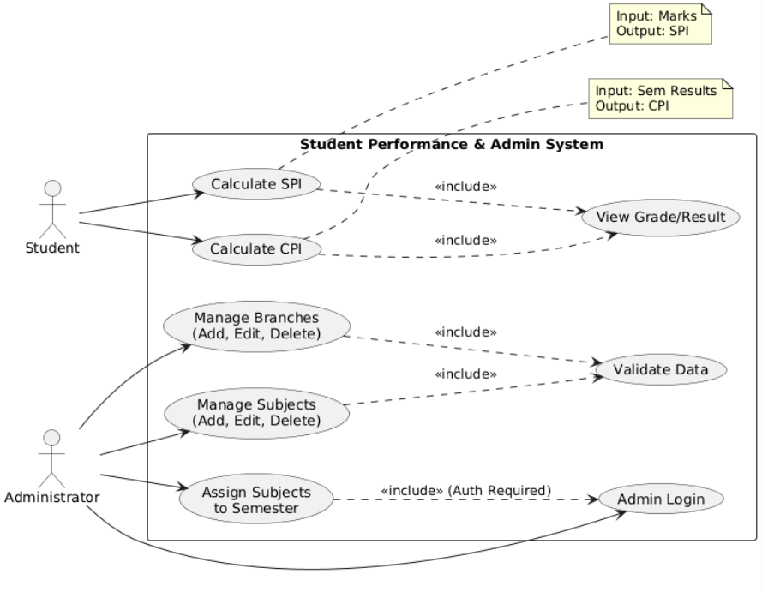
Fig 4.1-Use-Case Diagram

4.3 CLASS DIAGRAM

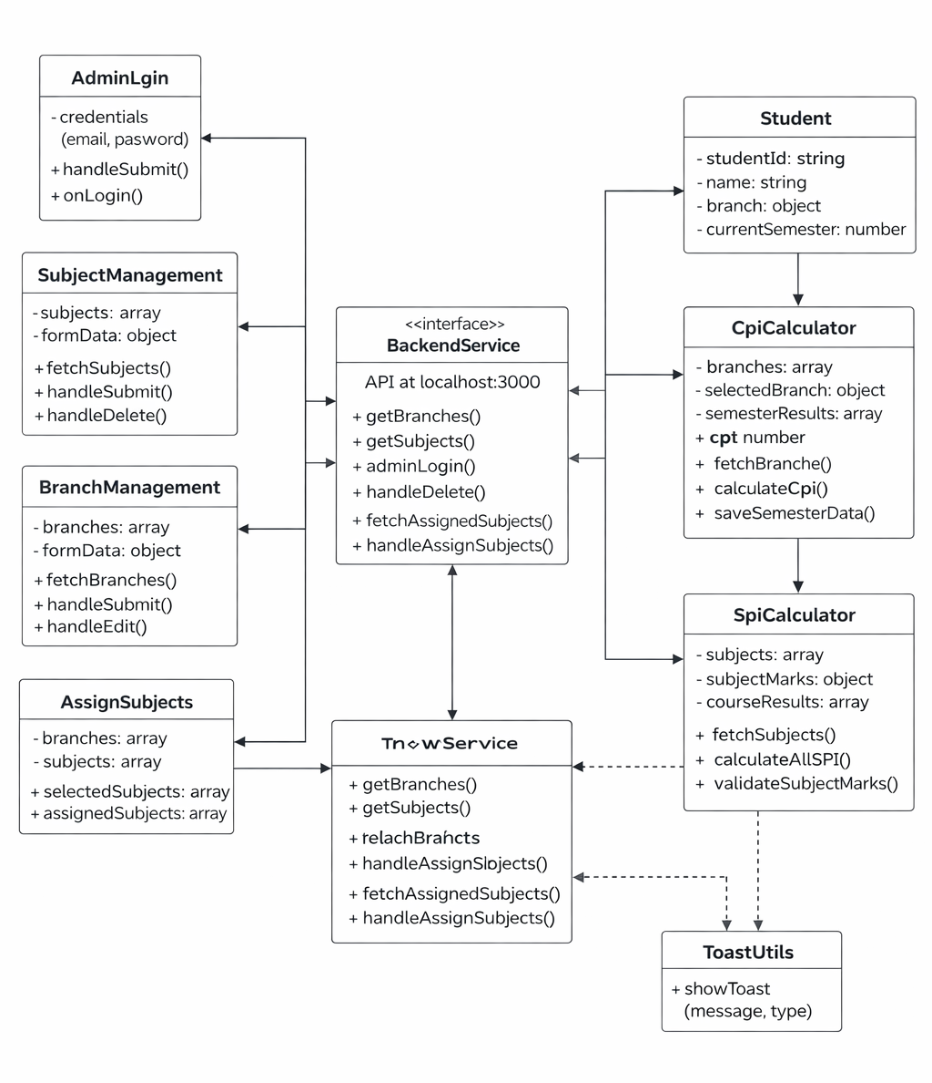

Fig 4.2-Class Diagram

4.4 FLOW-CHART

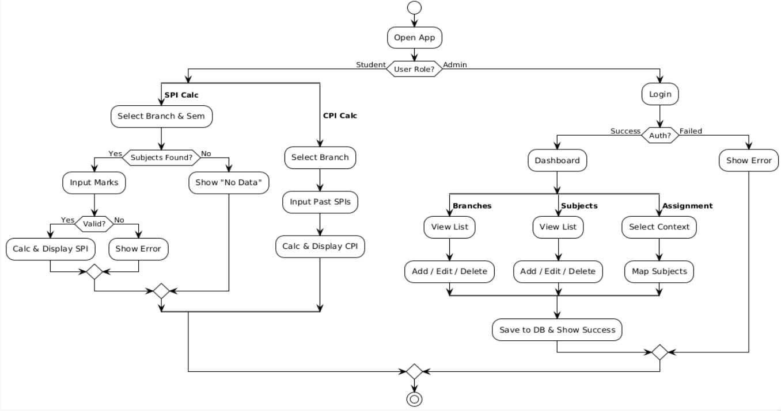
Fig 4.3-Flow Chart

CHAPTER 5: SYSTEM DESIGN
5.1 SYSTEM ARCHITACTURTE

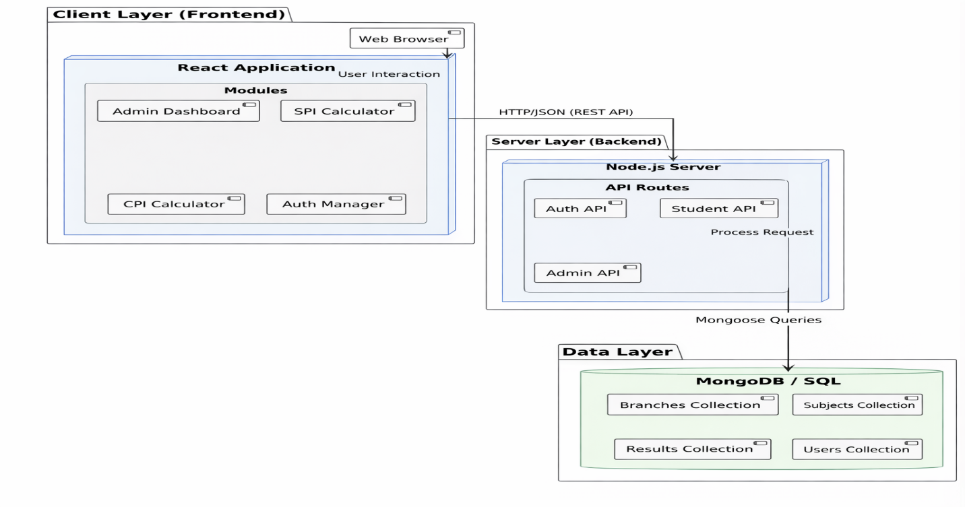
Fig 4.4-System Architacture

5.2 DATAFLOW DIAGRAM

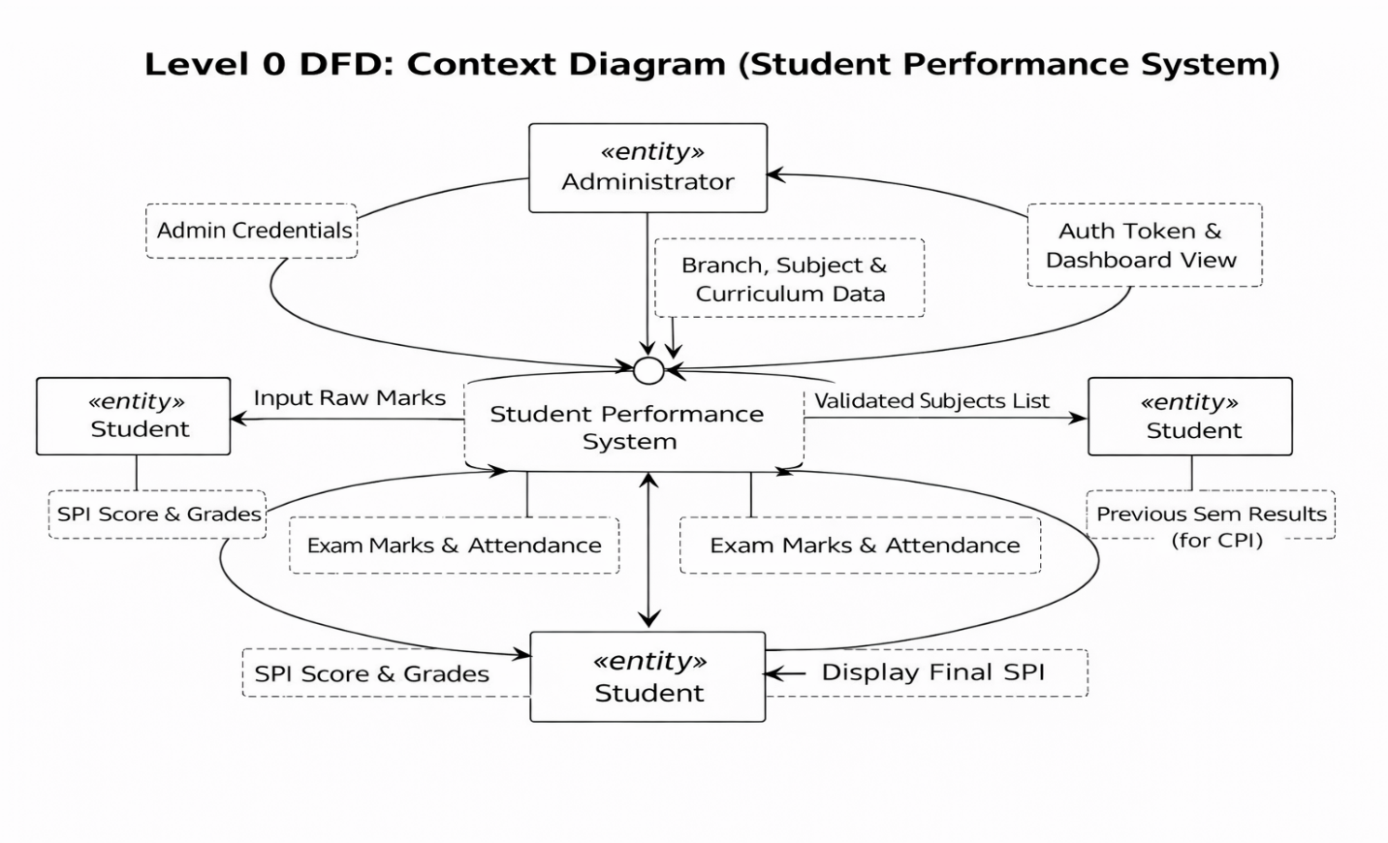

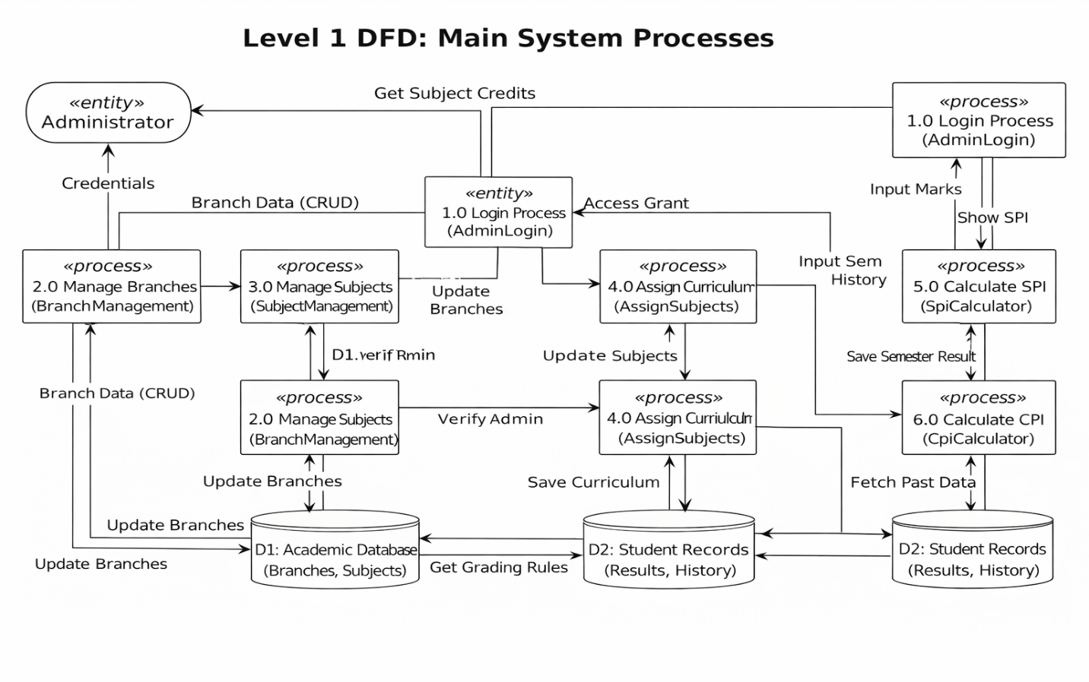

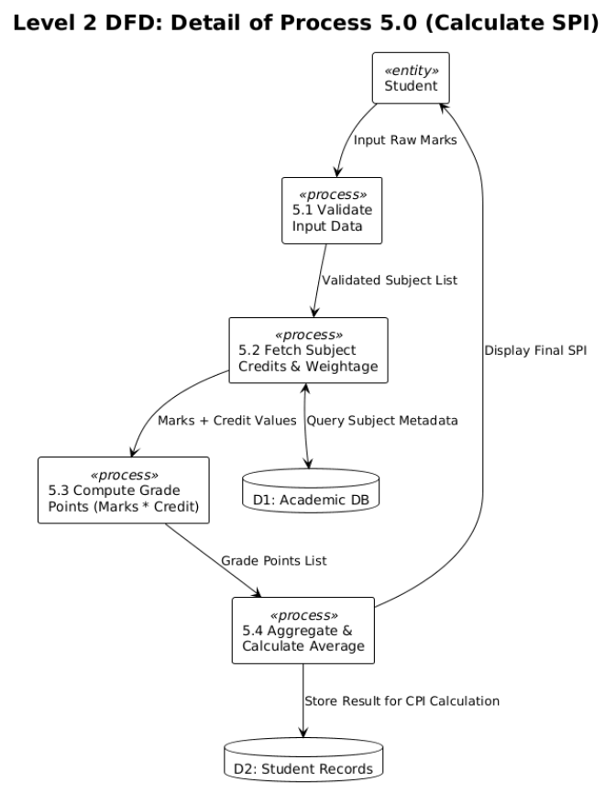

Fig 4.5-Dataflow diagram

CHAPTER 6: IMPLEMENTATION PLANNING
6.1 IMPLEMENTATION ENVIRONMENT
Single vs Multiuser:
- SPI-Quest is designed to handle multiple concurrent student users who can perform grade calculations simultaneously without interference.
- The admin panel remains a single-user interface restricted to authorized personnel via secure credential verification.
- Database concurrency is managed by MongoDB to ensure data integrity when multiple administrative changes occur.
GUI vs Non-GUI:
- The system is entirely GUI-based and accessible through any standard modern web browser.
- The React.js frontend provides a Single Page Application (SPA) experience, which eliminates page reloads during navigation.
- Navigation is structured using a tab-based system to separate the SPI calculator, CPI calculator, and Admin tools.
- The interface is built with responsive design principles to ensure usability on both desktop and mobile browsers.

6.2 PROGRAM/MODULES SPECIFICATION
SPI Calculation Module
- The core grading logic of the application is implemented within the spiCalculator.service.js file.
- This module computes the percentage achieved per subject and determines the final grade, ranging from AA to FF.
- It enforces university-specific fail conditions and returns a weighted SPI for the semester.

Grading Algorithm
- Percentage >= 84.5%: Grade AA, Points 10
- Percentage >= 74.5%: Grade AB, Points 9
- Percentage >= 64.5%: Grade BB, Points 8
- Percentage >= 54.5%: Grade BC, Points 7
- Percentage >= 44.5%: Grade CC, Points 6
- Percentage >= 39.5%: Grade CD, Points 5
- Below 39.5% or failure to meet specific conditions: Grade FF, Points 0

FF (Fail) Conditions
- External marks must be less than 35% of the maximum external marks to trigger an FF grade.
- Term-work marks must be less than 35% of the maximum term-work marks.
- Sessional marks must be less than 8 in absolute value, regardless of the percentage achieved.

CPI Calculation Module
- This module is contained in cpiCalculator.service.js and uses the formula: CPI = Sum(SPI_i * Credits_i) / Sum(Credits_i) across all semesters.
- It accepts an array of semester objects containing SPI and credit data and returns the final weighted CPI.

Branch Management Module
- This module handles CRUD operations for the Branch documents in the database.
- It supports creating new branches with a specified number of semesters and updating their structures.
- Subject assignments to specific semesters are managed using the SubjectData reference model.

Subject Management Module
- Manages all CRUD operations for the SubjectData documents.
- Each record stores the subject code, name, and total credit hours.
- It maintains the maximum possible marks for sessional, term-work, external, and attendance components.

6.3 CODING STANDARDS
- ES Module syntax (import/export) used throughout both frontend and backend
- camelCase naming for functions and variables
- Component-based architecture in React with single responsibility per component
- All API calls use async/await with try-catch error handling
- Environment variables used for all sensitive configuration (DB URI, admin credentials)
- Proper indentation and inline comments for complex logic sections

CHAPTER 7: TESTING
7.1 TESTING PLAN
Both White Box and Black Box testing approaches were employed for SPI-Quest. White Box testing was applied to the grading algorithm and SPI/CPI calculation logic since the internal workings are known and must produce mathematically precise results. Black Box testing was used for UI flows and API endpoint validation.

7.2 TESTING STRATEGY
Testing was carried out in a hierarchical manner across the following phases:
- Unit Testing: Individual functions including calculateSPI, calculateCPI, and calculateGradeAndPoints were tested with isolated inputs.
- Integration Testing: API endpoint integration with MongoDB was tested to ensure data flows correctly from frontend to backend to database.
- Usability Testing: The UI was tested for correct flow, responsive design, and error handling (invalid marks, missing fields).

7.3 Test Cases - SPI Calculator (User)

Test Case | Input | Expected Output | Result
Select Branch | Branch dropdown selection | Semesters populated for selected branch | Pass
Select Semester | Semester dropdown selection | Subjects list loaded for semester | Pass
Enter Valid Marks | Marks within component maxima | Grade and points computed correctly | Pass
SPI Calculation | All subject marks entered | Weighted SPI displayed accurately | Pass
FF Rule - External | External < 35% of max | Grade shows FF, Points = 0 | Pass
FF Rule - Termwork | Termwork < 35% of max | Grade shows FF, Points = 0 | Pass
FF Rule - Sessional | Sessional marks < 8 | Grade shows FF, Points = 0 | Pass
Edit Subject | Modify entered marks | Updated grade and SPI reflected | Pass
Delete Subject | Remove a subject entry | Subject removed, SPI recalculated | Pass
Show Details | Toggle details view | Full mark breakdown displayed | Pass

7.4 Test Cases - CPI Calculator

Test Case | Input | Expected Output | Result
Add Semester | SPI and credits for a semester | Semester added to list | Pass
CPI Calculation | Multiple semesters with SPI/credits | Weighted CPI computed correctly | Pass
Edit Semester | Modify SPI or credits | CPI recalculated accordingly | Pass
Delete Semester | Remove a semester | Semester removed, CPI updated | Pass

7.5 Test Cases - Admin Panel

Entity | Test Case | Expected Output | Result
Admin | Login with correct credentials | Successful login, admin panel visible | Pass
Admin | Login with wrong credentials | Login failure message shown | Pass
Branch | Create new branch | Branch appears in list | Pass
Branch | Update branch name | Updated name reflected | Pass
Branch | Delete branch | Branch removed from list | Pass
Subject | Create new subject | Subject appears in list | Pass
Subject | Update subject credits | Updated credits saved | Pass
Subject | Delete subject | Subject removed from database | Pass
Assign | Assign subjects to semester | Subjects linked to semester | Pass
Admin | Logout | Admin session cleared | Pass

CJAPETR 8: USER MANUAL
Register (Student):
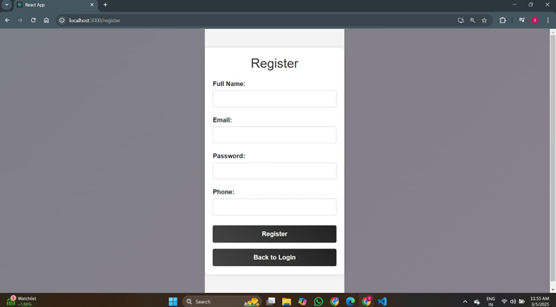

Login:
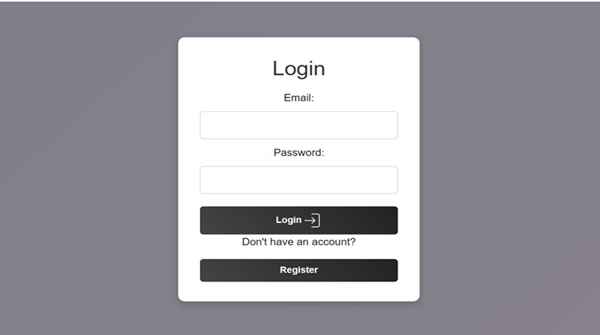
Dashboard (Student):
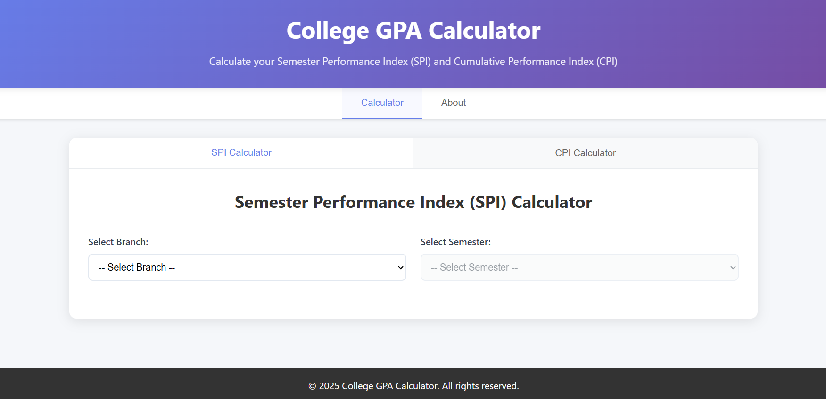

List of Semesters (Student):
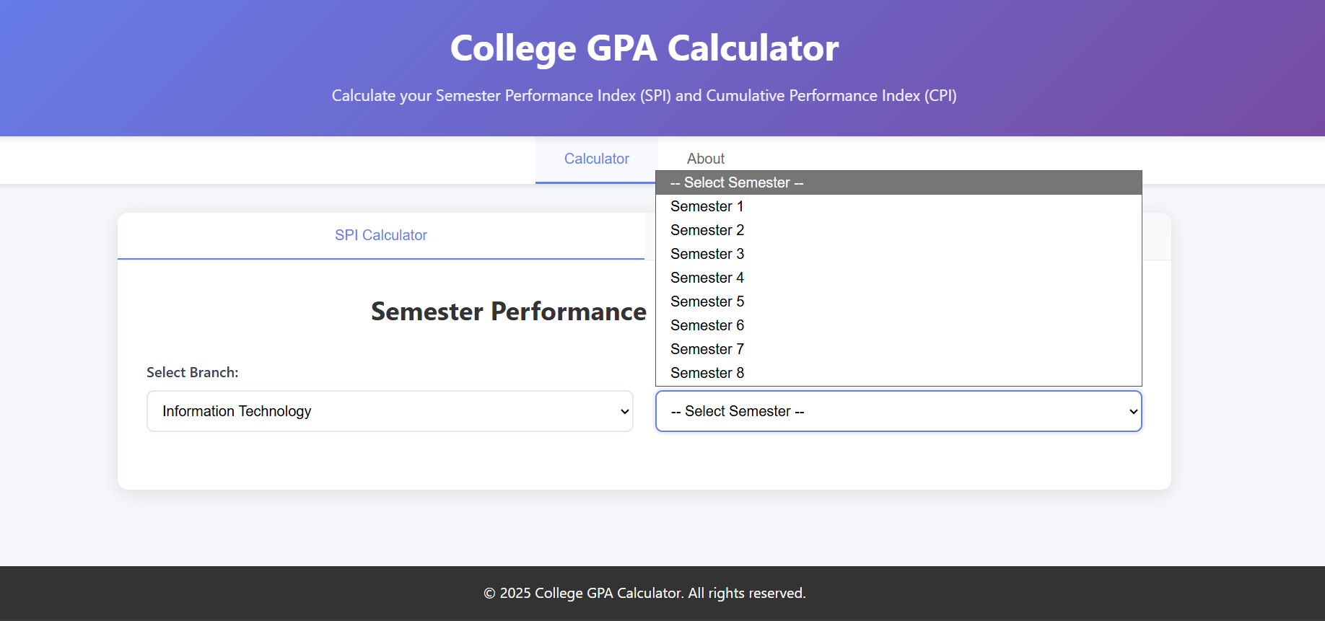

Enter Marks (Student):
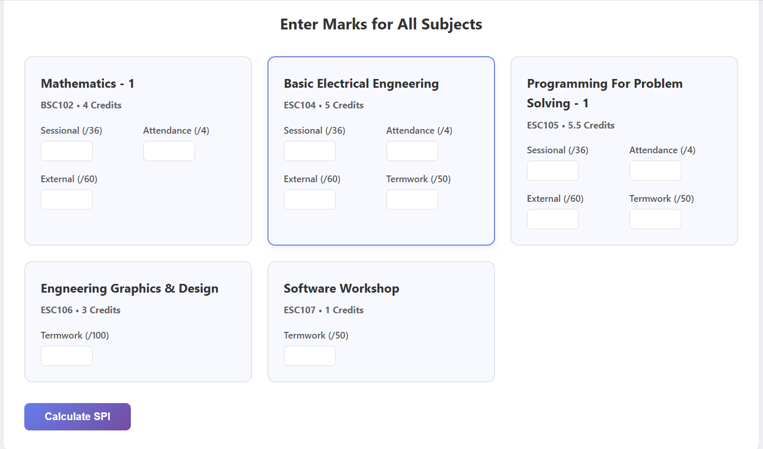

SPI Result (Student):
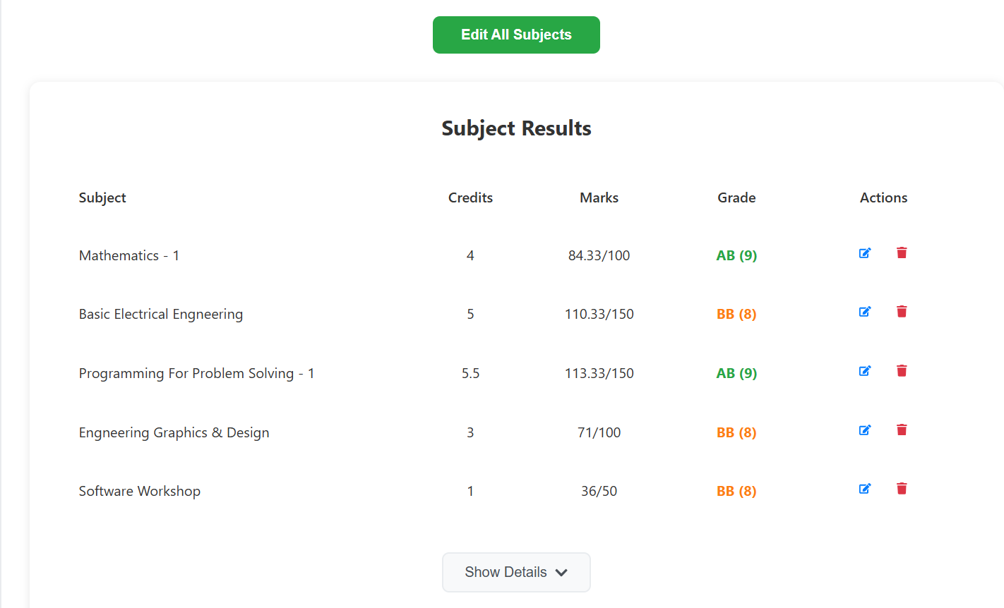

CPI Dashboard (Student):
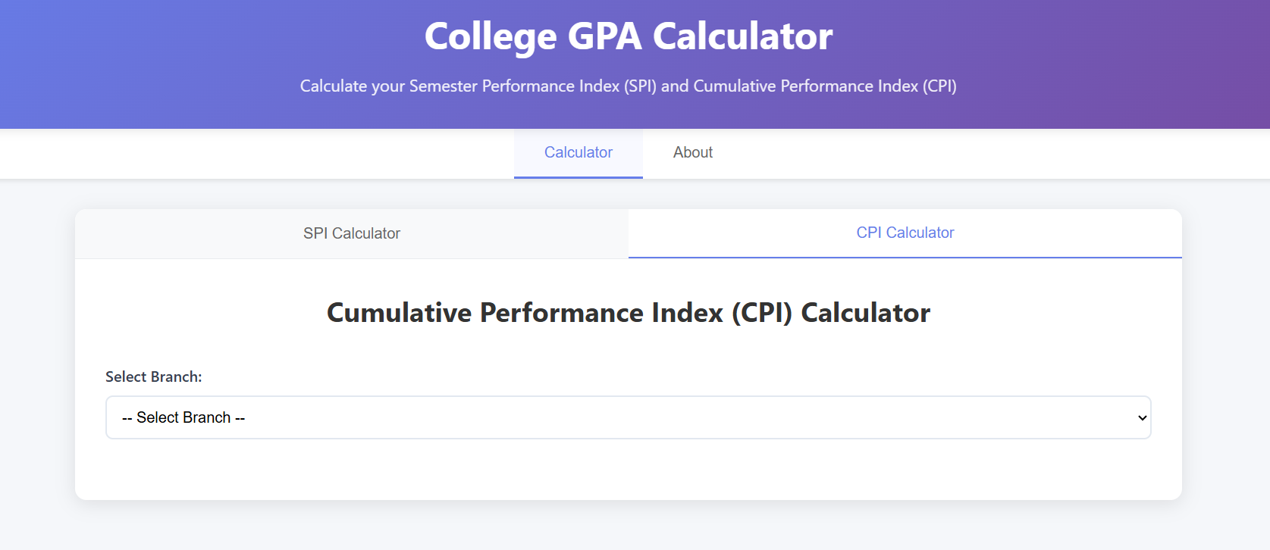

Enter SPI (Student):
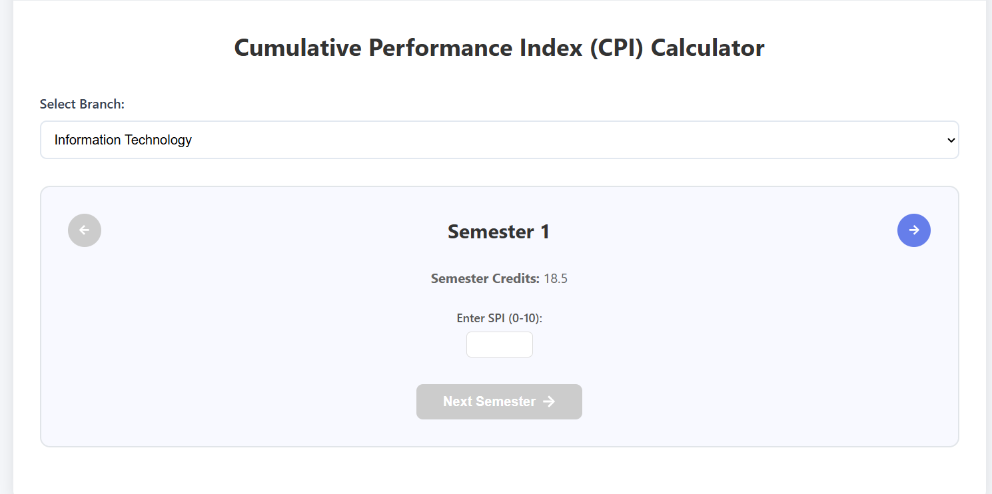

CPI Result (Student):
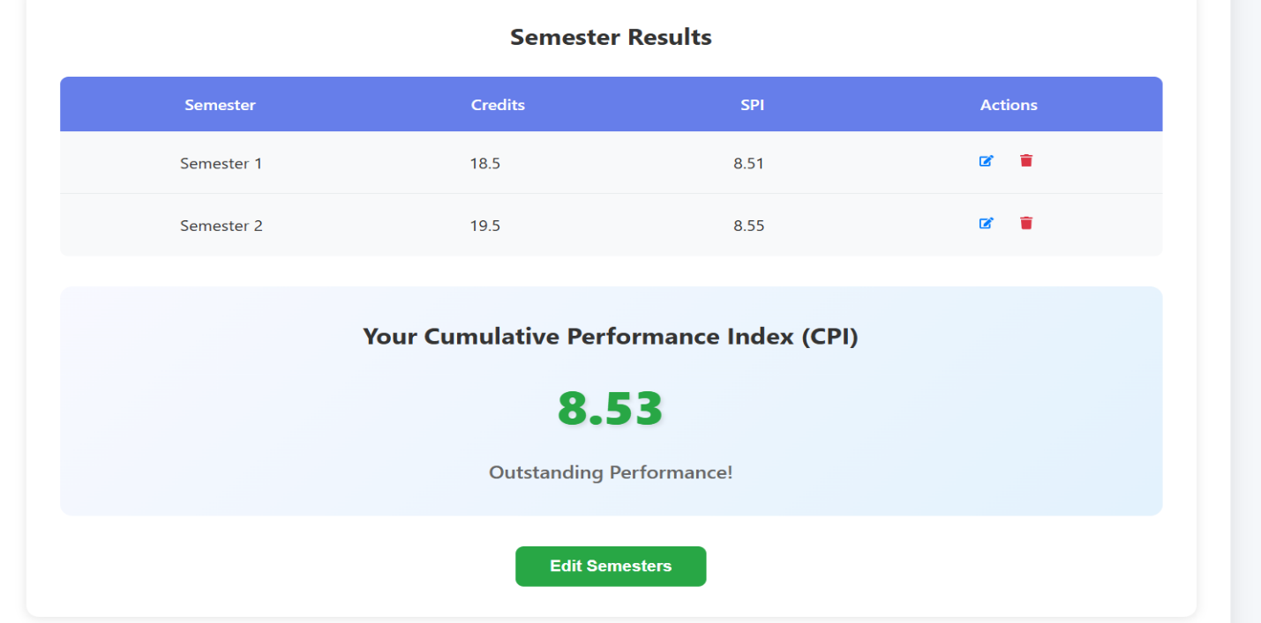

Login (Admin):
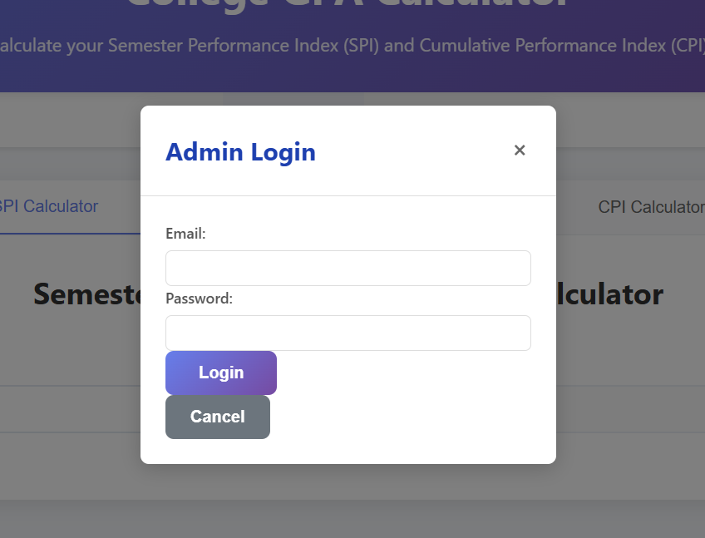

Subject Management (Admin):
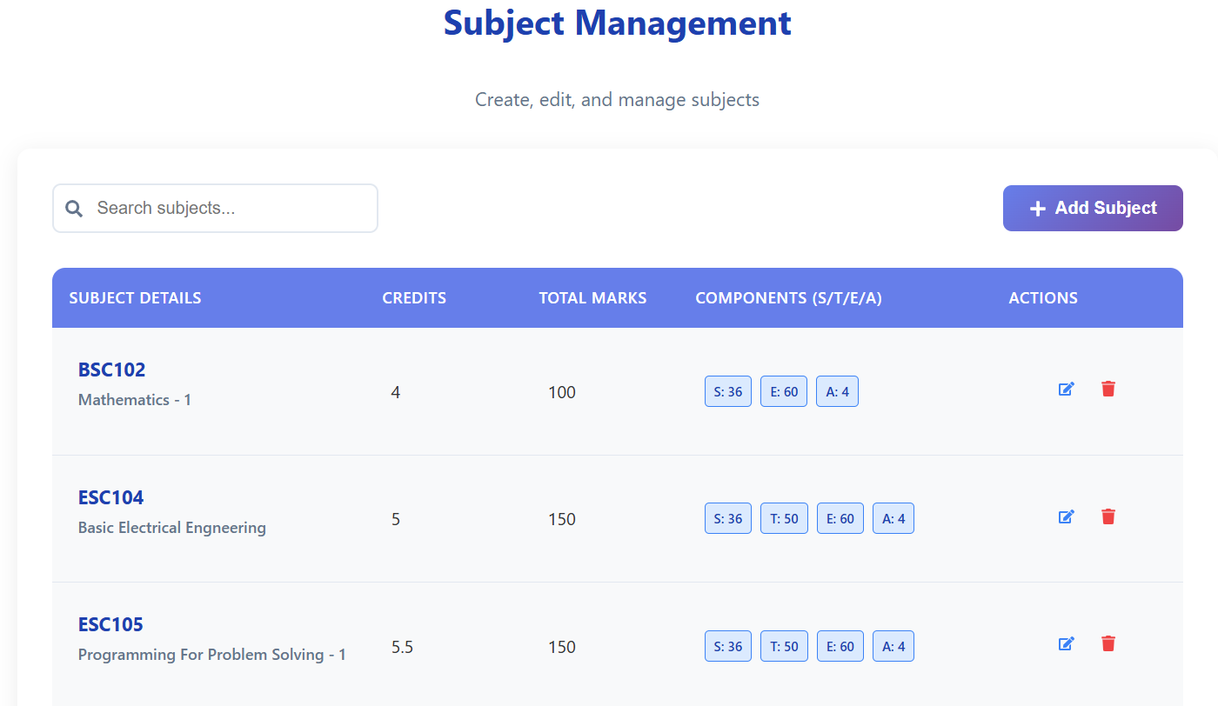
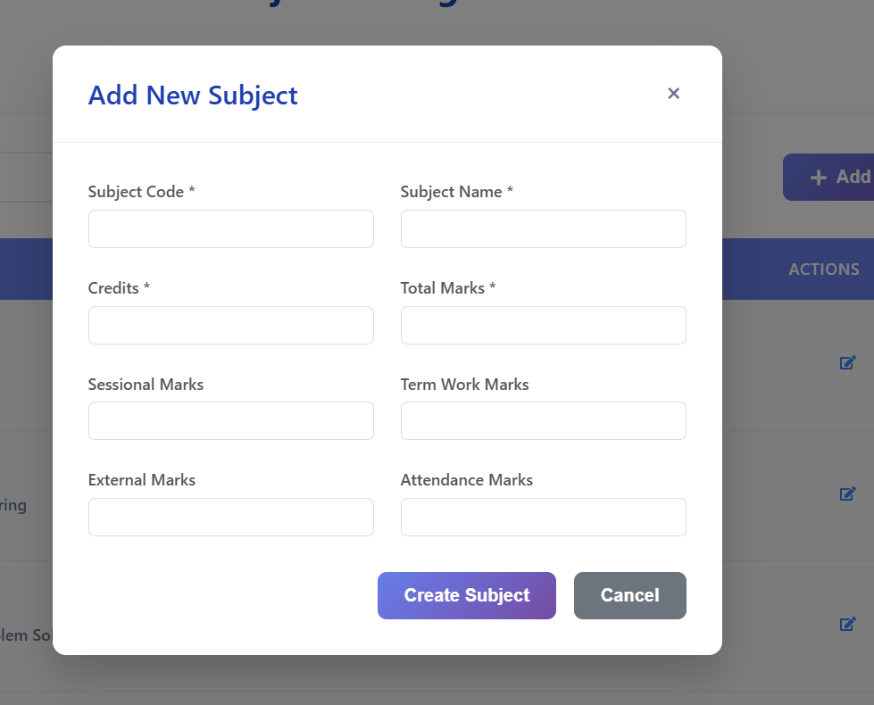

Branch Mangement (Admin):
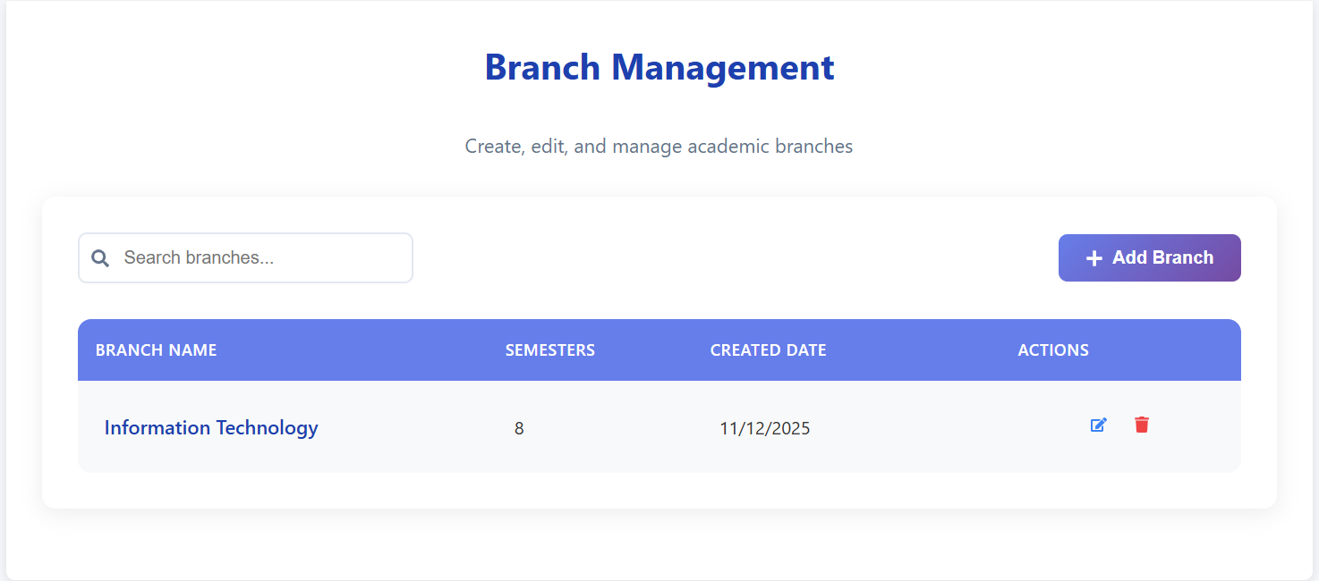
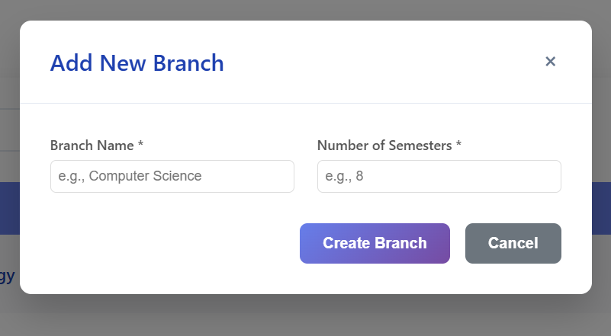

Assign Subject (Admin):
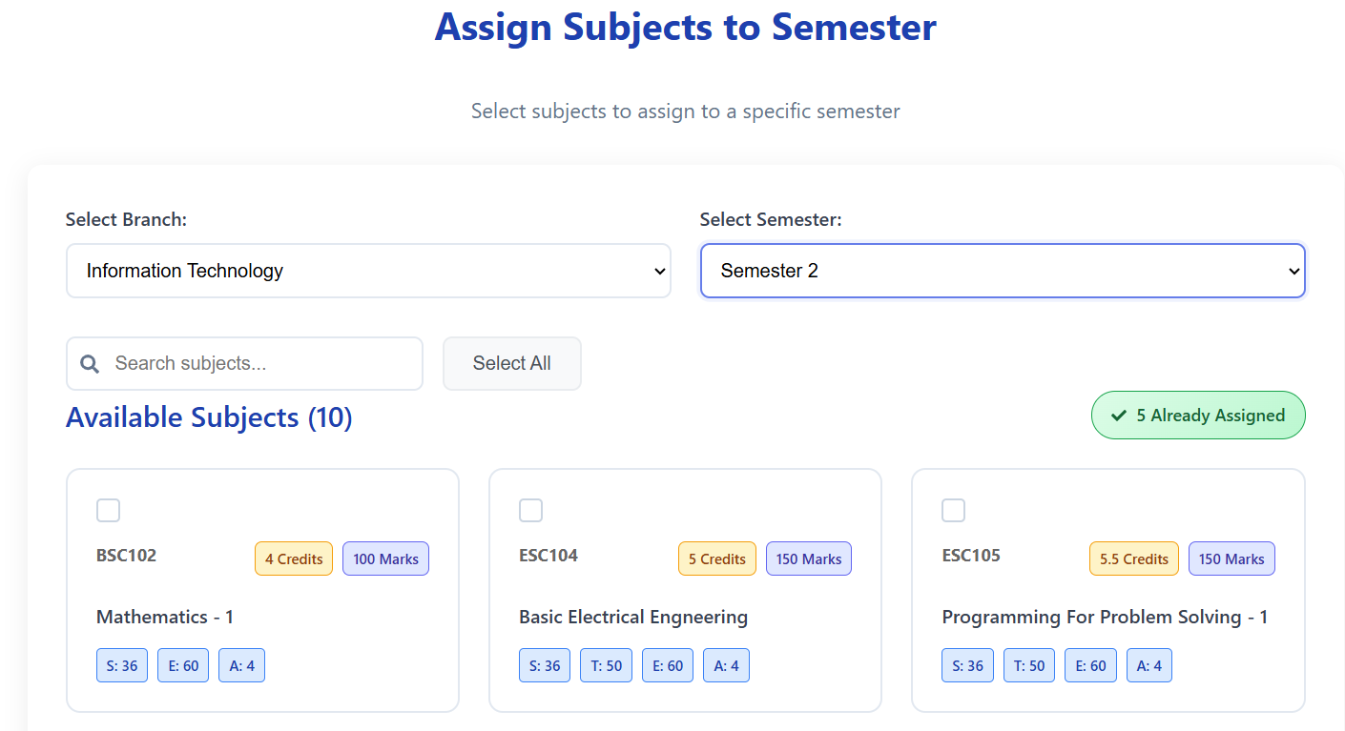
CHAPTER 9: LIMITATION AND FUTURE ENHANCEMENT
9.1 LIMITATION
- Admin Authentication: Current implementation uses static credentials from environment variables. No JWT token-based session management, making the system less secure for production deployment.
- No Student Account System: Students do not have accounts; they cannot save or retrieve their previously calculated SPI/CPI results after closing the browser.
- Manual Mark Entry: Marks are entered manually by the student. There is no integration with the university's official grade portal for automatic import.
- Single University Support: The system is currently configured for DDU's grading scheme only. Other universities with different grading rules are not supported.
- No Mark Validation Alerts: While FF rules are enforced, the system does not proactively warn students when entered marks approach the FF threshold.

9.2 FUTURE ENHANCEMENT
- Student Authentication: Implement user registration and login using JWT so students can save and review their historical SPI/CPI data.
- Result History: Allow students to store and view past semester results and track academic progress over time.
- Multi-University Support: Parameterize the grading rules so the system can support multiple universities with different grade boundaries and fail conditions.
- PDF Report Generation: Allow students to export their SPI/CPI results as a formatted PDF document.
- Real-Time Notifications: Proactively warn students when entered marks are close to the FF threshold for any component.
- Mobile Application: Develop a React Native or PWA version for improved mobile accessibility.
- Integration with University Portal: Explore API integration with DDU's academic systems for automatic mark import.

CHAPTER 10: CONCLUSION AND DISCUSSION
10.1 CONCLUSION
SPI-Quest successfully delivers a reliable, accurate, and user-friendly platform for DDU students to calculate their SPI and CPI. The system faithfully implements DDU's official grading scheme, including grade boundaries (AA through FF) and the three fail conditions, ensuring results that mirror the university's actual academic computation.
Built on the MERN stack, the application demonstrates the power of full-stack JavaScript development for educational tools. The modular architecture, clean separation of concerns, and RESTful API design ensure that the system is maintainable and extensible for future enhancements.

10.2 DISCUSSION
10.2.1 Problem Encountered
- Grading Logic Complexity: Translating DDU's multi-component grading scheme (including FF rules for individual components) into server-side code required careful analysis of edge cases.
- Dynamic Data Loading: Managing dependent dropdowns (branch -> semester -> subjects) with proper loading states and error handling in React required careful state management.
- Admin Session Management: Implementing a lightweight but functional admin authentication flow without a full JWT system while keeping the UI responsive.
- Data Modeling: Designing the MongoDB schema to support flexible branch-semester-subject hierarchies while enabling efficient querying.

10.2.2 Possible Solutions
- Modular Service Layer: The grading logic was extracted into a dedicated service (spiCalculator.service.js) with comprehensive edge case handling, making it easy to test and update independently.
- React State Management: useState and useEffect hooks were used strategically to manage loading, selection, and data states without external state management libraries.
- Environment Variables: Admin credentials stored in .env with dotenv, keeping sensitive data out of source code.
- Mongoose Population: MongoDB's populate() feature was used to efficiently resolve subject references within branch documents.

10.2.3 Summary of Project Work
SPI-Quest was conceived, designed, and developed as a complete full-stack application from scratch during the final year internship. The project demonstrates competency in React.js frontend development, Node.js/Express.js backend development, MongoDB data modeling, RESTful API design, and implementation of complex domain-specific business logic (academic grading rules). The experience gained through this project provides a strong foundation for professional software development.

CHAPTER 11: REFERENCES

● React: https://react.dev/
● Geeksforgeeks: https://www.geeksforgeeks.org/
● MongoDB: https://www.mongodb.com/atlas/database/
● Nodejs: https://nodejs.org/en
● Npm: https://www.npmjs.com/
● Stackoverflow: https://stackoverflow.com
● W3 Schools: https://www.w3schools.com/
● Youtube: https://www.youtube.com/

CHAPTER 12: EXPERIENCES
During my final year, I developed SPI-Quest as a Full Stack Developer — a College GPA Calculator that computes SPI (Semester Performance Index) and CPI (Cumulative Performance Index) for DDU students based on the university's official grading system.
The main challenge was accurately translating DDU's complex grading rules into code. The system needed to handle four different mark components (sessional, term-work, attendance, external) and enforce strict FF conditions for each component individually. I solved this by writing a dedicated service-layer function that handles all edge cases cleanly.
For the backend, I used Node.js and Express.js to build a RESTful API with routes for SPI calculation, CPI calculation, branch management, and subject management. MongoDB with Mongoose was used for data persistence, with a schema design that supports flexible branch-semester-subject hierarchies.
The frontend was built using React.js (with Vite), where I created separate, reusable components for each feature: SPI calculator, CPI calculator, admin panel, branch management, subject management, and subject assignment. Managing dependent dropdown state (branch → semester → subjects) taught me a great deal about React's useEffect and useState patterns.
One of the most rewarding aspects was verifying that the computed SPI values matched students' actual official results — confirming that the grading algorithm was correctly implemented.
Through this project, I gained hands-on experience in building a production-quality full-stack application from scratch. I improved my understanding of RESTful API design, MongoDB data modeling, React component architecture, and deployment practices.
I am deeply grateful to Mr. Chintan Gor (CTO, eSparkBiz Technologies) for his guidance and mentorship throughout this project. His practical insights went far beyond technical help and shaped my approach to professional software development

