Feature Requirements Specification

PRODUCT RELEASE
FEATURE

Document Number : FRS EMS-2023-01
Revision Number : 1.0
Issue Date : 08/02/2024

RideNext Software Solutions Pvt Ltd
174/ A,19th Main, HSR Layout Sector 4,
Bengaluru 560102

© Copyright 2019, RideNext Software Solutions Pvt Ltd.

Draft/ Rev No | Date | Author | Section changed | Reason for changes
0.1 | 01/06/2023 | RideNext Team | Original
1.0 | 08/02/2024 | RideNext Team |  | Internal Review Comments

Table Of Contents
1. INTRODUCTION 4
1.1. Purpose 4
1.2. Scope 4
1.3. Acronyms 5
1.4. References 5
1.5. Open Issues 5
2. DESCRIPTION 6
2.1. Product Perspective 6
2.2. Assumptions 7
2.3. Open Source 7
3. FUNCTIONAL REQUIREMENTS 8
3.1. General Requirement 8
3.2. Netconf Requirement 8
3.3. Ves Requirement 10
3.4. Web Ui Requirement 10
3.5. Platform Requirement 11
3.6. Simulator Requirement 11
4. EXTERNAL INTERFACE REQUIREMENT 13
4.1. Hardware Specification 13
4.2. Software Specification 13
5. PERFORMANCE REQUIREMENT 13
6. other requirements 13
6.1. Database 13

INTRODUCTION

Purpose

The purpose of this document is to define and describe the functional requirements of the 5G SMO(O1 Termination) / EMS component. This document serves as an input document for all stakeholders involved in the development, testing, and deployment of the system, providing an outline of the expected functionalities, features, and interactions.

Scope

According to the O-RAN.WG1.O1-Interface.0-v04.00 document [1.4] , all Managed Elements (Near-Real-Time RIC, O-CU-CP, O-CU-UP, O-DU and O-RU) implement the O1-interface.
The O-RAN-OAM-interface specification defines:
- NETCONF for Configuration Management (CM) and
- VES for Fault Management (FM), Performance Management (PM) and other events
The scope covers 5G compliant SMO (O1 Termination) / EMS component which support NETCONF and VES interface with functional requirements as mentioned in section 3.

Acronyms

SMO Service Management Operations
NF Network Function
PNF Physical Network Function
VNF Virtualized Network Function
EMS Element Management System
FCAPS Fault, Configuration, Accounting, Performance and Security
ODL Opendaylight
SDNR Software Defined network Controller for Radio

References
- O-RAN.WG1.OAD-R003-v10.00
- O-RAN.WG1.O1-Interface.0-v04.00
- O-RAN.WG10.O1-Interface.0-R003-v11.00
- O-RAN.WG4.MP.0-R003-v13.00
- 3GPP TS28.532 v16.6.0
- 3GPP TS28.552 v16.6.0

Open Issues

    - Current Open Issues
Sl. No. | Description | Status | Remarks

    - Resolved Open Issues
Sl. No. | Description | Status | Remarks

DESCRIPTION

The SMO manages the O-RAN NF FCAPS Management Services. This offers capabilities to manage and orchestrate managed elements. Managed elements expose their management services to managers. Managers consume the management services.
Examples of Management Services supported by O-RAN include:
- Provisioning
- Fault Supervision
- Performance Assurance
- Trace Management
- File Management
- Software Management
- Communication Surveillance
- Startup and Registration of a Physical Network Function (PNF)
- Instantiation and Termination of a Virtualized Network Function (VNF)
- Scaling Management Services for VNF

Product Perspective

The SMO manages FCAPS for the O-RAN NFs. An Element Management System (EMS) in the context of 5G refers to a system designed to manage and monitor the various network elements within a 5G network infrastructure. O1 termination or EMS is one of the components inside SMO. The key functionality includes configuring, monitoring, and controlling network elements such as Base Stations and Radio Units to ensure efficient and optimal network performance. The EMS functional components and its interfaces to external elements are described in figure below.

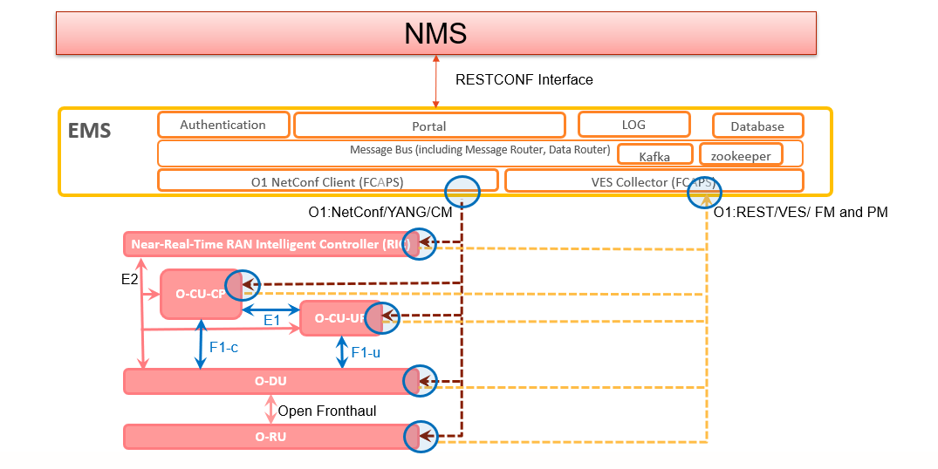
Figure 1: Components and Interfaces

Assumptions

- OpenDaylight and O-RAN framework with NETCONF plugin is used to communicate on south bound interface.
- Target NFs mentioned in this document are limited to O-CU-CP, O-CU-UP, O-DU and O-RU.
- Devices and NF’s are used in this document interchangeably. NF’s are logical representation of physical devices.

Open Source
- Opensource used in this project is based on Apache V2.0 license model.

FUNCTIONAL REQUIREMENTS

General Requirement
ID:: R03100;
SMO (O1 Termination) / EMS Architecture shall support configuration of NFs using NETCONF protocol.

ID:: R03101;
SMO (O1 Termination) / EMS Architecture shall support faults of NFs using VES protocol. Additionally, faults shall be accessible through NETCONF yangs provided by NF’s.

ID:: R03102;
SMO (O1 Termination) / EMS Architecture shall support management of PM, PM data collection/storage/query/statistical reports for counters from NFs.
Note: KPI derivation is not in scope.

ID:: R03103;
SMO (O1 Termination) / EMS Architecture shall support restconf interface towards north bound.

ID:: R03104;
SMO (O1 Termination) / EMS Architecture shall support operation logging functionality for debug purpose dynamically.

ID:: R03105;
SMO (O1 Termination) / EMS Architecture shall support hierarchical and hybrid management of O-RAN O-DU and O-RU components as defined in O-RAN.WG4.MP.0-R003 [1.4].

ID:: R03106;
SMO (O1 Termination) / EMS Architecture shall support Call home and pnfRegistration from NF devices.

Netconf Requirement
The SMO (O1 Termination) / EMS component shall provide provisioning management services.

ID:: R03201;
The provisioning management service shall support the following NETCONF operations as specified in RFC 6241.
- get
- get-config
- edit-config
- lock
- unlock
- close-session
- kill-session

ID:: R03202;
The provisioning management service shall support the following NETCONF capabilities:

- writable-running
- rollback-on-error
- validate
- xpath
ID:: R03203;
The provisioning management service shall support YANG1.1, defined in RFC 7950.

ID:: R03204;
The provisioning management service shall have the capability to establish a NETCONF session with its authorized consumer upon request from the consumer.

ID:: R03205;
The provisioning management service shall have the capability to establish a NETCONF session by providing device IP address, port and user details.

ID:: R03206;
The provisioning management service shall support an established NETCONF session until the authorized consumer terminates the session.
NOTE: The consumer may want to perform multiple provisioning management services operations during a single NETCONF Session.

ID:: R03207;
The provisioning management service shall support NETCONF over SSH or NETCONF over TLS.

Ves Requirement

An O1 notification is a JSON encoded asynchronous notification sent from a NF’s to a EMS / SMO consumer over the O1 interface using REST/HTTP.

ID:: R03301;
SMO (O1 Termination) / EMS shall support O-RAN defined O1 PNF notification encoded in JSON over REST/HTTP.

ID:: R03302;
SMO (O1 Termination) / EMS shall support legacy VES encoded in JSON over REST/HTTP. VES event, consisting of a VES commonEventHeader and faultFields, as specified in (ONAP VES Event Listener Specification v7.2, May 2020).
ID:: R03303;
SMO (O1 Termination) / EMS shall support O-RAN defined notifyFileReady encoded in JSON over REST/HTTP. EMS shall get files using sftp from NF’s specified in notifyFileReady message.

ID:: R03304;
SMO (O1 Termination) / EMS shall support VES Heartbeat encoded in JSON over REST/HTTP.

Web Ui Requirement
ID:: R03401;
SMO (O1 Termination) / EMS shall support api gateway .i.e. Single access point of Web Clients to SDNR. External access to SDNR is through secure communication using https protocol.

ID:: R03402;
SMO (O1 Termination) / EMS shall support user authentication using REST API. The keyCloack is used for User management.

ID:: R03403;
SMO (O1 Termination) / EMS shall support 'Connect' application on ODL which provides up-to-date connectivity information about the devices in the network.

ID:: R03404;
SMO (O1 Termination) / EMS shall support adding devices using web UI.

ID:: R03405;
SMO (O1 Termination) / EMS shall support connection status changes between ODL Controller and NetConf servers on NF’s.
ID:: R03406;
SMO (O1 Termination) / EMS shall support filtering of devices.

ID:: R03407;
SMO (O1 Termination) / EMS shall support fault application on ODL to log current and history alarms. Current alarm shall have alarms which are currently opened at NF’s until corresponding clear alarm is received.

ID:: R03408;
SMO (O1 Termination) / EMS shall support fault application on ODL for enable / disable notifications dynamically.

ID:: R03409;
SMO (O1 Termination) / EMS shall support displaying counters from NF’s. There shall be an option to choose date and time for logging counters at Web UI.

ID:: R03410;
SMO (O1 Termination) / EMS shall support displaying graphs for counters from NF’s.

ID:: R03411;
SMO (O1 Termination) / EMS shall support profile page to upload initial configuration files, which can be used to associate initial configuration file for a device.

ID:: R03412;
SMO (O1 Termination) / EMS shall support event logs of VES message received from devices.
ID:: R03413;
SMO (O1 Termination) / EMS shall support customization according to Tejas web UI.

Platform Requirement
ID:: R03501;
SMO (O1 Termination) / EMS shall be running on docker environment. The deployment shall be done using docker compose.

ID:: R03502;
SMO (O1 Termination) / EMS shall have provision to configure networks required internal and outside using api gateway.

Note: Customization as per deployment network shall be done by deployment team.

Simulator Requirement

ID:: R03601;
Simulator shall support NETCONF devices having yang capability to generate alarm and configuration.

EXTERNAL INTERFACE REQUIREMENT

Hardware Specification

ID:: R4101; Single cluster deployment

- 16-Core
- 32 GB RAM
- 200 GB Storage

Software Specification

ID:: R4201;
SMO (O1 Termination) / EMS will be developed on Ubuntu 18.04 / 20.04. However, O1 termination / EMS will have option to deploy images on Centos and Ubuntu Linux operating system on docker environment.

PERFORMANCE REQUIREMENT

ID:: R5001;
SMO (O1 Termination) /EMS shall support 3000 connected devices at south bound and 50 concurrent sessions at Web UI.

other requirements

Database
Current software uses Elastic Search DB.

ID:: R6101;
SMO (O1 Termination) / EMS shall support CRUD (Create, Read, Update, Delete) operations on DB for internal data maintenance.

