**React Hooks Assignment**

Name: - Pruthvi Gadhiya

Id no.:-500235241

Git-hub link:- <https://github.com/Pruthvi1881/React-Hooks>

Step-1:- useState

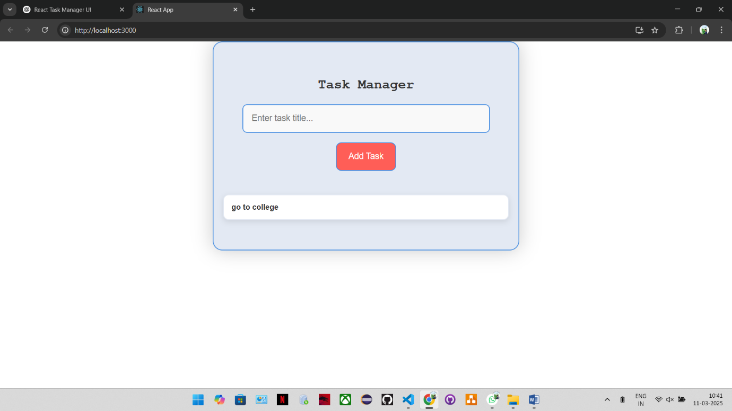

**Explanation:**

We need to create a form where users can enter a task with a title and description. We'll use useState to store the list of tasks.

**Code Snippet:**

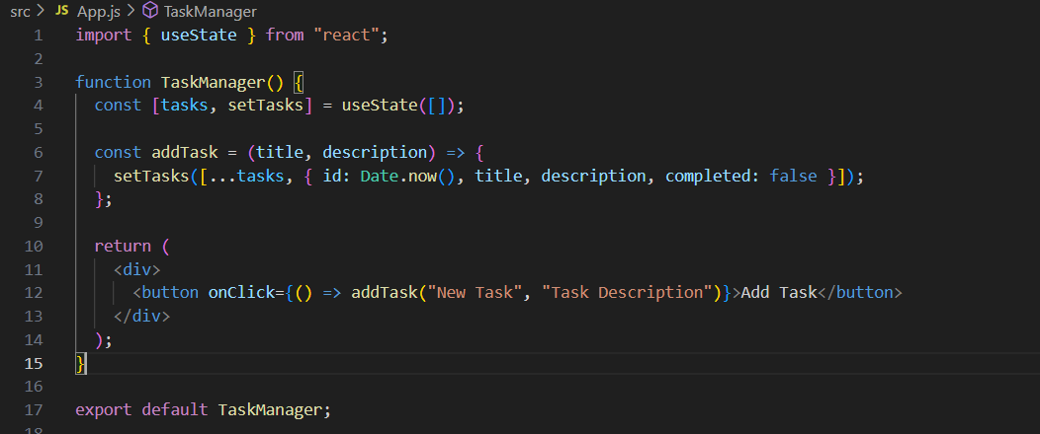

Step-2:- useEffect

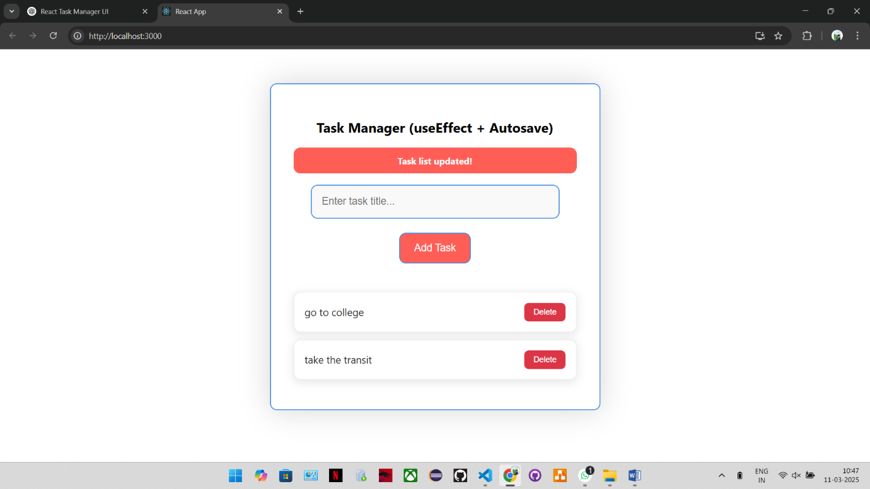

**Explanation:**

Whenever a task is added or removed, we should save the updated list to localStorage. Also, we'll show an alert whenever the task list changes.

**Code Snippet:**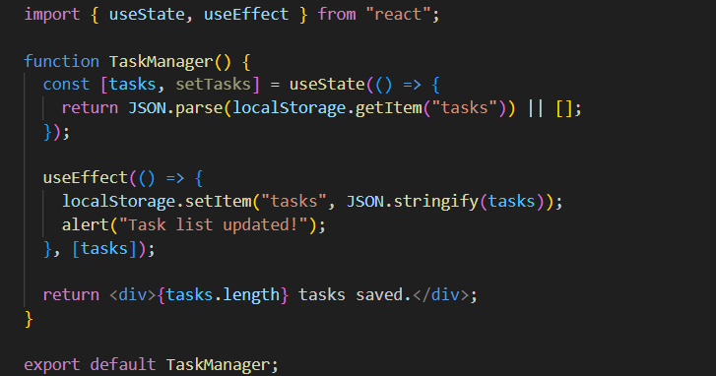

Local storage:-

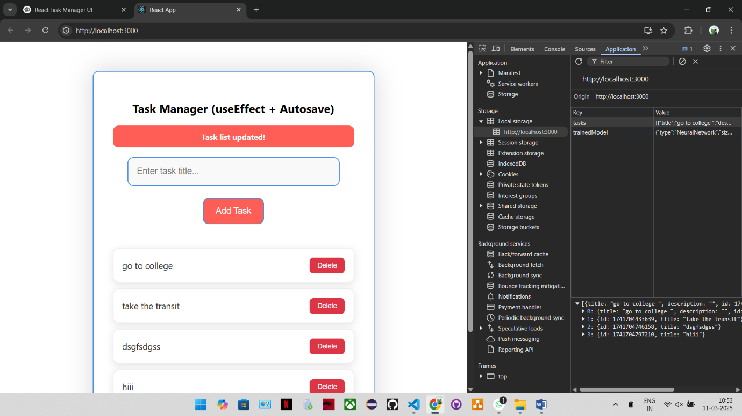

Step-3:- useContext

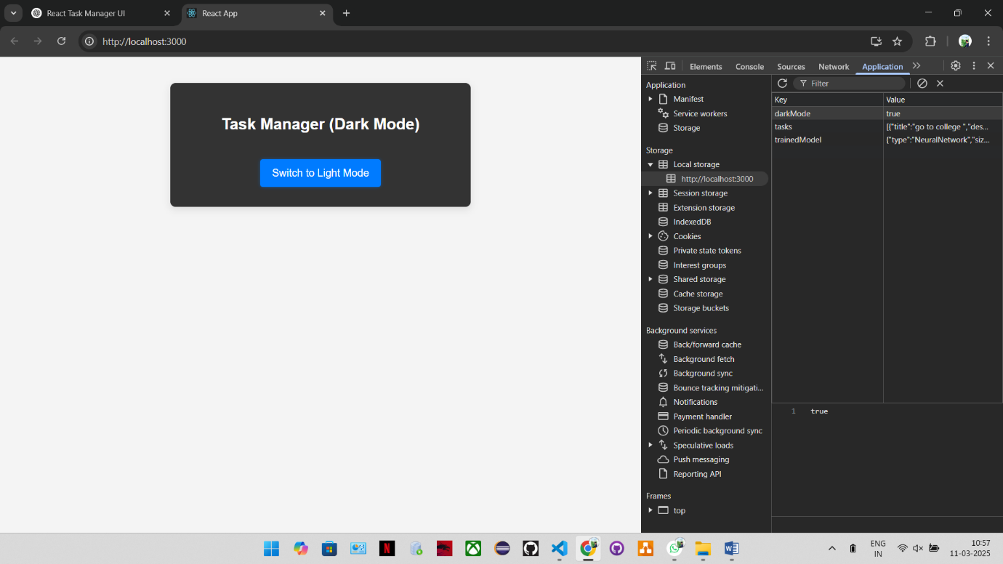

Explanation:

We'll create a ThemeContext to switch between dark and light mode. The theme should be remembered even after the page reloads.

**Code Snippet:**

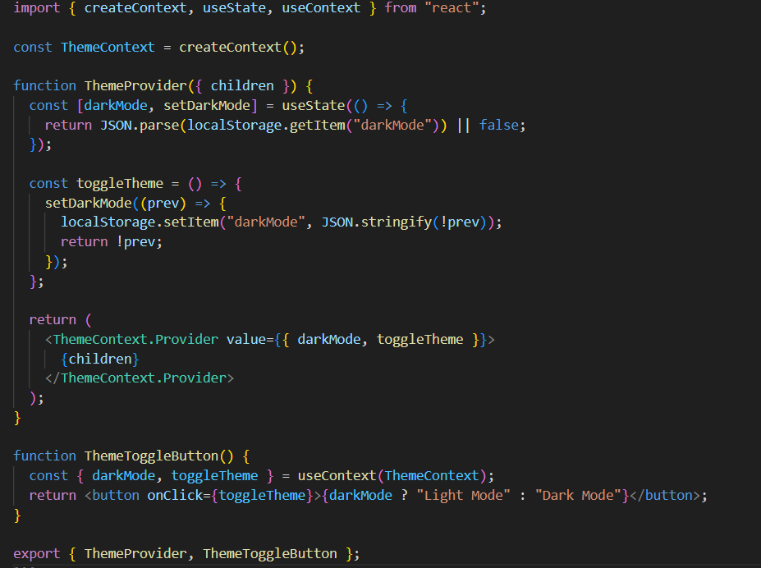

Step-4:- useReducer

1-task_added

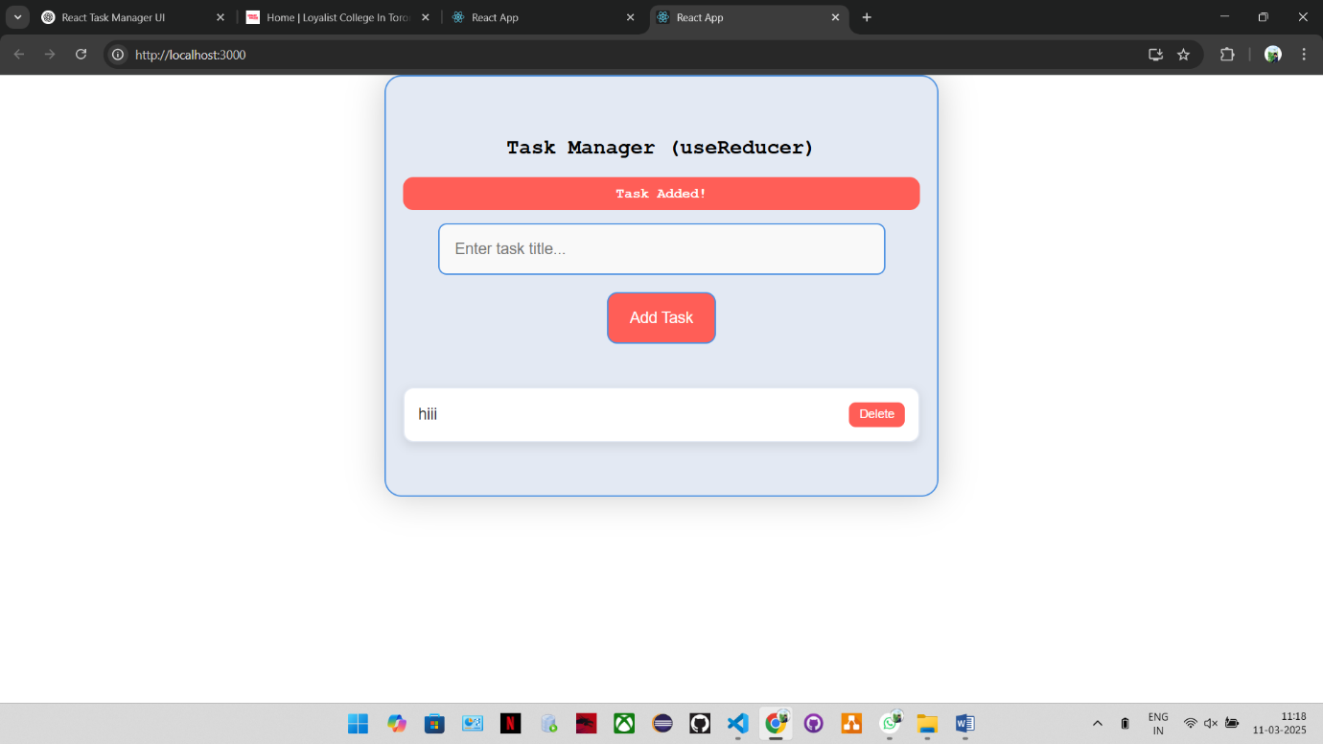

2-task_updated

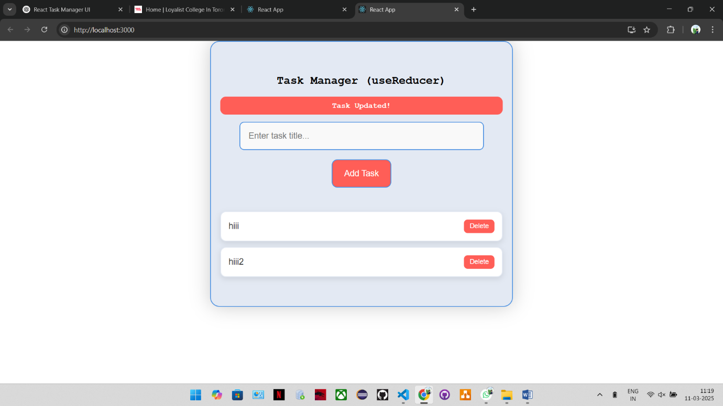

3-task_deleted

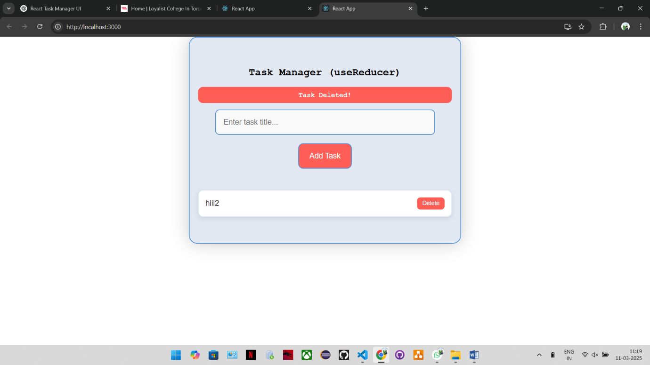

Explanation:

Instead of useState, we'll use useReducer to manage adding, updating, and deleting tasks in a structured way.

**Code Snippet:**

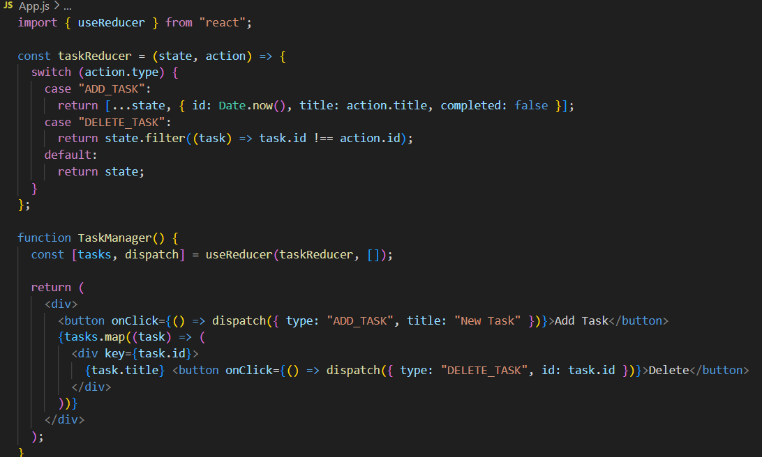

Step-5:- useRef

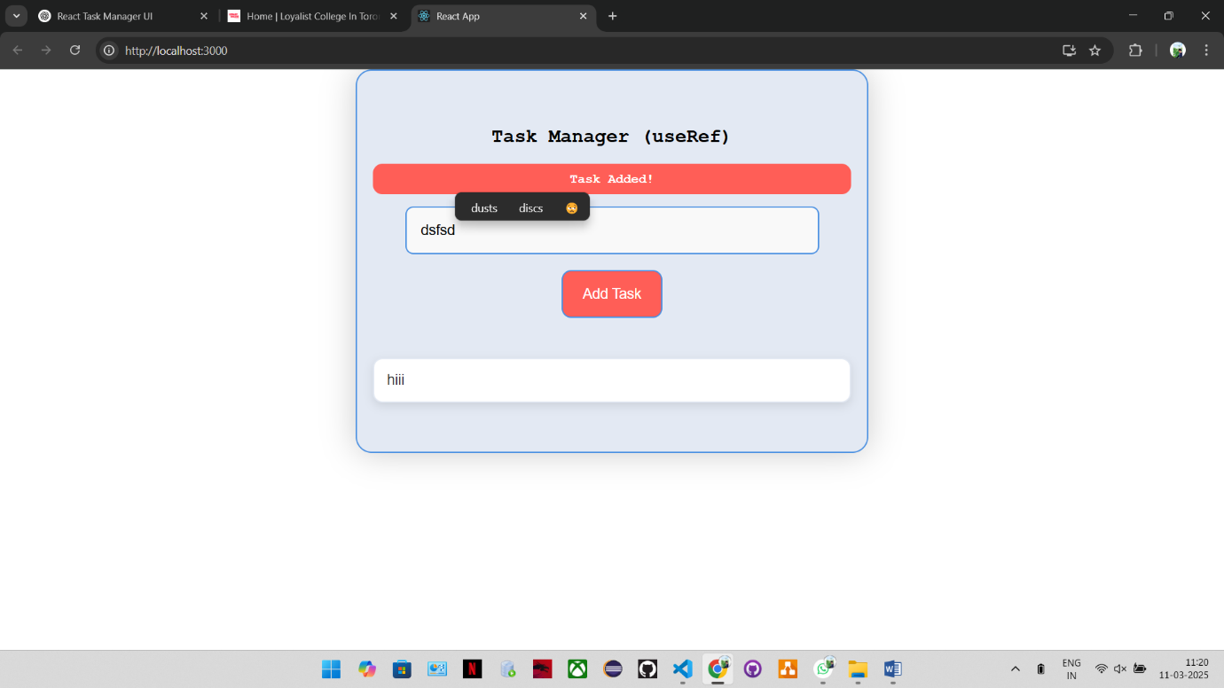

Explanation:

We'll use useRef to store a reference to the task input field so it gets auto-focused when the component loads.

**Code Snippet:**

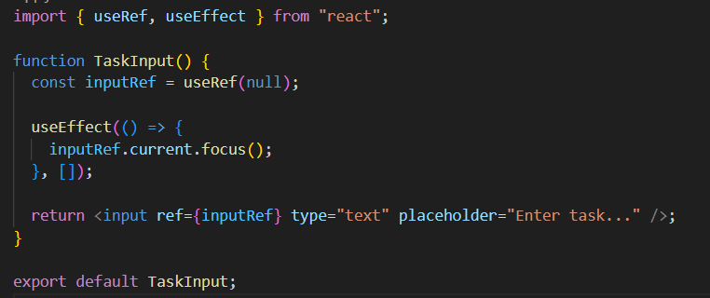

Step-6:- useMemo

1-completed_task_filter

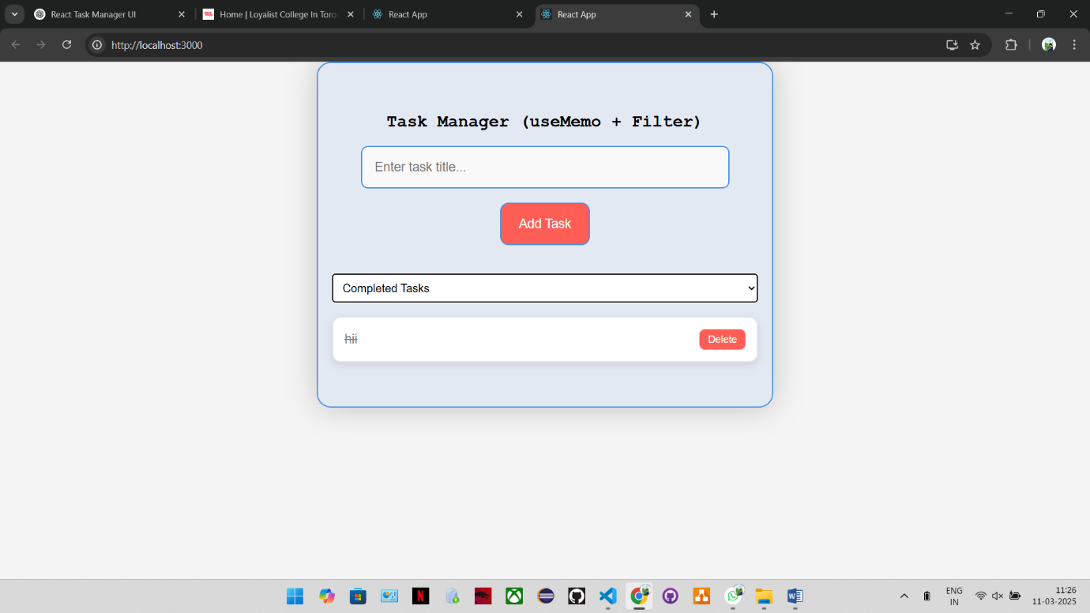

2-incompleted_task_filter

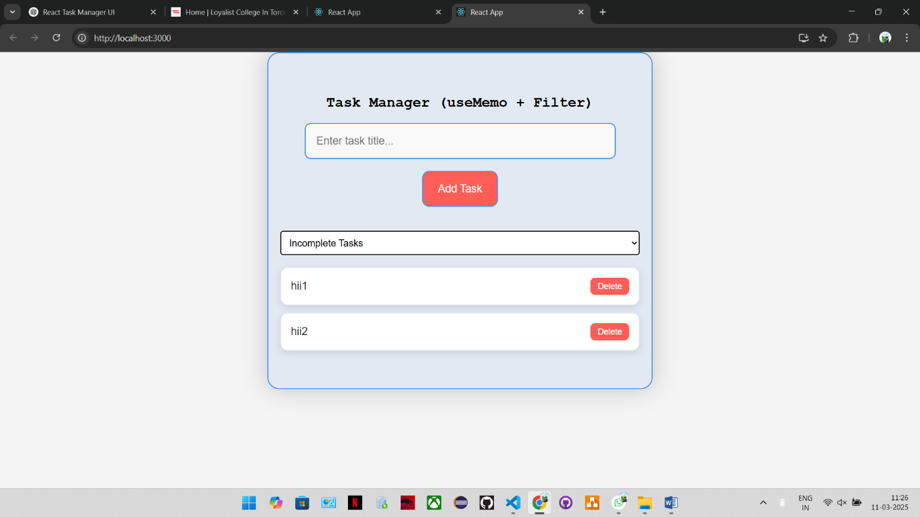

Explanation:

Filtering tasks can be slow if there are too many. We'll use useMemo to optimize it and prevent unnecessary calculations.

**Code Snippet:**

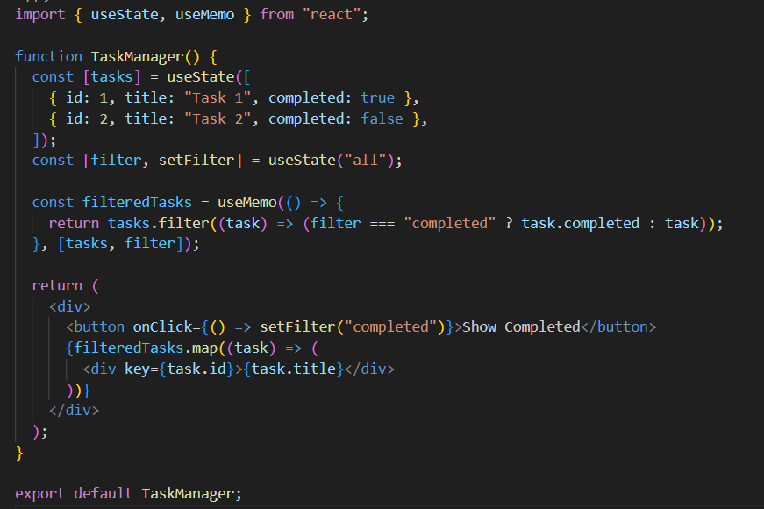

Step-7:- useCallback

1-added_tasks

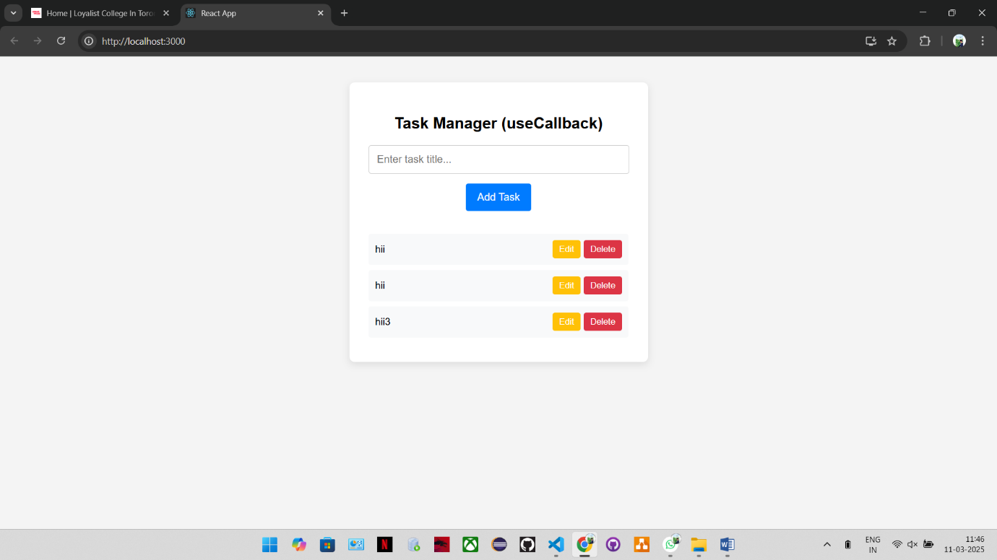

2-edited_task

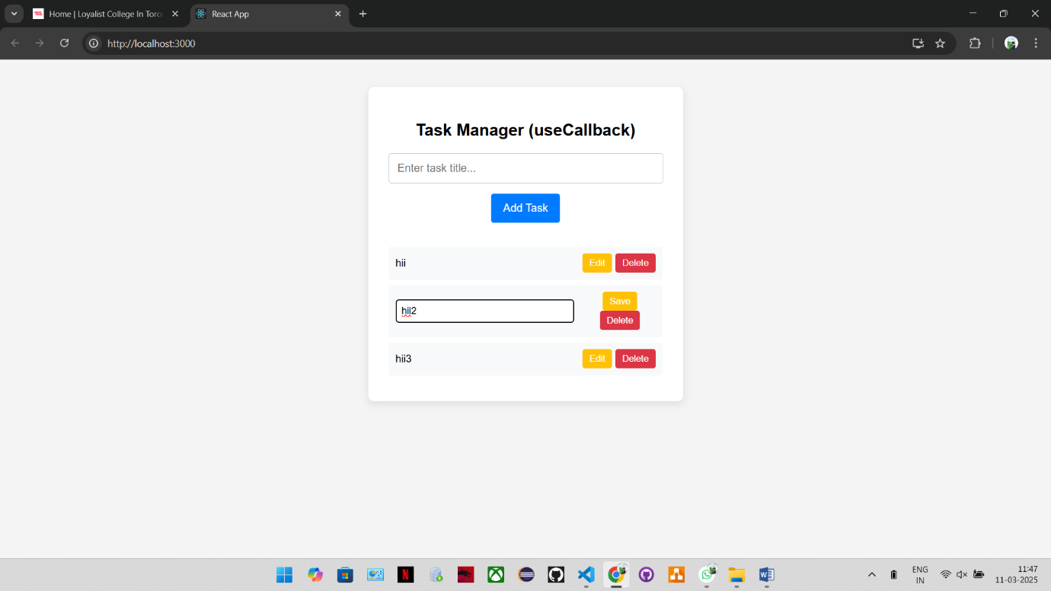

Explanation:

If a function is created every time the component re-renders, it can slow down performance. We'll use useCallback to optimize event handlers.

**Code Snippet:**

