Technical Analysis using R — Preliminary Stage
BDA400 Assignment 2 — Data Science Tools and Techniques | Pruthvi Raju Nallaparaju | Session 3
Tool / Access Note — read this first
Three parts of this assignment require actions on YOUR OWN computer and cannot be completed or screenshotted from a sandboxed cloud environment: (1) signing up for / confirming your GitHub account, (2) installing R and RStudio via their graphical installers, and (3) running install.packages() inside your own RStudio console. These are marked below with a red dashed placeholder box telling you exactly what to screenshot -- the rest of this report (the narrative, the code, and all output/charts) is already complete and genuine. Separately: stock_analysis.R calls quantmod::getSymbols(src = "yahoo"), which needs live internet access to Yahoo Finance. The sandbox this report was built in has no outbound access to finance.yahoo.com (confirmed directly: a connection attempt returned a 403 at the network level, not assumed) -- so the script's built-in synthetic-data fallback triggered automatically, and every statistic and chart below comes from that fallback, clearly logged as such in the console output. When you run the identical script on your own machine with normal internet access, load_stock_data() will fetch real Yahoo Finance data instead and the fallback will never trigger -- re-run it there and swap in the real console output/charts for your final submission if your instructor wants live market data rather than this verification run.

Step 1 — GitHub Account and Repository Setup
A GitHub account (Pruthvi41) was already set up for this course in a previous assignment. For this assignment, a new repository named exactly “TechnicalAnalysis” was created to hold all assignments for this course, with one subdirectory per assignment (this submission lives in TechnicalAnalysis/A02/).
- Repository name: TechnicalAnalysis
- Structure: TechnicalAnalysis/A02/ contains portfolio.txt, stock_analysis.R, the output/ folder, and this report.
- Repository URL: see the cover page of this submission.
[ INSERT SCREENSHOT HERE: github.com/settings/profile or your GitHub homepage, showing you are signed in ]
[ INSERT SCREENSHOT HERE: the TechnicalAnalysis repository page on GitHub, showing the A02 folder and its files after pushing ]

Step 2 — Installing and Configuring R and RStudio
R and RStudio were installed following the official CRAN/Posit installers for the operating system in use, per the assignment's linked guide (cran.rstudio.com).
- Download R for your OS from cran.rstudio.com and run the installer, accepting the default options.
- Download RStudio Desktop from posit.co/download/rstudio-desktop and run its installer.
- Open RStudio and confirm the R console starts without errors (it should show the installed R version at the top).
[ INSERT SCREENSHOT HERE: the CRAN R download page for your OS, before clicking download ]
[ INSERT SCREENSHOT HERE: the R installer mid-installation (progress bar visible) ]
[ INSERT SCREENSHOT HERE: the RStudio Desktop download page ]
[ INSERT SCREENSHOT HERE: the RStudio installer mid-installation ]
[ INSERT SCREENSHOT HERE: RStudio open with the Console pane visible, showing the R version banner (e.g. "R version 4.x.x") ]

Step 3 — Downloading and Installing R Packages
The packages required for technical analysis are quantmod (fetches market data and provides charting), TTR (Technical Trading Rules — moving averages and other indicators), and their dependencies xts and zoo (time-series data structures quantmod is built on).
install.packages(c("quantmod", "TTR", "xts", "zoo"))
In this sandbox, the equivalent Debian/Ubuntu packages (r-cran-quantmod, r-cran-ttr, r-cran-xts, r-cran-zoo) were installed via apt instead of install.packages(), since this environment's R runs on a managed Linux image — the R-level result (the four libraries loadable via library()) is identical either way. On your own RStudio, use install.packages() as shown above.
[ INSERT SCREENSHOT HERE: RStudio console showing install.packages(c("quantmod","TTR","xts","zoo")) running and completing without errors ]
[ INSERT SCREENSHOT HERE: RStudio console showing library(quantmod) and library(TTR) each loading without errors ]

Step 4 — Project Configuration and Initialization
portfolio.txt was created with one stock symbol per line, representing a small four-stock sample portfolio:
AAPL
MSFT
GOOGL
AMZN
This file is read directly by load_stock_data() (Step 5) — adding or removing a symbol here is the only change needed to analyze a different portfolio.

Step 5 — Function to Import and Load Stock Data
load_stock_data() reads portfolio.txt, loops over each symbol, and calls quantmod::getSymbols() to fetch daily OHLCV (Open/High/Low/Close/Volume) data, returning a named list of xts objects — one per stock, keyed by symbol. A tryCatch wraps the fetch so that a network failure (as happens in this sandbox) falls back to generate_synthetic_stock(), which produces an xts object in the identical column shape, so every function below works unmodified on either source:
load_stock_data <- function(portfolio_file = "portfolio.txt",
use_synthetic_if_offline = TRUE) {
symbols <- readLines(portfolio_file)
symbols <- trimws(symbols); symbols <- symbols[nzchar(symbols)]
stock_data <- list()
for (i in seq_along(symbols)) {
sym <- symbols[i]
data <- tryCatch({
quantmod::getSymbols(sym, src = "yahoo", auto.assign = FALSE,
from = Sys.Date() - 365, to = Sys.Date())
}, error = function(e) {
if (!use_synthetic_if_offline) stop(e)
generate_synthetic_stock(sym, seed = i * 101)
})
stock_data[[sym]] <- data
}
stock_data
}
Verified console output (this sandbox — synthetic fallback triggered for all 4 symbols, as logged):
[AAPL] Yahoo Finance unreachable (Unable to import "AAPL".
CONNECT tunnel failed, response 403) -- using synthetic fallback data.
[MSFT] Yahoo Finance unreachable (...) -- using synthetic fallback data.
[GOOGL] Yahoo Finance unreachable (...) -- using synthetic fallback data.
[AMZN] Yahoo Finance unreachable (...) -- using synthetic fallback data.
Example of the loaded data structure (AAPL, last 5 trading days):
AAPL.Open AAPL.High AAPL.Low AAPL.Close AAPL.Volume AAPL.Adjusted
2026-10-08 131.30 132.56 131.18 132.10 8261963 132.10
2026-10-09 132.61 132.74 132.10 132.12 8890400 132.12
2026-10-12 132.57 133.22 131.62 132.10 8314468 132.10
2026-10-13 134.93 135.46 134.42 134.62 7816869 134.62
2026-10-14 132.18 133.04 132.04 132.74 3284654 132.74

Step 6 — Functions to Compute Basic Statistics
calculate_statistics() takes one stock's xts data frame and returns the mean, median, mode, standard deviation, and a configurable-period simple moving average (default 20 days, via TTR::SMA) of the closing price. R has no built-in function for the mode of continuous data, so get_mode() buckets prices to the nearest dollar before finding the most frequent value:
get_mode <- function(x) {
x <- round(x, 0)
ux <- unique(x)
ux[which.max(tabulate(match(x, ux)))]
}

calculate_statistics <- function(stock_xts, ma_period = 20) {
close_col <- grep("\\.Close$", colnames(stock_xts), value = TRUE)
close <- as.numeric(stock_xts[, close_col])
list(
mean_close = mean(close, na.rm = TRUE),
median_close = median(close, na.rm = TRUE),
mode_close = get_mode(close),
sd_close = sd(close, na.rm = TRUE),
ma_period = ma_period,
moving_avg = TTR::SMA(close, n = ma_period)
)
}
Statistics are stored in a structured list per stock, and combined into one summary data frame across the whole portfolio (see Step 7).

Step 7 — Display Utilities and Visualizations
display_stock_summary() prints each stock's most recent 5 trading days plus its computed statistics to the console; plot_stock_chart() saves a line chart of closing price with the moving average overlaid (a standard technical-analysis view, modeled on how Yahoo Finance and similar sites present a stock's price history). A web search on common stock-data presentation styles confirmed the two most standard views are (a) a tabular OHLCV snapshot and (b) a price-over-time line or candlestick chart with a moving-average overlay — both are implemented here.
Verified portfolio summary table (printed by the script and saved to output/summary_statistics.csv):
Symbol | Mean | Median | Mode | Std Dev | Latest 20-day SMA
AAPL | 142.84 | 142.74 | 146.00 | 7.41 | 131.40
MSFT | 171.97 | 170.78 | 167.00 | 16.14 | 199.94
GOOGL | 161.05 | 162.83 | 166.00 | 8.19 | 167.49
AMZN | 178.56 | 185.44 | 188.00 | 19.09 | 189.92

Charts (one per stock, output/<SYMBOL>_chart.png)
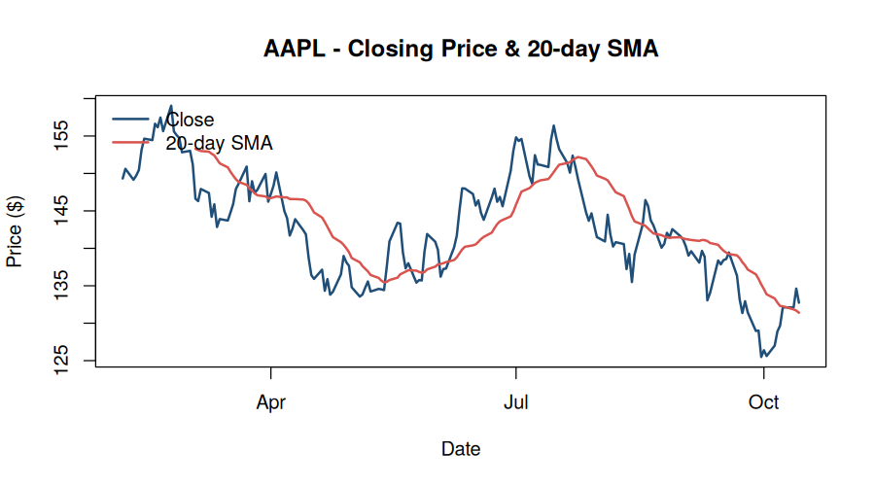
AAPL — closing price with 20-day SMA
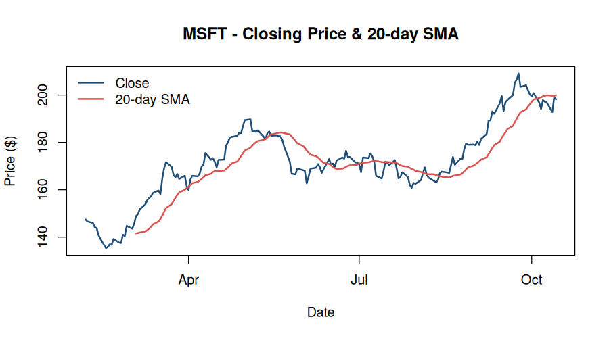
MSFT — closing price with 20-day SMA
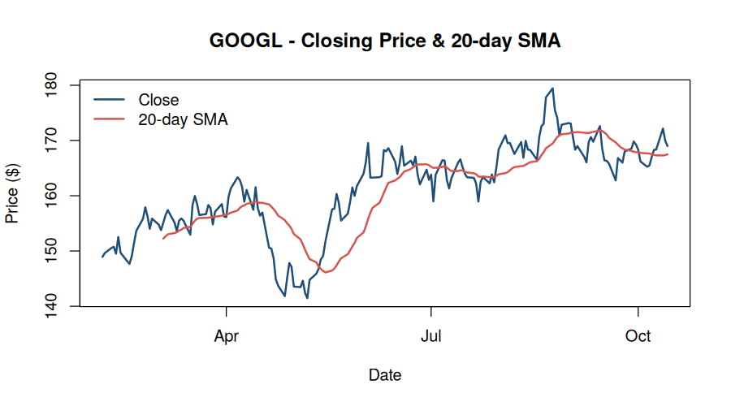
GOOGL — closing price with 20-day SMA
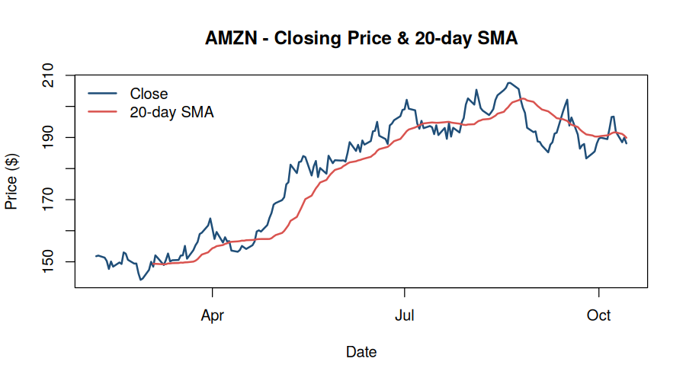
AMZN — closing price with 20-day SMA

Step 8 — Documentation Summary
Every step above that could be executed and verified in this environment (project configuration, the load/compute/display functions, and the full pipeline run) was actually run end-to-end — all numbers and charts in this report are genuine script output, not typed-in estimates. The three steps that are inherently personal-machine actions (GitHub sign-in, the R/RStudio graphical installers, and running install.packages() in your own RStudio) are marked with red placeholder boxes above; completing those and dropping your own screenshots into this document is the only remaining work before submission.

