**Nonplanar Graphene Framework as Epitaxial Zn Anode Substrate**

Pruthvi Banginwar, Jingxu Zheng

**Abstract:** During battery charging, metals tend to form dendritic growths and become difficult to recover. This also results in reduced efficiency and charge density over multiple cycles. We report a method for epitaxial growth that builds upon Zheng, et. al.’s work for controlled growth, nucleation, and reversibility of metal anodes. Graphene’s low lattice mismatch with Zinc makes it an ideal candidate as a substrate for epitaxial growth of Zinc, locking in a preferred crystallographic orientation. We hypothesize that embedding graphene into a carbon cloth matrix will increase the surface area of graphene available for electrodeposition would lead to elevated areal capacity while maintaining the nucleation benefits that epitaxial growth brings. We demonstrate that Zn. Graphene batteries developed this way can achieve exceptional Coulombic Efficiency (>99.6%) for hundreds of cycles at 1-16 mAh/cm2 current areal capacities.

**1. Introduction**

In an energy-hungry world that is transitioning to relying on renewable sources of energy, the need for rechargeable, affordable, long-term energy storage is increasing. Anodes that use Zinc, along with other electrochemically active metals, are of scientific and technological interest due to the role they play in batteries with high density in energy storage per unit area or volume. The materials used in the formulation of the batteries, tested in this study allow higher areal capacity per dollar than traditional materials. ZnTFSI was used as an electrolyte salt in this study, although Zinc Perchlorate could hypothetically work just as well, and is cheaper to use.

One of the biggest problems facing Zinc batteries is the propensity for dendritic growth to both cause significant loss of active material -- causing low Coulombic Efficiency -- and pierce the separator -- shorting the battery and causing relatively low cyclability. A battery that utilizes epitaxial growth of Zinc onto graphene with low lattice mismatch and strain would greatly reduce these issues, as Zheng, et. al. showed, and we further build upon here.

The thin, yet 3D framework of the carbon cloth matrix, exposes a higher surface area of graphene than a 2D substrate for the same 2D area. The ridges and weaves provide more available surface area. Having more surface area exposed provides more area for zinc deposition, thus hypothetically allowing greater areal capacity per 2D unit of area. The carbon cloth used in this study is of a negligible thickness, and does significantly affect the weight or volume of the battery.

**2. Experimental procedures**

A piece of zinc metal is used as the anode. The cathode is prepared by adding some volume of an aqueous graphene dispersion (4% by weight) onto the carbon cloth, which is held inside the negative case of the CR 2032 cell. A common lab spatula was used to spread the dispersion onto the carbon cloth and apply pressure. A spacer was placed directly above to apply further pressure and allow the dispersion to more thoroughly wet the carbon cloth. The resulting configuration is shown in Figure 1. This is placed into an oven to dry and for the graphene to bind to the activated carbon cloth. After removal, the spacer and carbon cloth were removed from the negative case.

A Glass fiber separator(s) was/(were) added to the positive case over the zinc metal. A micropipette was used to wet it with 0.5 M ZnTFSI in Acetonitrile electrolyte. The carbon cloth, now with the dried graphene dispersion bound to it, is added on top, then the cell is assembled to completion as shown in Figure 2, and clamped shut.

The cells are then put into a voltammeter and tested against specific currents and areal capacities.

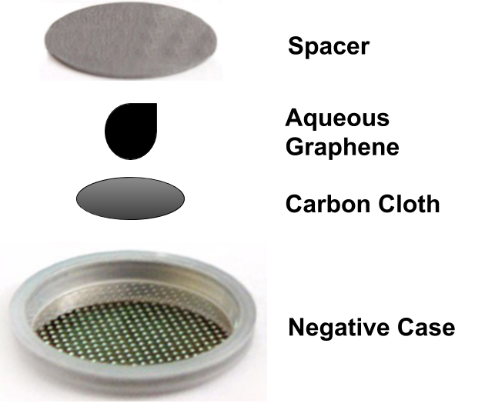

Figure 1: Diagram of cathode before and during drying stage.

**3. Results and Discussion**

In performing the Coulombic efficiency measurement of Zn plating stripping, a string of physical battery explosions were observed. We hypothesized that these explosions are caused by the hydrogen evolution reaction (HER) in aqueous ZnSO4 electrolyte, creating a large pressure in the closed coin-cell batteries.

To evaluate this hypothesis, I switched to using an organic electrolyte -- **ZnTFSI in Acetonitrile (ACN)**. I was unsure of why the batteries would do this when using an aqueous electrolyte but because they popped open, even before performing any voltammetry tests, there must have been some spontaneous gas generation. ZnTFSI is a more expensive salt, although we tried ordering Zinc Perchlorate, which is cheaper, but it never arrived. After that, the batteries started working like a charm. I've had a lot of trouble with batteries shorting, and I've experimented with separators and physical positioning of the battery during testing in order to try to stop this. It has seemed to have an effect on areal capacities under **40 mAh**/cm2-- which seems to be a struggling point for these batteries, as I've described below. Following are some trends I've noted from my research this fall.

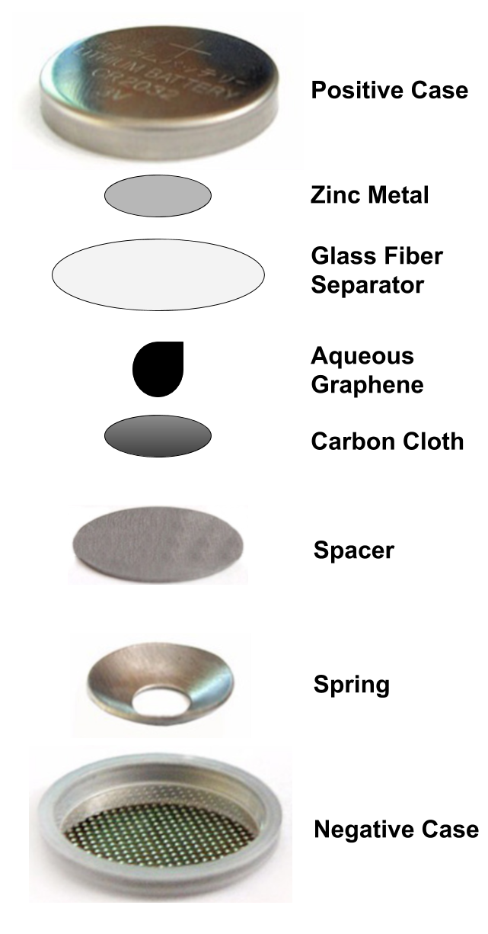

* Figure 2: Diagram of assembled coin cells

Summary of trends for Fall 2019

* Mass loading vs Areal Capacity -- not tested, although we expect there to be a positive relationship
* As shown in the table below, I can discern no clear relationship between areal capacity and cycles until shorting, although it is clear that at 31.58 mAh/cm2, the battery can not handle many cycles.

|  |  |  |  |  |  |
| --- | --- | --- | --- | --- | --- |
| Areal Capacity (mAh/cm2) | Current (mA) | Cycles until Short | Coulombic Efficiency Achieved (%) | Other details about assembly | Date made |
| **15.79** | 20 | not yet -- 182+ at last check on 12/20/2019 | 99.6+% | * 200 μL aqueous graphene (dried) * 250 μL 0.5 M ZnTFSI in ACN electrolyte * 1 thick glass fiber separators * ½ in diameter Zn Anode * ½ in diameter Carbon Cloth in cathode * Aqueous graphene dispersion was smeared into carbon cloth with a doctor blade, then the stainless steel spacer was pressed on top of the wet carbon cloth to really push the slurry through. Dried with the spacer on top of the carbon cloth * Undergoing testing cathode side up | 12/5/2019 |
| 15.79 | 40 | 38 | 99.5% | * 200 μL aqueous graphene (dried) * 250 μL 0.5 M ZnTFSI in ACN electrolyte * 1 thick glass fiber separators * ½ in diameter Zn Anode * ½ in diameter Carbon Cloth in cathode * Aqueous graphene dispersion was smeared into carbon cloth with a doctor blade, then the stainless steel spacer was pressed on top of the wet carbon cloth to really push the slurry through. Dried with the spacer on top of the carbon cloth * Underwent testing with cathode side up | 12/8/2019 |
| 31.58 | 20 | 5 | 99.4% (for later cycles) | * 200 μL aqueous graphene (dried) * 250 μL 0.5 M ZnTFSI in ACN electrolyte * 1 thick glass fiber separators * ½ in diameter Zn Anode * ½ in diameter Carbon Cloth in cathode * Aqueous graphene dispersion was smeared into carbon cloth with a doctor blade, then the stainless steel spacer was pressed on top of the wet carbon cloth to really push the slurry through. Dried with the spacer on top of the carbon cloth * Underwent testing cathode side down | 12/5/2019 |
| 3.95 | 20 | 123 | 99.8% | * 100 μL aqueous graphene (dried) * 250 μL 0.5 M ZnTFSI in ACN electrolyte * 2 thin glass fiber separators * ½ in diameter Zn Anode * ½ in diameter Carbon Cloth in cathode * Aqueous graphene dispersion was smeared into carbon cloth with a doctor blade, then the stainless steel spacer was pressed on top of the wet carbon cloth to really push the slurry through. Dried without the spacer present * Underwent testing cathode side down | 11/18/2019 |
| 1.58 | 10 | 23 | 99.14% | * 60 μL aqueous graphene (dried) * 150 μL 0.5 M ZnTFSI in ACN electrolyte * 2 thin glass fiber separators * ½ in diameter Zn Anode * ½ in diameter Carbon Cloth in cathode * Aqueous graphene dispersion was smeared into carbon cloth with a doctor blade * Dried without spacer present * Underwent testing cathode side down | 11/16/2019 |
| 31.58 | 20 | 4 | 99.4% (for later cycles) | * 200 μL aqueous graphene (dried) * 250 μL 0.5 M ZnTFSI in ACN electrolyte * 1 thick glass fiber separators * ½ in diameter Zn Anode * ½ in diameter Carbon Cloth in cathode * Aqueous graphene dispersion was smeared into carbon cloth with a doctor blade, then the stainless steel spacer was pressed on top of the wet carbon cloth to really push the slurry through. Dried with the spacer on top of the carbon cloth * Underwent testing cathode side up | 12/8/2019 |

* Table 1: Areal Capacity and current vs cycles until shorting

1. 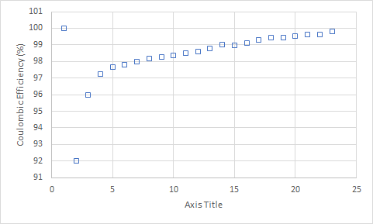
2. 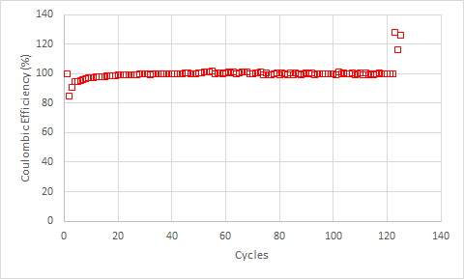
3. 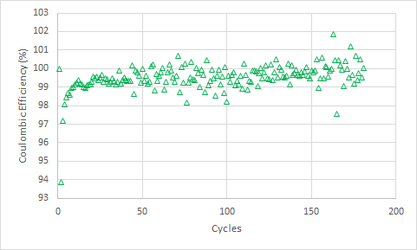
4. 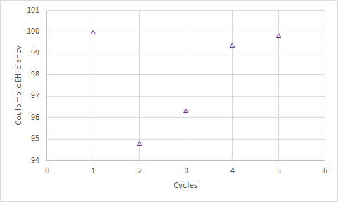
5. 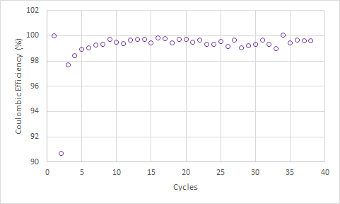
6. 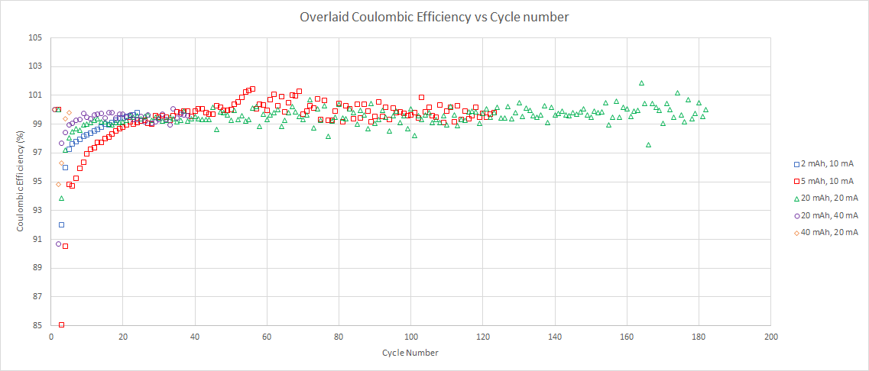

* Figure 3: Coulombic Efficiency vs Cycle number for various areal capacities and current cycles a), 1.58 mAh/cm2, 10 mA, b) 3.95 mAh/cm2, 10 mA, c) 15.79 mAh/cm2, 20 mA, d) 31.58 mAh/cm2, 20 mA, e) 15.79 mAh/cm2, 40 mA, and f) an overlaid plot of all of them. This illustrates more clearly the stark difference in cyclability of the various batteries before shorting.
* The battery could theoretically hold more than 15.79 mAh/cm2 well with long cycle life, but I did not delve into finding this limit.
* It thus seems like with a 200 μL mass loading of aqueous graphene, the capability to store 31.58 mAh/cm2 is possible, but has poor cyclability. Using thicker glass fiber separator did not make a difference. I did not use Celgard 3501 as it is meant for aqueous electrolytes. This is a stark difference in cyclability vs the 15.79 mAh/cm2 battery with the same exact assembly otherwise; so this lack of cyclability may have something to do with the inability of Zinc to deposit epitaxially over more layers across the carbon cloth matrix (?)
* I am currently investigating whether changing the physical position of the battery during testing can affect its cycle life before shorting in case of gravitational effects. i.e. whether having the cathode side facing up or down makes a difference. I investigated this because, as Bonnick, et. al. hypothesized, the electrolyte that flows into the spring area of the cell can become disconnected from the bulk by gravity when the cap faces down. As Kent hypothesized, the gravitational force can increase the ability to strip the cathode by enhancing the natural convection induced by the concentration gradient. The convective flow field is known to have a nontrivial effect on the electrodeposition morphology. So far, it has been working for the 20 mAh battery, but I can’t make a clear conclusion due to lack of data.
  + Reference: P. Bonnick and J. R. Dahn, “A Simple Coin Cell Design for Testing Rechargeable Zinc-Air or Alkaline Battery Systems,” J. Electrochem. Soc., 159, A981 (2012)
    - <http://jes.ecsdl.org/content/159/7/A981.short>
* A clear trend between areal capacity and coulombic efficiency could not be determined from the data taken

**4. Conclusions**

As compared to Zheng et, al.’s results, we achieved higher areal capacities, although cyclability became such a large issue at high areal capacities that we did not test greater capacities.

A clear trend between areal capacity and coulombic efficiency could not be determined from the data.

Evidence of epitaxial growth could be obtained by SEM imaging of the cell at various points in its charge/discharge cycles. This information could substantially support/disprove our hypothesis of epitaxial growth contributing to the exceptional Coulombic Efficiencies and areal capacities achieved.

The low cyclability of these batteries warrants further investigation. What caused some cells to last significantly longer than others, and why there was an especially low number of cycles until short at high areal capacities (30+ mAh/cm2) is important to know and could be minimized in future designs.

One of the most interesting changes made to the Zheng, et. al.’s design was that of the electrolyte used. His design incorporated an aqueous ZnSO4 electrolyte, although the same electrolyte caused significant unwanted side reactions with the batteries tested in this study. Experimentally, the organic ZnTFSI-ACN system used in this study performed far better than the aqueous ZnSO4-H2O system used by Zheng, et. al., although ZnClO4-ACN would likely perform well as well. The organic electrolytes seem to fare better in this circumstance. The exact reason for the poor performance of the aqueous electrolyte is unknown, and something to further investigate. It could reveal useful information about how electrolytes interact with the cathode in this type of battery.