Title of Your Project
Your Name(s) here
Florida Institute of Technology

Abstract
The purpose of this document is three-fold. First, it describes the requirements of the project proposal. Second, it presents this information in a style your proposal should mimic. Third, it helps teach academic writing techniques. Your proposal is expected to have an abstract. An abstract is a two-paragraph maximum executive summary of your work. It should briefly outline your problem statement and its (expected) contributions.

INTRODUCTION
You should begin by introducing your topic. In this section, you should define the core terminology specific to the field, introduce the problem statement, and make clear the benefits (motivate!) of resolving that problem statement. The main difference between the ABSTRACT and Introduction sections is that the abstract summarizes the entire project, including results, whereas the introduction only provides the motivation of the problem and an overview of the proposed solution.

Answer each of the following questions in one paragraph to compose your introduction:

Problem Statement. One paragraph to describe the problem that you are tackling.

Motivation. Why is this problem interesting and relevant to the (graphics/games/UI) research community?

Proposed Solution. How do we propose to tackle this problem (that has been identified in the previous paragraphs, is interesting to the community, and has yet to be tackled by other researchers)?

Contributions. An enumeration of the contributions of the senior design project

This project makes the following contributions:
- Contribution 1
- Contribution 2

Design Goals
Who is the target Audience for your project? How does the audience benefit? What goals or objectives will you solve for the user?

Projects Proposed Features and Functionality
What features and functionality will you implement for your design project?
- Feature 1
- Feature 2
- Feature 3

RELATED WORK
Perhaps the most important section of your proposal is related work. In this section, create a taxonomy of prior work relevant for your project. Here you demonstrate that you have read and understand what others in the field have done. This ensures you (1) know the state-of-the-art, (2) are not directly copying others work, and (3) you know the performance levels you must achieve to make a contribution. As you discuss each related work, make note of how each has advanced the field. Then, enumerate how your project extends and enhances prior work.

Example Subsection Header
This section should have in-line citations to your bibliography. We are going to require that your proposal has (at least) 6 references. List all bibliographical references in 9-point Times, single-spaced, at the end of your paper in alphabetical order. When referenced in the text, enclose the citation index in square brackets, for example [Lou90]. Where appropriate, include the name(s) of editors of referenced books.
For your references please use the following formats:
- one author: first 3 chars plus year - e.g.[Lou90]
- two, three or four authors: first char of each family name plus year - e.g.[FH93] or [KSS97] or [LFTG97]
- more than 3 authors: first char of family name from first 3 authors followed by a '*' followed by the year -e.g.[BFH*98] or [FvDF*93]

PROJECT PROPOSAL
Now is the time to introduce your proposed project in all of its glory. Admittedly, this will be difficult. Even so, setting and realizing realistic research goals is an important skill. Begin by summarizing what you are going to do and the expected benefit it will bring.

PLEASE PROVIDE DETAILS IN THIS SECTION.

Anticipated Approach
Having summarized what you are going to do, it’s time to describe how you plan to do it. Let us suppose you are going to create a service that takes a cell-phone picture of a building and returns the building’s name via text message. In this case you might want to talk about establishing a server to receive pictures via MMS. Once the picture is received, you will run an edge extraction algorithm over it. Then, similarity between the submitted picture and those stored (and tagged) in a MySQL database will be computing using algorithm XYZ. Finally, the tag of the most similar image will be returned to the user.

Target Platforms
What software (e.g. Unity, Maya, CUDA, etc) and hardware platforms (NIVIDIA Graphics cards, Vicon system, etc) will you use?

Evaluation Criteria
Suppose you have implemented your approach, and it’s fully functioning. In this section, think about how your project can be evaluated to show that it works better than previous work. For example, if you were implementing a hair simulation, you might compare your results to videos of existing hair simulations. Think in terms of making a comparison to something for the purposes of showing how or why your proposed technique works better.
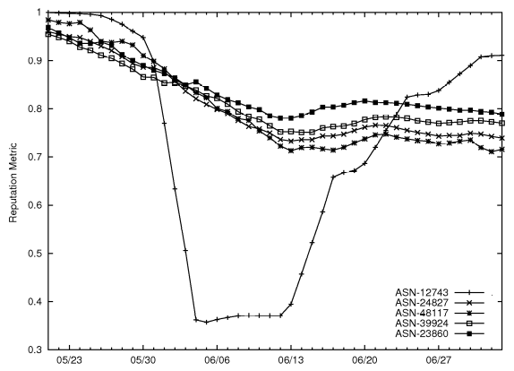
Figure 1: Here is a sample figure. Please provide figures and images if they are helpful for explanation, please also reference your figure in your text.

RESEARCH TIMELINE
Finally, we would like you to speculate about the pace of your research progress. This section need not be long, but we would like you to specify several milestones which we can use to gauge your progress throughout the semester. If this is a group project, please list who is responsible for which tasks. For example:

Project Milestone Report (Alpha Version)
- Completed all background reading
- Proposed software framework is functioning with simple base case
- Collected all necessary data and images

Project Final Deliverables
List what you will deliver at the end of the semester
- Software having particular features
- Demo 1
- Demo 2
- Documentation

Project Future Tasks
- Imagine you had 6 more months to work on this project. How would you extend the project to make it even more robust and fully-featured?

You should insert a GANT CHART, see figure 2, to visualize your timeline of tasks. This timeline is very important for planning your time. Budget things the best you can and leave buffer space, especially at the end of the semester and before the alpha review, to account for tasks taking longer than expected. This is a 130 hour project, so we expect you to spend 10-12 hours per week over the course of the semester. You can use tables in word or import an excel image to easily add such a table to this document.

(remove line)

You will fill in the following sections as you make progress on your project, particularly for the alpha review and the final deliverable. In these sections, list pseudo-code, charts, images, examples, etc. to show what you’ve done over the course of the semester.

Method

RESULTS

CONCLUSIONS and FUTURE WORK
APPENDIX
- Optional Appendix
Some text here. Some text here. Some text here.

(remove line)

References
[BFH*98] | BUHMANN J. M., FELLNER D. W., HELD M., KETTERER J., PUZICHA J.: Dithered color quantization. Computer Graphics Forum 17, 3 (Sept. 1998), C219–C231. (Proc. Eurographics’ 98).
[FH*93] | FELLNER D. W., HELMBERG C.: Robust rendering of general ellipses and elliptical arcs. ACM TOG 12, 3 (July 1993), 251–276.
[FvDF*93] | FOLEY J. D., VAN DAM A., FEINER S. K., HUGHES J. F., PHILLIPS R.: Introduction to Computer Graphics. Addison-Wesley, 1993.
[KSS97] | KOBBELT L., STAMMINGER M., SEIDEL H.P.: Using subdivision on hierarchical data to reconstruct radiosity distribution. Computer Graphics Forum 16, 3 (1997), C347–C355. (Proc. Eurographics’97).
[LFTG97] | LAFORTUNE E. P., FOO S.-C., TORRANCE K. E., GREENBERG D. P.: Non-linear approximation of reflectance functions. In Proc. SIGGRAPH ’97 (1997), vol. 31, pp. 117–126.
[Lou90] | LOUS Y. L.: Report on the First Eurographics Workshop on Visualization in Scientific Computing. Computer Graphics Forum 9, 4 (Dec.  1990), 371–372.

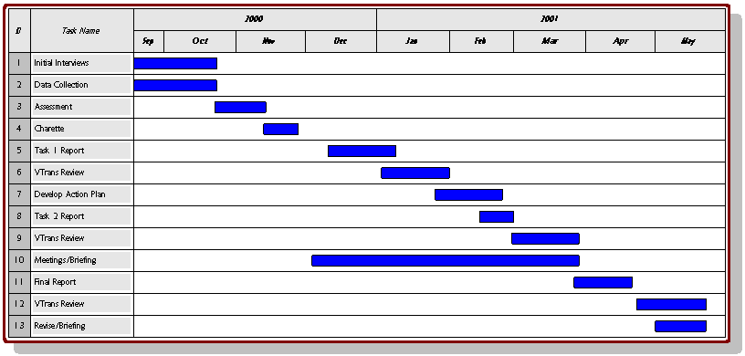
Figure 2: For publications with color tables and figures that span two columns like your gant chart or results will.

