**Project :- 1 (Extra_Credit)**

Name: Pruthvik H Kakadiya

ID: 1001861545

Work Done: Whole project Solo (no team)

1. Create 2 interactive (command line) or form or Web interfaces to **INSERT a new record in each of the 2 tables DEPARTMENT and PROJECT**. Each interface should allow the users to enter the attribute values of the new record, then INSERT the record in the table. Use the interfaces to insert 2 new records in each of the 2 tables. Turn in query results that show the new records that you inserted in each table.

I have used python as my interactive programming language.

First using the Tkinter python library (Python Library to make simple and basic GUI applications ) I have made two forms

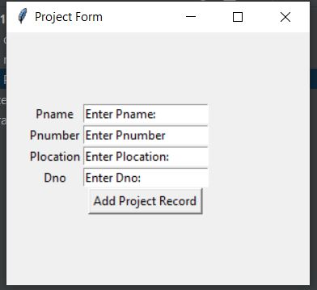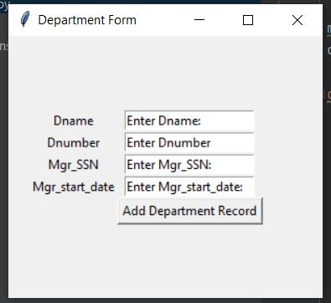1: Department _form 2: Project_form

On the button click(for buttons Add Department Record & Add Project Record) events of these forms I have run the mysql connection code to connect these form’s codes to my mysql database and the query to INSERT records in tables Department and Project accordingly.

* Screenshots of INSERT INTO query:

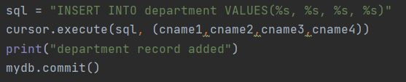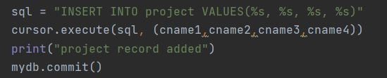

Here cname1-4 represents the columns 1-4 in respective areas Tables.

* Screenshots of records added:

For department table I have inserted these two records.

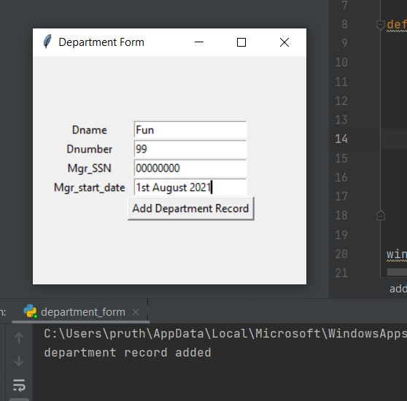

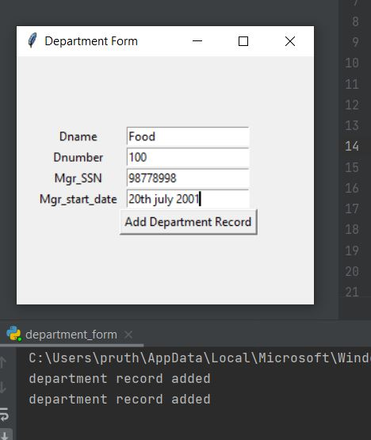

* Screenshot of query to show these records in database:

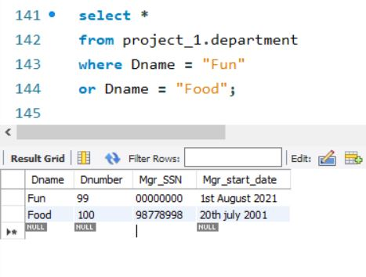

For Project table I have inserted these two records.

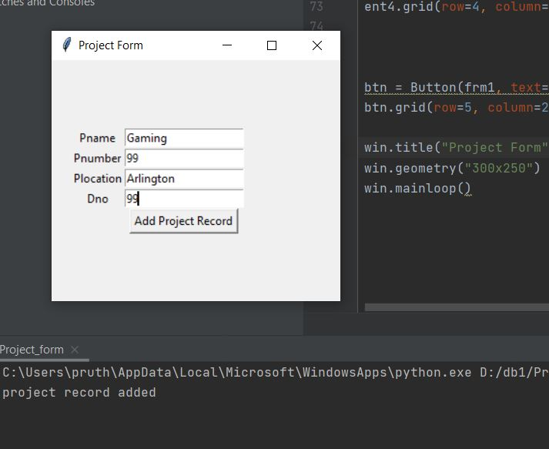

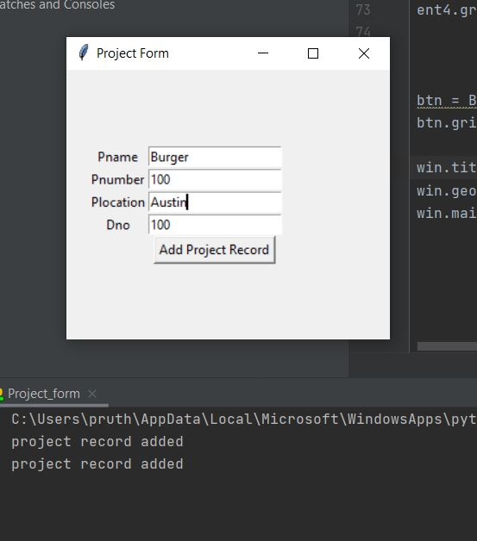

* Screenshot of query to show these records in database:

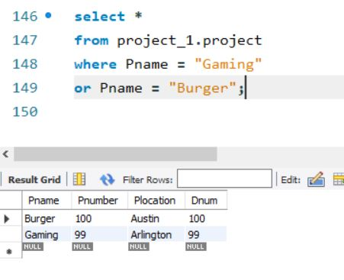

With this document I have also submitted the Department_form.py and Project_form.py which contains source codes of how I implemented each forms and connected them with mysql database.

1. Create 2 VIEWS as follows: **the first view PROJ_EMPS.** The view will have the following information: PROJ_EMPS (PNAME, LNAME, FNAME, HOURS) and will order the project info by PNAME in ascending order and within each PNAME the employees will be ordered by LNAME, FNAME in ascending order also. **The second view PROJ_SUMMARY** will have one record for each project and will include the information PROJ_SUMMARY (PNAME, NO_OF_EMPS, TOTAL_HOURS), where NO_OF_EMPS is the number (COUNT) of employees currently working on the project and TOTAL_HOURS is the SUM of the HOURS that the employees work on the project. Order the data by PNAME in descending order.

Query: view 1:

CREATE VIEW PROJ_EMPS as

select project.Pname, employee.Lname, employee.Fname, works_on.Hours

from employee, project, works_on

where project.pnumber = works_on.Pno

and employee.SSN = works_on.ESSN

ORDER BY project.Pname,employee.Lname, employee.Fname ASC;

Select * from PROJ_EMPS;

Screenshot:

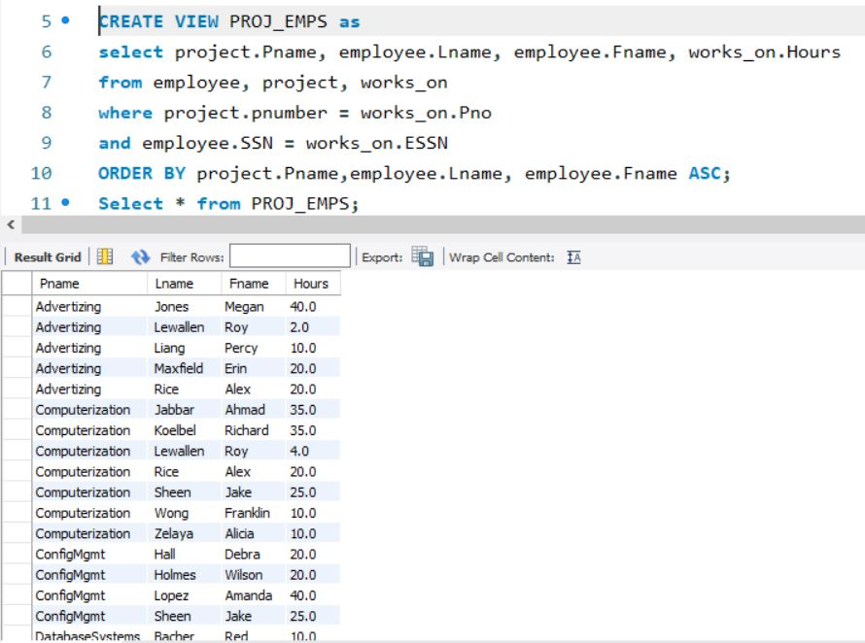

Query: view 2:

CREATE VIEW PROJ_SUMMARY as

select project.Pname, count(works_on.ESSN) as Number_of_Employees, sum(works_on.Hours) as Total_Hours

from project, works_on

where project.pnumber = works_on.Pno

group by Pname

ORDER BY project.Pname DESC;

Select * from PROJ_SUMMARY;

Screenshot:

