**Project :- 1 (Part_2)**

Name: Pruthvik H Kakadiya

ID: 1001861545

Work Done: Whole project Solo (no team)

**Write SQL queries OR use a simple Web interfaces to get the results of the following queries:**

1. For the “Research” department, retrieve all the names, salaries and employees ID of all employees who work in that department and earn salary less than 60000.

Query:

select Fname, Lname, Salary, SSN as Employee_Id

from employee, department

where Dname = "Research"

and Dnumber = Dno

and Salary < 60000

Screenshot:

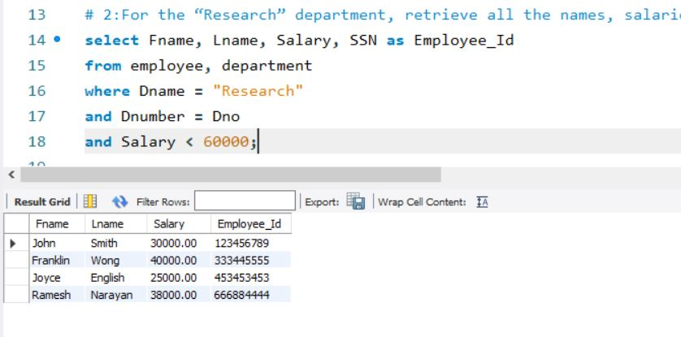

1. Enter a department name, and retrieve all the names and salaries of all employees who work in that department.

# change value of var_department_name varible to reterive output for desired department name.

Query:

set @var_department_name = "Administration";

select Fname, Lname, Salary

from employee, department

where Dname = @var_department_name

and Dnumber = Dno ;

Screenshot:

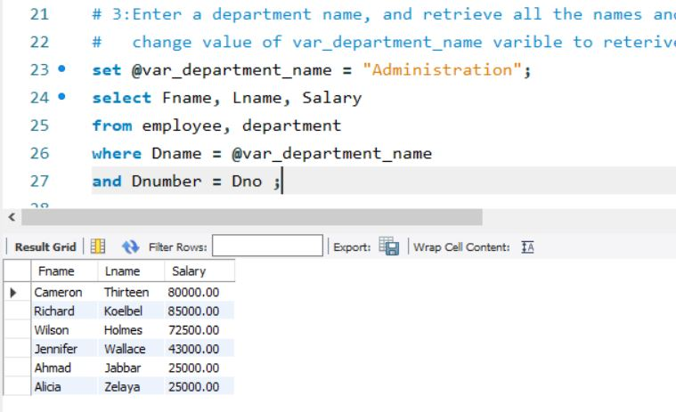

1. For the employee, whose last name is “Henderson” and first name is “Mike”, retrieve a list of projects names/hours per week that the employee works on.

Query:

select Pname as Project_names, Hours as Hours_per_week

from employee, works_on, project

where Lname = " Henderson"

and Fname = "Mike"

and ESSN = SSN

and Pnumber = Pno ;

Screenshot:

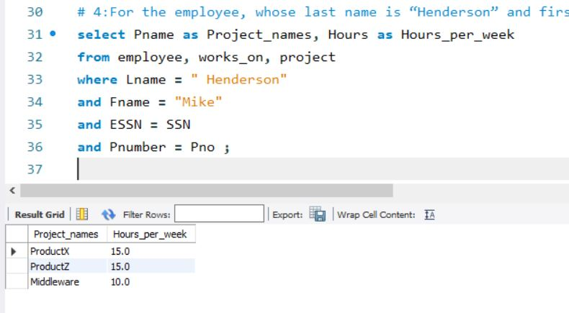

1. Enter an employee last name and first name and retrieve a list of projects names/hours per week that the employee works on.

# change value of variables var_last_name & var_first_name to get output for a pertivular employee

Query:

set @var_last_name = " Borg";

set @var_first_name = "James";

select Pname as Project_names, Hours as Hours_per_week

from employee, works_on, project

where Lname = @var_last_name

and Fname = @var_first_name

and ESSN = SSN

and Pnumber = Pno ;

Screenshot:

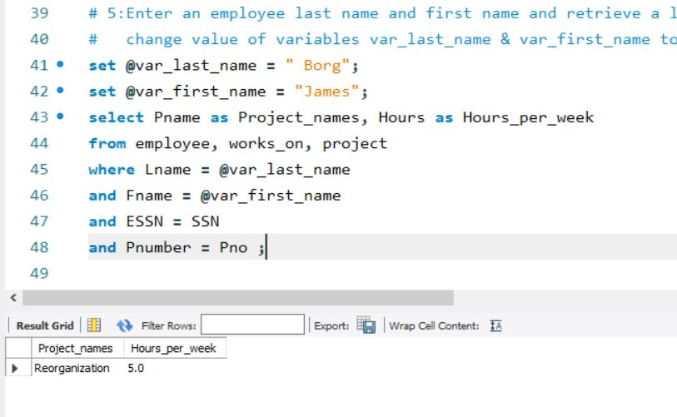

1. Enter a department name and retrieve the total (sum) of all employee salaries who work in the department.

# change value of var_dept_name varible to reterive output for desired department name.

Query:

set @var_dept_name = "Sales";

select sum(Salary) as Total_Salary

from employee,department

where Dname = @var_dept_name

and Dnumber = Dno;

Screenshot:

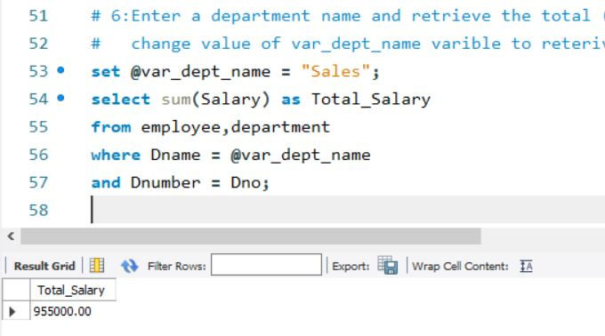

1. For each department Located in Texas, retrieve the department name and the number (count) employees who work in that department. Order the result by number of employees in descending order.

Query:

select Dname, count(SSN) as Number_of_Employees

from employee, department, dept_locations

where employee.Dno = department.Dnumber

and department.Dnumber =

(select dept_locations.Dnumber

where dept_locations.Dlocation in (' Houston', ' Dallas',' Arlington',' Austin'))

group by Dname

order by count(SSN) desc;

Screenshot:

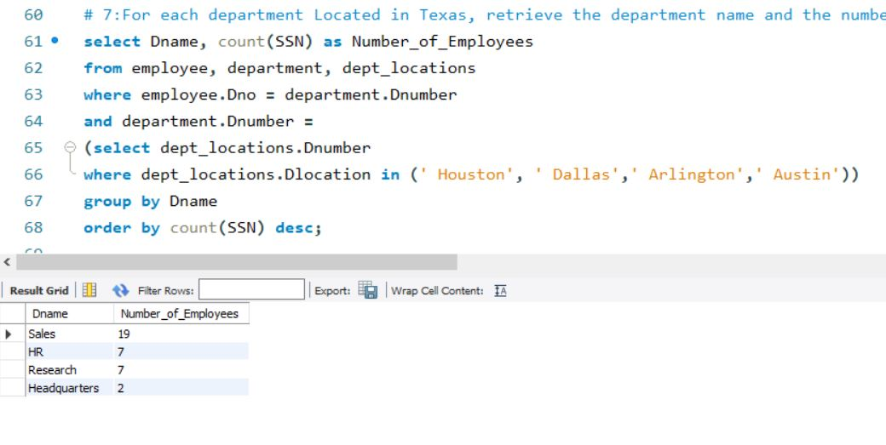

1. For each department, retrieve the department name and the number (count) of employees who work in that department. and have a salary greater or equal to 50000. Order the result by number of employees in descending order.

Query:

select Dname, count(SSN) as Number_of_Employees

from employee, department

where employee.Dno = department.Dnumber

and Salary >= 50000

group by Dname

order by count(SSN) desc;

Screenshot:

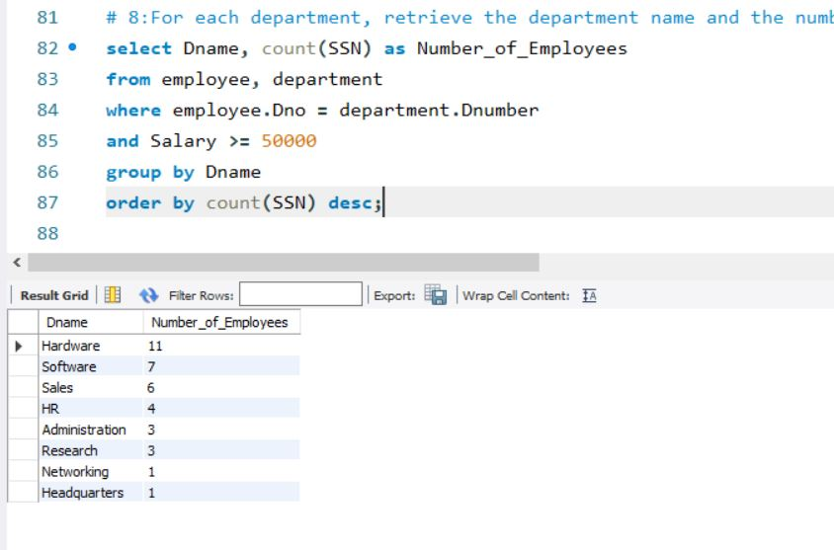

1. For each department, retrieve the following information: the department name; the first and last name of the employee who manages the department; the number (count) of employees who work in the department; the total (sum of) salaries of the employees who work in that department; and the highest and lowest salary of the employees who work in that department. Order the result alphabetically by department name.

Query:

select Dname,E.Fname,E.Lname,

count(employee.SSN) as Number_of_Employees,

sum(employee.Salary) as Total_Salary,

max(employee.Salary) as Highest_Salary,

min(employee.Salary) as Lowest_Salary

from department,employee as E,employee

where E.SSN = department.Mgr_SSN

and employee.Dno = department.Dnumber

group by Dname

order by Dname asc;

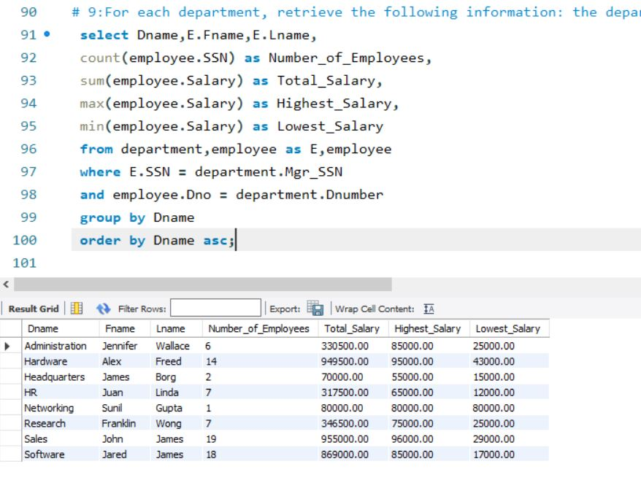

1. For each project, retrieve the project name and the number (count) of employees who are working on that project. Order the result in descending order by number of employees.

Query:

select Pname, count(works_on.ESSN) as Number_of_Employees

from project, works_on

where project.Pnumber = works_on.Pno

group by Pname

order by count(works_on.ESSN) desc;

Screenshot:

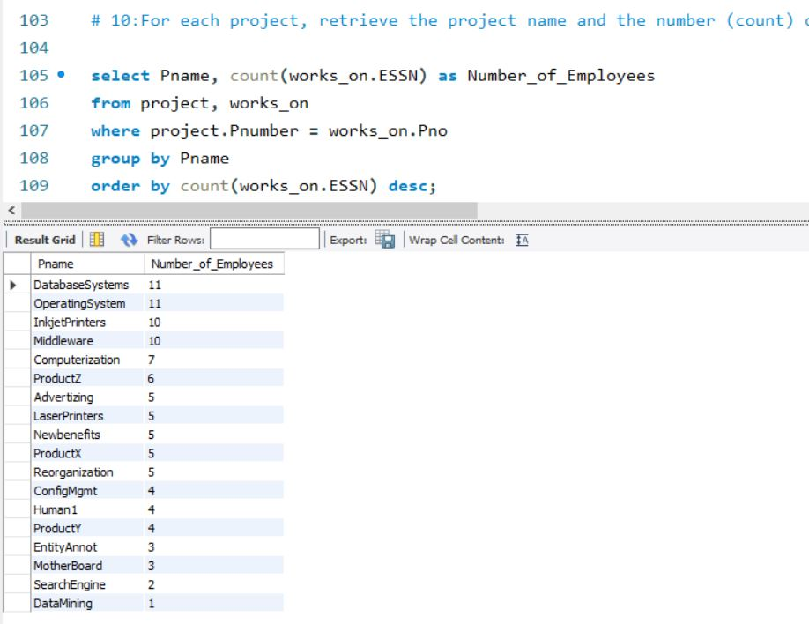

1. For each employee who is a supervisor, retrieve the employee first and last

name and the number (count) of employees that are supervised. Order the result in descending order.

Query:

select E.Fname,E.Lname,count(employee.SSN) as Number_of_Employees

from department,employee as E,employee

where E.SSN = department.Mgr_SSN

and employee.Super_ssn = E.SSN

and employee.Super_ssn != employee.SSN

and employee.Super_ssn != 'null'

group by E.Fname, E.Lname

order by count(employee.SSN) desc;

Screenshot:

