**Project :- 1**

Name: Pruthvik H Kakadiya

ID: 1001861545

Work Done: Whole project Solo (no team)

1. I have used MySQL server and MySQL workbench.
2. source codes for SQL create statements:

create database Project_1;

use Project_1;

create table Employee (

Fname varchar(15) not null,

Minit char,

Lname varchar(15) not null,

SSN char(9) not null,

Bdate date,

Address varchar(30),

sex char, Salary decimal(10,2),

Super_SSN char(9),

Dno int not null, primary key(SSN)

);

create table Department (

Dname varchar(15),

Dnumber int not null,

Mgr_SSN char(9) not null,

MGR_start_date date,

unique(Dname),

foreign key(Mgr_SSN) references Employee(SSN),

primary key(Dnumber)

);

create table Project (

Pname varchar(15) unique,

Pnumber int not null,

Plocation varchar(15),

Dnum int not null,

Foreign key(Dnum) references Department(Dnumber),

primary key(Pnumber)

);

create table Works_On (

ESSN char(9) not null,

Pno int not null,

Hours decimal(3,1) not null,

primary key(ESSN,Pno),

foreign key(ESSN) references Employee(SSN),

foreign key(Pno) references Project(Pnumber)

);

create table Dept_Locations (

Dnumber int not null,

Dlocation varchar(15),

primary key(Dnumber,Dlocation),

foreign key(Dnumber) references Department(Dnumber)

);

show tables in Project_1;

Here are the screenshots of create statements (employee as an example and list of all the created tables)

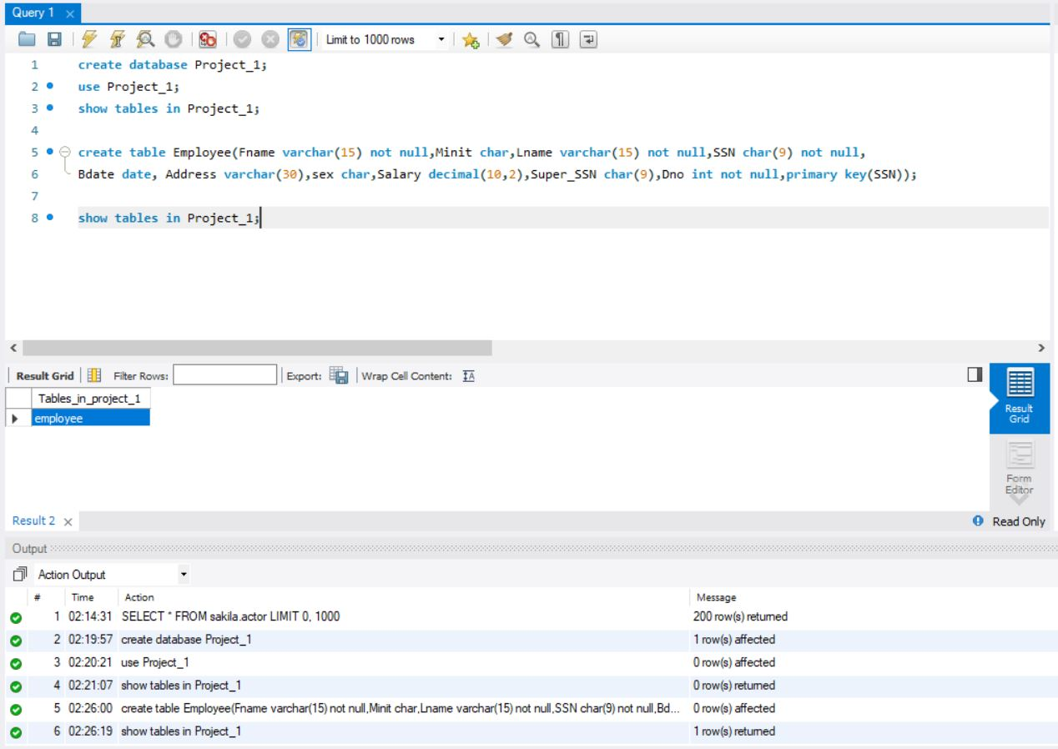

Create employee screenshot

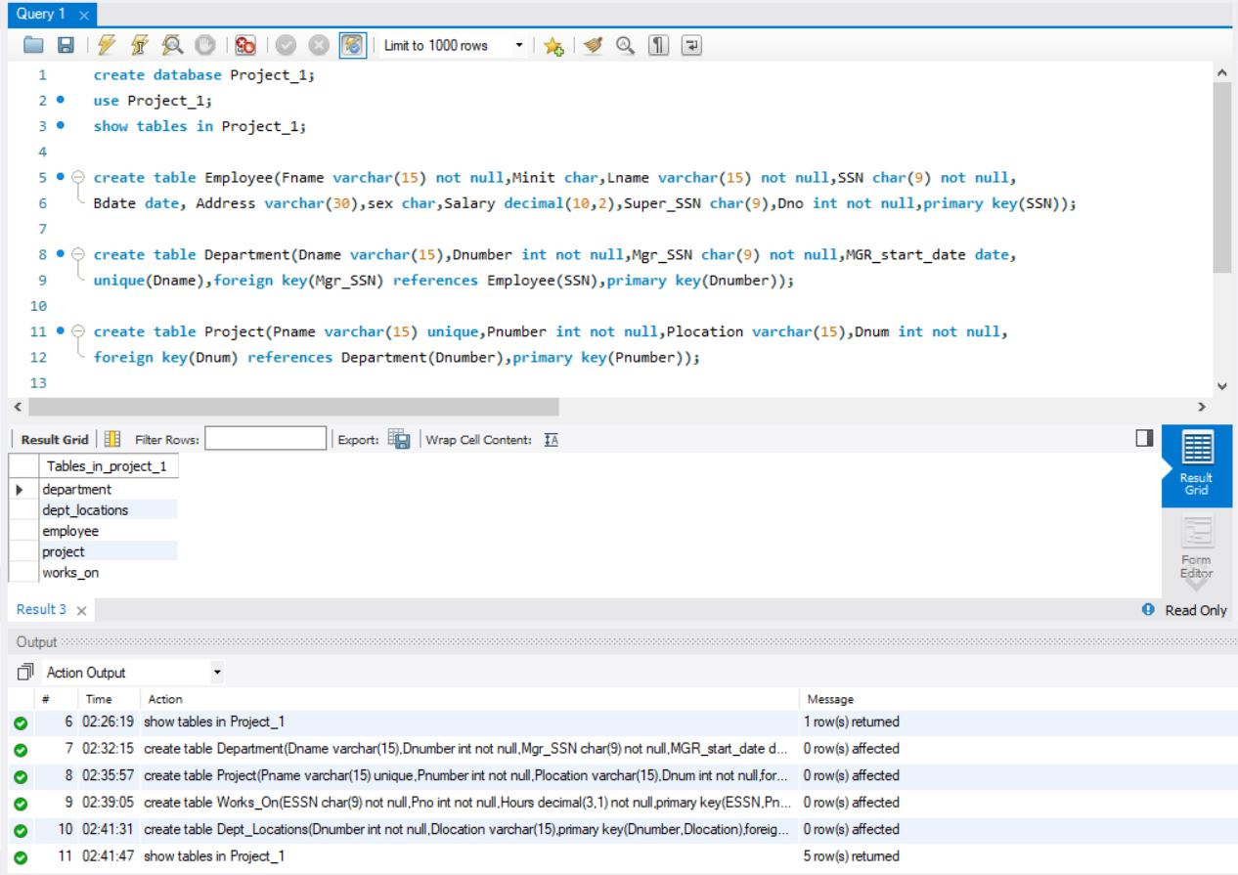

All tables

1. At first, I have converted all the .txt files into .csv files using excel (Mdos csv file) after that I have used Table Data Import method to load all the data in different tables.

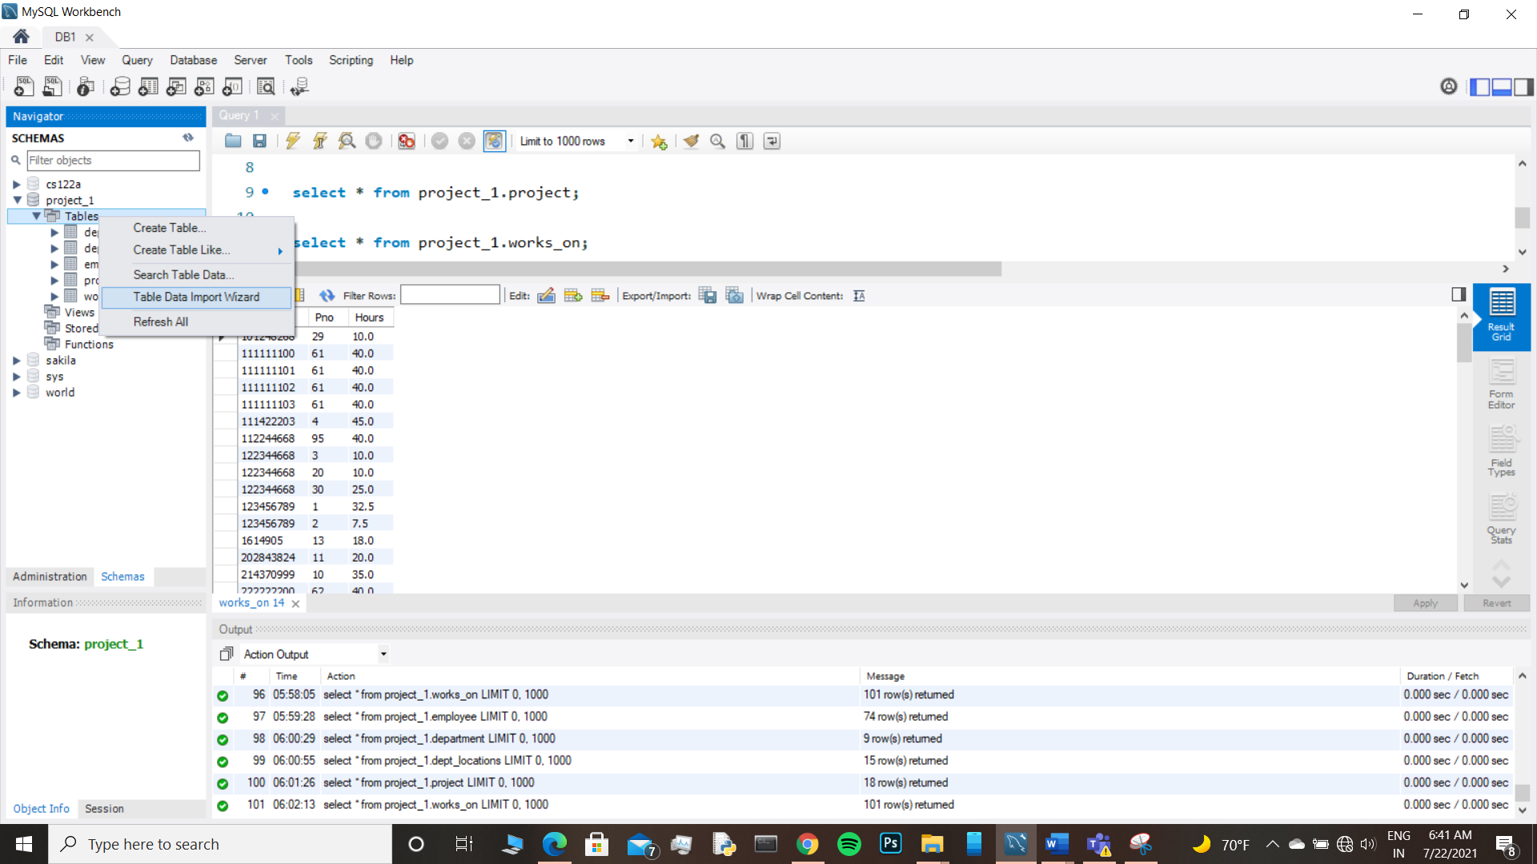

1. Source code for SQL create statements.

select * from project_1.employee;

select * from project_1.department;

select * from project_1.dept_locations;

select * from project_1.project;

select * from project_1.works_on;

Here are the screenshots of the individual tables with data:

**Employee Table**

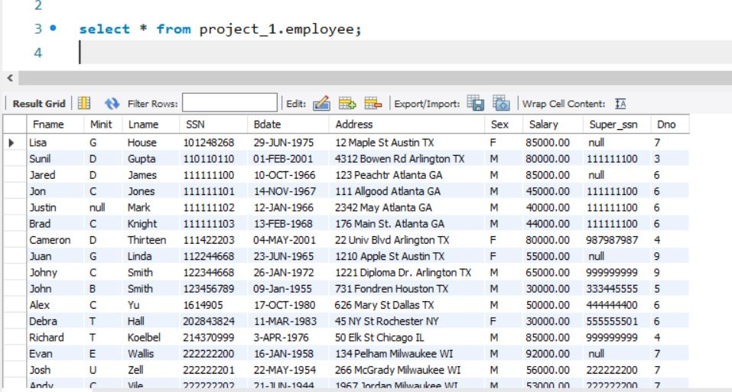

**Department Table**

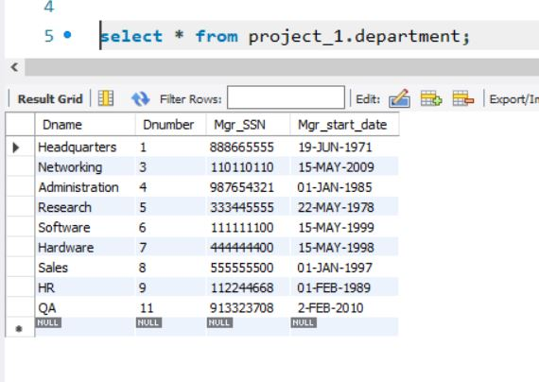

**Project Table**

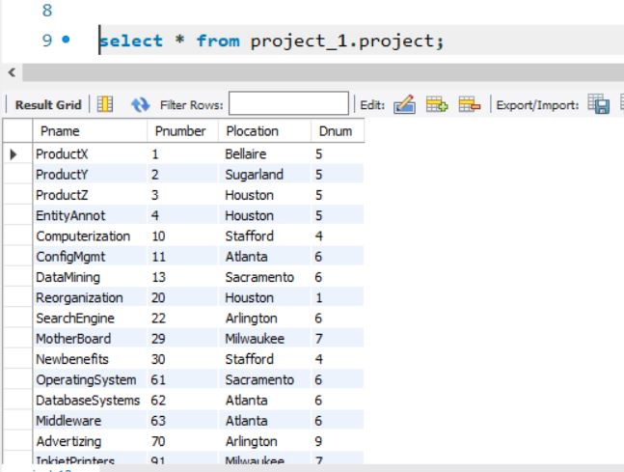

**Works_on Table**

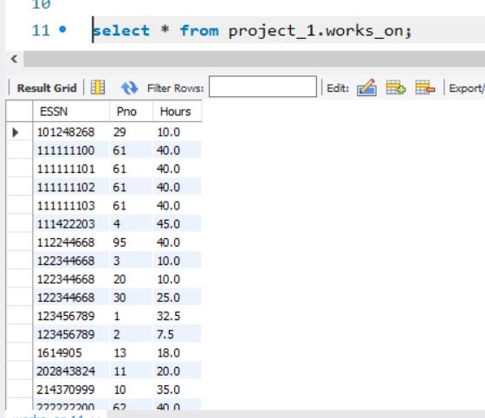

**Dept_locations Table**

