# Aim: String Operations. (index, strip, count, split, upper, lower, isupper, islower, translate, format, find, center, join).

## Program:

#string operations.

*str*='hello world!'

#index

print('index:',*str*.index('h'))

#strip

strs='     space       '

print('strip:',strs.strip())

#count

print('count:',*str*.count('l'))

#split

print('split:',*str*.split(' '))

#upper

print('upper:',*str*.upper())

#lower

print('lower:',*str*.lower())

#isupper

print('isupper:',*str*.isupper())

#islower

print('islower:',*str*.islower())

#translate

*dict* = {101: 69, 104: 72}

print('translate:',*str*.translate(*dict*))

#format

print('string is: {0}'.format(*str*))

#find

print('find:',*str*.find('wo'))

#center

print('center:',*str*.center(20,'*'))

#join

str2='*'

print('join:',str2.join(*str*))

## Output:

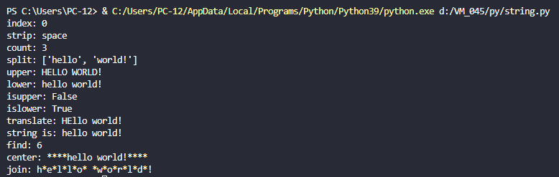

# Aim: List Operations. ( )

## Program:

#list operations

l=[1,'a',3,'b','c','d']

#index

print('index: ',l[3])

#range

print('range: ',l[0:5])

#insert

l[2]=2

print('insert element: ',l)

#delete

del (l[3])

print('delete: ',l)

#length

print('length: ',len(l))

#replicate

print('replicate: ',l*3)

#reverse

print('reverse: ',l[::-1])

## Output:

