Concept of Operating System

Assignment 1

**Problem 1:**

1. Navigate and List: Start by navigating to your home directory and list its contents. Then, move into a directory named "Linux Assignment" if it exists; otherwise, create it.

**Solution:**

Step 1: Open Ubuntu Application and type command pwd

**Explanation**: pwd Command signifies path from root to present working directory

Step 2: type cd .. which will navigate you to home directory

Explanation: cd .. Command is use to navigate you to previous directory from Current directory , In our case it was from cdac directory to home directory

Step 3: type ls command to list out all the content in home directory

Explanation: ls command is used to list out all the content of present directory

Step 4: type cd Linux_Assignment to navigate from home directory to Linux_Assignment

Explanation: cd command Stands for current Directory , To change to specific directory we have to use command like cd your-directory, but in our case linux_Assignment directory is not created

Step 5: type mkdir Linux_Assignment to create directory inside home directory

Explanation: mkdir stands for make directory it will create directory inside home directory. But it requires permission to create directory   
step 6: use sudo mkdir linux_Assignment to create directory inside home directory

* Sudo command runs as superuser allowing you to bypass permission restriction.

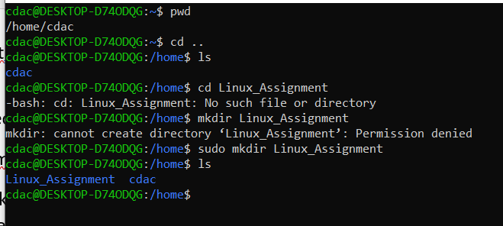

**Challenges:** Permission denied while creating directory in home directory

1. File Management:

Inside the "Linux Assignment" directory, create a new file named "file1.txt". Display its contents.

Solution:

Step 1: in home directory type sudo mkdir Linux_Assignment

This command will create Linux_Assignment directory

Step 2: type cd Linux_Assignment to navigate Linux_Assignment directory

Cd command is used to navigate to current directory

Step 3: sudo touch file1.txt

The touch command in Linux is used to update the access and modification times of files, or to create new files

Step 4: sudo nano file1.txt

The nano command in Linux is a command line text editor that allows users to create, edit, and save files.

Step 5: sudo cat file1.txt

The cat command in Linux reads and displays files contents, and can also concatenate files together.

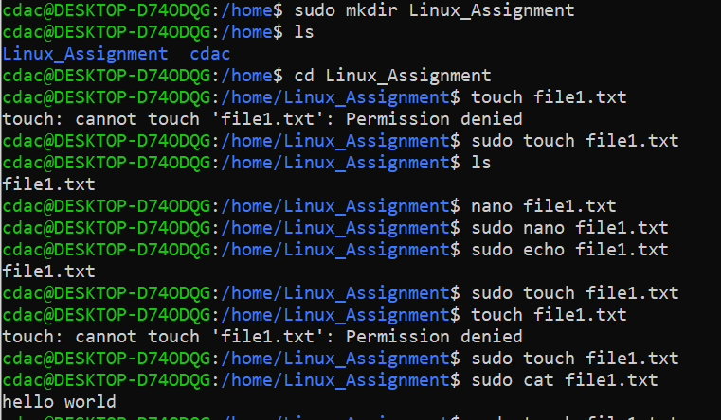

Challenges: without using sudo command cannot create file nor save the file in editor . therefore using sudo command at prefix was necessary for touch as well as for nano.

1. Directory Management:

Step 1: sudo mkdir docs

Creating directory docs inside Linux_Assignment directory

1. Copy and Move Files:

Step 1: sudo cp file1.txt docs/file2.txt

Cp command is used to copy a file

1. Permission and Ownership:

Change the permissions of "file2.txt" to allow read, write, and execute permissions for the owner and only read permissions for others. Then, change the owner of "file2.txt" to the current user.

Step 1: sudo chmod 744 file2.txt

This command will allow to read, write and execute permission for the owner and only read permission for other.

Step2: sudo chown $(whoami) file2.txt

This command will change the ownership of the file from root user to cdac , whoami command is use show the current username.

1. Final Checklist:

Finally, list the contents of the "Linux Assignment" directory and the root directory to ensure that all operations were performed correctly.

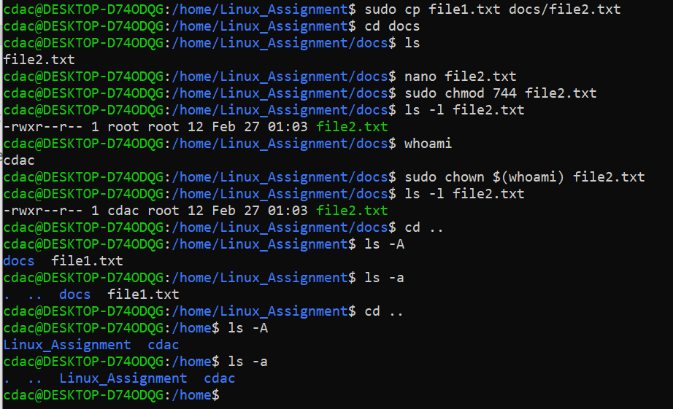

1. File Searching:
2. Search for all files with the extension ".txt" in the current directory and its subdirectories.

Step 1: find . -type f -name “*.txt”

Here find cmd is used to search for files

-type f cmd is used to search for files not for directories

-name it specifies which type of file to be searched

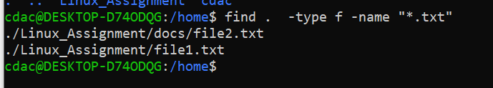

b) Display lines containing a specific word in a file (provide a file name and the specific word to search).

Step 1: grep “hello” file1.txt

This grep command is used to find the word from the file and display it at terminal , as this grep command is case sensitive to make it case insensitive use grep -i

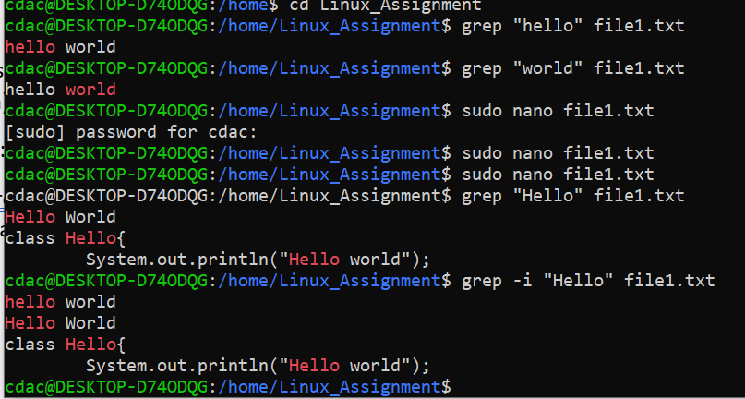

1. System Information:

Display Current System date and time.

Step : date

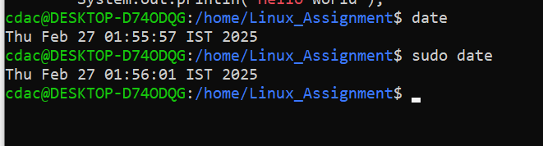

1. Networking:
2. Display the IP address of the system.

Step : hostname -I

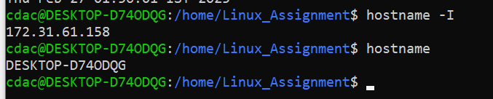

1. Ping a remote server to check connectivity (provide a remote server address to ping).

Step1: ping google.com

Step2: ping -c 4 google.com

The ping command is used to test network connectivity between your system and a remote server. It checks whether the remote system is reachable and measures the round-trip time (latency) for data packets to travel back and forth.

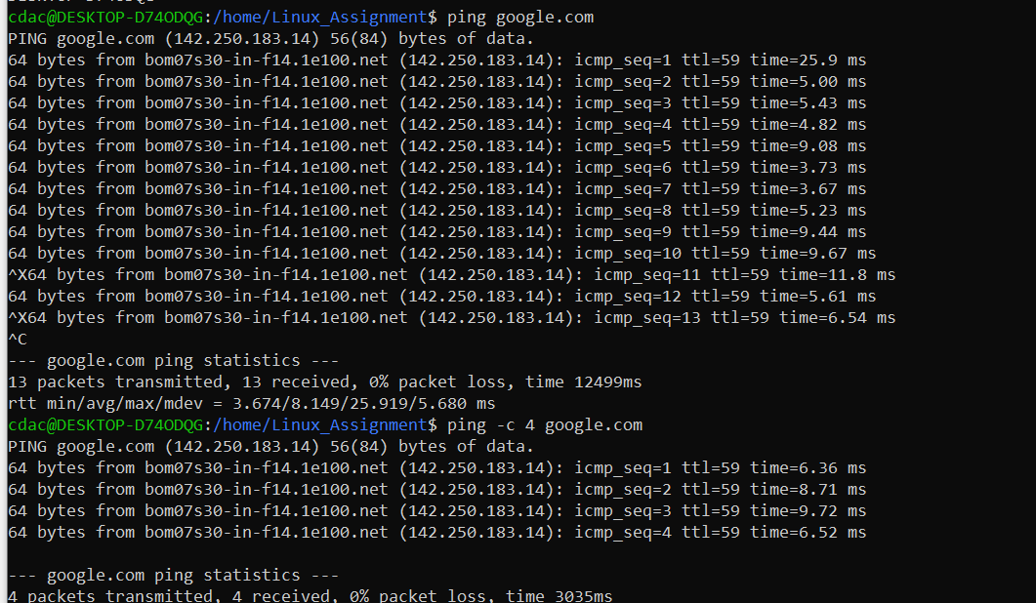

1. File Compression:

a. Compress the "docs" directory into a zip file.

Step : sudo zip -r docs.zip docs

This creates a compressed file named docs.zip containing the docs directory and all its contents.

1. Extract the contents of the zip file into a new directory.

Step : sudo unzip docs.zip -d new_docs

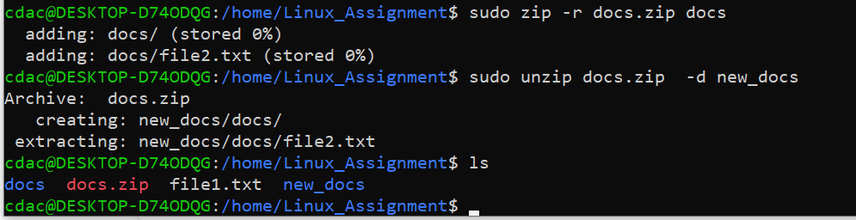

k) File Editing:

a. Open the "file1.txt" file in a text editor and add some text to it.

Step 1: sudo nano file1.txt

You will enter to editor type any text

1. Replace a specific word in the "file1.txt" file with another word (provide the original word and the word to replace it with).

Step 2: sed -I ‘s/original_word/new_word/g’ file1.txt

In this command -I stands for edit the file in place , s stands for substitution command, g stands for global replacement.

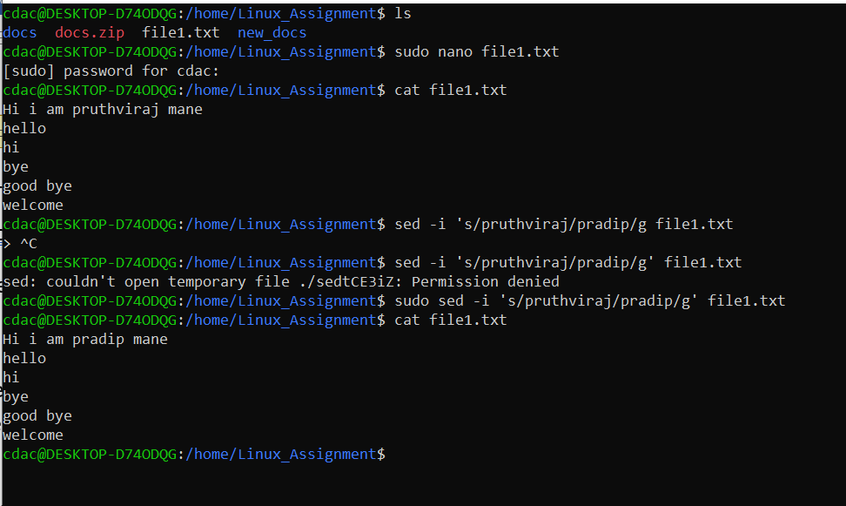

Problem 2: Read the instructions carefully and answer accordingly. If there is

any need to insert some data then do that as well.

a. Suppose you have a file named "data.txt" containing important information. Display the

first 10 lines of this file to quickly glance at its contents using a command.

Step 1: nano data1.txt

Explanation: it will create a file named as data1.txt , write a few lines of sentences in it

Step 2: head -10 data1.txt

Explanation: It will display 10 lines from top of file

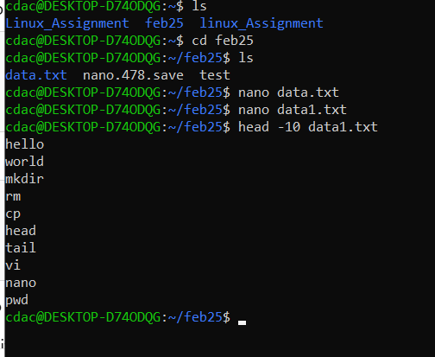

b. Now, to check the end of the file for any recent additions, display the last 5 lines of

"data.txt" using another command.

Step 1: tail -5 data1.txt

Explanation: This command will display last 5 lines of the file data1.txt

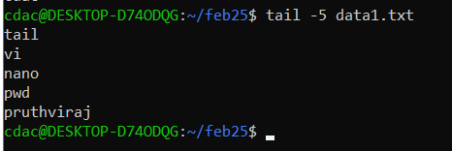

c. In a file named "numbers.txt," there are a series of numbers. Display the first 15 lines of

this file to analyze the initial data set.

Step 1: nano print_number.sh

It will create print_number file and open it where we need to write below code .this will print number 1 to 100 in number.txt file

#!/bin/bash

for i in {1..100}

do echo

$i >> numbers.txt

done

Step 2: chmod +x print_number.sh

Explanation: above command will change the mode of file to executable file by giving permission.

Step 3: now Run the script by command : ./print_numbers.sh

Step 4: check the output by using : cat numbers.txt

Step 5: head -15 numbers.txt

Explanation: This will display first 15 lines of code in numbers.txt file

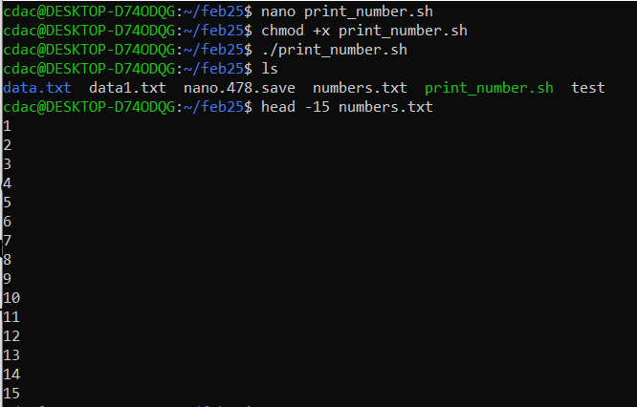

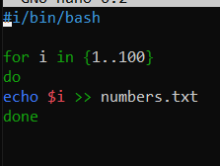

1. To focus on the last few numbers of the dataset, display the last 3 lines of "numbers.txt".

Step 1: tail -3 numbers.txt

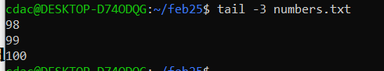

e. Imagine you have a file named "input.txt" with text content. Use a command to translate

all lowercase letters to uppercase in "input.txt" and save the modified text in a new file

named "output.txt."

Solution:

Step 1: nano input.txt

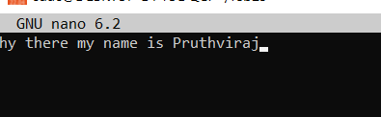

Step 1: cat input.txt | tr ‘a-z’ ‘A-Z’ > output.txt && mv output.txt input.txt

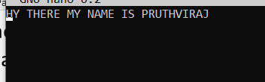

f. In a file named "duplicate.txt," there are several lines of text, some of which are

duplicates. Use a command to display only the unique lines from "duplicate.txt."

Step 1: nano duplicate.txt

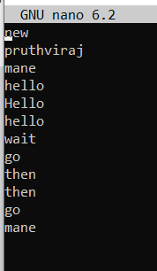

Step 2: sort duplicate.txt| uniq

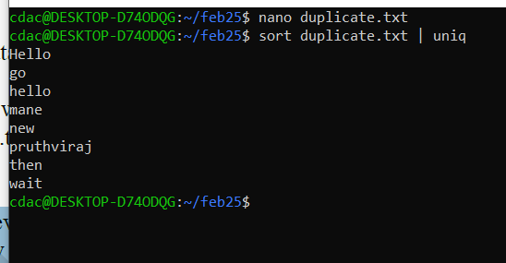

g. In a file named "fruit.txt," there is a list of fruits, but some fruits are repeated. Use a

command to display each unique fruit along with the count of its occurrences in

"fruit.txt."

Step 1: nano fruit.txt

Step 2: sort fruit.txt | uniq -c

